html5 fundamentals

01.first website

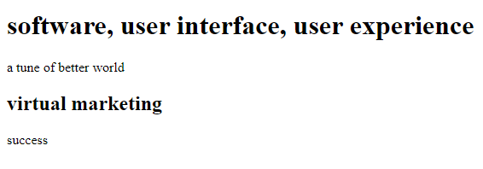

source

<!doctype html>

<html>

<head>

<title> idol wave </title>

</head>

<body>

<h1> software, user interface, user experience </h1>

<p> a tune of better world </p>

<h2> virtual marketing </h2>

<p> success </p>

</body>

</html>

save as

text.html

02a.line brake

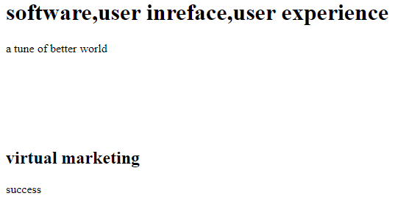

source

<!doctype html>

<html>

<head>

<title> idol wave </title>

</head>

<body>

<h1> software,user inreface,user experience </h1>

<p> a tune of better world </p>

<br>

<br>

<br>

<br>

<br>

<h2> virtual marketing </h2>

<p> success </p>

</body>

</html>

02b.! sign



source

<!doctype html>

<html>

<head>

<title> idol wave </title>

</head>

<body>

<h1> software,user inreface,user experience </h1>

<p> a tune of better world </p>

<br>

<br>

<br>

<br>

<br>

<! nothing will show for exclamation sign>

<h2> virtual marketing </h2>

<p> success </p>

</body>

</html>

02c.without ! sign

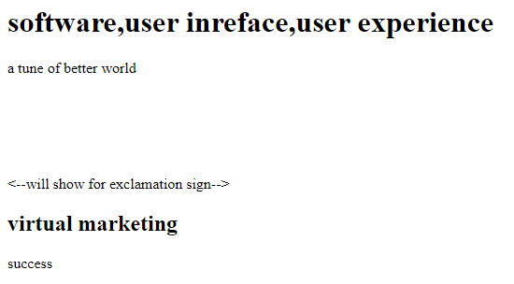

source

<!doctype html>

<html>

<head>

<title> idol wave </title>

</head>

<body>

<h1> software,user inreface,user experience </h1>

<p> a tune of better world </p>

<br>

<br>

<br>

<br>

<br>

<--will show for exclamation sign-->

<h2> virtual marketing </h2>

<p> success </p>

</body>

</html>

02d.space in text

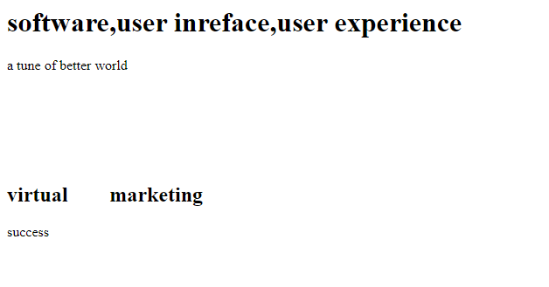

source

<!doctype html>

<html>

<head>

<title> idol wave </title>

</head>

<body>

<h1> software,user inreface,user experience </h1>

<p> a tune of better world </p>

<br>

<br>

<br>

<br>

<br>

<h2> virtual &nbsp&nbsp&nbsp&nbsp&nbsp&nbsp marketing </h2>

<p> success </p>

</body>

</html>

03a.ul (unorder list)

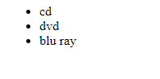

source

<!doctype html>

<html>

<head>

<title> idol wave </title>

</head>

<body>

<ul>

<li> cd </li>

<li> dvd </li>

<li> blu ray </li>

</ul>

</body>

</html>

03b.ol (order list)

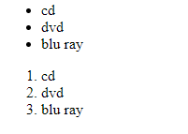

source

<!doctype html>

<html>

<head>

<title> idol wave </title>

</head>

<body>

<ul>

<li> cd </li>

<li> dvd </li>

<li> blu ray </li>

</ul>

<ol>

<li> cd </li>

<li> dvd </li>

<li> blu ray </li>

</ol>

</body>

</html>

04a.table-01

C:\Users\User\Desktop\html.07.PNG

source

<!doctype html>

<html>

<head>

<title> idol wave </title>

</head>

<body>

<table>

<tr>

<th> the planets </th>

<th> the oceans </th>

<th> the deserts </th>

</tr>

<tr>

<td> earth </td>

<td> pacific </td>

<td> sahara </td>

</tr>

</table>

</body>

</html>

04b.table-02

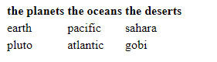

source

<!doctype html>

<html>

<head>

<title> idol wave </title>

</head>

<body>

<table>

<tr>

<th> the planets </th>

<th> the oceans </th>

<th> the deserts </th>

</tr>

<tr>

<td> earth </td>

<td> pacific </td>

<td> sahara </td>

</tr>

<tr>

<td> pluto </td>

<td> atlantic </td>

<td> gobi </td>

</tr>

</table> </body> </html>

05.adding links

C:\Users\User\Desktop\html.09.PNG

source

<!doctype html>

<html>

<head>

<title> idol wave </title>

</head>

<body>

<p> please click on this link

<a href="http://idolwave.org/"> idol wave </a>

</p>

</body>

</html>

06.creating a link in same page

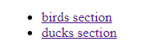 C:\Users\User\Desktop\06b.PNG 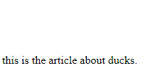

source

<!doctype html>

<html>

<head>

<title>idol wave</title>

</head>

<body>

<ul>

<li> <a href="#birds">birds section</a> </li>

<li> <a href="#ducks">ducks section</a> </li>

</ul>

<br>

<br>

<br>

<br>

<br>

<br>

<br>

<br>

<br>

<br>

<br>

<br>

<br>

<br>

<br>

<br>

<br>

<br>

<br>

<br>

<br>

<br>

<br>

<br>

<br>

<br>

<br>

<br>

<br>

<br>

<br>

<br>

<br>

<br>

<br>

<br>

<br>

<br>

<br>

<br>

<br>

<br>

<br>

<br>

<br>

<br>

<br>

<br>

<br>

<br>

<br>

<br>

<br>

<br>

<br>

<br>

<br>

<br>

<br>

<br>

<br>

<br>

<br>

<br>

<br>

<br>

<br>

<br>

<br>

<br>

<br>

<br>

<br>

<br>

<br>

<br>

<br>

<br>

<br>

<br>

<br>

<br>

<br>

<br>

<br>

<br>

<br>

<br>

<br>

<br>

<br>

<br>

<br>

<br>

<br>

<br>

<p> <a name="birds"> this is the article about birds. </a></p>

<br>

<br>

<br>

<br>

<br>

<br>

<br>

<br>

<br>

<br>

<br>

<br>

<br>

<br>

<br>

<br>

<br>

<br>

<br>

<br>

<br>

<br>

<br>

<br>

<br>

<br>

<br>

<br>

<br>

<br>

<br>

<br>

<br>

<br>

<br>

<br>

<br>

<br>

<br>

<br>

<br>

<br>

<br>

<br>

<br>

<br>

<br>

<br>

<br>

<br><br><br><br><br><br><br><br><br><br>

<br><br><br><br><br><p>

<a name="ducks"> this is the article about ducks. </a></p>

</body>

</html>

07. adding Image

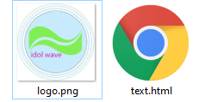

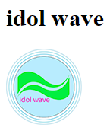

source

<!doctype html>

<html>

<head>

<title> idol wave </title>

</head>

<body>

<h1>idol wave</h1>

<p> <img src="logo.png"> </p>

</body>

</html>

08. resize Image

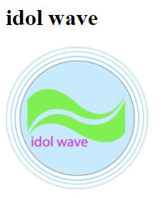

source

<!doctype html>

<html>

<head>

<title> idol wave </title>

</head>

<body>

<h1>idol wave</h1>

<p> <img src="logo.png" width="200" height="200"> </p>

</body>

</html>

09. parent element & child element relation

<!doctype html>

<html>

<head>

<title> </title>

</head>

<body> parent element

<h1> </h1>

<p> </p> child element

</body>

</html>

10a. text box



source

<!doctype html>

<html>

<head>

<title> idol wave </title>

</head>

<body>

<from action=" method="">

<input type="text" name="">

<!--Input elements go in here-->

</from>

</body>

</html>

10b. text box



source

<!doctype html>

<html>

<head>

<title> idol wave </title>

</head>

<body>

<from action=" method="">

<input type="text" name="">

<input type="text" name="">

<!--Input elements go in here-->

</from>

</body>

</html>

10c. text box

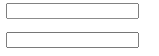

source

<!doctype html>

<html>

<head>

<title> idol wave </title>

</head>

<body>

<from action=" method="">

<input type="text" name="">

<br>

<br>

<input type="text" name="">

<!--Input elements go in here-->

</from>

</body>

</html>

11a. text box with label

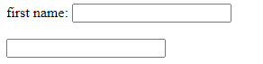

source:

<!doctype html>

<html>

<head>

<title> idol wave </title>

</head>

<body>

<from action=" method="">

<label for="firstname"> first name:</label>

<input type="text" id="firstname" name="">

<br>

<br>

<input type="text" name="">

<!--Input elements go in here-->

</from>

</body>

</html>

11b. text box with label

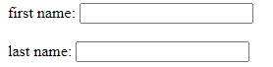

source:

<!doctype html>

<html>

<head>

<title> idol wave </title>

</head>

<body>

<from action=" method="">

<label for="firstname"> first name:</label>

<input type="text" id="firstname" name="">

<br>

<br>

<label for="lastname"> last name:</label>

<input type="text" id="lastname" name="">

<!--Input elements go in here-->

</from>

</body>

</html>

12a. multi line text box

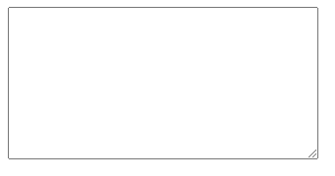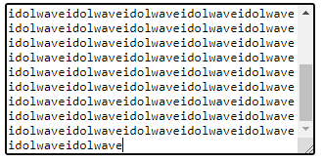

source:

<!doctype html>

<html>

<head>

<title> idol wave </title>

</head>

<body>

<from action="” method="">

<textarea rows="10" cols="40"></textarea></br>

</from>

</body>

</html>

12b. multi line text box big

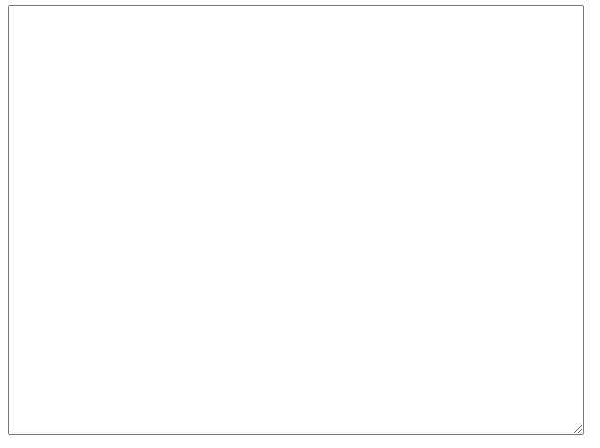

source:

<!doctype html>

<html>

<head>

<title> idol wave </title>

</head>

<body>

<from action="” method="">

<textarea rows="30" cols="80"></textarea></br>

</from>

</body>

</html>

12c. multi line text box with heading

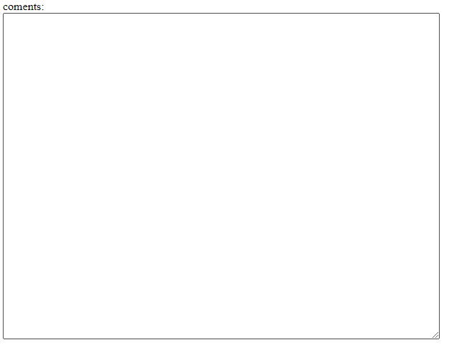

source:

<!doctype html>

<html>

<head>

<title> idol wave </title>

</head>

<body>

<from action="” method="">

coments: </br>

<textarea rows="30" cols="80"></textarea></br>

</from>

</body>

</html>

12d. multi line text box with submit button

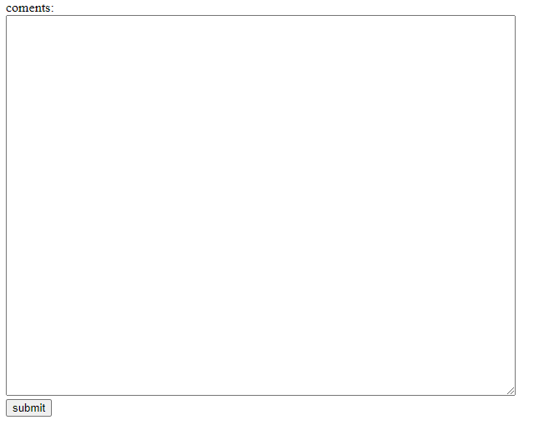

source:

<!doctype html>

<html>

<head>

<title> idol wave </title>

</head>

<body>

<from action="” method="">

coments: </br>

<textarea rows="30" cols="80"></textarea></br>

<input type="submit" value="submit">

</from>

</body>

</html>

13a. radio buttons

13a



source:

<!doctype html>

<html>

<head>

<title> idol wave </title>

</head>

<body>

<from action="" method="">

yes:

<input type="radio" name="yesorno" value=""> </br>

<input type="radio" name="yesorno" value="">



</from>

</body>

</html>

13b. radio buttons

C:\Users\User\AppData\Local\Microsoft\Windows\INetCache\Content.Word\13b.png

source:

<!doctype html>

<html>

<head>

<title> idol wave </title>

</head>

<body>

<from action="" method="">

yes:

<input type="radio" name="yesorno" value=""> </br>

no:

<input type="radio" name="yesorno1" value="">

</from>

</body>

</html>

14a. check box

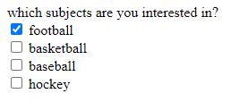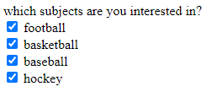

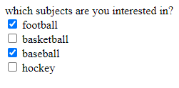

source:

<!doctype html>

<html>

<head>

<title> idol wave </title>

</head>

<body>

<from action="" method="">

which subjects are you interested in? <br>

<input type="checkbox" name""> football <br>

<input type="checkbox" name""> basketball <br>

<input type="checkbox" name""> baseball <br>

<input type="checkbox" name""> hockey

</from>

</body>

</html>

14b. check box

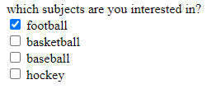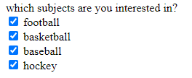

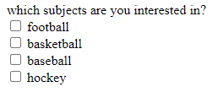

source:

<!doctype html>

<html>

<head>

<title> idol wave </title>

</head>

<body>

<from action="" method="">

which subjects are you interested in? <br>

<input type="checkbox" name"" checked="checked"> football <br>

<input type="checkbox" name""> basketball <br>

<input type="checkbox" name""> baseball <br>

<input type="checkbox" name""> hockey

</from>

</body>

</html>

15a. input number box

C:\Users\User\AppData\Local\Microsoft\Windows\INetCache\Content.Word\15aaa.png



source:

<!doctype html>

<html>

<head>

<title> idol wave </title>

</head>

<body>

<from action="" method="">

<input type="number">

</from>

</body>

</html>

15b. input number box with range



source:

<!doctype html>

<html>

<head>

<title> idol wave </title>

</head>

<body>

<from action="" method="">

<input type="number" min="0" max="50">

</from>

</body>

</html>

16.drop down list



source:

<!doctype html>

<html>

<head>

<title> idol wave </title>

</head>

<body>

<from action="" method="">

<select>

<option value="michigan">michigan</option>

<option value="alabama">alabama</option>

<option value="north dakota">north dakota</option>

</select>

</from>

</body>

</html>

17.date & number box



source:

<!doctype html>

<html>

<head>

<title> idol wave </title>

</head>

<body>

<from>

enter day you want to travel to cancun:

<input type="date" name="day">

</br>

number of days: <input type="number" name="numdays" min="01" max="10">

</from>

</body>

</html>

18a.fieldbox and legend elements

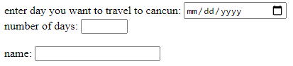

source:

<!doctype html>

<html>

<head>

<title> idol wave </title>

</head>

<body>

<from>

enter day you want to travel to cancun:

<input type="date" name="day">

</br>

number of days: <input type="number" name="numdays" min="01" max="10">

<br><br>

name: <input type=text">

</from>

</body>

</html>

18b.fieldbox and legend elements

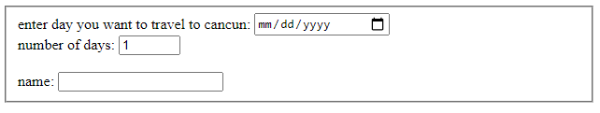

source:

<!doctype html>

<html>

<head>

<title> idol wave </title>

</head>

<body>

<from>

<fieldset>

enter day you want to travel to cancun:

<input type="date" name="day">

</br>

number of days: <input type="number" name="numdays" min="01" max="10">

<br><br>

name: <input type=text">

</fieldset>

</from>

</body>

</html>

18c.fieldbox and legend elements

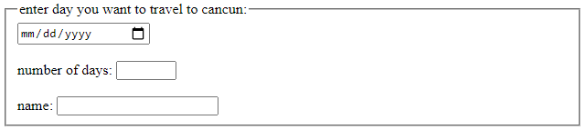

source:

<!doctype html>

<html>

<head>

<title> idol wave </title>

</head>

<body>

<from>

<fieldset>

<legend>enter day you want to travel to cancun:</legend>

<input type="date" name="day">

</br></br>

number of days: <input type="number" name="numdays" min="01" max="10">

<br><br>

name: <input type=text">

</fieldset>

</from>

</body>

</html>

19.attributes

attributes:

<p> </p>

<h1> </h1>

<body> </body>

<p class=”test”> some text in this paragraph </p>

<label for=”name”> name </label>

Here,

<p class=”test”>

<label for =”name”>

are attributes.

20.the meta element

meta:

<!doctype html>

<html>

<head>

<title> idol wave </title>

<meta name=”description”content=”this is a web age about information technology. we cover all the websites, graphics and advertisement in the world.”/>

<meta name=’keywords” content=”website, graphics, advertising./>

<meta http-wquiv=”content-language” content=”en-us”

</head>

<body>

<div>

</div>

</body>

</html>

21.escape characters

<!doctype html>

<html>

<head>

<title> idol wave </title>

</head>

<body>

<p>attribute character abbreviation coding </p>

</body>

</html>

Space ---------- &nbsp

TM ~~--------------~~  &#8482

& ---------------- &amp

--------------- &copy



< ----------------- &lt

> ----------------- &gt

? ----------------- &#63

22.bold and italic elamets

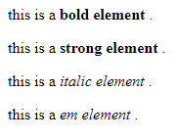

source:

<!doctype html>

<html>

<head>

<title> idol wave </title>

</head>

<body>

<p> this is a <b> bold element </b>. </p>

<p> this is a <strong> strong element </strong>. </p>

<p> this is a <i> italic element </i>. </p>

<p> this is a <em> em element </em>. </p>

<! b=strong is same command and i=em is same command>

</body>

</html>

23a.i frame element

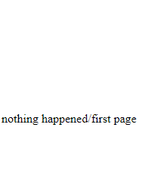

source:

<!doctype html>

<html>

<head>

<title> idol wave </title>

</head>

<body>

<iframe frameborder="" width="" height="" src="" name="" id="">

</iframe><br />

nothing happened

</body>

</html>

23b.i frame element



source:

<!doctype html>

<html>

<head>

<title> idol wave </title>

</head>

<body>

<iframe frameborder="1" width="200" height="200" src="" name="ouriframe" id="ouriframe">

</iframe><br />

</body>

</html>

23c.i frame element



source:

<!doctype html>

<html>

<head>

<title> idol wave </title>

</head>

<body>

<iframe frameborder="1" width="200" height="200" src="" name="ouriframe" id="ouriframe">

do you see this?

<! do yoju see this? is not showing because it is in side of closing iframe>

</iframe><br />

</body>

</html>

23d.i frame element

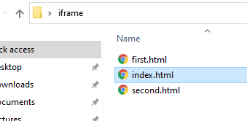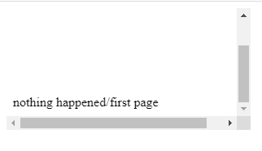

source:

<!doctype html>

<html>

<head>

<title> idol wave </title>

</head>

<body>

<iframe frameborder="" width="" height="" src="first.html" name="" id="">

</iframe><br />

</body>

</html>

23e.i frame element



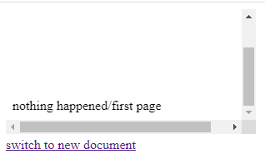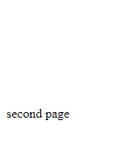

source:

<!doctype html>

<html>

<head>

<title> idol wave </title>

</head>

<body>

<iframe frameborder="" width="" height="" src="first.html" name="" id="">

</iframe><br />

<a href="second.html" target="ouriframe"> switch to new document</a>

</body>

</html>

24.sup and sub element(superscript and subscript)

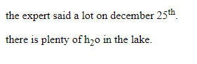

source:

<!doctype html>

<html>

<head>

<title> idol wave </title>

</head>

<body>

<p> the expert said a lot on december 25<sup>th</sup>.</p>

<p> there is plenty of h<sub>2</sub>o in the lake.</p>

</body>

</html>

25a. title and alt attributes

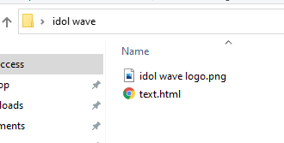

source:

<!doctype html>

<html>

<head>

<title> idol wave </title>

</head>

<body>

<img src="idol wave logo.png" width="200" height="200" title="idol wave" alt="idol wave">

<!as like image taging but this application for jquery>

</body>

</html>

25b. title and alt attributes





source:

<!doctype html>

<html>

<head>

<title> idol wave </title>

</head>

<body>

<img src="idol wave logo1.png" width="200" height="200" title="idol wave" alt="idol wave">

<!as like image taging but this application for jquery>

</body>

</html>

26a. audio element

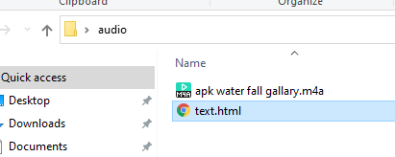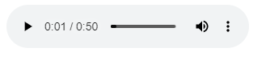

source:

<!doctype html>

<html>

<head>

<title> idol wave </title>

</head>

<body>

<audio controls="audiocontrols">

<source src="apk water fall gallary.m4a"/>

</audio>

<!-- three standard formats for web browsers are .mp3 .wav and .ogg -->

</body>

</html>

26b. audio element

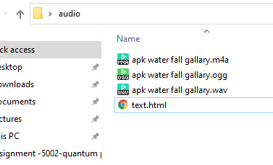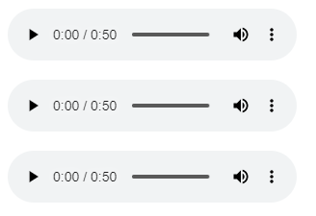

source:

<!doctype html>

<html>

<head>

<title> idol wave </title>

</head>

<body>

<p><audio controls="audiocontrols">

<source src="apk water fall gallary.m4a"/> </audio></p>

<p><audio controls="audiocontrols">

<source src="apk water fall gallary.wav"/> </audio></p>

<p><audio controls="audiocontrols">

<source src="apk water fall gallary.ogg"/> </audio></p>

<!-- three standard formats for web browsers are .mp3 .wav and .ogg -->

</body>

</html>

27a. audio element attributes

 

source:

<!doctype html>

<html>

<head>

<title> idol wave </title>

</head>

<body>

<audio controls>

<source src="apk water fall gallary.m4a"/>

</audio>

<!-- three standard formats for web browsers are .mp3 .wav and .ogg -->

</body>

</html>

27b. audio element attributes auto ply



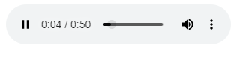

source:

<!doctype html>

<html>

<head>

<title> idol wave </title>

</head>

<body>

<audio controls autoplay>

<source src="apk water fall gallary.m4a"/>

</audio>

<!-- three standard formats for web browsers are .mp3 .wav and .ogg -->

</body>

</html>

27c. audio element attributes auto play over and over

 

source:

<!doctype html>

<html>

<head>

<title> idol wave </title>

</head>

<body>

<audio controls autoplay loop>

<source src="apk water fall gallary.m4a"/>

</audio>

<!-- three standard formats for web browsers are .mp3 .wav and .ogg -->

</body>

</html>

27d. audio element attributes auto play over and over with drag gable

 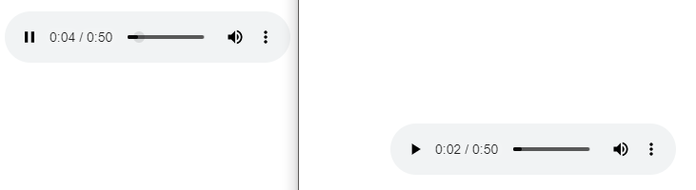

source:

<!doctype html>

<html>

<head>

<title> idol wave </title>

</head>

<body>

<audio controls auto play loop draggable="true">

<source src="apk water fall gallary.m4a"/>

</audio>

<!-- three standard formats for web browsers are .mp3 .wav and .ogg -->

</body>

</html>

28. video element

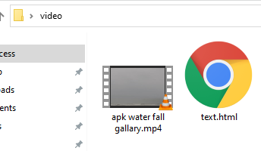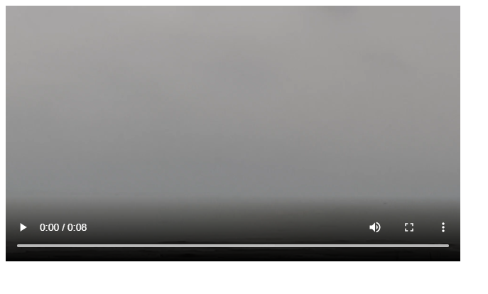

source:

<!doctype html>

<html>

<head>

<title> idol wave </title>

</head>

<body>

<video width="640" height="360" controls>

<source src="apk water fall gallary.mp4"/>

</video>

<!--standard video formats for web browsers are .mp4 .webm and .ogg -->

</body>

</html>

html5

to

vanilla-css3

and

javascrift