Blog- Meknes – Meknes Stories-Inspire-Blog

Subject:
Meknes – Meknes Stories
How to tell the human and cultural stories of Meknes through a participatory blog?

Primary User Identification

salma – Busy Reader (Priority)
Age/Context:
22 years old, a university student in Meknes. She reads articles on her smartphone between classes or during short breaks. She enjoys discovering stories about her city and learning from other people’s experiences.
Main Objective:
To quickly read recent and interesting stories about Meknes, without spending too much time searching.
Key Needs: - Quickly find popular or trending articles.
- Save and share articles with friends.
- Enjoy short, clear, and visual content suitable for mobile reading.
- Access content easily, even with an average internet connection.
Frustration:
Slow navigation, unclear titles, too much text, and lack of summarized content for short reading times.
Environment:
Smartphone (Android), average Wi-Fi or 4G connection, short sessions of 5–10 minutes between classes.

Alex – Tourist Visitor
Age/Context:
29 years old, international traveler visiting Meknes to explore its authentic culture and history. Uses a smartphone for quick searches while traveling and a laptop for planning visits.
Main Objective:
To discover the human and cultural stories of Meknes and find meaningful places to visit based on locals’ experiences.
Key Needs: - Access short and visual articles about local culture and people.
- Find recommendations for cultural places, events, or hidden gems.
- Save or share stories and itineraries.
- Use the platform easily even with a limited mobile connection.
Frustration:
Difficulty finding reliable and engaging information about local culture. Many websites are outdated, text-heavy, or not optimized for mobile.
Environment:
Android smartphone and laptop, limited mobile data while traveling.

Define the Problem and the Solution

Problem Statement
For the busy reader, who struggles to find short and engaging stories about Meknes,
we want to create a mobile-friendly participatory blog where she can quickly read, save, and share local human and cultural stories,
so that she can stay connected to her city and its people without wasting time.
For the tourist visitor, who lacks access to authentic and well-presented cultural content,
we want to build a story-sharing platform that gathers articles, photos, and local experiences from the community,
so that they can discover Meknes’ heritage and plan meaningful visits even with a limited connection.

5. Main Features and Use Cases

5.1 Brainstorm – All Possible Features
- Browse list of human and cultural stories about Meknes
- View story details (description, location, images, author, date)
- Save stories to favorites
- Share stories on social media
- Comment or leave feedback on stories
- Receive notifications about new stories or updates
- Filter stories by category (culture, history, events, people, hidden gems…)
- Access offline mode for low-connectivity users
- Access the platform via mobile app (Android)
- Register as a contributor to publish stories
- Moderate or manage content (for administrators)

5.2 Prioritized Features (MoSCoW Method)
Fonctionnalité | Description | Priorité (MoSCoW)
Lister les articles | Permet à tous les utilisateurs (visiteurs, enregistrés, admin) de voir les articles récents et les histoires publiées | Must
Ouvrir un article | Affiche le contenu complet d’un article, avec ses images, auteur, date de publication et localisation si disponible | Must
Sauvegarder un article | L’utilisateur enregistré peut ajouter un article à ses favoris pour le consulter plus tard | Should
Commenter / Aimer / Partager un article | Permet aux utilisateurs enregistrés d’interagir avec le contenu via commentaires, likes ou partage | Should
Publier un article / une mise à jour | Permet aux contributeurs et aux administrateurs de publier de nouveaux articles sur la plateforme | Must
Rechercher / Filtrer les articles | Permet aux utilisateurs de rechercher des articles par mot-clé ou par catégorie | Could
Gérer les articles publiés | L’administrateur peut modifier, approuver ou supprimer les articles pour modérer le contenu | Should
Recevoir notifications | Les utilisateurs reçoivent des notifications pour les nouveaux articles ou réponses aux commentaires | Could
Mode hors-ligne | Permet la lecture des articles sauvegardés même sans connexion internet | Could

5.3 Use Cases (UC)
ID | Acteur | Cas d’utilisation (UC) | Priorité
UC1 | Visiteur / Utilisateur enregistré / Admin | Accueil (Afficher la liste des articles) | Must
UC2 | Visiteur / Utilisateur enregistré / Admin | Consulter un article en détail | Must
UC3 | Utilisateur enregistré / Admin | Ajouter un article aux favoris | Should
UC4 | Utilisateur enregistré / Admin | Commenter / Aimer / Partager un article | Should
UC5 | Contributeur / Admin | Publier un article ou une mise à jour | Must
UC6 | Utilisateur enregistré / Admin | Rechercher ou filtrer des articles par catégorie | Could
UC7 | Admin | Gérer / Modérer le contenu publié | Should
UC8 | Utilisateur enregistré | Recevoir des notifications sur les nouveaux articles | Could
UC9 | Utilisateur enregistré | Lire les articles sauvegardés hors-ligne | Could
UC10 | Contributeur | Soumettre un nouvel article pour approbation | Must

Use Case Diagram
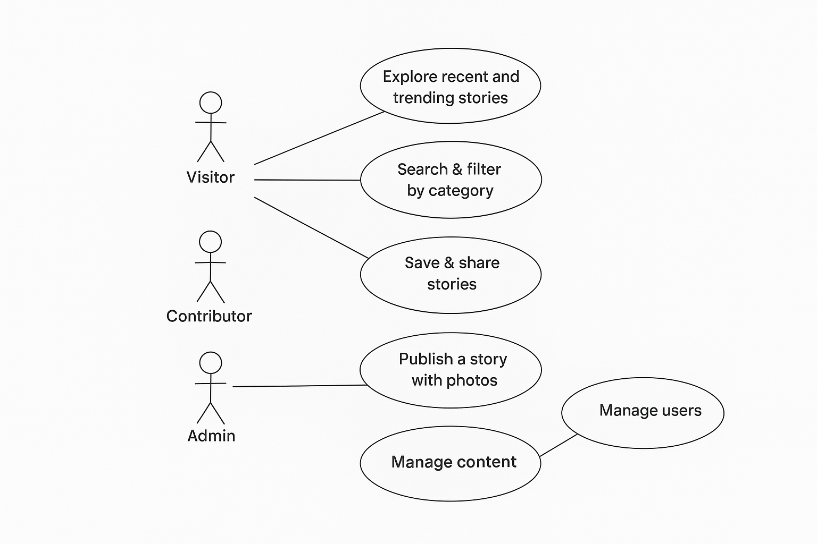
Use Case Diagram – Meknes Stories Blog

6. Wireframes / UI Suggestions
Home Screen:
- Latest stories in card layout with title, image, short summary
- Search bar and category filters
- Trending or popular stories section
Article Detail Page:
- Full content with images, author, date, and location
- Buttons: Save, Share, Comment, Like
- Related stories suggestions
Profile / Favorites Page:
- Saved stories
- User comments and contributions
Admin / Contributor Dashboard:
- Publish new stories
- Approve or edit submissions
- Track views, likes, and shares

7. Technical Considerations
- Platform: Mobile-first web, Android app
- Backend: CMS for managing articles and user contributions
- Database: Store articles, users, comments, categories, and favorites
- Offline Mode: Cache saved stories for low connectivity
- Notifications: Push notifications for new articles or comments
- Performance: Optimize images and content for low bandwidth

8. Conclusion
The Meknes Stories participatory blog allows both locals and visitors to explore the human and cultural heritage of Meknes. By focusing on short, visual, mobile-friendly stories and enabling community participation, the platform meets the needs of busy readers and tourists, fostering cultural discovery and local engagement.

