Sentiment Classification of Drug Reviews
with Hand-Implemented LSTM Variants
Advanced Natural Language Processing — Lab Project on Recurrent Neural Networks
Mohamed Amine Lamrid
Badr Misraoui
Lab group E $⋅$University year 2026/2027
Code: https://github.com/amine2003lamrid-hue/drug-review-lstm
Abstract
We classify patient drug reviews from Drugs.com as positive or negative with recurrent networks whose cells are implemented from scratch in PyTorch using only nn.Linear. A vanilla LSTM baseline is compared with two efficiency-oriented variants, the Coupled Input–Forget Gate LSTM (CIFG) and the LSTM with recurrent projection (LSTMP), under an identical protocol, and the baseline’s sensitivity to learning rate, optimizer, batch size and weight initialization is studied one factor at a time. [TO FILL AFTER RUN]

Goal of the task
The UCI Drug Review dataset contains patient reviews of medications rated from 1 to 10. We frame it as binary sentiment classification: a review is positive if its rating is $≥7$ and negative if it is $≤4$; neutral reviews (5–6) are discarded. The study has three goals: (i) build a vanilla LSTM baseline; (ii) test whether two non-vanilla cells, CIFG and LSTMP, can match it with fewer parameters; (iii) measure how optimization hyperparameters affect the baseline. All cells are written with nn.Linear as the only linear operation; no built-in recurrent module (nn.LSTM, nn.LSTMCell, nn.RNN) is used, which a unit test verifies automatically.

Exploratory data analysis
The official files contain 161,297 training and 53,766 test reviews. Dropping the 19,185 neutral reviews leaves 146,941 training and 48,937 test reviews. Ratings are strongly polarized (10 and 1 dominate, Fig. 1a), so the binary task is well defined, but the classes are imbalanced: 72.7% of the training reviews are positive (72.4% in test, Fig. 1b). A constant “positive” classifier would therefore already reach about 72.4% accuracy, so we use macro-F1 for model selection and as the headline metric.
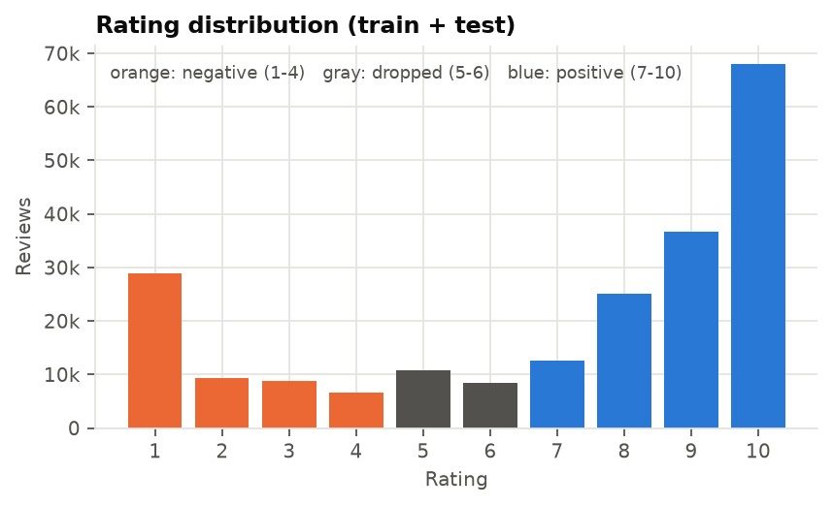  Ratings (orange: negative, gray: dropped, blue: positive) | 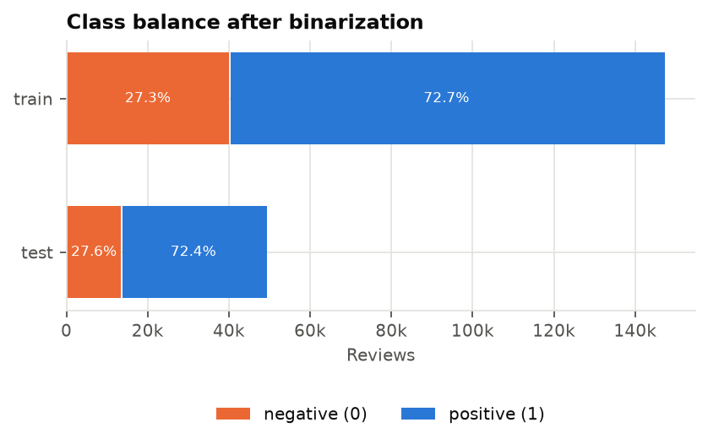  Class balance after binarization |  | 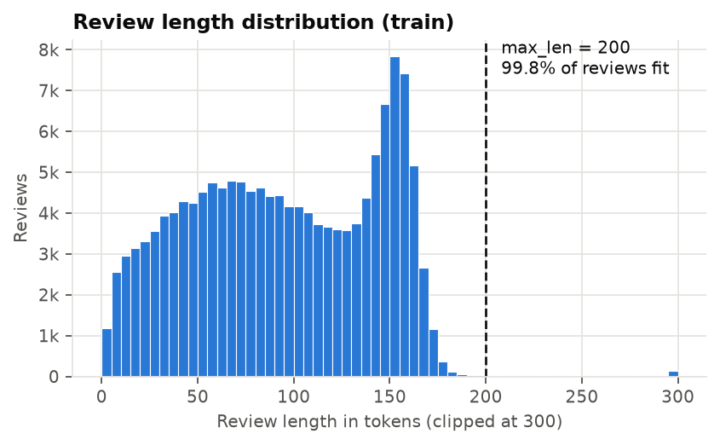  Review length in tokens (train) | 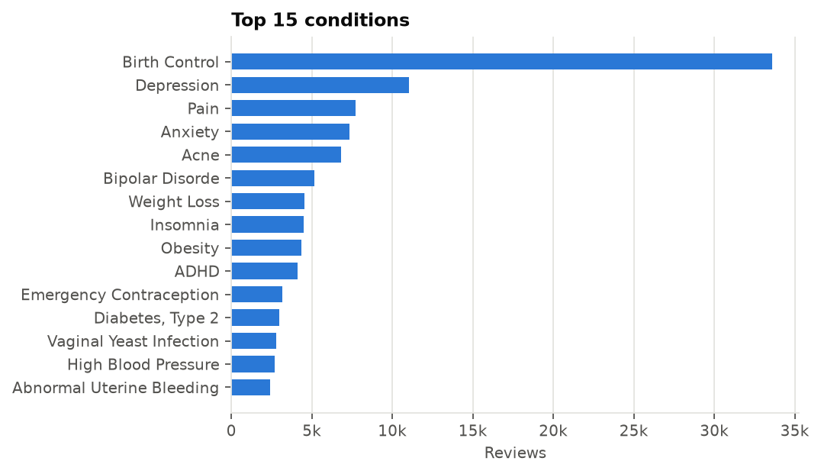  Most reviewed conditions
Figure 1: Exploratory data analysis of the Drug Review dataset.

Preprocessing.
Reviews are HTML-unescaped (the raw text contains entities such as &#039;), lowercased, stripped of quotes and tokenized with a regular expression keeping words, contractions and the punctuation marks ! ? . ,. The mean review length is 94 tokens (median 93, 95th percentile 162), with a sharp drop around 160 tokens that reflects a length limit on the website (Fig. 1c). A maximum length of 200 tokens keeps 99.8% of reviews untruncated. The reviews cover 898 conditions and 3,617 drugs, led by birth control, depression and pain (Fig. 1d).

Splits.
The official test file is the test set; the official training file is split 90/10 (stratified, seed 42) into training and validation sets. To fit free-GPU budgets we draw stratified subsamples of 40,000 / 5,000 / 10,000 reviews, which preserve the original class ratio and so introduce no artificial imbalance. The vocabulary (minimum frequency 2, at most 20k types, <pad>$=0$, <unk>$=1$) is built on the training subset only and contains 18,664 tokens.

Modeling approach

Architecture.
All models share one pipeline: token ids $→$ embedding (128-d) $→$ one recurrent layer built from the chosen cell (hidden size $H=256$) $→$ dropout 0.3 $→$ linear layer $→$ 2 logits. A generic RecurrentLayer unrolls any cell over time and supports stacking with inter-layer dropout. Batches are padded to their longest review; at padded positions the state $(h,c)$ is frozen by a mask, so the classifier receives the hidden state at each review’s true last token. For speed, the gate pre-activations are fused into one nn.Linear for $x_{t}$ and one bias-free nn.Linear for $h_{t−1}$ (each gate keeps exactly one bias, as in the equations), and $W_{x}x_{t}$ is computed for all time steps in a single matrix product before the time loop.

Vanilla LSTM (baseline).
$$\begin{aligned}i_{t}&=σ(W_{hi}h_{t−1}+W_{xi}x_{t}+b_{i}),&f_{t}&=σ(W_{hf}h_{t−1}+W_{xf}x_{t}+b_{f}),&o_{t}&=σ(W_{ho}h_{t−1}+W_{xo}x_{t}+b_{o}), \\ g_{t}&=tanh(W_{hg}h_{t−1}+W_{xg}x_{t}+b_{g}),&c_{t}&=f_{t}⊙c_{t−1}+i_{t}⊙g_{t},&h_{t}&=o_{t}⊙tanh(c_{t}).\end{aligned}$$

CIFG-LSTM.
The input gate is tied to the forget gate, $i_{t}=1−f_{t}$; everything else is unchanged. The cell can only write new content in proportion to what it forgets. Greff et al. found that this coupling costs little accuracy, while it removes a whole gate: 25% fewer recurrent parameters (3 gate blocks instead of 4).

LSTMP.
The gates are computed from $x_{t}$ and the projected previous state $h_{t−1}∈R^{P}$, while the cell state stays in $R^{H}$:
$$m_{t}=o_{t}⊙tanh(c_{t}), h_{t}=W_{p}m_{t}+b_{p}, W_{p}∈R^{P×H}, P<H.$$
The four recurrent matrices now act on a $P$-dimensional state, so their cost drops from $4H^{2}$ to $4HP$ at the price of one $H×P$ projection. Sak et al. introduced this cell to make large acoustic models cheaper. With $H=256$ and $P=128$, LSTMP keeps a 256-d memory with roughly the parameter budget of CIFG, which makes the two variants directly comparable. Both variants therefore ask the same question: can we keep the vanilla accuracy with fewer parameters?
Table 1: Trainable parameters ($D=128$, $H=256$). The recurrent counts follow $4H(D+H+1)$ (vanilla), $3H(D+H+1)$ (CIFG) and $4H(D+P+1)+PH+P$ (LSTMP); unit tests check these formulae. Totals include the 18,664$×$128 embedding, which dominates.
Cell | Recurrent params | Total params (incl. embedding + classifier) | vs vanilla (recurrent)
Vanilla LSTM | 394,240 | 2,783,746 | +0.0%
CIFG-LSTM | 295,680 | 2,685,186 | -25.0%
LSTMP (P=128) | 296,064 | 2,685,314 | -24.9%
LSTMP (P=64) | 214,080 | 2,603,202 | -45.7%

Verification.
tests/test_cells.py checks the output shapes, the parameter formulae, $i_{t}=1−f_{t}$ for CIFG, agreement of the vanilla cell with a direct evaluation of its equations, invariance of the final state to extra padding, and the absence of built-in recurrent modules in src/.

Hyperparameter design choices

Shared protocol.
Every run uses the same splits, the same seed (42), the same seeded length-bucketed batch order, cross-entropy loss, gradient-norm clipping at 1.0, and at most 10 epochs with early stopping on validation macro-F1 (patience 3). The checkpoint with the best validation macro-F1 is evaluated once on the test set. Forget-gate biases start at 1 (other biases at 0) so that the cells remember by default early in training.

Baseline.
Adam, learning rate ${10}^{−3}$, batch size 128, Xavier-uniform initialization, embedding 128, hidden 256, dropout 0.3. These are standard settings for LSTM text classifiers; the layer sizes were kept moderate so that each run fits in a free Colab GPU session.

Study.
Starting from the baseline we change one factor at a time on the vanilla model: learning rate ${10}^{−3}$ vs $5⋅{10}^{−3}$; Adam vs SGD (momentum 0.9, lr 0.05); batch size 64 / 128 / 256; Xavier-uniform vs orthogonal recurrent weights (Table 2, Fig. 2).
Table 2: Hyperparameter study on the vanilla LSTM (test set; model chosen on validation macro-F1).
[TO FILL AFTER RUN]
[TO FILL AFTER RUN: figure hparam_comparison.png]
Figure 2: Test macro-F1 of each hyperparameter variant; the dashed line marks the baseline.
[TO FILL AFTER RUN]

Final model performance and evaluation

Architecture comparison.
Table 3 compares the three cells with identical hyperparameters.
Table 3: Architecture comparison on the test set (same splits, seed, hyperparameters and protocol).
[TO FILL AFTER RUN]
[TO FILL AFTER RUN]
[TO FILL AFTER RUN: figure val_curves.png]
Figure 3: Validation loss and macro-F1 per epoch for the three cells.
[TO FILL AFTER RUN: figure params_vs_f1.png]
Figure 4: Recurrent-layer parameters versus test macro-F1 (the F1 axis does not start at zero).
Projection size (bonus). [TO FILL AFTER RUN]

Final model.
[TO FILL AFTER RUN]
[TO FILL AFTER RUN: figure confusion_matrix.png]
Figure 5: Test confusion matrix of the final model (counts and row-normalized rates).
[TO FILL AFTER RUN]

Limitations and potential improvements
- Single seed. Every result comes from one seed, so differences of a few thousandths of macro-F1 are within noise; repeating each run with 3–5 seeds would give confidence intervals.
- Last-state bottleneck. A bidirectional layer or attention pooling over all hidden states would avoid relying on the final state alone, which hurts long reviews whose verdict appears early.
- Pretrained embeddings (GloVe, fastText, or embeddings trained on medical text) would help with rare drug names and side-effect vocabulary.
- Other cells. The Working Memory Connections (WMC) cell, in which the cell state drives the gates, is a natural fourth variant; stacked layers are already supported by the code.
- Class imbalance. A class-weighted loss or a decision threshold tuned on validation could raise recall on the negative class without resampling.
- Task and data. A 3-class setting that keeps neutral reviews, training on the full 132k training reviews, and a joint learning-rate/batch-size search would make the conclusions stronger.

References.
K. Greff et al., “LSTM: A Search Space Odyssey,” IEEE TNNLS, 2017 (arXiv:1503.04069). H. Sak, A. Senior, F. Beaufays, “Long Short-Term Memory Recurrent Neural Network Architectures for Large Scale Acoustic Modeling,” Interspeech, 2014. F. Landi et al., “Working Memory Connections for LSTM,” Neural Networks, 2021. F. Gräßer et al., “Aspect-Based Sentiment Analysis of Drug Reviews Applying Cross-Domain and Cross-Data Learning,” Digital Health, 2018 (dataset).

