Cilento [from Wikipedia.org]

Coordinates: 40°17′24″N 15°28′34″E
From Wikipedia, the free encyclopedia
For other uses, see Cilento (disambiguation).
For the national park, see Cilento and Vallo di Diano National Park.
Cilento
UNESCO World Heritage Site
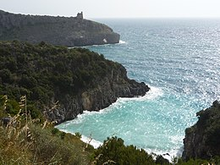
The coast of Cilento nearby Marina di Camerota
Location | Province of Salerno, Campania, Italy
Part of | Cilento and Vallo di Diano National Park with the Archeological Sites of Paestum and Velia, and the Certosa di Padula
Criteria | Cultural: (iii)(iv)
Reference | 842
Inscription | 1998 (22nd Session)
Coordinates | 40°17′24″N 15°28′34″E
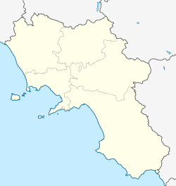
Location of Cilento in Campania
Show map of CampaniaShow map of ItalyShow all
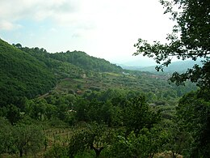National Park nearby Cannalonga
Cilento (Italian: [tʃi.len.to]) is an Italian geographical region of Campania in the central and southern part of the province of Salerno and an important tourist area of southern Italy.
Cilento is known as one of the centers of Mediterranean diet.
Geography
[edit]
The coast of Cilento is located on the Tyrrhenian Sea, stretching from Paestum to the Gulf of Policastro, near the town of Sapri. Most of the touristic destinations in the coast are frazioni (hamlets) of comuni (municipalities) whose seats are inland; examples include Santa Maria di Castellabate, Acciaroli, Velia, Palinuro, Marina di Camerota, Scario and Policastro Bussentino.
The inner boundaries are the Alburni mountains and Vallo di Diano, sometimes considered as part of Cilentan geographical region, which has in Sala Consilina its largest center. The most important towns in this area are Vallo della Lucania (in the middle), Sapri and Agropoli: this is the largest town of Cilento and the principal harbour. Most of this area is included in "Cilento and Vallo di Diano National Park".
Inland communes
[edit]
- Alfano
- Campora
- Celle di Bulgheria
- Felitto
- Futani
- Laurino
Moio Della Civitella
- Montano Antilia
- Monte Cicerale
- Monteforte Cilento
- Morigerati
- Ogliastro Cilento
- Omignano
- Ottati
- Piaggine
- Salento
- Sessa cilento
- Prignano Cilento
- Rutino
- Sacco
- Stio
- Torchiara
- Tortorella
- Trentinara
- Vallo della Lucania
Seaside Communes
[edit]
- Agropoli
- Ascea
- Camerota
- Capaccio
- Caprioli
- Casal Velino
- Castellabate
- Centola
- Montecorice
- Palinuro
- Pisciotta
- Pollica
- San Giovanni a Piro
- San Mauro Cilento
- Sapri
History
[edit]
Greek colonies
[edit]
The region is steeped in Greek mythology and legends^{[citation needed]}, as in the names of some towns^{[citation needed]}, which is also visible in the remains of the colonies of Velia (ancient Elea) and Paestum (ancient Poseidonia). Velia was also the seat of "Eleatics", a school of pre-Socratic philosophers as Parmenides, Zeno of Elea and Melissus of Samos).^{[citation needed]}
Cilento comes by the Latin word Cis Alentum, meaning "On this side of the Alento".^{[1]}
Sixth province of Campania
[edit]
In the 1990s it was proposed to make Cilento a new province of Campania.^{[2]} This proposal has never come near to implementation; in particular there was the difficulty of choosing an administrative centre. The four candidates were Vallo della Lucania (in the most central position), Agropoli (the largest town, situated in the north), Sala Consilina (the most populous town of Vallo di Diano) and Sapri (in the centre of southern Cilento, with the most important railway station).^{[citation needed]} Another more recent proposal was to move Cilento from Campania to Basilicata, as a third province^{[3]} together with the existing provinces of Potenza and Matera.
The Cultural Pyramid
[edit]
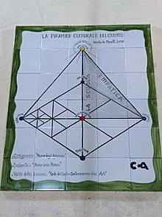Cultural Pyramid of Cilento devised by Menotti Lerro exposed in the square of Salento
In 2020, the poet Menotti Lerro drew an innovative Cultural Pyramid of Cilento.^{[4]} The form of this came out adding the "Cultural Triangle" he founded (Omignano - "The Aphorisms Village", Salento - "The Poetry Village" and Vallo della Lucania "Seat of the Contemporary Center of the Arts") at the historical summits of high cultural tradition in Cilento: Paestum, Velia and Palinuro. In a second moment also Trentinara - "The Village of Love" joined. Within the Triangle a new literary, artistic, philosophical and cultural movement arose: the Empathism (Empathic School).^{[5][6][7][8]}
National Park
[edit]
Main article: Cilento and Vallo di Diano National Park
In 1991, Cilento and Vallo di Diano National Park was instituted to preserve the landscape and promote tourism. In 1998, the park became a World Heritage Site of UNESCO.
Coast
[edit]
Main article: Cilentan Coast
The Cilentan Coast, or Costiera Cilentana in Italian, is a stretch of coastline situated in the gulfs of Salerno and Policastro, extending in 16 municipalities; from Capaccio-Paestum in the north-west to Sapri in the south-east.
Language
[edit]
Main article: Cilentan language
Cilento was part of ancient Lucania, and its language is influenced by Lucanian. In the north of Cilento the dialect is more influenced by Neapolitan, but in the south it has many similarities with Sicilian.
Cilento DOC
[edit]
Italian wine, red, white and rose, under the Cilento DOC appellation comes from this area. Grapes destined for DOC product must be harvested to a maximum yield of 12 tonnes/hectare with the finished red wines fermented to a minimum alcohol level of 11.5% and the whites and roses fermented to 11%.^{[9]}
Red Cilento wines are a blend of 60-70% Aglianico, 15-20% of Piedirosso and/or Primitivo, 10-20% Barbera and up to 10% of other local red grape varieties. The whites are a blend of 60-65% Fiano, 20-30% Trebbiano, 10-15% of Greco and/or Malvasia bianca with up to 10% of other local white varieties. The roses are blends of 70-80% Sangiovese, 10-15% of Piedirosso and/or Primitivo and up to 10% of other local red grape varieties. A separate varietal Aglianico can also be produced under the Cilento DOC provided that at least 85% of the wine is Aglianico with Primitivo and/or Piedirosso permitted to fill in the remainder and that the wine is aged at least one year before it is released.^{[9]}

