Paestum
ancient city, Italy
Print Cite Share Feedback
Also known as: Poseidonia
Written and fact-checked by

The Editors of Encyclopaedia Britannica
Last Updated: Article History

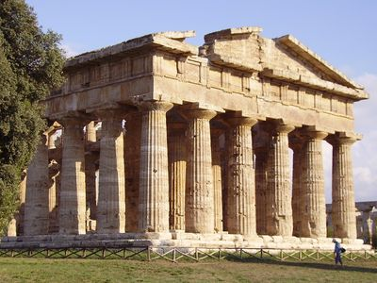
Paestum: Temple of Apollo
See all media
Category: Geography & Travel
Greek: Poseidonia
Related Places:

Italy ancient Greece Basilicata
See all related content →
Paestum, Greek Poseidonia, ancient city in southern Italy near the west coast, 22 miles (35 km) southeast of modern Salerno and 5 miles (8 km) south of the Sele (ancient Silarus) River. Paestum is noted for its splendidly preserved Greek temples.
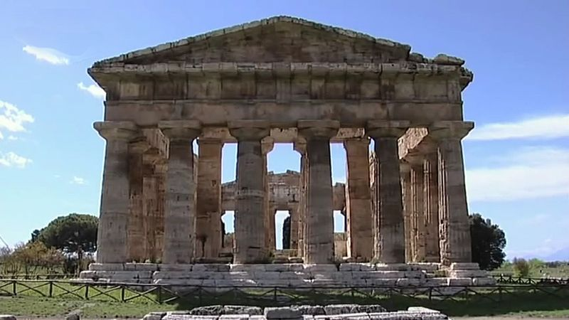

Visit the ruins of the ancient Greek colony of Paestum and discover its history, culture, and society
See all videos for this article
Poseidonia was probably founded about 600 BC by Greek colonists from Sybaris, along the Gulf of Taranto, and it had become a flourishing town by 540, judging from its temples. After many years’ resistance the city came under the domination of the Lucanians (an indigenous Italic people) sometime before 400 BC, after which its name was changed to Paestum. Alexander, the king of Epirus, defeated the Lucanians at Paestum about 332 BC, but the city remained Lucanian until 273, when it came under Roman rule and a Latin colony was founded there. The city supported Rome during the Second Punic War. The locality was still prosperous during the early years of the Roman Empire, but the gradual silting up of the mouth of the Silarus River eventually created a malarial swamp, and Paestum was finally deserted after being sacked by Muslim raiders in AD 871. The abandoned site’s remains were rediscovered in the 18th century.
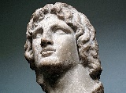
Britannica Quiz
Ancient Greece

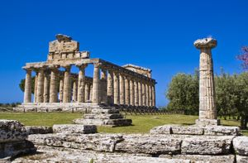
Paestum, Italy: Temple of Athena
The ancient Greek part of Paestum consists of two sacred areas containing three Doric temples in a remarkable state of preservation. During the ensuing Roman period a typical forum and town layout grew up between the two ancient Greek sanctuaries. Of the three temples, the Temple of Athena (the so-called Temple of Ceres) and the Temple of Hera I (the so-called Basilica) date from the 6th century BC, while the Temple of Hera II (the so-called Temple of Neptune) was probably built about 460 BC and is the best preserved of the three. The Temple of Peace in the forum is a Corinthian-Doric building begun perhaps in the 2nd century BC. Traces of a Roman amphitheatre and other buildings, as well as intersecting main streets, have also been found. The circuit of the town walls, which are built of travertine blocks and are 15–20 feet (5–6 m) thick, is about 3 miles (5 km) in circumference. In July 1969 a farmer uncovered an ancient Lucanian tomb that contained Greek frescoes painted in the early classical style. Paestum’s archaeological museum contains these and other treasures from the site.

