Supervisor signatures

Nadim Khemir | Wafe Mehrez

Dedication

Acknowledgements:

In delivering this report, I have been fortunate enough to have been assisted by many individuals whom I wish to acknowledge here. First and foremost, a heart-felt note of thanks to Nadim khemir, my professional supervisor, for his generosity in dispensing advice, his willingness to answer my million and one questions, his insightful advice, his honest feedback to my ideas, and for giving me endless weeks of sleepless nights working on this project.
I wish to acknowledge the works of the individuals and groups who contributed to several free code libraries which I’ve reused to deliver the final software prototype tool.
Declaration:

I declare that this thesis was composed by myself, that the work contained herein is my own except where explicitly stated otherwise in the text, and that this work has not been submitted for any other degree or professional qualification except as specified.

(M^{ed} Amine Bouzid)

Table of Contents
1. Project framework 11
1.1 Introduction 11
1.2 All Around the World enterprise «AAW» 12
1.3 Open source vs closed source 14
1.3.1 Open source 14
1.3.2 Closed source 14
1.3.3 Difference between open source and closed source 15
1.4 Sources and methods 15
1.4.1 Agile method 15
2. Project scope 18
2.1 Introduction 18
2.2 Analysis of existing requirement tools 19
2.2.1 Commercial tools 19
2.2.2 In house tools 24
2.2.3 Open source tools 25
2.3 Business process analysis 26
2.3.1 Functionality process analysis 28
2.3.2 Business process analysis tools 28
2.3.3 Benefits analysis 29
2.4 Requirement management 30
2.4.1 Introduction 30
2.4.2 Search requirements 31
2.4.2.1 Using a search form 32
2.4.2.2 Continuous search/analysis 33
2.4.2.3 Search history 34
2.4.2.4 Analysis history 34
2.4.3 Elicitation 35
2.4.3.1 Brainstorming 36
2.4.3.2 Document analysis 37
2.4.3.3 Focus groups 38
2.4.3.4 Interface analysis 39
2.4.3.5 Interviews 40
2.4.3.6 Observation 41
2.4.3.7 Prototyping 42
2.4.3.7.1 Requirement view “Type 1” 43
2.4.3.8 Requirements workshops 43
2.4.3.9 Use cases 43
2.4.4 Characteristics of a good requirement 44
2.4.5 Validation 45
2.4.6 Categorization 47
2.4.7 Deduplication 48
2.5 User right management 48
2.6 Crowdsourcing 49
2.7 Version control 50
3 Design 53
3.1 Concept 53
3.2 Use cases 53
3.2.1 General user use case 53
3.2.2 Use case refinement «Manage Database» 54
3.2.2.1 Description of use case refinement «Manage Database» 54
3.2.2.2 Description of use case refinement “Manage data” 54
3.2.3 Use case refinement «Manage Requirement Views» 58
3.2.3.1 Description of use case refinement «Drag & Drop Requirement views» 58
3.2.3.2 Description of use case refinement «Delete Requirement views» 58
3.2.3.3 Description of use case refinement «Customize Requirement Views» 59
3.2.3.4 Description of use case refinement «Modify Requirement views» 59
3.2.4 Use case refinement «Edit Attributes» 59
3.2.4.1 Description of use case refinement «Review Attributes» 60
3.2.4.2 Description of use case refinement «Update Attributes» 60
3.2.4.3 Description of use case refinement «Add Attributes» 60
3.2.4.4 Description of use case refinement «Delete Attributes» 60
3.2.5 Use case refinement «Edit Categories» 61
3.2.5.1 Description of use case refinement «Remove Category» 61
3.2.5.2 Description of use case refinement «Add Category» 61
3.2.5.3 Description of use case refinement «Modify Category» 61
3.2.5.4 Description of use case refinement «Drag and Drop Category» 62
3.2.5.5 Description of use case refinement «Review Category» 62
3.3 Data base format «File System» 62
3.4 Static view 64
3.4.1 Class diagram 65
3.5 Dynamic Views 69
3.4.1 Sequence diagram «Connexion» 69
3.4.2 Sequence diagram «Add new requirement view» 71
3.4.3 Sequence diagram «Add new requirement view “Terminal”» 73
3.4.4 Sequence diagram «Use “Terminus”» 73
3.4.5 Sequence diagram «Remove view» 74
4. Realization 75
4.1 Realization of the WEB application 75
4.1.1 Connexion view 75
4.1.2 Error screen 76
4.1.3 Expose screen 76
4.1.4 Add new requirement screen 77
4.1.5 UI terminal screen 78
4. Development 79
4.1 Use libraries 79
Introduction 79
This part will show all the libraries that I used to develop my own web application. 79
4.1.1 Dragula 79
4.1.2 Ventus 80
4.1.3 Ng-sortable 80
4.2 Use languages 81
4.2.1 Node.JS 81
4.2.2 HTML 81
4.3 Conclusion 82

Illustration Index
Figure 1: Official web site for AAW 12
Figure 2: Agile processus 18
Figure 3: Requisite Pro screenshot view 21
Figure 4: Innoslate screenshot view 24
Figure 5: Doors screenshot view 25
Figure 6: Visure screenshot view 27
Figure 7: In house tool screenshot view 29
Image3 31
Figure 8: Business process analysis cycle 35
Figure 9: Requirement management cycle 41
Figure 10: User search form view 42
Figure 11: Search form view 43
Figure 12: continuous analysis view 44
Figure 13: Continuous analysis curve 44
Figure 14: Search history view 45
Image4 46
Figure 16: Brainstorming view 47
Figure 17: Document analysis view 49
Figure 18:Focus groups view 51
Figure 19: Interface analysis view 52
Figure 20: Interviews view 54
Figure 21: Observation view 56
Image1 57
Figure 23: V model software develpment 60
Figure 24: Requirement deduplication 63
Figure 24: Git tree «Branch» 68
Figure 25: Github screenshot 70
Figure 26: Use case «General» 71
Figure 27: Use case «Manage database» 72
Figure 28: Use case «Manage requirement views» 74
Figure 29: Use case «Edit Attributes» 75
Figure 30: Use case «Edit Categories» 77
Figure 31 : Class diagram 80
Figure 32: Sequence diagram «Connexion» 81
Image2 82
Figure 34: Sequence diagram «Add new requirement view “Terminal”» 83
Figure 35: Sequence diagram «Use “Terminus”» 83
Figure 36: Sequence diagram «Remove view» 84
Figure 37: Server connexion view 85
Figure 38: Application error screenshot 86
Figure 39: Apllication expose screenshot 86
Figure 40: Requirement view 87
Figure 41: Master template 88
Figure 42: Application terminal 88
Figure 43: Dragula library 89
Figure 44: Ventus library 90
Figure 45: Ng-sortable library 90

General Introduction
The field of Requirements Engineering (RE) is relatively new, so it seems appropriate to begin by asking some very basic questions: What is RE all about? When is it needed? What kinds of activities are involved in doing RE? Our answers to these questions provide both a motivation and a scope for the techniques introduced in the remainder of the book. We will begin with the idea of a software-intensive system, by which we mean an interrelated set of human activities, supported by computer technology.
The requirements express the purpose of such a system. They allow us to say something meaningful about how good a particular system is, by exposing how well it suits its purpose. Or, more usefully, they allow us to predict how well it will suit its purpose, if we design it in a particular way. The idea of human-centered design is crucial – the real goal of an engineering process is to improve human activities in some way, rather than to build some technological artifact.[1]

1. Project framework

1.1 Introduction

- Main objective
Develop a tool for requirement specification management for non-technical users.
The tool interfaces with an existing application, with the main goal to improve the user interface.
- The project targets the following audience
  - Non-technical users
  - Product management.
  - The marketing group.
  - Engineers «used to work in a distributed development environment».
  - End users
- Project content description
  - Understand requirement management .
  - Make a comparative study of different requirement management tools.
  - Gather requirements.
  - Analysis of the methods used for the processing of specification in the company.
  - Proposal for improvement of the application.
    - Development of interfaces specific to non-technical type of the users.
    - Implementation of proposals accepted by the company.

1.2 All Around the World enterprise «AAW»


Figure 1: Official web site for AAW
    - Presentation
All Around the World “AAW”, a joint stock company with a single partner, has been active since 2013. headquartered in France with a keen tendency towards Agile software development and a healthy obsession for Perl. The work is their passion and clients from all around the world are relying on they for Agile training, software audits, systems development and maintenance.
- Training
Compelling training is one of the most cost-effective ways of improving the employees productivity. All Around The World offers training that focuses on the real needs and specializes in software testing, Perl development and improving the Agile development practices.
While they also offer custom training including simply pairing with the developers they also have a variety of “ready to go” training courses, including:
- Introduction to Perl
- Testing from Zero to Hero
- Agile Companies Go POP

1.3 Open source vs closed source

- Introduction
In this project, the company suggested that we present the project under Linux software because their benefits :
- The existing tool was written under Linux.
- Using other open source libraries.
- Freedom of platform.
- Everything about Linux is free.
- Can get quick help from other Linux users.

1.3.1 Open source
Open Source Software “OSS” is computer software with its source code made available with a license in which the copyright holder provides the rights to study, change and distribute the software to anyone and for any purpose. Open source software may be developed in a collaborative public manner. Open source software is the most prominent example of open source development and often compared to “technically defined” user-generated content or “legally defined” open-content movements.[7],[8]
Examples: «Linux, Mozilla Firefox, Java, MySql ...»

1.3.2 Closed source
Closed source software or “proprietary” is a type of computer program source code development. With closed source software, the source code is not shared with the public for anyone to look or make changes to. Closed source is the opposite of open source.[9]
Examples: «Windows, Microsoft office, IOS ...»

1.3.3 Difference between open source and closed source
CLOSED SOURCE SOFTWARE | OPEN SOURCE SOFTWARE
- Protected by copyrights, sold to earn money. | - Software is distributed free of cost
- Development is centralized, undertaken by expert developers. | - Any individual can develop or modify the software.
- Quality assurance and bug removal is done by small team. | - Huge no. of individuals are available for improving quality and bug removal.
- Software requirements are finalized by organization itself. | - User can modify or develop a software as per his own needs.
- Formal risk assessment process – monitored and managed throughout project. | - No formal risk assessment process.

1.4 Sources and methods

- Introduction

1.4.1 Agile method
Agile software development is a group of software development methods in which solutions evolve through collaboration between self-organizing, cross-functional teams. It promotes adaptive planning, evolutionary development, early delivery, continuous improvement, and encourages rapid flexible response to change.
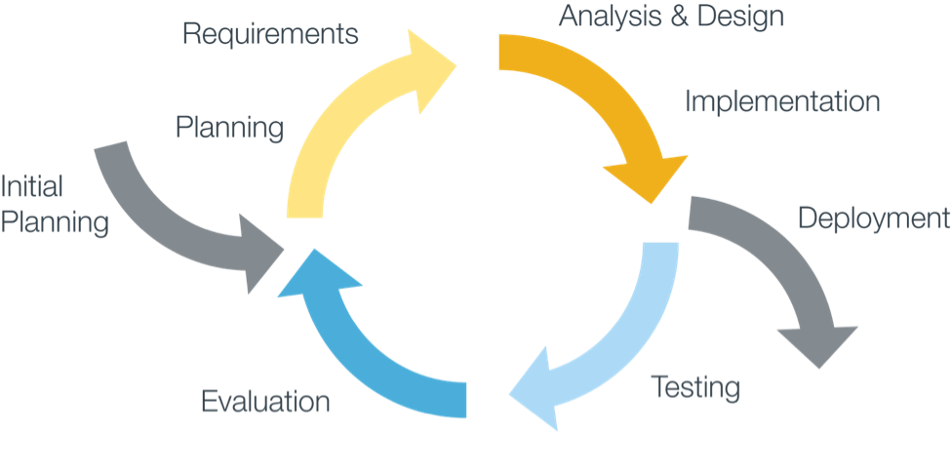
Figure 2: Agile processus
To consistently help our clients achieve the results they want, we employ an agile methodology for building and maintaining hight-quality software products. This process has proven itself in numerous successful releases to the market.[10],[11]
Methodology benefits.
- Faster development time.
- Lower overall cost.
- Focus on the right solution.
- A minimum of your time.

1.4.2 Steps we have taken to develop this software.
- Brainstorm to understand your goals for the software. Correction nadim
- Create an initial “proof of concept” prototype.
- Evolve and adjust the prototype through multiple iterations in a series of milestones based on feedback from you and other stakeholders ¹.
- Get closer to your final goals with each iteration and milestone.
- Re-factor the code and architecture throughout the entire life-cycle of the project to improve and streamline internal structure.
- Make you part of the development team through short brainstorming sessions – along with using and testing the evolving prototype – without taking up too much of your time.
- Deliver a final core software product that meets your highest expectations, along with your schedule.

2. Project scope

2.1 Introduction

To better the existing user interface I analyze existing requirements tools “commercial, in house and open source” to find what is making them easier for the end user to use.
I will list the difficulties the engineer have working with the current application as well as the advantages. Based on their requirements I will create a new user interface to make it easier to use (analyse difficulté, liste des charge)

2.2 Analysis of existing requirement tools

2.2.1 Commercial tools
- RequisitePro “IBM”
Software delivery organizations must ensure that requirements from IBM Rational RequisitePro are integrated into the tools used by different stakeholders. Today, requirements are defined, reviewed, worked on and tested by various groups. This has led organizations to create complex workflows⁵, processes, and documents, which can slow development and increase costs.
Tasktop⁶ addresses this by allowing requirements to be synchronized from RequisitePro to the rest of your software delivery tools. So you can flow requirements from one tool to another with no need for users to create reports, run extracts or attend meetings.
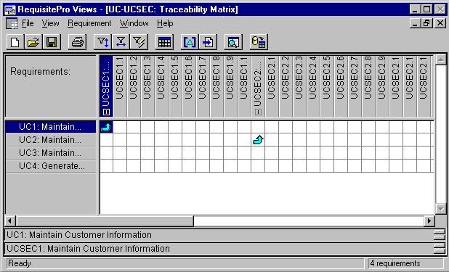
Requirements are synchronized in real-time, stakeholders can review them in the context of their own tool, and everyone in the software delivery process is kept abreast of the latest comments or changes.[6]
Figure 3: Requisite Pro screenshot view

- Innoslate
Innoslate is a modern web-based systems engineering tool. This cloud or on-premise application was made specifically for systems engineers by systems engineers.
Innoslate provides the first modern systems engineering tool that supports the full life-cycle from Requirements Definition and Management to Operations and Support.
Innoslate takes the next step in software as a service implementation of new and classic systems engineering principles and practices to address today's and future systems of system level problems.
Innoslate provides a secure, transparent, and automatically upgraded environment to reduce IT costs and enhance collaboration on small and large problems.[5]
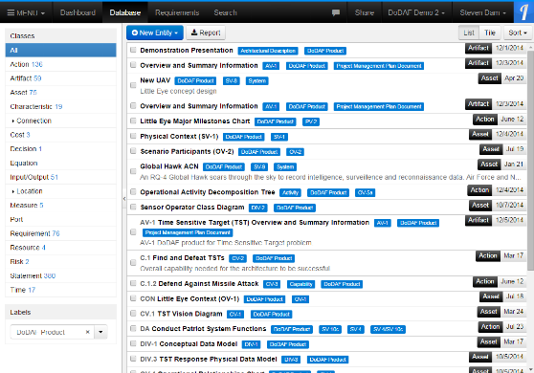
Figure 4: Innoslate screenshot view

- Rational DOORS
DOORS is part of a commercial suite of requirements management software produced by Telelogic. It is designed to manage large sets of requirements; large projects can have requirements that number in the thousands, with hundreds of users.
DOORS also supports concurrent and remote access by many users at once. There are many commercial software packages that offer requirements management functionality; Telelogic DOORS is one of the market leaders.
The aim of DOORS is to capture, link, trace, analyze and manage changes to information to ensure a project’s compliance with specified requirements and standards.[3],[4]
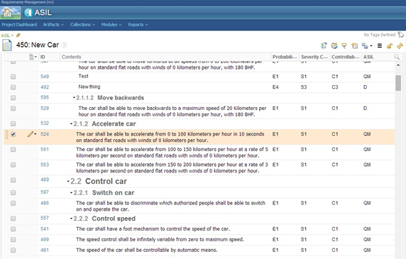
Figure 5: Doors screenshot view

- Visure
Visure define requirements definition and management as a global set of different activities where requirements specification and subsequent management thereof are not sufficient and other activities are required, such as requirements capture, analysis, verification and validation, without forgetting to carry out adequate change configuration and control management, in addition to the traceability of the requirements to the rest of the project elements.[14]
Visure not only helps its clients to expedite the requirements definition and management implementation process but also to use and manage it, through the use of different mechanisms and training, evaluation and specialized consulting activities.
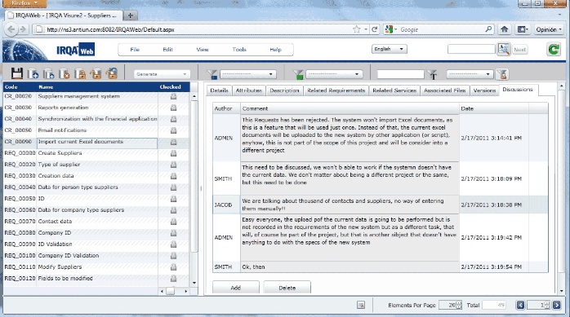
Figure 6: Visure screenshot view

- Comparative study of commercial software requirements tools
Tools /  Attributes | Template | Use case modeling | Prototyping and audit | “TRS ⁹ ” | Scalability ¹⁰ | External interface | Version control
RequisitePro
DOORS
Innoslate
Visure

2.2.2 In house tools
The in-house tool implements a set of applications that the user can use it to do requirement handling.
Its goals of are.
- Keep things us simple if possible.
- The user interface provided by your platform.
- Power users like the command line.
- Handle small to middle size projects. ‘which are the most common’
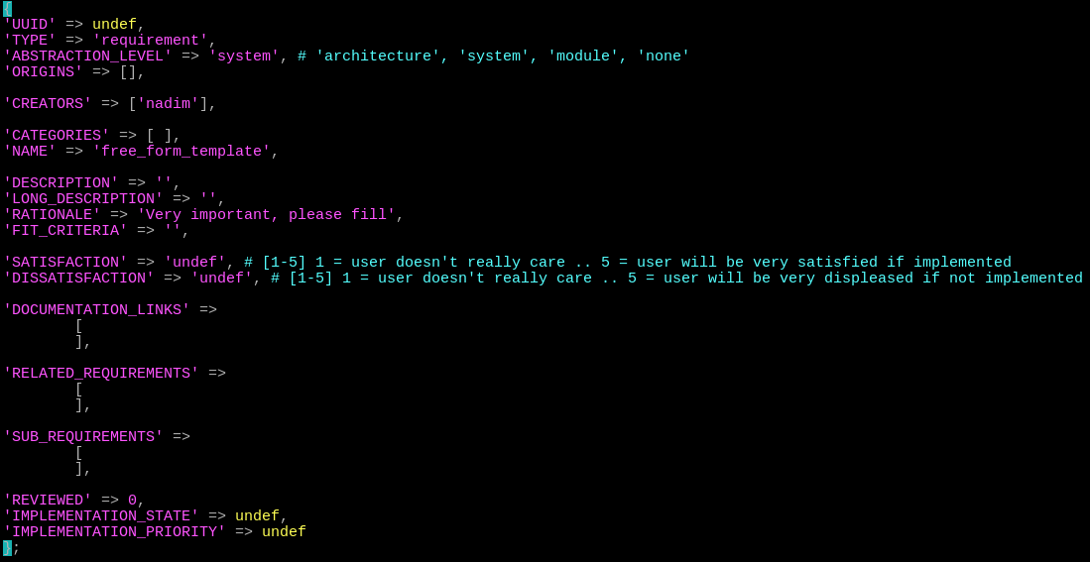
Figure 7: In house tool screenshot view
After using this application we found interaction problems that need fixing. For example “it’s hard to install for non technical users”. I will interview with the client, ask technical and non-technical users to define a better user interface. This project is about the new interface of the application.

2.2.3 Open source tools
- ReqSimile
ReqSimile is a Java application that operates on requirement sets.
Upon selection of a requirement in one requirement set, ReqSimile calculates the similarity to all the requirements in another requirements set “which could also be the same set in order for finding duplicates and other relations ships”.
It is like bringing intelligent search engine functionality to requirements management. The only difference is that you never start empty-handed and decide on a relevant query. The query is made up of the requirement you select[1]
ReqSimile may be used interactively to assign links between requirements. The links are stored in a separate database table and may represent any relationship you prefer depending on the requirements management process “e.g. same, duplicate, similar, related, etc.”.[2]
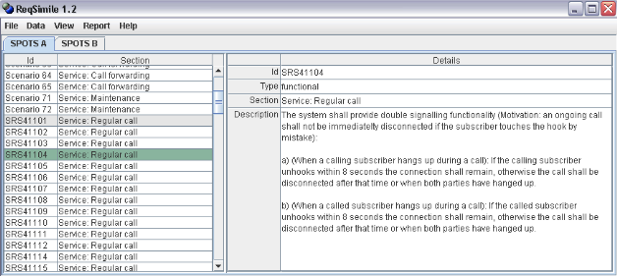

- The Minireq
The Minireq is a simple Command Line Interface “CLI” tool created for writing requirements in various Markdown files and building a general requirements document from these files “sort of GitBook[15]”. It also provides basic Domain Specific Languages[16] “DSL” for tracing requirement to other software projects artifacts, as well as software estimations by PERT ² [17].
The Minireq is simple enough in itself, but when you combine it with Ruby “through Rake or Thor”, a modern text editor “I use Atom ³ [18]” and Git, this combination will bring you unprecedented power and flexibility in requirements management.[19]

2.3 Business process analysis

- Introduction
Requirement gathering prototype
- Presentation
Business process ¹¹ analysis helps an organization improve how it conducts its functions and activities in order to reduce overall costs, provide more efficient use of scarce resources, and better support customers. It introduces the notion of process orientation, of concentrating on and re-thinking end-to-end activities that create value for customers, while removing unnecessary, non-value added work.
Generally technology is implemented to automate or streamline business processes, so it is important to conduct a business process analysis to understand how the process works and how it can be improved.
- First basic steps to take
The BPA cycle can be chopped into four steps, like in the picture below.
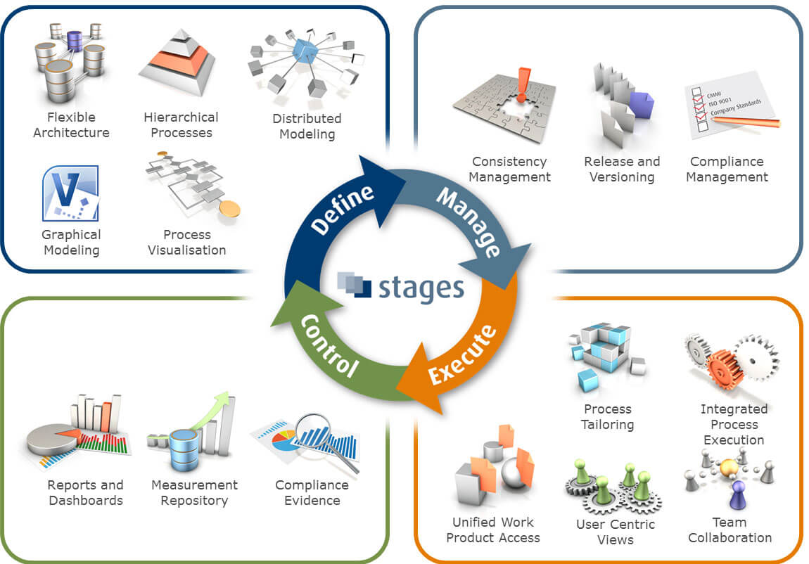
Figure 8: Business process analysis cycle
- Step 1: Create an A0 sized overview, a process landscape of your current business functions and cross reference them with business processes. This is your as-is situation. Use a reference model from your industry to start off.
- Step 2: Copy the overview and call it a to be landscape. identify and draw the most important process starting events, outcomes and business activities in the cross reference matrix.
- Step 3: Point out where there are issues in your current processes
- Step 4: Look at the future products and services you want to deliver to future markets and clients. Write down what inevitably will change the coming years.
- Step 5: identify the new starting events and outcomes of your processes and top activities to create, produce and deliver these products across the functions.
- Step 6: Take every business process and detail its description and create an activity schema per business process.
- Benefits
- Fewer overtime hours | - More stable work environment
- Improved working conditions | - Improved quality of work life
- Improved employee morale | - Reduced employee turnover
- Better company image | - Improved management of project risk

2.3.1 Functionality process analysis
- Introduction
Process analysis answers the question: “How?” Process analysis explains how the sequential steps of a procedure lead to its accomplishment; or, how a certain series of events occurred. There are two kinds of process analysis: directional and informational.
Directional, or prescriptive, process analysis asks: How do you do it? This kind of analysis examines how to do something in such a way that a process may be repeated.
The analysis provides directions, as in the methods section of a laboratory report, or prescribes a certain process to follow.
Informational, or descriptive, process analysis asks: How does it work or occur? How is it done? This kind of analysis explains how something is, or was, accomplished. The analysis provides information, as in the outline of an organic process, or describes how “not why” certain events led to a particular outcome.

2.3.2 Business process analysis tools
“BPA” tools are primarily intended for use by business end users looking to document, analyze and streamline complex processes, thereby improving productivity, increasing quality, and becoming more agile and effective. These tools also support the roles of business process architect and business process analyst, and enable them to better understand business processes, events, work flows and data using proven modeling techniques.
“BPA” tools permit users to diagram their processes, noting “generally abstracted” rules or specifications to promote understanding, validate this information using standard methodologies and best practices enabled by the software, and ideally, automate the models into deployable applications that leverage their analytical efforts and comply with the business process rules. “BPA” tools feature the following functionality:
- Business model drawing and development | - Ease of use in operation, development and administration
- Business model analysis | - Multiuser support / versioning and extensibility
- Methodology and use | - Performance and scalability
- Integration and automation | - Vertical-industry and horizontal cross-industry template support

2.3.3 Benefits analysis
Business process analysis can be used to achieve the following:
- To document implicit knowledge, capture and record manual and sometimes non-documented processes, ex: process manuals for private and public sectors.
- To analyze individual actions, documents and data involved in international trade, which jointly or individually involve commercial, transport, regulatory and financial procedures.
- To locate problematic areas that cause delays in moving goods from seller to buyer across borders, such as unnecessary forms and documents and repetitive data elements.
- To identify opportunities for improvement, such as reducing the number of trade documents and minimizing data requirements.

2.4 Requirement management

2.4.1 Introduction
Requirements management is the process of collecting, analyzing, refining, and prioritizing product requirements and then planning for their delivery. The purpose of requirements management is to ensure that the organization validates and meets the needs of its customers and external and internal stakeholders.
Requirements management involves communication between the project team members and stakeholders, and adjustment to requirements changes throughout the course of the project. To prevent one class of requirements from overriding another, constant communication among members of the development team is critical. Requirements management does not end with product release. From that point on, the data coming in about the application’s acceptability is gathered and fed into the Investigation phase of the next generation or release. Thus the process begins again.[11]
- Requirement presentation:
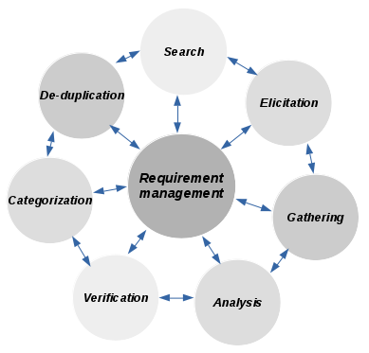
Figure 9: Requirement management cycle
Requirements definition provides a solid foundation for the end product and provides the first view of what the intended product must do and clear descriptions of how it should perform. Requirements definition also provides a basis for design and serves as a foundation for testing and user acceptance of the end product. Requirements definition captures all levels of requirements and helps to ensure that the project meets its objectives within the agreed upon limitations of time, cost and functionality.[12]
Requirements definition is used to identify goals, needs, and objectives of the end product by asking questions like:
- What problem are we trying to solve?
- What do we need to do to solve the problem?
- How do we accomplish solving the problem?

2.4.2 Search requirements
An important part of requirement engineering involved searching within the requirements to find correlations between them. To better the user interface, searching and the visualization of the results must be designed to help the requirement management.
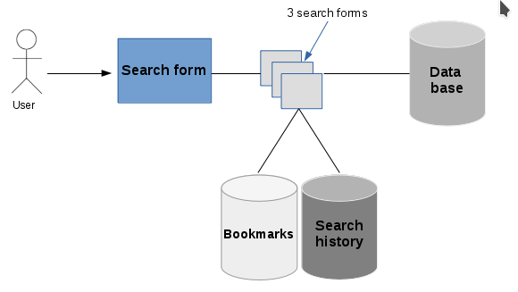
Figure 10: User search form view
This part “Search” allows users to :
- Make the search in a easy way.
- Access to the global database.
- Save the best searches in the bookmarks.
- Access to the local search database history.

2.4.2.1 Using a search form
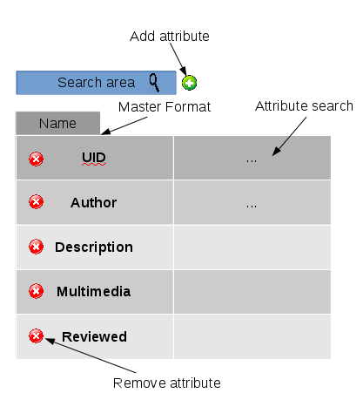
Figure 11: Search form view
The search form attribute specifies a short hint that describes the expected value of an input field “simple value or a short description of the expected format”.
We created this template to help the non-technical create searches, here the user can make easy search by adding or removing the attribute.
The search form allows the user to search for keywords and phrases across the major fields of the requirement: UID, Author, Description, Multimedia, Reviewed, Satisfaction. …

2.4.2.2 Continuous search/analysis
Rather than run a one-time search, we can define searches, and more complex analysis, to be run continuously “while requirements are added, removed, or modified ...”.
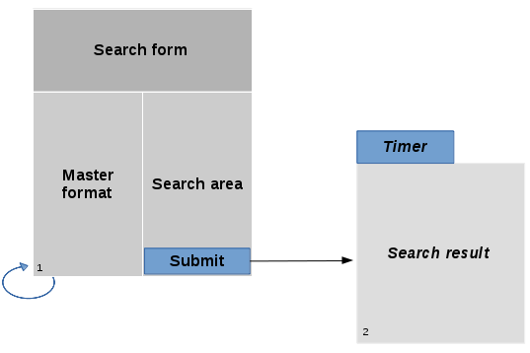
Figure 12: Continuous analysis view
The continuous search/analysis can give a more efficient help as results are automatically updated, but when the number of requirements increase, the time needed to run the continuous searches increases making the user interface less responsive.
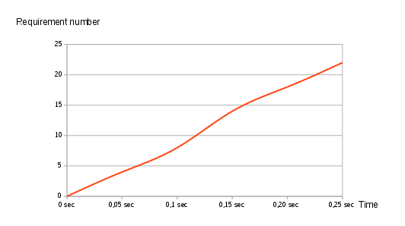
Figure 13: Continuous analysis curve

2.4.2.3 Search history
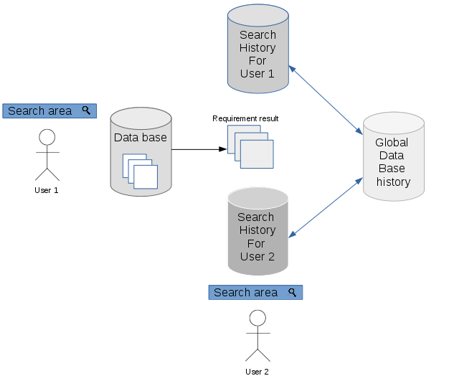
Figure 14: Search history view
Search history allow users to :
- Retrieve queries.
- Collaborate requirement result with other users.
- Save history result of all users in a global database history search.

2.4.2.4 Analysis history
A set of analysis can be presented for different points in time showing how the requirements have evolved through that period.
- Trying to ameliorate the category that have the less requirements.
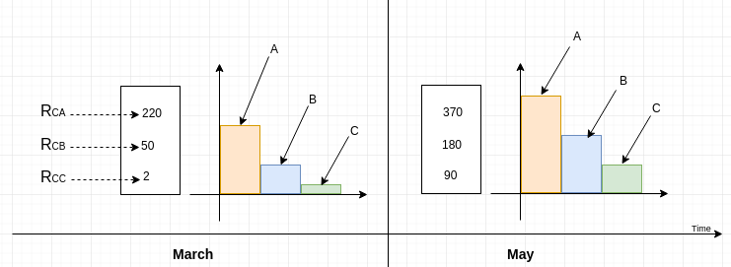
Figure 15: Analysis history

2.4.3 Elicitation
- Introduction
Requirements elicitation is the practice of collecting the requirements of a system from users, customers and other stakeholders. The practice is also sometimes referred to as “requirement gathering”.[21] The term elicitation is used in books and research to raise the fact that good requirements cannot just be collected from the customer, as would be indicated by the name requirements gathering. Requirements elicitation is non-trivial because you can never be sure you get all requirements from the user and customer by just asking them what the system should do OR NOT do .[22]
Requirements elicitation practices include[23]:
- Brainstorming
- Document analysis
- Focus groups
- Interface analysis
- Interviews
- Observation
- Prototyping
- Questionnaire

2.4.3.1 Brainstorming
Process for generating creative ideas and solutions through intensive and freewheeling group discussion.
Every participant is encouraged to think aloud and suggest as many ideas as possible, no matter seemingly how outlandish or bizarre. Analysis, discussion, or criticism of the aired ideas is allowed only when the brainstorming session is over and evaluation session begins.[24]
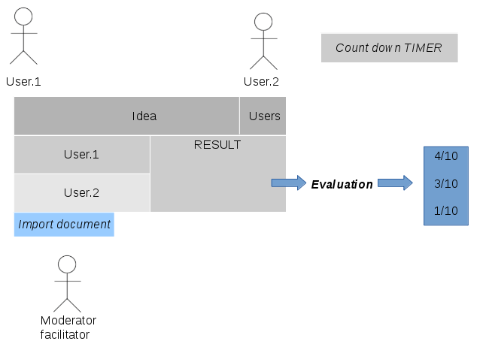
Figure 16: Brainstorming view
Brainstorming help engineer in the enterprise to:
- Collect more idea for the project.
- Solve the problems.
- Improve creative thinking.
- Team work in a collaborative way.
- The moderator collect the ideas and sorted it from important to less important “Evaluation”.
- Virtual Brainstorming
“Ex: Video conference”:
As we know the business world becomes more global, you may find yourself collaborating with colleagues and clients from all over the world.
Because of this, online meeting software has become a vital tool for businesses. With the right meeting technology, individuals can still stay connected no matter their geographic locations.[25]

2.4.3.2 Document analysis
Document analysis technique is one of the most effective ways of kick-starting the requirements elicitation phase. It is the art of studying relevant business, system and project documentation with the objective of understanding the business, the project background and identifying requirements or opportunities for improvement.
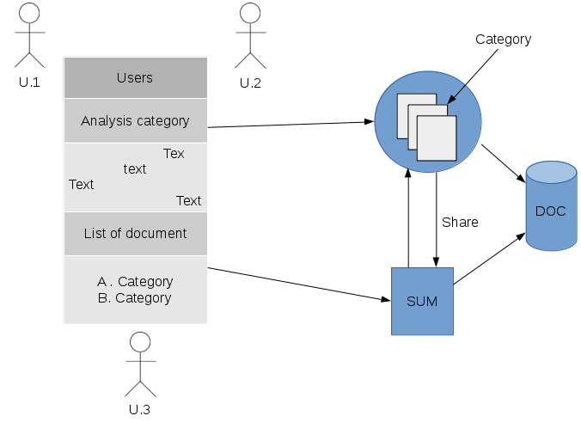
It’s a means of gathering information before scheduling interviews or other elicitation sessions with stakeholders. It can complement other elicitation techniques like workshops ⁴, interviews and prototyping by serving as a means of verifying requirements.[26]
Figure 17: Document analysis view
- Elicit information from existing documentation.
- List new ideas.
- Find requirement by categories.

2.4.3.3 Focus groups
Focus group sessions are organized with the aim of gathering qualitative information from participants. They are a great way of achieving a deep understanding of the thoughts, attitudes and perceptions of participants on a range of topics. Focus groups can also help with identifying problems and issues related to a certain idea. As a result, adequate thought and planning should go into its preparation.
Focus groups offer a means of gathering information that is subjective by seeking answers to open-ended questions. Instead of distributing basic questionnaires that deliver data requiring further analysis, focus groups allow organizers to share their perspectives in a non-threatening, collaborative and interactive environment. Focus groups also provide a great platform for eliciting requirements and understanding stakeholders' perspectives on different issues.[27]
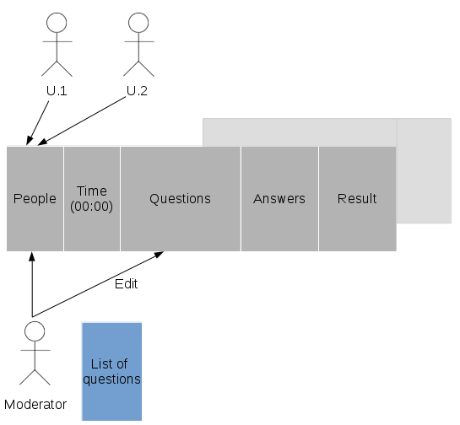
Figure 18:Focus groups view
- An adequate thought and planning should go into its preparation.
- Ensure the objectives of the group are clear.
- The moderator/facilitator should present the questions in a way that triggers discussion and concisely enough to steer participants in the right direction.
- Select participants carefully.
- All questions and answers should saved in the template.
- The moderator/facilitator write concluding analysis in the result part
- The result should reflecting on the major ideological themes of the group discussion
- The participants should respect the time of the meeting

2.4.3.4 Interface analysis
An interface is a shared boundary between two components. Most systems require connections with other applications, hardware and peripheral devices to function properly. Interface Analysis is a business analysis elicitation technique that helps to identify interfaces between solutions/applications to determine the requirements for ensuring that the components⁷ interact with one another effectively.[28]
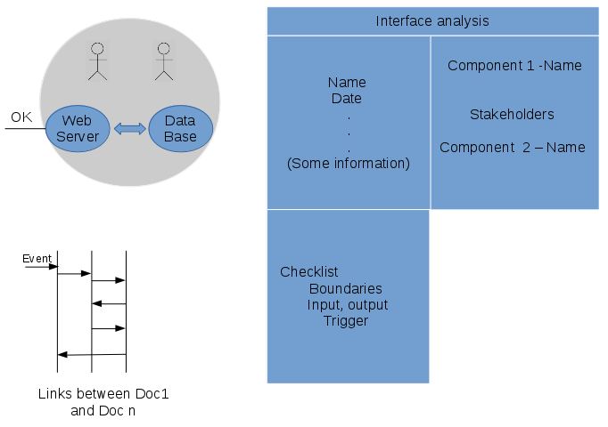
Figure 19: Interface analysis view
- Need prior understanding of project / application

2.4.3.5 Interviews
Interviews are one of the most popular business analysis techniques. They can be used to verify facts, clarify ambiguity, trigger enthusiasm, engage end users, identify requirements and solicit opinions and ideas.
BABOK V2[29] defines an interview as a systematic approach for eliciting information from a person “or a group of people” in an informal or formal setting by asking questions and documenting the responses.[30]

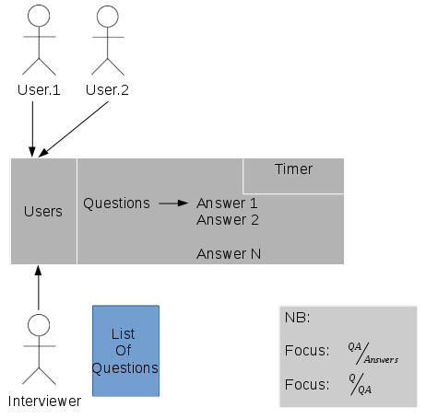
Figure 20: Interviews view
- The questions should be structured
- The questions should be wrote before the interview
- Focus must be “>1”, to say that it is a successful interviews
- The interview must be in a collaborative way, to collect more ideas about the project / application

2.4.3.6 Observation
Most people are used to observing events in their personal and professional lives. In some cases, we come to conclusions based on the events we observe. The observation technique is an effective means of deciphering how a user does their job by conducting an assessment of their work environment. It increases the analyst's familiarity with the culture and working style of a group of people. This technique can also be used to verify requirements and deliver instant requirements worthy of consideration.
Every observation must be guided by clearly stated objectives. The analyst should know what data is to be collected, how observation will be done, when and where to observe, how the data will be collected and what the data will be used for after analysis.
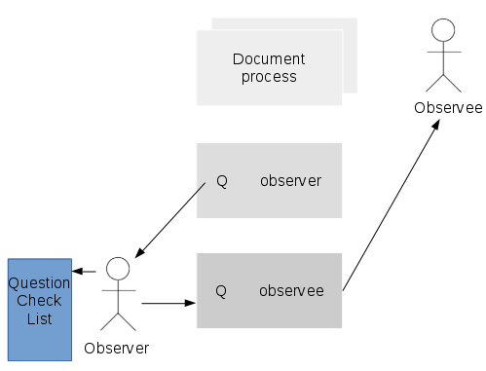
Figure 21: Observation view
- The data gathered during observation sessions are quite reliable; it is often used to confirm the data extracted using other techniques
- Observation can be used to extract information on the physical environment where the task is performed. For example, the analyst can get information on level of noise, physical layout, traffic and so on
- It allows the analyst to perform work measurements

2.4.3.7 Prototyping
I once worked on a project that involved a series of discussions and consultations on whether to build or buy software. After extensive analysis, the decision was made to build the system in-house. To get started however, we had to prove that it could be done. We did this through a proof of concept / prototype.
A proof of concept / prototype is a demonstration aimed at verifying that certain concepts or theories can be achieved. A prototype is designed to determine feasibility, but does not represent the final deliverable.[31]
- Requirement view «Type 1»
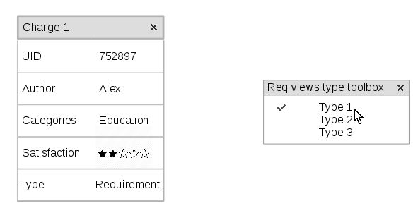
Requirement view
- This is the standard type of requirement view.
- User can chose the of requirement view from the toolbox.
- Requirement view «Type 2»
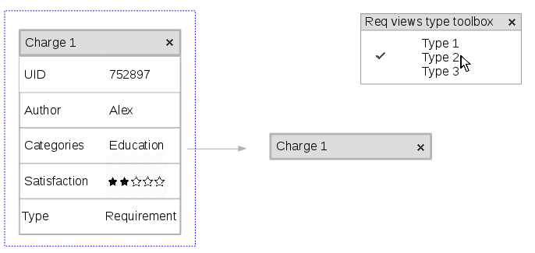
  - User select the requirement view and chose the new type from requirement view toolbox.
  - The requirement view display in a new way.
- Requirement view «Type 3»
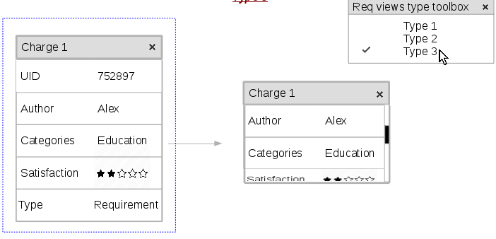
  - User select the requirement view and chose the new type from requirement view toolbox.
  - The requirement view display in a new way.
- Different ways to open requirement views
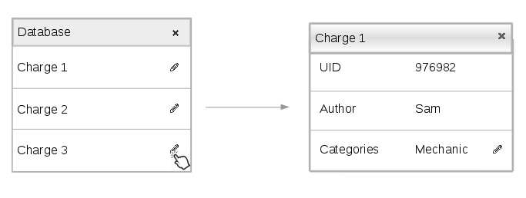
- User press the pen icon, then a requirement view will display in the interface.
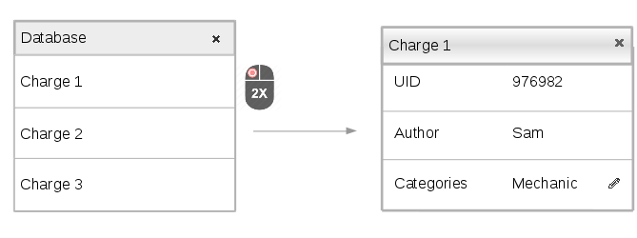
- User can make also double click in requirement name, than a new requirement view will display.

- Modify category
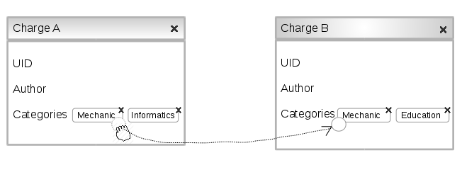
- User can modify category by drag and drop. “Drag category from element and drop it in another element”
- Requirement analysis
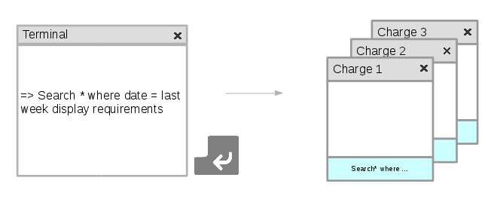
- User write command in the terminal, and press “ENTER” to confirm it.
- The result will display in requirement views.

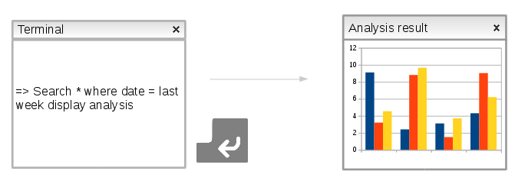
- User write the command in the interface, and press “ENTER”
- The result will display in a new analysis result window.
- Requirement group
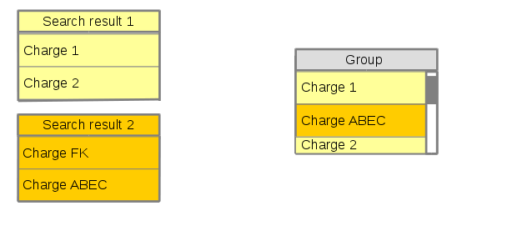
- User create group to collect requirements.
- User move requirement from group to another by making drag and drop.
- Each requirement has the same color of it search result.
- Requirement preview
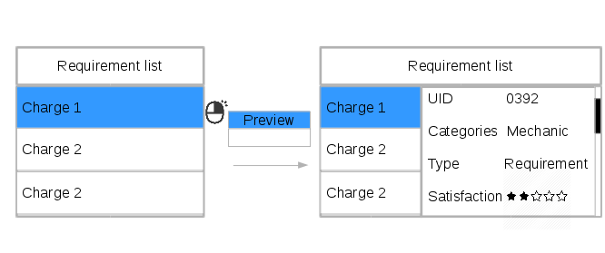
- User press right click and chose preview from the list.
- Requirement preview field will display.
- Select multiple elements
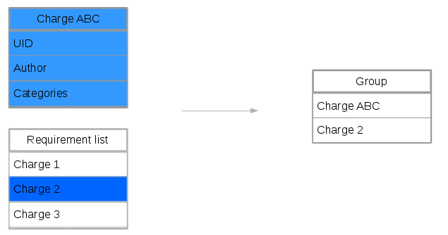
- User select more than element from the interface and press “ENTER”
- New element will display.

2.4.3.8 Requirements workshops
Involves analyzing the results of elicitation sessions and creating representations of those results. When that representation focuses on a solution, the outcome is known as “a design”.
This is where Design Thinking steps up. A Design Thinking approach enables Business Analysts to solve the wicked business problems they’ve always faced, but from a user-centric standpoint and following an iterative process. Design thinking is a way for BAs to create products that meet enterprise expectations by focusing on the right problems and finding the right solutions, all the while delivering products that users expects.
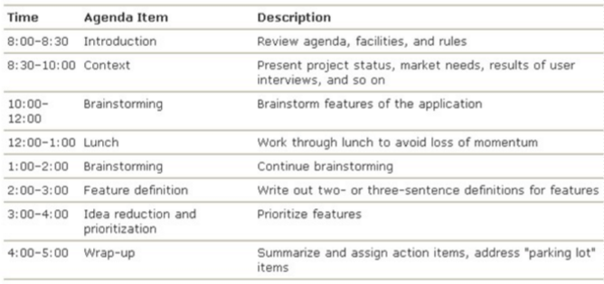
Figure 22: Sample agenda for requirement workshops

2.4.3.9 Use cases
Use cases are basically stories that describe how discrete processes work.
The stories include people “actors” and describe how the solution works from a user perspective.
Use cases may be easier for the users to articulate, although the use cases may need to be distilled later into the more specific detailed requirements.

2.4.4 Characteristics of a good requirement
Requirements analysis is critical to the success or failure of a systems or software project. The requirements should be documented, actionable, measurable, testable, traceable, related to identified business needs or opportunities, and defined to a level of detail sufficient for system design.[36]
A requirement should be:
Cohesive: The requirement defines a single aspect of the desired business process or system.
Complete: The individual requirement is not missing necessary or relevant information. Additionally, the entire set of requirements should cover all relevant requirements.
Consistent: The requirement does not contradict another requirement.
Modifiable: Like requirements should be grouped together to allow similar requirements to be modified together in order to maintain consistency.
Correct: The requirement meets the actual business or system need. An incorrect requirement can still be implemented resulting in a business process or system that does not meet the business needs.
Observable: The requirement defines an aspect of the system that can be noticed or observed by a user. This is often referred to as “Implementation Agnostic” as the requirement should not specify aspects of system architecture, physical design or implementation decisions.
Feasible: The requirement can be implemented within the constraints of the project including the agreed upon system architecture or other physical design or implementation decisions.
Unambiguous: The requirement is written objectively such that there is only a single interpretation of the meaning of the requirement.
Verifiable: It can be shown that the requirement has been met by the final solution via inspection, demonstration, test, or analysis.[37,38]

2.4.5 Validation
Validation is the process of determining whether or not the products of a given phase of the software development cycle fulfill the requirements established during the previous phase.
Creating the test description while working on the requirements insures that both work involved in understanding requirements and defining how to validate its implementation are done at the same time. Test driven development (TDD)can also be applied to requirements; in the TDD case no requirement is valid if tests are not attached to it. Test description should be an intrinsic part of the requirement engineering, thinking test as part of the requirement not something that is added to it.
Software can be validated in different manners, we describe the V model below, keeping in mind that our test descriptions should fit in it.
The process of evaluating software at the end of the software development process to ensure compliance⁸ with software requirements.[32]
- Verification / Validation accepted method
- Test
- Analysis
- Demonstration
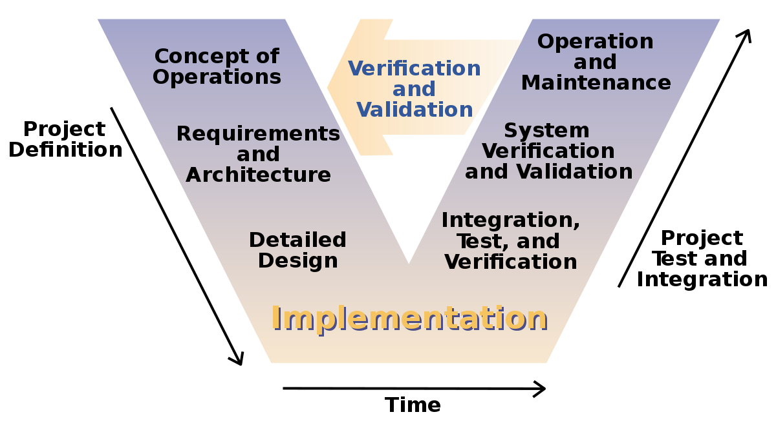
Figure 23: V model software development
V-model means verification and validation model. Just like the waterfall model, the V-Shaped life-cycle[50] is a sequential path of execution of processes. Each phase must be completed before the next phase begins. V-Model is one of the many software development models. Testing of the product is planned in parallel with a corresponding phase of development in V-Model. [51]
- Advantages
  - Simple and easy to use.
  - Testing activities like planning, test designing happens well before cording. This saves a lot of time. Hence higher chance of success over the waterfall model.
  - Proactive defect tracking – that is defects are found at early stage.
  - Avoids the downward flow of the defects.
  - Works well for small projects where requirements are easily understood.[52]
- Disadvantages
  - Very rigid and least flexible.
  - Software is developed during the implementation phase, so no early prototypes of the software are produced.
  - If any changes happen in midway, then the test documents along with requirement documents has to be updated. [52]

2.4.6 Categorization
A category set is used to organize requirements according to a classification scheme.
- Why categorize requirements?
  - Organizing the presentation of requirements according to different viewpoints, and the needs of different audiences.
  - Determining the requirements applicable to different aspects of development. For example,safety requirements need special assurance activities, while reliability requirements can be important drivers of certain aspects of the design.
  - Viewing or reporting requirements according to categories to assess relationships between associated requirements, to identify conflicts and overlaps, or to assess completeness and/or consistency.
  - Planning, modeling and managing requirements-related activities.

2.4.7 Deduplication
- Introduction
Deduplication is used to provide an efficient method to duplicate requirements:
- Compare the similarity between requirements.
- Find relation between requirements.
- Sort and array requirement by categories “Figure24”
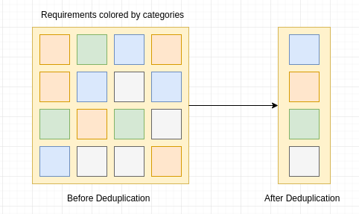
Figure 24: Requirement deduplication

2.5 User right management

User Rights Management specifies access rights to different employees related to the different modules in the system. Access policy is formalized as access control rules where the system uses the access control rules to decide what level of access a particular authenticated user should have to secure resources controlled by the system.
- User right management in the project
  - Every user in the application can have interface.
  - Every user can customize the application according to their needs.
  - Every user can add, modify and remove elements from the application.
  - All users have the access to all pages in the application.

2.6 Crowdsourcing
- About Crowdsourcing
  - It is a group of people “Non-technique” collaborated to complete a task in a project.
  - They work in the same time “Parallel” and in a different place around the world.
  - They work in their own platform.
  - It’s an outsourcing of activity.
- The Whys and Hows of Crowdsourcing
Non-profits can use crowdsourcing for a number of purposes, including cultivating new volunteers and donors and spreading the word about your organization’s work to a larger audience.
At its simplest, crowdsourcing is community engagement. Engaging a community whether it’s your local community, your group of volunteers, donors and clients, or a community of like-minded people who share an interest in your cause, can provide you with ideas, feedback and contributions you might not otherwise get. It can also demonstrate transparency and openness in decision-making.
But there are some cautions to keep in mind, the most important of which is to keep crowdsourcing simple and meaningful. For example, if your organization is drafting a social media policy, your volunteer manager might share a draft with an on-line community of volunteers and ask for their feedback. If your organization wanted to come up with new plans for an annual fund-raising event, your fund-raising manager might email all your organization’s supporters to ask for ideas.[53]

2.7 Version control

- Introduction
The company suggested that all the project file must be stored in a version control server.
- Presentation
Version control “also known as revision control or source control” is a category of processes and tools designed to keep track of multiple different versions of software, content, documents, websites and other information in development. Any system that provides change tracking and control over programming source code and documentation can be considered version control software. The practice has been a part of creative processes almost as long as writing has existed.[34]
- Why version control ?
  - Lets people share files and stay up-to-date with the latest version.
  - Track Changes. As files are updated, you can leave messages explaining why the change happened «Commit, stored in the VCS». This makes it easy to see how a file is evolving over time, and why.
  - Branching and merging. You can branch a copy of your code into a separate area and modify it in isolation «Make changes separately». Later, you can merge your work back into the common area.
- GIT
Git is a free and open source distributed version control system designed to handle everything from small to very large projects with speed and efficiency.

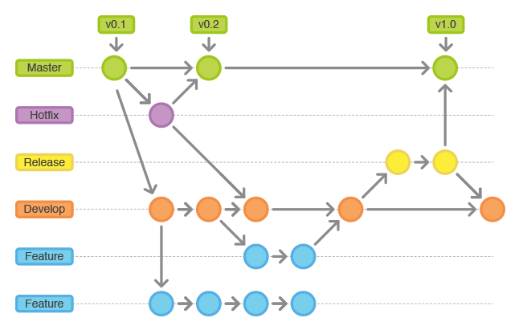
Figure 24: Git tree «Branch»
URL: « https://github.com/amine95bz/PFE »
- Github
GitHub is a web-based Git or version control repository ¹³ and Internet hosting service. It offers all of the distributed version control and source code management “SCM” functionality of Git as well as adding its own features. It provides access control and several collaboration features such as bug tracking, feature requests and task management.
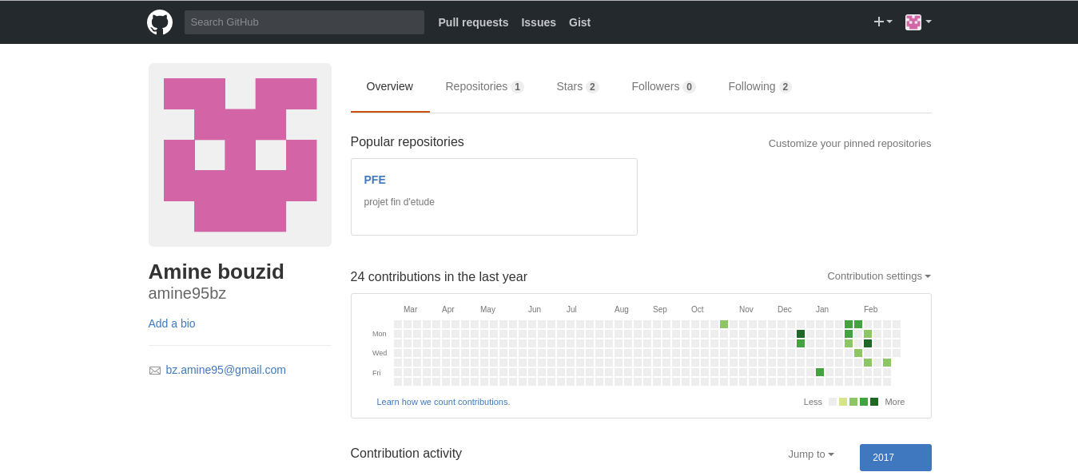
Figure 25: Github screenshot

3 Design

3.1 Concept

- Introduction
The design phase is an essential part of the development cycle of the system in order to reproduce a high-quality application and minimize redundancy and risk of errors. Indeed, it makes it possible to decide how to realize what has been specified in the phase of specification of the needs.
In this part we will begin by defining the architecture of the application.

3.2 Use cases

- Introduction
A use case diagram at its simplest is a representation of a user's interaction with the system that shows the relationship between the user and the different use cases in which the user is involved. A use case diagram can identify the different types of users of a system and the different use cases and will often be accompanied by other types of diagrams as well.

3.2.1 General user use case
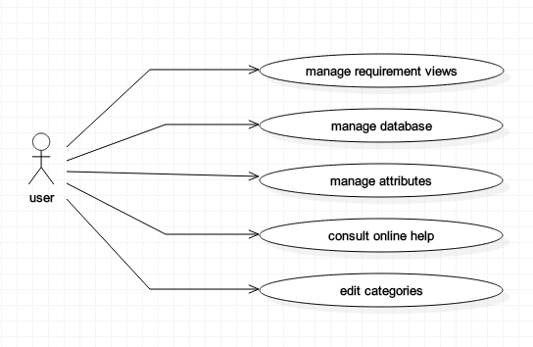
Figure 26: Use case «General»

3.2.2 Use case refinement «Manage Database»
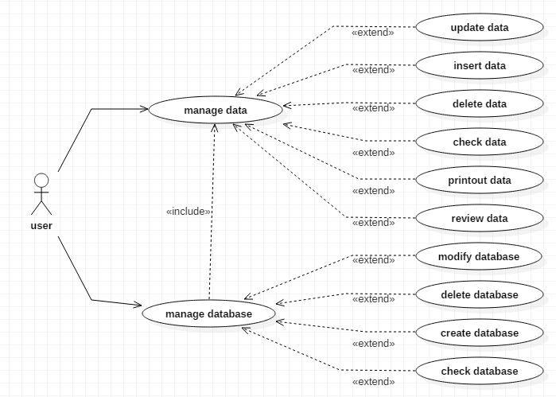
Figure 27: Use case «Manage database»

3.2.2.1 Description of use case refinement «Manage Database»
Use case | Manage database
Actors | User: Technical user / Non-technical user
Main scenario | In this part user can manage the database according to their needs.

3.2.2.2 Description of use case refinement “Manage data”
Use case | Manage data
Actors | User: Technical / Non-technical user
Main scenario | In this part users can manage the data as their needs.  User can «Insert, update, delete, check, printout, review»
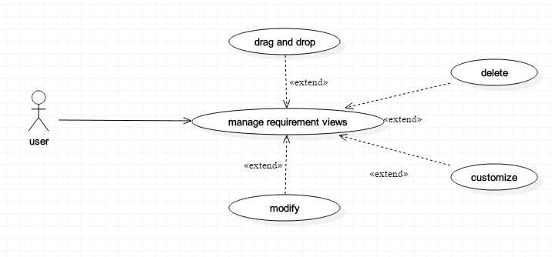

3.2.3 Use case refinement «Manage Requirement Views»
Figure 28: Use case «Manage requirement views»

3.2.3.1 Description of use case refinement «Drag & Drop Requirement views»
Use case | Drag and drop requirement views
Actors | User: Technical / Non-technical user
Main scenario | User can make drag and drop.  Drag and drop is used to describe the action of selecting an object or section of text, moving it “dragging”, and then placing it “dropping” into an alternate area.

3.2.3.2 Description of use case refinement «Delete Requirement views»
Use case | Delete requirement views
Actors | User: Technical / Non-technical user
Main scenario | User click the “x” to remove the requirement view, a new window will display to confirm the choice

3.2.3.3 Description of use case refinement «Customize Requirement Views»
Use case | Customize requirement views
Actors | User: technical / Non-technical user
Main scenario | User can customize the size of requirement views, he can adjust the window as he like.

3.2.3.4 Description of use case refinement «Modify Requirement views»
Use case | Modify requirement views
Actors | User: technical / Non-technical user
Main scenario | User can modify the requirement views by making double click into the requirement name. After modification a new window will display to confirm modification.

3.2.4 Use case refinement «Edit Attributes»
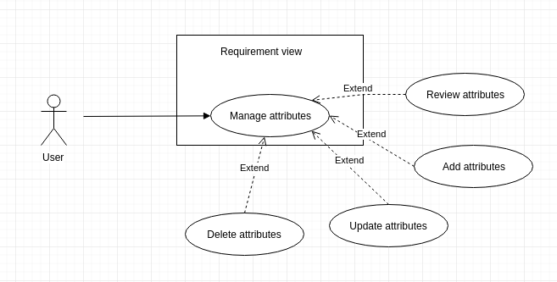
Figure 29: Use case «Edit Attributes»

3.2.4.1 Description of use case refinement «Review Attributes»
Use case | Review attributes
Actors | User: technical / Non-technical user
Main scenario | In this part user can make review attributes by making double click into requirement name.

3.2.4.2 Description of use case refinement «Update Attributes»
Use case | Update attributes
Actors | User: technical / Non-technical user
Main scenario | In this part user can open “Double click” the attributes and make update.

3.2.4.3 Description of use case refinement «Add Attributes»
Use case | Add attributes
Actors | User: technical / Non-technical user
Main scenario | In this part user can add attributes by clicking the check-box to display the new attribute area.

3.2.4.4 Description of use case refinement «Delete Attributes»
Use case | Delete attributes
Actors | User: technical / Non-technical user
Main scenario | The user click the remove button and validate his chose

3.2.5 Use case refinement «Edit Categories»
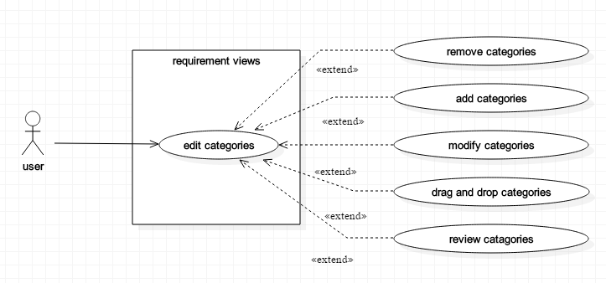
Figure 30: Use case «Edit Categories»

3.2.5.1 Description of use case refinement «Remove Category»
Use case | Remove category
Actors | User: technical / Non-technical user
Main scenario | User can remove category by clicking the “X” button

3.2.5.2 Description of use case refinement «Add Category»
Use case | Add category
Actors | User: technical / Non-technical user
Main scenario | User can add a new category by clicking into the category input area.

3.2.5.3 Description of use case refinement «Modify Category»
Use case | Modify category
Actors | User: technical / Non-technical user
Main scenario | User can modify category by making double click into requirement category

3.2.5.4 Description of use case refinement «Drag and Drop Category»
Use case | Drag and drop category
Actors | User: technical / Non-technical user
Main scenario | User can add new category by making drag from another requirement view and drop it in the place that he want. Also user can make drag and drop to delete category.

3.2.5.5 Description of use case refinement «Review Category»
Use case | Review category
Actors | User: technical / Non-technical user
Main scenario | User can make category review by clicking the right button and chose review from the list.

3.3 Data base format «File System»

- Introduction
In this project the company suggested that we must used the File System format like a database. To make the synchronization between the terminal and the application easy.
- What is File System format?
A file system is used to control how data is stored and retrieved. Without a file system, information placed in a storage area would be one large body of data with no way to tell where one piece of information stops and the next begins.
Examples of file system include a hard drive, the CDs, DVDs and BDs in an optical drive ¹² or on a flash drive. Any place that a PC stores data is employing the use of some type of file system.[49]
- Why we choose file system?
  - A file management system will allow user to create and store Meta data. Meta data is data about files. It supports heterogeneous operating systems including all flavors of the Unix operating system as well as Linux and Windows.
  - A file is indexed for faster and easier retrieval. Gives structure to all your info. You will be able to manage all your information much easier.
  - The data stored in the database can be shared among multiple users or application programs.

3.4 Static view

- Introduction
This part will be interested in the presentation of the class diagram relating to our application.

3.4.1 Class diagram
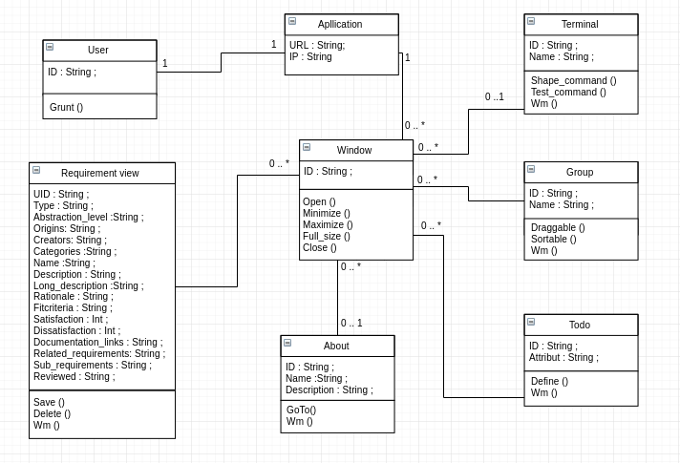
Figure 31 : Class diagram

3.5 Dynamic Views
The sequence diagram represents the chronological sequence of the operations performed by an actor: entering data, consulting data, starting a process… . It indicates the objects that the actor will manipulate, and the operations that move from one object to another.
To do this, we present in the following part some sequence diagrams of use cases described in the previous chapter.

3.4.1 Sequence diagram «Connexion»
Textual description: User write the command in the terminal and press «Enter» to execute it. The command sent to the system and verify if it is executable, if not an error message will display.
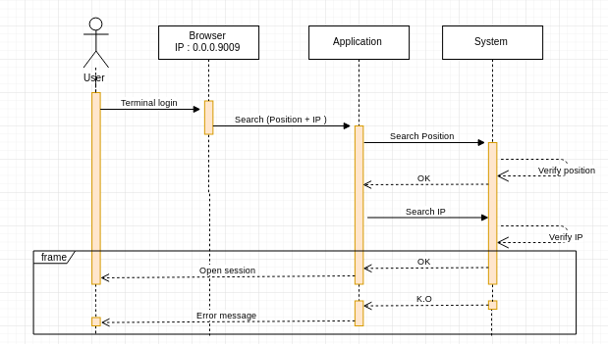
Figure 32: Sequence diagram «Connexion»

3.4.2 Sequence diagram «Add new requirement view»
Textual description: The use can add a new requirement view by clicking the button «Add requirement view» in the menu. A new window will display in the interface.
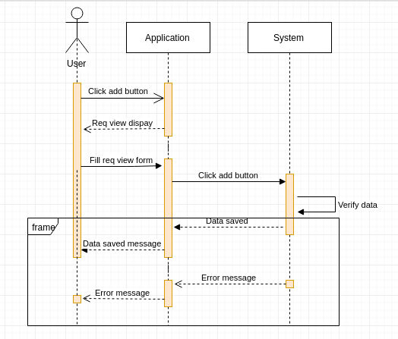
Figure 33: Sequence diagram «Add new requirement view»

3.4.3 Sequence diagram «Add new requirement view “Terminal”»
Textual description: The user write the command to open requirement in the terminal and press «Enter» to execute it. User fill the attributes and submit it.
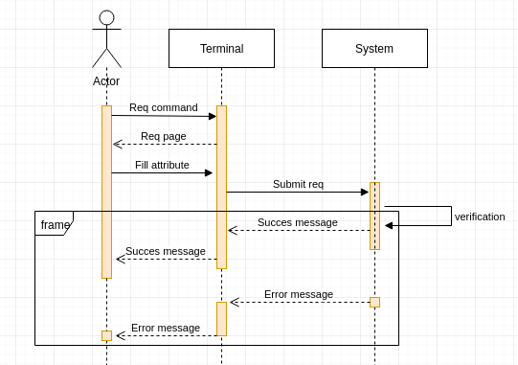
Figure 34: Sequence diagram «Add new requirement view “Terminal”»

3.4.4 Sequence diagram «Use “Terminus”»
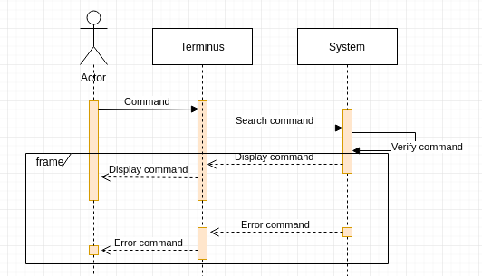
Textual description: User write a command on the terminal and press «Enter», then the terminus display the result.
Figure 35: Sequence diagram «Use “Terminus”»

3.4.5 Sequence diagram «Remove view»
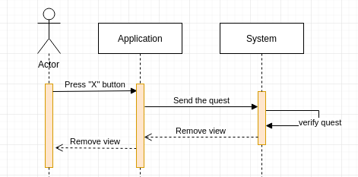
Textual description: User press «X» button with the cursor to disable the view from the interface. The application send the quest to the system.
Figure 36: Sequence diagram «Remove view»

4. Realization

- Introduction
This part is devoted to the description of the implementation phase of this project. We will present some interfaces to illustrate more clearly the various uses of the application.

4.1 Realization of the WEB application

4.1.1 Connexion view
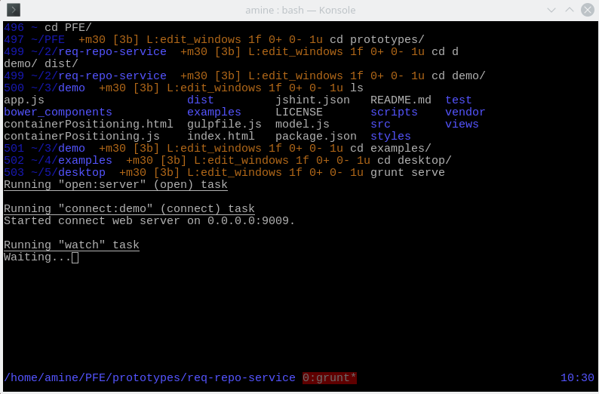
Figure 37: Server connexion view
Textual description: This screenshot shows the user how to connect to the server by writing the command «Grunt serve».

4.1.2 Error screen
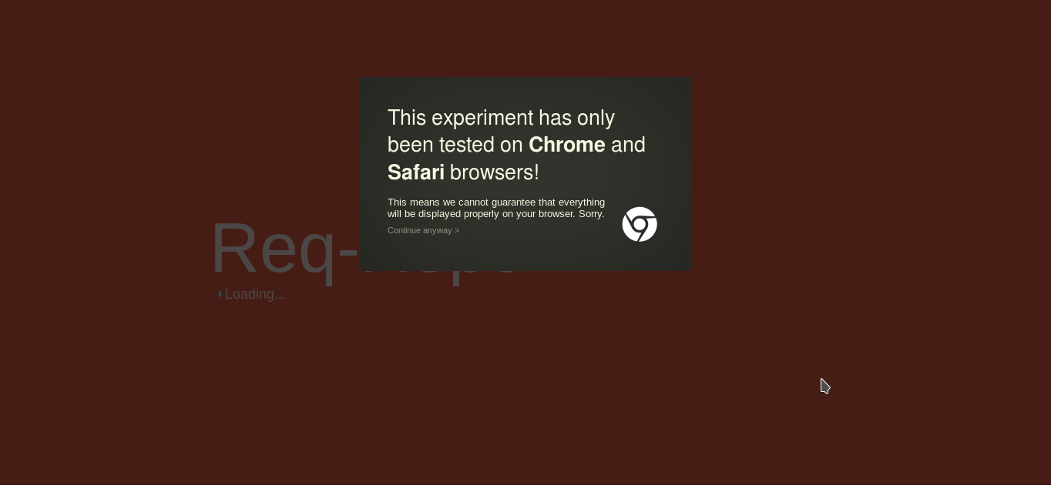
Figure 38: Application error screenshot
Textual description: This screen-shot shows the user that the application has been only test on Chrome and Safari browsers.

4.1.3 Expose screen
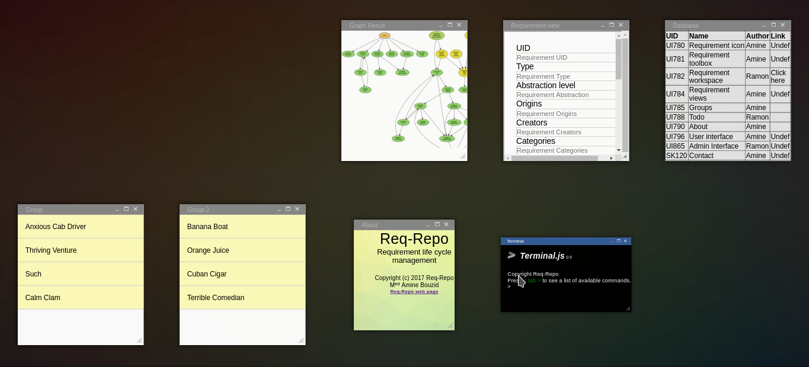
Figure 39: Apllication expose screenshot
Textual description: This screen-shot shows the user how he can make the expose of windows in the interface. This function also allow the user to choose one of the windows displayed on the screen.

4.1.4 Add new requirement screen
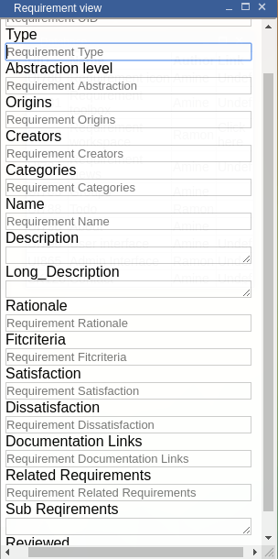
Figure 40: Requirement view
Textual description: This screen-shot shows the requirement view “In the application interface” that allows user to fill the requirement attributes in the application interface.
Figure 41: Master template
Textual description: This screen-shot shows the master template “Requirement view in the terminal”.

4.1.5 UI terminal screen
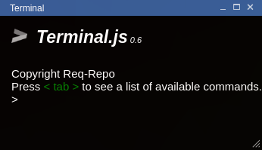
Figure 42: Application terminal
Textual description: This screenshot shows the UI terminal, it allow to manage and execute commands in the interface.

4. Development

4.1 Use libraries

Introduction

This part will show all the libraries that I used to develop my own web application.

4.1.1 Dragula
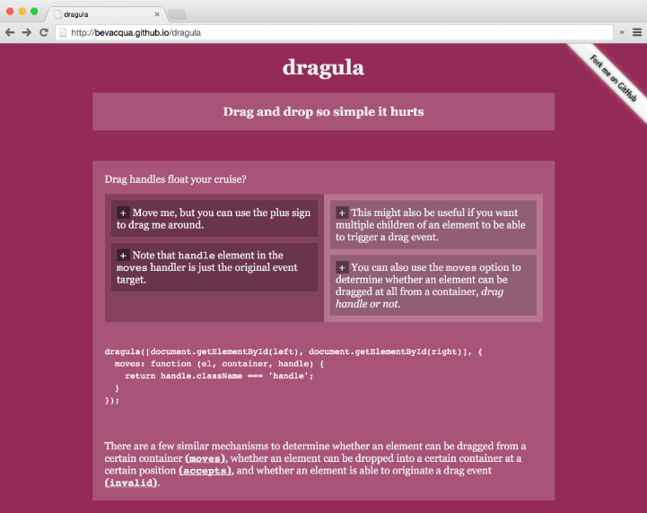
Figure 43: Dragula library
Textual description: Drag and drop library «Dragula» helped me to make the groups on the interface draggable and sortable in the same time.
First time I implement the library codes, I found a problem with drag element from group and drop it in another group, because the windows in the interface are DOM elements.[56]

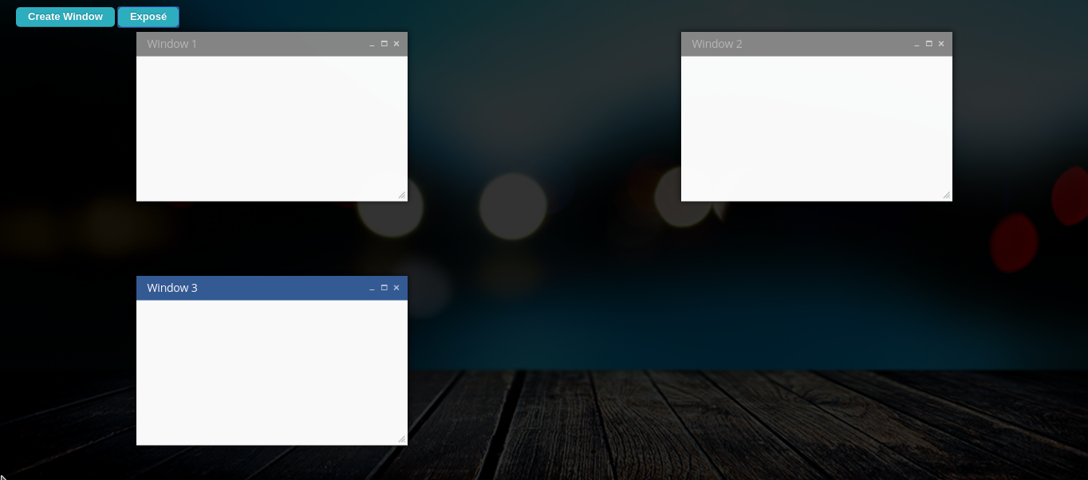
4.1.2 Ventus
Figure 44: Ventus library
Textual description: Window manager library «Ventus» helped me to create my own interface with customized windows also to make them draggable, using Javascript.
Also it helped me to implement my own windows on the application interface.
First time I found a little problem with windows content style. And I resolve this problem by asking the library creator.[57]

4.1.3 Ng-sortable
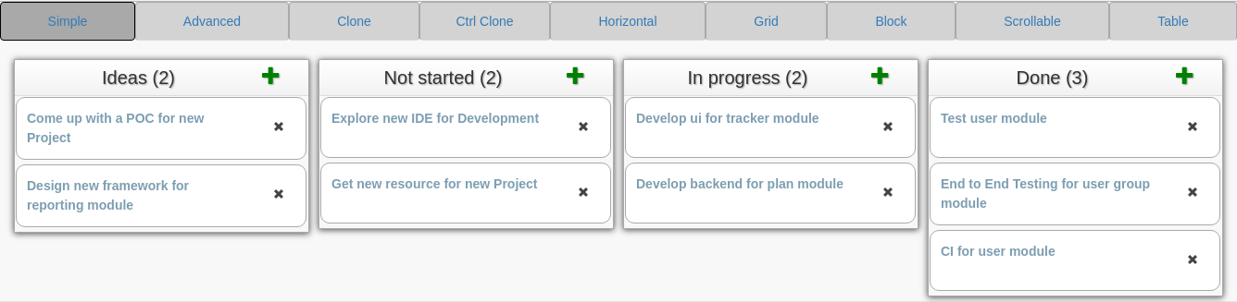
Figure 45: Ng-sortable library
Textual description: I started my work with using this library, but I found that it didn’t support drag and drop and draggable in the same time, also I can only work in one requirement. So that’s why I decided to change the library. [58]

4.2 Use languages

4.2.1 Node.JS
- Presentation
Node.js is an open-source, cross-platform JavaScript runtime environment for developing a diverse variety of server tools and applications. Although Node.js is not a JavaScript framework, many of its basic modules are written in JavaScript, and developers can write new modules in JavaScript. The runtime environment interprets JavaScript using Google's V8 JavaScript engine.
Node.js has an event-driven architecture capable of asynchronous Input/Output. These design choices aim to optimize throughput and scalability in Web applications with many input/output operations, as well as for real-time Web applications “Real time communication program”.
The Node.js distributed development project, governed by the Node.js Foundation, is facilitated by the Linux Foundation's Collaborative Projects program. [55]

4.2.2 HTML
- Web Presentation
HTML5, is a markup language used for structuring and presenting content on the World Wide Web. It is the fifth and current version of the HTML standard.
It was published in October 2014 by the World Wide Web Consortium “W3C” to improve the language with support for the latest multimedia, while keeping it both easily readable by humans and consistently understood by computers and devices such as web browsers, parsers, etc. HTML5 is intended to subsume not only HTML4, but also XHTML and DOM Level 2 HTML.
- Own Presentation
HTML stands for Hypertext Markup Language. It is used to create the general look of a website or web application. The color, text, images and buttons are all designed inside HTML and CSS “Cascading Style Sheet”.

4.3 Conclusion
In this part, we presented the technological choice we adopted for the realization of our project. We established the deployment diagram of our solution and presented the different interfaces of our web application
General conclusion:
This report is the synthesis of a work carried out within the framework of our Final project assignment within AAW.
The aim of this project was the renovation of an existing application with the design, realization and implementation of a web requirement repository application.
We began this report with a collection of the necessary information to draw up a state of the existing, present the study of the existing, a critique and the proposed solution. Then, we specify the needs to be met by our application, which allowed us to distinguish the different actors interacting with the intended application. The objective of the next part was the detailed analysis and design, in which we presented a detailed design through the presentation of the static and dynamic views of the system. The last part of our project was the realization part which was devoted to the presentation of the development environment, the deployment environment and some interfaces presented in the form of screenshots.
Finally, it is worth noting that this Final project assignment was very beneficial for me to discover the professional world and to put into practice my basic knowledge and those acquired during my internship within AAW.
References:

- ReqSmile: http://reqsimile.sourceforge.net/
- ReqSmile: https://sourceforge.net/projects/reqsimile/?source=typ_redirect
- DOORS: doc, Tools for Requirements Management: a Comparison of Telelogic DOORS and the HV Tony Cant, Jim McCarthy and Robyn Stanley Information Networks Division Defence Science and Technology Organization.
- DOORS: http://www-03.ibm.com/software/products/en/ratidoor
- Innoslate: https://www.innoslate.com/solutions/
- Requisite Pro “IBM”: https://www.ibm.com/support/knowledgecenter/SSSHCT_7.1.0/com.ibm.reqpro.help/get_start/c_product_overview.html
- Open source: https://opensource.com/
- Open source https://fr.wikipedia.org/wiki /Open_source
- Closed source: https://en.wikipedia.org/wiki/Proprietary_software
- The agile movement: http://agilemethodology.org/
- The agile movement: https://fr.wikipedia.org/wiki/M%C3%A9thode_agile
- Requirement management: Computer Supported Cooperative Work in Design, 2007. CSCWD 2007. 11th International Conference on
- Requirements: https://www2.cdc.gov/cdcup/library/practices_guides/CDC_UP_Requirements_Management_Practices_Guide.pdf
- Visure: http://www.visuresolutions.com/
- GitBook: https://help.gitbook.com/basics/what-is-gitbook.html
- Domain specific language: https://en.wikipedia.org/wiki/Domain-specific_language
- PERT: http://searchsoftwarequality.techtarget.com/definition/PERT-chart
- Atom: https://atom.io/
- The MinReq: https://github.com/nvoynov/minireq
- Dartmouth College Library, Hanover, NH, USA 03755 web site http://www.dartmouth.edu/~library/home/help/libcat/keyword.html?mswitch-redir=classic
- Elicitation: https://en.wikipedia.org/wiki/Requirements_elicitation
- Elicitation: http://fr.slideshare.net/vivacemente/requirement-elicitation
- Elicitation: http://fr.slideshare.net/PeteFrey1/10-requirement-elicitation-techniques-for-b-as
- Brainstorming: http://www.brainstorming.co.uk/tutorials/whatisbrainstorming.html
- virtual brainstorming: https://www.pgi.com/blog/2013/08/seven-ways-to-get-great-ideas-out-of-a-virtual-brainstorming-session/
- Document analysis: https://businessanalystlearnings.com/ba-techniques/2013/5/17/understanding-the-document-analysis-technique
- Focus groups: Guidebook Series - A Beginner's Guide To Requirements Elicitation: What To Do Before, During & After The Event, site web: https://businessanalystlearnings.com
- Interface analysis: https://businessanalystlearnings.com/ba-techniques/2014/5/31/interface-analysis
- BABOK V2: http://www.slideshare.net/carlitos5071989/babok-v20
- Interviews: https://businessanalystlearnings.com/ba-techniques/2013/7/18/interviews-requirements-elicitation-technique
- Prototyping: https://businessanalystlearnings.com/blog/2013/9/1/proof-of-concept-benefits-risks-of-prototyping-in-business-analysis?rq=prototyping%20analysis
- Verification & validation: software requirements and design specifications. Boehm, B W IEEE Software. Vol. 1, no. 1, pp. 75-88. 1984
- Categorization:
- Version control: https://techterms.com/definition/version_control
- Version control: https://www.git-tower.com/learn/git/ebook/en/desktop-gui/basics/why-use-version-control
- Req analysis: https://en.wikipedia.org/wiki/Requirements_analysis
- characteristic: http://www.modernanalyst.com/Careers/InterviewQuestions/tabid/128/ID/1169/What-are-the-characteristics-of-a-good-requirement.aspx
- characteristic: http://www.informit.com/articles/article.aspx?p=1152528&seqNum=4
- Gathering: https://www.projectsmart.co.uk/requirements-gathering.php
- Virtual machine: https://pubs.vmware.com/vsphere-50/index.jsp?topic=%2Fcom.vmware.vsphere.vm_admin.doc_50%2FGUID-CEFF6D89-8C19-4143-8C26-4B6D6734D2CB.html
- Snapshot: http://searchdatabackup.techtarget.com/definition/storage-snapshot
- Snapshot: https://linux.die.net/EVMSUG/whatissnapshotting.html
- Snapshot testing: https://medium.com/@dschmidt1992/jest-snapshot-testing-3ef9fa1222bb#.ykgxe3fsi
- URM:http://docs.aws.amazon.com/elastictranscoder/latest/developerguide/drm.html
- User right:https://www.mediawiki.org/wiki/Manual:User_rights
- One to one interview:http://www.goldmantech.co.za/candidates/interview-advice/one-to-one-interview
- Group interviews:https://www.themuse.com/advice/standing-out-from-the-crowd-how-to-nail-a-group-interview
- Facilitated sessions: https://en.wikibooks.org/wiki/Business_Analysis_Guidebook/Facilitation_and_Elicitation_Techniques
- file system: http://www.academia.edu/7423594/REPORT_ON_FILE_SYSTEM_AND_DATABASE_MANAGEMENT_SYSTEM
- V-Shaped life cycle: https://prezi.com/9ukgmq1ayz_y/v-shaped-life-cycle-model/
- V-Model: https://en.wikipedia.org/wiki/V-Model
- Advantages & disadvantages V-Model: http://testingfreak.com/v-model-software-testing-advantages-disadvantages-v-model/
- Crowdsourcing: https://dailycrowdsource.com/training/crowdsourcing/what-is-crowdsourcing
- http://www.pbworks.com/project-collaboration/
- https://openclassrooms.com/courses/ultra-fast-applications-using-node-js
- https://github.com/bevacqua/dragula
- http://www.qooxdoo.org/
- https://github.com/a5hik/ng-sortable

Term Definitions:
1.Stakeholders :
- Intern : employees , owner , manager
- Extern : government , society , creditor
- Stakeholder analysis, it is claimed, can be used to analyses an organization's performance and determine its future strategic direction

2.PERT:
- Program evalution and review technique, is a static tool used for project management, designed to analyze and represent the tasks.

2.PERT (fr):
- PERT est une methode conventionnelle utilisable en gestion de projet

3.Atom:
- “atom.io”, is a HTML text editor

4.Workshops:
- “document analysis” a meeting at which a group of people engage in intensive discusion and activity on a particular subject or project.

4.Workshops (fr):
- Un atelier axé sur un theme de travail au sein d'un congré ou d'un salon professionel.

5.Workflows:
- Progression of steps (tasks, events, interactions) that comprise a work process, involve two or more persons, and create or add value to the organization's activities

5.Workflows (fr):
- On appelle workflow management “gestion du flux de travail” la modélisation et la gestion informatique de l'ensemble des tâches à accomplir et des différents acteurs impliqués dans la réalisation d'un processus métier

6.Tasktop:
- Software development lifecycle integration

7.Component:
- A part or element of a larger whole, especially a part of a machine

8.Compliance:
- Act of obeying an order

9.TRS:
- Technical requirement specification
10.Scalability
- The ability of a product to adapt to a change in the order of magnitude of demand.

10.Scalability (fr)
- la capacité d'un produit à s'adapter à un changement d'ordre de grandeur de la demande.

11.Business process:
- A work process fulfilling (part of) a business goal. What is done, by whom, and when it is done.

12.Optical drive:
- Piece of computer hardware

13.Repository “repo”:
- The database storing the files.

