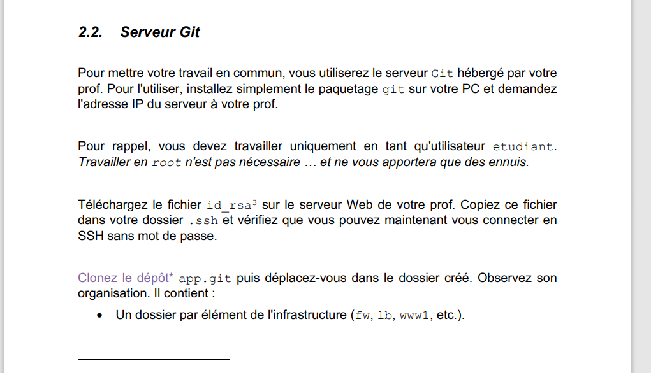

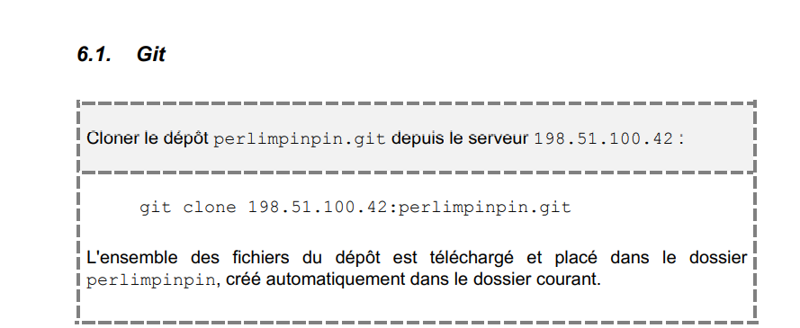



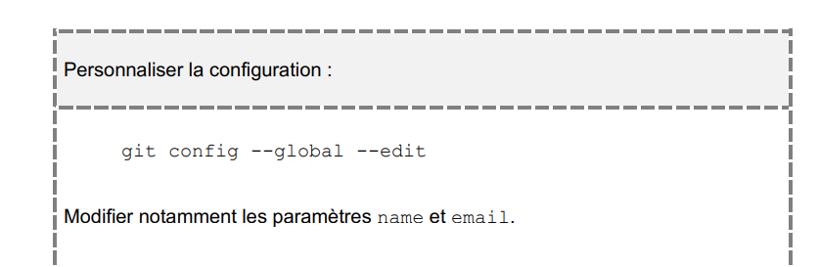

touch {fw,lb,www1,…}.json



Git add

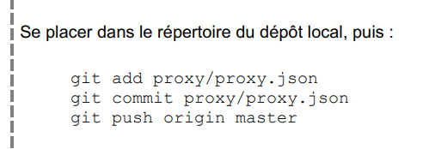

Git pull



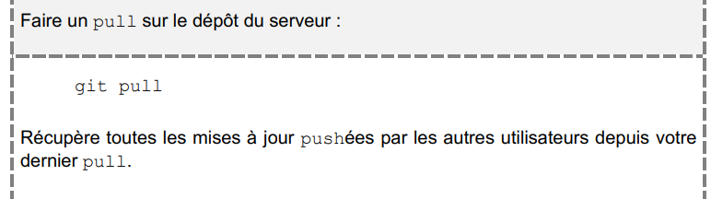

Git log



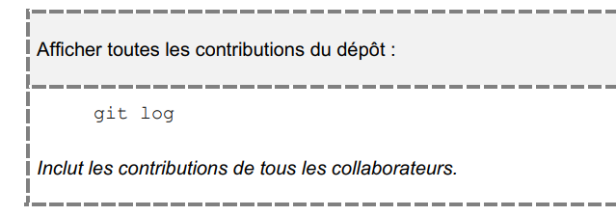

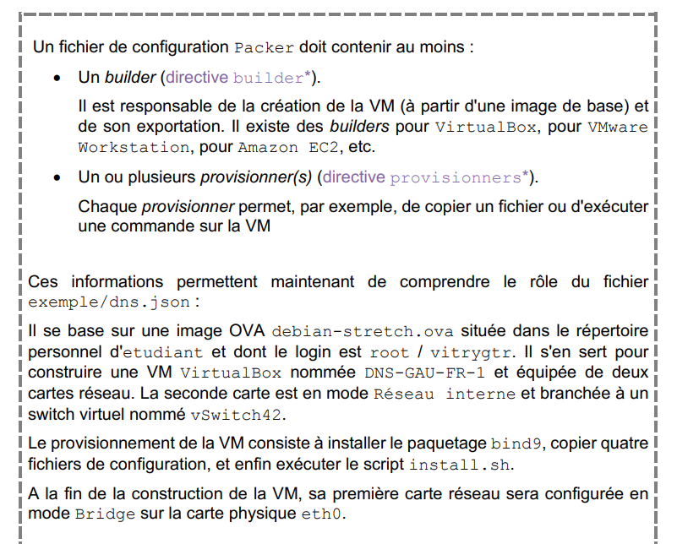

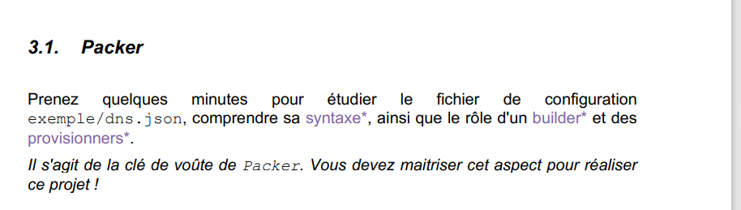

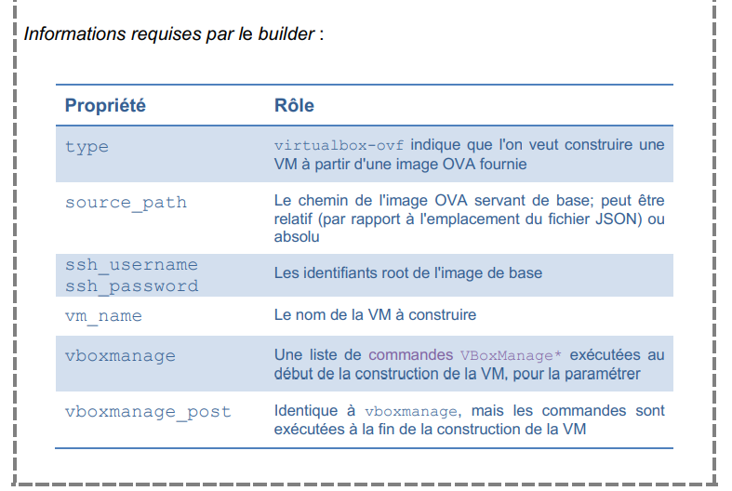

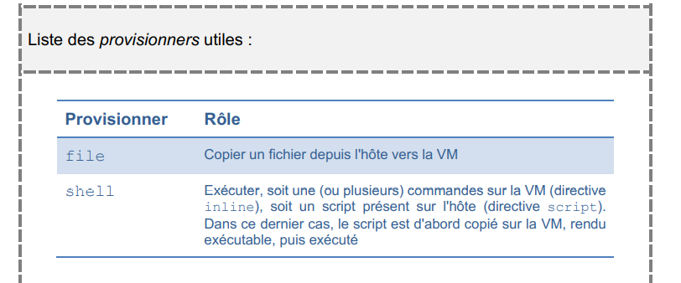

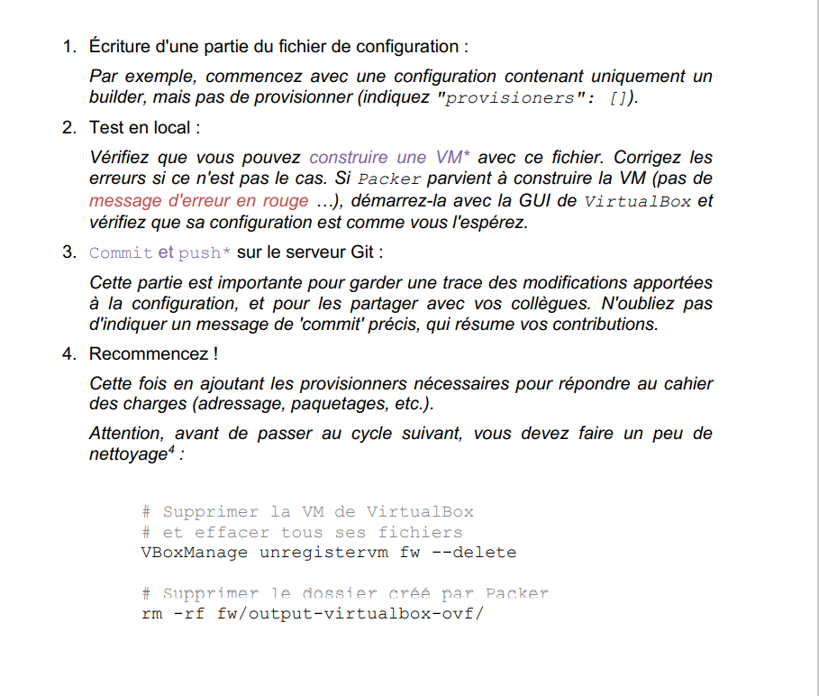

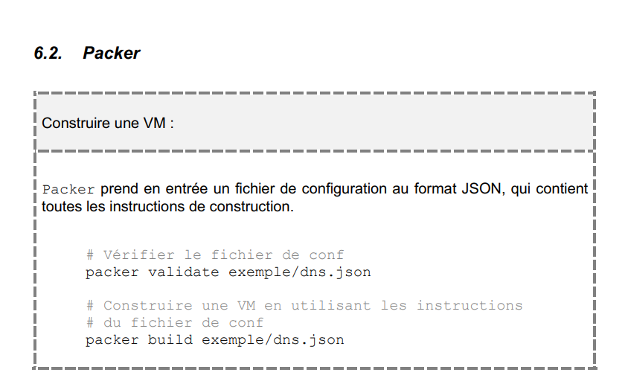

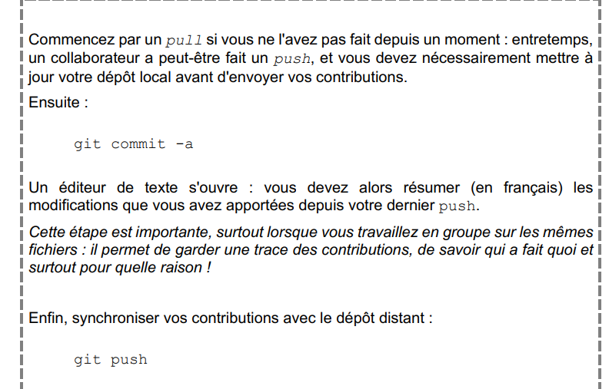

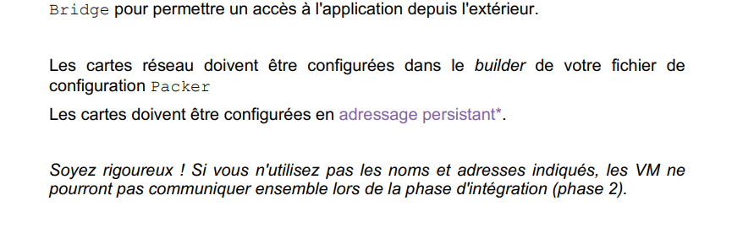

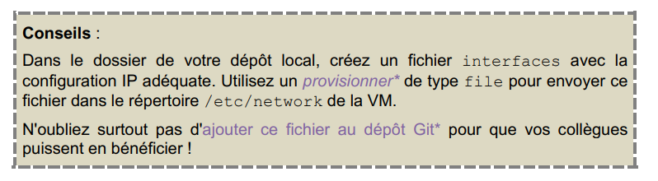

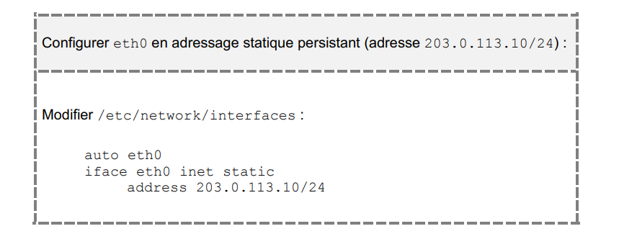

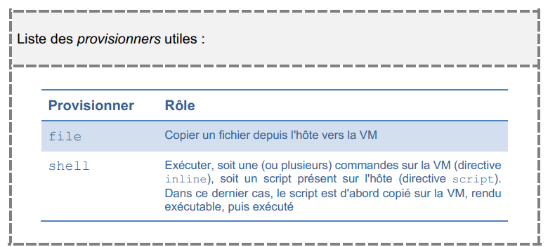

{

"type": "file",

"source": "/home/etudiant/app/fw/etc/network/interfaces",

"destination": "/etc/network/interfaces"

}

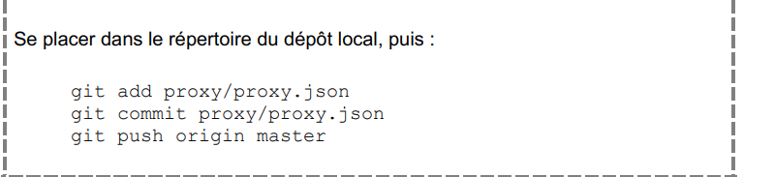

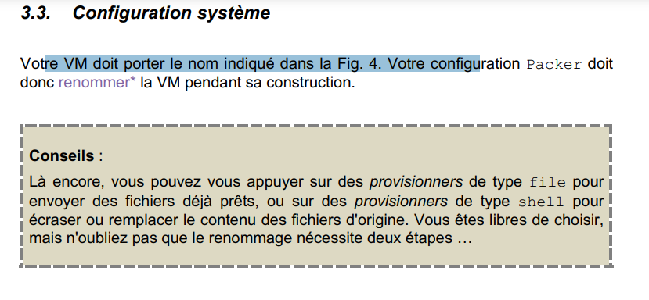

{

"type": "shell",

"inline": ["sudo hostnamectl set-hostname fw "]

}

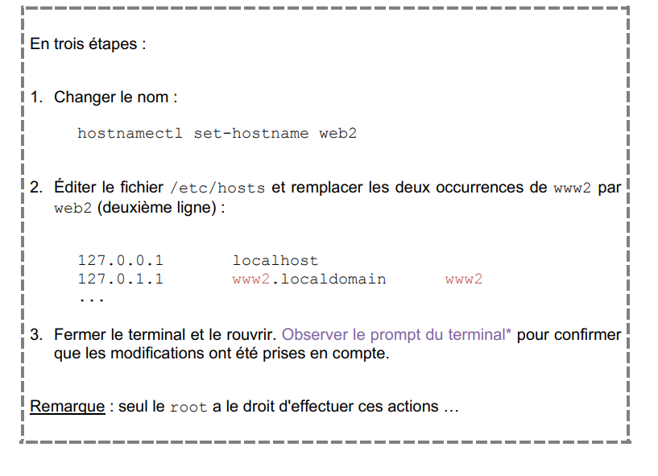

{

"type": "file",

"source": "/home/etudiant/repo/fw/etc/hosts",

"destination": "/etc/hosts "

}

    - 3 ème étape : reboot

            ```json

            {

                "type": "shell",

                "inline": ["reboot"]

            }

        ```

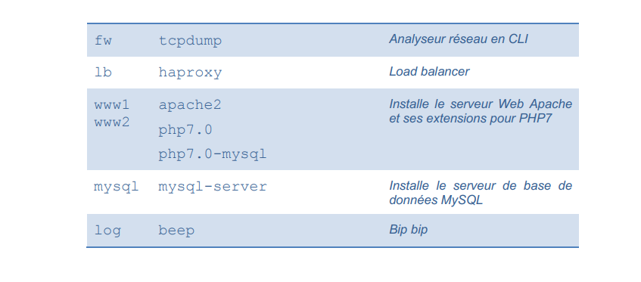

{

"type": "shell",

"inline": ["sudo apt-get update –y && sudo apt-get install –y tcpdump"]

}

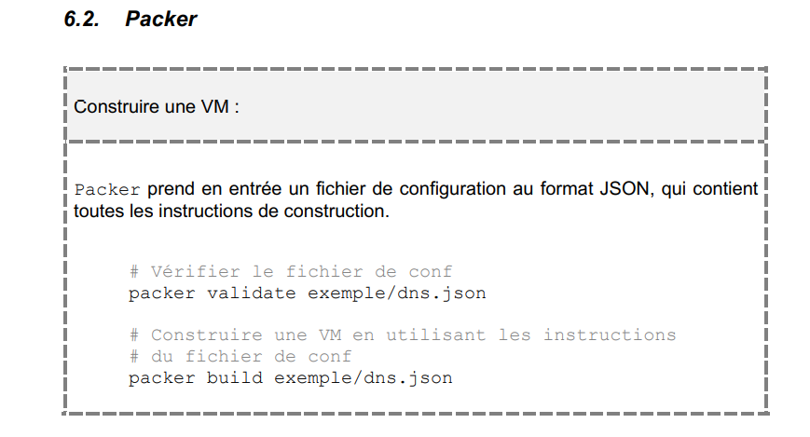

# Synthèse 1 :

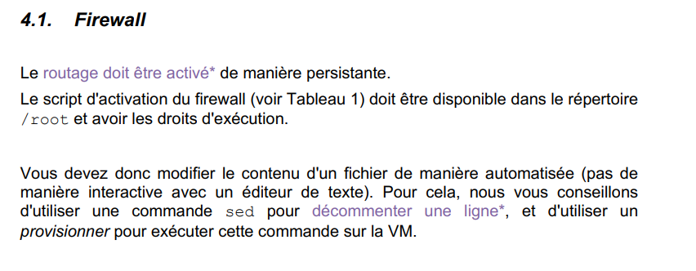

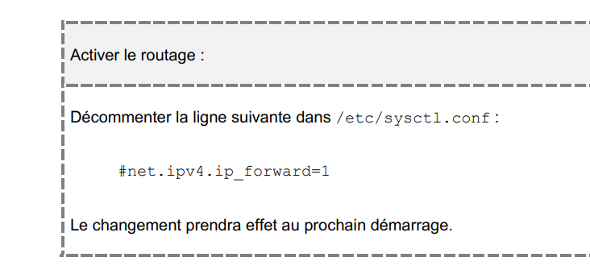

{

"type": "file",

"source": "/home/etudiant/repo/fw/routing.sh ",

"destination": "/root/routing.sh"

}

{

"type": "shell",

"inline": ["sudo cd /root && sudo chmod +x routing.sh && ./routing.sh"]

}

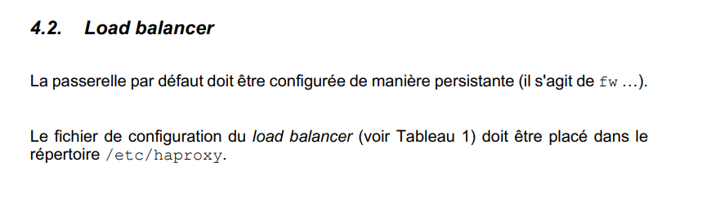

[File - Provisioners | Packer by HashiCorp](https://www.packer.io/docs/provisioners/file)

[Shell - Provisioners | Packer by HashiCorp](https://www.packer.io/docs/provisioners/shell)