SOLID Lab – Project: Refactoring a Parking Garage Application
Report: code review (Q2), class diagram (Q6) and answers

Q1. Actors who can ask for a change in ParkingGarage
- Management / pricing: fee per vehicle type (fee).
- Cashier / finance: payment methods and cancellation rules (checkout, cancel).
- Accounting / reporting: format of the daily report (dailyReport).
- Operations / IT: destination and technology of the parking.log journal.
- Customer service: format of the receipts shown or logged.
Five reasons to change for a single class: this violates the SRP. The code confirms it: fee (l. 12-19), checkout (l. 21-31), cancel (l. 33-42) and dailyReport (l. 44-51) serve different actors, and the logger field (l. 9) ties the class to a file.

Q2. Code review table
Principle | Class | Line(s) | Smell
SRP | ParkingGarage | l. 7-52 (fee l. 12-19, checkout l. 21-31, cancel l. 33-42, dailyReport l. 44-51) | Pricing, payments, receipt and report formatting, and logging in one class: 5 actors, 5 reasons to change (God class).
OCP | ParkingGarage.fee | l. 13-18: switch on vehicle.getType() | Every new vehicle type forces a modification of the class (shotgun surgery). The type is an unchecked String (Vehicle l. 5).
OCP | ParkingGarage.checkout / dailyReport | l. 27-28 and l. 45-50 | Receipt and report formats are hard-coded: a CSV report forces a modification of the class.
LSP | CashPayment.refund | l. 11-13: throw new UnsupportedOperationException | The subtype breaks the contract of PaymentMethod: it throws an exception the interface does not announce.
LSP | ParkingGarage.cancel | l. 35: if (method instanceof CashPayment) | Workaround: the caller must know the concrete subtypes (and duplicates the cash business rule).
ISP | PaymentMethod | l. 6: void refund(double amount) | Fat interface: forces refund() on payment methods that cannot refund.
DIP | ParkingGarage | l. 9: new FileLogger("parking.log") | The business logic creates and depends on a concrete infrastructure class; it cannot be injected or replaced.

Q3. Files to edit with the current design
Change request | Existing files to edit
a. New vehicle type BUS (15 MAD/h) | ParkingGarage (switch in fee, l. 13-18); Main to use it.
b. Mobile wallet payment, refundable | New class WalletPayment; ParkingGarage.cancel (instanceof, l. 35); Main.
c. Receipts logged in a database | ParkingGarage (logger field l. 9 and call l. 30); new log class; Main.
d. Daily report in CSV format | ParkingGarage.dailyReport (l. 44-51); Main.
In all four cases ParkingGarage must be modified.

Q4. Removing the instanceof CashPayment test
Without the test, cancelling the cash payment calls CashPayment.refund, which throws UnsupportedOperationException ("Cash cannot be refunded by the machine"). Run on the original code, the program prints the three payments and then stops on this exception (CashPayment.java:12, called from ParkingGarage.cancel).
- Principle broken: LSP. CashPayment is not substitutable for PaymentMethod: it throws an exception that the contract does not announce.
- Why instanceof is not an acceptable fix: it hides the defect instead of fixing it, forces ParkingGarage to know every subtype (OCP violation), and every new non-refundable payment method will need a new test.

Q5. Why a test is impossible with the current design
ParkingGarage creates its own FileLogger: there is no injection point to replace it. Every checkout writes to parking.log, so the fee and the checkout of a truck cannot be tested without creating the file. This is a DIP violation.

Q6. Class diagram of the refactored design
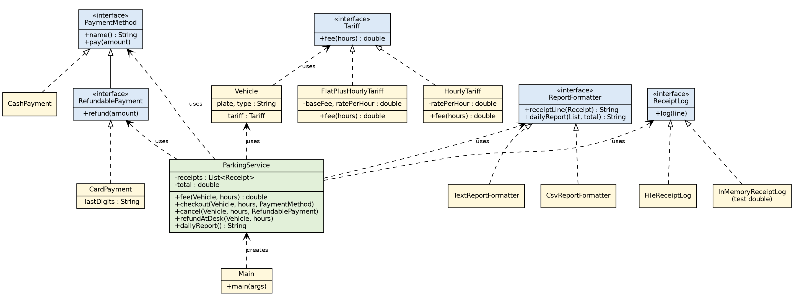
The abstractions Tariff, RefundablePayment, ReportFormatter and ReceiptLog correspond to points a to d of the assignment. ReceiptLog lives in the same package as ParkingService (DIP) and FileReceiptLog conforms to it.

Q7. Implementation
The complete code is in the attached project (src/parking/refactored). It was compiled and run, and its output was compared with the output of the original code (diff command): it is identical, character for character. Steps:
- OCP: Tariff, HourlyTariff (car 5 MAD/h, motorbike 2 MAD/h), FlatPlusHourlyTariff (truck: 20 + 10 MAD/h), Vehicle (record). No more switch on the type.
- ISP and LSP: PaymentMethod, RefundablePayment, CardPayment, CashPayment (without refund).
- SRP: Receipt, ReportFormatter, TextReportFormatter, CsvReportFormatter.
- DIP: ReceiptLog, FileReceiptLog, InMemoryReceiptLog.
- Orchestration: ParkingService (constructor taking ReceiptLog and ReportFormatter) and Main as the composition root.
Design choice: the required output contains "Refund ... at the desk", while Q8 requires that cancelling a cash payment is rejected at compile time. refundAtDesk is therefore a separate business operation that no longer goes through PaymentMethod.

Q8. Cancelling a cash payment through ParkingService
The call service.cancel(bike, 2, cash) is rejected at compile time:
error: incompatible types: CashPayment cannot be converted to RefundablePayment
In Q4 the same mistake only appeared at run time (UnsupportedOperationException). The check moved from run time to compile time.

Q9. ParkingServiceTest
ParkingServiceTest checks the fees (15, 4 and 60 MAD), the total of the daily report (79.0 MAD for three payments) and the number of logged receipts. Result: "All tests passed", without creating any file.
Test double needed: a fake of ReceiptLog, InMemoryReceiptLog, which keeps the lines in memory instead of writing a file.

Q10. Validation with the four change requests
Change request | Existing files opened
a. BUS at 15 MAD/h | Main only: new Vehicle("...", "BUS", new HourlyTariff(15)).
b. Refundable wallet | New file WalletPayment implements RefundablePayment; Main only.
c. Receipts in a database | New file DbReceiptLog implements ReceiptLog; Main only.
d. CSV report | None (CsvReportFormatter already exists); Main: new ParkingService(log, new CsvReportFormatter()).
Goal reached: no existing file is modified, except Main.

