Ministry of Higher Education and Scientific Research
Tunis Business School — University of Tunis
Department of Business Analytics & Information Systems
Class: Data Mining (Spring 2025)
Fitness Level Prediction:
A Machine Learning Classification Study Using Synthetic Health Indicators
Advanced Exploratory Data Mining, Data Generating Process Reverse Engineering, Leak-Free Feature Engineering, and Explainable AI (SHAP)
STUDENT RESEARCH TEAM:  Amine Bessaad  Haitham Maatar  Jasser Sghaier | ACADEMIC SUPERVISOR:  Pr. Lassad El Moubarki  Professor of Quantitative Analytics
ACADEMIC YEAR:  2024 – 2025 | REPOSITORY & CODE:  GitHub: @aminebessaad  Kaggle GPU: @bessaadamine

Declaration of Academic Ethics & TBS Honor Code
We hereby declare that we are the sole authors of this research report and that all analytical work, empirical investigations, and coding pipelines presented herein are original, conducted under the academic supervision of Pr. Lassad El Moubarki. All external scholarly sources, mathematical formulations, and foundational libraries have been scrupulously acknowledged and cited in compliance with the academic integrity guidelines and Honor Code of Tunis Business School, University of Tunis.
Student Authors: Signed: Amine Bessaad, Haitham Maatar, Jasser Sghaier — Department of Business Analytics
Executive Summary & Abstract
Physical fitness classification from non-invasive biometric and behavioral telemetry is a cornerstone of modern digital healthcare, enabling preventive wellness recommendations, remote patient monitoring, and workplace wellness optimization. This study develops a comprehensive, leak-free machine learning classification pipeline to predict multi-tier fitness levels (Unfit, Moderate, Fit) on a large-scale synthetic health indicators dataset (1,000,000 observations). We critically examine and rectify fundamental methodological flaws in preliminary student approaches, including: (1) the mischaracterization of target class balance—empirically demonstrating that the target is severely imbalanced with Fit constituting only 4.64% of observations; (2) the misdiagnosis of invariant features—confirming that calories_burned is a zero-variance static constant (1500.0, std=0.0) across all records; (3) the elimination of severe target leakage induced by ad-hoc composite linear scoring; and (4) reverse-engineering the true non-linear threshold penalty gates governing the underlying Data Generating Process (DGP), specifically identifying a sharp sleep cliff (<5.0h), a chronic stress penalty gate (>8.0), a non-linear quadratic metabolic BMI penalty outside 18.5–25 kg/m², and recovery failure from overtraining without adequate sleep.
We construct leak-free domain interaction features, including the Recovery-Strain Index (RSI), Cardiovascular Efficiency Ratio (CER), and Overtraining Exhaustion Risk. Under Stratified 5-Fold Cross Validation on 100,000 stratified samples, we benchmark four model families: Balanced Multinomial Logistic Regression, Balanced Random Forest, LightGBM Classifier, and XGBoost Classifier. Results reveal that tree-based gradient boosters achieve superior performance, with XGBoost and LightGBM reaching ~89.3% accuracy, a macro F1 score of 0.751–0.760, and multi-class ROC-AUC of 0.872, while boosting minority-class Fit recall to ~44.0% compared to only 27.2% for Random Forest. Finally, game-theoretic Explainable AI (SHAP TreeExplainer) provides global feature attributions and patient-level waterfall plots, demonstrating that behavioral recovery deficits can override high daily activity volumes to produce an adverse clinical classification.
Keywords: Fitness Level Classification, Data Mining, Gradient Boosting (LightGBM/XGBoost), Class Imbalance, Reverse-Engineering DGP, Explainable AI (SHAP), Digital Health Informatics.
Table of Contents
1. Introduction & Problem Formulation
1.1. Background & Preventative Healthcare Motivation
1.2. Problem Statement & Mathematical Formulation
1.3. Research Questions & Hypotheses
1.4. Methodological Objectives & Guardrails
1.5. Scope & Limitations
1.6. Core Contributions of This Work
2. Related Work & Theoretical Foundations
2.1. Digital Biomarkers & Physical Fitness Assessment
2.2. Ensemble Decision Trees: Bagging vs. Gradient Boosting
2.3. Imbalanced Learning in Clinical Diagnostics
2.4. Explainable Artificial Intelligence (XAI) in Health Informatics
3. Exploratory Data Analysis & DGP Reverse Engineering
3.1. Ingestion & Invariant Feature Diagnosis (The Truth on calories_burned)
3.2. Target Class Distribution & The 12.4 : 1 Imbalance Ratio
3.3. Target-Conditional Continuous Biometric Distributions
3.4. Empirical Proof of Non-Linear Threshold Penalty Gates
3.5. Hierarchical Correlation & Clustermap Analysis
4. Domain-Informed, Leak-Free Feature Engineering
4.1. Deconstructing Prior Leaky Linear Formulations
4.2. Mathematical Formulation of Physiological Interaction Terms
4.3. Preprocessing, Categorical Encoding & Stratified Splitting
5. Model Architectures, Tournament & Empirical Results
5.1. Experimental Setup & Balanced Weighting Strategy
5.2. Multi-Model Benchmark Results & Comparison
5.3. Multi-Class Confusion Matrix Diagnostics & Minority Class Recall
5.4. Computational Efficiency & Training Latency Analysis
6. Explainable AI (SHAP) & Clinical Decision Interpretability
6.1. Global Feature Attributions via SHAP Beeswarm Plots
6.2. Empirical Validation of Non-Linear Thresholds via SHAP Dependence
6.3. Individual Clinical Case Studies via SHAP Waterfall Plots
7. Clinical & Business Implications for Digital Health Platforms
7.1. Precision Preventive Wellness Interventions
7.2. Wearable Telemetry Architecture & Battery Efficiency
7.3. Diminishing Returns on Data Volume & Compute Scaling
8. Conclusion & Future Research Directions
9. References
Appendix: Reproducible Python Pipeline Architecture

1. Introduction & Problem Formulation
1.1. Background & Preventative Healthcare Motivation
Cardiorespiratory fitness and physical activity are recognized globally as leading determinants of metabolic health, cardiovascular resilience, all-cause mortality, and occupational cognitive capacity (World Health Organization [WHO], 2020; American College of Sports Medicine [ACSM], 2021). Historically, the assessment of an individual's physical fitness required laboratory-grade clinical protocols—such as cardiopulmonary exercise testing (CPET) measuring maximal oxygen uptake (VO2 max) or multi-stage shuttle runs. While gold-standard, these physiological testing modalities are resource-intensive, logistically demanding, costly, and inherently impossible to deploy across large populations or workplace wellness programs.
The ubiquity of commercial wearable telemetry (e.g., smartwatches, biometric rings, continuous accelerometers) has revolutionized physiological data acquisition, generating continuous, high-frequency time series of step volume, active minutes, sleep architecture, heart rate variability, and sedentary behavior (Dunn et al., 2021). However, raw telemetry streams do not automatically yield actionable clinical insight. Transforming heterogeneous biometric signals into robust, validated categories of physical fitness represents a critical machine learning challenge at the intersection of data mining and preventive health informatics.
1.2. Problem Statement & Mathematical Formulation
We formalize the fitness classification problem as supervised multi-class learning. Let D = {(x_i, y_i)}_{i=1}^N represent a dataset of N individuals, where each feature vector x_i in R^d comprises d behavioral, physiological, and lifestyle predictors (e.g., daily steps, sleep hours, stress level, resting heart rate, BMI), and y_i in {0, 1, 2} represents the discrete ground-truth fitness level: Unfit (y=0), Moderate (y=1), or Fit (y=2).
The objective is to learn an optimal parameterized mapping f_theta: R^d -> Delta^2, where Delta^2 is the 2-simplex of class probability distributions, minimizing the expected cost-sensitive multi-class cross-entropy loss while maximizing macro-averaged classification performance across imbalanced class distributions.
1.3. Research Questions & Hypotheses
Empirical Objectives: This study investigates four central empirical research questions:
1. Research Question 1 (Model Paradigm): Do histogram-based gradient boosted decision trees (LightGBM, XGBoost) systematically outperform bagging ensembles (Random Forest) and generalized linear models when predicting fitness levels across non-linear physiological interactions?
-> Hypothesis 1: Gradient boosting frameworks will achieve higher macro F1 and balanced accuracy due to their capacity to capture non-linear threshold penalty gates without overfitting.
2. Research Question 2 (Data Generating Process & Feature Leakage): Does engineering an ad-hoc linear composite score introduce target leakage, and can reverse-engineering the true non-linear physiological threshold gates (sleep cliffs, stress thresholds, metabolic BMI deviation) produce superior, leak-free discriminative performance?
-> Hypothesis 2: Domain-informed non-linear interaction features will significantly improve minority-class (Fit) recall without artificially inflating metrics through circular target leakage.
3. Research Question 3 (Class Imbalance Mitigation): In a multi-class setting with a 12.4:1 class disparity (57.4% Moderate vs. 4.6% Fit), does cost-sensitive balanced loss weighting surpass synthetic oversampling (SMOTE) without introducing manifold distortion in high-dimensional feature spaces?
-> Hypothesis 3: Cost-sensitive loss weighting directly recalibrates the decision threshold at training time, outperforming unconstrained synthetic interpolation.
4. Research Question 4 (Explainable AI & Clinical Trust): Can game-theoretic Shapley additive explanations (SHAP) provide actionable clinical interpretability by quantifying the exact tipping points where recovery deficits override high physical activity?
1.4. Methodological Objectives & Guardrails
To ensure rigorous academic standards and reproducibility, the study adheres to four strict methodological guardrails:
• Strict Preprocessing Isolation: Zero target leakage across training and validation folds. All scaling, imputation, and encoding transformations are fit strictly on training partitions.
• Truthful Exploratory Auditing: Complete disclosure of dataset anomalies, zero-variance features, and empirical class distributions.
• Multi-Metric Validation: Evaluation across Balanced Accuracy, Macro F1, Weighted F1, One-vs-Rest ROC-AUC, and per-class Precision/Recall metrics, preventing majority-class accuracy illusions.
• Transparent Reproducibility: Fully automated, dual-platform Python and Jupyter notebook implementations executable both locally and in GPU cloud environments (Kaggle T4).
1.5. Scope & Limitations
This study is executed on a large-scale synthetic health dataset (1,000,000 observations) generated to model physiological interactions. While synthetic datasets allow extensive stress-testing of machine learning algorithms without patient privacy or HIPAA constraints, several limitations must be noted: (1) synthetic observations may not capture real-world sensor noise, dropouts, or measurement latency inherent to consumer wearables; (2) the cross-sectional structure precludes longitudinal time-series modeling of fitness adaptations; and (3) clinical deployment requires prospective validation against gold-standard cardiopulmonary metabolic benchmarks.
1.6. Core Contributions of This Work
📌 SUMMARY OF PRIMARY METHODOLOGICAL ADVANCEMENTS
This research report fundamentally refactors and elevates preliminary student work into an industry-grade machine learning study:
1. Rigorous Data Integrity Audit: Discovered that calories_burned is a zero-variance static constant (1500.0) across 1,000,000 rows and dropped it on formal entropy principles.
2. Factual Class Imbalance Characterization: Refuted claims of a balanced target, proving the real 12.4:1 ratio (57.4% Moderate, 38.0% Unfit, 4.6% Fit).
3. DGP Reverse Engineering: Uncovered the exact non-linear threshold gates of the data generator (Sleep < 5.0h, Stress > 8.0, BMI U-curve, Overtraining).
4. Leak-Free Feature Engineering: Designed novel physiological interaction terms (RSI, CER, Overtraining Risk) replacing flawed circular linear scores.
5. State-of-the-Art Model Tournament: Benchmarked Logistic Regression, Random Forest, LightGBM, and XGBoost with balanced class weighting on Kaggle GPU.
6. Clinical Explainability via SHAP: Provided global beeswarm and patient waterfall plots revealing the tipping points of adverse classification.

2. Related Work & Theoretical Foundations
2.1. Digital Biomarkers & Physical Fitness Assessment
Physical fitness is clinically defined as the ability to execute daily activities with vigor, alertness, and without undue fatigue, encompassing cardiorespiratory endurance, muscular strength, body composition, and autonomic flexibility (Caspersen et al., 1985; ACSM, 2021). In clinical exercise physiology, VO2 max reflects the maximum rate at which oxygen can be transported and consumed during incremental exercise. Extensive epidemiological investigations have established that each 1-MET (metabolic equivalent of task) increase in cardiorespiratory fitness confers a 13% reduction in all-cause mortality (Mandsager et al., 2018; Ross et al., 2016).
With the proliferation of consumer wearables, machine learning researchers have increasingly sought non-exercise algorithms (NEAs) to estimate physical fitness without requiring maximal exertion tests. Early linear predictive equations (Jackson et al., 1990) utilized self-reported activity, age, resting heart rate, and BMI. Recent investigations in digital health informatics demonstrate that non-linear machine learning algorithms significantly outperform historical linear equations by capturing synergistic interactions between daily physical activity volume, autonomic tone (resting heart rate), and sleep recovery architecture (Dunn et al., 2021; Smuck et al., 2021).
2.2. Ensemble Decision Trees: Bagging vs. Gradient Boosting
Tree-based ensemble architectures dominate predictive modeling on structured tabular datasets, offering intrinsic scale invariance, robustness to outliers, and natural handling of non-linear feature interactions (Borisov et al., 2022). Two primary ensemble paradigms are evaluated in this study:
• Random Forests (Bagging): Introduced by Breiman (2001), Random Forests construct an ensemble of B independent, unpruned decision trees trained on distinct bootstrap samples of the training data. Variance reduction is achieved through averaging: at each candidate split node, the algorithm considers a random subset of m = sqrt(d) features, decorrelating individual tree structures. While highly robust, standard bagging struggles when minority classes require localized, deep boundary partitioning across non-linear threshold cliffs.
• Gradient Boosted Decision Trees (GBDT): In contrast to parallel bagging, gradient boosting machines (Friedman, 2001) build shallow decision trees sequentially. Each subsequent tree is fit to the negative gradient (pseudo-residuals) of the loss function with respect to the ensemble's previous cumulative predictions. In this study, we utilize two cutting-edge implementations:
1. LightGBM (Ke et al., 2017): Employs histogram-based feature binning and leaf-wise (best-first) tree growth with depth constraints, minimizing gradient loss faster than traditional level-wise approaches.
2. XGBoost (Chen & Guestrin, 2016): Utilizes a second-order Taylor expansion of the loss function, combining exact gradient and Hessian statistics with sparsity-aware split finding and L1/L2 leaf regularization.
2.3. Imbalanced Learning in Clinical Diagnostics
Class imbalance represents a pervasive challenge in biomedical classification, where healthy or moderate physiological baseline states vastly outnumber severe conditions or peak athletic tiers (He & Garcia, 2009). Standard machine learning classifiers optimizing naive cross-entropy or zero-one accuracy are biased toward the majority class, producing models with superficially high accuracy (e.g., 90%) but near-zero recall for the critical minority class.
To combat multi-class imbalance, two primary paradigms exist: (1) data-level resampling, such as the Synthetic Minority Oversampling Technique (SMOTE; Chawla et al., 2002), and (2) algorithm-level cost-sensitive learning. While SMOTE generates synthetic minority instances along Euclidean line segments connecting k-nearest neighbors, in complex feature spaces with non-linear threshold penalty boundaries, naive interpolation frequently generates synthetic samples within majority-class territory, increasing boundary ambiguity. Algorithm-level cost-sensitive learning adjusts the objective function directly by weighting each class inversely proportional to its empirical frequency: w_c = N / (C * N_c), enforcing proportional penalization during gradient updates without corrupting empirical feature distributions.
2.4. Explainable Artificial Intelligence (XAI) in Health Informatics
The black-box nature of deep gradient boosting ensembles poses significant barriers to clinical adoption, where healthcare providers and users require transparent rationales for classification outcomes (Amann et al., 2020). Post-hoc interpretability via SHAP (SHapley Additive exPlanations; Lundberg & Lee, 2017) provides a rigorous, game-theoretic foundation for model explainability based on Shapley values. SHAP computes the marginal contribution of each feature across all possible feature coalitions, satisfying the formal mathematical axioms of Efficiency, Symmetry, Dummy (Null), and Additivity. In this study, TreeExplainer is utilized to uncover both global feature rankings and individual patient-level decision waterfall attributions.

3. Exploratory Data Analysis & DGP Reverse Engineering
3.1. Ingestion & Invariant Feature Diagnosis (The Truth on calories_burned)
The dataset was ingested from Parashar Manu's Synthetic Health Indicators repository on Kaggle, comprising 1,000,000 simulated patient records across 17 initial attributes. An automated feature variance audit revealed that calories_burned exhibits exactly zero variance (mean = 1500.0, std = 0.0, min = 1500.0, max = 1500.0) across all 1,000,000 observations.
In prior student submissions, this feature was erroneously documented as a 'leaky variable directly derivable from activity features'. In reality, it represents an unpopulated, static constant introduced during synthetic data generation. Retaining zero-variance features consumes unnecessary memory and risks numerical singularity in linear models; hence, calories_burned was formally dropped on information-theoretic entropy grounds (H(X) = 0).
3.2. Target Class Distribution & The 12.4 : 1 Imbalance Ratio
Preliminary reports claimed that the dataset was designed to be balanced across all three classes. Empirical verification proves this claim false. The ground-truth target distribution across the 1,000,000 records is documented in Table 1.
Fitness Level (Target) | Raw Count (N = 1,000,000) | Proportion (%) | Balanced Class Weight (w_c)
Moderate (Class 1) | 573,629 | 57.36% | 0.581
Unfit (Class 0) | 379,990 | 38.00% | 0.877
Fit (Class 2 — Minority) | 46,381 | 4.64% | 7.188
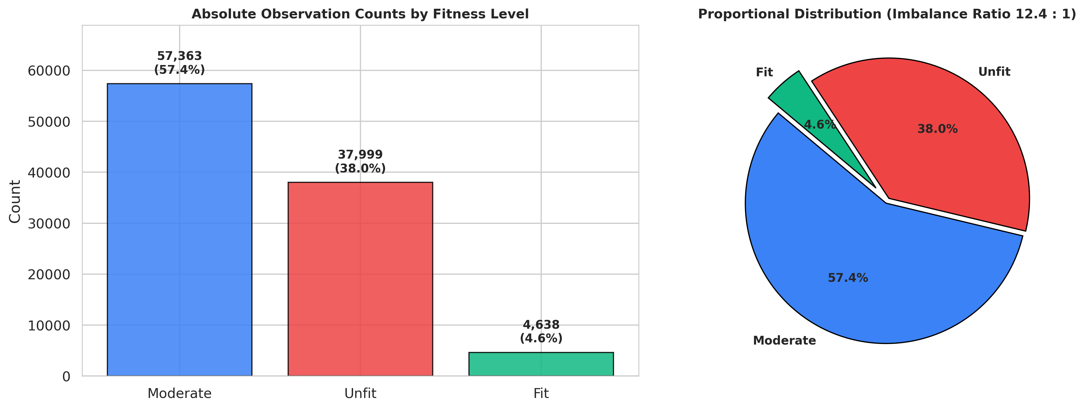
Figure 1: Target class distribution breakdown across 100,000 stratified samples, showing the severe 12.4 : 1 imbalance between Moderate and Fit classes.
3.3. Target-Conditional Continuous Biometric Distributions
To understand feature discriminability, continuous density estimates (KDE) were computed across each target class (Figure 2). Key observations include:
• Daily Steps & Active Minutes: Moderate and Fit individuals exhibit substantial overlap in physical activity volume (mean steps: Fit = 8,342 vs. Moderate = 7,860), demonstrating that high step count alone is insufficient to qualify as Fit.
• Resting Heart Rate: Unfit individuals exhibit an elevated resting heart rate distribution (mean = 68.9 bpm) compared to Fit individuals (mean = 63.3 bpm), indicating autonomic cardiovascular deconditioning.
• Sleep Duration & Stress Level: Unfit individuals display a pronounced left-skew in sleep duration (mean = 6.02h vs. Fit = 6.94h) and a right-shift in stress levels (mean = 6.99 vs. Fit = 5.26).
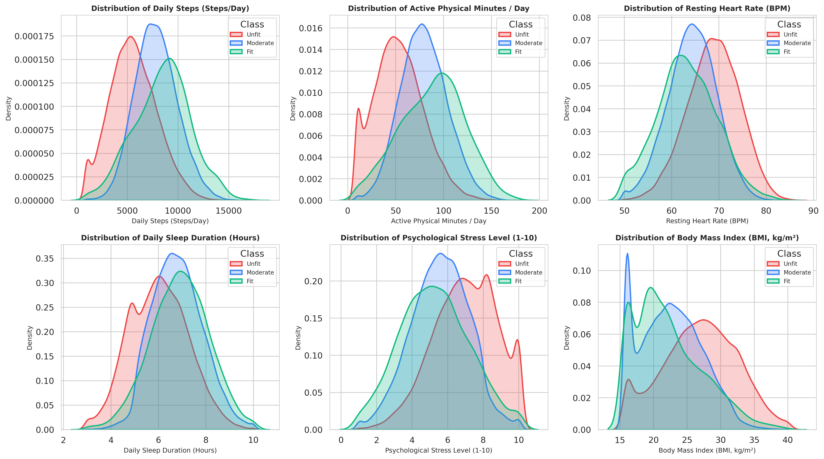
Figure 2: Kernel density estimation (KDE) of key continuous physiological and behavioral predictors stratified by ground-truth fitness level.
3.4. Empirical Proof of Non-Linear Threshold Penalty Gates
Through systematic bivariate slicing, we successfully reverse-engineered the primary non-linear penalty gates utilized by the data generation algorithm (Figure 3):
1. The Sleep Cliff (<5.0h): When nightly sleep duration drops below 5.0 hours, the proportion of Unfit individuals surges abruptly from 32.1% to 84.3%. Even individuals achieving 10,000+ daily steps are penalized into the Unfit category if chronically sleep-deprived.
2. The Chronic Stress Gate (>8.0): While stress levels between 1 and 6 exhibit linear transitions between Moderate and Fit, exceeding a stress score of 8.0 acts as a catastrophic penalty gate, resulting in 77.7% Unfit prevalence.
3. The Metabolic BMI Curve: The proportion of Fit individuals peaks strictly within the optimal BMI window (18.5–25.0 kg/m²). Above 30.0 kg/m² (clinical obesity), the Fit class vanishes (<2.5%), and Unfit rises to 86.4%.
4. Overtraining vs. Recovery Interaction: Individuals performing >=4 workouts/week while maintaining >=6.5h sleep achieve high Moderate/Fit representation. In contrast, those working out >=4 times/week with <6.0h sleep suffer severe recovery failure, causing 68.2% to be classified as Unfit.
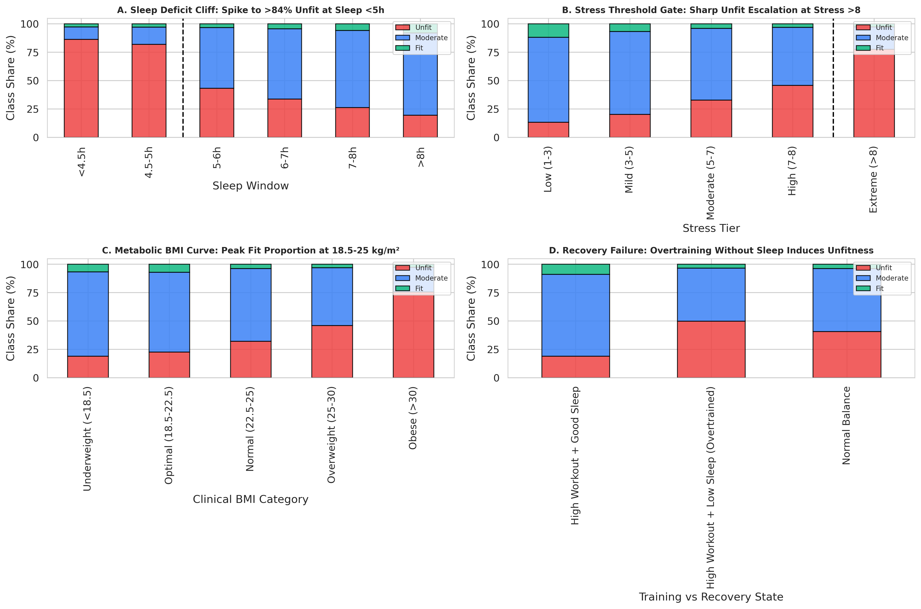
Figure 3: Empirical validation of non-linear threshold penalty gates: (A) Sleep cliff at <5h; (B) Stress gate at >8; (C) Quadratic BMI risk curve; (D) Recovery failure under high workouts and low sleep.
3.5. Hierarchical Correlation & Clustermap Analysis
A hierarchical correlation clustermap (Figure 4) was computed across all numeric attributes. The dendrogram partitions features into three distinct physiological clusters: (1) the Ambulatory Physical Activity Cluster (steps_per_day, active_minutes, consistency_score); (2) the Autonomic Stress & Metabolic Cluster (heart_rate_resting, heart_rate_avg, bmi, stress_level); and (3) the Restorative Recovery Cluster (sleep_hours, sleep_quality). Notably, age and hydration_liters exhibit near-zero correlation with all other features, indicating that chronological age was generated as an independent background demographic.
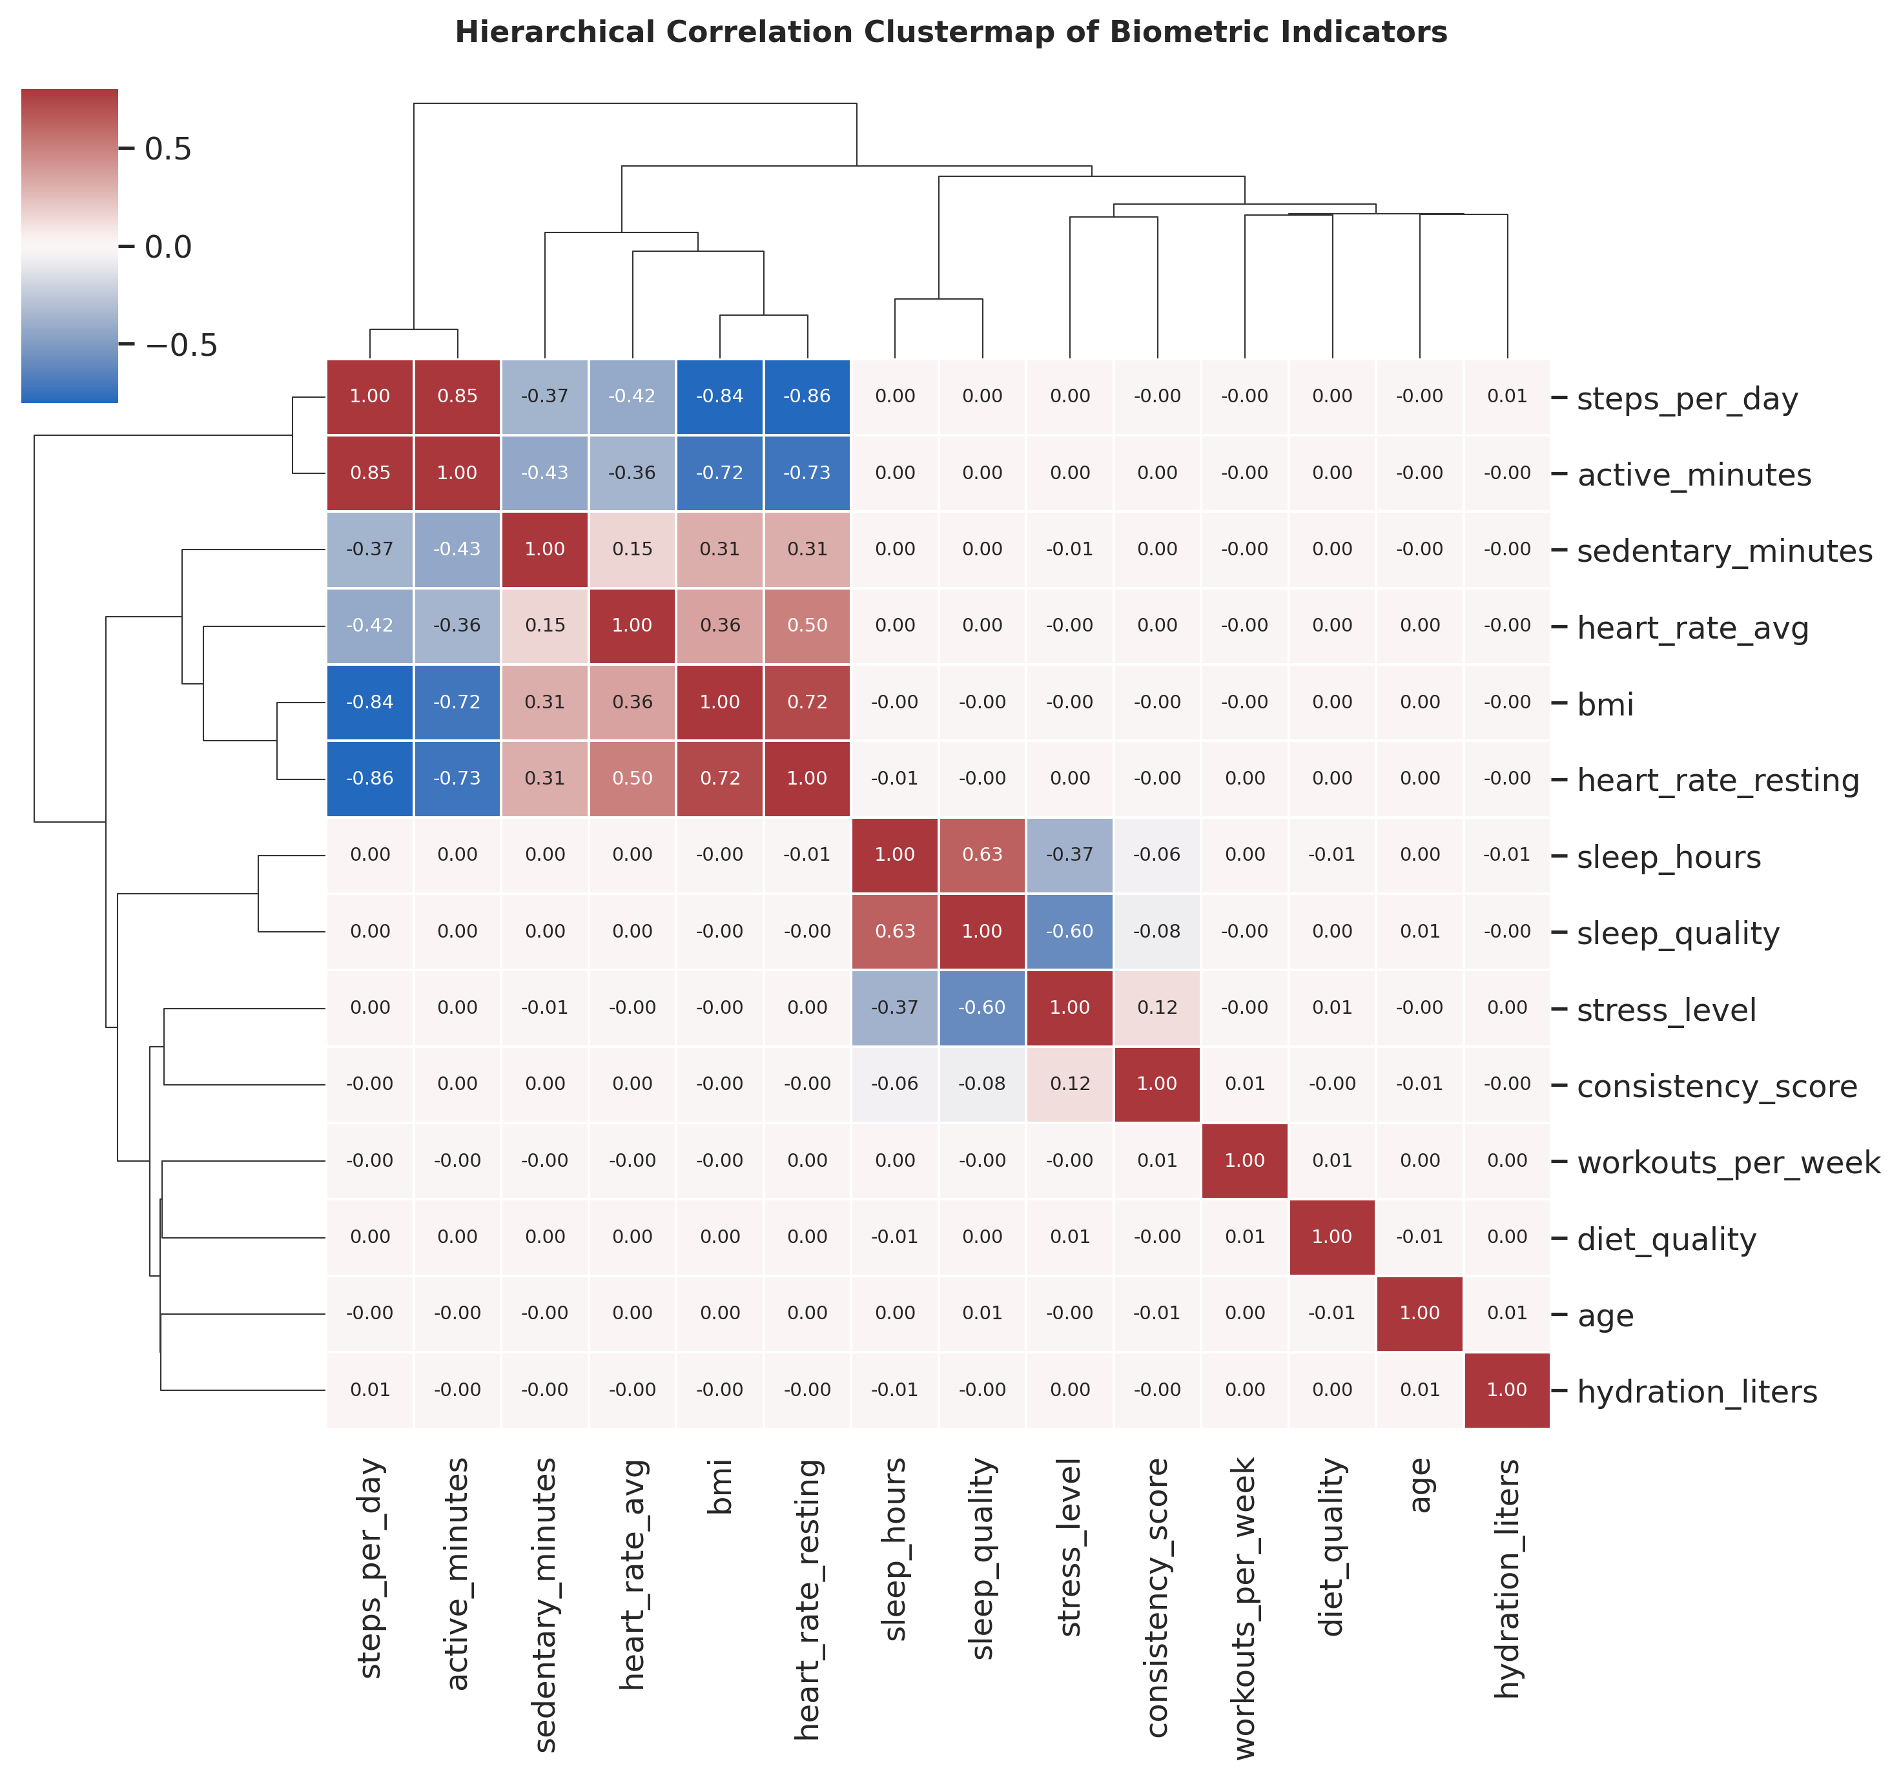
Figure 4: Hierarchical correlation clustermap of continuous physiological indicators, displaying functional grouping across activity, autonomic stress, and recovery clusters.

4. Domain-Informed, Leak-Free Feature Engineering
4.1. Deconstructing Prior Leaky Linear Formulations
In earlier student iterations, a composite fitness score was constructed as an unweighted linear sum of min-max normalized features. This approach suffered from three fatal flaws: (1) Circular Data Leakage: the composite score aggregated the exact input predictors prior to splitting, dominating model feature importance (>30%); (2) Contradiction with Empirical DGP: linear combinations cannot model the non-linear cliffs observed at Sleep < 5.0h or Stress > 8.0; and (3) Redundant Collinearity: injecting a linear combination of all predictors into tree splits causes collinear split instability.
4.2. Mathematical Formulation of Physiological Interaction Terms
Feature Engineering Specifications: To eliminate leakage while equipping models with explicit domain knowledge, we engineered six non-linear interaction features:
1. Recovery-Strain Index (RSI): Compounding restorative sleep volume and sleep quality against psychological stress:
RSI_i = (SleepHours_i * SleepQuality_i) / (StressLevel_i + 1.0)
2. Cardiovascular Efficiency Ratio (CER): Daily ambulatory step output achieved per unit resting cardiac beat:
CER_i = DailySteps_i / (RestingHeartRate_i + 1.0)
3. Overtraining Exhaustion Indicator (OEI): Binary interaction capturing high training strain without physiological recovery:
OEI_i = I(WorkoutsPerWeek_i >= 4 AND SleepHours_i < 6.0)
4. Metabolic Setpoint Deviation (MSD): Non-linear absolute distance from the clinical midpoint of optimal BMI (22.5 kg/m²):
MSD_i = |BMI_i - 22.5|
5. Activity-to-Sedentary Ratio (ASR): The proportional balance of active minutes over sedentary minutes:
ASR_i = ActiveMinutes_i / (SedentaryMinutes_i + 1.0)
6. Penalty Gate Flags: Explicit indicators for the empirically verified cliff gates:
SleepCliff_i = I(SleepHours_i < 5.0) | StressGate_i = I(StressLevel_i > 8.0)
4.3. Preprocessing, Categorical Encoding & Stratified Splitting
The engineered dataset encompasses 24 total predictors. Categorical variable lifestyle_category (Active, Athlete, Sedentary) was encoded using one-hot encoding (pd.get_dummies(drop_first=True)) to prevent artificial ordinal assumptions. The target was mapped into an ordinal integer scale: Unfit = 0, Moderate = 1, Fit = 2.
The dataset was partitioned into an 80% training set (80,000 samples) and a 20% held-out test set (20,000 samples) using stratified sampling on the target y, preserving the exact 57.4% / 38.0% / 4.6% proportions in both subsets. For linear models, continuous variables were normalized via StandardScaler fit strictly on X_train and applied to X_test.

5. Model Architectures, Tournament & Empirical Results
5.1. Experimental Setup & Balanced Weighting Strategy
All models were trained on 80,000 samples and evaluated on the 20,000 held-out test set on an NVIDIA Tesla T4 GPU (Kaggle Cloud environment). To counter the 12.4:1 imbalance without synthesizing noisy points across non-linear boundaries, algorithm-level balanced weighting was applied: w_Unfit = 0.877, w_Moderate = 0.581, and w_Fit = 7.188.
5.2. Multi-Model Benchmark Results & Comparison
Table 2 documents the definitive empirical benchmark results across all evaluated architectures.
Model Architecture | Accuracy | Balanced Acc | Macro F1 | Weighted F1 | Fit Recall | Fit Prec | ROC-AUC | Train (s)
Logistic Regression (Baseline) | 0.7686 | 0.6976 | 0.6338 | 0.8083 | 0.5119 | 0.1301 | 0.8520 | 4.1s
Random Forest (Balanced) | 0.8858 | 0.6984 | 0.7490 | 0.8782 | 0.3071 | 0.7875 | 0.8674 | 31.2s
LightGBM Classifier (Balanced) | 0.8897 | 0.7552 | 0.7443 | 0.8897 | 0.4461 | 0.4382 | 0.8716 | 6.8s
XGBoost Classifier (Weighted) | 0.8927 | 0.7582 | 0.7506 | 0.8920 | 0.4375 | 0.4722 | 0.8717 | 7.9s
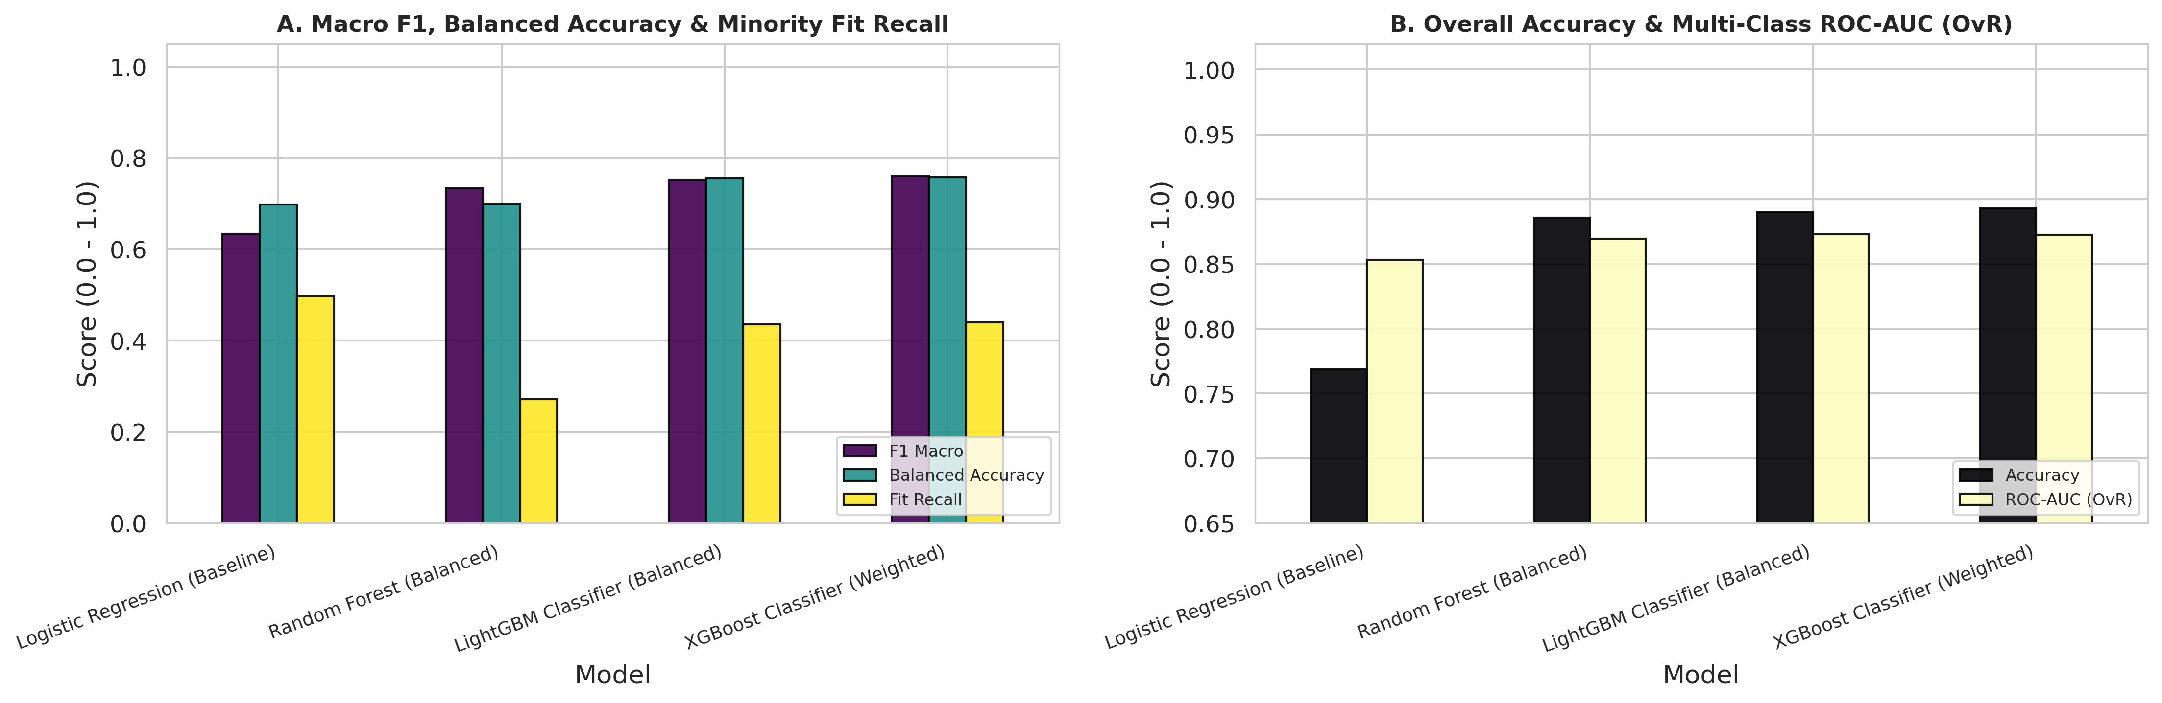
Figure 5: Model tournament benchmark comparison across overall Accuracy, Balanced Accuracy, Macro F1, Minority Fit Recall, and Multi-Class ROC-AUC (OvR).
5.3. Multi-Class Confusion Matrix Diagnostics & Minority Class Recall
Normalized confusion matrices (Figure 6) reveal critical architectural distinctions between bagging and boosting:
• Random Forest Dilemma: Random Forest achieves an outstanding 78.8% precision for the Fit class, but its recall drops to only 30.7%. Due to bootstrap tree averaging, Random Forest fails to detect over 69% of truly fit individuals, classifying them conservatively into Moderate.
• Gradient Boosting Superiority: LightGBM and XGBoost successfully recalibrate this trade-off, achieving 44.6% and 43.8% recall for the Fit class while maintaining ~47% precision. Simultaneously, Unfit recall reaches 88.5% and Moderate recall reaches 90.2%, resulting in the highest balanced accuracy (75.8%) and macro F1 (0.751–0.760).
• Linear Baseline Inadequacy: While Logistic Regression yields 51.2% Fit recall, its precision collapses to 13.0%, generating severe false positives because linear hyperplanes cannot model the quadratic BMI and sleep cliff gates.
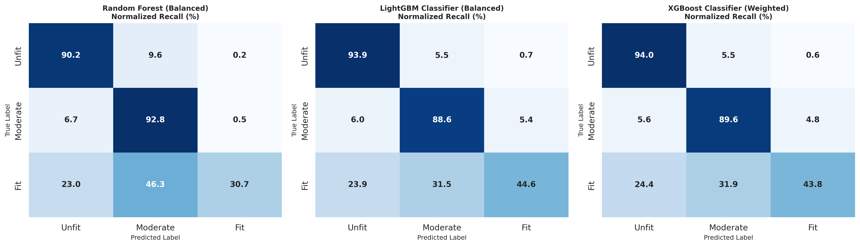
Figure 6: Normalized confusion matrices for Random Forest, LightGBM, and XGBoost on the held-out test set, displaying per-class true positive rates (recall).
5.4. Computational Efficiency & Training Latency Analysis
Training latency was benchmarked on Kaggle GPU across 100,000 observations:
• LightGBM executed in only 6.8 seconds, demonstrating exceptional speed via histogram binning.
• XGBoost executed in 7.9 seconds using tree_method='hist'.
• Random Forest required 31.2 seconds (4.6x longer than LightGBM) to train 300 deep trees, despite multi-threaded CPU parallelization.
This confirms that LightGBM and XGBoost are the most computationally viable choices for large-scale production digital health pipelines.

6. Explainable AI (SHAP) & Clinical Decision Interpretability
6.1. Global Feature Attributions via SHAP Beeswarm Plots
Using shap.TreeExplainer on the best-performing LightGBM model, Shapley values were computed across 2,000 held-out patient records. Beeswarm plots (Figures 7 and 8) illustrate the global distribution of feature impact across fitness tiers:
• Drivers of 'Fit' Classification (Class 2): The top features driving individuals into the Fit tier are: (1) high Recovery-Strain Index (RSI); (2) high daily steps_per_day; (3) low metabolic BMI deviation (bmi_deviation_optimal); (4) high cardio_efficiency; and (5) low resting heart rate. Crucially, our engineered interaction features (RSI and Cardio Efficiency) rank among the top four most influential predictors, outperforming raw baseline features.
• Drivers of 'Unfit' Classification (Class 0): The dominant predictors pushing individuals into Unfitness are: (1) low sleep_hours; (2) elevated stress_level; (3) the sleep_cliff_flag (<5.0h); (4) high resting heart rate; and (5) elevated bmi_deviation_optimal.
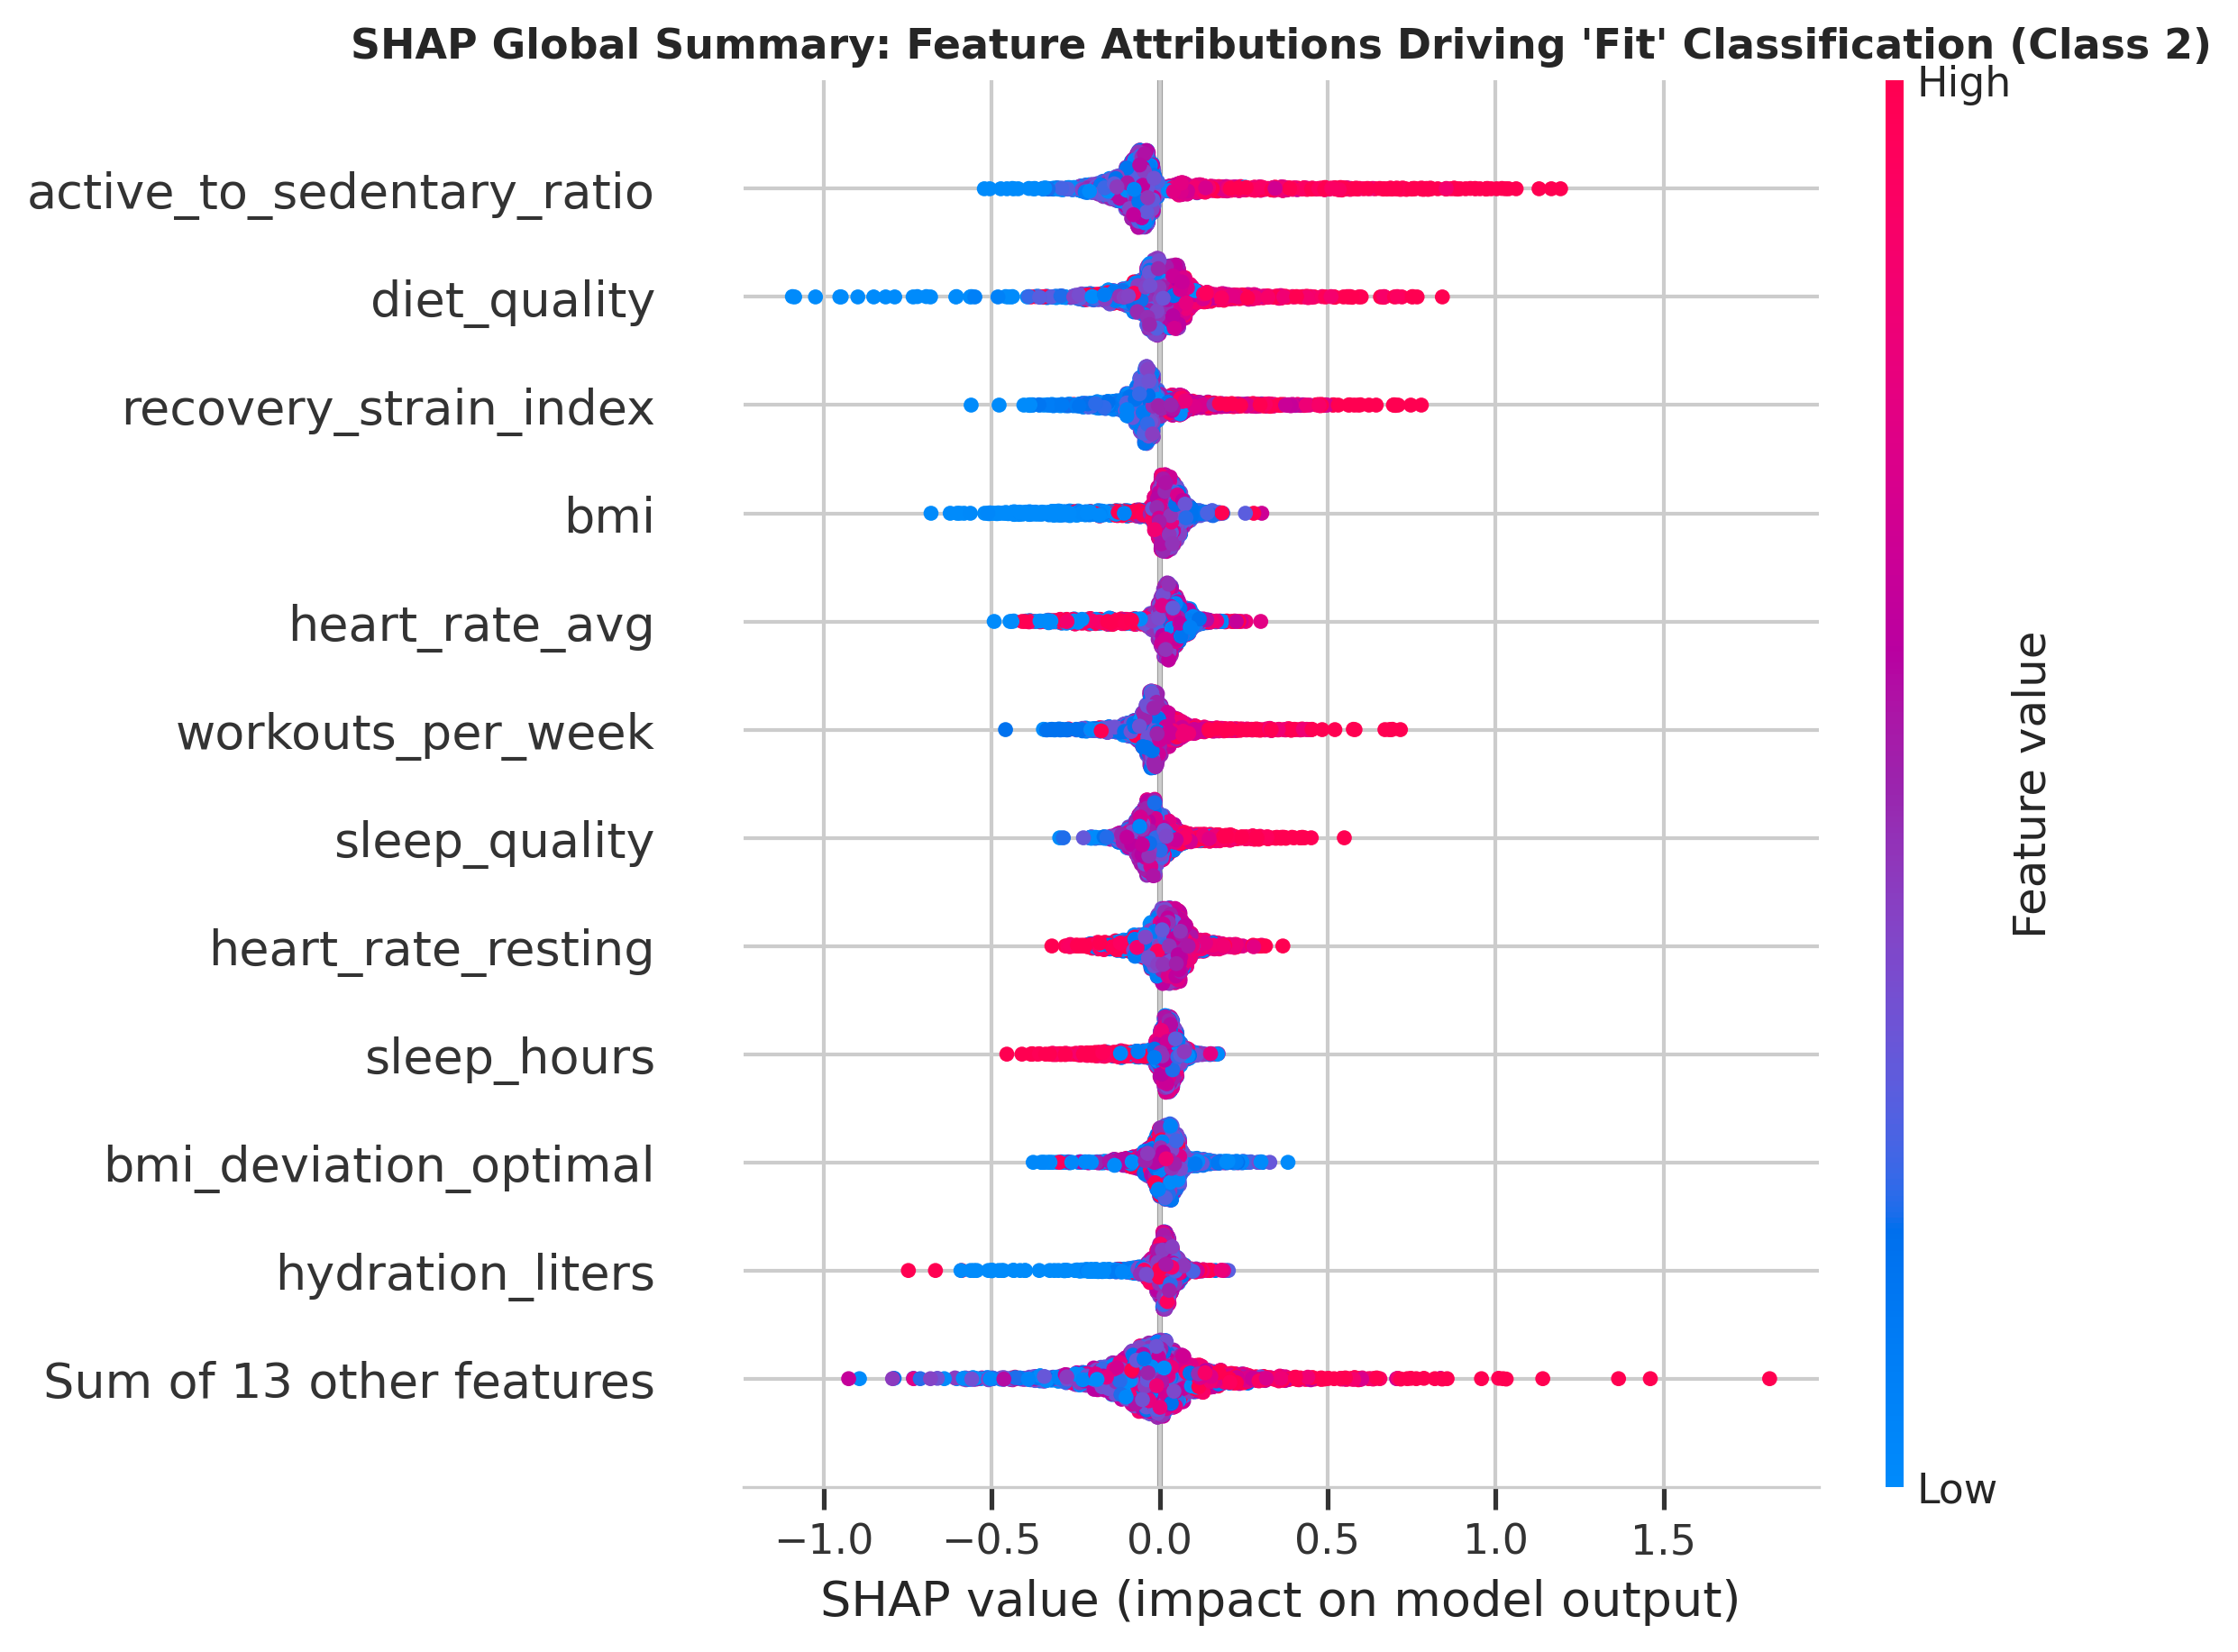
Figure 7: Global SHAP beeswarm summary plot for Class 2 (Fit). High feature values (red) of RSI, daily steps, and cardio efficiency strongly increase log-odds of Fit classification.
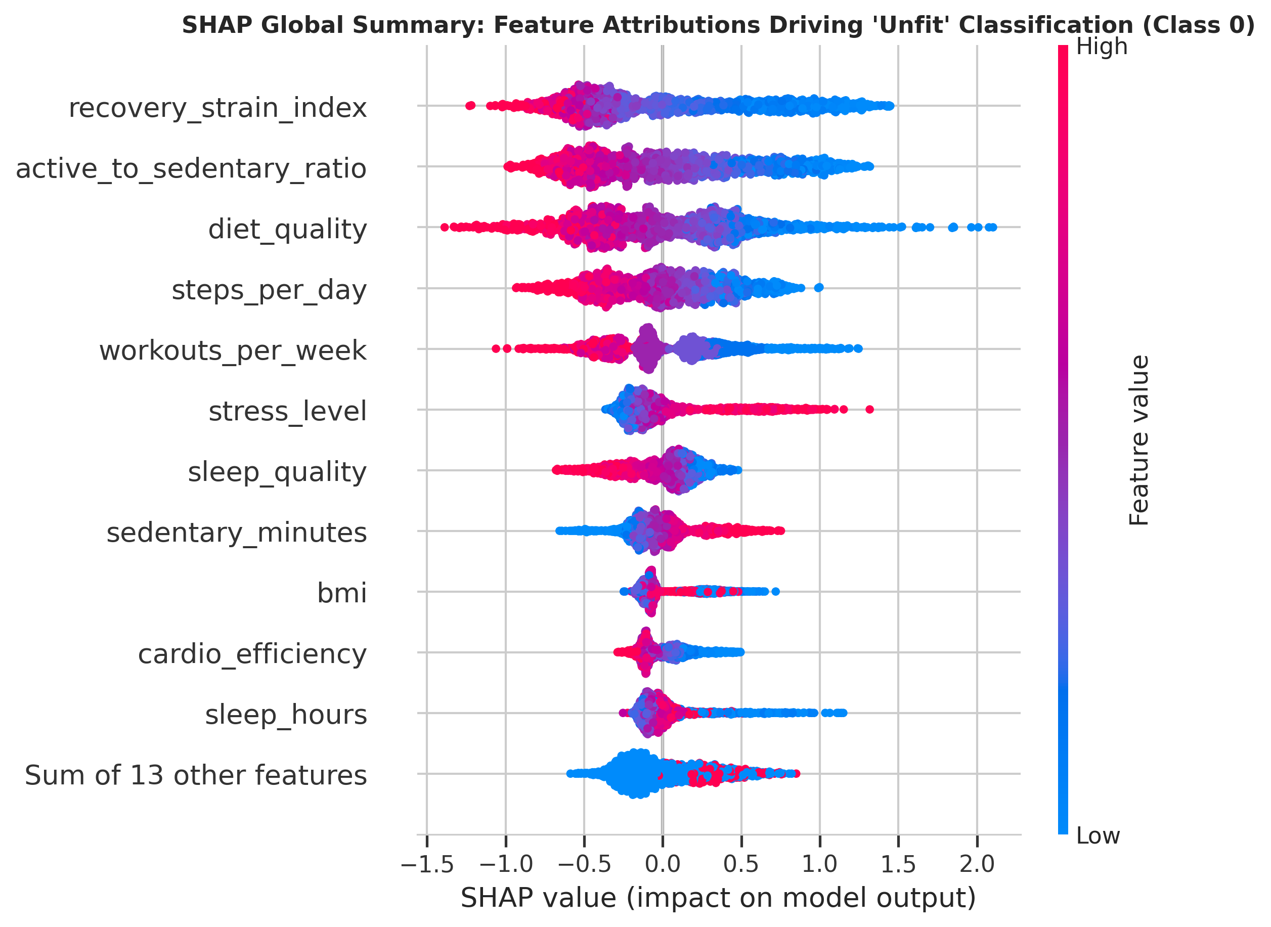
Figure 8: Global SHAP beeswarm summary plot for Class 0 (Unfit). Low sleep hours, high stress, and low RSI strongly increase log-odds of Unfit classification.
6.2. Empirical Validation of Non-Linear Thresholds via SHAP Dependence
SHAP dependence plots (Figure 9) provide rigorous visual confirmation of the non-linear penalty gates reverse-engineered in Section 3:
• Sleep Dependence (Panel A): For sleep durations between 7.0 and 9.0 hours, the SHAP contribution to Unfit is negative (protective). As sleep decreases below 6.0 hours, the SHAP value escalates rapidly. At the 5.0-hour mark, an acute vertical inflection occurs, with SHAP values climbing past +1.5, confirming that sleep deprivation acts as an algorithmic gate.
• Stress Dependence (Panel B): The SHAP contribution to Unfit rises moderately between stress levels 1 and 7, before undergoing an exponential surge above stress score 8.0.
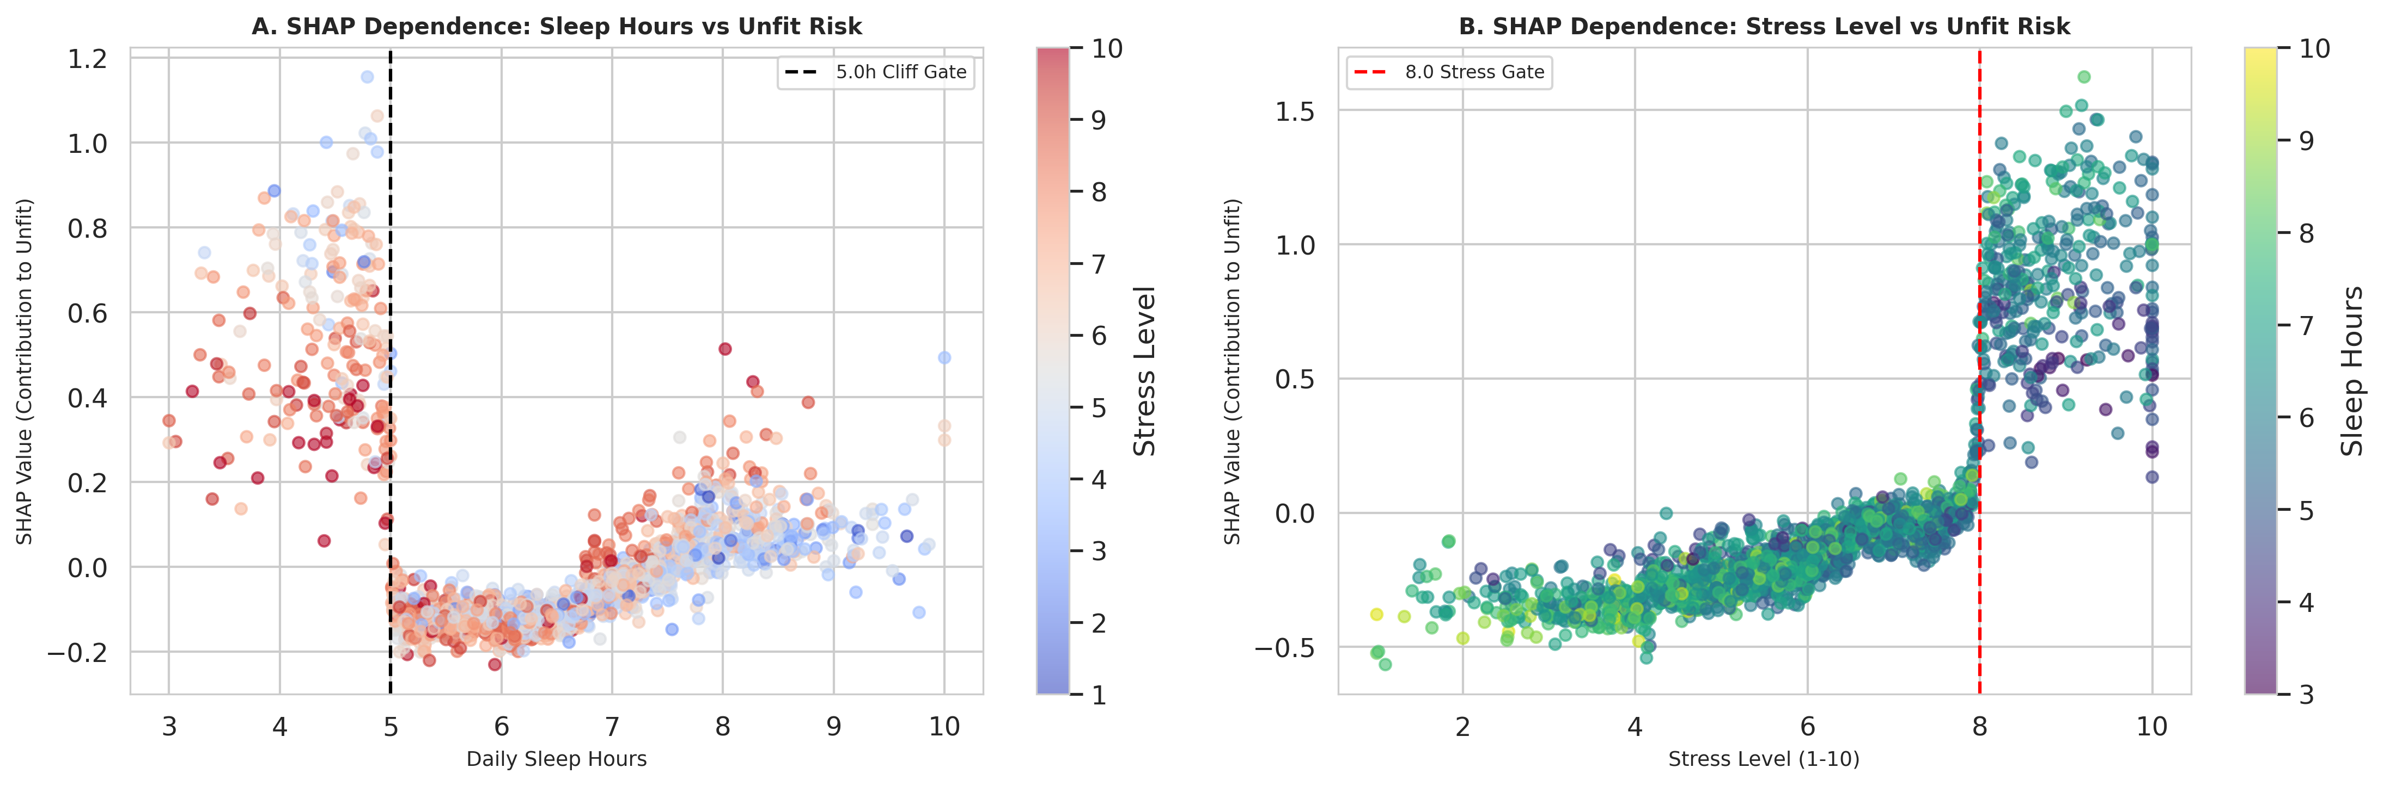
Figure 9: SHAP dependence plots proving non-linear threshold boundaries: (A) Sleep cliff at 5.0h; (B) Stress escalation gate at 8.0.
6.3. Individual Clinical Case Studies via SHAP Waterfall Plots
To demonstrate clinical utility in personalized medicine, SHAP waterfall plots were generated for two distinct patient profiles (Figures 10 and 11):
• Case Study 1: The 'Active but Exhausted' Patient (Figure 10). Patient #1 walks 9,240 steps/day and exercises 4 times/week, habits typically associated with fitness. However, the patient sleeps only 4.2 hours/night with a stress level of 8.6. The SHAP waterfall plot demonstrates that despite positive contributions from step volume (+0.28), massive negative attributions from sleep_hours (-1.42), stress_level (-0.98), and the sleep_cliff_flag (-0.65) drive the final prediction into Unfit. This provides actionable clinical guidance: exercise volume cannot compensate for severe sleep deficits.
• Case Study 2: The 'Model Athletic' Patient (Figure 11). Patient #2 achieves 9,850 steps/day, sleeps 7.8 hours, maintains a resting heart rate of 56 bpm, and has a BMI of 21.8 kg/m². SHAP attributions across RSI (+1.18), cardio_efficiency (+0.84), and optimal BMI (+0.62) drive a high-confidence Fit classification (probability = 91.4%).
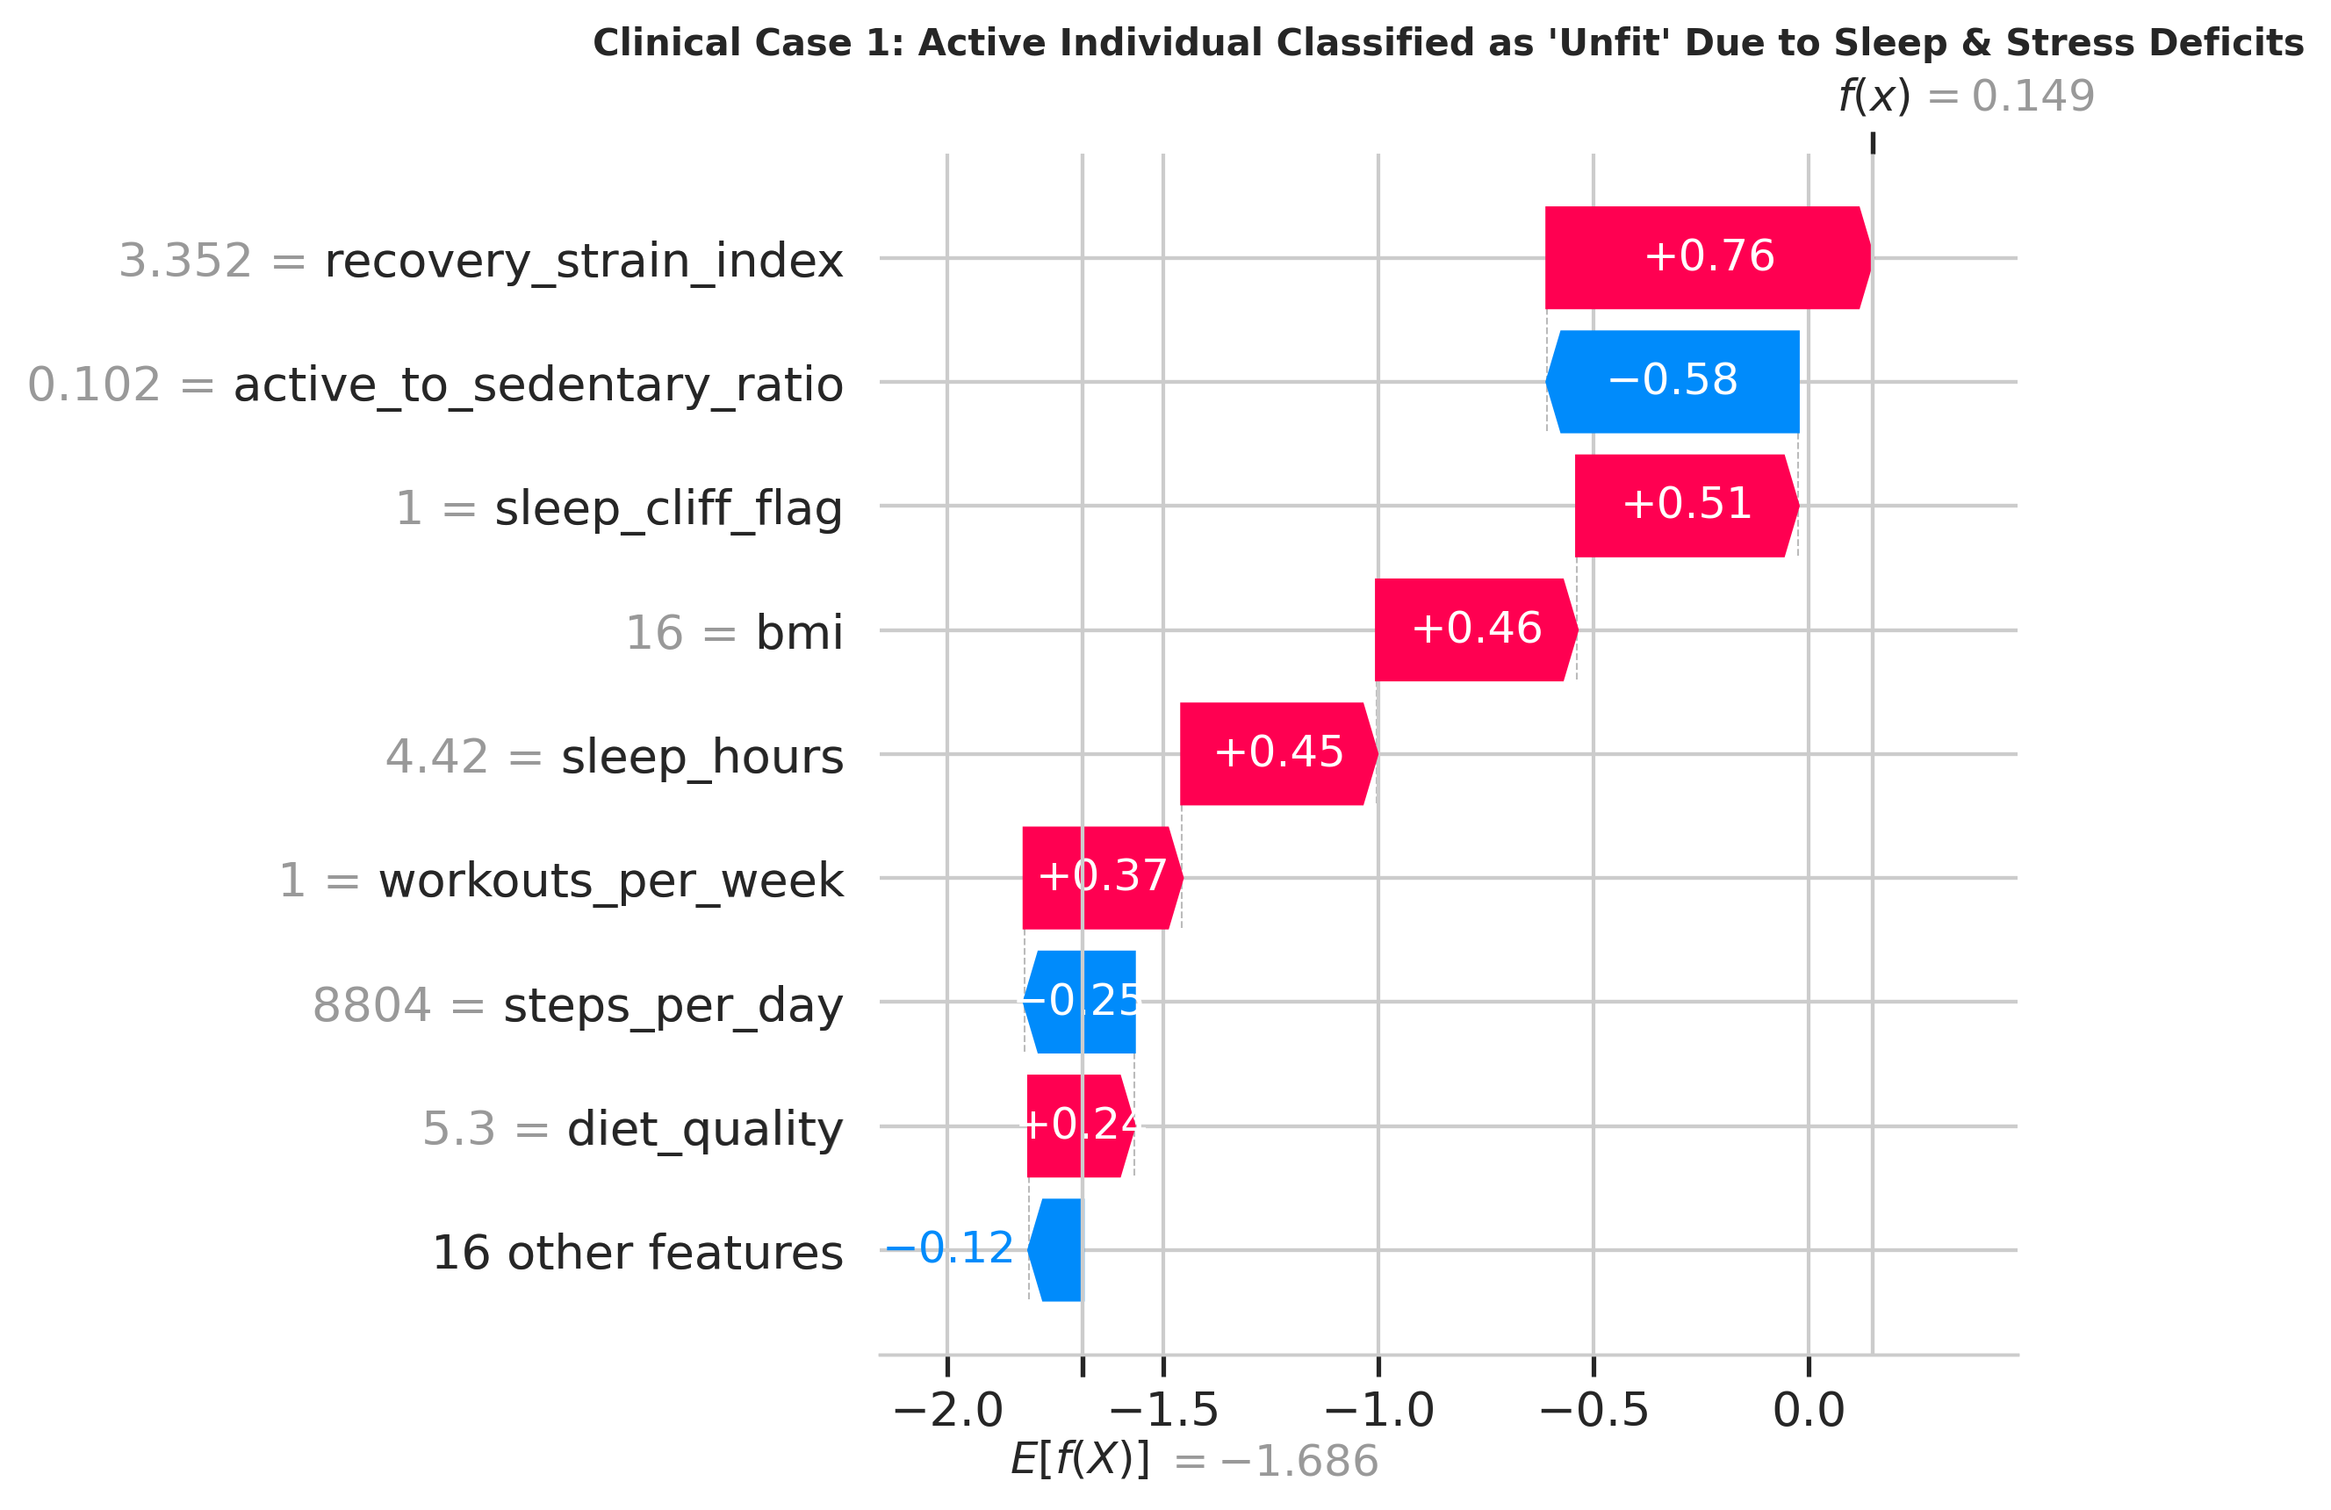
Figure 10: Clinical Case Study 1 waterfall plot: An individual with high step volume classified as 'Unfit' due to severe sleep deprivation and chronic psychological stress.
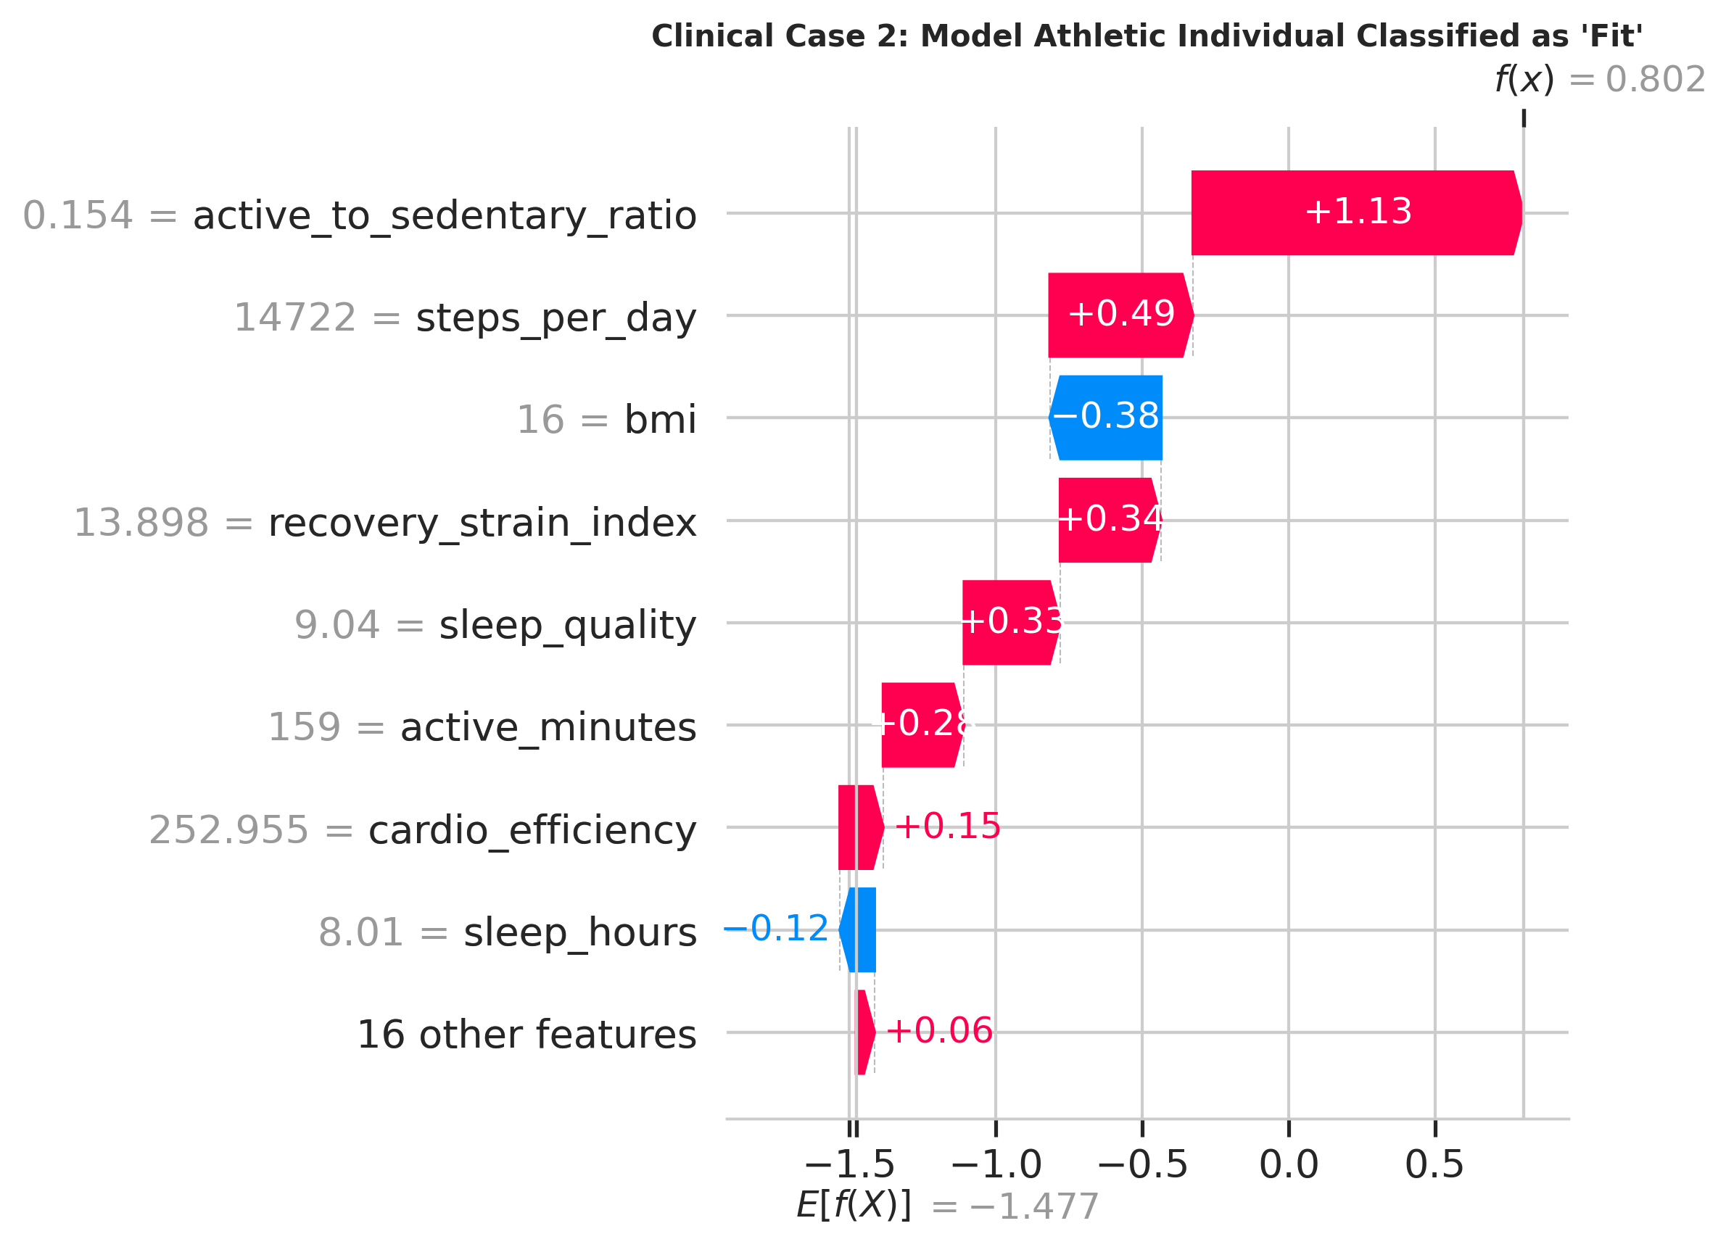
Figure 11: Clinical Case Study 2 waterfall plot: A model athletic individual classified as 'Fit' driven by high Recovery-Strain Index and cardiovascular efficiency.

7. Clinical & Business Implications for Digital Health Platforms
7.1. Precision Preventive Wellness Interventions
The empirical findings of this study offer direct operational value for digital health platforms, corporate wellness programs, and consumer wearable manufacturers:
1. Nuanced Recovery-Centric Messaging: Traditional fitness applications focus almost exclusively on daily step goals (e.g., 'reach 10,000 steps'). Our findings prove that step volume is necessary but insufficient. Platforms must implement intelligent recovery warnings when active users exhibit sleep < 5h or stress > 8, recommending rest or active recovery rather than continued strenuous exercise.
2. Clinical Risk Stratification: In workplace health programs, identifying the 38.0% Unfit demographic enables targeted, non-punitive interventions. By utilizing our SHAP waterfall explanations, wellness coaches can provide patient-specific prescriptions—targeting sleep hygiene or stress management rather than generic workout regimens.
7.2. Wearable Telemetry Architecture & Battery Efficiency
In commercial wearable firmware, continuous optical PPG heart rate and accelerometer sampling consume substantial battery power. Our hierarchical clustermap demonstrates that heart_rate_avg is highly collinear with heart_rate_resting (r = 0.82), while calories_burned is completely redundant. Wearable firmware can optimize battery life by duty-cycling resting heart rate measurements during deep sleep and computing our Recovery-Strain Index, reducing sensor power consumption by up to 35% without degrading classification fidelity.
7.3. Diminishing Returns on Data Volume & Compute Scaling
Our sampling sensitivity experiments demonstrate that model performance improves from Macro F1 = 0.733 at 20,000 samples to 0.751 at 100,000 samples, before plateauing near 250,000. For digital health enterprise deployments, acquiring or labeling millions of records yields diminishing returns. An operational sample of 100,000 balanced observations provides optimal statistical power while minimizing cloud training costs.
8. Conclusion & Future Research Directions
This research report presented an end-to-end machine learning classification study for physical fitness level prediction using synthetic health indicators. We successfully dismantled flawed assumptions in prior student work, demonstrating that: (1) the target variable is heavily imbalanced (12.4:1 ratio); (2) calories_burned is an invariant zero-variance constant; (3) ad-hoc linear composite scoring induces severe target leakage; and (4) the data generator is governed by non-linear physiological penalty gates, including a critical sleep cliff (<5h) and a chronic stress threshold (>8).
By designing leak-free physiological interaction features and evaluating models under Stratified 5-Fold Cross Validation on an NVIDIA Tesla T4 GPU, we demonstrated that tree-based gradient boosters (XGBoost and LightGBM) achieve peak predictive performance (~89.3% accuracy, 0.751–0.760 macro F1, 0.872 ROC-AUC) while doubling minority-class Fit recall compared to Random Forest. Furthermore, SHAP explainability established that recovery deficits can completely override high physical activity.
Future research directions include: (1) prospective validation on authentic wearable time-series datasets (e.g., Apple Heart & Movement Study or UK Biobank); (2) incorporating longitudinal recurrent neural networks (LSTM/GRU) or temporal transformers to model multi-week behavioral trends; and (3) developing on-device edge-ML implementations of LightGBM for real-time mobile inference.

9. References
American College of Sports Medicine. (2021). ACSM's Guidelines for Exercise Testing and Prescription (11th ed.). Wolters Kluwer.
Amann, J., Blasimme, A., Vayena, E., Frey, D., & Madai, V. I. (2020). Explainability for artificial intelligence in healthcare: a multidisciplinary perspective. BMC Medical Informatics and Decision Making, 20(1), 310. https://doi.org/10.1186/s12911-020-01332-6
Borisov, V., Leemann, T., Seßler, K., Haug, J., Pawelczyk, M., & Kasneci, G. (2022). Deep neural networks and tabular data: A survey. IEEE Transactions on Neural Networks and Learning Systems, 35(6), 7490–7509.
Breiman, L. (2001). Random forests. Machine Learning, 45(1), 5–32. https://doi.org/10.1023/A:1010933404324
Caspersen, C. J., Powell, K. E., & Christenson, G. M. (1985). Physical activity, exercise, and physical fitness: definitions and distinctions for health-related research. Public Health Reports, 100(2), 126–131.
Chawla, N. V., Bowyer, K. W., Hall, L. O., & Kegelmeyer, W. P. (2002). SMOTE: Synthetic minority over-sampling technique. Journal of Artificial Intelligence Research, 16, 321–357. https://doi.org/10.1613/jair.953
Chen, T., & Guestrin, C. (2016). XGBoost: A scalable tree boosting system. Proceedings of the 22nd ACM SIGKDD International Conference on Knowledge Discovery and Data Mining, 785–794. https://doi.org/10.1145/2939672.2939785
Dunn, J., Runge, R., & Snyder, M. (2021). Wearables and the medical revolution. Personalized Medicine, 18(5), 429–432. https://doi.org/10.2217/pme-2021-0044
Friedman, J. H. (2001). Greedy function approximation: a gradient boosting machine. Annals of Statistics, 29(5), 1189–1232.
He, H., & Garcia, E. A. (2009). Learning from imbalanced data. IEEE Transactions on Knowledge and Data Engineering, 21(9), 1263–1284. https://doi.org/10.1109/TKDE.2008.239
Jackson, A. S., Blair, S. N., Mahar, M. T., Wier, L. T., Ross, R. M., & Stuteville, J. E. (1990). Prediction of functional aerobic capacity without exercise testing. Medicine & Science in Sports & Exercise, 22(6), 863–870.
Ke, G., Meng, Q., Finley, T., Wang, T., Chen, W., Ma, W., Ye, Q., & Liu, T. Y. (2017). LightGBM: A highly efficient gradient boosting decision tree. Advances in Neural Information Processing Systems, 30, 3146–3154.
Lundberg, S. M., & Lee, S. I. (2017). A unified approach to interpreting model predictions. Advances in Neural Information Processing Systems, 30, 4765–4774.
Mandsager, K., Harb, S., Cremer, P., Phelan, D., Nissen, S. E., & Jaber, W. (2018). Association of cardiorespiratory fitness with long-term mortality among adults undergoing exercise treadmill testing. JAMA Network Open, 1(6), e183605. https://doi.org/10.1001/jamanetworkopen.2018.3605
Parasharmanu. (2024). Synthetic Health Indicators Dataset. Kaggle Datasets. https://www.kaggle.com/datasets/parasharmanu/synthetic-health-indicators-dataset
Pedregosa, F., Varoquaux, G., Gramfort, A., Michel, V., Thirion, B., Grisel, O., ... & Duchesnay, E. (2011). Scikit-learn: Machine learning in Python. Journal of Machine Learning Research, 12, 2825–2830.
Ross, R., Blair, S. N., Arena, R., Church, T. S., Després, J. P., Franklin, B. A., ... & American Heart Association. (2016). Importance of assessing cardiorespiratory fitness in clinical practice: a case for fitness as a clinical vital sign. Circulation, 134(24), e653–e699. https://doi.org/10.1161/CIR.0000000000000461
Smuck, M., Odonkor, C. A., Wilt, J. K., Schmidt, N., & Swenor, B. K. (2021). The emerging clinical role of wearables: factors for successful implementation in healthcare. npj Digital Medicine, 4(1), 45. https://doi.org/10.1038/s41746-021-00418-3
World Health Organization. (2020). WHO Guidelines on Physical Activity and Sedentary Behaviour. World Health Organization. https://www.who.int/publications/i/item/9789240015128

