South Mediterranean University

Language and Cultural Institute

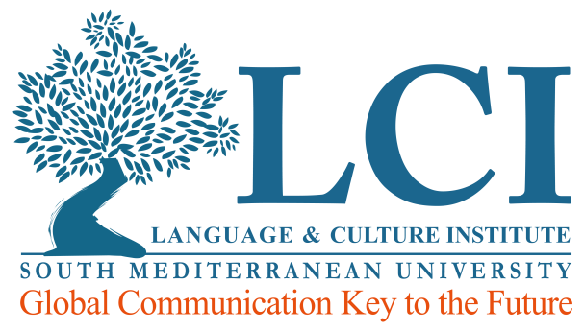

**Certificate of Achievement**

We hereby certify that

**Amel Khelif**

Has successfully completed the course

**Business English Business 1**

Date: From 22.10.2018 to 12.02.2019

Pattie ceresani

director

South Mediterranean University

Language and Cultural Institute



**Certificate of Participation**

We hereby certify that

**Mohamed Redissi**

Has participated in the course

**Business English Business 1**

Date: From 22.10.2018 to 12.02.2019

Pattie ceresani

director