How to adapt the code to the correct COM port:

1. On Windows, open the device manager
2. Locate the COM port of the Bluetooth dongle (example: COM12)

If it does not appear, start by pairing your computer with HC-05 mode (the password is 1234) in Windows 10 ‘Bluetooth and Other Settings’ page

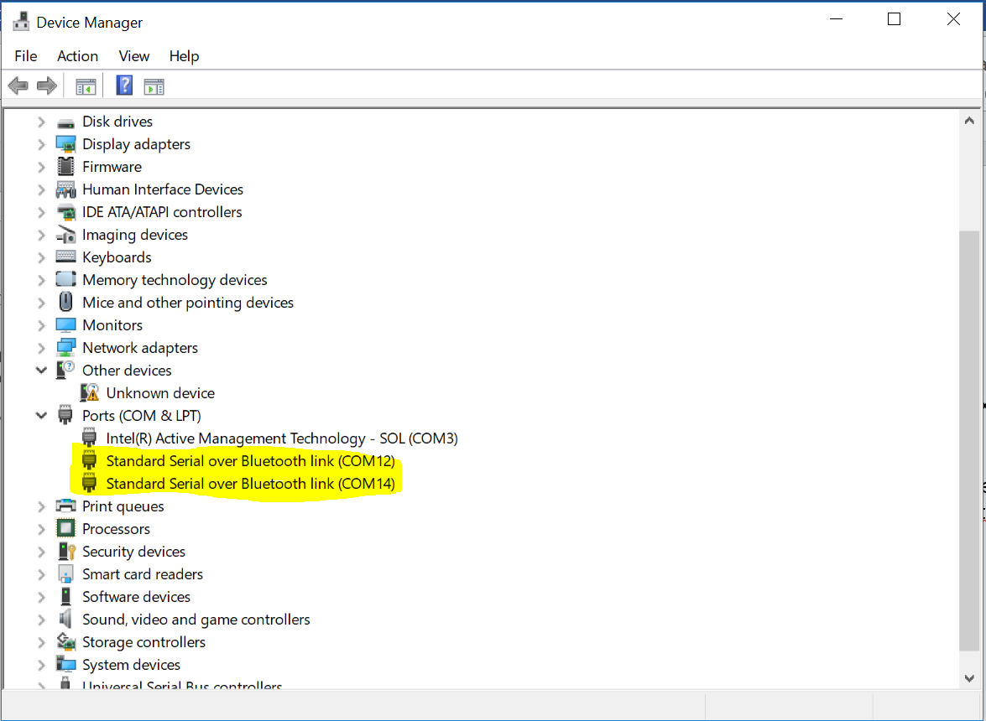

1. Change the script (line 49) change ser=serial.Serial(‘COMX’) into ser=serial.Serial(‘COM12’) (if the Bluetooth is on COM12)

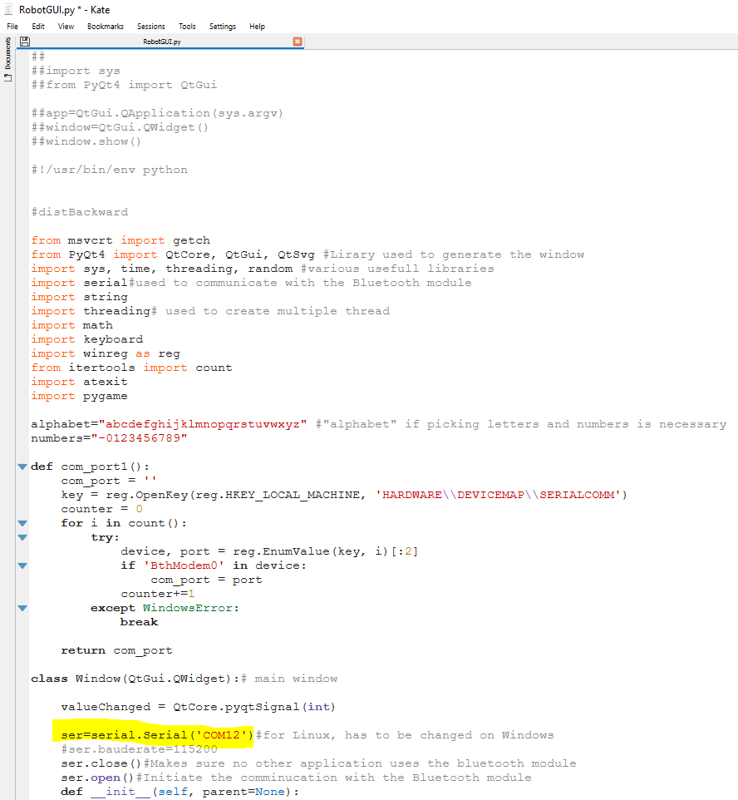

1. Open the command prompt and go to the folder containing the python script
2. Type “pyinstaller --onefile RobotGUI.py”, This command creates a few folder, the one containing the executable application is called “dist” (make sure you have installed all the libraries of the .py file)

Before generating a new executable file, don’t forget to delete the old one

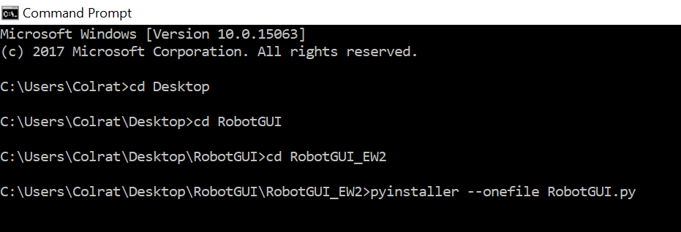

1. Move the picture “logo.png” in the “dist” folder

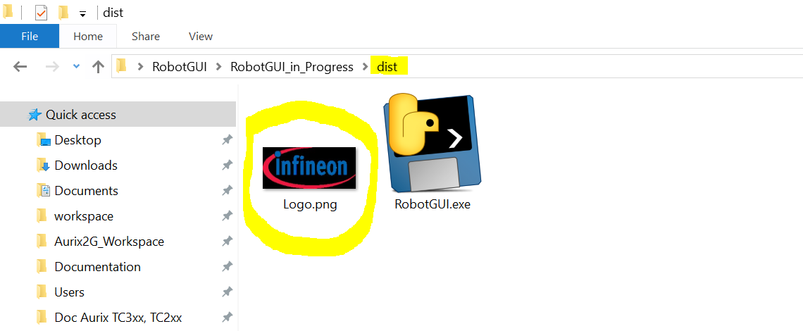

1. Launch the application by clicking on RobotGUI.exe ☺

