1.open new project and follow those steps

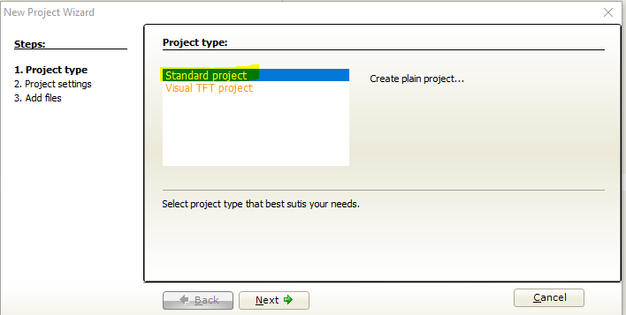

2. chose P16F877A

And change the frequency to 20MHZ

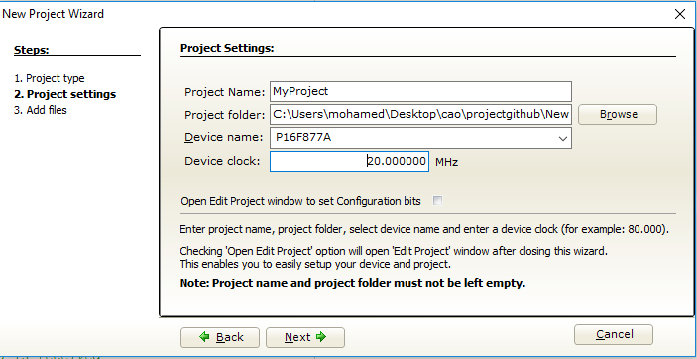

3. copy this code and you can find out of those folders “code”

char x;

TrisD=0;

PortD=0;

Lcd_Init();//Initialize LCD

Lcd_Cmd(_Lcd_CURSOR_OFF); //Cusrsor off

UART1_Init(9600);

Delay_ms(100);

Lcd_out(1,1,"Welcome in ^_^");

Lcd_out(2,1,"Explain UART");

Delay_ms(1000);

LCD_Cmd(_LCD_CLEAR);

while (1)

{

if (UART1_Data_Ready()) // if data is received

{

i = UART1_Read();

if(i=='1'){

// portd=0;

LCD_Cmd(_LCD_CLEAR);

Lcd_out(2,1,"pompe"); //write data to lcd

portd.f0=1; //Turn on pump and indicated by turning the first led

portd.f1=0; //Turn off Vanne and indicated by turning off the second led

}

else if(i=='2'){

//portd=0;

LCD_Cmd(_LCD_CLEAR);

Lcd_out(2,1,"vanne"); //write data to lcd

portd.f1=1;//the inverse of the first procedure

portd.f0=0;

}

else

{

portd=0x00;

if(i=='0'){

LCD_Cmd(_LCD_CLEAR);

Lcd_out(2,1,"pump and vanne off");//write data to lcd

portd.f1=0;// the two leds are off

portd.f0=0;

LCD_Cmd(_LCD_RETURN_HOME);

goto k;

}

LCD_Chr_Cp(i); //write data to lcd

k:

;

}

}

}

}

4. include the necessary libraries

If you didn’t know what to import check all the cases

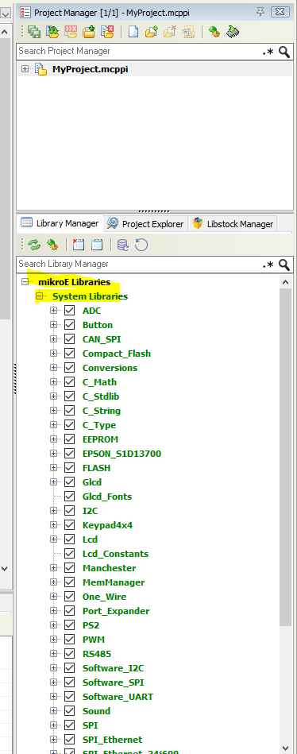

5. build the program

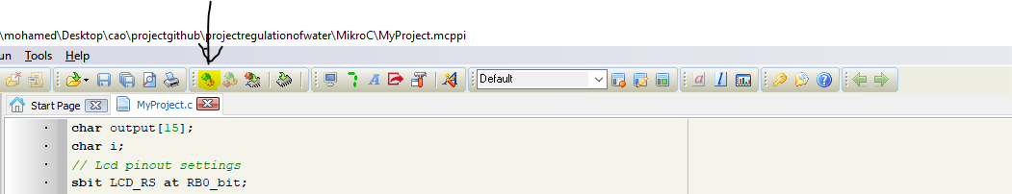

6.go to the path of this program and search for .hex file this is what we will need in the Labcenter electronics.