1.open the project named « prjcet »

2.double click in the PIC card

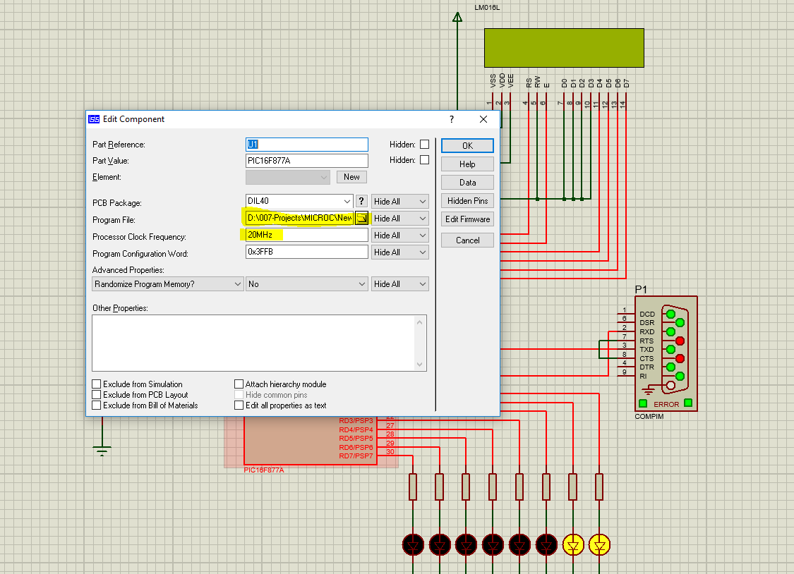

3.the card is already configured as 20 MHZ and you only need to browse for the .hex file in mikroc project. Upload it

4.open labview project the virtual serial port program:

Click to add pair in our case we work with COM1 and COM2

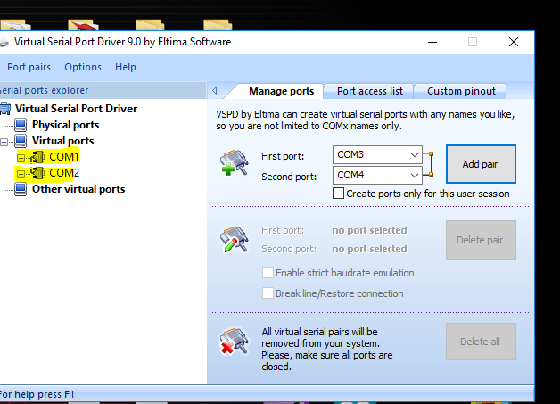

5. double click in COMPIM change the COM to COM2

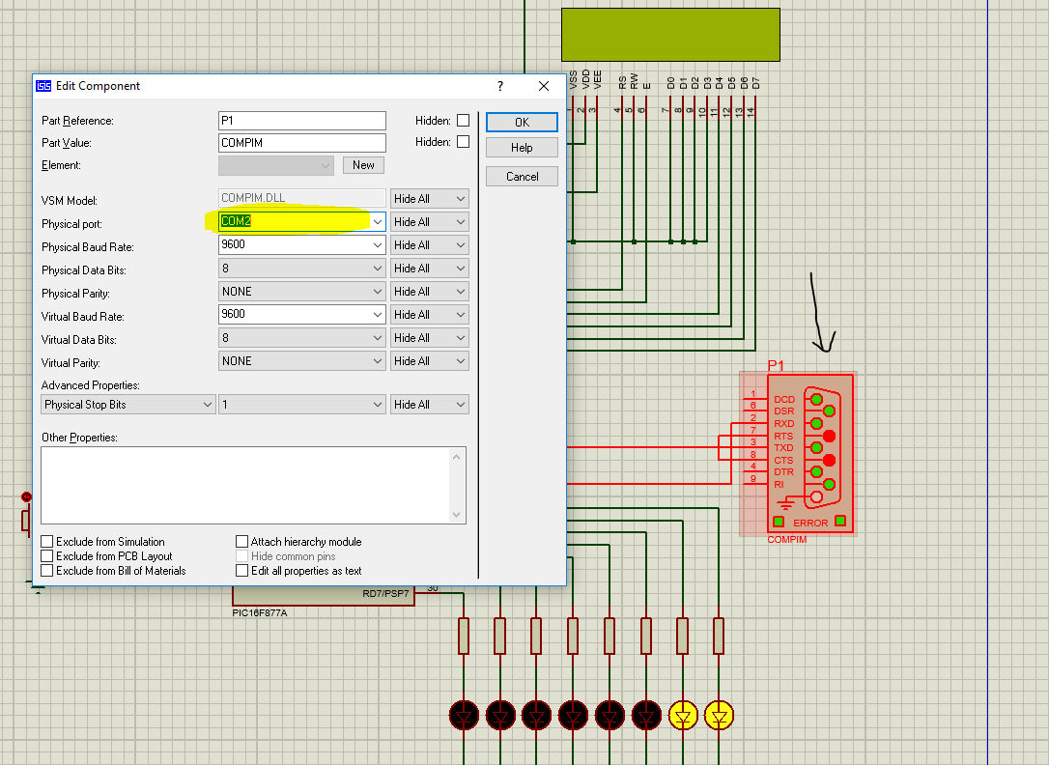

Go to labview and chose COM1 in VISA resource

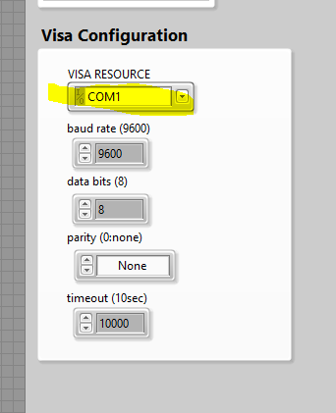

6.run labview then labcenter electronics and then enjoy regulation and communication between both of these programs (the first led indicated that the pump work and we write also in the lcd)