Before you read those instructions please read the file “notes”

1. Enter the website

<https://www.ibm.com/watson/services/visual-recognition/>

1. Create and an account and get the API credential

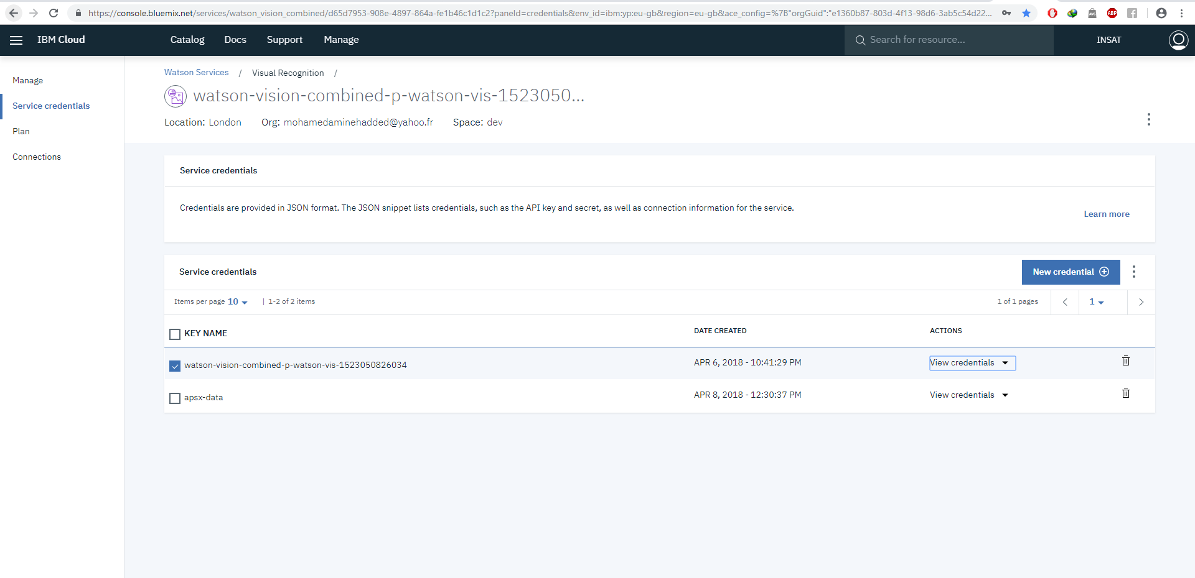

3.Enter to this website

<https://watson-visual-recognition.ng.bluemix.net/login/>

and put your credential

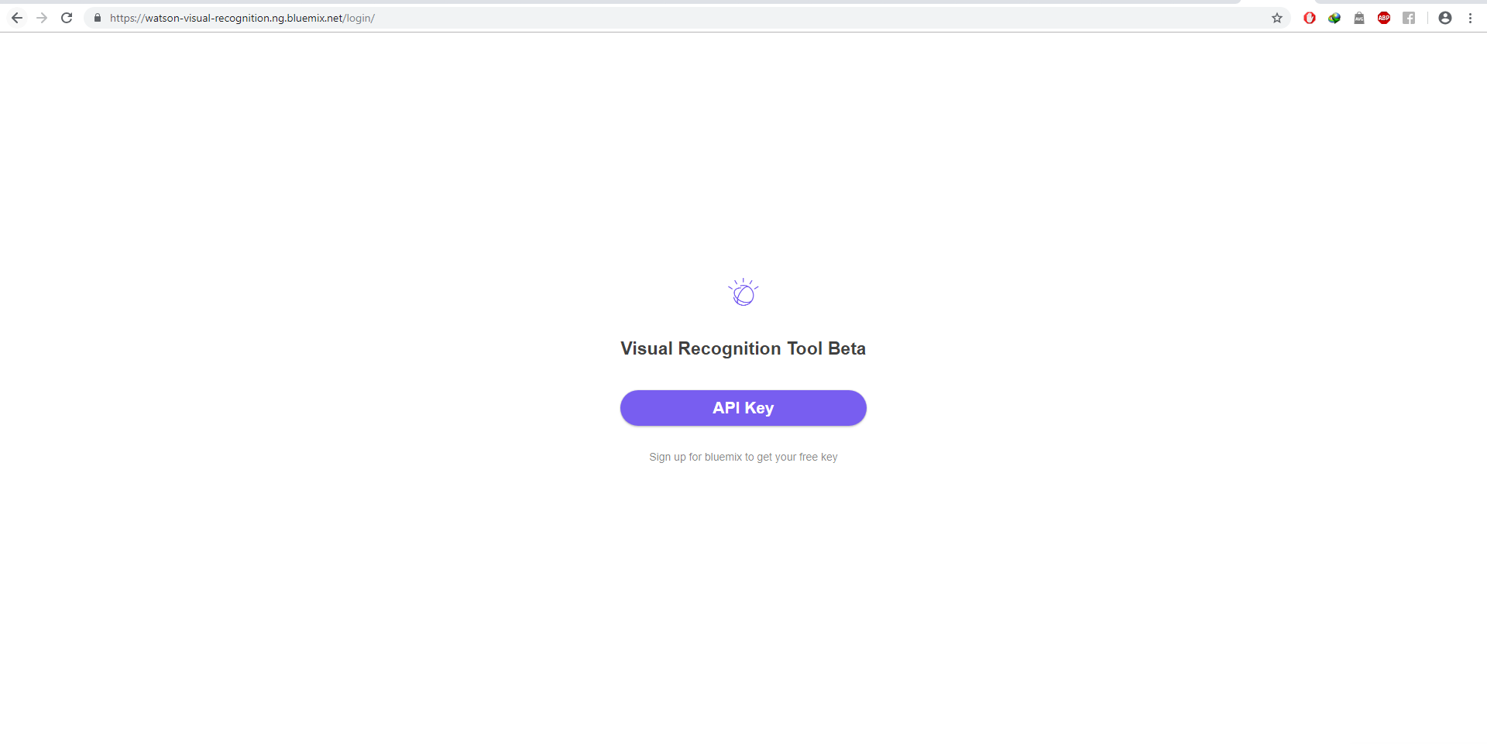

4.After putting your credential: create a classifier and in it a positive and negative photos of the something that you want to identify (for example : a fresh fruits in the positive class and damaged fruits in the negative class)

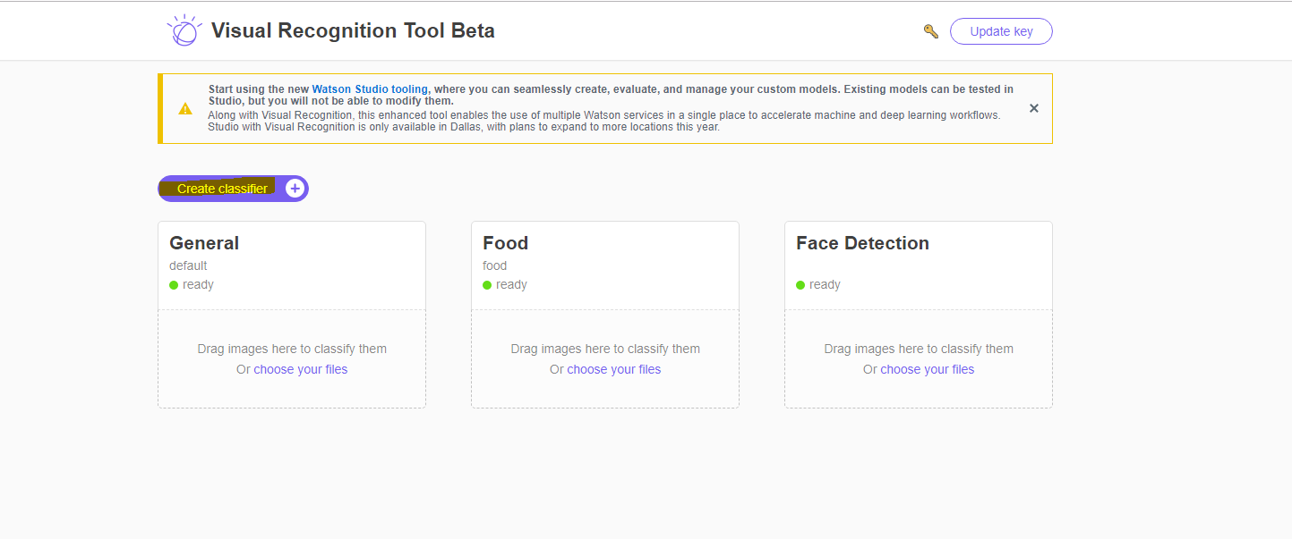

Your classifier is going to be trained in a while and then you can test it in the same website by choosing a file from the files that you put and then it will give the result

5. for the raspberry part:

Open node-red.

Copy the code in the file named “javascript code”

And imported to your node-red

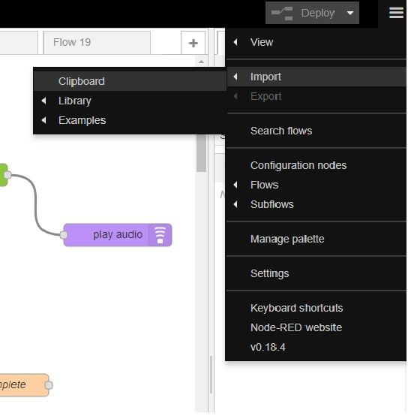

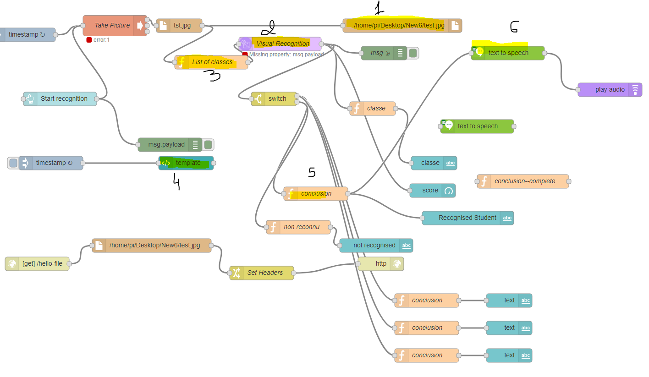

Follow those instructions:

1 double click on 1: and put the directory that you like to save the last photo taken by the webcam

2 put your credential in the area of API key (after clicking on 2) the same credential of the IBM Watson

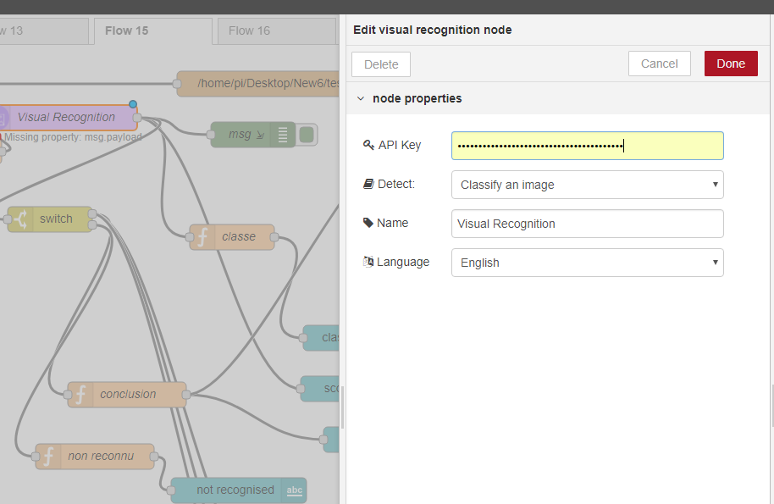

3.click on 3 and put the name of your classifier that you created in this website

<https://watson-visual-recognition.ng.bluemix.net/login/>

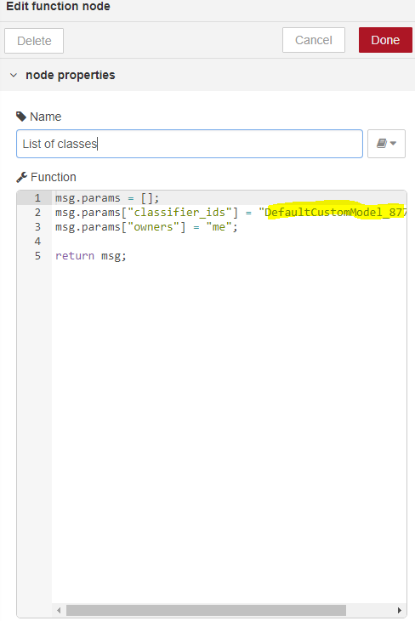

1. Open the application ipcamera and then get the ip from it and put it like this:

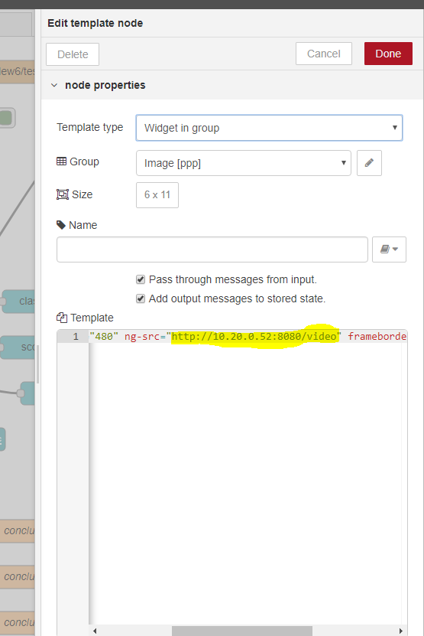

5.

You can modify the second line the first part:

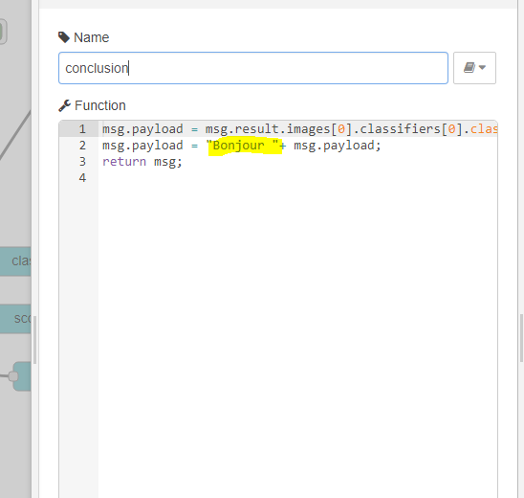

6. this is optional you have to get the free credit of the service text to speech

7.deploy it and then open copy the first part of the url of node red link

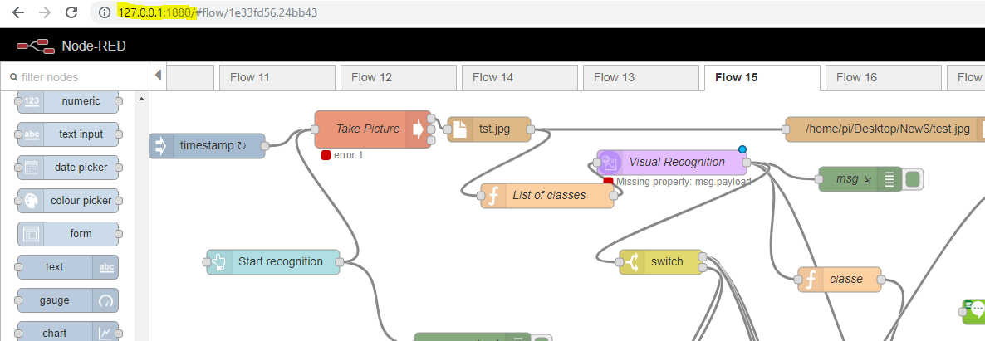

Open new tab and copy it and add ui the url gonna looking like that 127.0.0.1:1880/ui in my case and you’ll get the dashboard and the stream and a button when you click the button a photo going to be captured by the webcam -> saved in the directory that you put at the first time -> send to your classifier in the cloud -> and display the result and the percentage of certitude of the identification.

