

**PROJECT REPORT**

**Ant Catcher**

**2D Game**

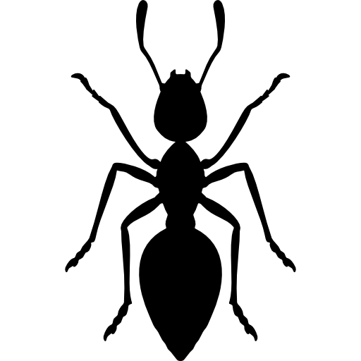

Prepared by

Amine Hrimech

Framed by

Professor Lozano Ibañez, Miguel

School year: 2019/2020

Abstract

Nowadays, video-game industry is one of the biggest and fastest growing around, providing jobs to many people and having a very big market. From the 1950s until now, many different video-game genres were created suiting different people tastes. Among them, high score games mainly consist of a player trying to complete the game while evading different obstacles which can include enemies, environmental objects in order to make a good score.

During my whole life, I have spent countless hours playing a great variety of video-games. I was always interested in developing one by myself, and that really encouraged me to make this project, which I have named Ant Catcher.

By making Ant Catcher, I have learned how the 2d games can be designed and developed by a single person. This process includes the usage of different tools and libraries such as box2d

Contents

Introduction 3

How to play 4

The classes of the game 4

The Elements of the game 5

Game test 5

1-Start Page: 5

2-Gmae Page: 6

2-Score Page: 8

Conclusion 9

# Introduction

A videogame is a game played in an electronic device, where one or diverse players interact with it.

Nowadays, the videogame industry is an ever growing sector able to compete with both cinema and music industries, actually surpassing their profits. The future of videogames is constantly changing and open to new markets, for example games on smartphones and tablets.

Ant Catcher game is one where the player tries to catch as many ants as possible by avoiding certain obstacles in a limited time-frame. The game developed in this project is essentially a high score 2D game.

.

# How to play

In order to play this game, Press the start button then you have to use the mouse to control and guide the queen ant. So basically you have to move your mouse to control the queen ant to catch the ants that appears and also to avoid the debris and if you touch any ant it will automatically stick with the queen ant that you control, in case if you touch any debris that will make you lose some of the ants that you have caught.

Eventually after the time out you will get your score which is how many ants you have caught.

# The classes of the game

* Ant class: this class can be attached to antblob or floating in the river.
* AntBlob class: this class used to manage the how ants behave together around the queen.
* Collidable class: this class used in order to generic class for the any collidable. It is destroyed when y is bigger than screen height.
* Floater class: this class used for the debris in the river, receives and image and dimensions in the constructor.
* River class: this class contains the margins box2d colliders and image.
* Rope class: this class is a rope joint to connect between two objects.
* AntCatcher: is the main class of the game

# The Elements of the game

* River is the main background of the game and all the elements (ants and debris) will be moving inside this river.
* Ant Queen is the ant that can be controlled by the user. Once it touches an ant, the ant attaches to it.
* Ants are a type of floating object that can be attached to the ant queen once the collision has been detected.
* Floating debris are objects that appear in the river and are carried by the current. Once they collide with ants attached to the queen these ants eject once again into the current.

# Game test

## 1-Start Page:

This page contains some instructions about how to play the game and the start button to start the game

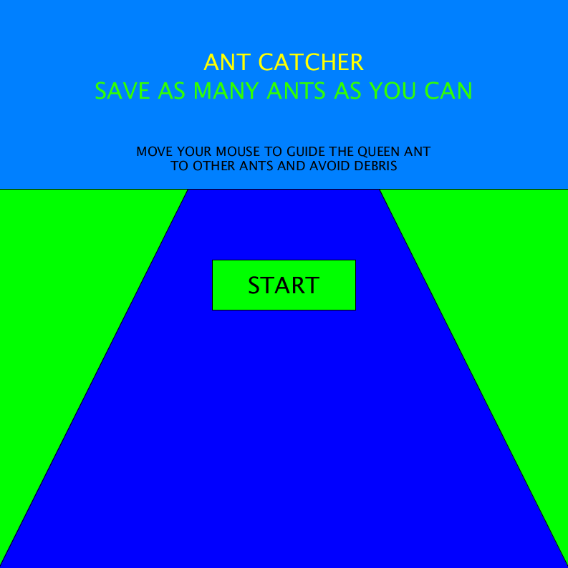

## 2-Gmae Page:

Once the game started, the timer will automatically start also the debris and ants will float in the river .and the number of ants caught is incremented automatically

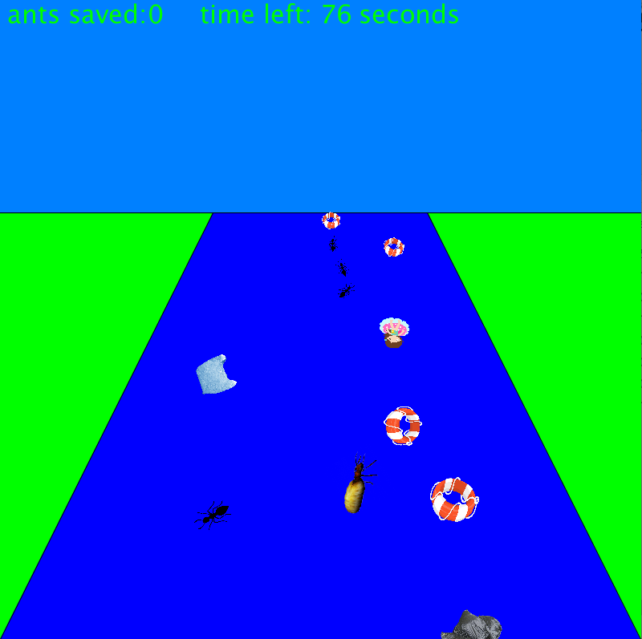

Once When you touch any ants it will automatically stick on the queen ant that you control just like the screen below

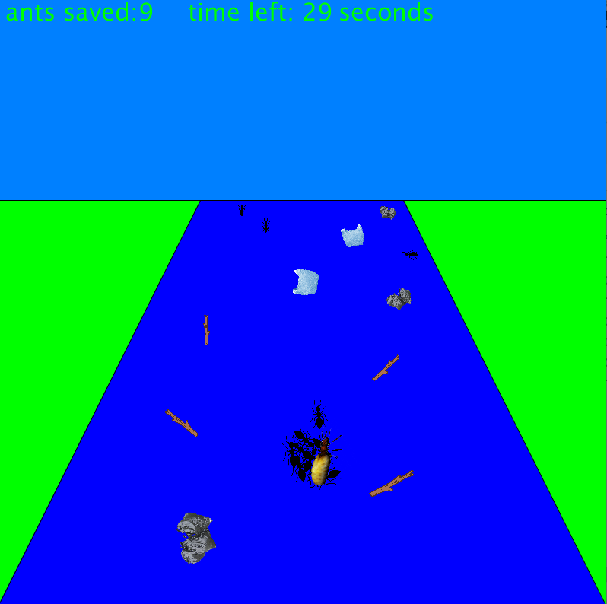

## 2-Score Page:

After the time out, a page will show up for a couple of seconds to inform you about your score

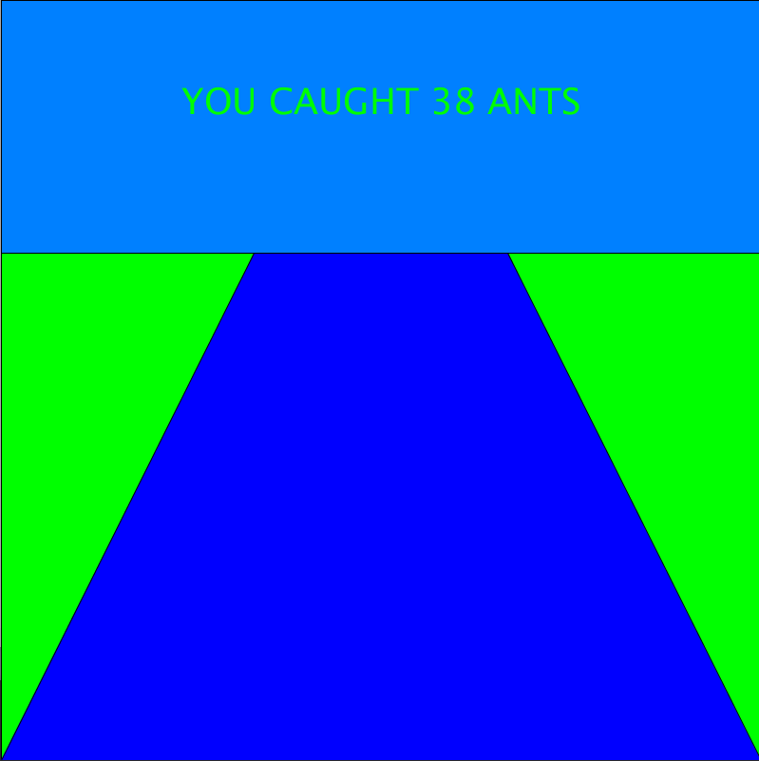

# Conclusion

During my whole life, I have spent countless hours playing video-games. As I grew older, I often found myself analyzing the games and started asking different questions like: how did they do that? could I do it by myself? could I do it better? Little by little, when I started developing this 2D game and found out that game development is an infinitely big world that provides many exciting things to learn.

Therefore, the main objective of this project was to entirely design and develop a 2D game in high score game genre, entitled Ant Catcher, while at the same time learning different libraries and tools needed for game development. In order to be able to achieve this main objective, I have split the project into a set of different targets from which the specific tasks were later created.

Finally, I would like to highlight that most of the things done throughout this project were learned while developing it, as I had very little experience in the whole process of 2D game development. I had made very simple 2D game based on the box2D physical engine