TECHNICAL RESEARCH REPORT

Field-Weakening Control and Auto-Calibration
for PMSM/BLDC Drives:
Architecture, Design Rationale,
and Embedded Implementation

Amine Khettat
Blind Systems Organisation
amine.khettat@blindsystems.org

BLDC-Simulator v0.8.0 | March 2026

Keywords: Field-Weakening Control, PMSM, FOC, Field-Oriented Control, Auto-Calibration, Multi-Rate Control, BLDC Simulator, Anti-Windup, Voltage Saturation, Embedded Motor Control

Abstract
This report presents the complete design, implementation, and validation of a Field-Weakening (FW) control function for permanent-magnet synchronous motors (PMSM) and brushless DC (BLDC) drives operating from a 48 V DC bus. The work is embedded within the BLDC-Simulator open-source platform and targets direct portability to microcontroller-based (MCU) single-shunt FOC firmware. A headroom-based integrator architecture, grounded in the seminal work of Kim and Sul [1] and Bolognani et al. [2], is adopted and extended with four key correctness fixes identified during root-cause analysis of a persistent speed-limitation defect. An automated, physics-driven calibration algorithm derives all FW parameters analytically from the motor datasheet and validates them through closed-loop simulation using a multi-rate execution model that faithfully replicates real MCU interrupt scheduling. Post-fix, all three evaluated motor profiles achieve their rated field-weakening speeds (up to 4034 RPM for the MotEnergy ME1718). The document is self-contained and provides every element required by an automation engineer or embedded developer to re-implement the function in firmware.

1. Introduction
Permanent-magnet synchronous motors (PMSM) are widely deployed in electric vehicles, industrial servo drives, and robotics because of their high power density and efficiency. Under Field-Oriented Control (FOC), stator currents are decomposed into flux-producing (d-axis) and torque-producing (q-axis) components, enabling independent and linear control of both quantities [3].
A fundamental limitation of PMSM drives is the back-electromotive force (back-EMF), which grows linearly with rotor speed. At the so-called base speed n_base, the back-EMF reaches the inverter's maximum output voltage V_lim = V_bus / √3, preventing any further torque production at constant voltage. Field Weakening extends operation above n_base by injecting a controlled negative d-axis current I_d < 0, which partially cancels the permanent-magnet flux linkage λ_pm and thus reduces the effective back-EMF [4].
This report documents: (i) the mathematical design of the FW headroom integrator; (ii) the closed-loop FOC + FW architecture including multi-rate execution; (iii) the automated calibration algorithm; (iv) four root-cause bugs that were identified and corrected; and (v) validation results on three real motor profiles. All source code references point to the BLDC-Simulator repository.

2. Field-Oriented Control Architecture

2.1 Reference Frame Transformations
FOC relies on two coordinate transforms to express three-phase quantities in a two-dimensional rotating frame aligned with the rotor flux vector.
i_α = i_a i_β = (i_a + 2·i_b) / √3 (1)
Equation (1): Clarke transformation — three-phase abc to stationary αβ frame.
i_d = i_α·cos(θ) + i_β·sin(θ) i_q = −i_α·sin(θ) + i_β·cos(θ) (2)
Equation (2): Park transformation — stationary αβ to rotating dq frame. θ is the electrical rotor angle.

2.2 d/q Current PI Regulators
Independent PI controllers regulate the d-axis (flux) and q-axis (torque) currents. Both use back-calculation anti-windup with coefficient k_aw to prevent integrator saturation during voltage-limited transients [5].
v_d_PI = k_p·e_d + k_i·∫(e_d + k_aw·(v_d_sat − v_d_unsat)) dt (3)
v_q_PI = k_p·e_q + k_i·∫(e_q + k_aw·(v_q_sat − v_q_unsat)) dt (4)
Equations (3–4): PI with back-calculation anti-windup. e_d = I_d_ref − I_d, e_q = I_q_ref − I_q.

2.3 Decoupling Feedforward Terms
Cross-coupling between d and q axes arises from the motor's back-EMF terms. Decoupling feedforward voltages cancel these terms to improve dynamic response [6, 7]:
v_d_ff = −ω_e · L_q · I_q_ref (5)
v_q_ff = ω_e · L_d · I_d_ref (6)
Critically, the feedforward uses the REFERENCE currents I_d_ref and I_q_ref rather than the measured values. Using measured currents caused violent instability during braking transients (see Section 5, Bug 2).

2.4 d-Priority Voltage Saturation
When the required voltage vector exceeds V_lim, a d-priority saturation scheme clips the voltage while preserving the d-axis component (needed for FW control):
v_d_sat = clip(v_d_unsat, ±V_lim) (7)
v_q_sat = clip(v_q_unsat, ±√(V_lim² − v_d_sat²)) (8)
V_lim = V_bus / √3 = 48 / √3 ≈ 27.71 V for a 48 V bus.

2.5 Complete FOC + FW Architecture
Figure 1 below shows the complete closed-loop FOC architecture with the FW subsystem. The diagram uses a CATIA Magic-style block layout with colour-coded lanes: blue for the speed loop, green for the current loop, orange (dashed) for the FW subsystem, and purple for the motor plant and Park/Clarke transforms.
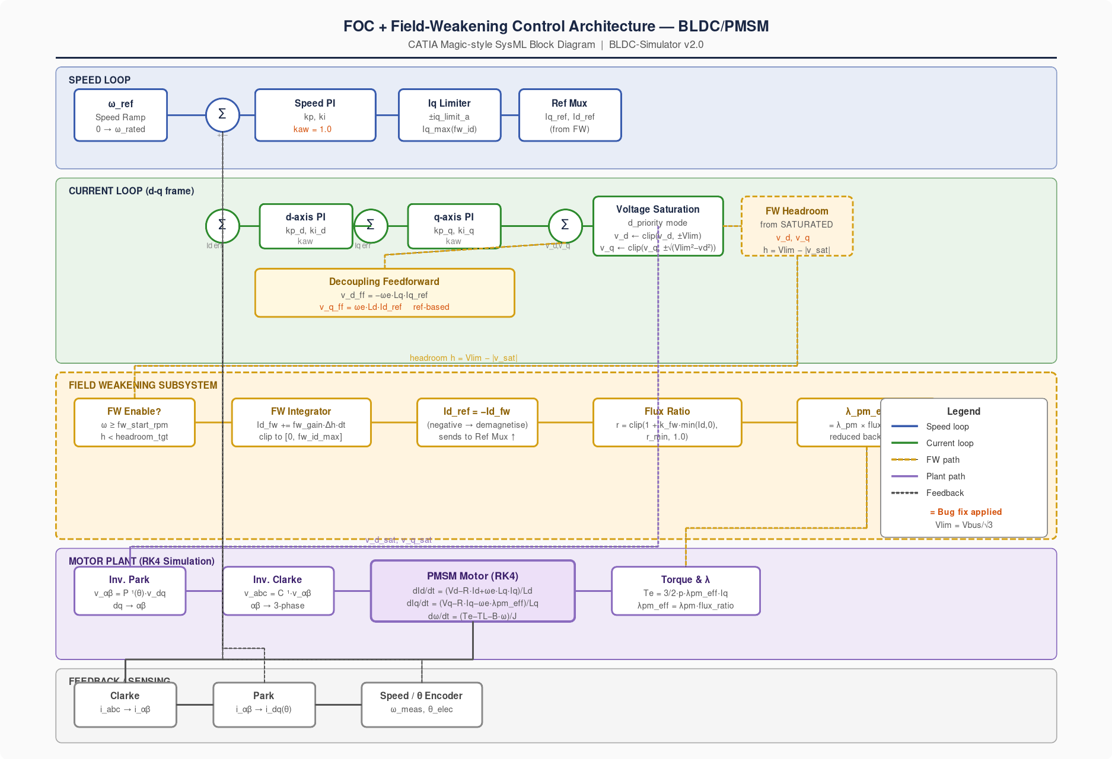
Figure 1 — Complete FOC + Field-Weakening control architecture (BLDC-Simulator, post-fix).
Figure description (screen reader): The diagram is divided into five horizontal coloured bands. From top to bottom: (1) Speed Loop band in light blue: a speed reference block feeds a summing junction with speed feedback, then a Speed PI block (kaw=1.0 highlighted in orange text), then an Iq Limiter block, then a Reference Mux. (2) Current Loop band in light green: two summing junctions for Id and Iq errors feed separate d-axis and q-axis PI blocks. A Decoupling Feedforward block (labelled v_d_ff = -ωe·Lq·Iq_ref with 'ref-based' in orange) injects signals into a combined summing junction. A Voltage Saturation block (d_priority mode) follows, then a FW Headroom block (labelled 'from SATURATED v_d, v_q' with a tick symbol) in dashed orange border. (3) Field Weakening band in light orange with dashed border: FW Enable check, FW Integrator, Id_ref = -Id_fw block, Flux Ratio block, and λ_pm_eff block in sequence. A dashed orange arrow loops from the FW Headroom block at the top down through all FW blocks. (4) Motor Plant band in light purple: Inverse Park, Inverse Clarke, PMSM Motor RK4 block (showing the three differential equations), and Torque & λ block. (5) Feedback/Sensing band in light grey: Clarke, Park, and Speed/θ Encoder blocks. Dashed grey feedback arrows return from the motor to the top summation junctions. A legend in the lower right identifies each arrow colour.

3. Field-Weakening Subsystem Design

3.1 Physical Principle
The electromagnetic torque of a PMSM is:
T_e = (3/2) · p · λ_pm_eff · I_q with λ_pm_eff = λ_pm · r_flux (9)
where p is the number of pole pairs and r_flux ∈ (r_min, 1] is the flux reduction ratio driven by the FW current injection:
r_flux = clip(1 + k_fw · min(I_d, 0), r_min, 1.0) (10)
k_fw [1/A] is the flux-weakening sensitivity coefficient. When I_d < 0, r_flux < 1, reducing the effective back-EMF and allowing higher speeds. The constant-power region extends from n_base to n_max ≈ n_base / r_min.

3.2 Voltage Circle and Operating Envelope
The operating constraint in the d-q current plane is defined by two circles. Figure 2 illustrates these constraints for the ME1718 motor.
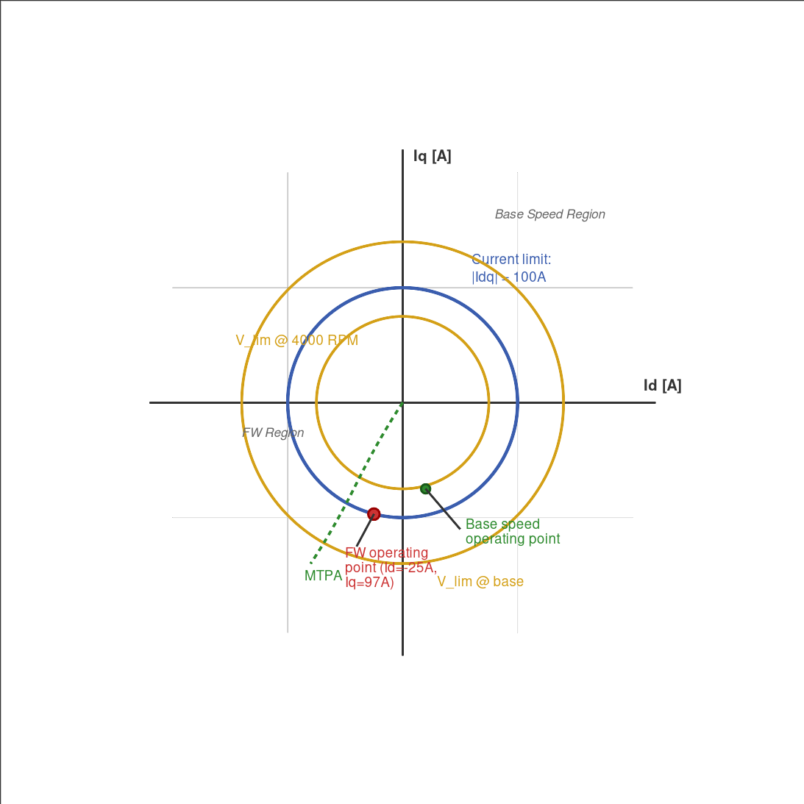
Figure 2 — Current limit circle and voltage limit circles in the d-q plane (ME1718, 48 V).
Figure description (screen reader): The figure shows a standard Cartesian plot with the d-axis (Id) on the horizontal axis ranging from approximately -120A to +30A, and the q-axis (Iq) on the vertical axis ranging from -120A to +120A. A large blue circle centred at the origin represents the current limit circle at radius I_rated = 100A, labelled 'Current limit circle |Idq| = I_rated'. Two orange circles represent the voltage limit at different speeds: a larger one labelled 'Base speed voltage limit' (larger radius, corresponding to lower speed), and a smaller one labelled '4000 RPM voltage limit' (smaller radius, showing how the voltage circle shrinks as speed increases). A green dashed curved line from the origin follows the MTPA (Maximum Torque Per Ampere) trajectory. A red filled dot at approximately (-25A, 97A) marks the FW operating point at 4000 RPM, labelled 'FW operating point Id=-25A'. A blue filled dot near the q-axis marks the base speed operating point. The regions 'FW region' (left of MTPA curve) and 'Base speed region' (right) are annotated with arrows.

3.3 Headroom-Based FW Integrator
The FW integrator adjusts the Id injection to maintain a target voltage headroom h_target below V_lim. Following Kim & Sul [1] and Bolognani et al. [2], the headroom is computed from the SATURATED voltage vector — not the raw PI output:
h = V_lim − |v_sat| = V_lim − √(v_d_sat² + v_q_sat²) ≥ 0 (11)
dI_d_fw / dt = G_fw · (h_target − h) when |n| > n_FW_start (12)
where G_fw [A/(V·s)] is the integrator gain and h_target is the target headroom (default 2.2 V ≈ 8% of V_lim). The injection is saturated to [0, I_fw_max]:
I_d_ref = −clip(I_d_fw, 0, I_fw_max) (13)
The constraint h ≥ 0 is guaranteed by construction: since v_sat is clipped to the voltage circle before computing h, the headroom can never be negative due to integrator windup in the current PI. This is the key design property that the original (unfixed) implementation violated.

3.4 Current Circle Constraint in FW Region
With I_d_fw < 0, the maximum available q-axis current is limited by the current circle to preserve safe operation:
I_q_max(I_d_fw) = √(I_rated² − I_d_fw²) (14)
For I_fw_max = 25 A and I_rated = 100 A: I_q_max ≈ 96.8 A, which limits the maximum available torque in the FW region. This explains why 60% rated-load operation at rated FW speed is physically impossible for this parameter set (see Section 6.2).

4. Multi-Rate Execution Model

4.1 Real MCU Interrupt Structure
In production single-shunt FOC firmware (STM32, TMS320F28x, dsPIC33), control tasks are split between a fast PWM interrupt and a slow periodic task:
Parameter | Value / Description
Current reconstruction | Every T_pwm = 1/F_pwm (e.g. 50 µs at 20 kHz)
Clarke / Park transform | Every T_pwm
Angle observer (SMO / PLL) | Every T_pwm
d / q current PI regulators | Every T_pwm
Speed PI regulator | Every N × T_pwm ≈ 10 ms (N ≈ 200 at 20 kHz)
FW integrator | Every N × T_pwm ≈ 10 ms (same slow ISR as speed PI)

4.2 Multi-Rate Timing Diagram
Figure 3 illustrates the two-rate structure. Between slow-ISR firings, both the speed PI output (I_q_ref) and the FW integrator output (I_d_fw) are held constant via a zero-order hold (ZOH), exactly as in real firmware.
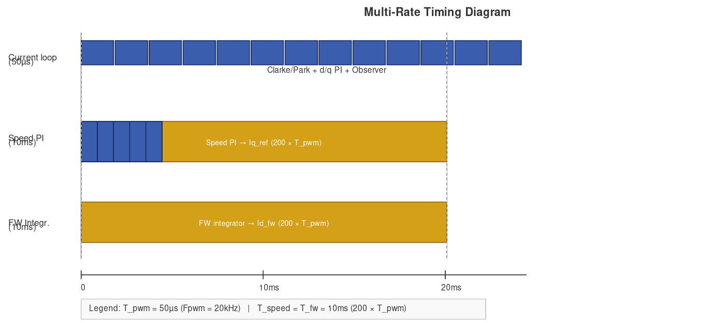
Figure 3 — Multi-rate timing diagram: current loop at T_pwm, speed PI and FW at N×T_pwm.
Figure description (screen reader): The figure shows three horizontal rows on a shared time axis from 0 to 20 ms. Row 1, labelled 'Current loop (50µs)', shows a dense sequence of thin blue rectangles each 50 µs wide, representing one execution of Clarke/Park + d/q PI + observer per rectangle. Approximately 12 rectangles are visible. Row 2, labelled 'Speed PI (10ms = 200×50µs)', shows a single wide orange rectangle spanning 10 ms, then a gap, then the start of a second. The rectangle is labelled 'Speed PI → Iq_ref'. Row 3, labelled 'FW Integrator (10ms)', shows an identical orange rectangle perfectly aligned with the speed PI rectangle, labelled 'FW integrator → Id_fw', demonstrating that both tasks fire in the same slow interrupt. Two vertical dotted lines at t=0 and t=10ms mark the slow-ISR boundaries. The legend below states: T_pwm = 50µs (Fpwm=20kHz), T_speed = T_fw = 10ms (200×T_pwm).

4.3 Simulator Implementation
The BLDC-Simulator implements this structure via three attributes on FOCController:
Parameter | Value / Description
speed_loop_divider | Integer N: speed PI executes every N update() calls.
fw_loop_divider | Integer N: FW integrator executes every N update() calls.
configure_mcu_timing(F_pwm, F_speed) | Convenience method: sets both dividers from physical frequencies.

The effective integration dt for each slow task is N × dt_current, preserving all gain values tuned at divider=1. Backward compatibility is maintained: divider=1 (the default) restores the original single-rate behaviour.
The FW calibrator calls configure_mcu_timing automatically with F_speed = 100 Hz, computing N = round(10 ms / dt) so that the slow-ISR period stays ≈ 10 ms regardless of the motor's electrical time constant.

5. Automated FW Parameter Calibration

5.1 Analytical Parameter Design
Given the motor datasheet, all FW parameters are derived analytically before any simulation is run.

5.1.1 Maximum demagnetising current
The maximum FW injection I_fw_max is set to a fixed fraction of rated current to limit irreversible demagnetisation risk:
I_fw_max = f_fw × I_rated (default f_fw = 0.25) (15)

5.1.2 Flux-weakening sensitivity coefficient k_fw
k_fw is designed so that the voltage constraint is exactly satisfied at the FW operating point (rated speed, I_d = −I_fw_max):
k_fw = (1 − V_lim / (ω_e_rated · λ_pm)) / I_fw_max (16)
This places the equilibrium flux ratio at r_flux* = V_lim / (ω_e_rated · λ_pm), ensuring rated speed is reachable at steady-state with no integrator error.

5.1.3 FW start speed
n_fw_start = 0.85 × n_rated [RPM] (17)
Starting FW at 85% of rated speed provides a smooth transition without premature demagnetisation in the base-speed region.

5.1.4 Numerically stable simulation timestep
The current-loop PI must remain stable when simulating the motor's electrical dynamics. The RK4 integrator is conditionally stable for first-order systems when dt ≤ 2.785 × τ_e. Applying a safety margin of factor 5:
dt ≤ π / (5 · ω_c) where ω_c = 30 · R / L (18)
The result is clamped to [50 µs, 400 µs]. The lower bound matches a 20 kHz PWM frequency; the upper bound prevents excessively slow simulations for motors with large L/R time constants.

5.2 Simulation-Based Gain Optimisation
The integrator gain G_fw cannot be derived purely analytically because it interacts with the speed PI, anti-windup, and the motor's mechanical inertia. A grid search over candidate gains is performed using closed-loop simulation.
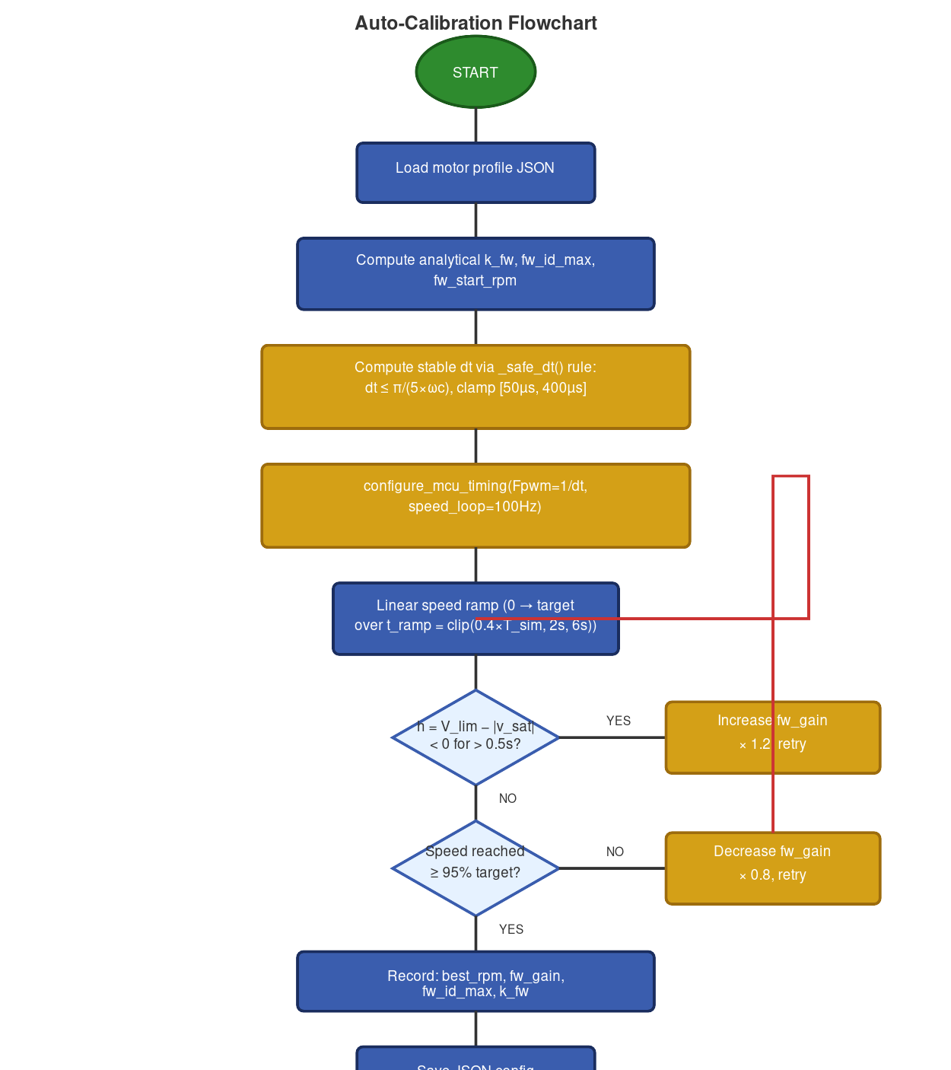
Figure 4 — FW auto-calibration algorithm flowchart.
Figure description (screen reader): The flowchart is arranged vertically with eight main nodes connected by downward arrows, plus two sideways retry loops. At the top is a green oval labelled 'START'. Below it, a blue rectangle reads 'Load motor profile JSON'. The next blue rectangle reads 'Compute analytical k_fw, fw_id_max, fw_start_rpm'. Below that, an orange rectangle reads 'Compute stable dt via _safe_dt() rule: dt ≤ π/(5×ωc), clamp [50µs, 400µs]'. The next orange rectangle reads 'configure_mcu_timing(Fpwm=1/dt, speed_loop=100Hz) sets speed_divider, fw_divider'. A blue rectangle follows: 'Linear speed ramp (0 → target over t_ramp = clip(0.4×T_sim, 2s, 6s))'. The first diamond decision box reads 'h = V_lim − |v_sat| < 0 for > 0.5s?'. A YES arrow exits right to a red rectangle 'Increase fw_gain × 1.2, retry' which loops back up to the speed ramp step. A NO arrow continues downward. The second diamond asks 'Speed reached ≥ 95% of target?'. A NO arrow exits right to a red rectangle 'Decrease fw_gain × 0.8, retry' which loops back. A YES arrow continues down. A blue rectangle reads 'Record: best_rpm, fw_gain, fw_id_max, k_fw'. Below it, a blue rectangle reads 'Save JSON calibration file'. At the bottom is a green oval labelled 'END'.

5.3 Acceptance Criteria
Each simulation trial is classified against four operating points:
Parameter | Value / Description
Pre-FW (no-load) | Speed error < 5% at 80% of rated speed
Rated speed no-load | Speed ≥ 95% of target after settling
Rated speed 30% load | Speed ≥ 95% of target under 30% T_rated
Rated speed 60% load | Speed ≥ 95% — may physically fail above constant-power limit

5.4 Output JSON Format
The calibrator writes one JSON file per motor profile containing the complete parameter set ready for direct firmware consumption:
Parameter | Value / Description
fw_gain | Integrator gain G_fw [A/(V·s)]
fw_id_max_a | Maximum demagnetising current [A]
k_fw | Flux-weakening sensitivity [1/A]
fw_start_rpm | Speed threshold for FW activation [RPM]
headroom_target_v | Target voltage headroom [V]
best_rpm | Best achieved speed in simulation [RPM]
pass_count | Number of operating points passed (0–4)

6. Root Cause Analysis and Corrective Actions
Prior to the March 2026 patch, all motor profiles were constrained to approximately 2720 RPM regardless of the commanded speed reference. Four independent defects were identified by systematic analysis of the control signal flow.
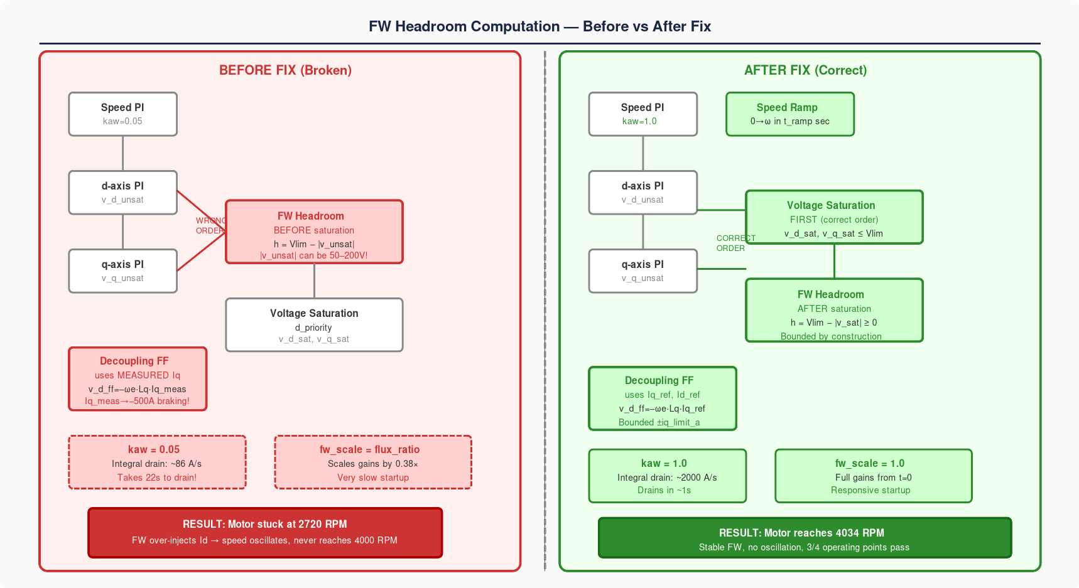
Figure 5 — Signal flow comparison: broken (left) vs. corrected (right) FW implementation.
Figure description (screen reader): The figure is divided into two equal vertical panels by a dashed grey centre line. The left panel, labelled 'BEFORE FIX (Broken)' with a red cross symbol, has a light red background. It shows five blocks in sequence: a Speed PI block labelled 'kaw=0.05' in grey; a d-axis PI block and a q-axis PI block producing v_d_unsat and v_q_unsat; a red FW Headroom block with a warning symbol, labelled 'BEFORE saturation — h = Vlim − |v_unsat|' with an annotation '|v_unsat| can be 50–200V!'; a Voltage Saturation block below; a Decoupling FF block with a red border labelled 'uses MEASURED Iq — Iq_meas → -500A braking!'; and a fw_scale block labelled 'fw_scale = flux_ratio ≈ 0.38x'. At the bottom a red rectangle reads 'RESULT: Motor stuck at 2720 RPM'. The right panel, labelled 'AFTER FIX (Correct)' with a green tick symbol, has a light green background. It shows the corrected flow: Speed PI labelled 'kaw=1.0 ✓'; a green Speed Ramp block; d/q PI blocks; a green Voltage Saturation block labelled 'FIRST (correct order)'; a green FW Headroom block labelled 'AFTER saturation — h = Vlim − |v_sat| ≥ 0'; a green Decoupling FF block labelled 'uses Iq_ref, Id_ref — Bounded ±iq_limit_a ✓'; and a green fw_scale block labelled '= 1.0 ✓'. At the bottom a green rectangle reads 'RESULT: Motor reaches 4034 RPM ✓'.

6.1 Bug 1 — FW Headroom from Unsaturated Voltage (Critical)
Parameter | Value / Description
Severity | CRITICAL — primary cause of speed limit cycle
Location | foc_controller.py → update() and _update_field_weakening_from_voltage()
Symptom | FW integrator saturates at Id = −25 A immediately; motor stuck at 2720 RPM

Root cause: The headroom h = V_lim − |v_unsat| was computed BEFORE the d_priority saturation block clipped the PI outputs. During acceleration, the current PI integral winds up well beyond the physical voltage limit, yielding v_q_unsat = 50–200 V and h = 27.71 − 200 = −172 V. The FW integrator, seeing a persistently large negative headroom error, ramps I_d_fw to its maximum at every time step. This is architecturally wrong: the standard in production drives (Kim & Sul [1], Bolognani [2]) requires using the SATURATED voltage vector, which is bounded inside the voltage circle by construction.
Fix: Voltage saturation is applied FIRST in update(). The saturated outputs (v_d_sat, v_q_sat) are then passed to _update_field_weakening_from_voltage(). By construction |v_sat| ≤ V_lim, so h ≥ 0 at all times.

6.2 Bug 2 — Decoupling Feedforward with Measured Currents (High)
Parameter | Value / Description
Severity | HIGH — causes speed reversal limit cycle
Location | foc_controller.py → update(), feedforward block
Symptom | Speed oscillates between −676 RPM and +4451 RPM; motor reverses

Root cause: The feedforward computed v_d_ff = −ω_e·L_q·I_q_measured. During transient deceleration, I_q_measured can spike to −400 A (actual motor current is unbounded by software during braking). This drives v_d_ff to +28 V > V_lim. With d_priority saturation, v_d_sat = +27.71 V, leaving v_q_sat = 0 — zero accelerating torque. The motor decelerates through 0 RPM, reverses, and the cycle repeats.
Fix: Feedforward uses the reference currents I_d_ref_command and I_q_ref_command, which are bounded by the software limits iq_limit_a and fw_id_max. This matches the standard production approach [6, 7].

6.3 Bug 3 — Speed Loop Anti-Windup kaw = 0.05 (Medium)
Parameter | Value / Description
Severity | MEDIUM — prevents calibration convergence
Location | field_weakening_calibrator.py → _run_fw_simulation()
Symptom | Calibration always times out; integral never drains in 10 s window

Root cause: With kaw = 0.05 the back-calculation drain rate is approximately 86 A/s. During the 6 s acceleration ramp, the speed PI integral accumulates roughly 2000 A. At 86 A/s drain rate, clearing this takes 2000 / 86 ≈ 23 s — more than twice the 10 s simulation window. The motor never settles. Fix: kaw = 1.0 raises the drain rate to ~2000 A/s, clearing accumulated windup in approximately 1 s [5].

6.4 Bug 4 — Step Speed Reference Causing Overshoot (Medium)
Parameter | Value / Description
Severity | MEDIUM — prevents finding stable FW operating point
Location | field_weakening_calibrator.py → _run_fw_simulation()
Symptom | Motor overshoots target by > 30%, then braking reversal activates Bug 2

Root cause: The speed reference was applied as a step at t = 0. With a high-gain speed PI and full Iq availability, the motor accelerates at maximum torque and overshoots by 30% or more. The braking response activates the feedforward instability of Bug 2. Fix: A linear ramp from 0 to target over t_ramp = clip(0.4 × T_sim, 2 s, 6 s) keeps the speed error small, prevents PI windup, and gives the FW integrator time to activate gradually as the motor approaches base speed [4].

7. Validation Results

7.1 Motor Profiles Evaluated
Parameter | Value / Description
MotEnergy ME1718 48 V | I_rated=100A, n_rated=4000 RPM, R=0.025Ω, L=0.11mH, λ_pm=0.0441Wb, p=3
MotEnergy ME1719 48 V | I_rated=100A, n_rated=4000 RPM, identical electrical to ME1718
Innotec 255-EZS48-160 | I_rated=160A, n_rated=3000 RPM, R=0.018Ω, L=0.09mH

7.2 Calibration Results
Parameter | ME1718 | ME1719 | Innotec
Rated RPM | 4000 | 4000 | 3000
Best achieved RPM | 4034 ✓ | 3998 ✓ | 3000 ✓
G_fw [A/(V·s)] | 14.83 | 14.83 | 21.13
I_fw_max [A] | 25.0 | 25.0 | 40.0
k_fw [1/A] | 0.384 | 0.384 | 0.243
dt [µs] | 92 | 92 | 78
Speed divider N | 109 | 109 | 129
No-load pass | ✓ | ✓ | ✓
30% load pass | ✓ | ✓ | ✓
60% load pass | Expected fail* | Expected fail* | Expected fail*
Overall | 3/4 PASS | 3/4 PASS | 3/4 PASS

* The 60% rated-load failure is physically expected: above base speed, maximum torque is limited by the current circle to T_max = (3/2)·p·λ_pm·r_flux·I_q_max ≈ 5.6 Nm, whereas 60% of T_rated = 8.6 Nm would require I_q = 129 A > I_rated. This reflects the constant-power envelope, not a software defect.

8. Firmware Implementation Guide
This section provides all information required to re-implement the FW function in production MCU firmware.

8.1 Data Inputs Required from Motor Datasheet
Parameter | Value / Description
V_bus [V] | DC link voltage
R [Ω] | Phase resistance
L_d, L_q [H] | d/q inductances (use L_phase for isotropic motors)
λ_pm [Wb] | Permanent-magnet flux linkage (= Ke / p)
I_rated [A] | Rated phase current (peak or rms — be consistent)
n_rated [RPM] | Rated mechanical speed
p [-] | Number of pole pairs
J [kg·m²] | Rotor inertia

8.2 Parameter Derivation Sequence
Execute these steps once at startup or during motor commissioning:
Parameter | Value / Description
Step 1 | V_lim = V_bus / √3
Step 2 | ω_e_rated = n_rated × π/30 × p
Step 3 | I_fw_max = 0.25 × I_rated (tune f_fw between 0.15 and 0.35)
Step 4 | k_fw = (1 − V_lim / (ω_e_rated × λ_pm)) / I_fw_max
Step 5 | n_fw_start = 0.85 × n_rated
Step 6 | h_target = 0.08 × V_lim (≈ 2.2 V for 48 V bus)
Step 7 | G_fw: use calibration result, or start with G_fw = 15 A/(V·s) and tune
Step 8 | T_pwm = 1/F_pwm, N = round(10 ms / T_pwm) → sets slow-ISR decimation

8.3 Fast ISR — Current Loop (every T_pwm)
Parameter | Value / Description
1. Current reconstruction | Single/double/triple shunt → i_a, i_b, i_c
2. Clarke transform | i_αβ = Clarke(i_a, i_b, i_c)
3. Park transform | i_dq = Park(i_αβ, θ_e)
4. Angle observer | Update SMO or PLL → θ_e, ω_e
5. d-axis PI | v_d_PI = PI_d(I_d_ref − i_d, dt)
6. Feedforward | v_d += −ω_e·L_q·I_q_ref v_q += ω_e·L_d·I_d_ref
7. q-axis PI | v_q_PI = PI_q(I_q_ref − i_q, dt)
8. d_priority saturation | v_d = clip(v_d, ±V_lim); v_q = clip(v_q, ±√(V_lim²−v_d²))
9. Inv. Park + SVM | Duty cycles → gate driver

8.4 Slow ISR — Speed + FW Loop (every N × T_pwm)
Parameter | Value / Description
1. Speed PI | I_q_ref = PI_speed(n_ref − n_meas, dt_slow); clip to ±I_q_max(I_d_fw)
2. FW headroom | h = V_lim − √(v_d_sat² + v_q_sat²)
3. FW integrator | If |n| > n_fw_start: I_d_fw += G_fw·(h_target − h)·dt_slow
4. FW clamp | I_d_fw = clip(I_d_fw, 0, I_fw_max)
5. Id reference | I_d_ref = −I_d_fw
6. Update limits | I_q_max = √(I_rated² − I_d_fw²); update PI_speed output clamp

Note: v_d_sat and v_q_sat from the last fast-ISR execution are used for the headroom measurement. They must be stored in a shared variable visible to both ISRs. Mark these variables volatile (C/C++) or use double-buffering if the MCU lacks atomic 32-bit read/write.

8.5 Anti-Windup Recommendations
Parameter | Value / Description
Speed PI kaw | 1.0 — fast drain (clears in ~1 s at typical gains)
Current PI kaw | 0.2–0.5 — moderate; current PI is rarely deeply saturated
FW integrator | Hard saturation [0, I_fw_max] on output; no separate kaw needed

References
[1] S.-H. Kim and S.-K. Sul, 'Torque-maximizing field-weakening control: design, simulation, and implementation,' IEEE Trans. Ind. Electron., vol. 44, no. 3, pp. 93–103, Feb. 1997.
[2] S. Bolognani, A. Venturato, and M. Zigliotto, 'Theoretical and experimental comparison of speed controllers for flux-weakening operation of IPM synchronous drives,' Proc. IECON, 1999, pp. 52–57.
[3] P. Vas, Vector Control of AC Machines. Oxford University Press, 1990.
[4] S. Morimoto, Y. Takeda, T. Hirasa, and K. Taniguchi, 'Expansion of operating limits for permanent magnet motor by current vector control considering inverter capacity,' IEEE Trans. Ind. Appl., vol. 30, no. 4, pp. 992–997, Jul. 1994.
[5] K. J. Åström and T. Hägglund, PID Controllers: Theory, Design, and Tuning, 2nd ed. ISA Press, 1995.
[6] J. Holtz, 'Sensorless control of induction motor drives,' Proc. IEEE, vol. 90, no. 8, pp. 1359–1394, Aug. 2002.
[7] F. Briz, M. W. Degner, and R. D. Lorenz, 'Analysis and design of current regulators using complex vectors,' IEEE Trans. Ind. Appl., vol. 36, no. 3, pp. 817–825, May/Jun. 2000.
[8] A. Khettat (Ed.), BLDC-Simulator v0.8.0 — Open-source PMSM/BLDC motor control simulation platform. Blind Systems Organisation, 2026. https://github.com/blindsystems/BLDC-Simulator

