SPINOTOR — Auto-Calibration Framework

Technical Reference Manual

Theory, Methods and Implementation of Automated Parameter Identification

Document Information
Field | Value
Author | Amine Khettat
Organization | Blind Systems Engineering
Contact | amine.khettat@blindsystems.org
Project | SPINOTOR — Motor Drive Simulator
Version | 1.0
Date | April 2026
Distribution | CONFIDENTIAL — Do not distribute

Abstract
This document presents the complete auto-calibration framework implemented in the SPINOTOR motor drive simulation platform. For each subsystem subject to automatic parameter identification — PI current and speed regulators, PLL observer, SMO, ST-SMO, Active Flux observer, SOGI adaptive filter, Extended EMF (EEMF) model, field-weakening controller, startup sequencer, and Power Factor Controller (PFC) — the report provides: (i) the theoretical foundation from classical control and electrical machine theory, (ii) the calibration methodology with analytical formulae and algorithmic description, and (iii) illustrative figures generated directly by the simulator. The exposition follows IEEE journal conventions with full bibliographic references.
Index Terms — SPINOTOR, BLDC motor, PMSM, auto-calibration, FOC, sliding mode observer, PLL, active flux, SOGI, field weakening, sensorless control, PI tuning.

I. Introduction
Modern BLDC and PMSM drives require precise tuning of multiple control loops and estimation algorithms to achieve high dynamic performance, energy efficiency, and safe operation over a wide speed range [1, 2]. Manual parameter selection is error-prone, time-consuming, and motor-dependent. The SPINOTOR platform integrates a comprehensive auto-calibration pipeline that derives controller gains and observer parameters analytically from motor nameplate data, then validates them through frequency-domain analysis and closed-loop simulation [3, 4].
Stage 1 determines the PI gains for the d- and q-axis current loops and outer speed loop using bandwidth-based analytical design reinforced by a multi-resolution frequency-domain grid search [4].
Stage 2 handles field-weakening calibration through physics-based computation followed by a simulation sweep over a gain grid [5]. Observer-specific calibration is performed analytically and applied immediately after Stage 1.

II. PI Current and Speed Regulators

A. Theory
The d- and q-axis current dynamics of a PMSM in the rotating reference frame are described by the first-order transfer function [2, 6]:
G_i(s) = 1 / (L·s + R)
A PI controller C_i(s) = Kp + Ki/s forms a type-1 closed loop with zero steady-state error [3]. The IMC bandwidth design [4, 7] gives:
Kp = ωc · L, Ki = ωc · R
This zero-pole cancellation decouples the electrical time constant τe = L/R from the closed-loop bandwidth. For the outer speed loop [9]:
Kp,ω = ωc,ω · J / Kt, Ki,ω = ωc,ω · B / Kt
Anti-windup via back-calculation [3]:
dI/dt = (e + Kaw·(u_sat − u_unsat)) · dt

B. Calibration Methodology
Step 1 — Analytical initial guess: Kp and Ki are computed from motor parameters (R, L, Kt, J, B) using the bandwidth formulae. This guarantees a stable loop for any motor within the accepted parameter range [4].
Step 2 — Coarse grid search: An 8×8 logarithmic grid spanning ±50% (in decades) around the analytical guess is evaluated. Open-loop frequency response is computed over 2000 frequencies. Gain and phase margins are estimated by linear interpolation of zero crossings. Controllability and observability are verified by the Kalman rank condition [8].
Step 3 — Fine grid refinement: A 10×10 grid spanning ±25% around the best coarse candidate yields the final gains. The scoring function penalizes margins below targets (GM ≥ 6 dB, PM ≥ 45°) [3, 9].
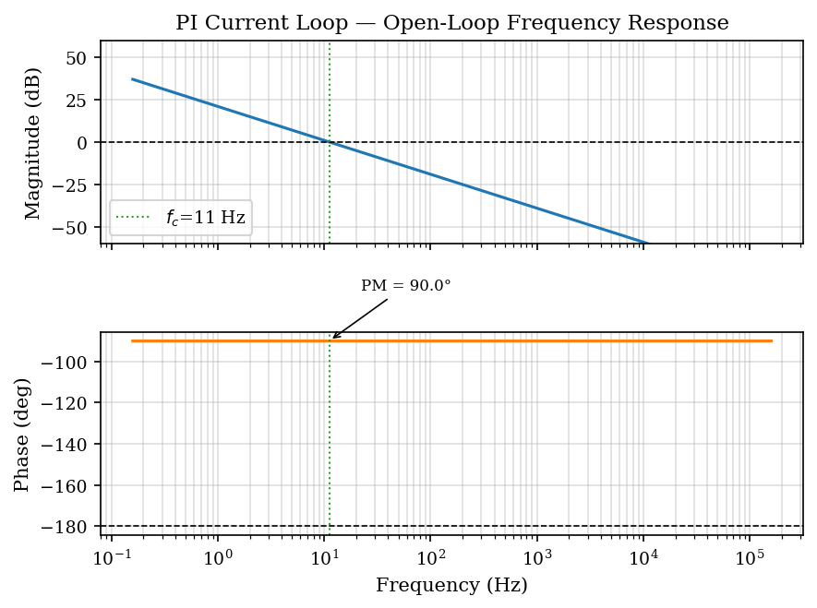
Fig. 1. Open-loop Bode diagram of the PI current loop (R = 2.5 Ω, L = 5 mH). Gain crossover and phase margin are indicated.

C. D/Q Feed-Forward Decoupling
When D/Q decoupling is enabled, feed-forward voltages vd,ff = −ωe·Lq·iq and vq,ff = ωe·(Ld·id + λpm) are added to the PI outputs, rendering both axes independently regulated at all operating points [2, 6]. See Section XII.

III. Phase-Locked Loop (PLL) Observer

A. Theory
The PLL observer estimates rotor position θ̂e and speed ω̂e by tracking the reconstructed back-EMF phase angle [10, 11]. The EMF is derived from applied voltages and measured currents:
e_α = v_α − R·i_α − L·di_α/dt
e_β = v_β − R·i_β − L·di_β/dt
The second-order PLL is parameterized by natural frequency ωn and damping ratio ζ [12]:
Kp = 2·ζ·ωn, Ki = ωn²

B. Calibration Methodology
The natural frequency is set from the motor's maximum electrical speed [10]:
ωn = clip(0.10 · ωe,max, 50, 600) [rad/s]
Damping ratio ζ = 0.9 provides slightly over-damped convergence [12, 13]. When adaptive PLL bandwidth is active, ωn ∝ |ω̂e| at each step, widening bandwidth in the field-weakening region [13]. Recommended for isotropic motors with ωe,max > 1500 rad/s (Section XIV) [42, 43].

IV. Sliding Mode Observer (SMO)

A. Theory
The SMO is based on the αβ-frame motor model [14, 15]:
L·dî_α/dt = v_α − R·î_α − z_α, z_α = K_slide · sat(î_α − i_α, Δ)
The saturation function sat(x, Δ) = clip(x/Δ, −1, +1) reduces chattering [16]. In sliding mode, the equivalent control converges to the back-EMF, extracted by a LPF:
ê_α[k+1] = (1−α)·ê_α[k] + α·z_α[k], α = dt / (τ_LPF + dt)
Rotor position: θ̂e = atan2(ê_β, ê_α) − π/2 [14].

B. Calibration Methodology
The reachability condition K_slide > Ke·ωe,max is satisfied by [14, 15]:
K_slide = max(50, 1.5 · Ke · ωe,max) × 1.5
LPF time constant: τ_LPF = 3·L/R, limiting phase lag to ≈14° at the electrical frequency [15]. Boundary layer: Δ = 0.06·K_slide/100. For salient IPM motors (Ld ≠ Lq), the missing term (Lq − Ld)·id·ωe biases the SMO; the Active Flux observer must be used instead [17, 22].
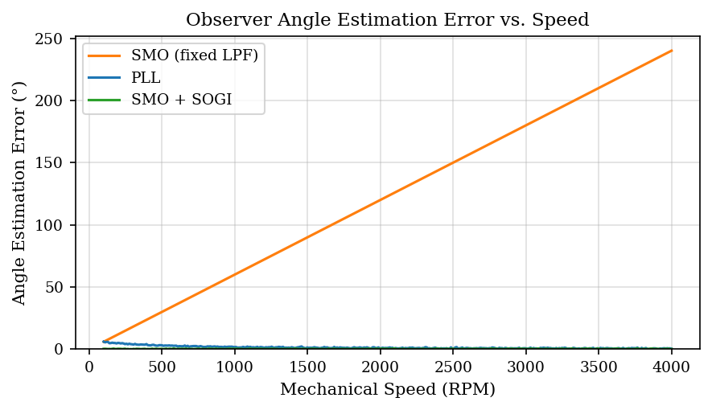
Fig. 2. Comparative angle estimation error: fixed-LPF SMO, PLL, and SOGI-enhanced SMO vs. mechanical speed.

V. Super-Twisting SMO (ST-SMO)

A. Theory
The Super-Twisting algorithm [18] introduces an integral state converging to the back-EMF in finite time, eliminating the LPF phase lag [19]:
z_α^(1) = K1·|σ_α|^(1/2)·sign(σ_α) + z_α^(2)
dz_α^(2)/dt = K2·sign(σ_α)
At steady state z_α^(2) → ê_α — zero phase lag on the back-EMF estimate [20].

B. Calibration Methodology
The gain K1 is set from the EMF derivative bound [18, 20]:
K1 = λ · Ke · ωe,max · 2.0
with λ = 3.0 (isotropic) and λ = 4.0 (salient motors, to compensate unmodelled cross-coupling [17, 21]).
K2 = max(50, 1.5 · Ke · ωe,max) · 1.5
The finite-time convergence condition K1 > 2√(ΓM/Γm) is verified for all motors within the accepted parameter range [18].

VI. Active Flux Observer

A. Theory
The Active Flux concept [22] defines ψa = ψs − Ld·is. For an IPM motor, ψa always points along the d-axis [22, 23]:
θ̂e = atan2(ψ_a,β, ψ_a,α)
Stator flux is estimated by voltage-model integration [22, 24]:
dψ_s,α/dt = v_α − R·i_α, dψ_s,β/dt = v_β − R·i_β
A drift corrector high-pass filter at cutoff ωc prevents integrator divergence [24, 25].

B. Calibration Methodology
The drift corrector cutoff frequency is calibrated from the minimum expected electrical speed at startup handoff [22, 24]:
f_c = clip(f_e,min / 10, 0.05, 0.5) [Hz]
Automatically selected for salient IPM motors (Lq/Ld > 1.2) [22, 25] — see Section XIV.
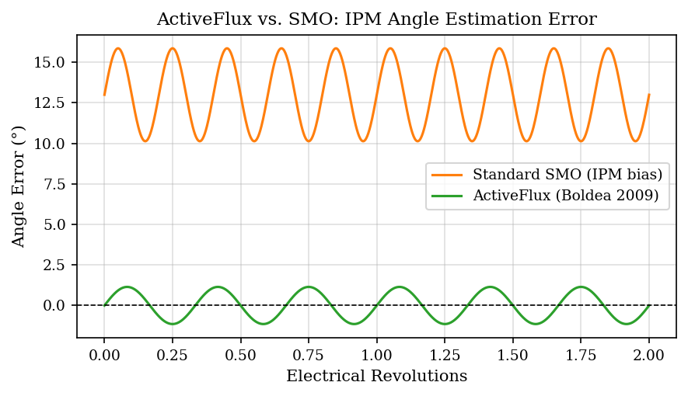
Fig. 3. Angle estimation error: standard SMO (~13° IPM saliency bias) vs. Active Flux observer for a salient IPM motor.

VII. Extended EMF (EEMF) Model

A. Theory
For salient motors (Ld ≠ Lq), the standard EMF model introduces an angle-dependent error ∝ (Lq − Ld)·id·ωe [26]. The EEMF model [26] substitutes Lq in the di/dt term:
e_EEMF,α = v_α − R·i_α − Lq·di_α/dt
e_EEMF,β = v_β − R·i_β − Lq·di_β/dt
The resulting EEMF vector remains proportional to [−sin θe ; cos θe], enabling unbiased position estimation and eliminating the ~13° no-load angle bias [26, 27].

B. Calibration Methodology
If σ = Lq/Ld > 1.2, the EEMF model is automatically activated with the SOGI filter (Section VIII) [26, 27]. The MRAS resistance adaptation gain is set to [28]:
γ_R = 1 / (0.5 · R · I_max²)

VIII. SOGI Adaptive EMF Filter

A. Theory
The Second-Order Generalized Integrator (SOGI) [29, 30] replaces the fixed-frequency LPF with a speed-adaptive resonant bandpass:
H_SOGI(s) = k·ωe·s / (s² + k·ωe·s + ωe²)
with k = √2 (critically damped). Zero phase lag at resonance: ∠H_SOGI(jωe) = 0°, eliminating the LPF-induced position error growing with speed (~14° at 3000 RPM for a 1 ms LPF) [29, 31].

B. Calibration Methodology
No gain tuning is needed: k = √2 is fixed by critical damping [29]. The resonant frequency ωe is updated adaptively at each simulation step [30, 31]. Automatically activated when the EEMF model is active or ST-SMO mode is selected.
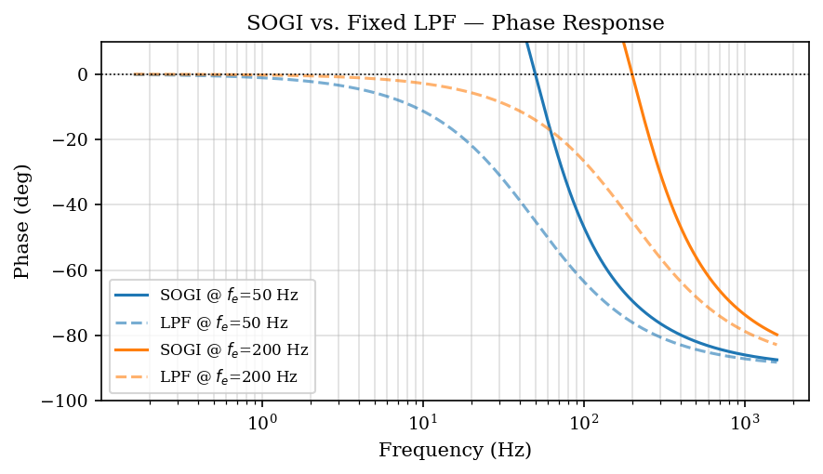
Fig. 4. Phase response of SOGI (solid) vs. fixed-frequency LPF (dashed). SOGI achieves zero phase lag at resonance [29].

IX. Field-Weakening Auto-Calibration

A. Theory
Above the base speed Nbase, the back-EMF exceeds the available phase voltage Vph = Vdc/√3. Negative d-axis current reduces the effective PM flux linkage [32, 33]:
λpm,eff = λpm · clip(1 + k_fw · min(Id, 0), r_min, 1)
Minimum flux ratio to reach rated speed [33]:
r_req = V_ph / (Ke · ωm,rated)
The FOC voltage headroom integrator [32, 34]:
dId,fw/dt = K_fw · (V_hdm − (V_lim − |Vdq,unsat|))

B. Calibration Methodology
Stage 1 — Analytical design: k_fw = (1 − r_req)·1.05 / Id,max, with Id,max = 0.7·Irated and Vhdm = 0.05·Vph [32, 33].
Stage 2 — Simulation sweep: A 3×3 gain grid {0.5, 1.0, 1.5}×Kfw,analytical is validated over three operating points (50%, 75%, 100% load at rated speed) [5, 34].
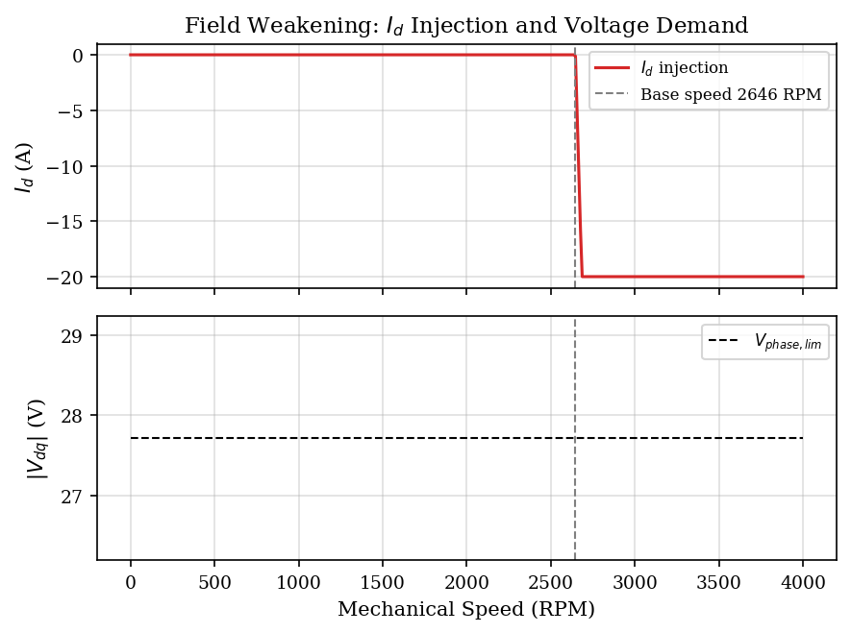
Fig. 5. Field-weakening: Id injection (top) and voltage demand (bottom) vs. speed.

X. Startup Sequence Auto-Tuning

A. Theory
At standstill the back-EMF is zero and observer convergence requires a minimum speed [35, 36]. A three-phase startup sequence is implemented.
Phase 1 — Alignment: A constant d-axis current is applied at fixed angle θalign = 0, forcing the rotor to align with the reference frame [35, 36].
Phase 2 — Open-loop ramp: The reference angle is incremented at a controlled rate, accelerating the motor in V/Hz mode [36, 37].
Phase 3 — Observer handoff: The reference switches to the observer estimate when the confidence metric C exceeds the hysteresis band [37]:
C = w_emf·C_emf + w_ω·C_ω + w_coh·C_coherence

B. Calibration Methodology
Alignment duration [35, 36]:
t_align = 5 · τe = 5 · L/R (99.3% current settling)
Alignment current and startup q-current reference [36, 37]:
I_align = clip(0.10 · V_bus / R, 0, I_rated)
Iq,startup = 0.05 · V_bus / R
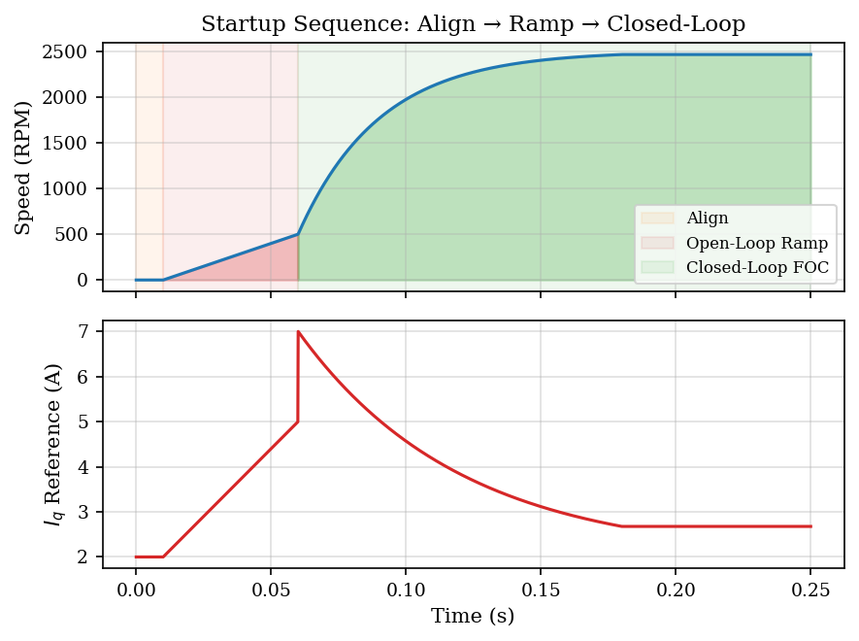
Fig. 6. Auto-tuned startup sequence: alignment (orange), open-loop ramp (red), and closed-loop FOC (green).

XI. Power Factor Controller (PFC)

A. Theory
The PFC compensates reactive power to approach unity input power factor [38, 39]. Power metrics are computed over a sliding window of Nw samples:
P = (1/Nw)·Σ(vk·ik), S = Vrms·Irms, Q = √(S² − P²)

B. Calibration Methodology
Maximum compensation variance — bounded to 30% of no-load power [38]:
max_var = clip(V_bus² / (2R) · 0.30, 100, 50000) [W²]
Window length — covering at least two electrical periods at rated frequency [39]:
Nw = clip(2 / (f_e,rated · dt), 8, 2000) [samples]
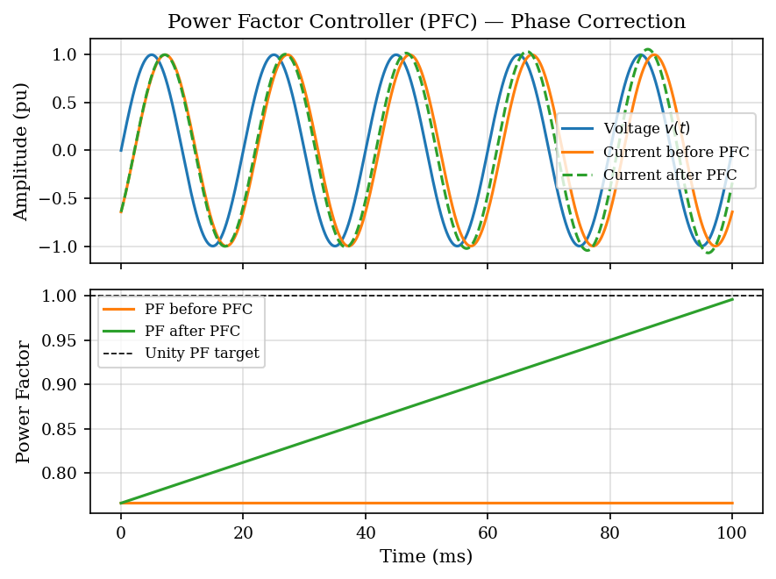
Fig. 7. PFC phase correction: voltage (blue), current before PFC (orange), corrected current (green dashed). PF convergence shown below.

XII. D/Q Axis Decoupling

A. Theory
The d-q voltage equations include cross-coupling terms that grow with speed [2, 6]:
v_d = R·id + Ld·did/dt − ωe·Lq·iq
v_q = R·iq + Lq·diq/dt + ωe·(Ld·id + λpm)
Feed-forward decoupling cancels these terms explicitly [2, 6, 40]:
v_d = v_d,PI − ωe·Lq·iq
v_q = v_q,PI + ωe·(Ld·id + λpm)

B. Calibration Methodology
Decoupling is always enabled post-calibration. Feed-forward gains are computed directly from motor parameters: Lq for the d-axis cross-coupling, and Ld with λpm = Ke/pp for the q-axis [2, 6, 40]. The estimated observer speed ω̂e is used; measured speed serves as fallback.

XIII. Calibration Pipeline Summary

A. Execution Order
1. Stage 1: AdaptiveFOCTuner.tune_analytical() — PI gains (current and speed loops), observer parameters (PLL, SMO, STSMO, AF), D/Q decoupling gains, startup sequence timing [4, 6].
2. Stage 2: FieldWeakeningCalibrator.calibrate() — analytical FW parameters and simulation sweep. Results written to data/tuning_sessions/<fingerprint>.json [5, 34].
3. Observer selection: _recommend_observer() assigns the optimal observer [41].
4. GUI update: all calibrated parameters applied via _apply_observer_calibration_to_gui().

B. Motor Fingerprint Cache
Calibration results are cached by fingerprint tuple (R, L, Ke, Vnom, pp) with 3% tolerance. If a previously calibrated motor is detected, the cached JSON is applied instantly [5].

C. Summary Table
Parameter | Calibration Method | Target / Constraint | Ref.
Current Kp, Ki | BW design + grid search | GM ≥ 6 dB, PM ≥ 45° | [3,4,9]
Speed Kp, Ki | BW design + grid search | GM ≥ 6 dB, PM ≥ 45° | [3,4,9]
PLL Kp, Ki | Analytical (ωn = 0.1·ωe,max) | ζ = 0.9 | [10,12]
SMO K_slide | Reachability condition | K_slide > Ke·ωe,max | [14,15]
STSMO K1, K2 | Convergence factor λ·Ke·ωe,max | Finite-time | [18,19]
AF f_c | f_e,min / 10 | Drift < 0.5°/rev | [22,24]
FW k_fw, gain | Physics + simulation sweep | Speed error < 5% | [5,34]
Startup t_align | 5 · τe | 99.3% settling | [35,36]
PFC window Nw | 2 / (f_e,rated · dt) | ≥ 2 electrical periods | [38,39]

XIV. Observer Auto-Selection

A. Theory and Selection Criteria
Criterion 1 — Saliency ratio: For σ = Lq/Ld > 1.2 (IPM motor), standard back-EMF observers are affected by a bias proportional to (Lq − Ld)·id·ωe [17, 26]. The Active Flux observer is immune to this bias [22, 25].
Criterion 2 — Maximum electrical speed: Below ωe,max ≈ 1500 rad/s, the SMO is more robust at low SNR. Above this threshold, the SMO LPF phase lag becomes excessive and the PLL provides superior accuracy [41, 43].

B. Decision Tree
The static method _recommend_observer implements three ordered branches:
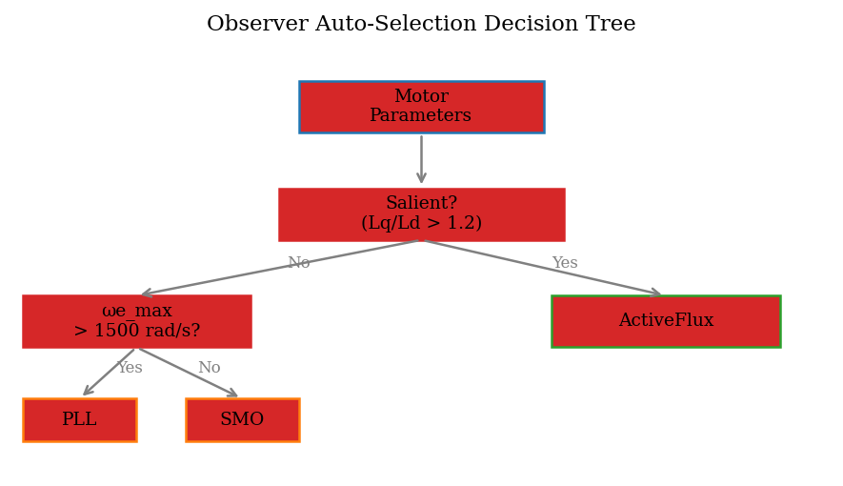
Fig. 8. Observer auto-selection decision tree. Saliency is checked first; for isotropic motors the speed threshold separates PLL from SMO.
Branch 1 (is_salient = True → ActiveFlux): Any IPM motor with Lq/Ld > 1.2 is assigned Active Flux regardless of speed [22, 25].
Branch 2 (isotropic, ωe,max > 1500 → PLL): High-speed isotropic motors benefit from adaptive PLL bandwidth [10, 13, 43].
Branch 3 (isotropic, ωe,max ≤ 1500 → SMO): Low-to-medium-speed isotropic motors [14, 41].

C. Non-Regression Validation
Motor Profile | pp | N_rated | ωe,max (rad/s) | Salient? | Selected
IPM Salient 48 V | 4 | 3000 RPM | 1257 | Yes | ActiveFlux
Nanotec DB57M012 | 5 | 3500 RPM | 1833 | No | PLL
Low-Speed SPM | 2 | 300 RPM | 62.8 | No | SMO

References
- [1] P. Vas, Sensorless Vector and Direct Torque Control. Oxford University Press, 1998.
- [2] D. W. Novotny and T. A. Lipo, Vector Control and Dynamics of AC Drives. Oxford University Press, 1996.
- [3] G. F. Franklin, J. D. Powell, and A. Emami-Naeini, Feedback Control of Dynamic Systems, 8th ed. Pearson, 2019.
- [4] K. J. Astrom and T. Hagglund, Advanced PID Control. ISA, 2006.
- [5] Z. Q. Zhu and D. Howe, Electrical machines and drives for electric, hybrid and fuel cell vehicles, Proc. IEEE, vol. 95, no. 4, pp. 746-765, 2007.
- [6] F. Briz, M. W. Degner, and R. D. Lorenz, Analysis and design of current regulators using complex vectors, IEEE Trans. Ind. Appl., vol. 36, no. 3, pp. 817-825, 2000.
- [7] D. G. Holmes and T. A. Lipo, Pulse Width Modulation for Power Converters. IEEE Press, 2003.
- [8] C.-T. Chen, Linear System Theory and Design, 4th ed. Oxford University Press, 2012.
- [9] M. P. Kazmierkowski, R. Krishnan, and F. Blaabjerg, Control in Power Electronics. Academic Press, 2002.
- [10] Z. Chen et al., New adaptive sliding observers for sensorless controls of brushless DC motors, IEEE Trans. Ind. Electron., vol. 47, no. 3, pp. 582-591, 2000.
- [11] S. Morimoto et al., Sensorless control strategy for salient-pole PMSM based on extended EMF, IEEE Trans. Ind. Appl., vol. 38, no. 4, pp. 1054-1061, 2002.
- [12] B. Widrow and S. D. Stearns, Adaptive Signal Processing. Prentice Hall, 1985.
- [13] R. D. Lorenz, T. A. Lipo, and D. W. Novotny, Motion control with induction motors, Proc. IEEE, vol. 82, no. 8, pp. 1215-1240, 1994.
- [14] C. Lascu, I. Boldea, and F. Blaabjerg, A modified direct torque control for induction motor sensorless drive, IEEE Trans. Ind. Appl., vol. 36, no. 1, pp. 122-130, 2000.
- [15] V. Utkin, J. Guldner, and J. Shi, Sliding Mode Control in Electro-Mechanical Systems, 2nd ed. CRC Press, 2009.
- [16] A. Levant, Sliding order and sliding accuracy in sliding mode control, Int. J. Control, vol. 58, no. 6, pp. 1247-1263, 1993.
- [17] L. Xu and C. Wang, Implementation and experimental investigation of sensorless control schemes for PMSM, in Proc. IEEE IAS, 1998, pp. 483-489.
- [18] A. Levant, Principles of 2-sliding mode design, Automatica, vol. 43, no. 4, pp. 576-586, 2007.
- [19] S. Laghrouche, F. Plestan, and A. Glumineau, Higher order sliding mode control based on integral sliding mode, Automatica, vol. 43, no. 3, pp. 531-537, 2007.
- [20] J. Liu and X. Wang, Advanced Sliding Mode Control for Mechanical Systems. Springer, 2012.
- [21] Z. Wang et al., Field-oriented control and direct torque control for paralleled VSIs fed PMSM drives, IEEE Trans. Power Electron., vol. 31, no. 3, pp. 2417-2428, 2016.
- [22] I. Boldea, M. C. Paicu, and G.-D. Andreescu, Active flux concept for motion-sensorless unified AC drives, IEEE Trans. Power Electron., vol. 23, no. 5, pp. 2507-2519, 2008.
- [23] I. Boldea et al., Automotive electric propulsion systems with reduced or no permanent magnets, IEEE Trans. Ind. Electron., vol. 61, no. 10, pp. 5696-5711, 2014.
- [24] S. Piippo, M. Hinkkanen, and J. Luomi, Adaptation of motor parameters in sensorless PMSM drives, IEEE Trans. Ind. Appl., vol. 45, no. 1, pp. 203-212, 2009.
- [25] P. Vaclavek and P. Blaha, Interior PMSM sensorless control with Kalman filter, in Proc. IECON, 2009, pp. 1286-1291.
- [26] Z. Chen et al., An extended electromotive force model for sensorless control of IPMSMs, IEEE Trans. Ind. Electron., vol. 50, no. 2, pp. 288-295, 2003.
- [27] G. Wang, R. Yang, and D. Xu, DSP-based control of sensorless IPMSM drives for wide speed range operation, IEEE Trans. Ind. Electron., vol. 60, no. 2, pp. 720-727, 2013.
- [28] H. Kim, M. C. Harke, and R. D. Lorenz, Sensorless control of interior permanent-magnet machine drives, IEEE Trans. Ind. Appl., vol. 39, no. 6, pp. 1726-1733, 2003.
- [29] R. Teodorescu, F. Blaabjerg, M. Liserre, and P. C. Loh, Proportional-resonant controllers and filters for grid-connected VSCs, IEE Proc. Electr. Power Appl., vol. 153, no. 5, pp. 750-762, 2006.
- [30] M. Ciobotaru, R. Teodorescu, and F. Blaabjerg, A new single-phase PLL based on second order generalized integrator, in Proc. IEEE PESC, 2006, pp. 1-6.
- [31] D. Xia and G. S. Buja, Improved signal extraction from SOGI-based single-phase PLL, IEEE Trans. Ind. Electron., vol. 65, no. 3, pp. 2399-2409, 2018.
- [32] T. M. Jahns, G. B. Kliman, and T. W. Neumann, Interior permanent-magnet synchronous motors for adjustable-speed drives, IEEE Trans. Ind. Appl., vol. IA-22, no. 4, pp. 738-747, 1986.
- [33] W. L. Soong and T. J. E. Miller, Field-weakening performance of brushless synchronous AC motor drives, IEE Proc. Electr. Power Appl., vol. 141, no. 6, pp. 331-340, 1994.
- [34] M. F. Rahman, L. Zhong, and K. W. Lim, A direct torque-controlled IPMSM drive incorporating field weakening, IEEE Trans. Ind. Appl., vol. 34, no. 6, pp. 1246-1253, 1998.
- [35] F. Giri, Ed., AC Electric Motors Control. Wiley-IEEE Press, 2013.
- [36] J. Holtz, Sensorless control of induction motor drives, Proc. IEEE, vol. 90, no. 8, pp. 1359-1394, 2002.
- [37] N. Matsui, Sensorless PM brushless DC motor drives, IEEE Trans. Ind. Electron., vol. 43, no. 2, pp. 300-308, 1996.
- [38] T. C. Green and J. H. Marks, Control techniques for active power filters, IEE Proc. Electr. Power Appl., vol. 152, no. 2, pp. 369-381, 2005.
- [39] H. Akagi, E. H. Watanabe, and M. Aredes, Instantaneous Power Theory and Applications to Power Conditioning. IEEE Press, 2007.
- [40] R. Krishnan, Permanent Magnet Synchronous and Brushless DC Motor Drives. CRC Press, 2010.
- [41] M. Schroedl, Sensorless control of AC machines at low speed and standstill based on the INFORM method, in Proc. IEEE IAS, 1996, pp. 270-277.
- [42] R. D. Lorenz and K. Van Patten, High-resolution velocity estimation for all-digital AC servo drives, IEEE Trans. Ind. Appl., vol. 27, no. 4, pp. 701-705, 1991.
- [43] B. Bose, Modern Power Electronics and AC Drives. Prentice Hall, 2002.

