Single Shunt Current Reconstruction in
Three-Phase PWM Inverters:
Theory, Modulation Strategies, Acquisition Window Analysis,
and Blind-Zone Compensation Methods

Technical Report — SVM Analyst Project
April 2026By Amine KHETTAT

Abstract
This report presents a comprehensive analysis of single shunt current reconstruction (SSCR) techniques for three-phase voltage source inverters (VSI). The single shunt topology is attractive for cost-sensitive drives because one resistor placed in the DC-bus negative rail can provide all three phase currents at the expense of specific PWM timing constraints. This document establishes the mathematical foundation of the acquisition window algorithm, examines the dependency of measurable window widths on the duty cycles produced by different modulation strategies—including Sinusoidal PWM (SPWM), Third-Harmonic Injection PWM (THIPWM), Space Vector Modulation (SVM), and all six Discontinuous PWM (DPWM) variants—and derives the conditions under which reconstruction fails (blind zones). Compensation methods for center-aligned and edge-aligned PWM schemes are presented, including minimum-pulse insertion, duty-cycle redistribution, and phase-time shifting. The analysis is directly tied to the SVM Analyst simulation platform.
Keywords: single shunt current sensing, PWM inverter, space vector modulation, DPWM, blind zone, dead time, ADC acquisition window, current reconstruction, motor control, IGBT inverter.

I. Introduction
Accurate measurement of three-phase motor currents is a fundamental requirement for field-oriented control (FOC) and direct torque control (DTC) of permanent-magnet synchronous motors (PMSM) and induction motors (IM) [1]. Traditionally, dedicated current sensors (Hall-effect or shunt-based) are placed in each motor phase, requiring three hardware channels. This approach is accurate and robust but increases bill-of-materials cost and PCB complexity.
The single shunt current reconstruction technique reduces the sensor count to one resistor in the DC-bus negative rail [2][3]. The shunt carries the sum of all active-low-side device currents and, during specific time intervals within every PWM period, carries exactly one phase current at a time. By careful ADC triggering within those intervals, all three phase currents can be estimated from two successive samples per period.
This approach is well established in low-cost drive inverters but presents specific challenges: (i) near sector boundaries of the modulation pattern the acquisition interval narrows and may vanish (blind zones); (ii) parasitic ringing after IGBT switching mandates a minimum settling time before sampling; (iii) dead-time blanking further reduces the usable window; and (iv) different modulation strategies generate markedly different window-width profiles across the electrical cycle [4][5].
Section II reviews the inverter topology and DC-bus shunt principle. Section III develops the PWM timing equations for center-aligned carriers. Section IV extends the analysis to all SVM sectors and all modulation flavors available in the SVM Analyst project. Section V characterizes blind zones. Section VI presents compensation strategies. Section VII addresses edge-aligned PWM and phase-shift methods. Section VIII discusses implementation in the SVM Analyst tool. Conclusions follow in Section IX.

II. Three-Phase VSI with Single DC-Bus Shunt
A three-phase two-level voltage source inverter (VSI) consists of three half-bridge legs, each containing a high-side switch (Q_xH, x ∈ {A, B, C}) and a low-side switch (Q_xL) as shown in Fig. 1. Dead time (t_d) is inserted around each switching transition to prevent cross-conduction.
When a low-side switch Q_xL conducts, the corresponding phase current i_x flows through the DC-bus negative rail and through the shunt resistor R_shunt. The instantaneous DC-bus current is therefore:
i_dc(t) = Σ [S_xL(t) · i_x(t)] for x ∈ {A, B, C} … (1)
where S_xL ∈ {0, 1} is the logical state of the low-side switch for phase x. The shunt voltage is:
v_shunt(t) = R_shunt · i_dc(t) … (2)
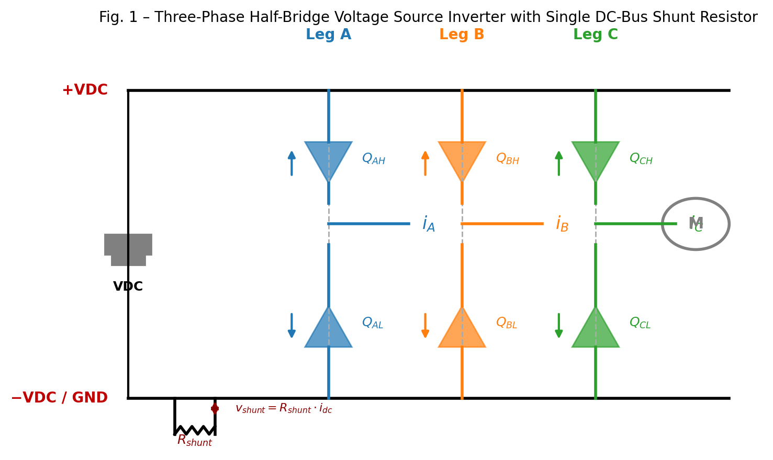
Fig. 1 – Three-Phase Half-Bridge VSI with Single DC-Bus Shunt Resistor.

III. Center-Aligned PWM: Acquisition Window Formation

III-A. Carrier Comparison and Duty Cycle
In center-aligned (symmetric, up-down counter) PWM, each phase x has a duty cycle D_x ∈ [0, 1] controlling the fraction of the period T_PWM during which Q_xH is ON and Q_xL is OFF. The turn-on time of phase x within a half-period is:

t_on,x = (T_PWM / 2) · (1 − D_x) … (3)

Because Q_xL is the complement of Q_xH (with dead time enforced), Q_xL is ON precisely when Q_xH is OFF, i.e., during [0, t_on,x] and [T_PWM − t_on,x, T_PWM]. Therefore, i_x appears on the shunt during those intervals.

III-B. Duty Cycle Ordering and Window Identification
For any PWM period, the three duty cycles are sorted:
D_max ≥ D_mid ≥ D_min (phases reassigned accordingly) … (4)
Using (3), the corresponding turn-on times satisfy t_on,max ≤ t_on,mid ≤ t_on,min. In the first half of the PWM period, the following state sequence occurs:
Time interval | Low-side switches ON | i_dc (shunt current)
[0, t_on,min] | All three | ≈ 0 (balanced, zero vector)
[t_on,min, t_on,mid] ← W₂ | max + mid only | = −i_min ← Sample 2
[t_on,mid, t_on,max] ← W₁ | max only | = i_max ← Sample 1
[t_on,max, T/2] | None (all high-side ON) | ≈ 0 (zero vector)

Table II – DC-Bus Shunt Current States in Center-Aligned PWM Half-Period.

Window W₁ corresponds to the interval when only the phase with the highest duty cycle has its low-side device ON, providing a direct measurement of i_max. Window W₂ gives i_dc = i_max + i_mid = −i_min (by Kirchhoff's current law, i_A + i_B + i_C = 0 for star-connected balanced load).

III-C. Window Width Equations
The ideal window widths within one half-period are:
W₁ = (T_PWM / 2) · (D_max − D_mid) … (5)
W₂ = (T_PWM / 2) · (D_mid − D_min) … (6)

After subtracting the dead time t_d (during which the shunt current is undefined due to switch-state transients), the effective widths are:
W₁_eff = max(W₁ − t_d, 0) … (7)
W₂_eff = max(W₂ − t_d, 0) … (8)

Reconstruction is possible for a given window when the effective width exceeds a minimum ADC acquisition time t_acq,min:
W_eff > t_acq,min (reconstruction condition) … (9)
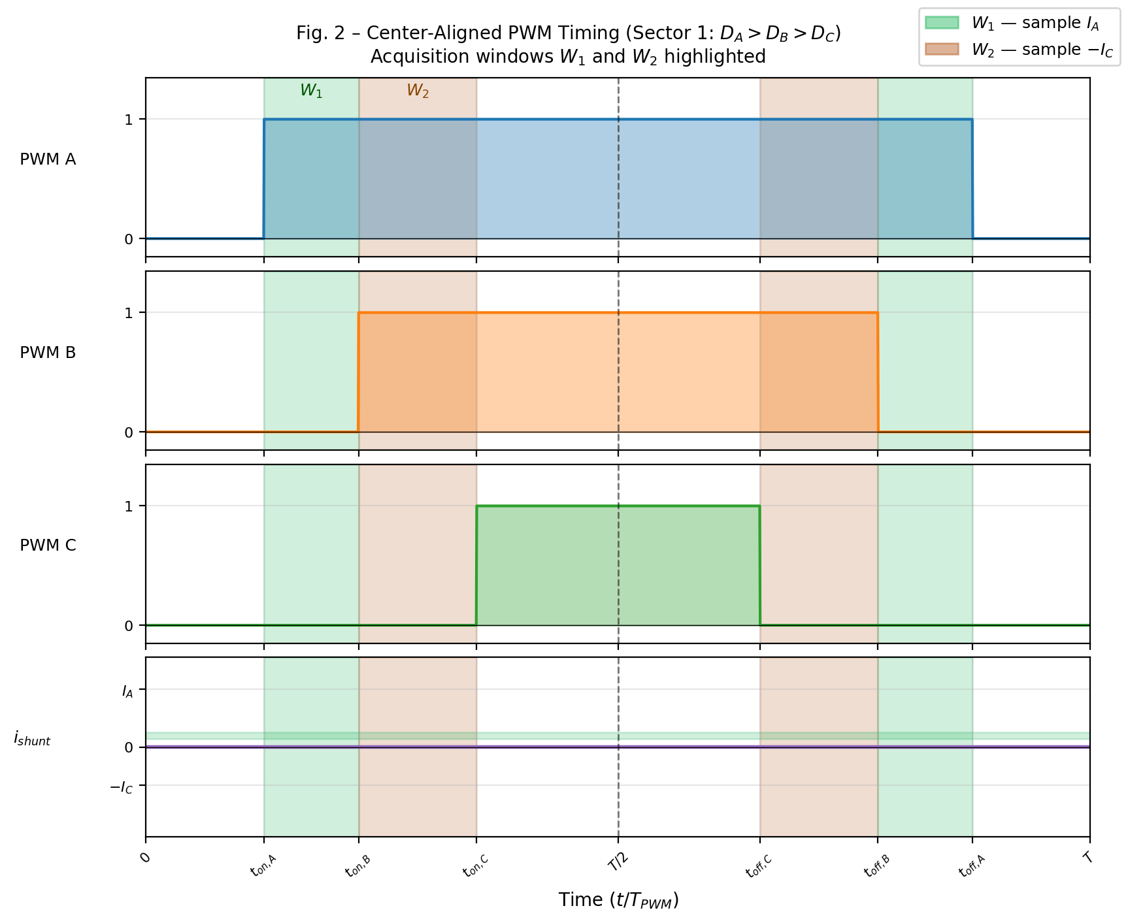
Fig. 2 – Center-Aligned PWM Timing Diagram (Sector 1, D_A > D_B > D_C). Green shading: W₁ (sample I_A); brown shading: W₂ (sample −I_C).
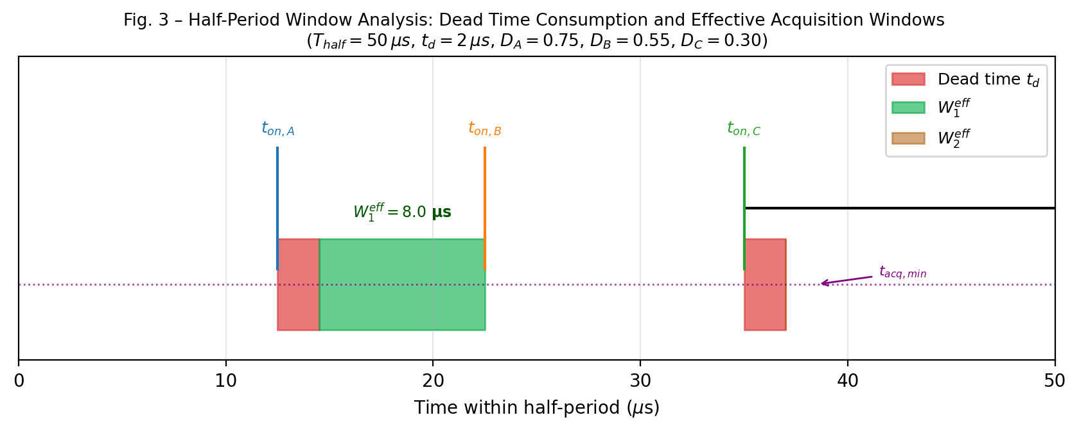
Fig. 3 – Half-Period Zoom: Dead-Time Consumption and Effective Acquisition Windows (T_half = 50 µs, t_d = 2 µs).

III-D. Current Reconstruction Identities
From the two samples, all three phase currents are obtained as follows. Let Sample 1 be taken at the center of W₁ and Sample 2 at the center of W₂:
î_max = Sample₁ … (10)
î_min = −Sample₂ … (11)
î_mid = −î_max − î_min (KCL) … (12)

The identities (10)–(12) are valid for all six SVM sectors because the window labeling always follows the sorted duty-cycle ordering of (4), regardless of which physical phase (A, B, or C) is D_max, D_mid, or D_min.

IV. SVM Sector Analysis and Phase Assignment

IV-A. SVM Hexagon and Sector Definition
Space Vector Modulation represents the three-phase voltage reference as a rotating voltage vector V_ref in the stationary αβ frame. The complex plane is partitioned into six 60° sectors, delimited by the six active voltage vectors of the inverter (Fig. 4). In each sector, the duty cycles produced by the SVM algorithm follow a known ordering of the three phases.
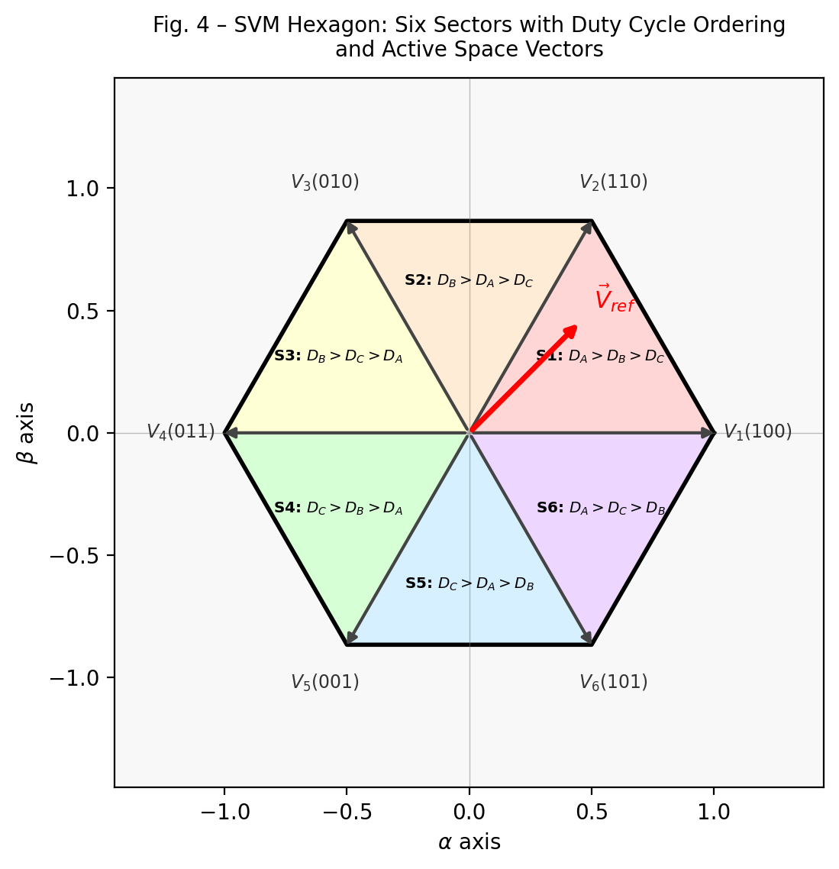
Fig. 4 – SVM Hexagon with Six Sectors and Their Corresponding Duty-Cycle Phase Orderings.

IV-B. Per-Sector Phase Ordering Table
Table III summarises the SVM sector boundaries, the duty-cycle ordering, and which physical phase current is measured by W₁ and W₂ in each sector.
Sector | θ_e range | D ordering | W₁ → measures | W₂ → measures
1 | 0° – 60° | D_A > D_B > D_C | +I_A | −I_C
2 | 60° – 120° | D_B > D_A > D_C | +I_B | −I_C
3 | 120° – 180° | D_B > D_C > D_A | +I_B | −I_A
4 | 180° – 240° | D_C > D_B > D_A | +I_C | −I_A
5 | 240° – 300° | D_C > D_A > D_B | +I_C | −I_B
6 | 300° – 360° | D_A > D_C > D_B | +I_A | −I_B

Table III – SVM Sector Duty-Cycle Ordering and Corresponding Shunt Measurements (W₁ and W₂).

IV-C. Extension to All Modulation Modes
The acquisition window algorithm of (5)–(9) is modulation-agnostic: it requires only the instantaneous per-period duty cycles D_A, D_B, D_C. However, different modulation strategies produce different duty-cycle profiles and therefore different window-width distributions over the electrical cycle.
Modulation Mode | Common-Mode Injected | Window-Width Characteristic
SPWM (Sinusoidal) | None | Smaller windows; D differs by up to 0.5·MI
THIPWM 1/6 | 1/6 × sin(3θ) | Moderate windows; 15% bus utilisation gain
THIPWM 1/4 | 1/4 × sin(3θ) | Near-SVM performance at explicit injection cost
Custom THIPWM | k × sin(3θ), k adjustable | Windows scale with injection factor k
SVM | Vmin/2 + Vmax/2 | Widest windows; optimal for SSCR (reference)
DPWM120 MAX | Clamp max to 1 for 120° | W₁ or W₂ collapses near clamp edge
DPWM120 MIN | Clamp min to 0 for 120° | Similar to MAX but at D=0 boundary
DPWM60 / DPWM30 | Alternating clamp strategies | Narrower but distributed blind zones

Table IV – Modulation Modes and Their Impact on SSCR Acquisition Windows.
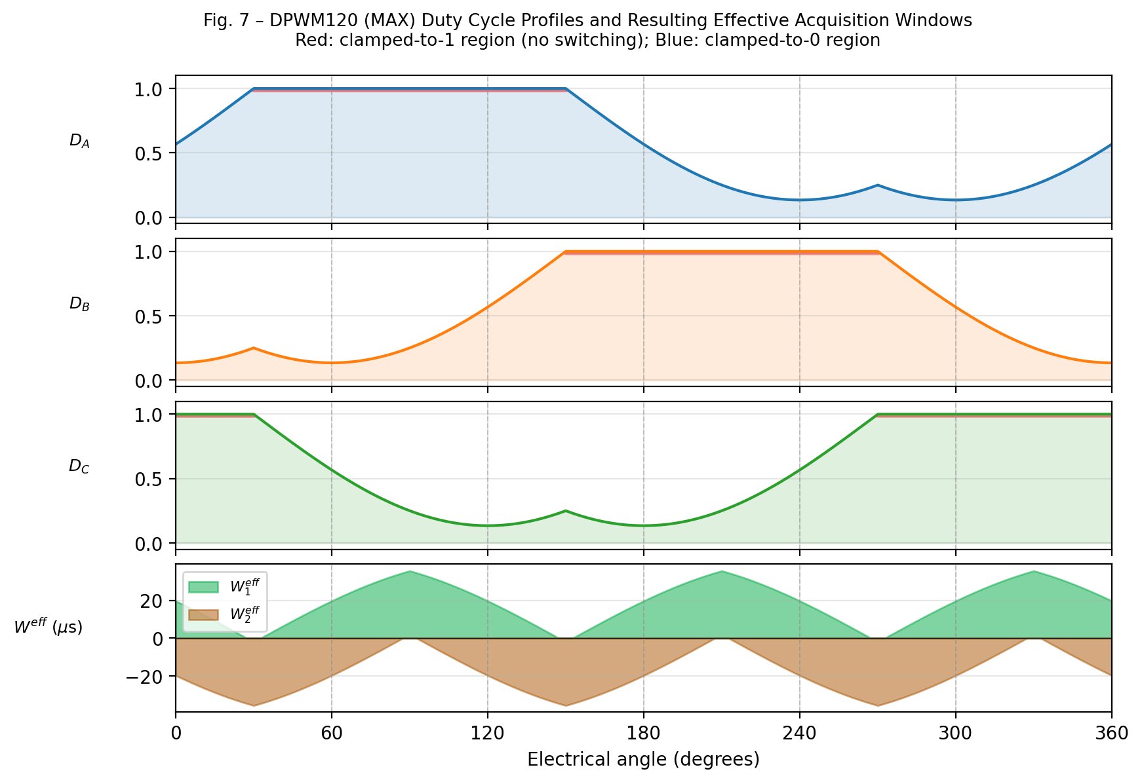
Fig. 7 – DPWM120 (MAX) Duty Cycle Profiles and Effective Acquisition Windows. Red: clamped-to-1 region; Blue: clamped-to-0 region.

V. Blind Zones: Analysis and Characterisation
Blind zones arise whenever one or both effective window widths fall below t_acq,min. Two distinct mechanisms produce blind zones:
- Sector boundary transition: As θ_e approaches a 60° boundary, the reference vector rotates toward the adjacent active vector. The two phases with closest duty cycles exchange their ordering (D_max ↔ D_mid or D_mid ↔ D_min), causing W₁ or W₂ to shrink to zero and then grow again in the new sector. The angular width of the blind zone depends on the modulation index MI and the PWM frequency ratio N = f_PWM / f_e.
- Clamped-phase effect (DPWM modes): When one phase is clamped to D = 1 (or D = 0), its turn-on time is at the very beginning (or end) of the half-period. This forces W₁ or W₂ to collapse to zero for the entire clamped region (typically 60° or 120°).
The angular extent of a sector-boundary blind zone Δθ_blind for W₁ is (for SVM):
Δθ_blind ≈ (2 / (π · MI)) · arcsin( (t_d + t_acq,min) / (T_PWM / 2) ) … (13)
For a typical drive: T_PWM = 100 µs (10 kHz), t_d = 2.5 µs, t_acq,min = 1.5 µs, MI = 0.8, Δθ_blind ≈ 7.5° on each side of a sector boundary, for a total of ~15° per sector boundary (12 boundaries per full cycle → ~180° total out of 360°).
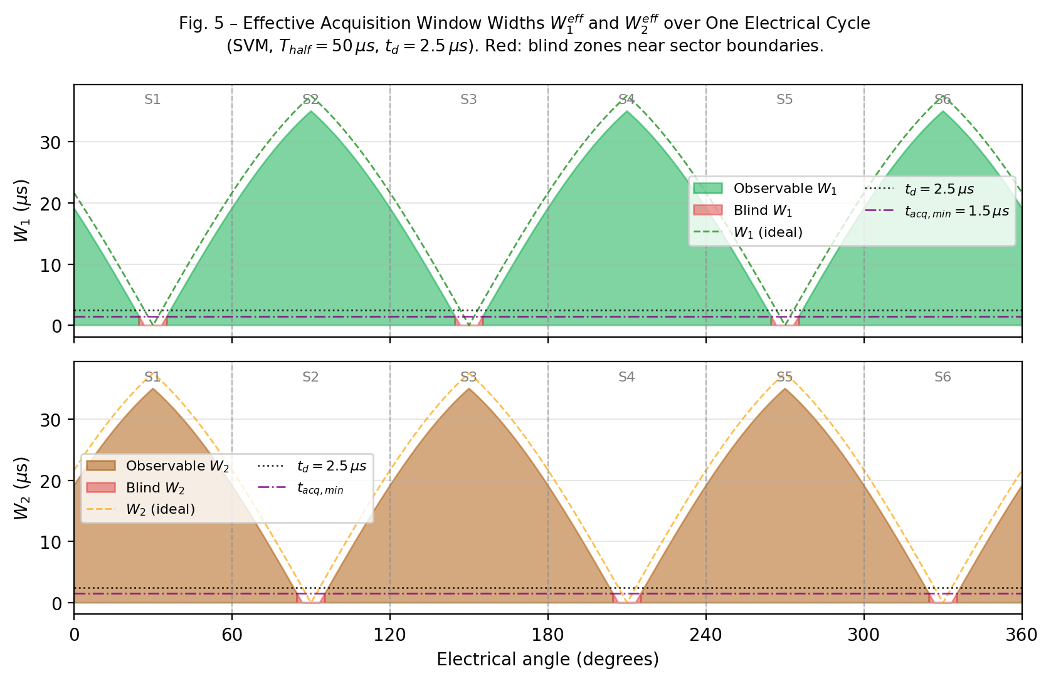
Fig. 5 – Effective Acquisition Window Widths W₁_eff (top) and W₂_eff (bottom) over One Full Electrical Cycle (SVM, T_half = 50 µs, t_d = 2.5 µs). Red areas indicate blind zones near sector boundaries.

VI. Blind Zone Compensation for Center-Aligned PWM

VI-A. Strategy Overview
Three main compensation strategies exist for center-aligned PWM blind zones [6][7]:
- Minimum pulse insertion: Forces a minimum separation between consecutive switching events. When |D_max − D_mid| < W_min / T_half, the duty cycles are artificially spread: D_max is increased and/or D_mid is decreased by δ = W_min / T_half until the window is measurable. This introduces a small voltage error that must be compensated by a feed-forward dead-time correction term.
- Duty-cycle redistribution: Redistributes the separation deficit symmetrically: one half is added to D_max and the other half subtracted from D_mid, minimising the fundamental voltage error compared to unilateral insertion.
- Phase-current estimation (hold-last-value): When neither W₁ nor W₂ is observable (deep blind zone), the last valid measurement is held and a model-based predictor (first-order Kalman filter or simple integrator) extrapolates the current. This is acceptable for a few consecutive PWM periods but degrades with longer blind zones.
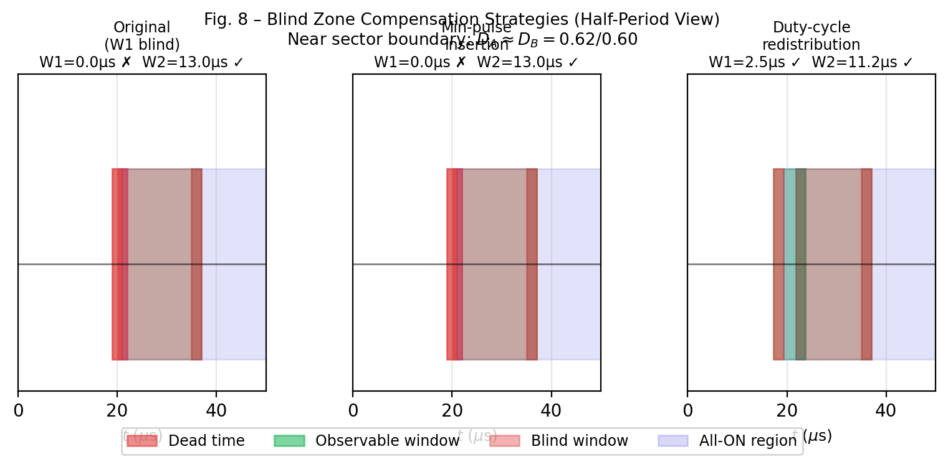
Fig. 8 – Blind Zone Compensation Near Sector Boundary (D_A ≈ D_B). Left: original (W₁ blind). Centre: min-pulse insertion. Right: duty-cycle redistribution.

VI-B. Voltage Error Analysis
Minimum-pulse insertion introduces a duty-cycle perturbation δ per phase. The resulting fundamental output voltage error is proportional to δ · V_DC / T_PWM. For δ = W_min / T_half with W_min = t_d + t_acq,min = 4 µs and T_half = 50 µs:
ΔV_output = δ · V_DC = (4 µs / 50 µs) · V_DC = 0.08 · V_DC (maximally, at boundary) … (14)
This error is localised to the narrow angular region near the sector boundary. Feed-forward correction inverts the perturbation on the next period, limiting steady-state current ripple to within the dead-time compensation error band.

VII. Edge-Aligned PWM and Phase-Shift Strategy

VII-A. Left-Aligned PWM Timing
In left-aligned (edge-aligned up-count) PWM, all three phase pulses start at t = 0. The turn-off times are:
t_off,x = D_x · T_PWM (left-aligned) … (15)
All three switching events are clustered near the beginning of the period. For the shunt to capture two independent measurements, transitions must be sufficiently separated. In the sorted ordering, the timing structure is:
W₁_LA = T_PWM · (D_max − D_mid) − t_d … (16)
W₂_LA = T_PWM · (D_mid − D_min) − t_d … (17)
Note that factors are T_PWM (not T_PWM / 2 as in center-aligned), because the asymmetric carrier has no symmetry benefit. This means edge-aligned PWM provides twice the nominal window width compared to center-aligned for the same duty cycle difference — but the windows occur only once per period, not twice.

VII-B. Right-Aligned PWM Timing
In right-aligned PWM, all pulses end at T_PWM. Turn-on times are:
t_on,x = T_PWM · (1 − D_x) (right-aligned) … (18)
The window equations remain identical in form to (16)–(17) because the relative separations between turn-on events are the same as for left-aligned turn-off events.

VII-C. Phase-Shift Strategy for Edge-Aligned PWM
A fundamental limitation of standard edge-aligned PWM is that all three switching transitions occur within a short burst at the start (or end) of the period, increasing EMI and potentially producing zero-window conditions when duty cycles are close. The phase-shift strategy addresses this by adding a static time offset Δt_x to each phase's PWM reference:
t_off,x_shifted = D_x · T_PWM + Δt_x (shifted PWM) … (19)
The shifts are chosen to guarantee a minimum separation between any two transitions. A common choice for three phases is:
Δt_A = 0 … (constant reference) … (20a–c)
Δt_A = 0, Δt_B = T_PWM/6, Δt_C = T_PWM/3 … (20)
With this choice, the transitions of B and C are guaranteed to be separated from A by at least T_PWM / 6, creating observable windows even when D_A ≈ D_B ≈ D_C (the worst case for window-width collapse in standard edge-aligned PWM). The phase shifts introduce a fundamental output voltage phase offset that can be compensated by adjusting the SVPWM reference angle accordingly.
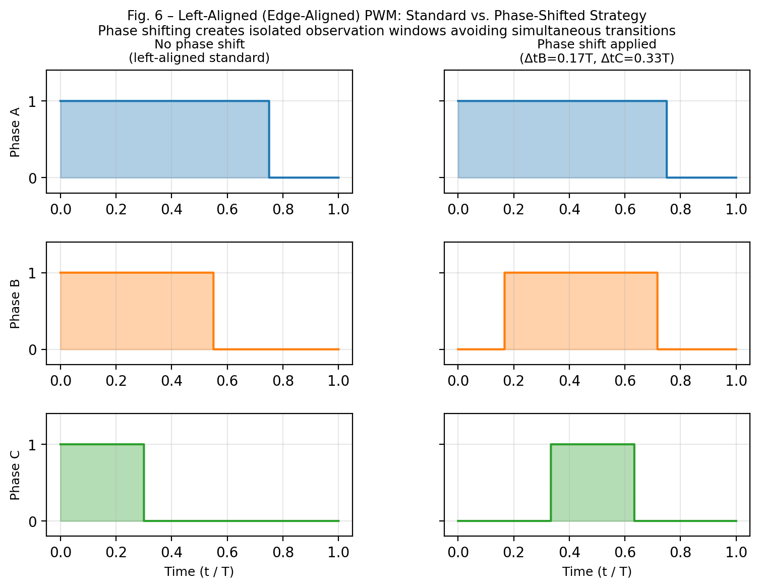
Fig. 6 – Left-Aligned PWM: Standard (left) vs. Phase-Shifted Strategy (right). Inter-phase time offsets create isolated measurement windows.

VIII. Integration in the SVM Analyst Tool

VIII-A. New Module Architecture
The SSCR feature is implemented as a new Python module svm_shaper/single_shunt.py containing pure numpy computation, plus a SingleShuntDialog class in gui.py. The module exposes the following public API:
- compute_single_shunt_analysis(config, result): Computes the full per-period acquisition analysis from an existing SimulationResult.
- get_sector_from_angle(theta_deg): Returns SVM sector (1–6) for a given electrical angle.
- get_duty_ordering(d_a, d_b, d_c): Returns sorted (max, mid, min) with associated phase labels.
- build_pwm_period_pulse_shapes(period, dead_time_us): Builds time-domain pulse shape arrays for a single PWM period, suitable for the zoom view.

VIII-B. Four-Panel Pedagogy Viewer
The SingleShuntDialog provides a four-panel animated view:
- Slow-time modulation panel: Shows the three-phase duty cycle envelopes (D_A, D_B, D_C) over one full electrical cycle with SVM sector colour bands and a time cursor.
- SVM hexagon panel: Displays the αβ-plane hexagon with the active sector highlighted and the reference vector rotating synchronously with the cursor position.
- PWM period zoom panel: Shows the selected period's three pulse waveforms at high resolution, with dead-time gaps highlighted in red and W₁, W₂ acquisition windows highlighted in green (observable) or red (blind).
- Acquisition info panel: Textual display: current sector, duty cycle ordering, W₁ and W₂ widths, which phase is measured, reconstruction feasibility, and KCL identity used.
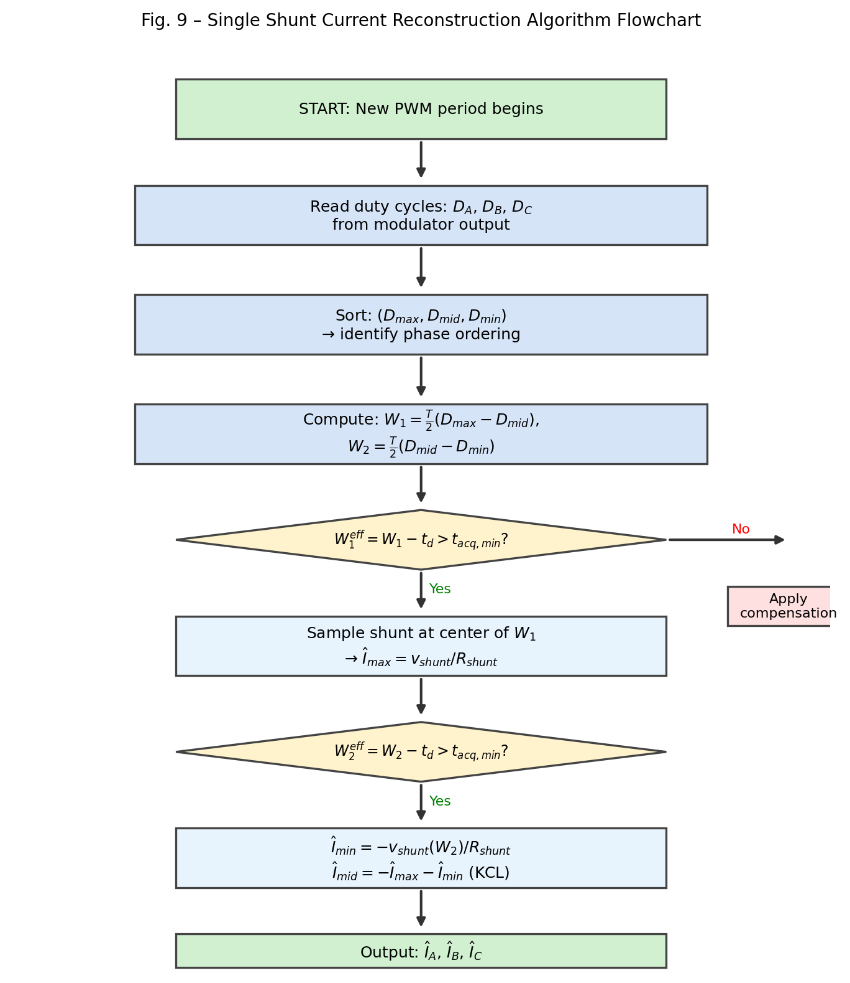
Fig. 9 – Single Shunt Current Reconstruction Algorithm Flowchart implemented in svm_shaper/single_shunt.py.

VIII-C. Compensation Strategy Selector
A drop-down menu in the SingleShuntDialog allows selecting the active compensation mode:
- None (display blind zones only — pedagogic mode)
- Minimum pulse insertion (adaptive δ per period)
- Duty-cycle redistribution (symmetric δ/2 adjustment)
- Hold-last-value predictor (for deep blind zones)
The selected strategy's duty-cycle perturbation is applied only to the time-domain visualisation and acquisition info within the dialog; it does not modify the main simulation result stored in SimulationResult.

IX. Conclusion
This report has presented a rigorous treatment of single shunt DC-bus current reconstruction for three-phase PWM inverters. The key contributions are:
- A unified window-width formula (5)–(8) valid for all duty-cycle orderings, all modulation modes, and both center-aligned and edge-aligned carriers.
- A per-sector phase assignment table (Table III) mapping shunt measurements to physical phase currents for all six SVM sectors.
- A quantitative blind-zone analysis (13) estimating the angular extent of reconstruction failure as a function of modulation index, PWM frequency, and dead time.
- A comparative evaluation of SPWM, THIPWM, SVM, and six DPWM variants with respect to their inherent SSCR window-width profiles (Table IV, Fig. 7).
- Three compensation strategies for center-aligned PWM blind zones, with a voltage-error bound (14).
- A phase-shift strategy for edge-aligned PWM that guarantees observable windows independent of the duty cycle values (20).
- An integration plan for the SVM Analyst simulation tool, implementing the above as a dedicated pedagogical viewer (svm_shaper/single_shunt.py, SingleShuntDialog).

X. Symbol Glossary
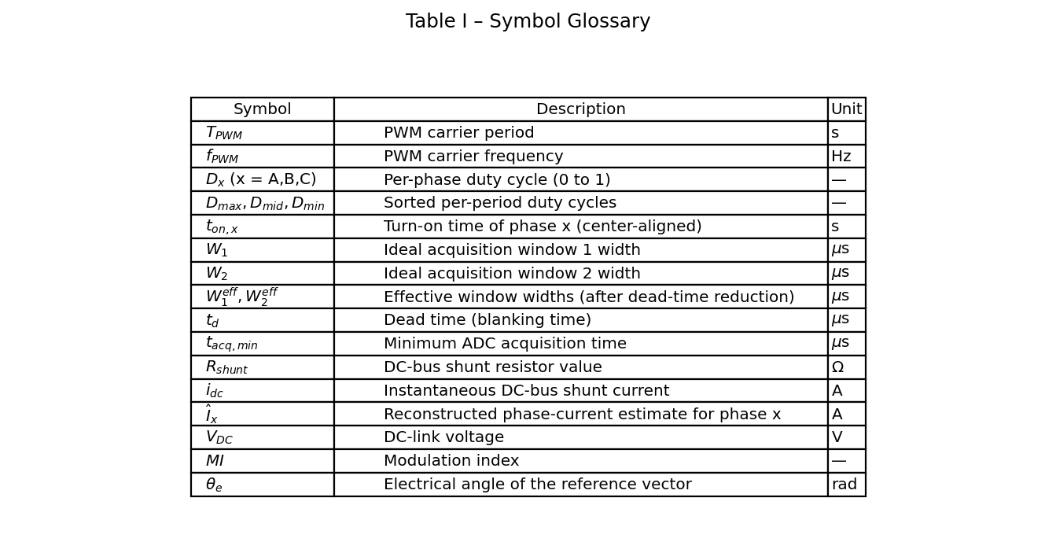
Table I – List of Symbols and Notation Used in This Report.

References
- [1] P. Vas, Sensorless Vector and Direct Torque Control, Oxford University Press, 1998.
- [2] J.-S. Kim and S.-K. Sul, 'New approaches for high-performance pulsed-width modulation with one current sensor,' IEEE Trans. Power Electron., vol. 11, no. 3, pp. 409–417, May 1996.
- [3] H. W. van der Broeck, H.-C. Skudelny, and G. V. Stanke, 'Analysis and realization of a pulsewidth modulator based on voltage space vectors,' IEEE Trans. Ind. Appl., vol. 24, no. 1, pp. 142–150, Jan./Feb. 1988.
- [4] M. Corley and R. Lorenz, 'Rotor position and velocity estimation for a salient-pole permanent magnet synchronous machine at standstill and high speeds,' IEEE Trans. Ind. Appl., vol. 34, no. 4, pp. 784–789, Jul./Aug. 1998.
- [5] J. Holtz, 'Pulsewidth modulation – a survey,' IEEE Trans. Ind. Electron., vol. 39, no. 5, pp. 410–420, Oct. 1992.
- [6] H. Kim, T. Jahns, 'Phase current reconstruction for AC motor drives using a DC link single current sensor and measurement voltage vectors,' IEEE Trans. Power Electron., vol. 21, no. 5, pp. 1413–1419, Sep. 2006.
- [7] L. Woo-Cheol, L. Taek-Kie, and H. Dong-Seok, 'A three-phase current-mismatch problem in a 3-phase AC power conditioning system using a single current sensor,' IEEE Trans. Power Electron., vol. 15, no. 6, pp. 1049–1056, Nov. 2000.
- [8] D. G. Holmes and T. A. Lipo, Pulse Width Modulation for Power Converters: Principles and Practice. Wiley-IEEE Press, 2003.
- [9] A. Hava, R. Kerkman, and T. Lipo, 'Simple analytical and graphical methods for carrier-based PWM-VSI drives,' IEEE Trans. Power Electron., vol. 14, no. 1, pp. 49–61, Jan. 1999.
- [10] R. Teodorescu, M. Liserre, and P. Rodriguez, Grid Converters for Photovoltaic and Wind Power Systems. Wiley-IEEE Press, 2011.

