Wergonic Resource Cleanup

1. Reclaimable Resources

Resource | Where | Size / detail
Orphaned droplet snapshot | DigitalOcean | 19.93 GB, created 2024-12-13
480 orphaned session folders | Firebase prod | ~1.5 GB
“django-unused” app | DigitalOcean | basic-xs, last deploy 2026-03-19
“wergonics-dev” Firebase project | Firebase dev | 0 objects (empty)

3. Top Organization #24 — RISE Ridskolan Projekt
Active span: 2024-01 → 2025-09 • Total sessions: 167 • Firebase: 4.95 GB • Postgres (sensor): 24.64 GB • Combined: 29.59 GB
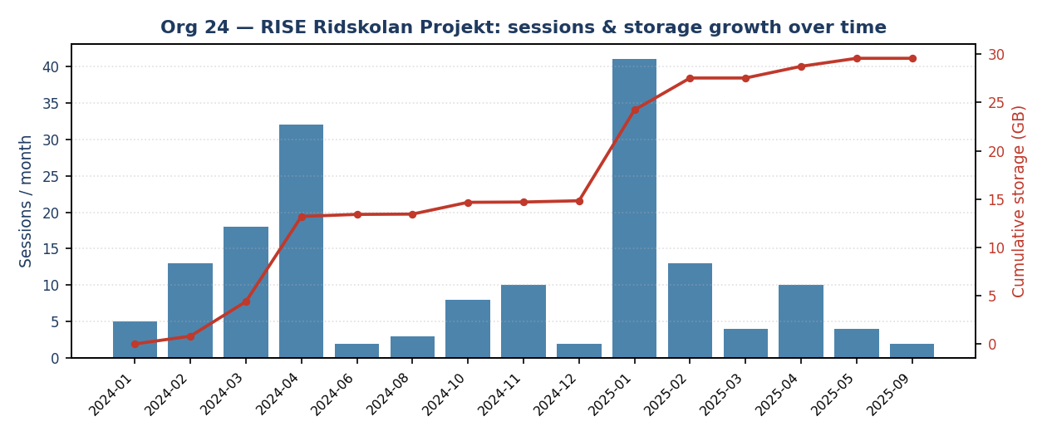
Month | Sessions | Firebase MB | Postgres MB | Combined GB
2024-01 | 5 | 11.9 | 0.0 | 0.01
2024-02 | 13 | 81.8 | 737.8 | 0.80
2024-03 | 18 | 410.9 | 3258.3 | 3.58
2024-04 | 32 | 1027.9 | 8004.8 | 8.82
2024-06 | 2 | 22.7 | 194.9 | 0.21
2024-08 | 3 | 3.0 | 27.2 | 0.03
2024-10 | 8 | 1251.7 | 0.0 | 1.22
2024-11 | 10 | 33.6 | 0.0 | 0.03
2024-12 | 2 | 135.6 | 0.0 | 0.13
2025-01 | 41 | 1357.3 | 8274.6 | 9.41
2025-02 | 13 | 449.6 | 2927.3 | 3.30
2025-03 | 4 | 0.6 | 3.8 | 0.00
2025-04 | 10 | 163.5 | 1072.8 | 1.21
2025-05 | 4 | 116.3 | 734.0 | 0.83
2025-09 | 2 | 0.0 | 0.0 | 0.00
TOTAL | 167 | 5066.3 | 25235.5 | 29.59

4. Top Organization #31 — KTH Thesis Work
Active span: 2025-02 → 2026-04 • Total sessions: 255 • Firebase: 3.41 GB • Postgres (sensor): 21.9 GB • Combined: 25.3 GB
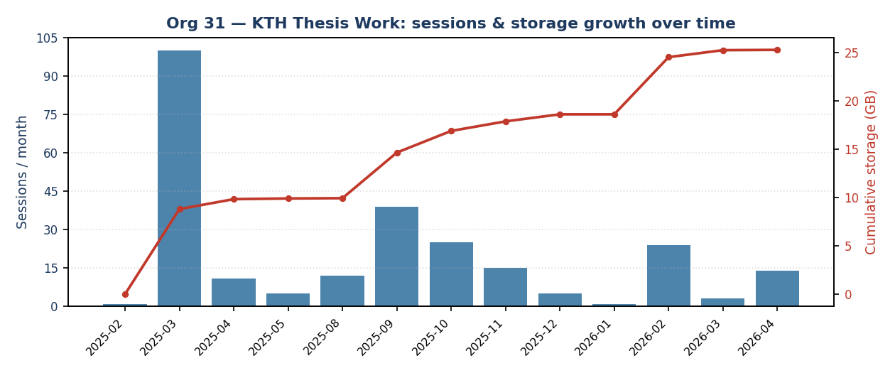
Month | Sessions | Firebase MB | Postgres MB | Combined GB
2025-02 | 1 | 0.8 | 6.8 | 0.01
2025-03 | 100 | 1310.6 | 7713.5 | 8.81
2025-04 | 11 | 213.3 | 844.3 | 1.03
2025-05 | 5 | 10.2 | 63.8 | 0.07
2025-08 | 12 | 4.1 | 26.5 | 0.03
2025-09 | 39 | 497.8 | 4336.5 | 4.72
2025-10 | 25 | 263.5 | 2025.2 | 2.24
2025-11 | 15 | 137.2 | 881.2 | 0.99
2025-12 | 5 | 79.3 | 669.5 | 0.73
2026-01 | 1 | 0.1 | 0.7 | 0.00
2026-02 | 24 | 885.3 | 5175.9 | 5.92
2026-03 | 3 | 84.7 | 653.3 | 0.72
2026-04 | 14 | 3.5 | 24.2 | 0.03
TOTAL | 255 | 3490.3 | 22421.4 | 25.30

