Commit tp3-1

Client

Server

Execution

Test de thread partir de l’ordinateur de mon collègue avec lipv4 de mon pc

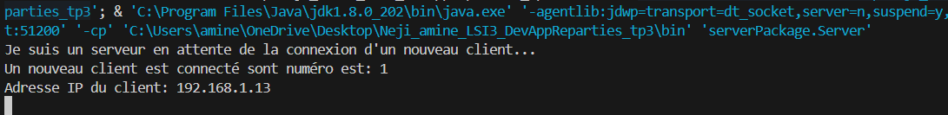

Test de thread avec le commande telent localhost

