Commit tp3_2:

Class serlizable operation:

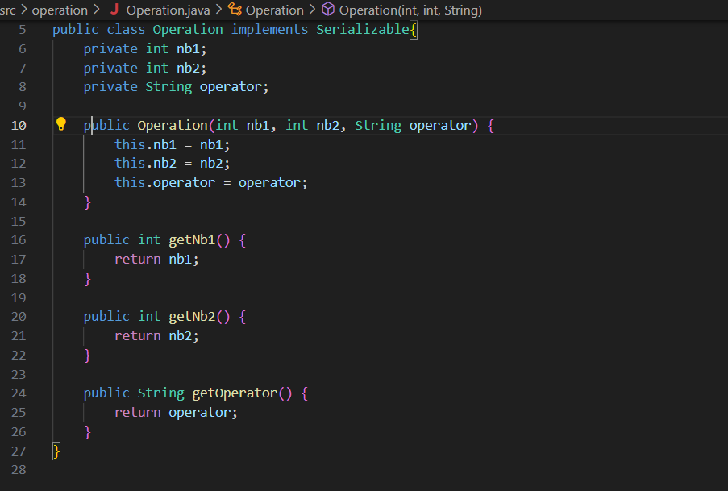

Class client

Class serveur

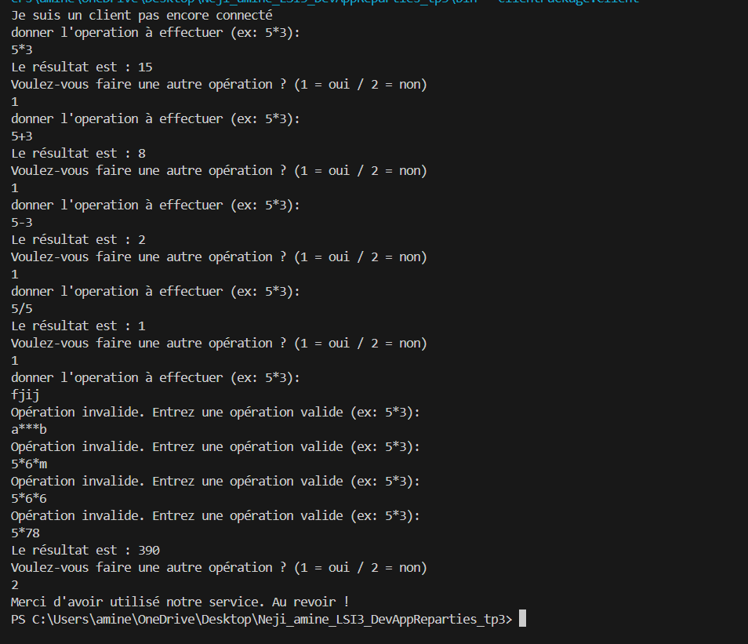Execution:

Test de connexion parallel: