Deep RL Assignment 1 Warmup Amin Ghafari Zeydabadi 25911193

Please check HW_README.md for instructions on how to run the codes

Section 2. Warmup

The mean loss function vs. iterations
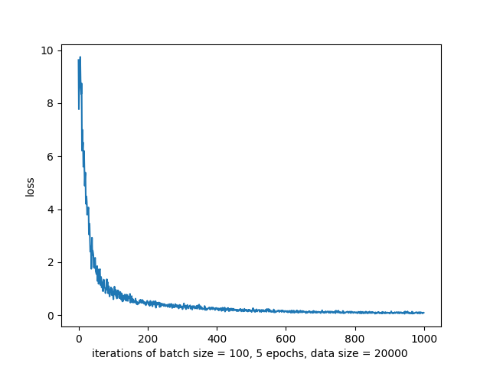

Section 3. Behavioral Cloning

1. Same network and iteration numbers for each case:

- A neural network with 3 fully connected hidden layer with 40, 40, and 20 nodes.
- Data size = 20000
- Number of epochs = 20
- Number of rollouts to find mean and std = 20

 | Expert-mean | Expert-std | Trained-mean | Trained-std
Hopper-v1 | 3778.45 | 3.72 | 445.81 | 216.96 | Not a good result
Ant-v1 | 4758.84 | 398.61 | 4425.80 | 239.27 | Comparable result

2. Hyperparameter: the number of training epochs,

Here we see how the number of training epochs affect the “returns” from the trained policy for Hopper-v1 and Ant-v:
- A neural network with 3 fully connected hidden layer with 40, 40, and 20 nodes.
- Data size = 20000
- epoch step = 5
- Number of rollouts to find mean and std = 20
- Number of epoch iteration = 10
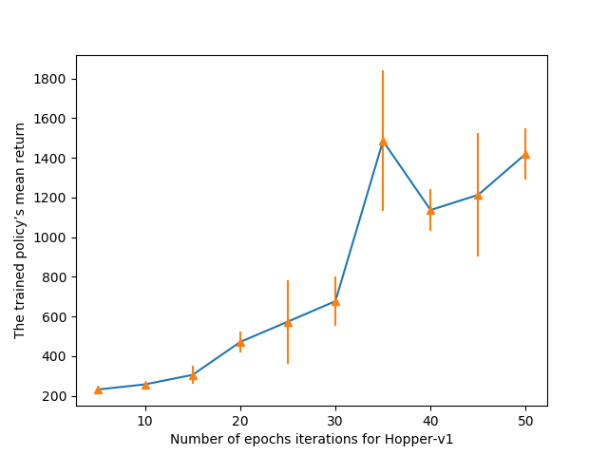
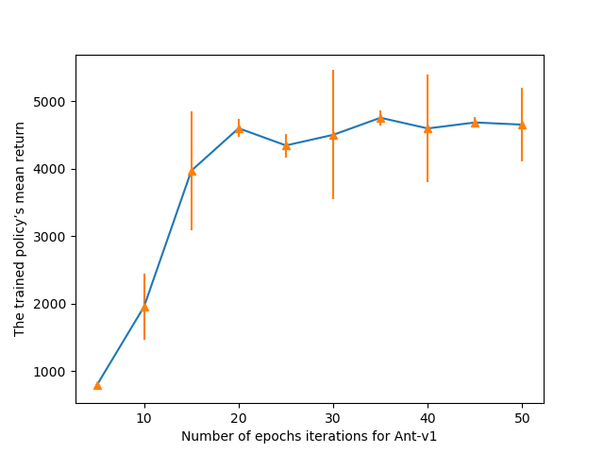

Section 4. DAgger

Hopper-v1
- A neural network with 3 fully connected hidden layer with 40, 40, and 20 nodes.
- Data size = 20000
- Number of epochs for each training = 20
- Number of rollouts to find mean and std = 20
- Number of Dagger iterations = 20

