Deep RL Assignment 3 Amin Ghafari Zeydabadi 25911193

Question 1

Run run_dqn_atari.dy default inputs.

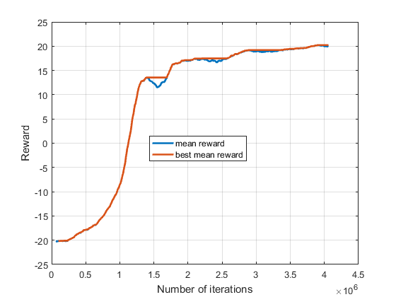

Question 2

Run run_dqn_ram.dy for different target update frequency.

Note: this part is done by run_dqn_ram.dy

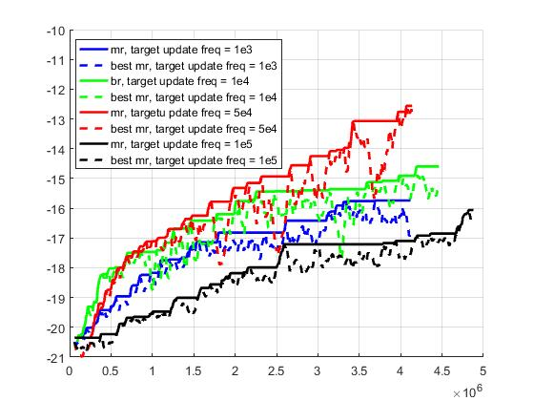

This is done to find the approximate the number which after that we should update our target function to get a better reward function in less time steps. Here if we update the target function after 5e4 time steps, the reward converges faster.