**WordPress**

**WordPress Install**

Download WordPress from <https://wordpress.org/download/>

Its installation prerequisites are Web server and Database.

Please refer to below link.

<https://codex.wordpress.org/Installing_WordPress#Famous_5-Minute_Installation>

**WordPress Plugins：**

1. **Simply Static**

Install and active Simply Static to generate static html files.

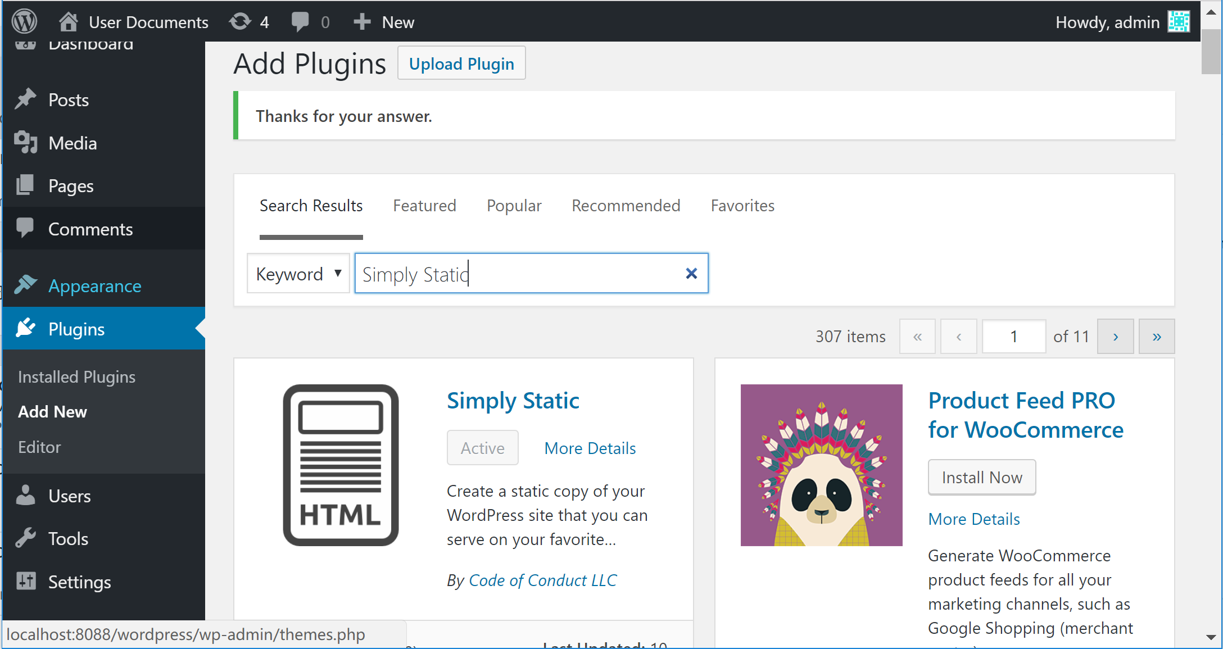

After installed, you can see the menu item on the left, you can set your settings.

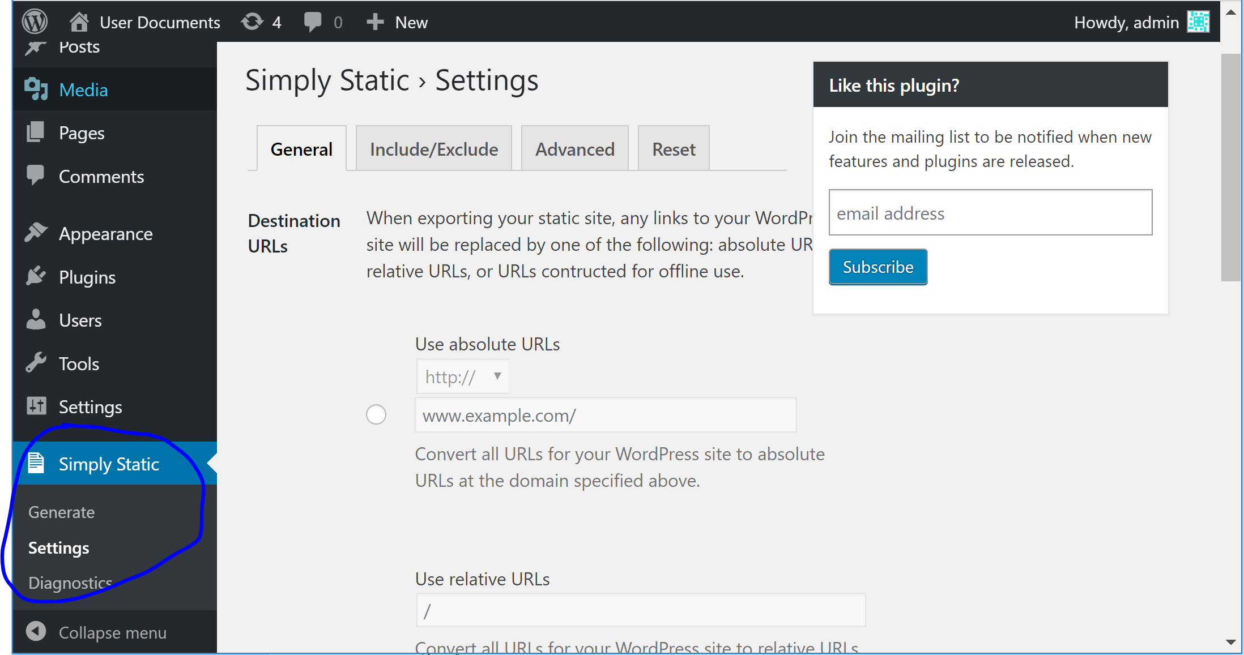

1. **Mammoth .docx converter**

Install and active Simply Static to import docx document.

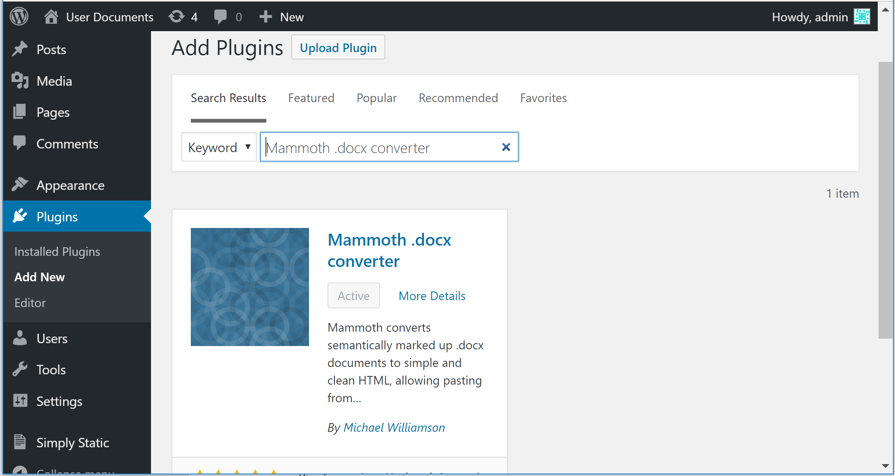

After installed, when you add new or edit post you can see the function at the bottom of the page, it allows you import docx document directly which contains both text and image.

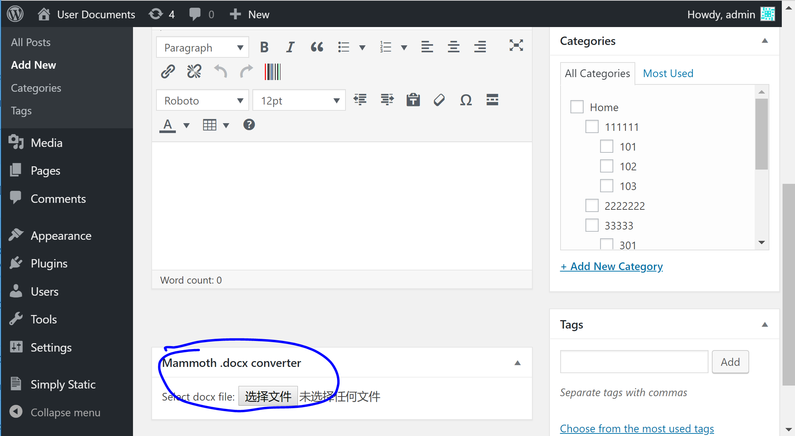

1. **Breadcrumb NavXT**

Install and active **Breadcrumb NavXT** to show navigation bar automatic.

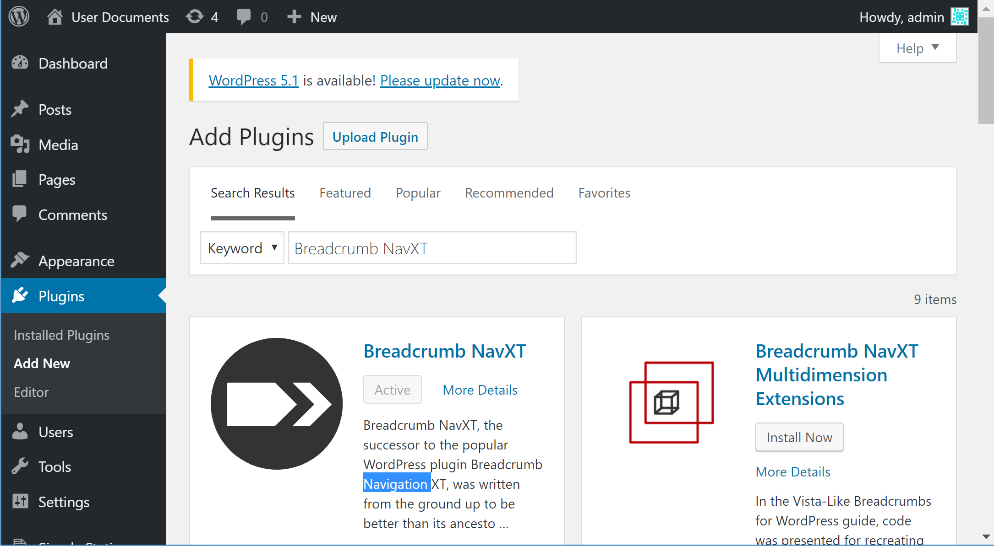

After installed, you can see the navigation bar on the page.

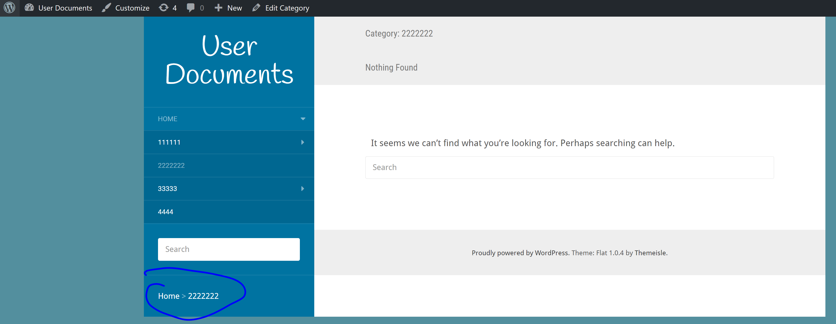

1. **Themes**

You can install and active theme which you need.

