**Virtual portfolio specification**

The virtual is a MINOTORE is a small customizable and easy to implement tool that aims to give the clients of LYXOR a better perspective of their investments and to test trading strategies in the past.

This document aims to give a better view of this project and to specify the needs taken from a previous version.

1. After logging in the user can consult his portfolios from the “Portfolio Manager” page and preform operations like create, read, update and delete portfolio.

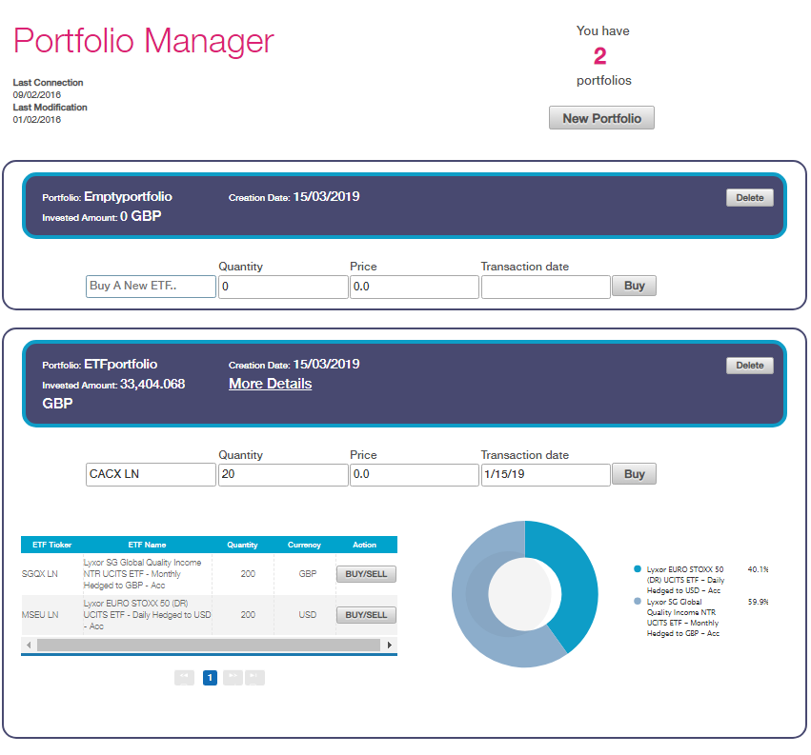

1. A user can create as many portfolios as he wishes by specifying a name and currency

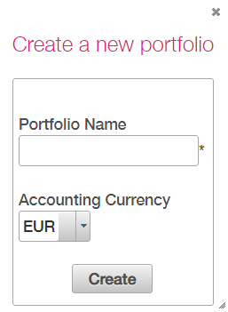

1. The user can get more data about the portfolio by clicking on More Details.

* **Overview:**
* ETF composition:

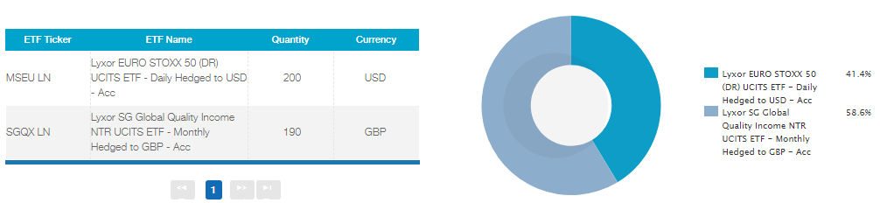Formula: (ETF quantity / total Number of shares) * 100 %

* Asset Class Composition:

The percentages of Fixed income, Commodities and equity of the portfolio.

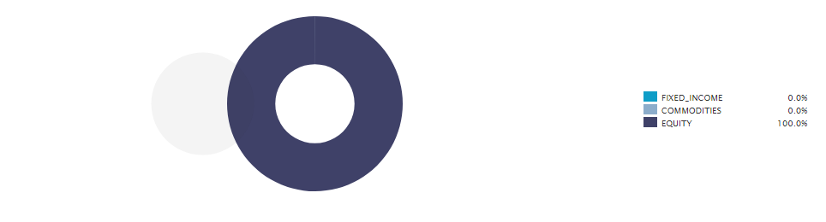

* Sectorial Breakdown:

The sectors (Financials, Industrials, Communication services, Health care, Consumer Discretionary, Information Technology, Consumer staples and Others) percentages of the portfolio.

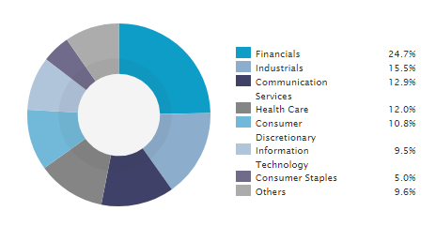

* Currencies Breakdown:

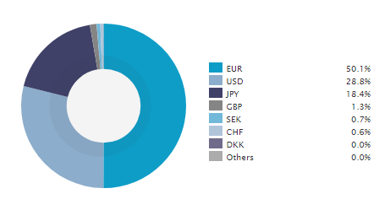The currencies (EUR, USD, JPY, GBP, SEK, CHF, DKK and others) percentages of the portfolio.

* **Profit & Loss:**
* Historical Realized Profit and Loss:

Show the cumulated profit and loss made by the user in the past only when position is reversed (buy than sell) in the form of area charts.

Formula:

Sum (price of bought ETFs * Quantity of bought ETFs) - Sum (price of Sold ETFs * Quantity of sold ETFs)

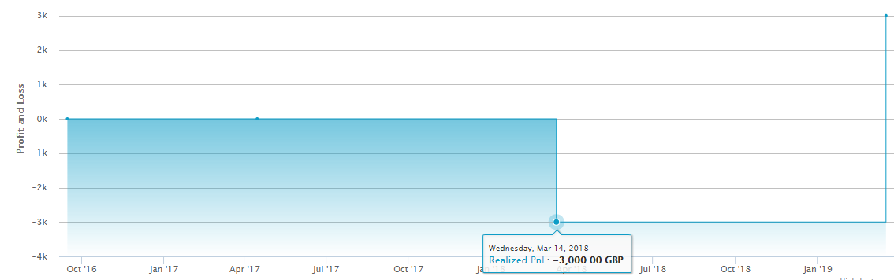

* Historical Unrealized Profit and Loss:

Show the cumulated profit and loss in case a user has sold the ETFs in the portfolio. The user can specify the time interval in which he wishes to see the investment potential, in the past.

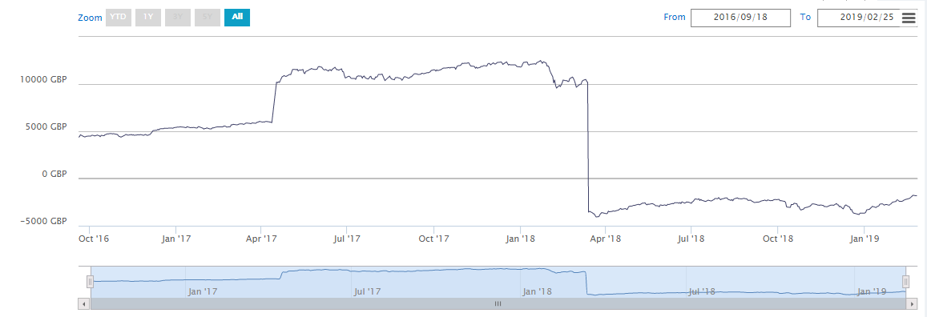

* **Portfolio Risk:**

Calculate the cumulated risk, volatility, ratios and correlation of the hole portfolio.

Formulas will be added later…

* **Transactions:**
* History of transactions:

get the list of all the transactions performed by this portfolio.

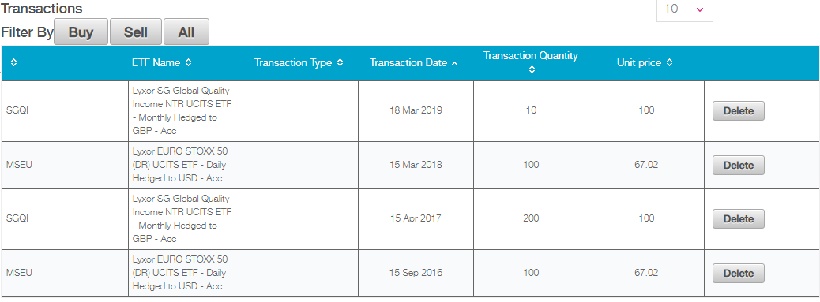

* **Documents:**
* Gives access to Factsheets, Prospectus, KIID, Annual Reports, Semi-Annual Reports, Notice to shareholder, UKRFS Reports of each ETF index in the user’s portfolio.

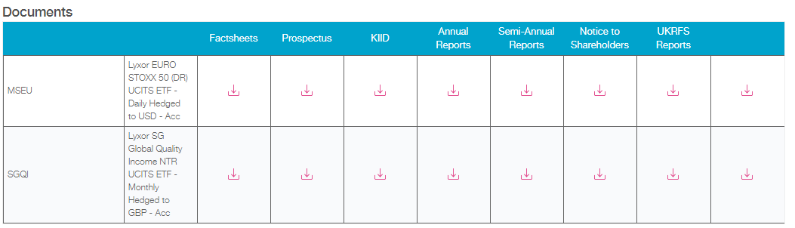

1. The user can buy a new ETF using the basic form on the “Portfolio Manager” page:

Constraints:

* ETF must exist.
* The Quantity must be greater than 0.
* The price must be greater than 0.1.
* Transaction date must be in the past.

Notes :

How could transaction be so unreal !

The model calculating profit and loss Is giving weird results.

A constraint must be added in a realistic way …..