**PURCHASE AND SALE AGREEMENT**

**BY AND BETWEEN**

**STIRLING BRIDGE GENERAL TRADING , HAIKOU, CHINA**

Represented by: **STIRLING BRIDGE CHEMICALS TRADING L.L.C , DUBAI, U.A.E.**

**and**

**SUD-CHEMIE INDIA PVT. LTD , GUJARAT, INDIA**

Represented by: **A T S HEAVY EQUIPMENT AND MACHINERY SPARE PARTS TRADING LLC , DUBAI, U.A.E.**

THIS PURCHASE AND SALE AGREEMENT is entered into this 18TH DAY OF DEC 2018, by and between **STIRLING BRIDGE GENERAL TRADING , HAIKOU, CHINA** Represented by: **STIRLING BRIDGE CHEMICALS TRADING L.L.C , DUBAI, U.A.E.** (hereinafter referred as "Buyer") with office address at the DUBAI, U.A.E. and **SUD-CHEMIE INDIA PVT. LTD , GUJARAT, INDIA** Represented by: **A T S HEAVY EQUIPMENT AND MACHINERY SPARE PARTS TRADING LLC , DUBAI, U.A.E..**

**RECITALS:**

**WHEREAS**, the **SUD-CHEMIE INDIA PVT. LTD , GUJARAT, INDIA** Represented by: **A T S HEAVY EQUIPMENT AND MACHINERY SPARE PARTS TRADING LLC , DUBAI, U.A.E..**  and **STIRLING BRIDGE GENERAL TRADING , HAIKOU, CHINA** Represented by: **STIRLING BRIDGE CHEMICALS TRADING L.L.C , DUBAI, U.A.E.**  can enter into this Sale and Purchase Agreement and sign pertinent documents with fullrights under terms and conditions specified therein;

**WHEREAS**, the **SUD-CHEMIE INDIA PVT. LTD , GUJARAT, INDIA desires to sell the Products defined below and the STIRLING BRIDGE GENERAL TRADING , HAIKOU, CHINA**  desires to purchase the Products from **SUD-CHEMIE INDIA PVT. LTD , GUJARAT, INDIA.**

**NOW THEREFORE**, in consideration of the mutual covenants and the agreements herein contained and other goods and valuable (the receipt and sufficiency of which are hereby acknowledged) the parties agree as follows:

1. **Sale of Product. SUD-CHEMIE INDIA PVT. LTD , GUJARAT, INDIA** hereby sells to **STIRLING BRIDGE GENERAL TRADING , HAIKOU, CHINA**  and **STIRLING BRIDGE GENERAL TRADING , HAIKOU, CHINA**  hereby purchases from **SUD-CHEMIE INDIA PVT. LTD , GUJARAT, INDIA** GERMANY the product details below:

|  |  |  |  |  |  |
| --- | --- | --- | --- | --- | --- |
| **SR. NO.** | **DESCRIPTION** | **UNIT OF MEASUREMENT** | **QTY** | **UNIT PRICE** | **AMOUNT** |
| 1 | Ideabond Building Material Pre-Painted Aluminium Strip | 12 | TONS | 4583.333333 | 55000.0 |

1. **Purchase Price. STIRLING BRIDGE GENERAL TRADING , HAIKOU, CHINA** shall pay to **SUD-CHEMIE INDIA PVT. LTD , GUJARAT, INDIA** for the Products and for all obligations specified herein, as fulland complete consideration therefore, the sum of **55000.0 AED** (Fifty Five Thousand Dirhams only).
2. **Payment.** Payment of the Purchase Price shall be made by **STIRLING BRIDGE GENERAL TRADING , HAIKOU, CHINA** or its representative **STIRLING BRIDGE CHEMICALS TRADING L.L.C , DUBAI, U.A.E.** to **SUD-CHEMIE INDIA PVT. LTD , GUJARAT, INDIA** or its representative **A T S HEAVY EQUIPMENT AND MACHINERY SPARE PARTS TRADING LLC , DUBAI, U.A.E.** in full payment in advance before the delivery date.
3. **Acceptance.** “Acceptance" of the Product shall be deemed to occur on the date when, in the reasonable opinion of STIRLING BRIDGE GENERAL TRADING , HAIKOU, CHINA the Product conforms to the Specifications, and has continuously operated in compliancewith the Specifications for thirty (30) days after Product Turnover.
4. **Indemnification.** In the event either party breaches or is deemed to have breached any of the representations and warranties contained in this Agreement, or fails to perform or comply with any of the covenants and agreements set forth in this Agreement, it shall hold harmless, indemnify and defend the other party, and its directors, officers, shareholders, attorneys, representatives and agents, from and against any damages incurred by the non-defaulting party.
5. **General. SUD-CHEMIE INDIA PVT. LTD , GUJARAT, INDIA** shall perform this Agreement in compliance with all applicable local laws, rules, regulations, and ordinances, and represents that it shall have obtained all licenses and permits required by law to engage in the activitiesnecessary to perform its obligations under this Agreement.

____________________________________________________  
**SUD-CHEMIE INDIA PVT. LTD , GUJARAT, INDIA**

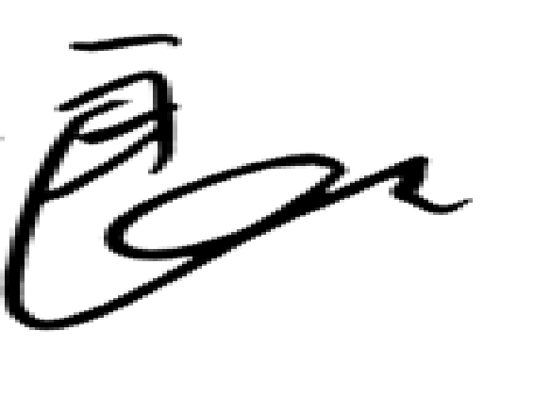

__________________________________________________________  
**STIRLING BRIDGE GENERAL TRADING , HAIKOU, CHINA**