**PURCHASE AND SALE AGREEMENT**

**BY AND BETWEEN**

**SHANGHAI SEVEN BENEVOLENCE INTERNATIONAL TRADE CO. LTD - SHANGHAI, CHINA**

Represented by: **BEYZADE GENERAL TRADING L.L.C - DUBAI, U.A.E**

**AND**

**SAUREX SPINNING SOULUTION GMBH & CO.KG - GILCHING, GERMANY**

THIS PURCHASE AND SALE AGREEMENT is entered into this 8TH day of December 2018, by and between **SHANGHAI SEVEN BENEVOLENCE INTERNATIONAL TRADE CO. LTD - SHANGHAI, CHINA** represented by **BEYZADE GENERAL TRADING L.L.C - DUBAI, U.A.E** (hereinafter referred as "Buyer") with office address at the United Arab Emirates and **SAUREX SPINNING SOULUTION GMBH & CO.KG - GILCHING, GERMANY**.

**RECITALS:**

**WHEREAS,** the **SAUREX SPINNING SOULUTION GMBH & CO.KG - GILCHING, GERMANY and SHANGHAI SEVEN BENEVOLENCE INTERNATIONAL TRADE CO. LTD - SHANGHAI, CHINA represented BEYZADE GENERAL TRADING L.L.C - DUBAI, U.A.E** can enter into this Sale and Purchase Agreement and sign pertinent documents with full rights under terms and conditions specified therein;

**WHEREAS,** the **SAUREX SPINNING SOULUTION GMBH & CO.KG - GILCHING, GERMANY** desires to sell the Products defined below and the **SHANGHAI SEVEN BENEVOLENCE INTERNATIONAL TRADE CO. LTD - SHANGHAI, CHINA** desires to purchase the Products from **SAUREX SPINNING SOULUTION GMBH & CO.KG - GILCHING, GERMANY.**

**NOW THEREFORE**, in consideration of the mutual covenants and the agreements herein contained and other goods and valuable (the receipt and sufficiency of which are hereby acknowledged) the parties agree as follows:

1. **Sale of Product**. **SAUREX SPINNING SOULUTION GMBH & CO.KG - GILCHING, GERMANY** hereby sells to **SHANGHAI SEVEN BENEVOLENCE INTERNATIONAL TRADE CO. LTD - SHANGHAI, CHINA** and **SHANGHAI SEVEN BENEVOLENCE INTERNATIONAL TRADE CO. LTD - SHANGHAI, CHINA** hereby purchases from **SAUREX SPINNING SOULUTION GMBH & CO.KG - GILCHING, GERMANY** the product details below:

|  |  |  |  |  |  |
| --- | --- | --- | --- | --- | --- |
| **SR. NO.** | **DESCRIPTION** | **UNIT OF MEASUREMENT** | **QTY** | **UNIT PRICE** | **AMOUNT** |
| 1 | 3003 O ANODIZED ALUMINUM TUBING | TONS | 47 | € 1,882.43 | € 88,474.00 |

1. **Purchase Price**.  **SHANGHAI SEVEN BENEVOLENCE INTERNATIONAL TRADE CO. LTD - SHANGHAI, CHINA** shall pay to **SAUREX SPINNING SOULUTION GMBH & CO.KG - GILCHING, GERMANY** for the Products and for all obligations specified herein, as full and complete consideration therefore, the sum of **€ 88,474.00** (EIGHTY EIGHT THOUSAND FOUR HUNDRED SEVENTY FOUR EUROS ONLY).
2. **Payment**. Payment of the Purchase Price shall be made by **SHANGHAI SEVEN BENEVOLENCE INTERNATIONAL TRADE CO. LTD - SHANGHAI, CHINA** or its representative **BEYZADE GENERAL TRADING L.L.C - DUBAI, U.A.E** to **SAUREX SPINNING SOULUTION GMBH & CO.KG - GILCHING, GERMANY** in full payment in advance before the delivery date.
3. **Acceptance**. “Acceptance" of the Product shall be deemed to occur on the date when, in the reasonable opinion of **SHANGHAI SEVEN BENEVOLENCE INTERNATIONAL TRADE CO. LTD - SHANGHAI, CHINA** the Product conforms to the Specifications, and has continuously operated in compliance with the Specifications for thirty (30) days after Product Turnover
4. **Indemnification.** In the event either party breaches or is deemed to have breached any of the representations and warranties contained in this Agreement, or fails to perform or comply with any of the covenants and agreements set forth in this Agreement, it shall hold harmless, indemnify and defend the other party, and its directors, officers, shareholders, attorneys, representatives and agents, from and against any damages incurred by the non-defaulting party.
5. **General.** **SAUREX SPINNING SOULUTION GMBH & CO.KG - GILCHING, GERMANY** shall perform this Agreement in compliance with all applicable local laws, rules, regulations, and ordinances, and represents that it shall have obtained all licenses and permits required by law to engage in the activities necessary to perform its obligations under this Agreement.

**________________________________________**

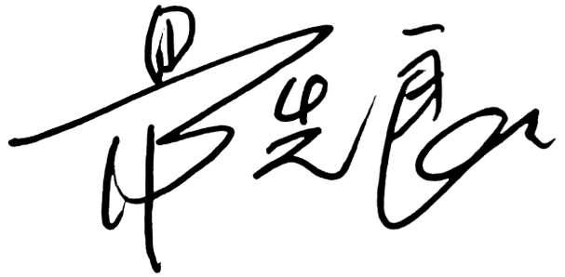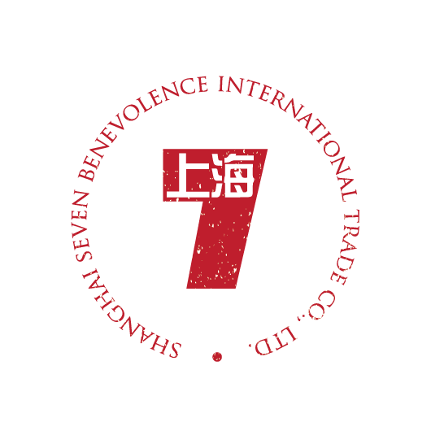**SAUREX SPINNING SOULUTION GMBH & CO.KG - GILCHING, GERMANY**

**_____________________________________________________________________________________________**

**SHANGHAI SEVEN BENEVOLENCE INTERNATIONAL TRADE CO. LTD - SHANGHAI, CHINA**