Project Deliverable 1
Amin Majdi

Recent development in technology paved the way for many new devices to pop up in the market. A considerable part of these devices uses sound as one of their communication ways. People with hearing problems are always excluded from the users of most of these devices. Video door-phone is one of these devices which works with "ringing". In this task, we will help people with hearing problems to answer the door with the help of the "stretch" robot.
We will simulate all the processes in this project using the Gazebo simulation. All the communications between the robot, doorbell and the person with a hearing problem will happen using ROS.
The robot receives a massage that somebody is at the door and departs to see who is at the door. The robot's database contains all the known people who are allowed to come in without permission. Suppose the person at the door is known to the robot. In that case, the robot will open the door and go back to the owner to let him know that somebody is coming in. if the person at the door is unknown, the robot asks the person to hold on and goes to the owner to let him know that an unknown person is at the door. If the owner gives permission, the robot will go and open the door. Otherwise, the robot will go to its home position.
The Stretch robot is a mobile robot that provides us with all the features we need in this project, like moving in the apartment, pulling, pushing, and notifying the owner. It is Gazebo-friendly, and all the required files for simulating the robot in the Gazebo environment are available. The robot has small wheels to move in the apartment and has an efficient gripper to help us open the door.
The following chart shows how the robot will react to the person at the door.

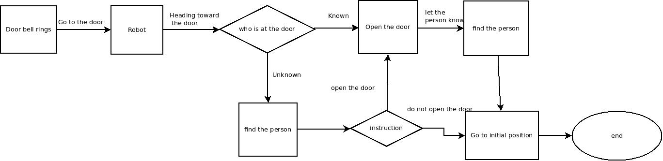
Flowchart decomposition:
Doorbell rings:
The doorbell will communicate with the robot through a Ros topic in this stage. After receiving the message from the doorbell, the robot departs to the door to get some information.
The robot goes to the door-phone
In this task, the robot knows precisely the map of the apartment and the location at which it is. This is a perception task as the robot needs to monitor all the objects around and move toward the door. The robot will do this task using depth cameras, which can help it know its location with respect to all objects around.
Recognizing the person at the door
In reality, the robot will do that using computer vision. It will analyze the door-phone screen to recognize the person at the door and find whether it knows the person or not, using its database. In this project, as the robot reaches the door, it will request a service. The ROS service will provide information about the person at the door.
Find the person
This task is also a computer vision mission. The robot needs to go to all the rooms and search for the person using its cameras. After finding the person, the robot will go near the person (Ideally stops at 1 meter distance), and the person will see the instruction on the robot's screen. If the robot asks the person about opening the door, in reality, the person can touch the screen to select the commend. The robot either goes to open the door or goes to its home position based on the command. All the communications between the robot and the person in this project will happen through ROS topics.
Opening the door
When the robot is at the door, it can approach the handle and use its gripper to open the door. To do so, the robot needs to see the door handle using its cameras. In this project, this step also happens through ROS topics.
Go to the initial position
The robot knows about its location at the moment. So this ask is the same as going to the door. The robot will find its way to go to its initial position.

