Amin Majdi

Game Name: Hit the button

The game Idea comes from the breakout game, but there is no brick to break. Instead of that, (in the simple version of the game) there is one button on the top, that the agent should hit that to win and receive the reward. So the episode will end either the agent lose or win (hit the button). My primary goal is to implement this simple game and train the agent to not lose. In a more advance game, we can add another button on the top (magic button) that every time the ball hit to that, if there is one ball in the game, the button create another ball and if there are two balls in the game the button omit that second ball which hit to that. In this game, the best strategy is creating a second ball and hit the reward button with that extra ball. This way, not only the agent receive the reward, but also the game will continue. So the agent should try to hit the magic button and create the second ball and hit the reward button and continue this circle to maximize its reward. There is no ready code for this game, but based on breakout code, It is possible to code this game in given time.

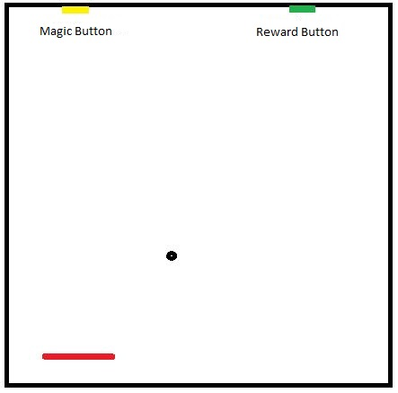

Fig.1 This picture shoes the advance game with the magic button. If the ball hit the magic button another ball will be added to the scene, but if there are two balls in the scene the magic button eliminates the ball.

