

*For Busy People*

*Learn Computer Skills Fast*

|  |  |  |
| --- | --- | --- |
|  | Introduction to PC |  |
| Microsoft Windows |  |
| Microsoft Word |  |
| Microsoft PowerPoint |  |
| Microsoft Excel |  |
| Internet Overview |  |
|  |  |
|  |  |
|  |  |
| **Amila Giragama**  [**aminogira@gmail.com**](mailto:aminogira@gmail.com)  **071-6848320** |  |
|  |  |

**1.1 Introduction to Computer**

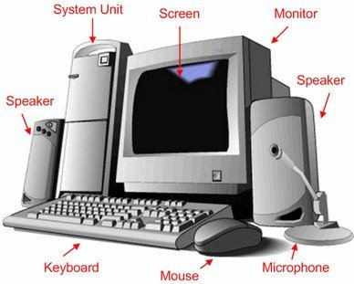

A programmable machine. The two principal characteristics of a computer are

* It responds to a specific set of [**instructions**](http://www.webopedia.com/TERM/C/instruction.html) in a well-defined manner.
* It can [**execute**](http://www.webopedia.com/TERM/C/execute.html) a prerecorded list of instructions (a [**program**](http://www.webopedia.com/TERM/C/program.html)).

Modern computers are electronic and [**digital**](http://www.webopedia.com/TERM/C/digital.html). The actual machinery wires, [**transistors**](http://www.webopedia.com/TERM/C/transistor.html), and circuits is called [**hardware**](http://www.webopedia.com/TERM/C/hardware.html), the instructions and [**data**](http://www.webopedia.com/TERM/C/data.html) are called [**software**](http://www.webopedia.com/TERM/C/software.html).

Computers can be generally classified by size and power as follows, though there is considerable overlap:

* [**Personal computer**](http://www.webopedia.com/TERM/C/personal_computer.html) **:** A small, single-[user](http://www.webopedia.com/TERM/C/user.html) computer based on a [microprocessor](http://www.webopedia.com/TERM/C/microprocessor.html). In addition to the microprocessor, a personal computer has a keyboard for entering data, a [monitor](http://www.webopedia.com/TERM/C/monitor.html) for displaying information, and a [storage device](http://www.webopedia.com/TERM/C/storage_device.html) for [saving](http://www.webopedia.com/TERM/C/save.html) data.
* [**Workstation**](http://www.webopedia.com/TERM/C/workstation.html) **:** A powerful, single-user computer. A workstation is like a personal computer, but it has a more powerful microprocessor and a higher-quality monitor.
* [**Minicomputer**](http://www.webopedia.com/TERM/C/minicomputer.html) **:** A [multi-user](http://www.webopedia.com/TERM/C/multi_user.html) computer capable of supporting from 10 to hundreds of users simultaneously.
* [**Mainframe**](http://www.webopedia.com/TERM/C/mainframe.html) **:** A powerful multi-user computer capable of supporting many hundreds or thousands of users simultaneously.
* [**Supercomputer**](http://www.webopedia.com/TERM/C/supercomputer.html) **:** An extremely fast computer that can perform hundreds of millions of instructions per second.

**1.2 Hardware Components**

Hardware is the tangible computer equipment such as a CPU, keyboard, mouse, monitor, etc.

http://www.npl.lib.va.us/Classes/Intro_Computer/keyboard.gif

|  |  |
| --- | --- |
| http://www.npl.lib.va.us/Classes/Intro_Computer/monitor.gif**Monitor**  The monitor displays the text and graphics generated by the computer. | **Keyboard**  The keyboard allows you to enter information into your computer. It is similar to a typewriter but has some different keys that perform special functions. |
| http://www.npl.lib.va.us/Classes/Intro_Computer/mouse.gif**Mouse**  The mouse is a pointing device that allows you to select and manipulate objects you see on your monitor. | http://www.npl.lib.va.us/Classes/Intro_Computer/floppy.gif**Floppy Disk (A: drive)**  Floppy disks go in the A: drive of your computer. They are removable storage on which your computer can read or write files. |
| **CD-ROM**  http://www.npl.lib.va.us/Classes/Intro_Computer/ROM.gif  The CD-ROM disks are inserted into your system's D: drive. They can store much more information than a floppy disk, but your computer cannot write to them. This is because they are Read-Only Memory (ROM). | http://www.npl.lib.va.us/Classes/Intro_Computer/harddisk.jpg**Hard Disk**    The hard disk is located inside the CPU and is similar to a floppy disk. The only differences are it cannot be removed, can store more data or files, and contains important files or programs. |
| http://www.npl.lib.va.us/Classes/Intro_Computer/printer.gif**Printer**  The printer prints text and pictures you create on your machine. | **Speakers or headphones**  http://www.npl.lib.va.us/Classes/Intro_Computer/speakers.gifhttp://www.npl.lib.va.us/Classes/Intro_Computer/headphones.gif    The headphones and Speakers allow the user to hear the audio portion of a program. |
| http://www.npl.lib.va.us/Classes/Intro_Computer/cpu2.gif**Central Processing Unit (CPU)**  The unit houses the brain of your computer, including the memory, power supply, and central processor. All other components are considered peripheral. |  |

Mouse

**Wheels**

**Left Click**

**Right Click**

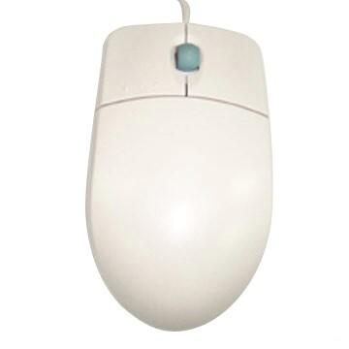

The mouse actions, by default, use the LEFT mouse button as the primary command button and the RIGHT mouse button as the alternate or menu access button. Most of the time you click the LEFT mouse button to **select** a file or folder to rename, copy, move, cut or delete it, in conjunction with the Edit Copy/ Edit Paste menus). In this document, all mouse clicks are assumed to be a LEFT click unless stated otherwise.

To **start a program** or open a file from within a folder or on the main area of the desktop you DOUBLE-CLICK the LEFT mouse button. To open a program or file from the Start menu or from the Quick launch toolbar at the bottom of your screen you SINGLE click the LEFT mouse button. Generally you will double-click the left mouse button more often than single-clicking it.

Keyboard

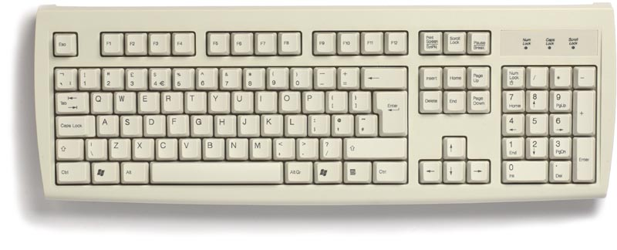

http://www.ckls.org/%7Ecrippel/computerlab/tutorials/keyboard/toprow.gif

The **Esc** key on the far left  
is the "Escape" key. The **F1 thorugh F12** keys are "function" keys.

http://www.ckls.org/%7Ecrippel/computerlab/tutorials/keyboard/secondrow.gif

The second row contains **numbers** and **symbols** (e.g., 9 and 0 contain opening and closing parenthesis).

* To type **numbers**, just press the keys.
* To type **symbols**, hold down a **Shift** key (shown below) with one hand and  
  press keys with the other hand.

http://www.ckls.org/%7Ecrippel/computerlab/tutorials/keyboard/sixthrow.gif

The keyboard has many useful ‘shortcuts’ to commands and it is worth learning some of these.

Sometimes you need to hold down the **SHIFT or CONTROL** key.

**1.3 Software**

Software is the computer programs, routines, and symbolic languages that control the function of the hardware, such as Windows, Word, Excel, etc.

1. **Operating System**  
   An operating system is the program (software) on top of which all programs run. It controls or operates the system and the relationships of the hardware and software. Windows is an example of an operating system.
2. **Application Program**

Includes programs that do real work for [users](http://www.webopedia.com/TERM/S/user.html). For example, [word processors](http://www.webopedia.com/TERM/S/word_processor.html), [spreadsheets](http://www.webopedia.com/TERM/S/spreadsheet.html), and [database management systems](http://www.webopedia.com/TERM/S/database_management_system_DBMS.html) fall under the category of applications software.

 Microsoft Word



Microsoft Power Point



Microsoft Excel

1.3. Windows

Cut, copy and paste

Three common keyboard commands involve **CUT** (remove a file or folder or document text etc. and place it somewhere else), **COPY**(keep the file or folder or text here but make a copy of it somewhere else) and **PASTE** (put what you have copied into a new place or document). The ‘menu’ way to do any of these three actions is by going the EDIT menu if it is available and then selecting CUT or COPY or PASTE.

* The keyboard way to do it involves holding down the CONTROL key (Ctrl) which is found to the left and to the right of your space bar.
* Then with the Control key held down (**make sure you have selected the folder or file or text that you want to do something to FIRST**) press the **x** key to cut (think of scissors!) or press **c** to copy (think of ‘c’ = copy) or **v** to paste (think of an arrow pointing down to where the item will go).

Microsoft Windows

A ‘window’ is the area contained within a rectangle that allows you to view something on your screen. Commonly you will have several windows open at one time (e.g. an e-mail window, an Internet window, a Word document window) and you need to know how to move from one window to another and how to move and resize windows.

|  |  |
| --- | --- |
| My Computer | Double click this Icon appeared in top left corner of the screen then u can see the My Computer Window with  (Title) in top left corner of the window and  ( Minimize , Maximize and Close Button) top right corner of the window. |

Selecting, moving and resizing Windows

 When you open most programs, there is an area on the top right of the program window where you can Minimize it (reduce it so that it disappears to the bottom of the screen inside the Quick Launch bar. This is the _ symbol (see illustration).

 The large rectangle symbol in the middle Maximize the window to fill the desktop. Clicking the button again (it changes to two intersecting rectangles when the window is Maximize) reduces it again to its original window size.  You need to reduce windows in size like this before you can move them.

 button closes the Window (and the file – so make sure you save before you close it!)

|  |  |
| --- | --- |
|  | Closes the whole program (SAVE first!) |
| Closes the document |

To move a window around your desktop

* First click the middle  window button to reduce (not totally Minimize) the window.
* Click the mouse pointer onto the title bar  blue / silver strip (depends on your Windows colour scheme) to the right of where you see the TITLE of the program or file you are working on.
* Now HOLD DOWN the LEFT mouse button and drag the window to where you want it.

Resizing a window using the mouse

This is a better way to control the size of a window and is useful if you want to have three or four windows on the desktop at the same time and want to see them side by side etc.

1. Always click the mouse in an empty white space inside the window to make sure that this window is the one ‘selected’ for the resizing.
2. Remember to click the middle reduce/increase size button to reduce the window in size so that you can see at least one or two of the edges if not all four.
3. Hover (don’t click yet) the mouse cursor/arrow over one of the edges of the screen and wait for the cursor to change to an arrow pointing in both directions like this:
4. While the mouse pointer is an arrow, click and hold down the mouse button on one of the visible corners of the window (often the bottom left or right window edges are more visible) and drag the window up diagonally to reduce it in size.

The Start Menu

|  |  |  |
| --- | --- | --- |
|  | When you click the green/silver/grey Start button (colour depends on your preferences), this is the gateway to your programs and files. The illustration and text below show you how to access various features | |
|  | | * The right hand side of the Start menu has several useful links/buttons to favourite folders (such as ‘My Documents’, ‘My Recent Documents’, ‘My Pictures’, Printers and Faxes’ etc. Single click to access these items. * Programs you have generally already used will appear down the left hand side. Single click any of these to start the program. * If you want to remove a program shortcut from this area, RIGHT click the program description (as shown) and select ‘**Remove from this list’**. The program is still on your computer as only this particular shortcut to it has been removed. * To make one of these shortcuts ALSO appear on your Desktop, RIGHT click the item and click Send To > **Desktop** * To start programs NOT listed here, click **the All Programs** button to access these. |

My Computer

|  |  |
| --- | --- |
|  | This is the heart of the computer’s file system and you can use it to find folders and files, access another drive (e.g. a floppy drive or a USB pen drive or your DVD/CD-R drive)  START > MY COMPUTER  Or double-click the MY Computer icon on the desktop  **Your hard drives**  System (C:)  Backup (F:)  Data (W:)  **Your DVD/CD-R Drive**  DVD-RAM Drive (D:)  **Your Removable USB**  Mihira (E:) |

Creating new folders and working with folders and files

If you simply kept adding files to your computer inside your folder you would eventually have a very long list of files to look at before deciding which one(s) to open. Think of a filing cabinet with papers all bundled up inside it and then think of a better alternative of having all these papers arranged inside folder dividers. To keep things organised and tidy, create new folders inside your folder. These yellow folders can be named and renamed and filed alphabetically. Inside these folders you can save your files or you can drag and drop files in My Documents into the folders you desire. You can even create shortcuts to these folders on your Desktop

Go to My Computer (double-clicking clicking the My Computer icon on your Desktop)

Open the drive where you save your data ( Data (W:) ) by double clicking

**File > New > Folder**

|  |  |
| --- | --- |
| When you create a new folder it looks as it does on the left – waiting for you to type a name. Single click (not double click) the highlighted blue area and write the name you would like this folder to be called. Do NOT include these characters: / \ = + . ; : & * $ etc |  |

Learn the basics of Personal Computers hardware/software components, Windows features, Start Menu, Taskbar, views and toolbars. Tasks include using multiple windows; opening, moving, sizing, closing, switching between windows; working with multimedia files; Cut, Copy and Paste. Students will learn File Management; how to organize files, folders, and shortcuts; work with Windows Explorer; and search for files and folders. Tasks include using the Recycle Bin, Customizing the Display, My Computer, Desktop, screen saver, wallpaper, Accessories and Control Panel.

Microsoft Word

**1.1 Start Microsoft Word**

* Click on the **Start** button in the bottom left hand corner of your computer screen.
* The Start button should be clicked once with the left mouse button.
* When the menu pops up, move your mouse up to **Programs** or **All Programs**.
* A sub menu will appear showing you all the software you have on your machine. Locate Microsoft Word
* Then click once with your left hand mouse button. Microsoft Word will start up

|  |  |
| --- | --- |
|  | The first thing to notice is the big white area dominating the screen. This is your page. Think of it as a blank piece of paper just waiting to be written on.  The most important thing on the big white area is that short vertical line at the top. Yours will probably be blinking on and off. The line is called a cursor (or caret) and this blinking is normal behavior for a cursor. |

**1.2 Saving Your MSWord Document**

|  |  |  |
| --- | --- | --- |
|  | |  |
|  | * To save the work you have just done, you'll need to use the menu bar that runs right across the top. * Locate your menu bar, and click with your left mouse button on the word "File". This menu will drop down * Move your mouse pointer to Save As and then click once with the left mouse button. You'll get the Save as dialogue box popping up. The Save As dialogue box will look like this: | |

|  |  |
| --- | --- |
|  | There are three main areas to the Save As dialogue box:  i).Where do you want to save your document?  ii).What do you want to call it?  iii).What type of document do you want to save it as? |

**Where do you want to save your document?**

|  |
| --- |
|  |
| As you can see, the Save in box says **My Documents**. This is the folder called "My Documents" that is on your C drive. In other words, if you clicked the "Save" button now, you'll be saving your work in your "My Documents" folder. |

|  |  |
| --- | --- |
|  | But you can save your work to anywhere you like on your computer. To see a list of places where you can save your work, click the little black down-pointing arrow just to the right of where it says "My Documents". You should get this |

|  |  |
| --- | --- |
|  | We can create a new folder in which to save our letter. To create a new folder, click on the New Folder icon, as shown in the image |

|  |  |
| --- | --- |
|  | You will get yet another dialogue popping up. Just go ahead and type in a name for your folder, Then click OK. Your are taken inside of your new folder. Your new folder inside the My Documents folder. |

### 1.3 Opening Microsoft Word Documents

|  |  |
| --- | --- |
|  |  |

**We'll shortly add an address** to the top of our Library Complaint letter. Before we do that, we'll learn how to open a file. After all, you might have closed down Microsoft Word, or your computer might have crashed. The result being that you no longer have your library letter loaded into Word. So here's how to Open a file you have saved, and want to work on again.

From the File menu, click **Open:**

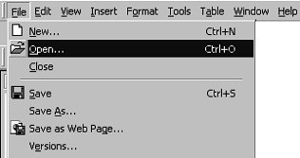

The Open dialogue box appears, and looks like the image below:

|  |  |
| --- | --- |
|  |  |

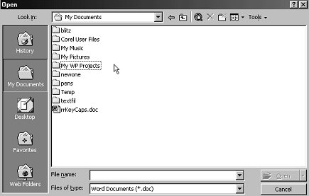

The Open dialogue box looks very similar to the Save As dialogue box. "Save in", "File name", and "Files of type" work in exactly the same way as the Save As dialogue box. Notice, though that the File name text box is blank, and the Open button is not available. It has been greyed out.

The reason that the Open button is greyed out, and therefore not available, is that text box is empty. Once you select a file, the Open button will be ready for us.

But the text box is empty because no file has been selected. A file is selected from the larger white area in the middle. Clicking on the file once with the left hand mouse button will select a file. In the previous image, there was only one file available for selection - a document called "rrKeyCaps.doc". That is not the one we want.

To locate the file we want, we need to open the folder called "My WP Projects". Because that's where we saved it. You can see from the image that this folder is in the list of folders, just below the folder called My Pictures:

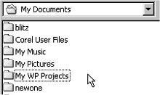

You can see also that we are in the folder called My Documents. To open up the folder we want, simply double click it. This will take us inside the My WP Projects:

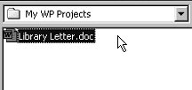

The whole Open dialogue box now looks like this:

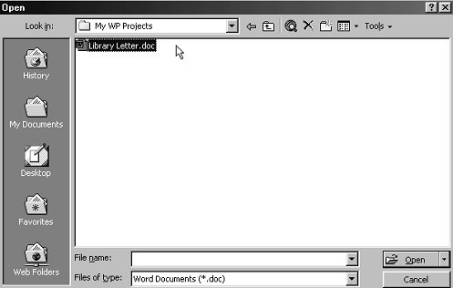

The file we want, Library Letter, has been clicked on. As a result, the Open button is no longer greyed out. We can go ahead and click it. When we do, our letter will open in Microsoft Word.

To recap then on how to open a file. Do the following

* Navigate to the folder where the file was saved
* Click on the file to select it
* Click the Open button

OK, now that you know how to Open a file, we can start adding the address to our letter.

**1.4**

**1.4 Print Document**