Microsoft Power Point

Lesson 4

|  |
| --- |
| *For Busy People Learn Computer Skills Fast* |
| **Sponsored and Conducted By**  **Softwatch Infosys (Pvt) Ltd.** |

Microsoft Power Point

Microsoft PowerPoint, part of the Office suite, is a presentation graphics application. A presentation is a combination of slides, handouts, notes, and outlines all in one file. You can add text, graphics, photos, clip art, sound and video to your slides. PowerPoint can help you present a topic at work, home, or school.

### The Parts of the PowerPoint Window

The **PowerPoint Window** has toolbars and panes to help you quickly create presentations. Most of the toolbars are common in Office applications but may feature options unique to PowerPoint.

* **Task Pane** - located on the right side of the computer screen, this pane allows you to select tasks in different categories and allows you to quickly enhance your slides in a few steps. It provides quick access to the most common actions and features in PowerPoint.

* **Outline and Slides Tabbed Pane** - allows the user to easily view the presentation in outline format (text), as well as a list of all the slides in the presentation (with visuals).
* **Help** - provides quick access to Help topics.

The default view for PowerPoint is the **Tri-Pane View**. This view, which opens when you launch PowerPoint, allows you to see multiple parts of a presentation at once.

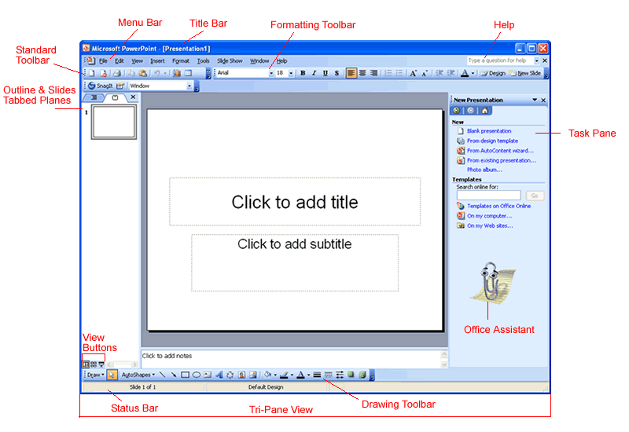

The **Outline and Slides Tabbed Panes** are located on the left side of the screen. Click on the tabs to view an outline or a slide of your presentation. The tabs render differently based on the size of the pane.

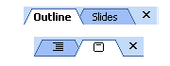

You can show or hide PowerPoint's toolbars. Click on the View menu and choose Toolbar. Decide which ones you want to show or hide.

### View Buttons and Slide Views

The **view buttons** at the left bottom corner of the screen allow three slide views: **Normal View**, **Slide Sorter View** and **Slide Show**.

View Buttons

The view buttons can be useful as you prepare your presentation. They control the way slides are displayed on the screen. Click a view button to see a different view.

**Normal View** Normal View Buttoncontains the **Outline and Slides Tabbed Panes** on the left, the **Slide pane** in the center and the **Task Pane** on the right.

The **Outline View** shows the text of your presentation for easy editing while **Slides View** shows text and graphics of the slide you're working on. Click on the tabs to switch between the two views. Under the center slide area is a place for notes.

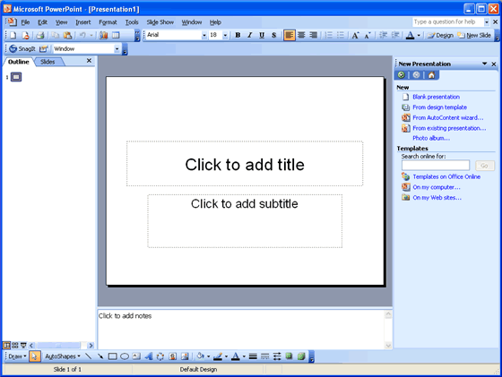

* You can hide or show the different panes in **Normal View**. To hide the Task Pane, click on the View menu and choose Task Pane. (The View menu also allows you to choose other views). To hide the Outline View and Slide Tabbed Panes, click on the X to the right of the Slides Tab.

### More Views

Here are some other views that may be useful as you create your presentations:

**Slide Sorter View** Slide Sorter View Button lets you see small versions of all the slides you have created. You can delete, copy, and move slides in this view.

**Slide Show** Slide Show Button lets you see your presentation electronically as it will appear to an audience.

### The Task Pane

The PowerPoint 2003 **Task Pane** is located on the right side of the screen. The down-pointing arrow in the top, right corner of the pane allows you to select different menus and tools. By default, the Task Pane appears when PowerPoint is launched.

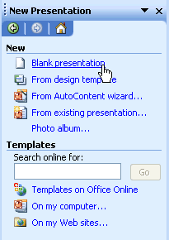

The **Slide Layout** and **Slide Design** panes within the Task Pane help organize layouts, design templates, and color schemes. When you select a design option, your slides are quickly updated with the new look.

You can view the Slide Layout and Slide Design panes by clicking on the **down-pointing arrow** next to **New Presentation** in the Task Pane.

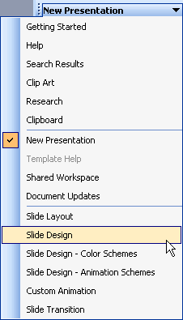

Select Slide Layout or Slide Design (Design Templates, Color Schemes, Animation Schemes). You'll learn more about using these panes later in this course.

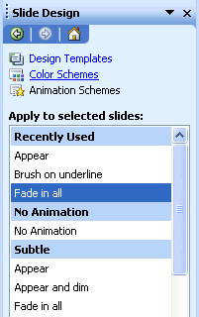

### Using the Task Pane

If you do not see the Task Pane on the right side of the PowerPoint window, you can easily access it.

##### To Open the Task Pane:

* Click **View****Task Pane**

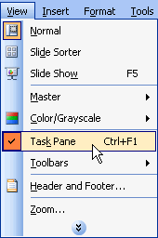

##### To View Different Panes:

* Click on the **down-pointing arrow** next to **New Presentation** and select different panes.
* Once you open different panes, you can move through them by clicking on the backward and forward arrow buttons at the top of the task pane.



##### To Close the Task Pane:

* Click the **X** on the right corner of the bar.

http://www.gcflearnfree.org/graphics/lessons/com_lesson_check.gifYou can hide or view the Task Pane by clicking on **View** **Task Pane**.

### Pull-Down Menus

PowerPoint’s menu bar initially displays commands that you most often use. To view infrequently used commands from a menu, use **pull-down menus**.

##### To View Commands in a Pull-Down Menu:

* Click on a menu in the menu bar. (File, Edit, View, Insert, etc.)
* Move your mouse pointer over the double arrows at the bottom of the pull-down menu.

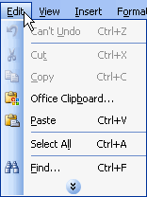

Notice that some menus have black arrows to the right. Slide your mouse pointer over the arrow to view more options. These are called **cascading menus**.

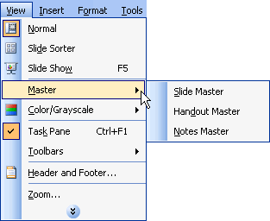

### Creating a Blank Presentation

PowerPoint offers three ways to create a presentation: **Blank presentation**, **From Design Template** or **From AutoContent Wizard**.

The Blank presentation option is one of the more commonly used methods. It offers several blank slides with layouts for text and graphics.

##### To Create a Blank Presentation:

* Open PowerPoint.
* A slide featuring a place for a title and subtitle appears by default. You may begin your presentation with this slide or choose a different slide layout.

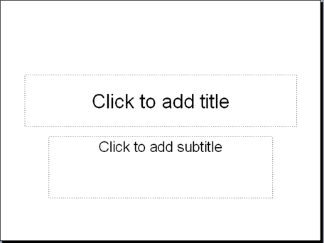

* The **New Presentation Pane** appears on the right side of the screen.
* Under **New**, click **Blank Presentation**.
* A list appears.

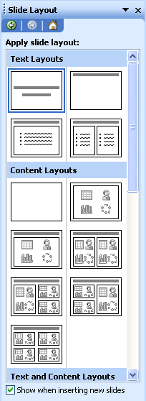

### Choosing a Slide Layout

As you work on your presentation, think about the type of layout you want. Do you want a slide with text and lots of clip art or one with text and a chart? PowerPoint offers many layout options.

##### To Choose a Slide Layout:

* Move your arrow pointer over the layouts or use the scroll bar in the **Slide Layout Pane**.
* A gray bar appears on the right of each layout.
* When you find a layout that you like, click the down-pointing arrow and choose Apply to Selected Slide.

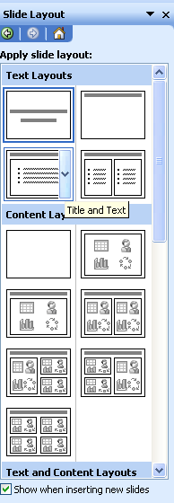

You can also click on the slide layout to apply it. Notice that the slide you are currently working on has a dark border in the Outline Pane.

### Placeholders

Once you choose a layout for your slides, you can begin adding text, graphics or other items. You do this with **placeholders** - specials places within a slide where you can add content.

##### To Add Text to a Placeholder:

* Click on the placeholder.
* Start typing.



(You'll learn about inserting clip art and other graphics into placeholders later in this course)

### Saving a Presentation

You can save, close, and exit presentations in PowerPoint just as you would while using other Microsoft applications.

##### To Save a Presentation:

* Click on **File** **Save**. (Ctrl + S)

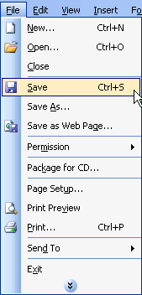

* Choose the location where you want to save your presentation. (My Documents is a good place).
* Type a name in the **File Name** box or keep the one that PowerPoint has provided.

### Adding a Design to an Existing Presentation

Do you have an existing presentation that you want to add a design to? PowerPoint makes it easy to enhance existing slides with a design template.

##### To Apply a Design to an Existing Presentation:

* Open PowerPoint.
* In the **Getting Started Task Pane**, under **Open**, click on the presentation you want or select **More...** to browse through the files.
* Click on the down-pointing arrow in the **Getting Started pane** and choose **Slide Design - Design Templates**.
* A list of templates appears.

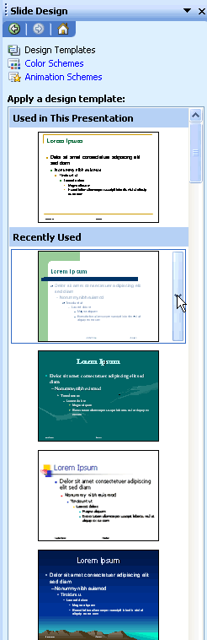

* Move your mouse pointer through the different designs or use the scroll bar.
* Click on the down-pointing arrow in the gray box next to the template that you like.
* Choose **Apply to All Slides**.

**Applying a Design Template to Selected Slides**

As you are working on your presentation, you can choose **Apply to Selected Slides** if you want one or more slides to have a different look.

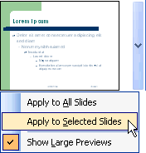

### Choosing a Color Scheme

PowerPoint's Design Templates have pre-selected colors but you can choose your own **color scheme**. A color scheme is a combination of colors for the text and background of your slides.

##### To Choose a Different Color Scheme:

* In the **Task Pane**, click on the down-pointing arrow in the gray bar next and choose **Slide Design - Color Schemes**.

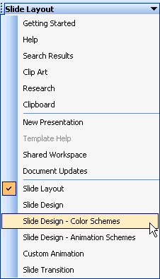

* A list of color schemes appears.
* Move your arrow pointer through the different color scheme options or use the scroll bar.
* When you find a color scheme that you like, click on the down-pointing arrow in the gray box and choose **Apply to All Slides**.

### Adding Text to an Original Slide

Many of PowerPoint's slides have text boxes already included and ready for you to add information. However, if you create an original slide you'll need to add a text box or two.

##### To Add Text to an Original Slide:

* Insert a **blank New Slide**.

Insert 
Blank Slide

* Click on the **Text Box button** in the **Drawing Toolbar**.

Insert Textbox button

* Click and drag your mouse pointer to create a text box on the slide.

Drag textboxOR

* Click on **Insert** **Text Box**.

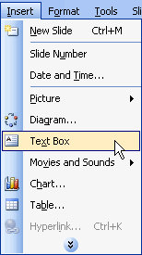

* Click and drag your mouse pointer to create a text box.

Drag textbox

**The Formatting Toolbar**

PowerPoint's default font or text type is Arial. However, you may want to change the font type, font size and more. Use the **Formatting Toolbar** to set the color, size, and overall look of your text. It doesn't matter whether the text is an original slide or is in a preset layout.

Here are some of the formatting options:

* Font type
* Font size
* Bold, Italics, and Underline
* Center, Align Left, and Align Right
* Bullets and Numbering
* Font color
* Increase Font Size
* Decrease Indent

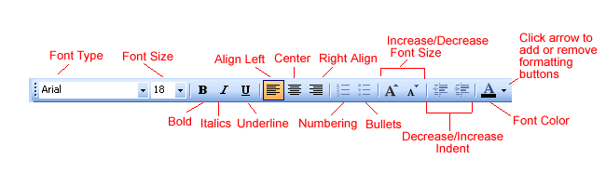

For more formatting buttons, click on the down-pointing arrow at the end of the toolbar. Choose **Add or Remove Buttons - Formatting**. Choose any additional options you want on the Formatting Toolbar. You can also choose **Show Buttons on Two Rows**.

### Formatting Text

The Formatting Toolbar allows you to make many changes to your text to give it the look you want for your presentation.

##### To Format Text

* In the Formatting Toolbar, click on the down-pointing arrow OR button for the item you want to format.
* For example, to set the font size for text you haven't typed yet, click on the down-pointing arrow next to the number and choose the font size. To change the font color, click on the down-pointing arrow next to the "underlined" A.

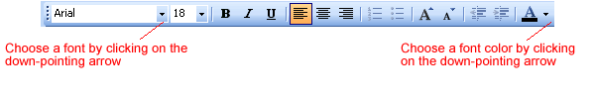

* To make formatting changes to existing text, highlight the text and click on the down-pointing arrow OR button for the formatting change.

Select text

### Take some time to experiment with the different formatting options to decide what's best for your presentation. Animating Slides

**Animating slides** involves adding movement and sometimes sound to text or to the slides in a presentation. Animation can help create a livelier and more interesting slide show. PowerPoint provides some preset animation or allows you to customize the animation to fit your needs.

##### To Animate Slides using Animation Schemes:

* Open the PowerPoint presentation that you want to work on.
* Select the slide that you want to animate.
* In the **Task Pane**, click the down-pointing arrow and select **Slide Design - Animation Schemes**.

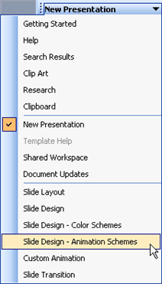

**Choosing Animation for Your Slides**

PowerPoint offers several options for animating your slides.

* Once you click on **Slide** **Design Animation Schemes**, the **Slide Design pane** appears with a list of options.



* Click on an **Animation Scheme** that you think might work well in your presentation. (To preview your choice, make sure that the AutoPreview option is checked).
* Preview different schemes to see which one best fits your slides.
* You can apply different animation to each individual slide or click on **APPLY TO ALL SLIDES**.
* Once you have applied your animation you can click on **Play** or **Slide Show** to view it.
* Remove animation by selecting **No Animation** in the white box.

**1.1 Start Microsoft Excel**

* Click on the **Start** button in the bottom left hand corner of your computer screen.
* The Start button should be clicked once with the left mouse button.
* When the menu pops up, move your mouse up to **Programs** or **All Programs**.
* A sub menu will appear showing you all the software you have on your machine. Locate Microsoft Excel
* Then click once with your left hand mouse button. Microsoft Excel will start up

|  |  |
| --- | --- |
| ex03_excelws | The first thing to notice is the big white cell area dominating the screen. This is your page. Think of it as a grid of paper just waiting to be Calculation.  The Microsoft Excel Most Probably use for Financial Calculation & Accounting part. If we add Formulas & more it will work. Also this is fully different from Microsoft Word  Also called a spreadsheet, the Workbook is a unique file created by Excel. |

**1.2 Component of Excel Window**

|  |  |  |
| --- | --- | --- |
| untitled | | * Here Title Bar & Menu bar Of the Excel Sheet |
| The Excel 2003 Toolbar | * Some commands in the menus have pictures or icons associated with them. These pictures may also appear as shortcuts in the Toolbar. | |
| The Excel 2003 Column HeadingsColumn Heading | * Each Excel spreadsheet contains 256 columns. Each column is named by a letter or combination of letters. | |
| The Excel 2003 Row HeadingsRow Heading:  Each spreadsheet contains 65,536 rows. Each row is named by a number | **Name Box**  The Excel 2003 Name Box  Shows the address of the current selection or active cell. | |
| **Formula Bar**  The Excel 2003 Formula Bar  Displays information entered-or being entered as you type-in the current or active cell. The contents of a cell can also be edited in the Formula bar. | **Navigation Buttons and Sheet Tabs**  The Excel 2003 Navigation Buttons  Navigation buttons allow you to move to another worksheet in an Excel workbook. Used to display the first, previous, next or last worksheets in the workbook. | |
| The Excel 2003 Cell | A cell is an intersection of a column and row. Each cell has a unique cell address. In the picture above, the cell address of the selected cell is B3. The heavy border around the selected cell is called the cell pointer. | |

……………………………………………………………………………………………………………………………………………………………………

……………………………………………………………………………………………………………………………………………………………………

……………………………………………………………………………………………………………………………………………………………………

……………………………………………………………………………………………………………………………………………………………………

……………………………………………………………………………………………………………………………………………………………………

……………………………………………………………………………………………………………………………………………………………………

**Above things are arrange in following order:**

|  |  |
| --- | --- |
| Excel 2003 Worksheet Components | An Excel worksheet is made up of columns and rows. Where these columns and rows intersect, they form little boxes called **cells**. The active cell, or the cell that can be acted upon, reveals a dark border. All other cells reveal a light gray border. Each cell has a name. Its name is comprised of two parts: the column letter and the row number.  In the following picture the cell C3, formed by the intersection of column C and row 3, contains the dark border. It is the active cell. |

**Working with the Excel Document**

|  |  |
| --- | --- |
| File New Menu Selection | Select File 🡪 New from the tool bar then then new excel Window will Popup  Like the following |

|  |  |
| --- | --- |
| Select Blank Workbook | Choose **Blank Workbook** under the **New** category heading.  A blank workbook opens in the Excel window. The **New Workbook** task pane is closed. |

**ADD the Data**

You can enter three types of data in a cell: **text, numbers**, and **formulas**. Text is any entry that is not a number or formula. Numbers are values used when making calculations. Formulas are mathematical calculations.

|  |  |
| --- | --- |
| The Insertion PointClick the cell where you want to type information.  Type the data. An insertion point appears in the cell as the data is typed. | Click the **Enter button** Enter buttonto end the entry and turn off the formula bar buttons.The Excel 2003 Formula Bar |
| Text is Entered in Cell or Formula Bar | The data can be typed in either the cell or the Formula bar. |
| Text Appears in Cell and Formula Bar When Typed | Data being typed appears in the both **active cell** and in the **formula bar**. |
|  |  |

…………………………………………………………………………………………………………………………………………………………………

……………………………………………………………………………………………………………………………………………………………………

……………………………………………………………………………………………………………………………………………………………………

……………………………………………………………………………………………………………………………………………………………………

**Edit the Data**

You can enter three types of data in a cell: **text, numbers**, and **formulas**. Text is any entry that is not a number or formula. Numbers are values used when making calculations. Formulas are mathematical calculations.

|  |  |  |
| --- | --- | --- |
| Direct Cell Editing | * Click the cell that contains the information to be changed. * Type the new entry. The old entry is **replaced** by the new entry.   If the original entry is long and requires only a minor adjustment (in spelling, for example), then you can directly edit the information in the cell. | |
| Edit Information in the Formula Bar | | * Click the cell that contains the information to be changed. * Edit the entry in the **formula bar**. |
|

|  |  |
| --- | --- |
| Clear Contents selection on the Shortcut Menu | **Deleting Information in a Cell**  To Delete Data that Already Appears in a Cell:  Click the cell that contains the information to be deleted.  Press the Delete key, or  Right-click and choose Clear Contents from the shortcut menu. |
| **SELECTING CELLS**  Cell Range | * Move to the **first cell** in the range. * The mouse pointer becomes a **large cross**. * Click-and-hold the left mouse button and **drag** left or right, up or down to the last cell you want to select. * Release the mouse button. * The cells you selected are shaded. |
| Select All Cells in a Column | Click the gray **Column** heading to select the entire column. (Click and drag the cursor across other column headings to select those columns). |
| Select All Cells in a Row | Click the gray **Row** heading to select the entire row. (Click and drag the cursor down through the row headings select those rows). |

### 1.3 Using functions

|  |  |  |  |  |  |  |  |  |  |  |  |  |  |  |  |  |  |  |  |  |  |
| --- | --- | --- | --- | --- | --- | --- | --- | --- | --- | --- | --- | --- | --- | --- | --- | --- | --- | --- | --- | --- | --- |
| About Formulas In school, you learned formulas used to calculate math problems. Microsoft Excel uses these same **formulas** to perform calculations in a spreadsheet.  A formula can be a combination of values (numbers or cell references) and math operators (+, -, /, \*, =) into an algebraic expression. Excel requires every formula to begin with an equal sign (=).  The following table illustrates the mathematical operators learned in school and those represented in Excel 2003.   |  |  |  | | --- | --- | --- | |  | School | Excel 2003 | | Addition | + | + | | Subtraction | - | - | | Multiplication | X | \* | | Division | / | / | | Equals | = | = |   The result of a formula-the answer to 2+3, for example-displays in the cell on the Excel worksheet. The formula is visible only in the formula bar. A formula's result will change as different numbers are entered into the cells included in the formula's definition.  Now we will see the step by step for add formula | | | |
| We want to add 2 & 3 the result will appear like this.sum | | Here we want to display results at A1 cell select that cellThen go to the function window and type “=2+3”Then results 5 will appear at the cell A1Other functions(+,-,\*,/ ) we can use like this. | |
| 2CEADD TWO CELL DATA’S | | | Here we assignA1=5A2=7We want to add this two data & display at A3Select A3 cell & in the function window you type ”=(A1+A2)”The results will appear at A3 .Other functions(+,-,\*,/ ) we can use like this. |
| MANYADD MANY CELL’S DATA’S | Here we assignA1=5A2=7A3=12We want to add this two data & display at A5Select A5 cell & in the function window you type ”=SUM(A1:A2)”The results will appear at A5.Other functions(SUM,AVERAGE,COUNT,MAX,MIN,etc) we can use like this. | | |

### 1.3 Drawing Charts

|  |  |  |
| --- | --- | --- |
| untitled | |  |
| chrt | * Locate your menu bar, and click with your left mouse button on the word "Insert". This menu will drop down * Move your mouse pointer to “Chart” and then click once with the left mouse button. You'll get the chart wizard popping up. | |

|  |  |
| --- | --- |
| chrtw | From these window you select the chart type that you want..  There are many charts  Column chart  Bar chart  Line chart  Pie Chart  And more…  Select appropriate chart type & press next |
| ex03_rangess_chart | Select data range that you want & press next |
| ch4 | Select the place that legend should appear and press next |

|  |  |
| --- | --- |
| ch5 | Select the place the chart will display whether a same window or new window?  Then press finish chart will create |

|  |  |
| --- | --- |
| chf |  |