# ASSIGNMENT 3 EECS 3214 – Winter 2021

Name – Prit Amin

Student ID – 216831232

NAT

1A. No fields in the http GET message changed.

Version: NO

Header Length: NO

Flags: NO

Checksum: YES

Source IP address is a part of checksum, and after passing through router it changes, so checksum also changes.

1B.

|  |  |
| --- | --- |
| NAT Translation Table | |
| WAN side | LAN side |
| 71.192.34.104, 4335 | 192.168.1.100, 4335 |

ICMP

2A. ICMP type: 8

ICMP code: 0

Other fields ICMP packet has is checksum, identifier, sequence number and data fields.

Bytes of checksum: 2 bytes

Bytes of sequence number: 2 bytes

Bytes of data fields: 2 bytes

2B. We know that ICMP error packet contains error in it. So along with IP header, it also has 8 bytes of ICMP packet that stores the error.

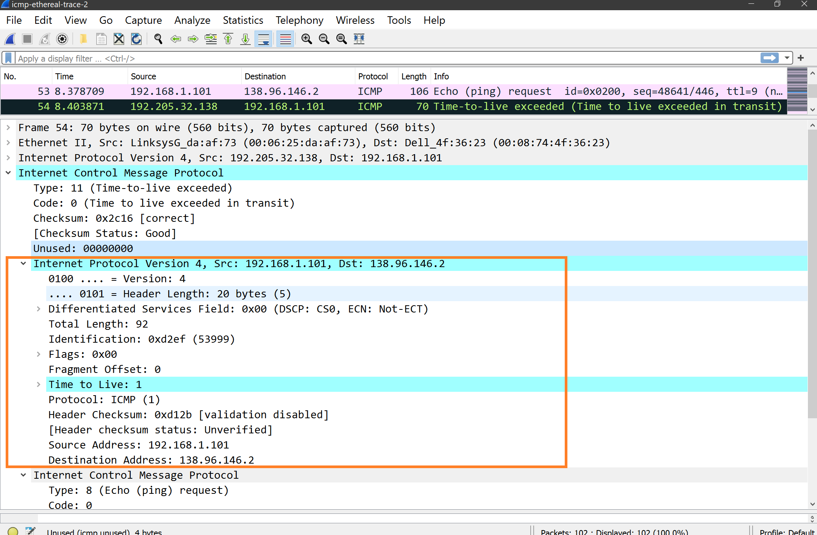

DHCP

3A.

|  |  |  |  |  |
| --- | --- | --- | --- | --- |
| DHCP message type | Source IP | Source MAC | Destination IP | Destination MAC |
| DHCP Discover | 0.0.0.0 | fc:77:74:22:f4:43 | 255.255.255.255 | ff:ff:ff:ff:ff:ff |
| DHCP Offer | 192.168.0.1 | 98:de:d0:4c:12:56 | 192.168.0.103 | fc:77:74:22:f4:43 |
| DHCP Request | 0.0.0.0 | fc:77:74:22:f4:43 | 255.255.255.255 | ff:ff:ff:ff:ff:ff |
| DHCP ACK | 192.168.0.1 | 98:de:d0:4c:12:56 | 192.168.0.103 | fc:77:74:22:f4:43 |

3B. In the experiment, Relay agent IP address is 0.0.0.0 which means Relay Agent Field lacks relay agent.

3C. Client does accepts the IP address offered by the DHCP server.

Option (50) : Requested IP Address (192.168.1.103) shows the client’s response.

3D. DHCP server makes ARP requests.

Before allotting IP address to client, DHCP server checks whether the IP address is already given to some other client by generating ARP request.

