GPRS Technical Report

Fast Phase Equilibrium Computations for Simulation of CO₂ Sequestration in Aquifers

March, 2006

Huanquan Pan

SUPRI-B Industrial Consortium

Department of Petroleum Engineering

Stanford University

Abstract
A large portion of CPU time spends in the phase equilibrium (flash) computations for the compositional simulation. We implemented a fast flash method in which the phase equilibrium constants are determined by table look-up to speed up the phase equilibrium computations in the simulation of CO₂ sequestration in aquifers. Our simulation results show that the fast flash method can be 10 times as fast as the rigorous one in our in-house general purpose research simulator (GPRS). The CPU time for the phase equilibrium computations drops from 31% of total execution time in the rigorous flash method to 5% in the fast flash method. The difference of the simulation results between the rigorous and fast flash methods is negligent. With the fast flash method, GPRS is able to run the CO₂ injection process within a couple of days in a PC for a very large aquifer (half million of grids) and long time (1000 years).

Introduction
Simulation of CO₂ sequestration in an aquifer is different from the simulation of gas injection process in oil production. First, an aquifer can be very large (miles x miles) and simulation time can be very long (hundreds or thousand of years). Second, the phase equilibrium computations can be much harder for the CO₂-H₂O system than those for the hydrocarbon mixtures because the phase properties of CO₂ and H₂O are totally different, for example, the phase equilibrium constant is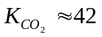, 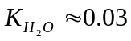 and 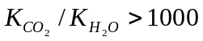 at 563 R and 1900 psia. An equation of state (EOS), for example Peng-Robinson (Robinson et al. 1985) equation of state (PR EOS), has been widely used to describe the phase properties in the compositional simulators. We have observed that the traditional flash calculation method in which the initial phase equilibrium constants are from Wilson’s correction always fails. The technique to bring back the phase equilibrium constants into two-phase regions (Pan and Firoozabadi, 2003) must be imposed to succeed in the flash computations. We also encounter problems to simulate the injection of CO₂ into an aquifer in Eclipse 300 by using an EOS. At high pressures the CO₂ density may be larger than the H₂O density. The phase status (gas or liquid) is identified by the density of the phase in Eclipse 300, therefore the CO₂ phase is incorrectly set to liquid and the H₂O phase to gas during the simulation.

GPRS has been proved to be robust in the compositional simulations and easy to be extended (Cao, 2002). Our goal is to extend GPRS to efficiently simulate CO₂ sequestration in very large size of aquifers and for very long time. The key to achieve the goal is to speed up the phase equilibrium computations and linear solver. This study will focus on the fast phase equilibrium computations.

We have observed that GPRS spends about one third of the execution time in the phase equilibrium computations for the simulation of CO₂ sequestration in an aquifer if we use the existing rigorous phase equilibrium computation method. If we can quickly do the phase equilibrium computations, we can save up to 30% of CUP time. The fast table look-up method has been implemented to speed up the phase equilibrium computations for the CO₂-H₂O system in GPRS.

Theory
The number of independent variables is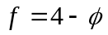for the CO₂-H₂O system, where is the number of phases. If there are two phases in the system, 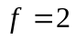, that is temperature and pressure. For the isothermal simulation, the reservoir temperature is fixed, therefore, at a given pressure value, all of the other properties (phase compositions, density, etc.) are obtained by thermodynamic equilibrium computations. Figure 1 shows a typical isothermal phase diagram for the CO₂-H₂O system.

The phase diagram (see Figure 1) consists of bubble point pressure (CO₂ solubility in water) on the left side and dew point pressure on the right side. During the simulation, given the cell pressure P and overall CO₂ mole fraction Z, one can get the phase equilibrium results by (see the line a-b in Figure 1):
- if 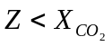, the cell is in single water phase;
- if 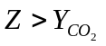, the cell is in single gas phase;
- if 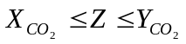, the cell is in two phases with concentrations: 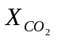and 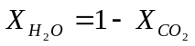 for water phase, 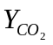 and 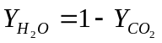for gas phase. With the known compositions of each phase, amount of each phase is then obtained by solving the Rachford-Rice equation.

In the implementation, we generate the equilibrium data: 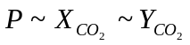at wide range of pressure at reservoir temperature using the rigorous flash in GPRS. The data is then written into a file as the format in Table 1.

The generation of the equilibrium data file behaves as the pre-process for the GPRS simulator, although the same GPRS executable is used because the code for generating equilibrium data file is embedded in the GPRS code package.

When a simulation starts, GPRS first reads the equilibrium data from the data file and then stores the data in an ordered C++ STL (Standard Template Library) container. During the simulation, at the given cell pressure P and overall CO₂ mole fraction Z, two pressure points: 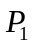 and 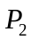 with 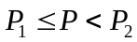 in the STL container are obtained by searching the ordered container, then the equilibrium compositions at the pressure P are interpolated linearly:

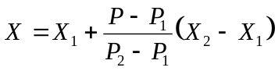 (1)

where X is either or . Once we get the equilibrium data and at the cell pressure P, then we can obtain the cell status (gas, oil, gas-oil) and compositions by comparing Z with or , which is described above. Once the equilibrium compositions are obtained, the density of each phase is then calculated by the PR EOS.

The key for the speed is how to efficiently find the two pressure points: and with in the equilibrium data set. Since we store the data set in a sorted STL container and use the build-in search algorithm of the container, the searching is very fast. We will discuss the issue later in the report.

Aquifer and Fluid Properties in Case Study
We choice a homogeneous aquifer in our simulation study. The permeability is 200, 200, and 50 md in X, Y and Z directions, the grid size is 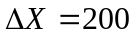, 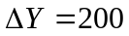 and 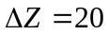 feet, respectively, the porosity is 0.3, the rock compressibility is 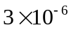/psia at the reference pressure 14.7 psia. The aquifer is isothermal and its temperature is 563.4 R. The top of the aquifer is at 8000 feet and the initial pressure is 2000 psia at the 8325 feet. The initial state of the aquifer is full of water. Note that we only study pure water without salt in it because the phase behavior of the salt-containing CO₂-H₂O system can be modeled by only adjusting the binary interaction coefficient 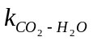 (Kumar, 2004). The properties of pure CO₂ and H₂O are listed in the Table 2. The binary interaction coefficient 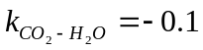 (Kumar, 2004).

Accuracy Validation from Standalone Flash Computations
The pressure range in the equilibrium data set: is between 100 to 9000 psia. In order to study the effect of the number of points (or the container size) in the equilibrium data set on the execution time and the accuracy, we select the pressure step of 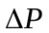= 10, 50 and 100 psia, respectively in the generation of the equilibrium data set. The number of data points in the equilibrium data set for the three pressure steps are 891, 179 and 90, respectively.

To study the accuracy, we compare the results from the fast method with those from the rigorous one in the standalone computations. We choice the pressure at 3225 psia and the range of feed CO₂ mole fraction from 0 to 0.995 with 10 points in the single gas phase, 13 points in the single water phase and 93 points in the two phases. All points in the single phase match each other between the fast and rigorous method. Table 3 lists the average deviations and Table 4 the maximum deviations between the fast and rigorous methods in the two-phase region.

As Tables 3 and 4 show, the average and maximum deviations between the fast and rigorous methods are less than the order of 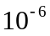.

Accuracy Validation by Simulation of 100 Grids
One two dimension, small size of the aquifer with 100 (10x1x10) grids is used with a production well in block (1,1,1) and an injection well in (10,1,10). The well controls are BHP=6000 psia for the injection well and BHP=400 psia for the production well.

Figure 2 plots the CO₂ injection rate, H₂O production rate and CO₂ production rate respectively. The results for these figures are from the rigorous flash method. As comparison, we also computed these results using the fast method with the pressure step of = 10, 50 and 100 psia in the equilibrium data set, respectively. Surprising us, all results are exactly same among these four simulations for the CO₂ injection rate, H₂O production rate and CO₂ production rate, the grid pressures, saturations, and concentrations of the aquifer on 150 days. If we use the VSS (Microsoft Visual Source Safe) “diff” command to distinguish any two corresponding output files among these simulations, the result is “identical”, which means the contents in one output file are the exactly same characters and digits as those in the other corresponding output file. The valid digits are 8 in any output.

To understand why the simulation results are insensitive to the number of points (or pressure step) in the equilibrium data set in the fast flash method, Figure 3a plots the bubble point curve which is close to linear relation at large range of pressure. Figure 3b show the zoomed bubble point line with pressure range of 100 psia. In this figure, dots represent the results with = 10 psia, and the line connects the first and last dots. The figure clearly shows that all dots are in the straight line which means the linear relation among these dots. The similar results for the dew point are also shown in Figure 3a and Figure 3b. The local linear relation with a reasonable pressure range in the bubble point and dew point curve explains why we get the identical results using different pressure step of in the fast flash method.

Efficiency and Accuracy Validation by Simulation of 9000 Grids
One three dimension aquifer with 9000 (30x30x10) grids is used with a production well in block (1,1,1) and an injection well in (29, 29,6-10). The well controls are BHP=6000 psia for the injection well and BHP=400 psia for the production well.

Figures 4 plots the CO₂ injection rate, H₂O production rate and CO₂ production rate respectively. The results for the figure are from the rigorous flash method. We also computed these results using the fast method with the pressure step of = 10, 50 and 100 psia, respectively in the equilibrium data set. Similar to the results in the previous sample of 100 grids, the results are very close to each other among these four simulations. The results of the VSS “diff” command show that over 95% of lines are identical and the difference is 1 in the last digit for the rest lines in any two corresponding output files. These compared results include the CO₂ injection rate, H₂O production rate and CO₂ production rate, the grid pressures, saturations, and concentrations of the aquifer on 10000 days.

To compare the computational efficiency among the rigorous method and the fast method with the pressure step of = 10, 50 and 100 psia, Table 5 lists the overall execution time and Table 6 shows the execution time spending in the flash computations for different approaches in a 2.26G CPU and 522K random memory PC.

As shown in Table 5, the execution time consists of:
- Initialization: set initial conditions for reservoir and wells
- Property Calculation: calculate the properties for all grid blocks and wells
- Linearization: calculate and assemble Jacobian and RHS
- Linear solver: solve the linear system
- Newton Update: perform Newton update
- Other: input/output, etc.
- Total: total execution time which is the summation of the time from 1 to 6.

As shown on the column 2 (labeled “Rigorous”) in Table 5, the major CPU time (over 98% of total execution time) spends in “Property Calculation”, “Linearization” and “Linear solver” parts in a compositional simulation if the rigorous method is used. The “Property Calculation” part which includes the flash computations occupies about 48% of the total execution time. It suppresses the execution time of the “Linear solver” (about 34% of total execution time). As shown in Table 6, 64% of the execution time of the “Property Calculation” spends in the flash computations, and the flash computations themselves occupied about one third of the total CUP time if the rigorous flash method is used.

If we compare the execution time using the fast flash method with = 10 psia (the results on column 3 in Table 5) with the time using the rigorous flash method (the results on column 2 in Table 5), we find that there is no much difference in the execution time of “Linearization” and “Linear solver” parts, but the execution time of “Property Calculation” decreases from 274.5 to 116.1 seconds, 158.4 seconds are saved. From Table 6, we know that the fast flash method can be 10 time as fast as the rigorous one and it saves 159.6 seconds of the execution time in the “Initialization” and “Property Calculation”. Compared with the rigorous method, the fast one can save about 28% of the total execution time and the CPU time for the flash computations drops from 31% to 4.3%.

The difference of the execution time among these three pressure steps in the fast method is very small (see Tables 5 and 6). We expected that the execution time with =10 psia should be longer than that with =100 psia because the number of the points are 891 with =10 psia and 90 with =100 psia in the equilibrium data set. The more data points, the longer time it should take for the pressure searching. However, as shown in Table 6, we do not get the execution time of the fast method in this order: t(=10) > t(=50) > t(=100). The searching algorithm for the STL sorted container is the binary search. The relation between the number of points in a sorted container vs. execution time is logarithmic for the binary search algorithm. The estimation shows that the difference of the execution time to search a pressure with 891 points (=10 psia) and the time with 90 points (=100 psia) in a sorted container is less than 40%. We believe that the execution time for searching pressure is so fast that the time may be negligent compared with the fluctuation of the computer CPU in this case.

Accuracy and Efficiency Validation by Simulation of Half Million Grids
One three dimension aquifer with half million (500x100x10) grids is used for the simulation study in a 2.8G CPU and 3.9G RAM computer. There are four production wells located in the four corner of the aquifer with block number (1,1,1), (500, 1,1), (1,100, 1) and (500, 100, 1), respectively. There is one injection well in the middle of aquifer penetrated in the bottom five layers with block numbers (250, 50, 6-10). The well control is BHP=3500 psia for the injection well and BHP=1000 psia for each of the production wells.

We run the simulation for 3650 days (10 years) using the rigorous flash method, the fast flash method with = 10, 50 and 100 psia in the equilibrium data set, respectively. Figure 5 plots the CO₂ injection rate in the injection well, the H₂O production rate in the production well No. 1 whose block number is (1, 1, 1). The H₂O production rates for other three production wells are almost the same as those in the production well No. 1. The CO₂ production rate is zero up to 10 years. Note that the results in Figures 5 are obtained by the rigorous flash method. Similar to the previous cases, among these four simulations, the VSS “diff” command shows that the contents of any output file for a production well are “identical”, and over 95% of the contents of the output for the injection well are “identical” with the difference being 1 in the last digit for the rest lines.

For the practical purpose, we also simulate the CO₂ injection process in large size (100000ftx20000ftx200ft or 19milex3.8milex200ft) of the aquifer for very long time (255500 days or 700 years) using the fast flash approach with = 10 and 100 psia in the equilibrium data set, respectively in a 2.8G CPU and 3.9G RAM computer. We use the full implicit method (FIM) and the GMRES iterative linear solver with CPR pre-conditioner (Cao, 2002). The pressure solver in the CPR pre-conditioner is SAMG (Jiang, 2004). The results from = 10 are plotted in Figure 6 for the CO₂ injection rate, the CO₂ and H₂O production rate in the production well No. 1. The CO₂ breaks through into the production well No. 1 on 102014 days (279.5 years). The VSS “diff” command shows that three no much differences in the counterpart output files between = 10 and 100 psia in the equilibrium data set.

Table 7 lists the overall execution time and Table 8 the execution time of the flash computations. The total execution time is about 42 hours. There are no much difference in the total execution time with the fast flash method of = 10 and 100 psia in the equilibrium data set. As discussed above, the size of the sorted container which stores the equilibrium data has negligent effect on the execution time even the simulation is long with half million grids. The flash computations take about 5% of the overall execution time.

The case study shows that GPRS is able to run the simulation of the CO₂ injection process in a realistic size of aquifer and for very long simulation time with the execution time in couple of days in a PC.

Discussion
The phase equilibrium (flash) computations in GPRS take about one third of the total CPU time for the CO₂-H₂O system if the rigorous flash method is used. Like any compositional simulator, the CPU time in the flash computations in GPRS is even longer than the time in liner solver. However, if the fast flash method is used, the execution time of the phase equilibrium computations for the CO₂-H₂O system reduces to 5% of the total CPU time.

The key to the speed for a table look-up flash method is to find the pressure in the pre-defined data set of phase equilibrium: . As shown in this study, if we store data in a sorted STL container and use its build-in search algorithm, the effect of the size (number of points) of the equilibrium data set on the execution time can be negligent. Note that if the data is stored in an array or a sequence container, finding the pressure in the equilibrium data set would be much more expensive because the execution time is linear with the size of the array while it is logarithmic for a sorted container.

At the high pressures, the linear relation holds for the certain range of pressure in the bubble or dew point curve. Our results show that the simulation results are almost the same between the pressure step = 10 and 100 psia in the equilibrium data set. Since the size of the equilibrium data set has negligent effect on the execution time, we still recommend using small pressure step to build the equilibrium data set.

For the salted aquifers, the phase equilibrium of the salt-containing CO₂-H₂O system can be modeled by adjusting the volume shift parameter of CO₂, H₂O and the binary interaction coefficient (Kumar 2004). Therefore, one can still use the fast flash method without any modification.

Note that the methodology of the fast flash method is not limited to the equation of state (PR EOS in GPRS). As matter of fact, it is independent of any fluid model. What we need is the isothermal bubble point and the dew point data (see Figure 1) which can be obtained from any kind of thermodynamic fluid model, empirical correlation or even from experimental data. The other widely used thermodynamic model for the CO₂-H₂O system is the Henry law for the CO₂ solubility in water or salt water (Li and Nghiem, 1986). In this circumstance, the bubble point and dew point curves in Figure 1 are obtained by the flash computations using the Henry law to express the CO₂ fugacity in the water phase.

With the fast flash method, GPRS should be able to run half million grids for one thousand years within a couple of days in a PC. Since we have speed up the phase equilibrium computations, making the linear solver fast in GPRS becomes our next effort for the CO₂ sequestration in aquifers. Currently, the linear solver takes about half of the total CPU time.

Conclusions
The major benefit from the fast flash method is:
- Reduce the execution time.
- Make simulation more stable.
With the fast flash method in GPRS, the execution time decreases about 28% and the phase equilibrium computations only take 5% of the total CPU time. The simulation of the CO₂ injection process in half million grid blocks for 700 years spends less than two days in a PC.

References

Cao, H.: “Development of Techniques for General Purpose Simulators” Ph.D. Dissertation, Stanford University, 2002.

Jiang, Y.: “Tracer Flow Modeling and Efficient Solvers for GPRS” M.S. Report, Stanford University, 2004.

Kumar, A.: “A Simulation Study of Carbon Sequestration in Deep Saline Aquifers” M.S. Thesis, University of Texas at Austin, 2004.

Li, Y.K. and Nghiem, L.X.: “Phase Equilibria of Oil, Gas and Water/Brine Mixtures from a Cubic Equation of State and Henry’s Law,” Can. J. Chem. Eng. (June 1986) 486-496.

Pan, H. and Firoozabadi, A.: "Fast and Robust Algorithm for Compositional Modeling: Part II – Two-Phase Flash computations," SPE J., (Dec. 2003) 380-391.

Robinson, D.B., Peng, D.Y. and Chung, S.Y.K.: “Development of Peng-Robinson Equation and Its Application to Phase Equilibrium in a System Containing Methanol,” Fluid Phase Equilibria, Vol. 24, p.25, 1985.

Implementation in GPRS
All interfaces and their implementations for the table look-up approach are in the “fluid” folder. A structure “equiDataStruct” is defined to represent a point () of equilibrium data set in “equiDataStruct.h” file. A new class “EquiData” in files “EquiData.h” and “EquiData.cpp” is created to store the equilibrium data table and to do the pressure search and linear interpolations. The interfaces are in the class “CompFluid” and all the implementations are in the class “PhaseEquiCalcBase”. In the input file, a new line is required to run the fast method as follows:

EXPFLASH DataGen/CO2H2O.dat

The detail is in the user manual. The implementation in the simulation is in “mthCompFluidModel.h” and “mthCompFluidModel.cpp” files under folder “mth”.

One new folder “DataGen” is created to prepare the equilibrium data set for the simulation. The class “explictFlashImp” (files: “explictFlashImp.h” and “explictFlashImp.cpp”) and class “UnitExpFlash” (files: “UnitExpFlash.h” and “UnitExpFlash.cpp”) are created to generate data set and do standalone test (see section Accuracy Validation from Standalone Flash Computations). An input file is required. Most of the input file is the same as the “FLUID-DATA” part in the “reservoir” section of simulation input. Appendix A shows a sample of the input file. To execute the generation of equilibrium data set, one needs to set a flag in “main.cpp” file as

bool isGenerateData = true;

At the beginning of the execution, one needs to input the input file (including path) on the screen after the following message:

Input the data file including path for generating equilibrium data set:

One then types “DataGen\CO2H2O.in” if the input name is “CO2H2O.in” in the folder “DataGen”. The path and name of output file is fixed as “DataGen\CO2H2O.dat”.

Once the equilibrium data set is generated, one can run the fast method by re-setting the flag in “main.cpp” file as

bool isGenerateData = false;

Appendix A: Input File for Creating Equilibrium Data Table
An sample of input file is given as follows:

NPHASES 2
NCOMPONENTS 2

# Phase data -------------
#PHASE_NAMES
GAS OIL

# --- component data -------------
#COMP_NAME
CO2 H2O

# --- Z(initial total mole fraction) for each component ---
length_of_table 2
1. 0.0 1.0
10000. 0.0 1.0

# --- Molecular Weight for each component ---
44.01 18.015

# --- Pc(Psia) for each component ---
1071.33111 3200.0

# --- Tc(R) for each component ---
547.4308 1164.77

#--- Vc (ft3/lb-mole) for each component -----
1.5058 0.8976

# --- W for each component ---
0.22394 0.344

# --- Volume Shift Parameter (Dimensionless S) ----
#0.024668 0.234867
0.024668 0.18
#0.0 0.0

#--- K[ij] for each pair component ----------
# Peng-Rubinson
0.0 -0.1
-0.1 0.0

#Flash method: SSI or NEWTON
SSI
# stabSwitchEps flashSwitchEps
#NEWTON 1.0e-1 1.0e-1

END

# flash temperature R
563.4
#start Pressure; Maximum Pressure; step Pressure (psia)
100 9000 10

#feed composition z (mole fraction)
0.5 0.5

Note that all input data are the same as the “FLUID-DATA” part in the “reservoir” section of simulation input except last three lines which are described as follows:
#flash temperature: it is a reservoir temperature, R;
#Pressure setting: minimum pressure, maximum pressure and pressure step (unit: psia) in the equilibrium data table;
#feed composition: overall composition of CO₂ and H₂O, the values of 0.5 and 0.5 are recommended.

Table 1 Equilibrium Data Format
P
….. | …… | ……
1910 | 0.023103 | 0.97082
1920 | 0.023121 | 0.970652
1930 | 0.02314 | 0.970485
1940 | 0.023159 | 0.97032
….. | …… | ……
1950 | 0.023177 | 0.970156
8980 | 0.030636 | 0.918745
8990 | 0.030643 | 0.918702
….. | …… | ……

Table 2: Properties of Pure Component
Component | Molecular Weight | Critical Pressure (psia) | Critical Temperature (R) | Critical Volume (ft³/lb-mole) | Acentric Factor | Volume Shift Parameter
CO₂ | 44.01 | 1071.33 | 547.43 | 1.5058 | 0.22394 | 0.024668
H₂O | 18.015 | 3200 | 1164.77 | 0.8976 | 0.344 | 0.18

Table 3: Average Deviations between Fast and Rigorous Method
Average Deviation* | =10 psia | =50 psia | =100 psia
liquid amount | 6.36561e-010 | 9.19662e-009 | 2.63164e-008
liquid amount % | 4.20692e-006 | 6.07724e-005 | 0.000173865
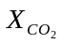 | 2.62793e-011 | 7.17769e-010 | 2.18053e-009
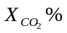 | 2.60126e-008 | 7.10486e-007 | 2.15842e-006
 | 5.93235e-010 | 8.57196e-009 | 2.45294e-008
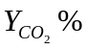 | 1.5554e-008 | 2.24747e-007 | 6.43133e-007
liquid density | 7.09331e-011 | 1.9374e-009 | 5.88568e-009
liquid density % | 5.21925e-010 | 1.42553e-008 | 4.33068e-008
gas density | 1.5187e-009 | 2.19446e-008 | 6.27963e-008
gas density % | 2.79025e-008 | 4.03177e-007 | 1.15373e-006
liquid molecular weight | 6.83132e-010 | 1.86584e-008 | 5.6683e-008
liquid molecular weight % | 9.1467e-010 | 2.49824e-008 | 7.58949e-008

* Average Deviation =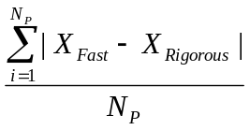 for any property X.
* X % =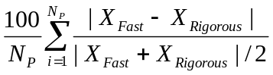 for any property X.

Table 4: Maximum Deviations between Fast and Rigorous Method
Maximum Deviation* | =10 psia | =50 psia | =100 psia
liquid amount | 9.68104e-008 | 8.89478e-007 | 2.49113e-006
liquid amount % | 0.000395451 | 0.00571261 | 0.0163433
 | 3.42866e-008 | 9.92866e-008 | 2.36787e-007
 | 3.39387e-005 | 9.82791e-005 | 0.000234385
 | 9.6882e-008 | 8.46882e-007 | 2.34688e-006
 | 2.54014e-006 | 2.22043e-005 | 6.15325e-005
liquid density | 9.25463e-008 | 2.67994e-007 | 6.39133e-007
liquid density % | 6.80955e-007 | 1.9719e-006 | 4.70273e-006
gas density | 2.48022e-007 | 2.16805e-006 | 6.00812e-006
gas density % | 4.55679e-006 | 3.98326e-005 | 0.000110385
liquid molecular weight | 8.91281e-007 | 2.58096e-006 | 6.15527e-006
liquid molecular weight % | 1.19337e-006 | 3.45574e-006 | 8.24151e-006
* Maximum Deviation =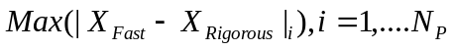 for any property X.
* Maximum X % =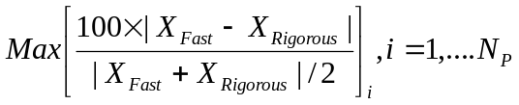 for any property X.

Table 5: Summary of Execution Time
Time (second) | Rigorous | Fast  (=10 psia) | Fast  (=50 psia) | Fast  (=100 psia)
Initialization | 1.218 | 0.406 | 0.406 | 0.406
Property Calculation | 274.493 | 116.091 | 115.477 | 115.526
Linearization | 94.361 | 94.636 | 94.267 | 95.241
Linear solver | 192.45 | 191.925 | 191.875 | 194.327
Newton Update | 2.115 | 1.624 | 2.168 | 1.83
Other | 4.344 | 4.398 | 4.401 | 4.36
Total | 568.981 | 409.08 | 408.549 | 411.69

Table 6: Execution Time on Flash
Time (second) | Rigorous | Fast  (=10 psia) | Fast  (=50 psia) | Fast  (=100 psia)
Initialization | 0.922 | 0.11 | 0.094 | 0.094
Property Calculation | 176.313 | 17.56 | 17.396 | 16.946

Table 7: Summary of Execution Time for half million of grid blocks
Time (second) | Fast  (=10 psia) | Fast  (=100 psia)
Initialization | 7 | 8
Property Calculation | 35880 | 35757
Linearization | 30417 | 30500
Linear solver | 84182 | 84373
Newton Update | 576 | 577
Other | 209 | 210
Total | 151271 | 151425

Table 8: Execution Time on Flash for half million of grid blocks
Time (second) | Fast  (=10 psia) | Fast  (=100 psia)
Initialization | 5 | 6
Property Calculation | 8016 | 7705

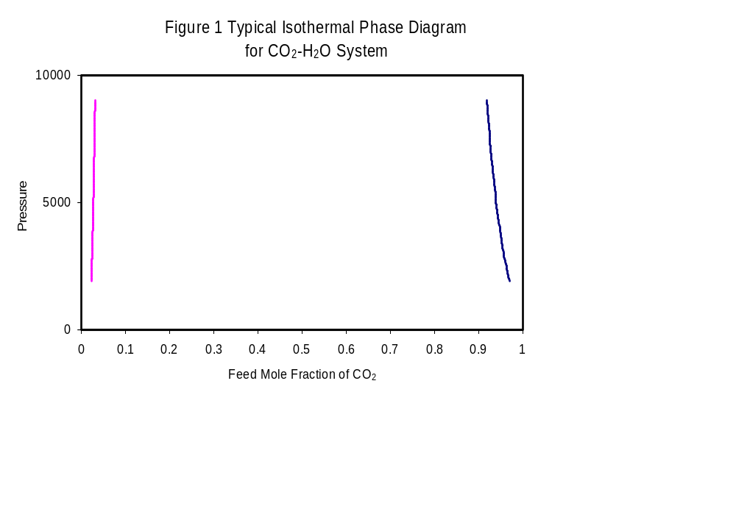
Bubble Point
Dew Point
P
a
b
Xco₂
Yco₂

