GPRS Technical Report

Implementation of Corner Point Geometry (CPG) Grids

January, 2009

Huanquan Pan

SUPRI-B Industrial Consortium

Department of Petroleum Engineering

Stanford University

1. Introduction

Corner Point Geometry (CPG) grids are widely used in industry because they better represent the reservoir with faults than structured grids do. We integrated a plugging-in CPG gridding component (static library) into GPRS to handle the CPG grids. The gridding software generates depth, volume & actnum of each cell and connection list. It also provides DX, DY, DZ & DZ*NTG of all cells for well index evaluations.

Note that the CPG gridding software in only for two-point flux approximation (TPFA).

2. Implementation

One new class: Grid2PCPG is created to handle the CPG grids. Grid2PCPG is inherited from class Grid2P. I implemented the integration in Grid2P & Grid2PCPG classes. Only handful interfaces (C functions) are required & they are in the head file “cpgapi.h”.

3. Input Data Format for CPG

The input data for the CPG gridding software are geometry & properties of each cell. The cell properties are porosity, permibility (Kx, Ky, Kz), NTG (net-to-growth) & actnum. Among these properties, NTG&Actnum are optional (set to 1 without input). The geometry input are the “COORD” & “ZCORN” which are the standard input for CPG in all commercial simulators (Eclipse, IMEX, etc.).

The basic assumption is that the corners of each cell in a vertical column of cells are always located on common straight lines for all layers (Fig. 1). These lines are defined by the “COORD” data and the positions of the corners by the “ZCORN” data. Suppose that the reservoir has NX * NY * NZ grids, there should be (NX+1)*(NY+1) such lines, and since the definition of each line requires the specification of two points, each itself requiring the specification of three coordinates, “COORD” expects to read 2 * 3 *(NX+1)*(NY+1) values.

(x1,y1,z1)
(x2,y2,z2)
z1
z2
z3
z4
z5
z6
z7
z8
Figure 1 CPG

The “COORD” reads two points for each line starting with top point, first by x-rows, then by y-rows. For example in Fig.2, NX=4, NY=2, NZ=1, the input order is
(1, 6) (2, 7) (3, 8) (4, 9) (5, 10)
(11, 16) (12, 17) (13, 18) (14, 19) (15, 20)
(21, 26) (22, 27) (23, 28) (24, 29) (25, 30)

Suppose the starting point is (0, 0, 425),
DX: 5 10 20 30
DY: 5 5 5 5
DZ: 55 55 55 55.

The data for “COORD” are

COORD # nx= 4, ny= 2
#--------- j= 1 ---------
0.000 0.000 425.000 0.000 0.000 480.000
5.000 0.000 425.000 5.000 0.000 480.000
15.000 0.000 425.000 15.000 0.000 480.000
35.000 0.000 425.000 35.000 0.000 480.000
65.000 0.000 425.000 65.000 0.000 480.000
#--------- j= 2 ---------
0.000 5.000 425.000 0.000 5.000 480.000
5.000 5.000 425.000 5.000 5.000 480.000
15.000 5.000 425.000 15.000 5.000 480.000
35.000 5.000 425.000 35.000 5.000 480.000
65.000 5.000 425.000 65.000 5.000 480.000
#--------- j= 3 ---------
0.000 15.000 425.000 0.000 15.000 480.000
5.000 15.000 425.000 5.000 15.000 480.000
15.000 15.000 425.000 15.000 15.000 480.000
35.000 15.000 425.000 35.000 15.000 480.000
65.000 15.000 425.000 65.000 15.000 480.000

The “ZCORN” reads the z-coordinate of all corners of each cell. Since there are 8 corners in a cell, there are total 8 * NX *NY * NZ values. The input data order is point by point, first X-rows, then Y-rows for each layer. The following describes the order (see Fig. 1):

For each layer K:
For each J:
Read (z1,z2) for all I
Read (z3,z4) for all I
For each J:
Read (z5,z6) for all I
Read (z7,z8) for all I

i.e., for each layer K one reads first the coordinates on the top surface, then on the bottom.

For the example in Fig. 2, the input point order is
1, 2 , 2, 3, 3, 4, 4, 5
11, 12 ,12, 13, 13, 14, 14, 15
11, 12,12, 13, 13, 14, 14, 15
21, 22, 22, 23, 23, 24, 24, 25
6, 7, 7, 8, 8, 9, 9, 10
16, 17, 17, 18, 18, 19, 19, 20
16, 17, 17, 18, 18, 19, 19, 20
26, 27, 27, 28, 28, 29, 29, 30

The Values are:
425.000 425.000 425.000 425.000 425.000 425.000 425.000 425.000
425.000 425.000 425.000 425.000 425.000 425.000 425.000 425.000
425.000 425.000 425.000 425.000 425.000 425.000 425.000 425.000
425.000 425.000 425.000 425.000 425.000 425.000 425.000 425.000
480.000 480.000 480.000 480.000 480.000 480.000 480.000 480.000
480.000 480.000 480.000 480.000 480.000 480.000 480.000 480.000
480.000 480.000 480.000 480.000 480.000 480.000 480.000 480.000
480.000 480.000 480.000 480.000 480.000 480.000 480.000 480.000

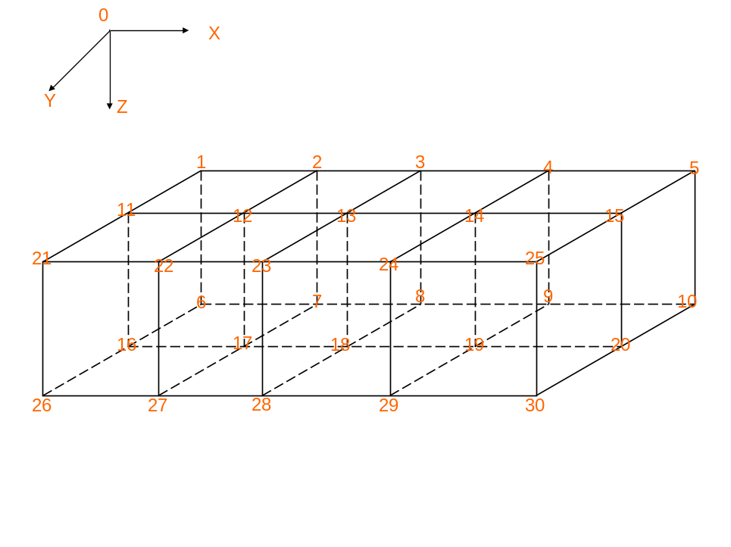

Figure 2 Sample Grids

4. Input Data

One key word: “CPG” is required before the key word “GRID_DATA”.

Other Keywards:

“COORD” , follows with the input data

“ZCORN”, follows with input data

“NTG”, follows with input data

“ACTNUM”, follows with input data. Only two integer values: 1—possitive, -1—negative

5. Output Data

One out put file: “CPGOut.txt” is generated for the output values of the CPG. The output includes:

Net to Gross (fraction),

Block bulk volume,

Pseudo CPG DX length,

Pseudo CPG DY length,

Pseudo CPG DZ length,

Pseudo CPG DZ*NTG lengths

Depth to block center

Active block (1=act,-1=inact)

9. Testing

One reservoir with 4 x 4 x 5 structured grids is tested. The simulation runs with input of regular structured grids & the other with CPG grids. The results are the same.

Test for large & complicated samples is under the way …..

