GPRS Technical Report

Implementation of Fast Phase Equilibrium Computations by Lookup Phase Equilibrium Constants K

January, 2007

Huanquan Pan

SUPRI-B Industrial Consortium

Department of Petroleum Engineering

Stanford University

1. Introduction
Phase equilibrium computations (PEC) spend the most (up to 70%) CPU time for the compositional simulations. In the some scenarios, we can speed up PEC significantly by using table lookup of phase equilibrium constant K values. These scenarios include:

- Any two-component mixture: the degree of freedom is one which is a pressure isothermally;
- Natural depletion of an oil or a gas reservoir
- Water injection in a gas or an oil reservoir
- Gas injection in the single hydrocarbon phase of reservoir

The only scenario in which the standard EOS flash is used is the near miscible gas injection. In this case, fluid is in the two-phase region for some cells.

The lookup approach can speed up simulation significantly. The speeding depends on the number of components of the reservoir fluid and fluid status in the reservoir. Since GPRS does not do any PEC once the reservoir fluid is in the two-phase region during natural depletion, no time-saving is obtained in his circumstances. All the time saving is from the single phase simulations like gas injection above saturation pressure, natural depletion with reservoir pressure higher than saturation pressure, water injection with one hydrocarbon phase.

There are two steps to implement the approach in GPRS. The first step is to generate the table of pressure vs. phase equilibrium constants (P-K table) and save the data in a file. The second step is to do PEC by table lookup of these data.

For a two-component mixture, for example CO2-H2O mixture, we found that the lookup P-X-Y table is much faster and more robust than the P-K table, where X is the composition of first component in bubble point and Y in dew point. The detailed implementation of the lookup P-X-Y table for the CO2 sequestration in aquifers is described in Ref. 1.

2. P-K Table Generation
We use the standard flash to generate data table for K values (or equilibrium composition X and Y for two component mixture) using the initial reservoir fluid via constant composition expansion process. The folder “DataGen” is created to store code files of the table generation. The function “explictFlashImp” (files: “explictFlashImp.h” and “explictFlashImp.cpp”) and class “UnitExpFlash” (files: “UnitExpFlash.h” and “UnitExpFlash.cpp”) are created to generate P-K (or P-X-Y) data tables. An input file is required and most of the input file is the same as the “FLUID-DATA” part in the “reservoir” section of simulation input, starting with the keyword “NPHASES” and ending with the keyword “END”. Following the keyword “END”, one needs to input reservoir temperature, pressure range and step size, composition of initial reservoir fluid, keyword for the type of equilibrium table (P-K, or P-X-Y). The input for SPE3 is listed as follows:

NPHASES 2
NCOMPONENTS 9

# Phase data -------------
#PHASE_NAMES
GAS OIL
………
………

EXPFLASH DataGen/spe3.dat

END

# flash temperature (R)
530
#start Pressure; Maximum Pressure; step Pressure, psia
10 2970 1

#feed composition z (initial composition of reservoir fluid)
.01210 .01940 .65990 .08690 .05910 .09670 .04745 .01515 .00330

#Equilibrium data type: KVALUES--K or COMPOSITIONS--equilibrium comps
KVALUES

To execute the generation of equilibrium data set, one needs to set a flag in “main.cpp” file as

bool isGenerateData = true;

At the beginning of the execution, one needs to input the input file (including path) on the screen after the following message:

Input the data file including path for generating equilibrium data set:

One then types “DataGen/spe3.in” if the input name is “spe3.in” in the folder “DataGen”. The name of output file is in the input file under keyword “EXPFLASH”, see the input file sample above. The data format in the generated file (spe3.dat) is

P K1 K2 …. KN

In the data file, the last second line is the saturation (bubble or dew) pressure. This is the same as the PVT input for a black oil. For the P-X-Y data, the format is

P X Y

Note that the second bottom line of the table is corresponding to the saturation (bubble or dew) point.

3. Implementation in GPRS
Once the equilibrium data set is generated, one can run the fast method by re-setting the flag in “main.cpp” file as

bool isGenerateData = false;

In the input file, a new line is required to run the lookup method as follows:

EXPFLASH DataGen/spe3.dat
#NUMFEI

This data file is generated by step one. Note that one should not change any content in the generated data file. If the explicit fugacity coefficient approach (see section 3.3 Fugacity Coefficients below) is implemented, the keyword “NUMFEI” is added as shown above. The detailed information of this keyword is in the user manual.

3.1 P-K Approach
When a simulation starts, GPRS first reads the P~K table from the data file and then stores the data in an ordered C++ STL (Standard Template Library) container. During the simulation, at the given cell pressure P and overall composition z_{i} (i=1, ..Nc), two pressure points: 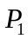 and 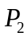 with 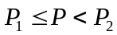 in the STL container are obtained by searching the ordered container, then the K_{i} of component i at the pressure P are interpolated linearly:
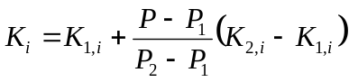 (1)
where K_{1,i} is the phase equilibrium constant of component i at and K_{2,i} at in the data table. Once we get the K_{i} values of all components of the mixture, then we can estimate the tangent plane distances by
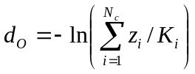 (2)
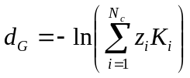 (3)
Where 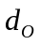is the tangent plane distance with initial oil status and 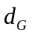 with initial gas status. If either of or is less then zero, then the cell is in the two-phase region, the amount and composition of each phase is then obtained by solving the Rachford-Rice equation using the lookup K_{i} values. Once the equilibrium compositions are obtained, the density of each phase is then calculated by the PR EOS and the viscosity is calculated by correlations. If both and are larger than zero, cell is in the single phase, the cell status (gas or oil) is then estimated.

3.2 P-X-Y Approach

Note that this approach only works for two-component mixture (CO2-H2O mixture, black oil). Given cell pressure P and overall composition z₁ and z₂, the phase compositions at P is obtained by linear interpolation of the 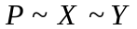table. Then, the phase equilibrium results are obtained by
- if 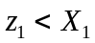, the cell is in single oil phase;
- if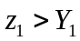, the cell is in single gas phase;
- if 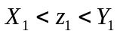, the cell is in two phases with concentrations: 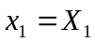and 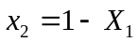 for oil phase, 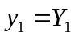 and 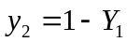 for gas phase. With the known compositions of each phase, amount of each phase is then obtained by solving the Rachford-Rice equation.

The key for the speed of the lookup approaches is how to efficiently find the two pressure points: and with in the data table. Since we store the data set in a sorted STL container and use the build-in search algorithm of the container, the searching is very fast and insensitive to the size of the data table.

3.3 Fugacity Coefficients

Two approaches of fugacity coefficients calculations are used for the implementation of lookup PEC in GPRS. The first one is the original PR EOS approach. The second one is the explicit fugacity coefficient approach described as follows:

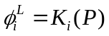 (4)
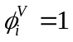 (5)
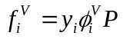 (6)
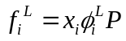 (7)
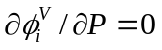 (8)
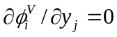 (9)
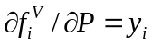 (10)
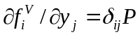 (11)
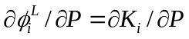 (12)
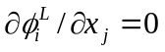 (13)
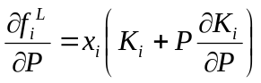 (14)
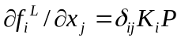 (15)
The 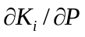 is estimated by
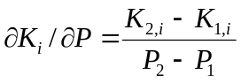 (16)
Given any . To implement the explicit approach, one needs to add the keyword “NUMFEI” below the keyword “EXPFLASH” ad described above. Note that there is no the explicit fugacity coefficient approach of the P-X-Y lookup for a two component mixture.

4. Test Cases

The test fluids and cases are listed as follows.
SPE3: 9 component gas condensates with initial single gas in the reservoir; the two gas-oil phase simulation is run with natural depletion and recycling separator gas in the single phase reservoir conditions;
SPE5: 6 component oil with three water-oil-gas phases; water injection in the three phase simulations
CO2-H2O mixture: gas injection into a pure aquifer.
We run three sets of simulations: standard EOS approach, lookup with EOS fugacity coefficient, lookup with explicit EOS fugacity coefficient (Eqns. 4-5) for all test cases. For CO2-H2O mixture, we also run the lookup of P-X-Y approach.

The simulation results of all different approaches are the same for each test case. The simulation time of lookup method is much faster than the standard EOS method. For example, the CPU time of lookup approach of SPE3 is only quarter of the time of standard approach for the gas injection. For the CO2-H2O mixture, the lookup of P-X-Y approach is much faster than the P-K approach. The P-X-Y approach avoids the computations of single phase status and identification in which the P-K approach does. The detailed simulation results and CPU time for all test cases are presented in Ref. 2.

We observed that the approach of lookup with EOS fugacity coefficient is more robust than the explicit fugacity coefficient (Eqns. 4-5). This may be due to the numerical derivative of Eqn. 16. The improvement may be made by directly generating the lookup P~dK_{i}/dP table. This should be tried in the black oil implementation. For any compositional simulation, we should avoid use the explicit fugacity coefficient, instead using the EOS fugacity coefficient.

We also observed that the accurate saturation pressure point (the last second line in data table) and the nearest points of the saturation point affect the robustness of the lookup approach. In VIP simulator (Ref. 3), the saturation pressure is directly calculated and the intervals close to the saturation pressure are one hundredth of normal intervals in the P-K table. GPRS has no capability to do saturation pressure calculations. Currently we use small pressure step (1 psia) to generate the lookup table. This leads to large size of the data table. Fortunately, our search algorithm is insensitive to the size of table. In a quick and simple approach, one can generate the table twice. The second generation is only in the saturation point with very small pressure step (<0.1).

References
- Pan, H.: “Explicit Phase Equilibrium Computations for Simulation of CO₂ Sequestration in Aquifers,” Technical Report, Stanford University, 2005.
- Pan. H. and Tchelepi, H.: “GPRS: Overview & Recent Progress”, presented at the 14th SUPRI-HW annual affiliates meeting, Nov. 13-14, 2006.
- Landmark, “VIP-Executive Technical Reference”, Chap. 23, 2002.

