GPRS Technical Report

Compositional Multisegment Well Model in GPRS

October 2009

Anna Semenova

SUPRI-B/HW Industrial Consortia

Department of Petroleum Engineering

Stanford University

Contents:

Contents: 2
Nomenclature 3
1. Introduction 6
2. Numerical solution 7
2.1. Equations and variables 7
2.2. Gibbs’ phase rule. Primary/secondary variables. Gaussian elimination. 12
2.3. Homogeneous and drift flux models 18
2.4. Derivatives 19
2.4.1. Production well. 19
2.4.1. Injection well. 29
2.5. Well controls 36
2.6. Phase appearance and disappearance. 37
3. Testing and validation 37
3.1. Example 1 (Comparison with Eclipse) 38
3.2. Example 2 (Comparison with Eclipse) 40
3.3. Example 3 (Drift-flux model) 45
3.4. Example 4 (Multilateral well) 49
3.5. Example 5 (Thermal) 51
Concluding remarks 53
Acknowledgements 53
References 54
Appendix A. Drift-flux model 57
Appendix B. Flash calculation 58

Nomenclature

Units
Latin Letters
A cross-sectional area of the well ft²
D well diameter ft
f_{c,p} fugacity of component c in phase p psi
f_{tp} friction factor
component of gravity along the well psi·ft²/lb
h the height difference between the two segments ft
H_{p} phase enthalpy Btu/lb
J Jacobian
M_{p} phase molar weight lb/(lb·mole)
n_{c} number of component
n_{p} number of phase
P reservoir pressure psi
P_{c} critical pressure psi
P^{w} well pressure psi
 heat loss to formation Btu/d
Re Reynolds number
t time s
T_{c} critical temperature F
T^{w} well temperature F
U_{p} phase internal energy Btu/lb
U_{to} overall heat transfer coefficient Btu/(d·ft²·F)
V volume of the segment ft³
V_{m} velocity of homogeneous fluid ft/s
V_{p} in-situ (flow) velocity of the phase p ft/s
V_{sp} superficial velocity of the phase p ft/s
WI well index ft³·cp/(psi·day)
x position along the wellbore ft
x_{c} molar fraction of component c in liquid phase
x_{cp} molar fraction of component c in phase p in the segment
y_{c} molar fraction of component c in gas phase

Greek Letters
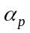 free holdup of phase p
δ_{ij} binary interaction coefficients
ε pipe roughness ft
ΔP_{a} acceleration component of pressure loss equation psi
ΔP_{f} frictional component of pressure loss equation psi
ΔP_{h} hydrostatic component of pressure loss equation psi
Δt s
Δx ft
θ inclination of segment from vertical
λ_{p} phase mobility 1/cp
μ_{m} mixture viscosity cp
μ_{p} phase viscosity cp
ρ_{m} mixture density lb/ft³
ρ_{p} phase density lb·mole/ft³
ω_{c} acentric factors

Subscripts
c critical property
c number of component
g gas phase
o oil phase
p number of phase
w aqueous phase
m mixture

1. Introduction
A thermal compositional model for multisegmented wells will be discussed in this document. Multisegmented wells are used to model advanced and smart wells, which can improve the economics of oil field operations. Such wells can contact larger regions of the reservoir than is possible with standard wells. Thermal effects are also in a great importance for such wells.

Modelling of thermal multisegmented wells is a challenge, because many effects should be taken in to account; among them are complicated trajectory of the well, pressure drop due to friction, slip between phases and proper modelling of temperature distribution in the well.

A lot of efforts were made towards modelling of thermal wells, starting from simple analytical models [9, 19] and ending with complicated numerical models [22, 23]. All models however have their own advantages and disadvantages. Our goal is to make general and efficient model and implement it to reservoir simulator.

Developed multisegment well model allows calculating temperature, pressure, in-situ phase fractions and component fractions profiles for realistic well geometries, such as multilateral, deviated and horizontal well. Model is available in black oil [12-15] and compositional formulation. Our model is numerical, fully coupled with reservoir [5], and has both thermal and isothermal options. In order to take slip between phases into account we chose drift-flux model, which is used for many years in oil and gas industry [8-11, 20, 21, and 27]. The drift-flux model we used in our simulation was proposed by Shi et al. [21]; it is based on experimental study of three-phase fluid and can take slip between gas, oil and water phases into account.

Our multisegment model is coupled with a very advance reservoir model, and it was implemented in Stanford’s General Purpose Research Simulator (GPRS). Detailed description of reservoir model could be found in [2-5, 25].

2. Numerical solution
Multisegmented well models are used to simulate processes in advanced and smart wells, as they are very flexible to model complicated trajectories of wells [9-10]. Multisegment wellbore models usually give more realistic results then standard ones, because they are been based on more complicated physics, which allows us to take some additional effects into account. They are also more complicated and need more processing time, because a system of equations should be solved for every segment of the well instead of just solving one equation in case of standard wellbore model.

In order to find a solution of compositional problem we need to solve a following system of equations:
F(X) = 0, (1)
where F(X) contains Equation (2)-(12) using implicit discretization, and X is vector of unknowns, which will be specified later.

2.1. Equations and variables
In our multisegment wellbore model we must solve system of (2n_{c}+4) equations (Eqs. (2)-(12)) for every segment of the well, where n_{c} is number of components including water component. This system of equation is shown below.

First of all we need to solve n_{c} mass balance equations:
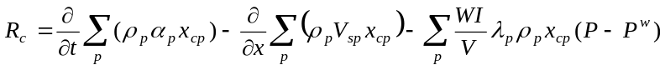, (2)
where t is time, ρ_{p} is the phase density, is free holdup of phase p, x_{cp} is the molar fraction of component c in phase p in the segment, x is position along the wellbore, V_{sp} is the superficial velocity of the phase p, V is the volume of the segment, 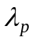is the mobility, WI is the well index and P^{w} is well pressure.

The equation for pressure is given by:
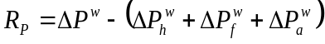, (3)
where ΔP_{h}, ΔP_{f}, ΔP_{a} are hydrostatic, frictional and acceleration components correspondingly.

The hydrostatic pressure difference between two segments is
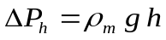, (4)
where 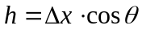, θ is inclination of segment from vertical, Δx is length of segment, 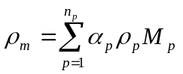 is mixture density, M_{p} is molar weight of phase p.
The frictional pressure component is
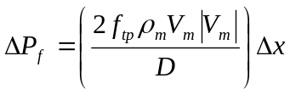, (5)
where 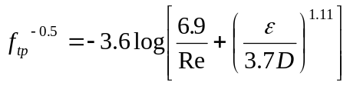 is the friction factor [7], 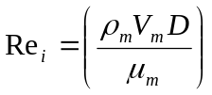 is Reynolds number, D is the wellbore diameter and 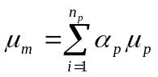 is mixture velocity.

The pressure component due to acceleration is given by following formula:
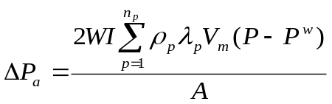, (6)
where A is cross-sectional area of the well.

Temperature is calculated from the energy balance equation:
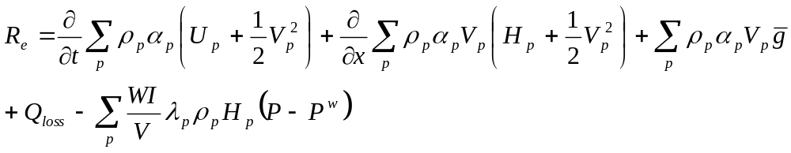, (7)
where Q_{loss} is heat exchange between the well and formation, U_{p} is the phase internal energy, H_{p} is the phase enthalpy, 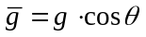 is the component of gravity along the well, θ is inclination of segment from vertical, g is gravitational acceleration and V_{p} = V_{sp}/α_{p} is the in-situ (flow) velocity of the phase p.

Heat exchange between wellbore and formation describes with the help of overall heat transfer coefficient U_{to}:
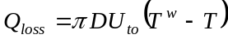, (8)
where T^{w} is the temperature of the fluid in the well, and T is the temperature of surroundings. Correlations for the coefficient U_{to} are described, for example, in [9], where U_{to} may take resistances of materials between tubing and formation into account, such is tubing wall, tubing insulation, cement, etc. It is very convenient for correct estimation of heat transfer between well and formation in case of complicated well completion.

We assume that water can stay only in liquid phase, so we solve only (n_{c}-1) equilibrium equations for hydrocarbon components:
, (9)
where y_{c} is gas mole fraction of component c, x_{c} is oil mole fraction of component c, f_{c,o} is fugacity of oil and f_{c,g} is fugacity of gas. Here fugacity is calculated by formula:
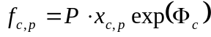, (10)
where 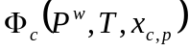 is taken from [9, 25, 26]. Additionally we need for each component: critical pressure P_{c}, critical temperature T_{c}, acentric factors ω_{c}, binary interaction coefficients δ_{ij}.

Last equations to solve in the system are three constraint equations; two of them are constraints for component mole fractions:
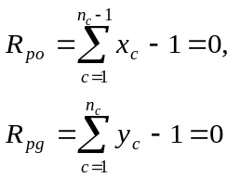, (11)
and the last one is for in-situ phase fractions or hold-ups:
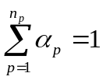. (12)
Totally we have (2n_{c}+4) equations, which are shown in Table 1, and (2n_{c}+4) variables (Table 2), so we can solve system (1).

Table 1. List of equations
Mass balance | Energy balance | Pressure loss | Equilibrium | Constraints | Total
n_{c} | 1 | 1 | n_{c}-1 | 3 | 2 n_{c}+4

Table 2. List of variables
P^{w} | T^{w} | V_{m} | α_{p} | y_{c} | x_{c} | Total
1 | 1 | 1 | 3 | n_{c}-1 | n_{c}-1 | 2 n_{c}+4

We use Newton method to linearize the system of Equations (1):
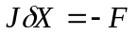, (13)
where F is residual vector for the system of Equations (2)-(12), the vector of unknowns X is as follows X={P^{w}, T^{w}, V_{m}, α_{g}, α_{w}, y₁,…, y_{nc-1}, x₁,…,x_{nc-1}} and 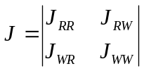 is Jacobian matrix. Here J_{RR} represents the derivatives of reservoir equations [5] with respect to the reservoir variables; J_{RW} represents the derivatives of reservoir equations with respect to the well variables; J_{WR} and J_{WW} represent the derivatives of well Equations (2)-(12) with respect to the reservoir and well variables respectively.

Example of structure of Jacobian is given in Figure 1. For isothermal model J_{RR} and J_{RW} parts of Jacobian are not equal to zero only for perforated segment; in Figure 1 it is shown with double black line and blue rectangle in Jacobian. In case of thermal model J_{RR} and J_{RW} are nonzero for every segment; in Figure 1 those additional segments are marked with double red lines and pink rectangles in Jacobian.

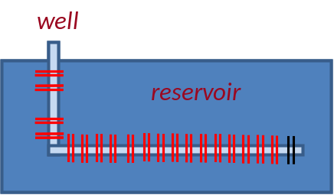 | 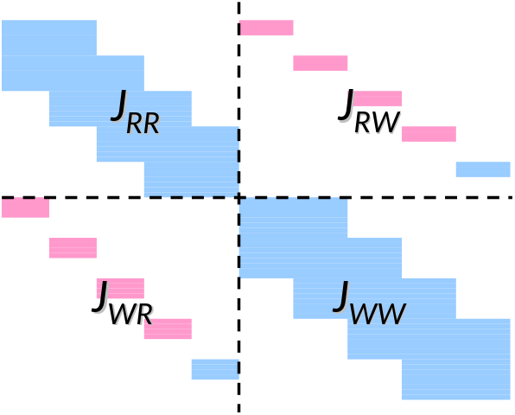
Figure 1. Structure of Jacobian.

The structure of J_{WW} is shown more detailed in the Figure 2. J_{WW} is block diagonal matrix, it has three diagonals: main diagonal element Diag, upper off-diagonal element offDiag+ and lower off-diagonal element offDiag-. The structure of J_{RR} matrix is very similar to J_{WW} [5].
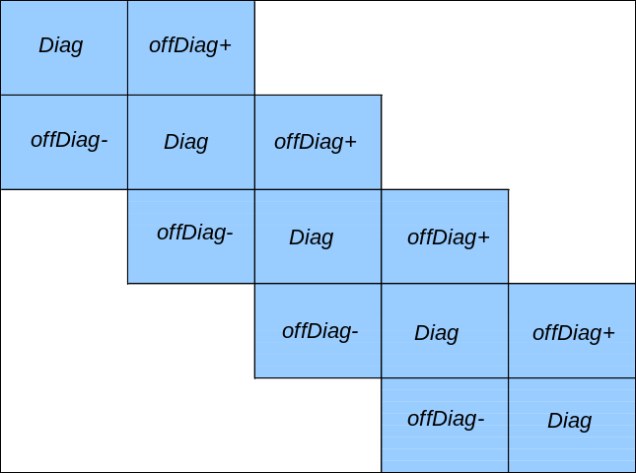
Figure 2. Structure of well part of Jacobian J_{WW.}

Described above multisegmented model has been implemented in Stanford’s GPRS simulator, which is sophisticated and effective tool for modeling of processes in reservoir and wells, such as gas and water injection and production, CO₂ sequestration and more [5, 12, 25].

2.2. Gibbs’ phase rule. Primary/secondary variables. Gaussian elimination.
In order to guaranty stability and convergence of the wellbore equations the system (1) should be solved fully implicitly. But luckily we don’t need to solve all (2n_{c}+4) equations implicitly. According to the Gibbs phase rule, the thermodynamic degrees of freedom f for system (1) are
f = n_{c} - n_{p} + 2. (14)
It fixes the intensive state of the system. To fix the extensive state of the system we need to add (n_{p}-1) in-situ volume fractions α_{p}. The final degrees of freedom are equal to (n_{c}+2) [2]. As (n_{c}+1) variables are enough to fix the extensive and intensive states of the system, at each time step we can solve Eqs. (2)-(12) only for (n_{c}+1) variables implicitly and update the other variables explicitly. That’s what we do for the reservoir equations [5], but the system of equations for wellbore is different. Relationship between pressure and flow rate in the wellbore is non-linear, and the mixture velocity of the fluid V_{m} can not be eliminated from the flow equations by using Eq. (3), so we have one extra equation (Eq. (3)) to solve and one extra variable to find (V_{m}). Consequently, for the wellbore we solve (n_{c}+2) primary equations (mass balance, energy balance and pressure equations) implicitly to find (n_{c}+2) primary variables, the other (n_{c}+2) variables (secondary) could be updated explicitly.

We choose following variables as the primary variables:
well pressure P^{w} 1,
well temperature T^{w} 1,
hold-ups α_{p} (n_{p}-1),
velocity V_{m} 1,
component mole fractions x_{cp} (n_{c}-n_{p}),
-------------------------------------------------------
total (n_{c}+2).

And following equations are the primary equations:
mass balance equations (1) R_{c} n_{c},
pressure loss equation (2) R_{p} 1,
energy equation (3) R_{e} 1,
---------------------------------------------------------
total (n_{c}+2).

So the set of primary variables is {P^{w}, T^{w}, V_{m}, α_{g}, α_{w}, y₁,…, y_{nc-3}}; the one for secondary variables is as follows {α_{o}, y_{nc-2}, y_{nc-1}, x₁,…, x_{nc-1}}, where subscripts o, g and w refer to oil, gas and water phases respectfully.

Figure 3 shows diagonal part Diag (from Figure 2.)of matrix J_{WW}, where A has derivatives of primary equations (pressure, energy, mass balance) with respect to primary variables, B has derivatives of primary equations with respect to secondary variables, C has derivatives of secondary equations (equilibrium equation and constraints) with respect to primary variables and D has derivatives of secondary equations with respect to secondary variables. For off-diagonal elements of matrix J_{WW} offDiag+ and offDiag- (Figure 2) the structure is exactly the same as for diagonal element Diag.

The structure of whole Jacobian J is shown in Figure 4, it includes J_{RR}, J_{WR}, J_{RW}, J_{WW} with their primary and secondary variables and equations (A, B, C and D). Here, for example, B_{RW} has derivatives of reservoir primary equations with respect to well secondary variables and D_{RR} has derivatives of reservoir secondary equations with respect to reservoir secondary variables.

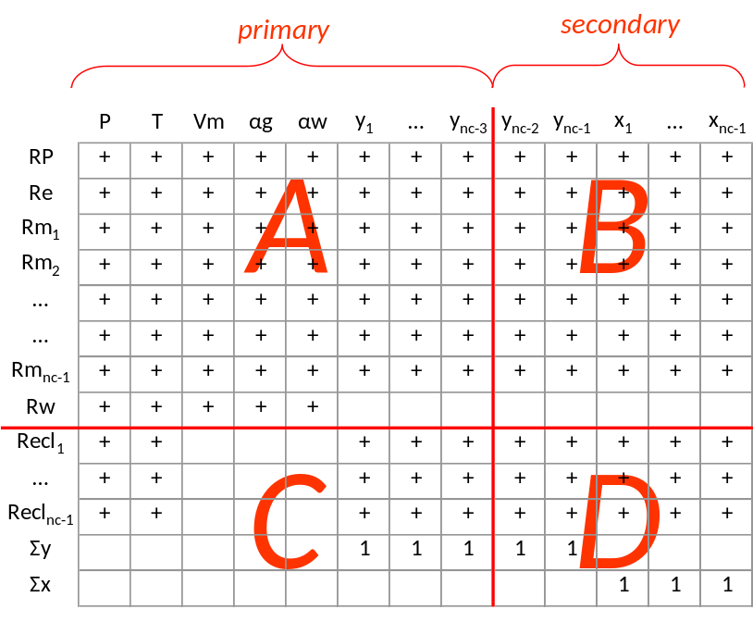
Figure 3. Primary and secondary variables for J_{WW}.

First we write J in a general form (Figure 4), and then we need to eliminate secondary equations and variables from Jacobian. After that we can solve the system (1) only for primary variables implicitly and update secondary variables explicitly. For the full system of (2n_{c}+4) equations perform Gaussian elimination, so as primary equations depend on primary variables only. This process is illustrated through Figures 4-6.

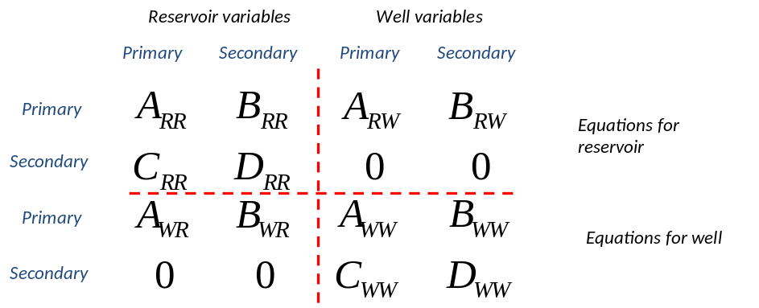
Figure 4. Scheme of Jacobian with primary and secondary variables and equations.

At first multiply derivatives of well secondary equations by D_{WW} (line 4 in Figure 4) and subtract them from derivatives of well primary equations (line 3 in Figure 4). Perform the same actions to derivatives of reservoir equations (lines 2 and 1 in Figure 4). The result is shown in Figure 5; here I is identity matrix.

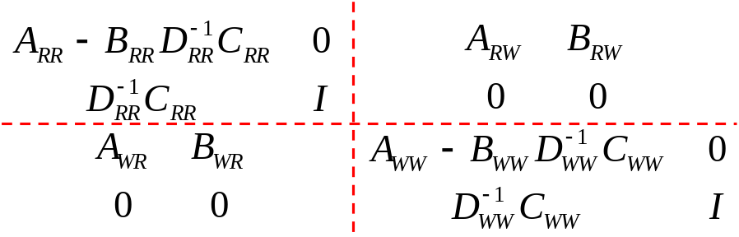
Figure 5. Reducing J to primary set (a).

After that we multiply derivatives of reservoir secondary equations (line 2 in Figure 5) by B_{WR} and then subtract them from derivatives of well primary equations (line 3 in Figure 5). We reduced J to primary set for well equations; then we do the same for the reservoir equations. Multiply derivatives of well secondary equations (line 4 in Figure 5) by B_{RW} and then subtract them from derivatives of reservoir primary equations (line 3 in Figure 5). Now the whole Jacobian matrix J is reduced to primary set, the result is shown in Figure 6. The green rectangles mark derivatives of primary equations, which depend only on primary variables. Now so we can solve system of equations only for those primary equations and variables implicitly.

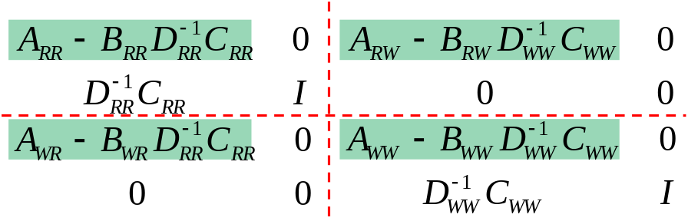
Figure 6. Reducing J to primary set (b).

After that, the secondary variables can be updated explicitly form the Figure 7. This figure shows Eq. (13) in details. Here M_{R} has residuals of primary reservoir equations, N_{R} has residuals of secondary reservoir equations, M_{W} has residuals of primary well equations, N_{W} has residuals of secondary well equations; X_{R,prm} and X_{R,sec} are primary and secondary variables for reservoir, X_{W,prm} and X_{W,sec} are primary and secondary variables for the well.

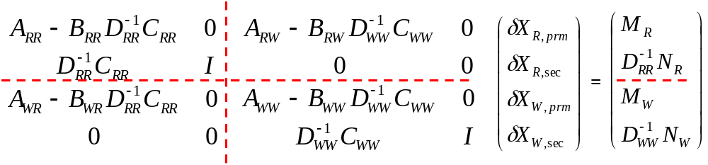Figure 7. Updating secondary variables

From Figure 7 we can find secondary variables for well and reservoir explicitly by formula:
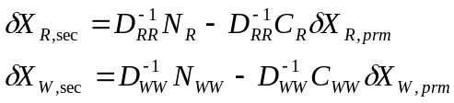 (15)

Should be noted that Gaussian elimination to primary set was shown only for the diagonal elements of Jacobian matrix J. The same procedure should be applied to lower and upper diagonal elements of J_{RR} and J_{WW}.

To make process clearer, the following operations are performed to system of equations (1) to reduce derivatives of primary equations with respect to secondary variables (parts B) in Jacobian J to zero:

- Well part:
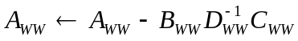
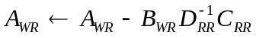
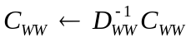
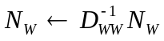

- Reservoir part:
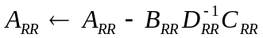
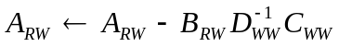
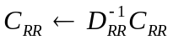
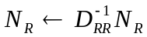

Here offDiag – and offDiag⁺ correspond to lower and upper diagonal elements, for example, offDiag –A_{WW} has derivatives of primary well equations with respect to primary well variables for lower diagonal element. Additionally we should make sure to select C_{WW} and D_{WW} from the same column as A_{RW}, B_{RW}, offDiag –A_{WW} and offDiag ⁺A_{WW} for the well part. For reservoir part we need select C_{RR} and D_{RR} from the same columns as A_{WR}, B_{WR}, offDiag –A_{RR} and offDiag ⁺A_{RR}.

The detailed procedure of elimination of primary parts from Jacobian for standard well is shown in [5]. It is much easier than for the multisegmented wells and could be easier to understand.

2.3. Homogeneous and drift flux models
The in-situ phase fractions distribution along the well in our simulation is defined with homogeneous (HO) or drift-flux (DF) models. Homogeneous model doesn’t allow slip between phases; it assumes that all phases are mixed well, so velocities of all phases are the same:
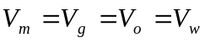. (16)
It is still a good approximation in some cases. But in general drift-flux model gives better results, as it takes slip between phases into account. The drift-flux model was initially proposed by Zuber and Findlay [27] for vertical two-phase bubble flow, where gas velocity V_{g} is calculated with formula:
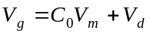, (17)
where C₀ is the profile parameter, V_{d} is drift velocity of the gas.

DF model is based on two assumptions:
1) the gas concentration and velocity profile are not uniform across the well cross-section, these effects are taken into account with the parameter C₀; and
2) gas tends to rise through the liquid in a vertical well because of buoyancy with the velocity V_{d}.

This simple approach is numerically efficient and has been successfully used for wellbore flow modeling.

In order to simulate in-situ phase fraction distribution along the well we use three-phase drift-flux model by Shi et al., [21], which is an extension of two-phase model [20], developed at Stanford University and based on set of experimental data. It allows to models slip between gas and liquid phases as well as slip between oil and water and different inclinations of the well (not only vertical).

Detail description of DF model is shown in Appendix A.

2.4. Derivatives
As we use Newton’s method to solve our composition problem, the big part of simulation is to write derivatives for Jacobian correctly. In this chapter we will first write our system of equations in discrete form for both production and injection wells. Then we will give a detailed description for all parts of Jacobian J, such as J_{RR,} J_{WR,} J_{RW} and J_{WW}, as well as off-diagonal parts, separately.

We will show derivatives for the mass balance, energy balance and pressure loss equations in details. Derivatives for equilibrium equations and constraints are the same as for reservoir model [5, 25], so we will skip detailed description of them.

2.4.1. Production well.
Let’s rewrite Equations (2-12) for the i_{th} segment of the well in discrete form.
Mass balance equations are:
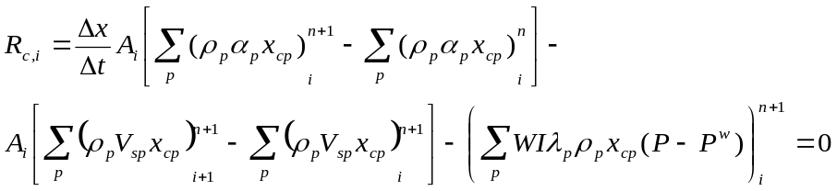, (18)
where c=1, …,n_{c}; λ_{p} and ρ_{p} are functions of reservoir pressure P, temperature T and mole fraction x_{cp}.

Pressure loss equation is
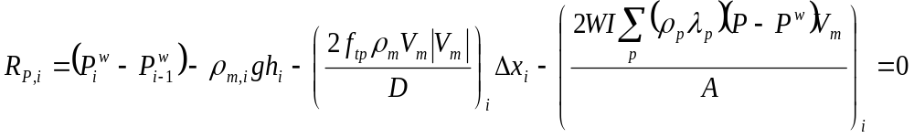. (19)

Energy balance equation is
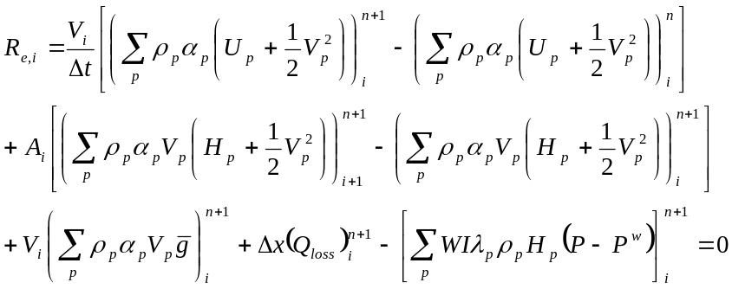, (20)
where ρ_{p} and H_{p} in last term depend on reservoir variables for production well.

Equilibrium equations for hydrocarbon components:
, (21)

Constraints for component mole fractions:
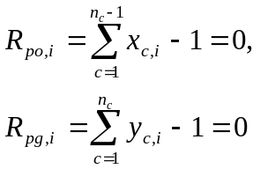, (22)
We don’t need to write derivatives for hold-up constraint (12), because we use it to update in-situ oil fraction 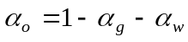 explicitly.

Equations R_{c}, R_{p} and R_{e} (18-22) are our residuals. Derivatives for all parts of Jacobian (J_{RR,} J_{WR,} J_{RW} and J_{WW}) are shown below:

J_{WW}
Diagonal part
1. For mass balance Eqs. (18):
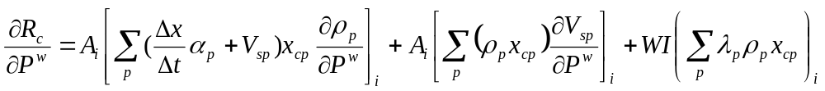,
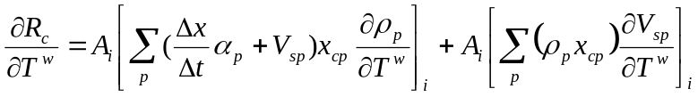,
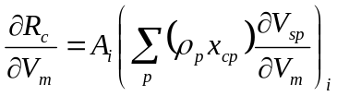,
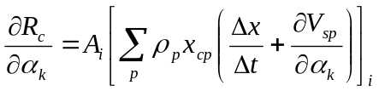,
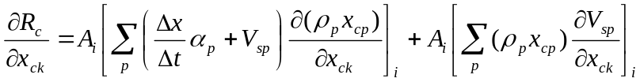,
where k = 1, 2, …, n_{c}-1.

In case of homogeneous model, derivatives are simpler:
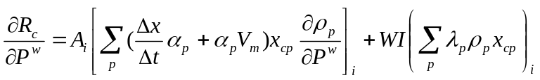,
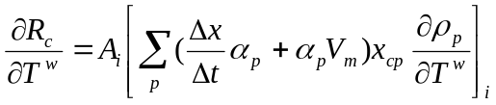,
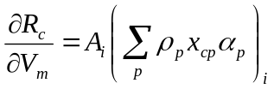,
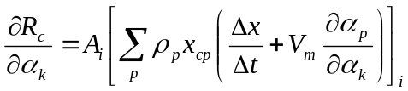,
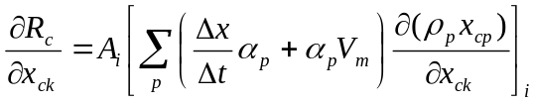;

2. Derivatives for pressure Eq. (19):
,
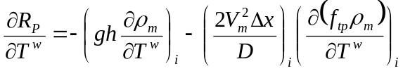,
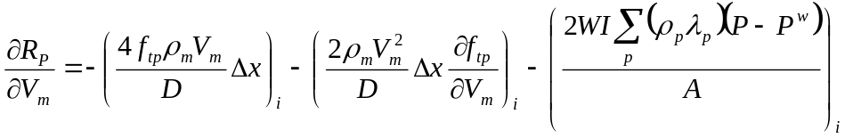,
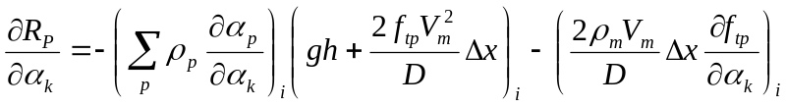,
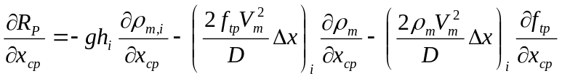;
where k = 1, 2, …, n_{c}-1. For the homogeneous model equations are the same.

3. For the energy Eq. (20):
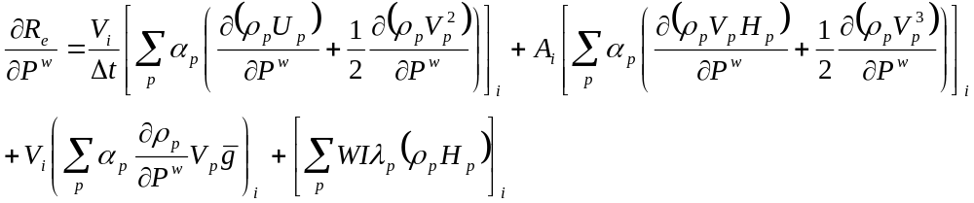,
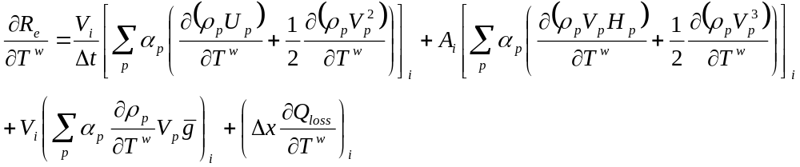,
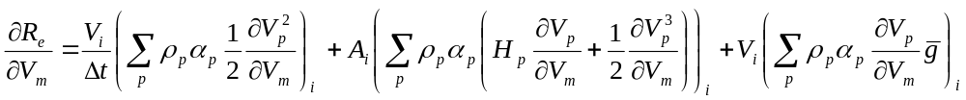,
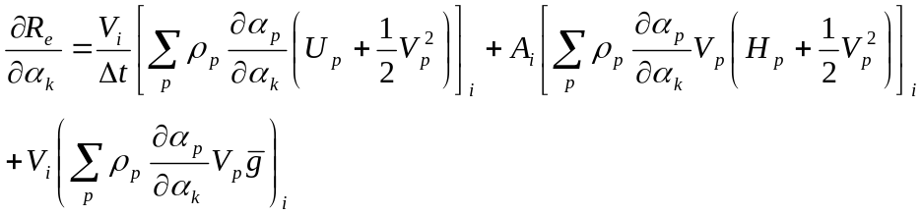,
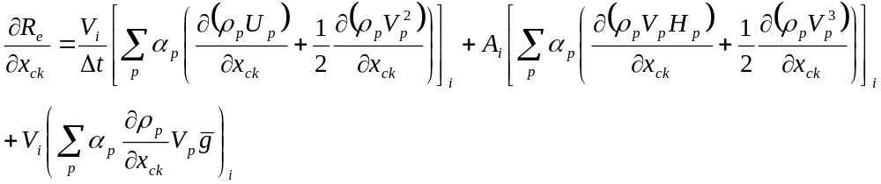.

The same derivatives are written for homogeneous model:
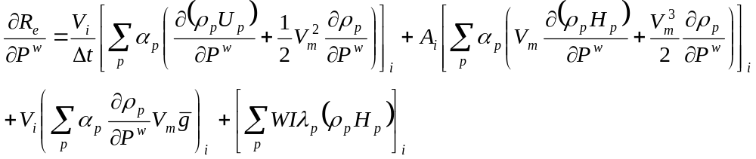,
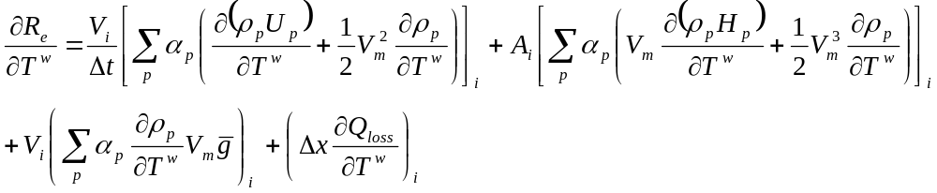,
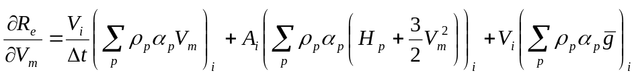,
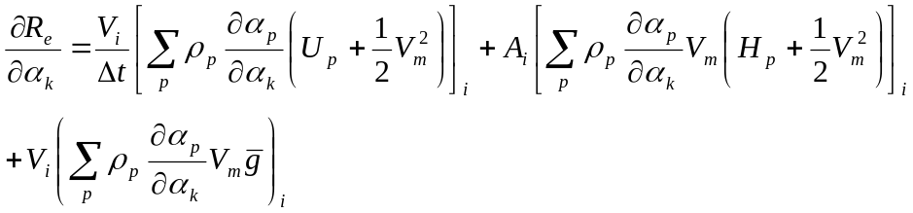,
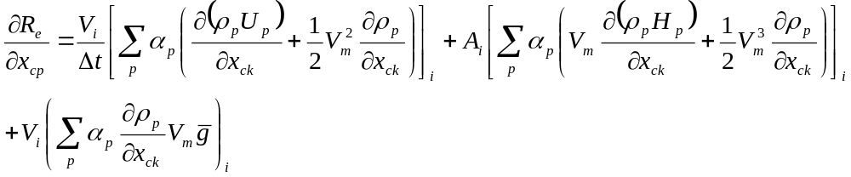
where k = 1, 2, …, n_{c}-1.

4. For phase equilibrium Eqs. (21):
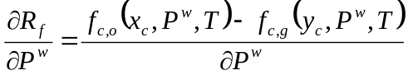,
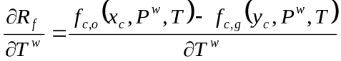,
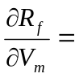0,
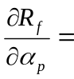0,
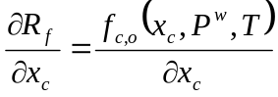,
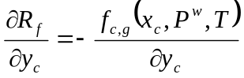.

5. For component mole fraction constraints (22):
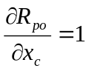,
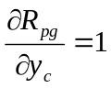.

The example of diagonal element of matrix J_{WW} for i_{th} segment is shown in Table 3.

Off- diagonal part A (i+1)
1. Derivatives for mass balance Eqs. (18):
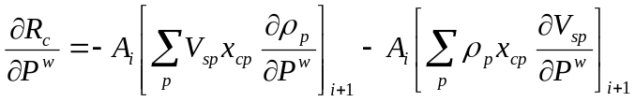,
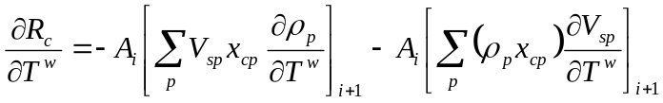,
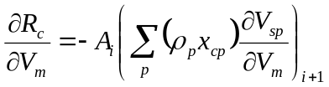,
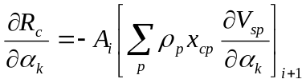,
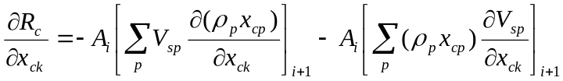,
where k = 1, 2, …, n_{c}-1.

2. For pressure Eq. (19):
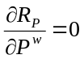, 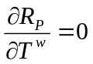, 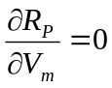, 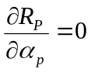, 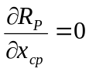.

3. Derivatives for the energy Eq. (20):
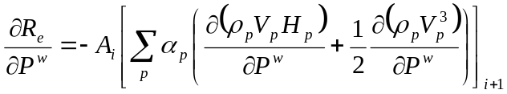,
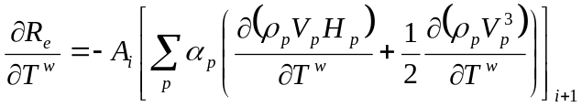,
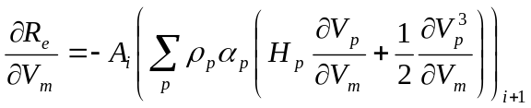,
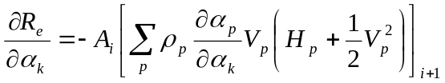,
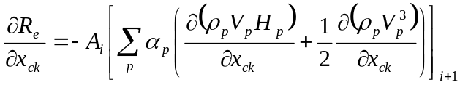;
where k = 1, 2, …, n_{c}-1.

4. For phase equilibrium Eqs. (21):
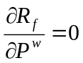, 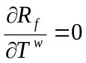, 0, 0, 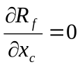, 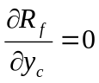;

5. For component mole fraction constraints (22):
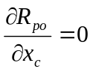, 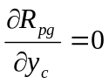.

The example of upper off-diagonal element of matrix J_{WW} for the same fluid as above is shown in Table 4.

Off- diagonal part B (i-1)
Only one derivative, which is not equal to zero, is for pressure loss Eq. (19):
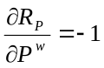.

Table 3. Diagonal element of J_{WW} matrix in case of 4 components (3 hydrocarbon components and water) and three phases.
 | P | T | V | α_{g} | α_{w} | y_{c1} | y_{c2} | y_{c3} | x_{c1} | x_{c2} | x_{c3}
R_{P} | + | + | + | + | + | + | + | + | + | + | +
R_{e} | + | + | + | + | + | + | + | + | + | + | +
R_{c1} | + | + | + | + | + | + |  |  | +
R_{c2} | + | + | + | + | + |  | + |  |  | +
R_{c3} | + | + | + | + | + |  |  | + |  |  | +
R_{w} | + | + | + | + | +
R_{f,c1} | + | + |  |  |  | + | + | + | + | + | +
R_{f,c2} | + | + |  |  |  | + | + | + | + | + | +
R_{f,c3} | + | + |  |  |  | + | + | + | + | + | +
R_{pg} |  |  |  |  |  | + | + | +
R_{po} |  |  |  |  |  |  |  |  | + | + | +

Table 4. Upper off-diagonal element of J_{WW} matrix in case of 4 components (3 hydrocarbon components and water) and three phases.
 | P | T | V | α_{g} | α_{w} | y_{c1} | y_{c2} | y_{c3} | x_{c1} | x_{c2} | x_{c3}
R_{P}
R_{e} | + | + | + | + | + | + | + | + | + | + | +
R_{c1} | + | + | + | + | + | + |  |  | +
R_{c2} | + | + | + | + | + |  | + |  |  | +
R_{c3} | + | + | + | + | + |  |  | + |  |  | +
R_{w} | + | + | + | + | +
R_{f,c1}
R_{f,c2}
R_{f,c3}
R_{pg}
R_{po}

J_{WR}
1. Derivatives for mass balance Eqs. (18):
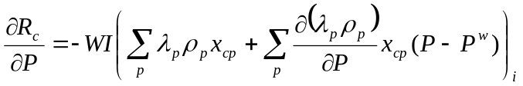,
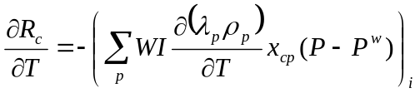,
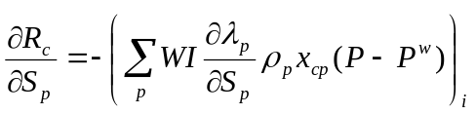,
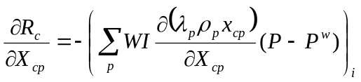,
where X_{cp} is mole fraction in reservoir.

2. For pressure Eq. (19):
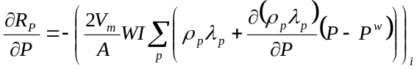,
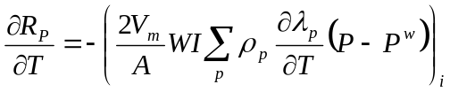,
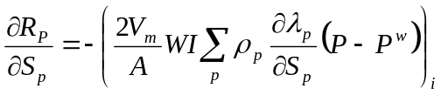,
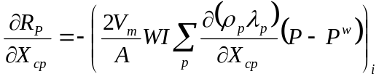;

3. For energy Eq. (20):
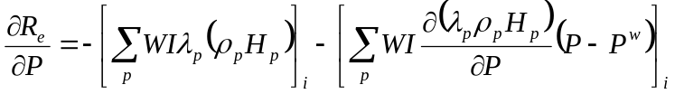,
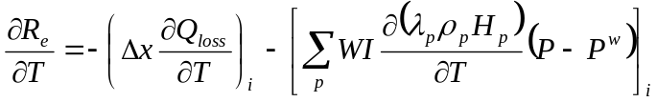,
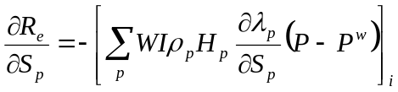,
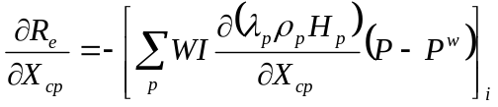.

4.-5. Phase equilibrium Eqs. (21) and component mole fraction constraints (22): derivatives are equal to zero.

J_{RR}
We will describe only derivatives from well terms of reservoir equations with respect to reservoir variables. Derivatives for all other terms were given in [5]. The well terms of reservoir equations are shown below:
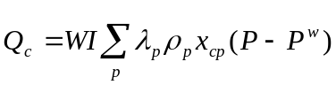 – for mass balance equations,
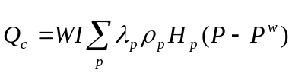 – for energy balance equation,
where c= 1, …, n_{c}, p= 1, …, n_{p}.

1. Derivatives for mass equations:
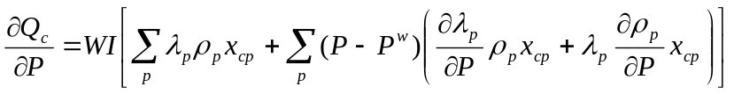,
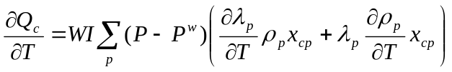,
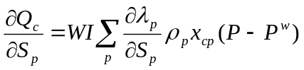,
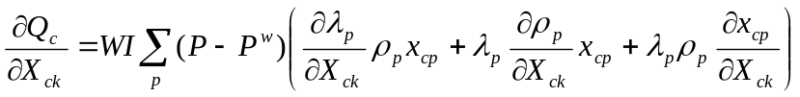.

2. Derivatives for the energy equation:
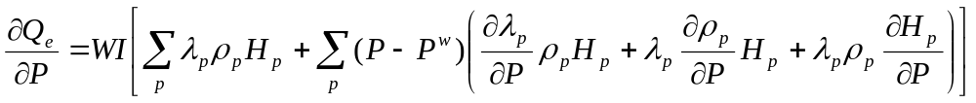,
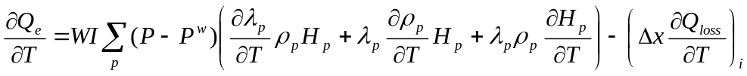,
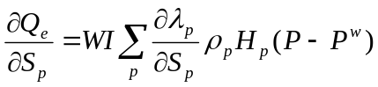,
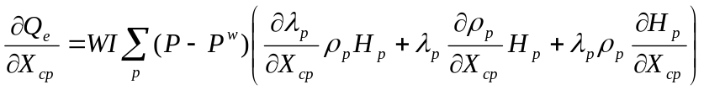.

J_{RW}
Almost all derivatives in this part are equal to zero, the exception is for perforated segments and shown below.

1. For mass balance equations:
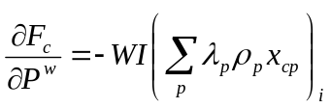;

2. For energy equation:
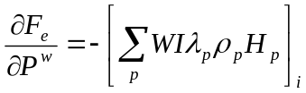;
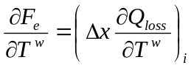

2.4.1. Injection well.
Equations (2)-(7) in discrete form are shown below. Equilibrium equations and constraints as well as their derivatives are skipped, because they are the same as for production well.

Mass balance equations are:
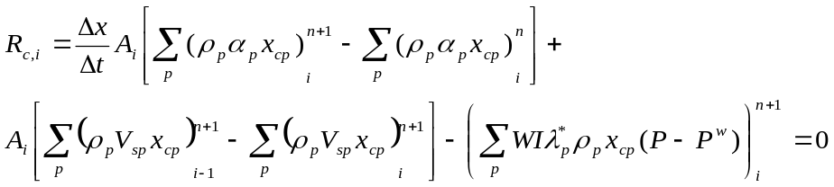, (23)
where ρ_{p} depends on well pressure P^{w}, temperature T^{w} and molar fractions x_{cp}. Phase mobility is calculated by formula 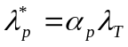, where 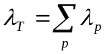 is total mobility. Some details about standard injection well calculations could be found in Pan H., 2005.

Pressure loss equation is
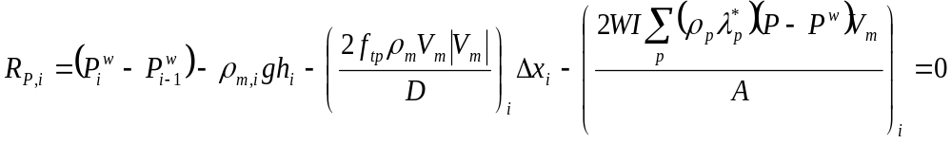, (24)
where ρ_{p} depends on well pressure P^{w} and T^{w}.

Energy balance equation is
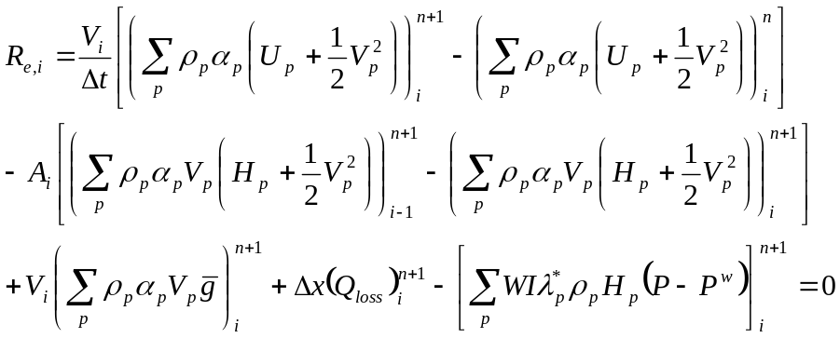, (25)
where ρ_{p} and H_{p} in last term depend on well variables.

Derivatives for Jacobian J:
J_{WW}
Diagonal part
1. Derivatives for mass balance Eqs. (23):
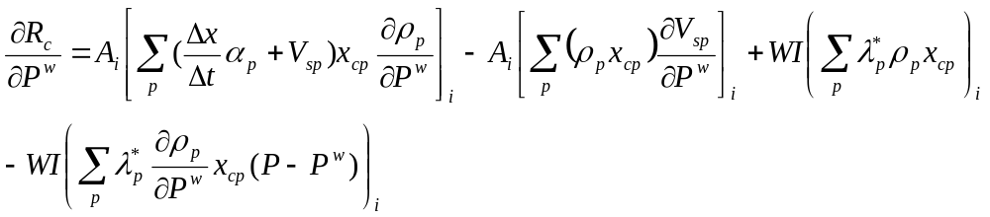,
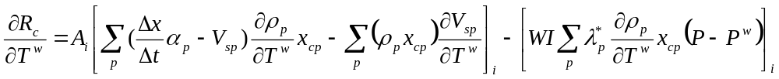,
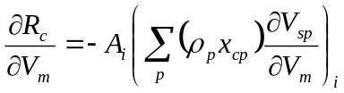,
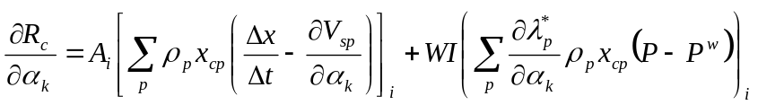,
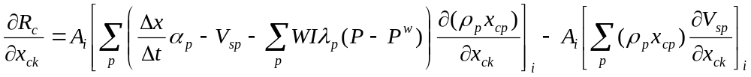,
where k = 1, 2, …, n_{c}-1.

2. For pressure Eq. (24):
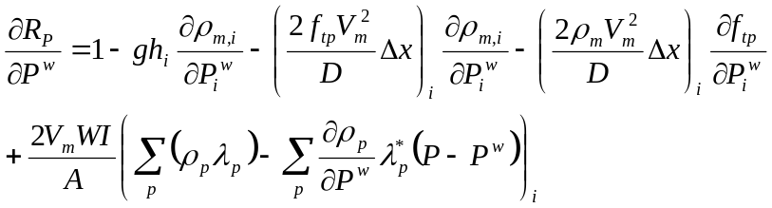,
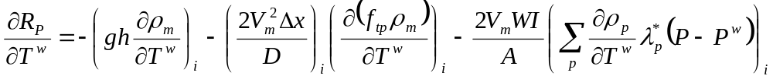,
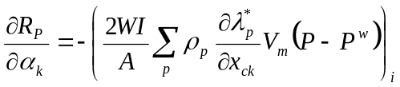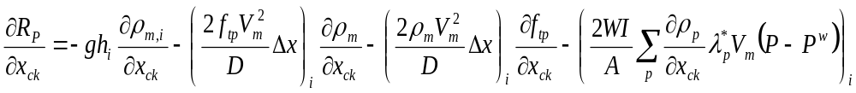where k = 1, 2, …, n_{c}-1.

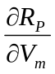, 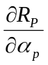, are the same as for production well;

3. Derivatives for energy Eq. (25):
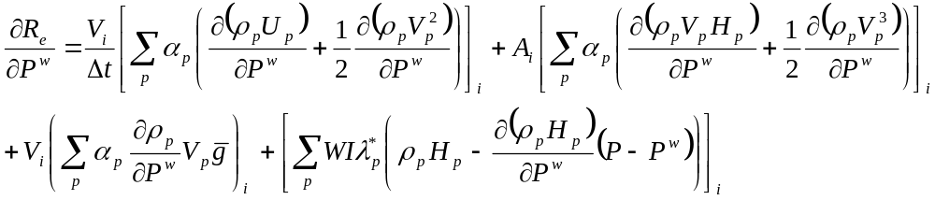,
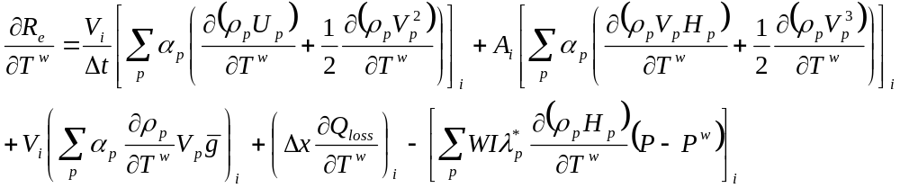,
,
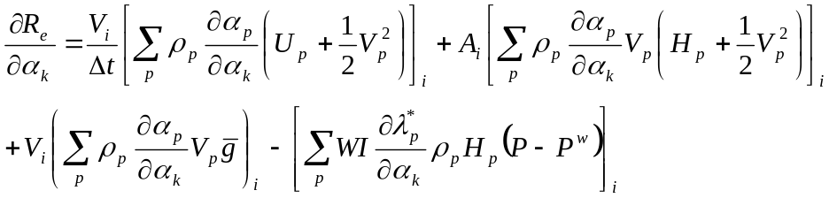,
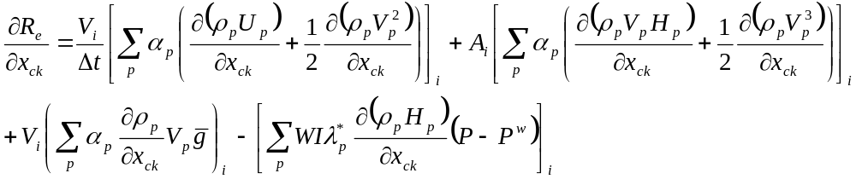;
where k = 1, 2, …, n_{c}-1.

Off- diagonal part A (i+1)
All derivatives are equal to zero.

Off- diagonal part B (i-1)
1. Derivatives for mass balance Eqs. (23):
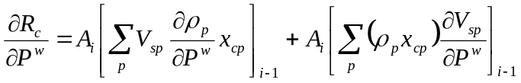,
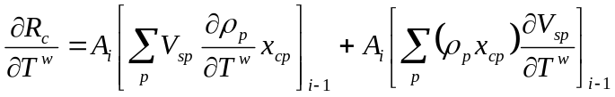,
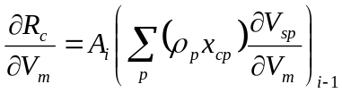,
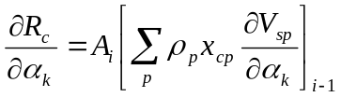,
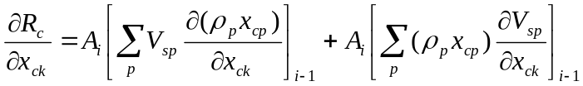;
where k = 1, 2, …, n_{c}-1.

2. For pressure Eq. (24):
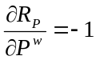, , 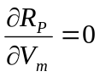, , ;

3. For energy Eq. (25):
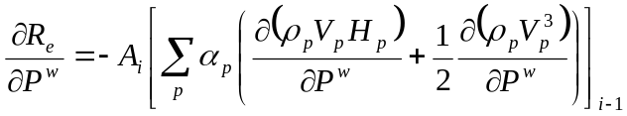,
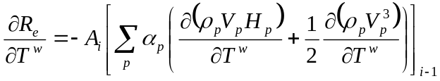,
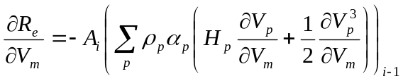,
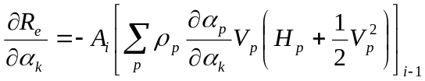,
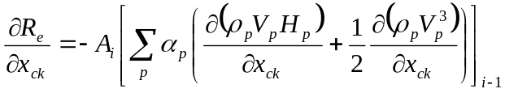;
where k = 1, 2, …, n_{c}-1.

J_{WR}
1. Derivatives for mass balance Eqs. (23):
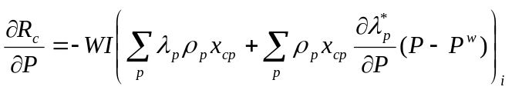,
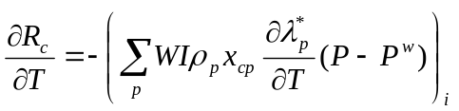,
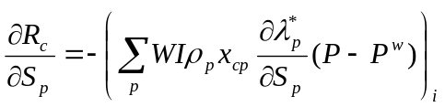,
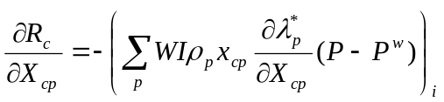;

2. For pressure Eq. (24): the same as for production well (V_{m}>0)

3. For energy Eq. (25):
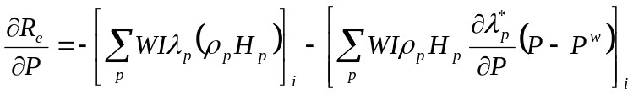,
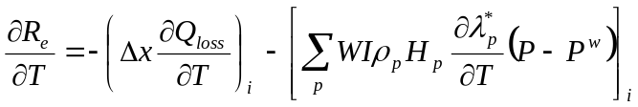,
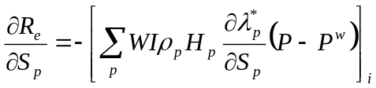,
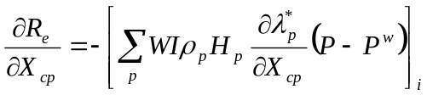.

J_{RR}
Derivatives for mass equations:
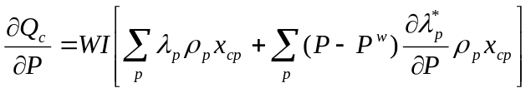,
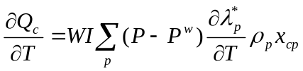,.
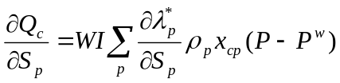,
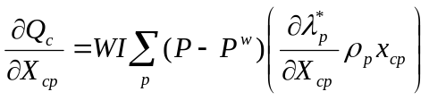.

For energy equation:
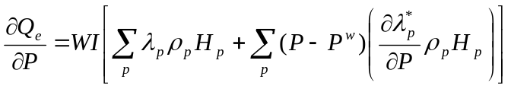,
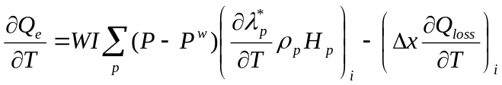,
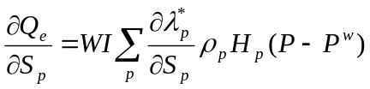,
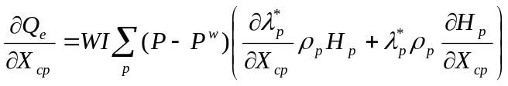.

J_{RW}
For mass equations:
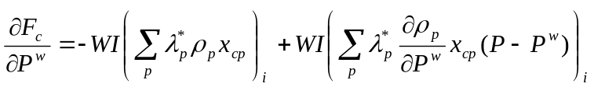,
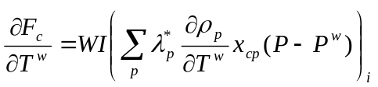,
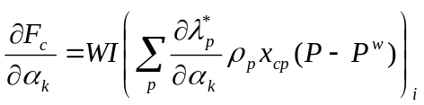,
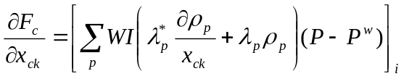;

For energy equation:
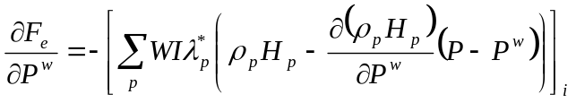,
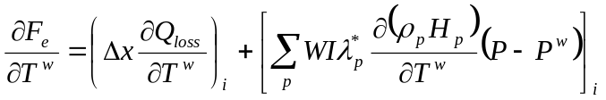,
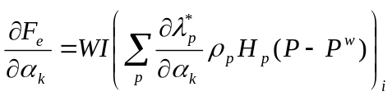,
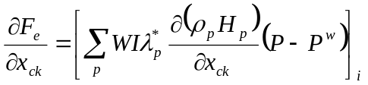;
where k = 1, 2, …, n_{c}-1.

2.5. Well controls
It should be noted that the flow in the first (top) segment of the well is always treated as homogeneous; and the first equation for that segment is the well control equation. In the case of constant pressure at the top segment, defined here as the bottom hole pressure (BHP), the well control equation is
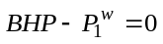, (26)
where P₁^{w} is pressure in the first segment of the well. In case we have rate control, we need to set a constant rate q_{p,1} of phase p at the wellhead and the equation takes the following form:
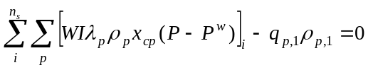, (27)
where ρ_{p,1} is density of phase p in the first segment and n_{s} is the number of segments in the well.

Currently we have implemented following well controls in our simulator, though other specifications could also be incorporated:
1) constant pressure at the wellhead (BHP),
2) constant oil rate at the wellhead (ORATE),
3) constant gas rate at the wellhead (GRATE),
4) constant water rate at the wellhead (WRATE),
5) constant liquid rate at the wellhead (LRATE),
6) time dependant oil rate at the wellhead (TORATE) and
7) time dependant gas rate at the wellhead (TGRATE).

2.6. Phase appearance and disappearance.
Phase appearance/disappearance in our multisegmented well model is treated very similarly to the way it was done for reservoir [5, 25].

When a segment has two hydrocarbon phases, we check in-situ phase fraction for each Newton iteration. If α_{o} ≤ 0 then oil phase disappears, and we need to find only (n_{c}+4) variables, which in this case are {P^{w}, T^{w}, V_{m}, α_{g}, α_{w}, y₁,…, y_{nc-1}}. If α_{g} ≤ 0 then gas phase disappears; and (n_{c}+4) variables to find are {P^{w}, T^{w}, V_{m}, α_{o}, α_{w}, x₁,…, x_{nc-1}}. In this case we just need to solve the system for primary variables implicitly and update only two secondary variables explicitly, in our case they are one in-situ phase fraction and one molar fraction.

When a segment has only one hydrocarbon phase we need to run stability test for each Newton iteration to make sure one hydrocarbon phase didn’t split into oil and gas. In case obtained two-phase system is stable we have (2n_{c}+3) variables again and need to solve the system (2)-(8) as it was described earlier.

3. Testing and validation
Capabilities of the model are demonstrated with four examples, which are calculated with both isothermal and thermal wellbore models. They show the importance of taking slip into account, phase appearance/disappearance in the wellbore and impact of the temperature on oil and gas rates during production. Examples are calculated with the different composition of fluids and for the different geometries of wellbore, which also includes multilateral well with two branches and angles of inclination from 0º to 90º (Figure 8 and Figure 16). Comparison with Eclipse simulator is also presented.

3.1. Example 1 (Comparison with Eclipse)
The first comparison with Eclipse simulator was made for the simple reservoir with 5 cells only and two wells: one multisegmented well producing under constant pressure BHP equal to 300 psi, and one standard well injecting hot water under constant pressure 700 psi. Temperature of injected water is 200 ºF. The heat transfer between wellbore and formation was not taken into account in this example. Other input parameters are presented in Table 5; schematic of the well is shown in Figure 8.

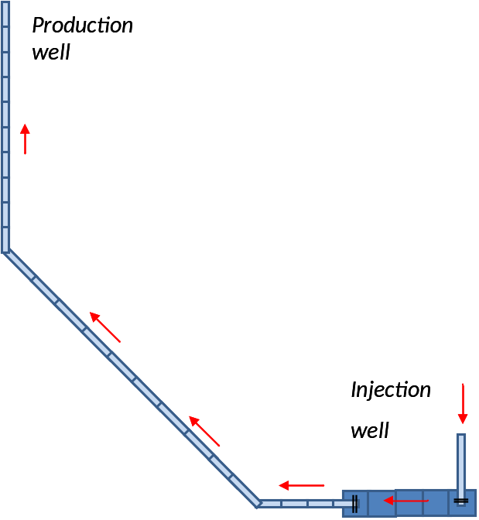
Figure 8. Schematic of well.

Table 5 – Input parameters
Reservoir grid block number 5×1×1
Size of reservoir (Δ_{x}×Δ_{y}×Δ_{z}), ft³ 100×100×20
Reservoir initial water saturation 0.12
Reservoir initial pressure, psi 500
Reservoir temperature, ºF 160
Reservoir permeability (k_{x}= k_{y} = k_{z}), md 100
Total well length, ft 822.84
Well diameter, ft 0.15
Well roughness 0.001
Well index, md·ft 3000
Size of the segment (vertical and horizontal), ft 20
Size of the segment (inclined), ft 28,284
Overall composition of reservoir fluid
C₁ 24
C₄ 0.16
C₆ 0.2
C₈ 0.4

We use homogeneous model of fluid flow for this example. Figure 9 shows variation of temperature and flow rates at the first segment of multisegmented well with time. Results obtained with Eclipse are shown with dots, GPRS with solid lines. They are quite similar: the temperature difference (∆T) is about 1 ºF, the pressure difference (∆P) is about 2 psi.

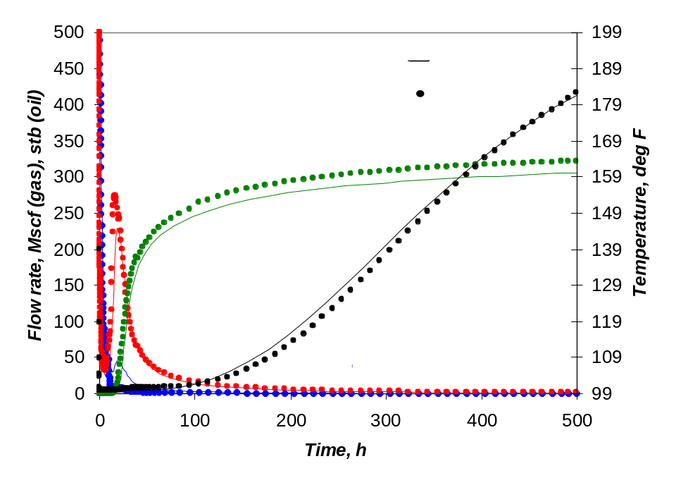
Figure 9. Variation of temperature and flow rates at the wellhead with time.

Figures 10 and 11 demonstrate in-situ phase fraction, pressure and temperature profiles 500 days after start of production. Results for Eclipse and GPRS are quite similar.

3.2. Example 2 (Comparison with Eclipse)
The scheme of well and reservoir for this comparison is shown in Figure 12. We have one multisegment production well and one standard injection well. Input parameters for producer are presented in Table 6. The injection well has the following parameters: injection fluid is water with temperature 200 ºF, BHP at the wellhead is equal to 700 psi.

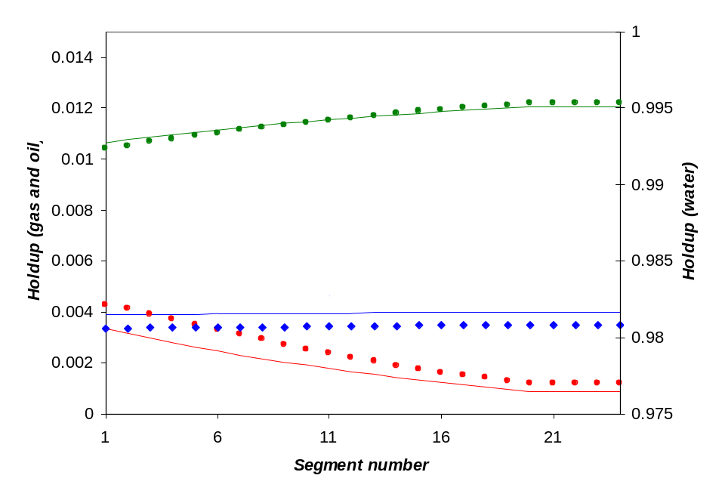
Figure 10. In-situ oil, gas and water fraction in the well.

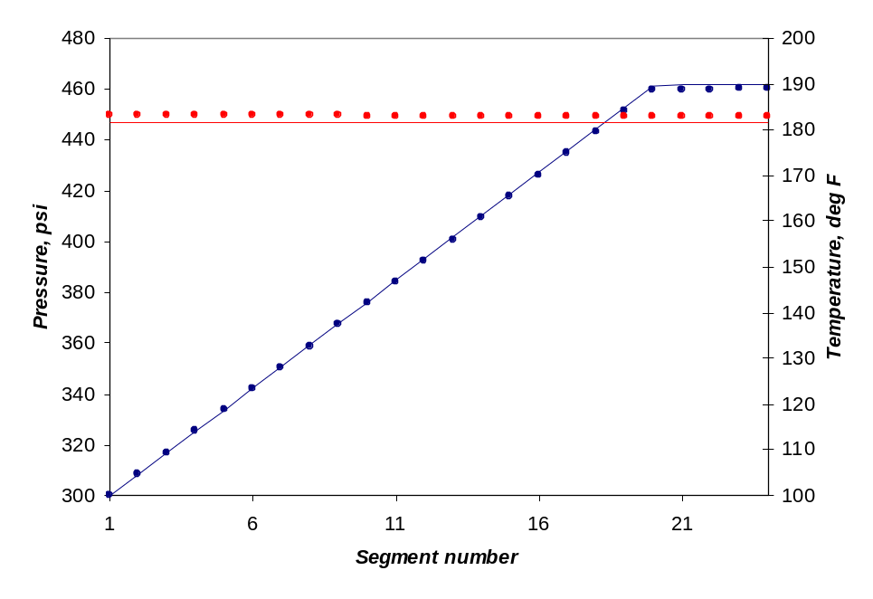
Figure 11. Temperature and pressure in the well.

Results presented in Figure 13 are quite similar for both GPRG and Eclipse. Total flow rate of gas and oil at wellhead before water breakthrough is a little bit different though, but it could be because of different correlation used in simulators. Results in Figure 13 are calculated with both homogeneous and drift-flux models.

Table 6 – Input parameters
Reservoir grid block number 15×1×20
Size of reservoir (Δ_{x}×Δ_{y}×Δ_{z}), ft³ 20×100×20
Reservoir initial water saturation 0.12
Reservoir initial pressure, psi 500
Reservoir temperature at the top boundary, ºF 160
Geothermal gradient, F/ft 0.05
Reservoir permeability (k_{x}= k_{y} = k_{z}), md 100
Total well length, ft 822.84
Well diameter, ft 0.15
Well roughness 0.001
Well index, md·ft 3000
Size of the segment (vertical and horizontal), ft 20
Size of the segment (inclined), ft 28,284
Overall heat transfer coefficient, Btu/(day·ft²·F) 500
Overall composition of reservoir fluid
C₁ 24
C₄ 0.16
C₆ 0.2
C₈ 0.4

We also show distributions of in-situ phase fractions, temperature and pressure along the well at about 3.5 days. These results are shown in Figure 14.
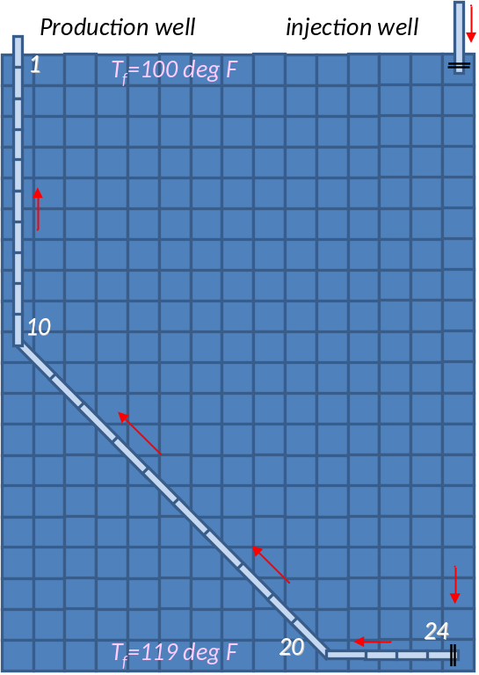
Figure 12. Schematic of the well

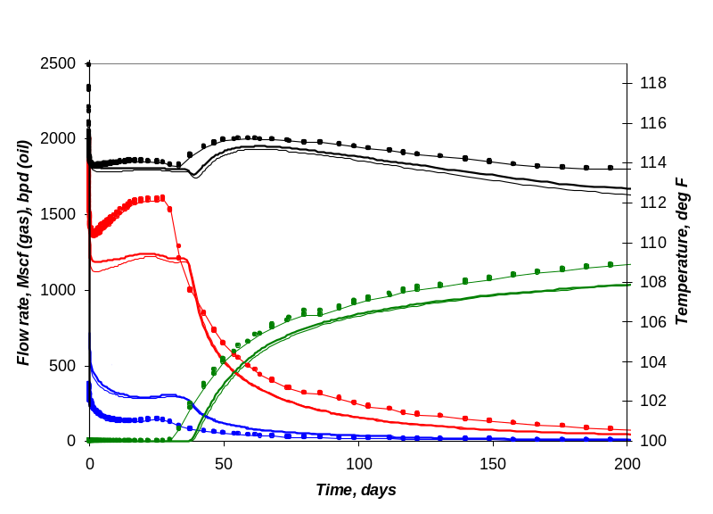
Figure 13. Temperature and flow rates at the wellhead.

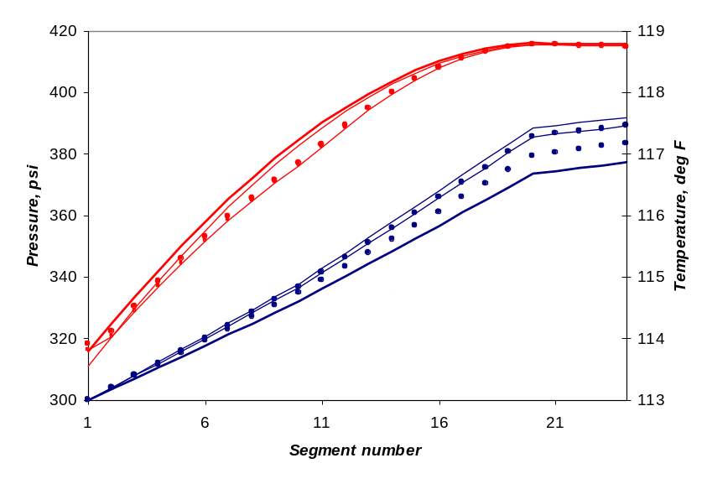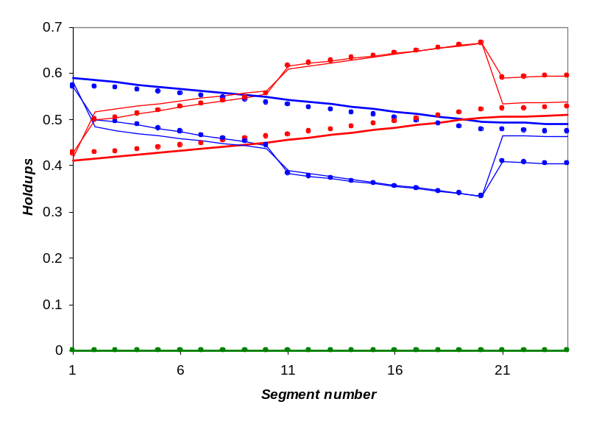
Figure 14. In-situ phase fractions, pressure and temperature profiles in the well after 3.5 days of production.

3.3. Example 3 (Drift-flux model)
The following example is calculated for a vertical producing well 900 ft long consisting of 30 segments and one perforation at the bottom of the well. Reservoir in this example is represented by 147 cells (7×7×3) and pressure in the perforated cell P_{f} is equal to 1400 psi. The well produces oil and gas under constant pressure P_{w} specified in the first segment of the well (we call it bottom hole pressure or BHP). Fluid is represented in terms of 6 hydrocarbon components, which are C₁, C₃, C₆, C₁₀, C₁₅, C₂₀, and water. Other input parameters are summarized in Table 7; values of critical properties are taken from [26].

Table 7 – Input parameters for example 1
Reservoir grid block number 7×7×3
Size of reservoir grid block Δ_{x}, ft 500
Size of reservoir grid block Δ_{y}, ft 500
Size of reservoir grid block Δ_{z} (for 3 layers), ft 20, 30, 50
Reservoir initial water saturation 0.2
Reservoir initial pressure, psi 1400
Reservoir temperature, ºF 160
Reservoir permeability k_{x} (for 3 layers), md 500, 50, 200
Reservoir permeability k_{y} (for 3 layers), md 500, 50, 200
Reservoir permeability k_{z} (for 3 layers), md 50, 50, 25
Well depth, ft 900
Well diameter, ft 0.15
Well roughness 0.001
Well index, md·ft 10800
Size of the well segment, ft 30
Overall composition of reservoir fluid
C₁ 0.5
C₃ 0.03
C₆ 0.07
C₁₀ 0.2
C₁₅ 0.15
C₂₀ 0.05

Calculations were made for two values of BHP equal to 1150 psi and 1200 psi to demonstrate hold-up effect at different velocities of wellbore fluid V_{m}. Figures 15 and 16 show results calculated for BHP = 1150 psi (example 1a), while results in Figures 17 and 19 are calculated for the higher pressure BHP = 1200 psi (example 1b). The calculations were performed with both homogeneous (HO) and drift-flux (DF) models, to clearly show the importance of taking slip between phases into account. The difference in oil flow rate for the HO and DF models reaches 200 bpd for the Example 1a (Figure 15) and about 700 bpd for the Example 1b (Figure 17). In the figures the thick lines correspond to HO and the thin lines to DF model. The behaviors of the flow rate curves calculated with and without slip are very different for the Example 1b (Figure 17). The production predicted with DF model stops about 130 days earlier than that predicted with HO model. In order to understand this behavior we refer to Figures 16 and 18. Only distribution of in-situ gas fractions is plotted here because water flow in the well is negligible and in-situ oil fractions can be found simply as 1-α_{g} (Equation 12). In Example 1a maximum difference between both models for in-situ gas fraction (Δα_{g}) is around 0.15 and the maximum the pressure difference (ΔP) is approximately 23 psi. For the Example 1b, by contrast, Δα_{g} is about 0.4 and ΔP is about 56 psi. Pressure values in the perforated well segment and formation are approximately the same. Because DF model takes slip between phases into account, oil tends to accumulate in the well and hydrostatic head is higher, than predicted with HO model. When pressure in the perforated segment and pressure in corresponding reservoir cell reach the same value production stops, which happens earlier if DF model is used.

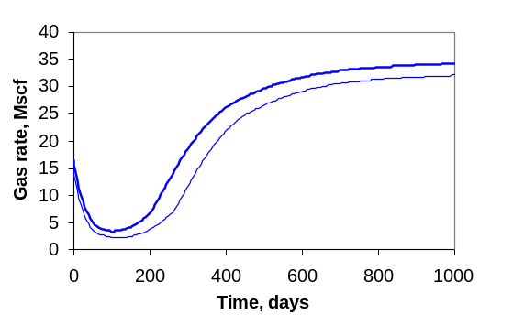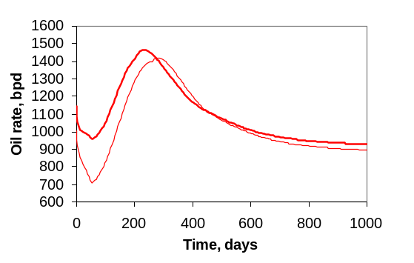
Figure 15. Gas and oil rate versus time for bottom hole pressure in the well BHP =1150 psi.

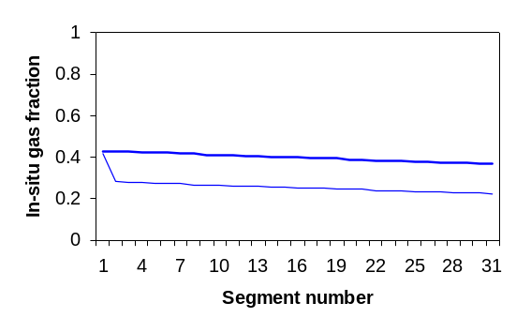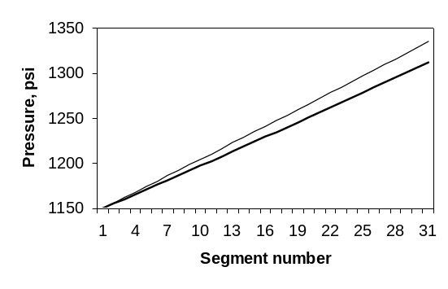
Figure 16. In-situ gas fraction and pressure in the well after ~ 63 days of production for BHP =1150 psi.

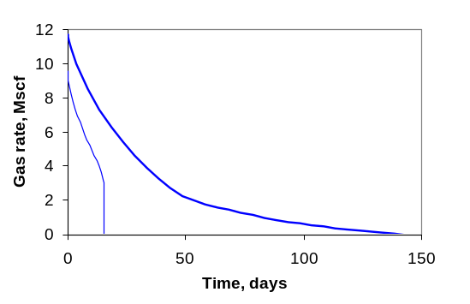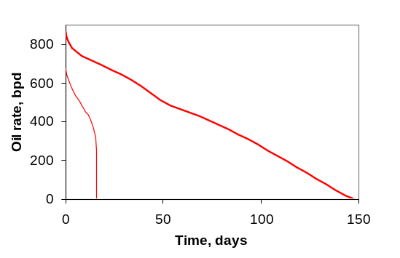
Figure 17 .Gas and oil rate versus time for BHP =1200 psi.

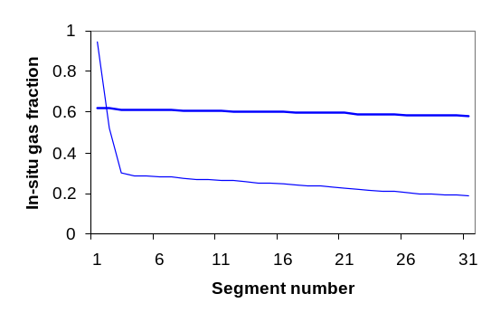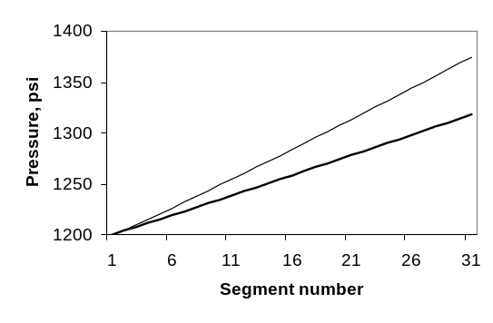
Figure 18. In-situ gas fraction and pressure in the well after ~ 15 days of production BHP =1200 psi.

The mean velocity V_{m} for the Example 1a varies from about 1.3 m/s to about 7 m/s, but always is greater than 1 m/s. In the Example 1b V_{m} is around 1 m/s or less. Specifically, for the cross-section shown in Figure 16, V_{m} is equal to about 1.3 m/s; in the Figure 17 velocity V_{m} is about 0.3 m/s. The slower velocity in the well the more important it is to take slippage between phases into account. For this particular example the dramatic difference between DF and HO models occurs when mean velocity is less than 1 m/s.

3.4. Example 4 (Multilateral well)
The second example is for a thermal multilateral well producing at a constant oil rate of 1000 bpd. The schematic of the well is shown in the Figure 19. The well has two branches: the first branch consist of 24 segments, where segments 1-10 are vertical, segments 11-20 are inclined with a slope of 45º and segments 21-24 are horizontal. The second branch has 14 horizontal segments and connects to the main branch at the segment 8 (Figure 19). Fluid in this example has three hydrocarbon components C₁, C₃ and C₇; the reservoir has 300 cells (15×1×20). Calculations were made with DF model. The overall heat transfer coefficient U_{to} for this example is equal to 500 Btu/(day·ft²·ºF). Other necessary input parameters are shown in Table 6 or were taken from [26] and [17].

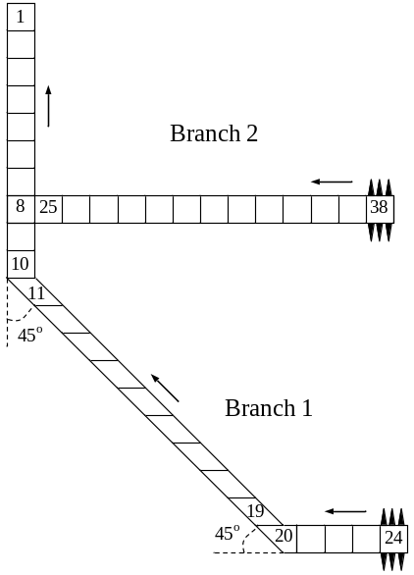
Figure 19. Schematic well (Example 2). Numbering shown as it was used in the program. For the display in figures an alternative scheme was used

Figure 20 shows temperature, pressure and in-situ gas fraction profiles in the well after about 10 days of production. Here to simplify presentation of the results, we have chosen different numeration of segments from that in Figure 19. For both branches numeration starts at the first segment and ends at the perforated segment, i.e., the first branch has 24 segments (from 1 to 24) and the second branch has 22 segments (from 1 to 22). At the segment 8 (junction) the two brunches come together. The temperature and in-situ gas fraction curves trace inflow from the second branch with a significant jump of approximately 10 ºF for temperature and 0.4 for in-situ gas fraction. The in-situ gas fraction curve changes when inclination changes as shown in Figure 20. Here the thin lines correspond to the first branch, the thick lines to the second branch (horizontal branch).

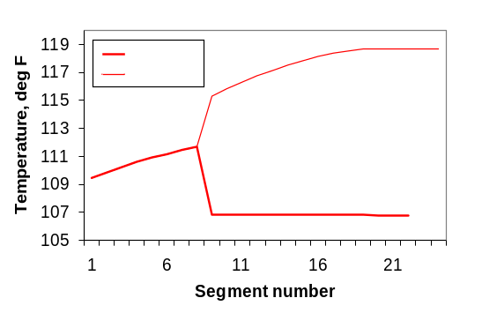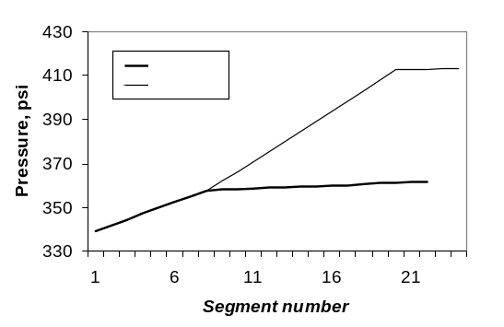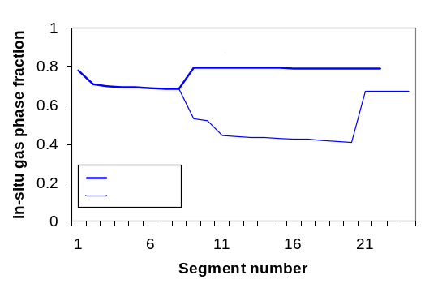
Figure 20. Temperature, pressure and in-situ gas fraction in the well after about 10 days of production (both branches are numbered starting from the wellhead: the first branch has 24 segments in total, the second branch has 22 segments).

3.5. Example 5 (Thermal)
The last example demonstrates impact of temperature on production rate. This example also illustrates the ability of our simulator to treat phase appearance/disappearance in the wellbore.

All calculations in this example were made for vertical well 4500 ft long, producing with constant pressure BHP of 500 psi; reservoir pressure is equal to 2300 psi, the geothermal temperature changes from 100 ºF at the top of reservoir to 160 ºF at the bottom. The total simulation time is 500 days. The other parameters are the same as for the previous example, except overall heat transfer coefficient: U_{to} = 100 and 2000 Btu/(day·ft²·ºF). This allows us to have significantly different temperature distribution in the wellbore (Figure 21) for those two cases. Figure 21 shows temperature profiles in the well at the end of calculation, i.e., after 500 days. One can see that the higher value of U_{to} the smaller difference between temperature in the wellbore and geothermal temperature. The maximum difference between temperature profiles calculated with different U_{to} reaches approximately 43 ºF.

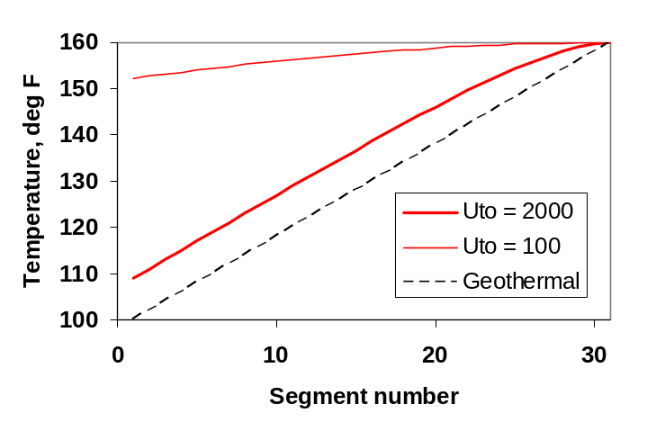
Figure 21. Temperature profiles along the well at the end of calculation (500 days) for different values of U_{to} and geothermal temperature.

Figure 22 demonstrates strong impact of temperature on oil and gas rates, it shows oil and gas rates calculated with U_{to} = 100 and 2000 Btu/(day·ft²·ºF). The difference in oil rate is about 218 bbd for this case, which is about 20 % of total oil rate. For the gas rate difference is approximately 1.15 Mscf or 30-50% of total gas rate. The impact of temperature could be in thermal oil recovery, such as in steam injection or SAGD processes.

Figure 23 shows distribution of gas and oil phase component fractions along the well after 500 days of production for U_{to} = 2000 Btu/(day·ft²·ºF). Segments are numbered starting from the wellhead. We have a total of 30 segments in this example segments and one perforation at the bottom of the well. One can see that component fractions change dramatically at the segment 15, especially gas component fraction, because at that segment fluid reaches its bubble point and gas starts to appear in the wellbore. Below this point there is only liquid in the well. The gas phase above segment 15 contains more than 90% C₁ (methane).

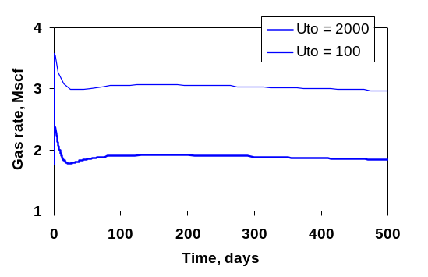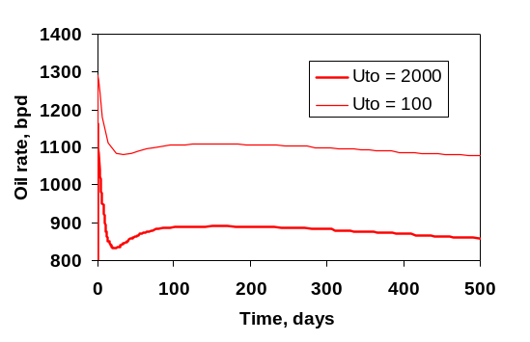
Figure 22. Gas and oil rate versus time for different values of U_{to}.

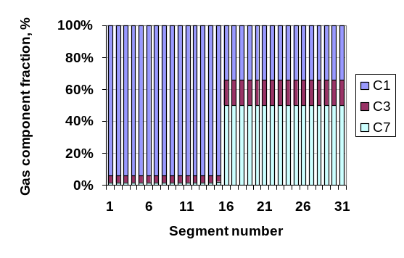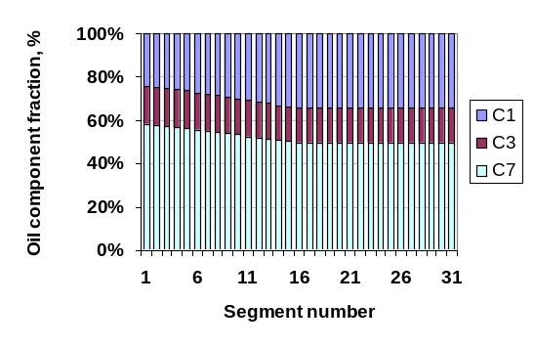
Figure 23. Gas and oil phase composition along the well after 500 days of production for U_{to} = 2000 Btu/(day·ft²·ºF).

Concluding remarks
Isothermal and thermal compositional multisegmented well models, both with slip (DF) and without slip (HO) between phases, were developed and implemented in GPRS. Models were successfully tested on challenging examples. With the examples presented here we have demonstrated the importance of taking slip between phases into account, the impact of temperature on oil and gas rates, and our ability to model phase appearance/disappearance in the wellbore. The examples also demonstrate that the model can handle horizontal, inclined and multilateral wells.

Acknowledgements
We thank the Schlumberger Foundation Faculty for the Future program and Shell International for financial support.

References
- Aziz K, Govier G.W. and Fogarasi M. Pressure Drop in Wells Producing Oil and Gas. The Journal of Canadian Petroleum Technology. July-September, 1972.
- Aziz K., Durlofsky L.J., Tchelepi H, and Gerritsen M. Notes for Petroleum Reservoir Simulation. Department of Energy Resource Engineering, Stanford University, 2006
- Aziz K and Settari A. Petroleum Reservoir Simulation. Blitzprint Ltd., Calgary, 2002.
- Aziz K. and Wong T.W. Considerations in the Development of Multipurpose Reservoir Simulation Models. Proceedings of the 1st and the 2nd International Forum on Reservoir simulation, Alpbach, Austria, Sept. 12-16, 1988 and Sept. 4-8, 1989.
- Cao H. Development of Techniques for General Purpose Simulators. Ph.D. dissertation. Department of Energy Resource Engineering, Stanford University, 2002
- Coats K.H, George W.D., Marcum B.E. Three-Dimensional Simulation of Stream Flooding. SPE 4500. 1974.
- Haaland SE. Simple and Explicit Formula for the Friction Factor in Turbulent Pipe Flow Including Natural Gas Pipelines. IFAG B-131, Div Aero and Gas Dynamics, The Norwegian Institution of Technology; 1981
- Hasan A.R. and Kabir C.S. A Simplified Model for Oil/Water Flow in Vertical and Deviated Wellbores. SPE Prod. & Facilities 14(1), February 1999.
- Hasan A.R. and Kabir C.S. Fluid Flow and Heat Transfer in Wellbores. Society of Petroleum Engineers, Richardson, Texas, 2002
- Holmes J.A. Modeling Wells and Production Facilities. 9th International Forum on Reservoir Simulation. Abu Dhabi, December 9-13, 2007
- Holmes J.A., Barkve T. and Lund O. Application of Multisegment Well Modeling to Simulate Flow in Advanced Wells. SPE Paper 50646, 1998
- Jiang Y. A Flexible Computational Framework for Efficient Integrated Smulation of Advanced Wells and Unstructured Reservoir Models. Ph.D. dissertation. Department of Energy Resource Engineering, Stanford University, 2007
- Livescu S. Thermal Implementation for Multisegment Wells. October 2006. SUPRI-B/HW Industrial Consortia, Department of Petroleum Engineering, Stanford University.
- Livescu S., Durlofsky L.J., Aziz K and Ginestra J.-C. A New Model for Simulating Nonisothermal Multiphase Flow in Wellbores and Pipes, in review, 2008
- Livescu S., Durlofsky L.J., Aziz K and Ginestra J.-C. Application of a New Fully Coupled Thermal Multiphase Wellbore Flow Model. SPE Paper 113215, 2008
- Pan H. Injection Well Implementation. GPRS Technical Report. October, 2005. SUPRI-B Industrial Consortium Department of Petroleum Engineering. Stanford University.
- Passut C.A. and Danner R.P. Correlation of Ideal Gas Enthalpy, Heat Capacity and Entropy. Ind. Eng. Chem. Process Des. Develop., Vol. 11, No. 4, 1972.
- Peaceman D.W. Interpretation of well-block pressures in numerical reservoir simulation, SPE Paper 6893, 1978
- Ramey H.J. Jr. Wellbore Heat Transmission. SPE Paper 96. April, 1962.
- Shi H., Holmes J.A., Durlofsky L.J, Aziz K., Diaz L.R., Alkaya B. and Oddie G. Drift-flux Modeling of Two-Phase Flow in Wellbores. SPE J. 10(1): 24-33, March 2005.
- Shi H., Holmes J.A., Diaz L.R., Durlofsky L.J and Aziz K. Drift-flux Parameters for Three-Phase Steady-State Flow in Wellbores. SPE J. 10(2): 130-137, June 2005.
- Shirdel M. and Sepehrnoori K. Development of a Coupled Compositional Wellbore/Reservoir Simulator for Modeling Pressure and Temperature Distribution in Horizontal Wells. SPE Paper 124806, 2009
- Stone T.W., Bennett J., Law D.H.-S. and Holmes J.A. Thermal Simulation with Multisegment Wells. SPE Reservoir Evaluation & Engineering, June, 2002.
- User’s Guide Winprop. Computer Modeling Group LTD., 2004.
- Voskov D. Description of Thermal GPRS. Technical Report. Energy Resource Engineering Department, Stanford University, 2006
- Walas S.M. Phase Equilibria in Chemical Engineering. 1985
- Zuber N. and Findlay J.A. Average Volumetric Concentration in 2-Phase Flow Systems. J. Heat Transfer 87 (4), 1965.

Appendix A. Drift-flux model
The expression for the drift-flux velocity can be derived by coupling data on the limits of counter-current flow made under a variety of flow conditions and interpolating between them to avoid discontinuities [20, 21]. This method is based on observations of the discontinuities between the gas-liquid relative velocities at low and high gas volume fractions and joints them with a ‘flooding curve’.
The average mixture velocity is the sum of the gas and liquid superficial velocities
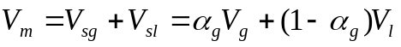 (A1)
Combining (4) and (A1), the average flow velocity of the liquid phase is
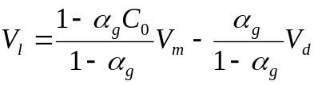 (A2)
The relative velocity relates to the rise velocity of gas through a stationary liquid. Thus, this can be related to the drift velocity,
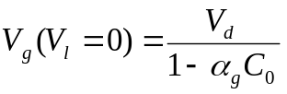 (A3)
At low values of 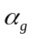we use the rise velocity of a bubble through a stagnant liquid, which is 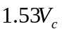, where 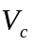is the characteristic velocity given by
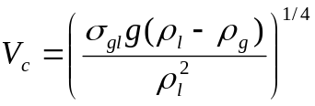 (A4)
Here, 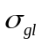is the gas-liquid interfacial tension. At high values of we use the ‘flooding velocity’, defined as the gas velocity that is just sufficient to support a thin annular film of liquid and prevent it from falling back against the gas flow,
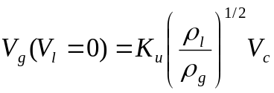 (A5)
where 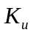is the ‘critical Kutateladze number’, which is related to the dimensionless pipe diameter
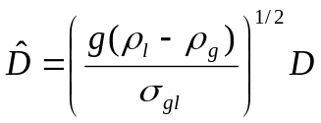 (A6)
Shi et al. provides a table of the critical Kutateladze number versus the dimensionless pipe diameter. To interpolate between the two extremes (low and high values of ), we make use of the flooding curve to define the limit of the counter-current flow regime. The gas and liquid flow rates that define the steady counter-current flow lie on the curve
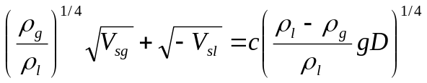 (A7)
where is a constant that depends on the pipe geometry. The sign convention is that upward flow is positive. We can normalize this curve to meet the flooding velocity in Equation (A5), as 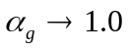, by substituting the right hand side of Equation (A7) with 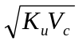. Note that Equation (17) can be written as
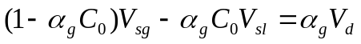 (A8)
Assuming that 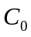does not vary with the flow velocity in the counter-current flow region (the region of interest), Equation (A8) describes a straight line on a graph with axes 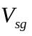and 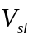, for given value of . Each of these straight lines should be tangential to the flooding curve - Equation (A7) renormalized. The flooding curve represents the limit of counter-current flow in the quadrant where 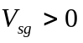and 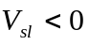. This requirement defines the drift velocity as a function of ,
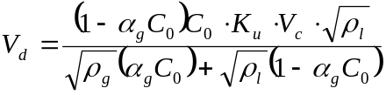 (A9)

Appendix B. Flash calculation
Algorithm for flash calculation and derivatives are the same as in [5], except for temperature derivatives, which are taken from [25]:


