GPRS Technical Report

Isothermal Multisegment Well Implementation

October 2008

Silviu Livescu, Hua Shi, Semenova Anna

SUPRI-B/HW Industrial Consortia

Department of Petroleum Engineering

Stanford University

- Introduction
The modeling of advanced (multilateral, horizontal, smart) wells requires more sophisticated well models than are required for conventional wells. Models for advanced wells must allow pressure, flow rate and fluid compositions to vary with position in the wellbore. This can be accomplished by discretizing the well into segments and solving the mass balance equations and pressure drop equation for each segment.
Our implementation for multisegment well can have an arbitrary number of segments. The segments are independent of the cells from the reservoir. The current version of GPRS can handle only the black-oil model and the flow is described by either the homogeneous or the drift-flux model (see H. Shi and the references therein).

- Equations and variables
The wellbore is considered as a system of one-dimensional segments. In the black-oil implementation, this system contains four primary variables corresponding to each segment. We use a natural variable set,
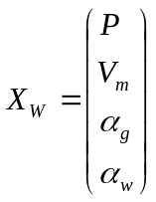 (1)
where 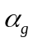 and α_{w} are the free gas and water holdups, V_{m} is mixture velocity, and P is pressure, respectively.
The governing equations for each segment are the mass balance equation for each component and a pressure equation. These four equations are solved to determine the four primary unknowns. The general mass balance for the component c in a segment is:
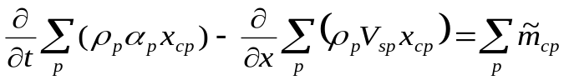 (2)
where t is time, ρ_{p} is the phase density, α_{p} is free holdup of phase p and x_{cp} is the molar fraction of component c in phase p in the segment. The first term in equation 2 represents the mass accumulation of the component c over a time step. In the second term, x is position along the wellbore and V_{sp} is the superficial velocity of the phase p. Therefore, the second term represents the flux of the component c over the segment. The phase superficial velocity is defined as
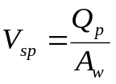 (3)
where A_{w} is the cross-sectional area of the well and Q_{p} is the phase volumetric flow rate. In the current implementation, we consider that the area is constant along the well, i.e. all segments have the same cross-sectional area. However, all the equations in this report are written for segments with inconstant area and further implementation into GPRS is needed.
Next, we present briefly the equations for the drift-flux and homogeneous models. The source/sink term,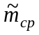, will be written explicitly later, depending on the well type (production/injection).

- Drift-flux and homogeneous models
  - Drift-flux model
The drift-flux model used by us requires the in-situ volume fractions of each phase in order to determine the superficial velocities across the well segment, given the global mixture velocity. In the following sub-section, we illustrate how the drift-flux model is implemented in a multisegment well model for simple gas-liquid, oil-water and oil-water-gas flows.
    - Gas-liquid flow
The main equation of the drift-flux model is:
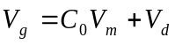 (4)
where V_{g} is the flow velocity of the gas phase, averaged across the segment area. C₀ is the profile parameter (or distribution coefficient), which describes the effect of the velocity and concentration profiles. V_{m} is the volumetric flux (or average velocity) of the mixture and V_{d} is the drift velocity of the gas, describing the buoyancy effect.
The superficial velocity of phase p is defined by equation 3 and, since the in-situ volume fraction α_{p} is defined as
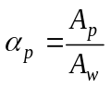, (5)
we can derive the relationship between superficial velocity and the in-situ (flow) velocity:
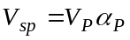 (6)

Furthermore, the superficial gas velocity is calculated as:
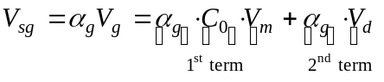 (7)
The first term is computed using the fluid conditions in the segment that is upstream to the junction, according to the direction of the mixture velocity V_{m}. The second term, representing the drift-flux across the junction, is given by
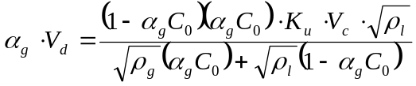 (8)
where the density of the liquid phase is an average of the two phases
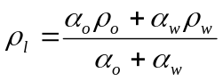 (9)
More details regarding derivation of (8) are given by Shi at el. and summarized in the Appendix. A distinction is made between the upper segment and the lower segment to calculate the drift-flux. The terms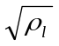and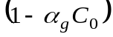are calculated using the conditions in the upper segment, while the terms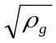and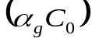are determined using the conditions in the lower segment. With this definition, the exchange of fluids across the junction will not occur if the upper segment is pure gas or the lower segment is pure liquid, which is a stable condition.
The constant K_{u} is calculated in the lower segment, i, and the rise velocity, V_{c}, is determined using the conditions in the upper segment, i+1.
Note that, when the drift-flux model is implemented in a well model for reservoir simulation, the well needs to have at least two segments.
    - Oil-water flow
The superficial velocity of oil across the junction is
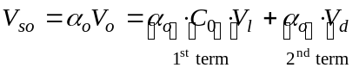 (10)
where the liquid mixture velocity, V_{l}, is given by
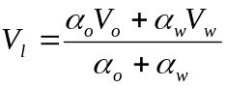 (11)
This liquid mixture velocity is defined such that the following condition is met,
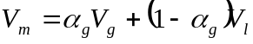 (12)
In equation 10, the first term is calculated from the conditions in the segment upstream to liquid flux V_{l}. The second term (drift-flux) is expressed as
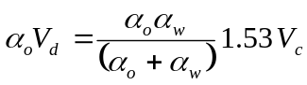 (13)
For the oil/water slip, equation (13) is detailed by Shi et al., based on the model proposed by Hassan and Kabir. At small values of 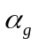, we use the droplet-rise velocity, i.e. the rise velocity of a bubble through a stagnant liquid, 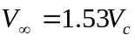, where 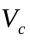is the characteristic velocity given in the Appendix.
The oil volume fraction, α_{o}, is taken from the lower segment, while the water volume fraction, α_{w}, is taken from the upper segment. So there will be an exchange of oil and water across the junction only if the upper segment contains some water and the lower segment contains some oil.
    - Gas-oil-water flow
A two-stage technique is proposed to model the three-phase (oil, water and gas) flow in wellbores. This approach uses two-phase liquid-gas and oil-water flow models. In the first stage, oil-water-gas flow is treated as a liquid-gas flow with flow-weighted average properties for the liquid phase. Thus, the liquid-gas interfacial tension and the liquid density are, respectively,
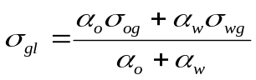 (14)
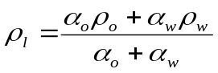 (15)
We determine the flow velocities of the gas and liquid phases using equation 4. In the second stage, the oil-water drift-flux model is applied to compute the oil and the water holdups within the liquid phase. The oil and water velocities within the liquid phase are found from a similar relation to equation 4,
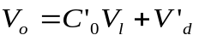 (16)
and from equation (11). Here, 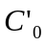is a profile parameter and 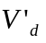is the oil-in-water drift velocity. For this calculation, we use the oil volume fraction in the liquid phase,
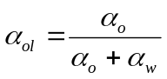 (17)
This very simplistic approach ignores any effect that the presence of a third phase may have on the respective two-phase flow models, and so must be regarded as highly tentative. Nevertheless, it does produce the expected qualitative behavior, enabling a stagnant three-phase mixture to separate into gas, oil and water zones through counter-current flow.
  - Homogeneous model
In the homogeneous model, all phases have the same velocities:
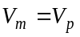 (18)
where V_{p} is the in-situ phase velocity.
Therefore, the superficial velocity corresponding to phase p is
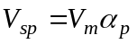 (19)
and its derivative with respect to V_{m} is simply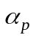.

- Production well – derivatives and Jacobian matrix
For a production well, the source term in equation 2 is expressed as
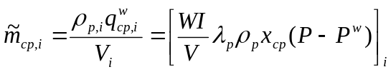 (20)
where V_{i} is the volume of the segment i, and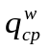is the volumetric flow of component c in phase p in and out of the grid block into the segment i, which is obtained from an inflow performance relationship. Here, 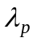is the mobility and WI is the well index, which has units of transmissibility. WI depends on the rock permeability and the block geometry. In a Cartesian grid, it is usually calculated from Peaceman’s expression. The well index is specified for each connection in GPRS input data file.
A more complex approach to compute the well index for nonconventional wells intersecting arbitrary blocks was developed by Wolfsteiner, Durlofski and Aziz and used in the AdWell software for uniform Cartesian grids. Currently, AdWell has the following well index enhancements:
- Computes the hydrostatic correction for the wellbore pressure.
- Adds the ‘projection well index’ in a block.
- Eliminates the limitation of only one well in the reservoir. However, more than one well in a block is prohibited.
- Allow different segment types (inflow, pipe, choke).
For more details regarding the well index computations, see references 2 and 7.
Using a finite difference discretization scheme in equation 2, the general mass balance equations for each component in dead black-oil formulation are
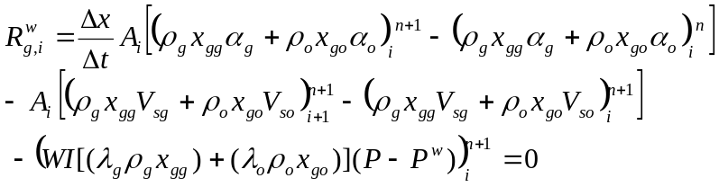

(21)

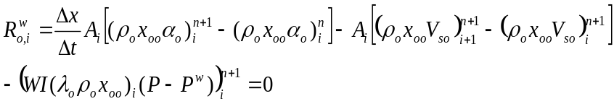 (22)
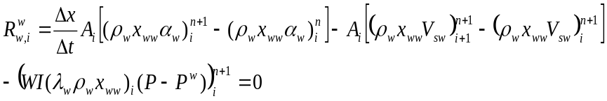 (23)
where n is the time step.
The pressure loss equation has three components, the hydrostatic, the frictional, and the acceleration components, respectively,
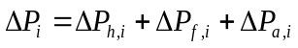 (24)
The hydrostatic pressure difference between the segments i and i+1 is given by
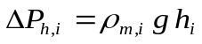 (25)
where g is the gravitational acceleration and h_{i} is the height difference between the two segments, which is equal to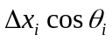. Here, θ_{i} is the inclination of the segment from vertical. The mixture density ρ_{m,i} is defined as
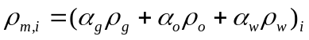 (26)
The frictional pressure component between the two segments is
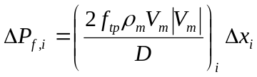 (27)
where f_{tp,i} is the friction factor and D_{i} is the wellbore diameter. The Haaland (1981) correlation is used to obtain this parameter
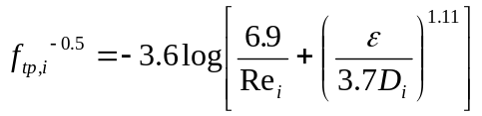 (28)
where is the pipe roughness and Re is the Reynolds number, defined as
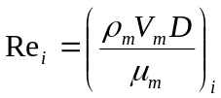 (29)
with 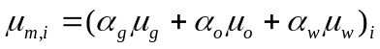.
The pressure component due to acceleration is given by
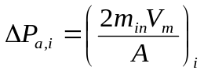 (30)
where m_{in,i} is the mass flow rate of the mixture entering the segment,
(31)
For more details regarding acceleration pressure component written in equation 30 see Ouyang and Ouyang, Arbabi and Aziz. Therefore, the residual equation for the pressure drop can then be written as:

(32)
The non-zero elements in RRJ, RWJ, WRJ, and WWJ are needed to form the Jacobian matrix for solving the coupled system of equations corresponding to the reservoir and the well. They are written explicitly in the next sub-sections.
  - Derivatives in RRJ and RWJ
The mass flow rate of the component c in a perforated cell is

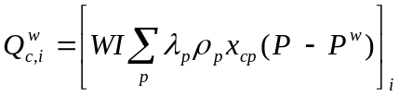 (33)
Thus, the non-zero elements in RRJ are

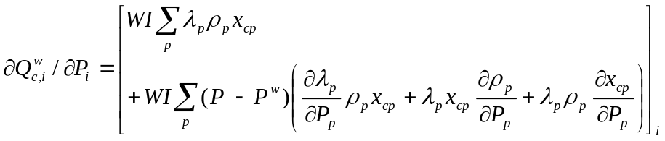 (34)

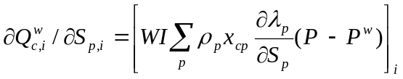 (35)
The only non-zero element in RWJ is

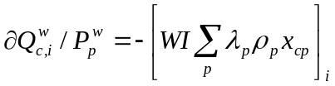 (36)
  - Derivatives in WWJ
We divide WWJ into three parts, the diagonal part, upper off-diagonal part (off-diagonal A part), and lower off-diagonal part (off-diagonal B part), and derive each of them separately.
    - The segment equations with respect to the variables of the same segment, i (i.e. diagonal part)
      - Pressure equation
The derivatives of the pressure equation 32 are

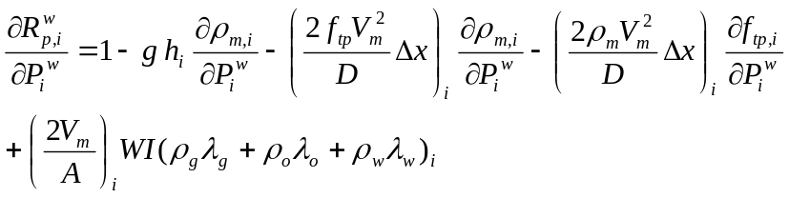 (37)

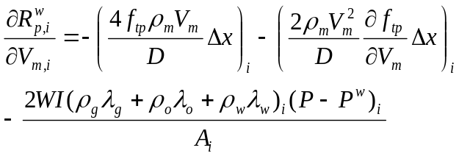 (38)

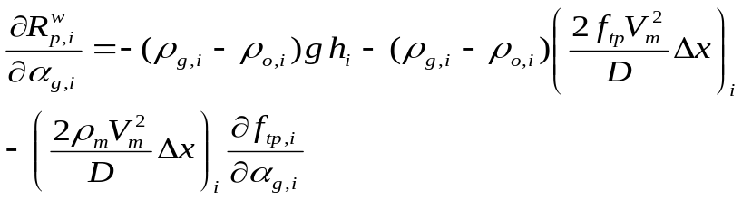 (39)

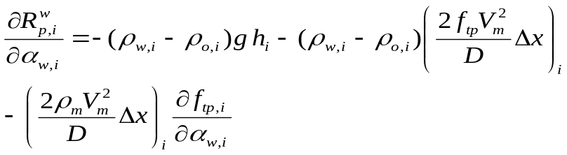 (40)
      - Gas component equation
The derivatives of the gas equation 21 are

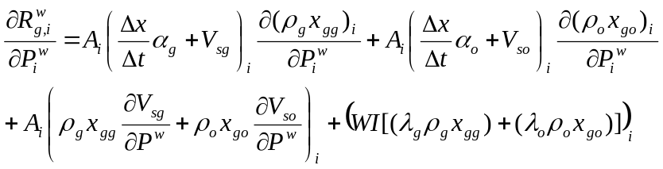 (41)

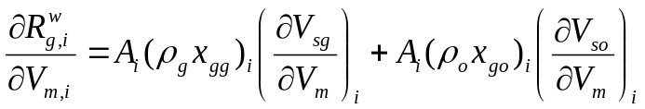 (42)

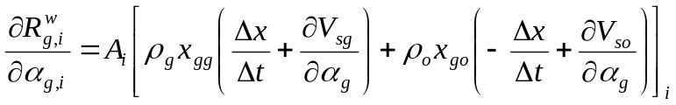 (43)
For the homogeneous model, the last equations become

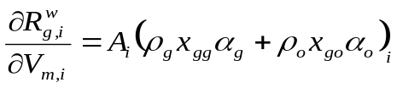 (44)

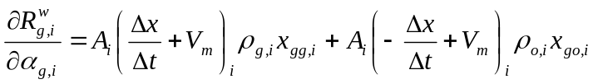 (45)

and, in addition, the derivative with respect to the water holdup is

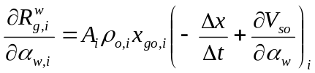 (46)
      - Oil component equation
The derivatives of the oil equation 22 are

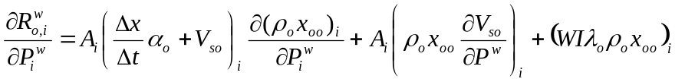 (47)

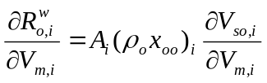 (48)

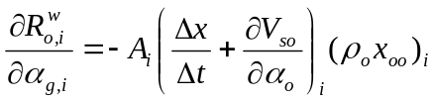 (49)

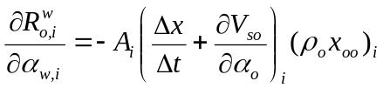 (50)
      - Water component equation
The derivatives of the water equation 23 are

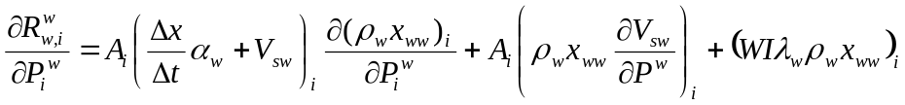 (51)

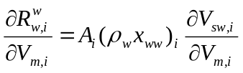 (52)

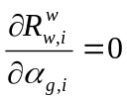 (53)

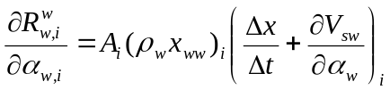 (54)
    - The segment equations with respect to the variables of the next segment, i+1 (i.e. off-diagonal A part)
      - Pressure equation
The pressure equation 32 is independent of the variables in the segment i+1,

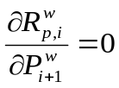 (55)

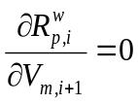 (56)

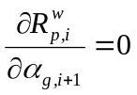 (57)

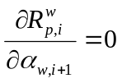 (58)
      - Gas component equation
The derivatives of the gas equation 21 are

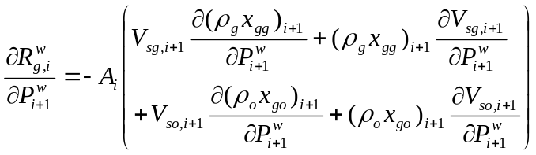 (59)

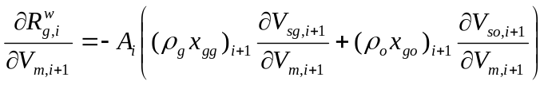 (60)

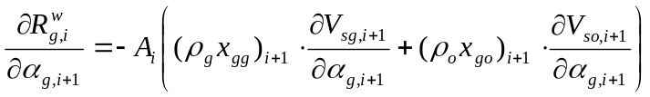 (61)

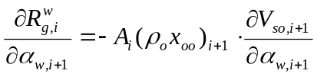 (62)
      - Oil component equation
The derivatives of the oil equation 22 are

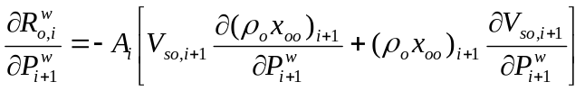 (63)

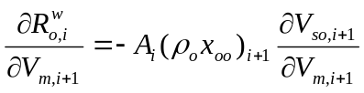 (64)

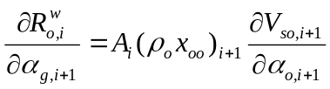 (65)

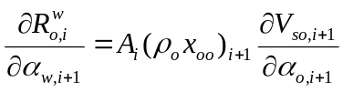 (66)
      - Water component equation
The derivatives of the water equation 23 are

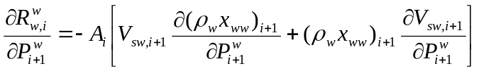 (67)

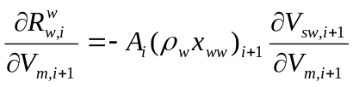 (68)

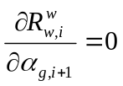 (69)

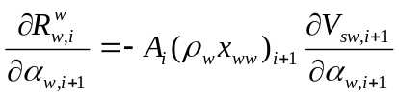 (70)
    - The segment equations with respect to the variables of the previous segment, i-1 (i.e. off-diagonal B part)
      - Pressure equation

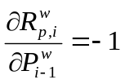 (71)

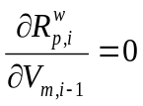 (72)

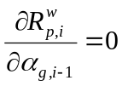 (73)

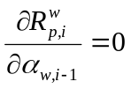 (74)
All the other derivatives are zero for the homogeneous model, because they are computed considering the downstream segment, i-1. For the drift-flux model, these derivatives are computed by flash calculations.
  - Derivatives in WRJ
      - Pressure equation

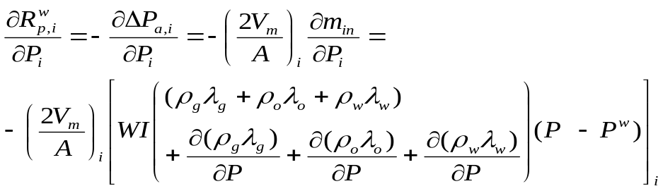 (75)

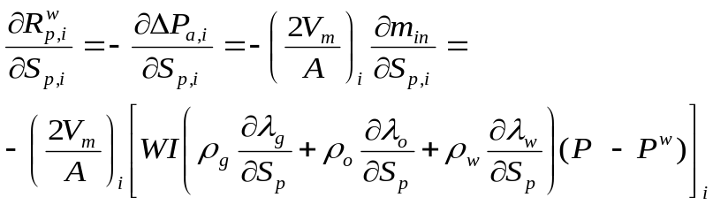 (76)
      - Gas component equation

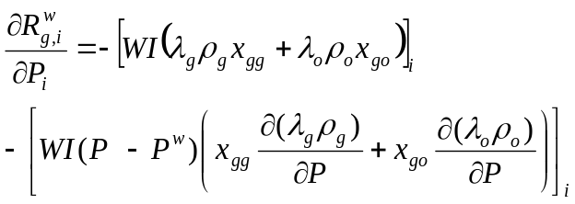 (77)

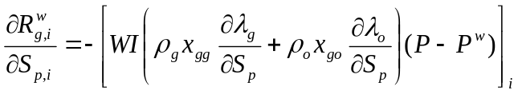 (78)
      - Oil and water component equations

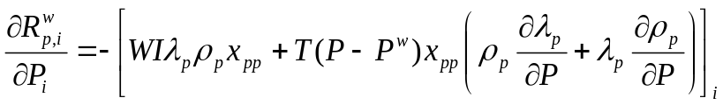 (79)

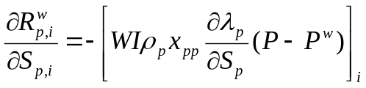 (80)
where p represents the oil and water phases.

- Injection well – derivatives and Jacobian matrix
In the current version of GPRS, only the injection of single-phase (water or gas) fluids is handled. Therefore,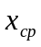is equal to 1.0 for the injection component, because there is no oil in the gas or water phases.
  - Derivatives in RRJ and RWJ
The mass flow rate of the component c in a perforated cell is

(81)

Here, the density,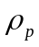, and the mole fraction of component c in phase p, , are treated as functions of the wellbore pressure, P^{w}.
The non-zero elements in RRJ are

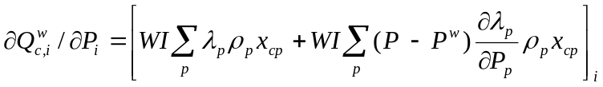 (82)

(83)
The only non-zero element in RWJ is

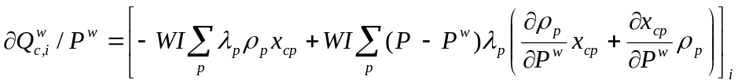 (84)
  - Derivatives in WRJ
      - Pressure equation

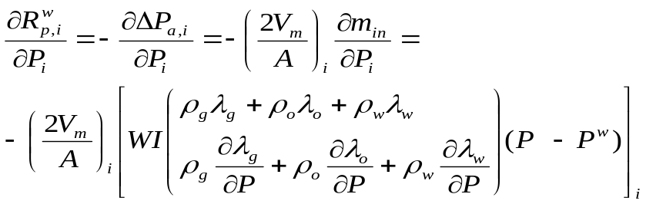 (85)

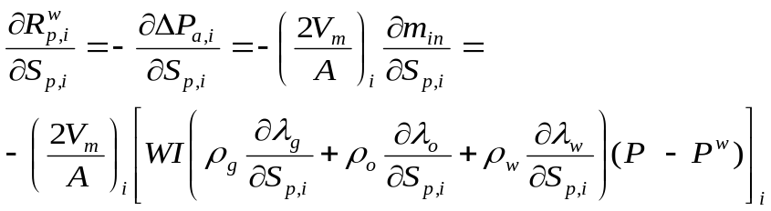 (86)
      - Gas component equation

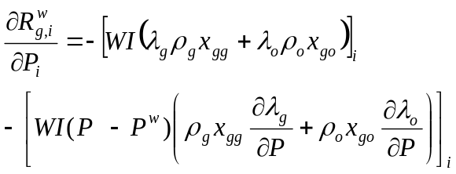 (87)

(88)
      - Oil and water component equations

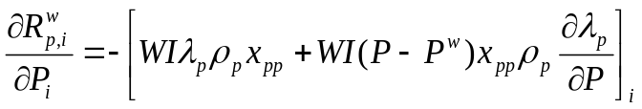 (89)

(90)
where p represents the oil and water phases.
  - Derivatives in WWJ
We divide again WWJ into three parts and present only the terms that are different from those written for production wells.
    - The segment equations with respect to the variables of the same segment, i (i.e. diagonal part)
      - Pressure equation

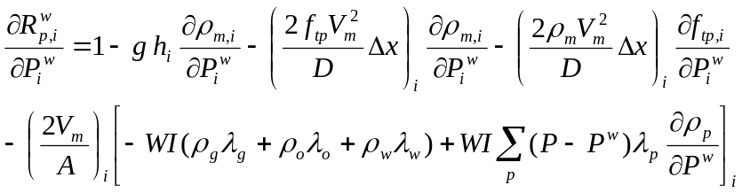 (91)

All other derivatives are unchanged.
      - Gas component equation

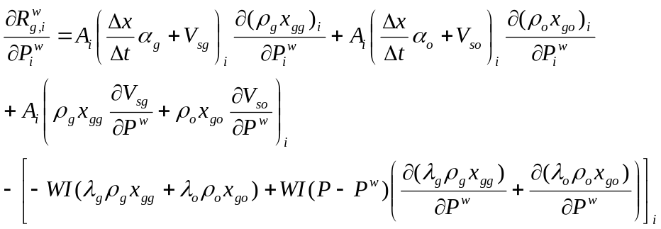 (92)

All other derivatives are unchanged.
      - Oil component equation

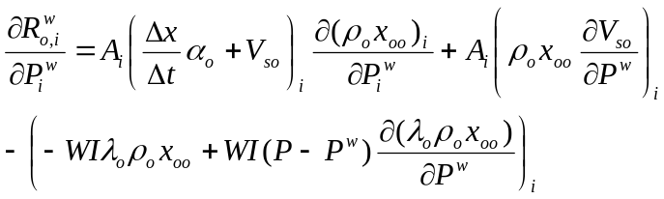 (93)

All other derivatives are unchanged.
      - Water component equation

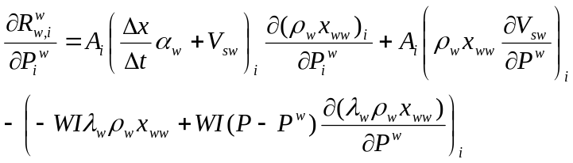 (94)

All other derivatives are unchanged.

- Well control
For both production and injection wells, the right hand side terms in the system of equations that needs to be solved are the same. The first term is

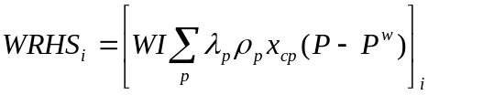 (95)
The second term depends on the well control. Currently, GPRS can handle the BHP and oil and water rate controls. Thus, for the BHP control, the condition is

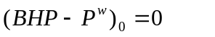 (96)
and for the rate controls, at steady state,

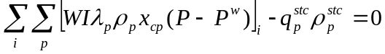, (97)
where 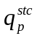and 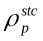are the constant injection rate and the density of phase p at standard conditions, respectively. The index 0 corresponds to the first segment (well head).
For liquid rate control right hand side term at well head is as follows:
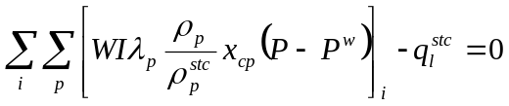, (98)
where 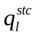 and 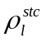 are the constant liquid rate and density at standard conditions.

- Limitations of the current implementation

The current implementation has the following limitations:
- Only the black-oil model is implemented into GPRS (no compositional model).
- BHP, and gas, oil, water and liquid (water+oil) rate controls are currently implemented.
- The injected fluid is single-phase for each well. Also, the injected fluid can be gas, oil or water (no mixture). We assume that the wellbore is at steady-state, i.e. the concentration of the injected fluid is constant in the wellbore and it is equal to the concentration at the well head.

- Testing and validation

We have tested our implementation in three cases. The results from GPRS were compared with those obtained from Eclipse 100. In all these cases only the results for the drift-flux model are presented.

- Two-phase gas-oil fluids. Because GPRS has not an option for gas injection and the oil injection is not of interest, we present only the situation of one production well with BHP control. A graphical sketch of this setup is shown in Figure 1.

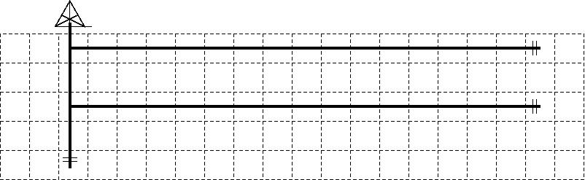
Figure 1. Geometry of the multisegment well.
The reservoir has 20x1x5 cells, and the well has 34 segments (one vertical and two horizontal branches). We checked the pressure and holdups in each segment and the gas and oil rates in the well. The results give a very good agreement with Eclipse, as can be seen in Figure 2.
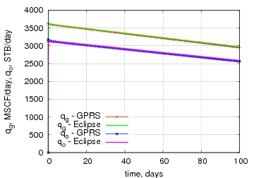
Figure 2. Two-phase gas-oil fluid, gas and oil rates in well.

- Two-phase oil-water fluids. This is a two-well system, with one production well with BHP control and one injection well with water rate control. First, both wells are horizontal. A graphical scheme is shown in Figure 3(a). The reservoir is homogenous with 20x1x5 blocks. Each well has 15 segments of the same length. Comparison between GPRS and Eclipse for different results is presented in Figure 4. Second, both wells are vertical. They are presented schematically in Figure 3(b). The reservoir has 10x1x10 blocks. Again, each well has 15 segments. Comparison between GPRS and Eclipse is presented in Figure 5. Good agreement was obtained in both cases.
(a) 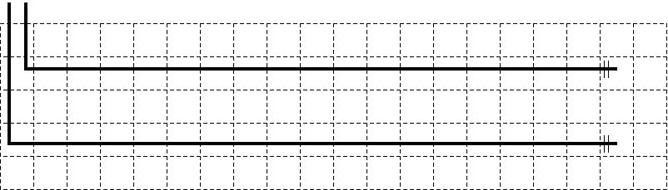 (b) 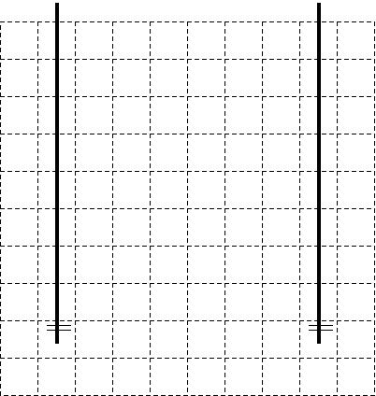
Figure 3. Schematic representation of two horizontal wells (a) and two vertical wells (b). In each case, the wells are one for production and one for injection.

(a)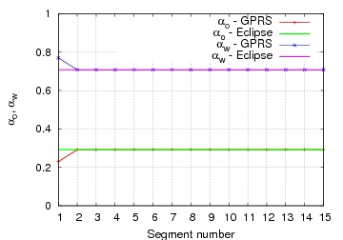(b)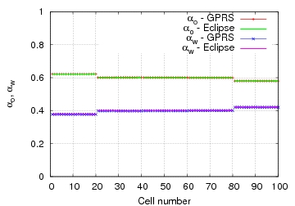
(c)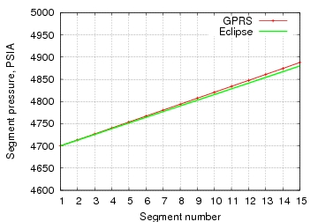(d)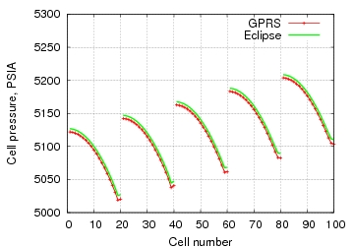

(e)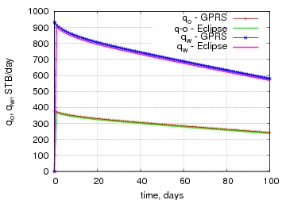
Figure 4. Two-phase oil-water fluid, comparison between GPRS and Eclipse for two horizontal wells – shown in Figure 3 (a): the oil and water holdups at time t = 100 days, along the production well (a) and in reservoir (b); the pressure at t = 100 days, along the production well (c) and in reservoir (d); the oil and water rates in the production well (e).
(a)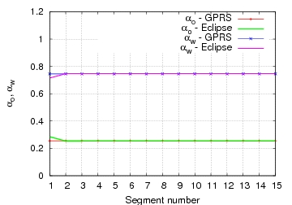(b)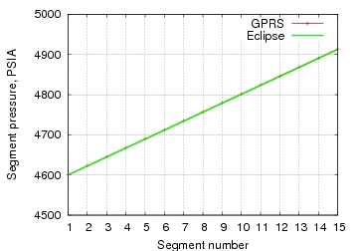
(c)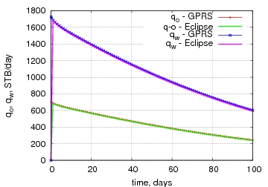
Figure 5. Two-phase oil-water fluid, comparison between GPRS and Eclipse for two vertical wells – shown in Figure 3 (b): the oil and water holdups at time t = 100 days along the production well (a); the pressure at t = 100 days along the production well (b); the oil and water rates in the production well (c).
- Three-phase gas-oil-water fluids. We use the same setup as in the previous case, i.e. a two-well system with one production well with BHP control and one injection well with water rate control. The only difference is that now the fluid is three-phase. First, both wells are horizontal, as shown in Figure 3(a). Second, both wells are vertical, as shown in Figure 3(b). Comparison between GPRS and Eclipse is presented in Figure 6, for the horizontal wells, and in Figure 7, for vertical wells. Again, very good agreement was obtained in both cases.

(a)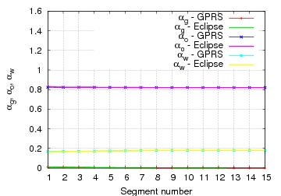(b)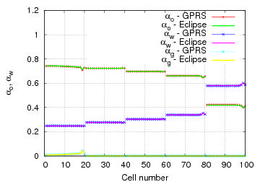
(c)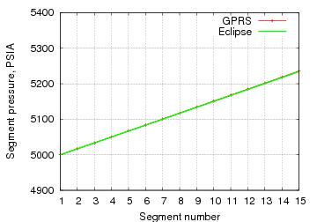(d)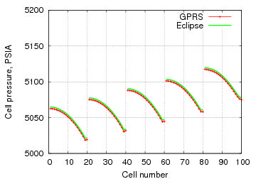
(e)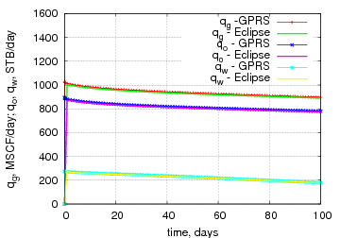
Figure 6. Three-phase gas-oil-water fluid, comparison between GPRS and Eclipse for two horizontal wells – shown in Figure 3 (a): the gas, oil and water holdups at time t = 100 days along the production well (a) and in reservoir, at time t = 400 days (b); the pressure at t = 100 days along the production well (c) and in reservoir, at time t = 400 days (d); the gas, oil and water rates in the production well (e).

(a)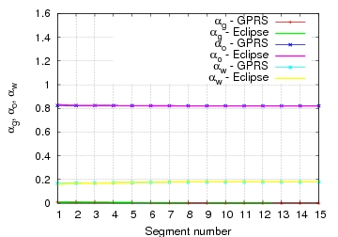(b)
(c)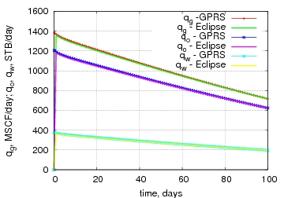
Figure 7. Three-phase gas-oil-water fluid, comparison between GPRS and Eclipse for two vertical wells – shown in Figure 3 (b): the gas, oil and water holdups at time t = 100 days along the production well (a); the pressure at t = 100 days along the production well (b); the gas, oil and water rates in the production well (c).

Figure 8 shows comparison between Eclipse and GPRS for constant liquid rate (a) and gas rate (b). Calculations were made for horizontal well and the same set of parameters as above. Agreement between results is good.

(a)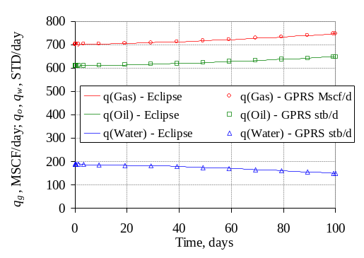 (b) 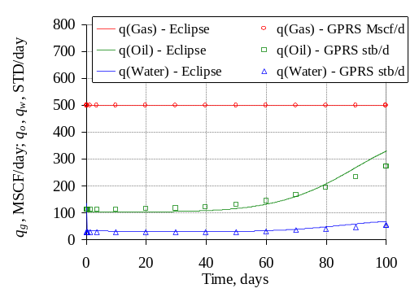

Figure 8. Three-phase gas-oil-water fluid, comparison between GPRS and Eclipse for two horizontal wells – shown in Figure 3 and (a) constant liquid rate 800 stb/day (a), constant gas rate 500 MSCF/day (b).

References
- A. R. Hassan and C. S. Kabir, A simplified model for oil/water flow in vertical and deviated wellbores, SPEPF 14, 56-62.
- H. Pan, Improvement of Well index calculations for Cartesian grids in AdWell 2.1 software, Technical Report, Department of Petroleum Engineering, Stanford University, March 2004.
- H. Pan, GPRS Technical Report: Injection Well Implementation, Department of Petroleum Engineering, Stanford University, October 2005.
- L.-B. Ouyang, Single phase and multiphase fluid flow in horizontal wells, Ph.D. dissertation, Department of Petroleum Engineering, Stanford University, August 1998.
- L.-B. Ouyang, S. Arbabi and K. Aziz, A single-phase wellbore-flow model for horizontal, vertical, and slanted wells, SPE 36608.
- H. Shi, J. A. Holmes, L. J. Durlofsky, K. Aziz, L. R. Diaz, B. Alkaya and G. Oddie, Drift-flux modeling of multiphase flow in wellbores, SPE 84228.
- C. Wolfsteiner, L. J. Durlofski and K. Aziz, Calculation of well index for nonconventional wells on arbitrary grids, Computational Geosciences, 7, 61-82 (2003).

Appendix
The expression for the drift-flux velocity can be derived by coupling data on the limits of counter-current flow made under a variety of flow conditions and interpolating between them to avoid discontinuities (see Shi et al. and references therein). This method is based on observations of the discontinuities between the gas-liquid relative velocities at low and high gas volume fractions and joints them with a ‘flooding curve’.
The average mixture velocity is the sum of the gas and liquid superficial velocities
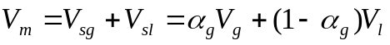 (A1)
Combining (4) and (A1), the average flow velocity of the liquid phase is
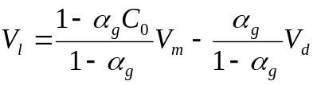 (A2)
The relative velocity relates to the rise velocity of gas through a stationary liquid. Thus, this can be related to the drift velocity,
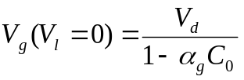 (A3)
At low values of we use the rise velocity of a bubble through a stagnant liquid, which is 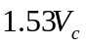, where is the characteristic velocity given by
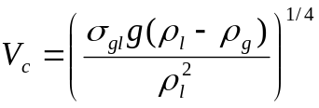 (A4)
Here, 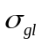is the gas-liquid interfacial tension. At high values of we use the ‘flooding velocity’, defined as the gas velocity that is just sufficient to support a thin annular film of liquid and prevent it from falling back against the gas flow,
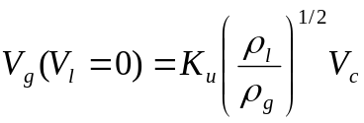 (A5)
where 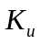is the ‘critical Kutateladze number’, which is related to the dimensionless pipe diameter
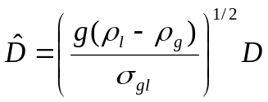 (A6)
Shi et al. provides a table of the critical Kutateladze number versus the dimensionless pipe diameter. To interpolate between the two extremes (low and high values of ), we make use of the flooding curve to define the limit of the counter-current flow regime. The gas and liquid flow rates that define the steady counter-current flow lie on the curve
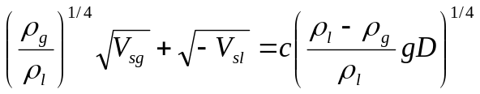 (A7)
where is a constant that depends on the pipe geometry. The sign convention is that upward flow is positive. We can normalize this curve to meet the flooding velocity in equation (A5), as 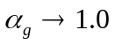, by substituting the right hand side of equation (A7) with 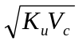. Note that equation (4) can be written as
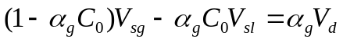 (A8)
Assuming that 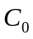does not vary with the flow velocity in the counter-current flow region (the region of interest), equation (A8) describes a straight line on a graph with axes 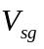and 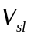, for given value of . Each of these straight lines should be tangential to the flooding curve - equation (A7) renormalized. The flooding curve represents the limit of counter-current flow in the quadrant where 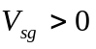and 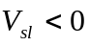. This requirement defines the drift velocity as a function of ,
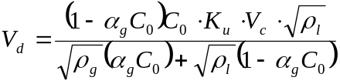 (A9)

