GPRS Technical Report

Implementation Document of Multi-Segment Well Black Oil Model
(Draft Version)
Hua Shi, Yuanlin Jiang, Jeremie Batias

Introduction

Multiphase flow effects in wellbores and pipes can have a strong impact on the performance of reservoirs and surface facilities. In the case of horizontal or multilateral wells, for example, pressure losses in the well can lead to a loss of production at the toe or overproduction at the heel. In order to model and thereby optimize the performance of wells or reservoirs coupled to surface facilities, accurate multiphase pipeflow models must be incorporated into reservoir simulators.
The modeling of advanced (multilateral, horizontal, smart) wells requires more sophisticated well models than are required for conventional wells. Models for advanced wells must allow pressure, flow rate and fluid compositions to vary with position in the wellbore, and enable different fluid streams to co-mingle at branch junctions (Holmes, 2003). This can be accomplished by discretizing the well into segments and solving the mass balance equations and pressure drop equation for each segment.
Multi-segment well can have arbitrary number of segments, which are the corresponding ones to the cells in reservoir. In our simulation, wells are not parts of reservoir. We treat wells, or the facilities (aggregate of wells), as a corresponding thing of the reservoir.

Equations and Variables

The wellbore is divided into a one-dimensional multi-segment system. In black oil implementation, the system contains four primary variables in each segment at each time step. Our set of variables implemented is the natural variable set, which is :
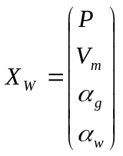
where 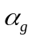is free gas holdup and α_{w} is oil holdup. V_{m} is mixture velocity, and P is pressure.
The governing equations for the system are the mass balance equation for each component and a pressure equation. These four equations are solved to determine the four primary unknowns. The general mass balance for component c is as follows:
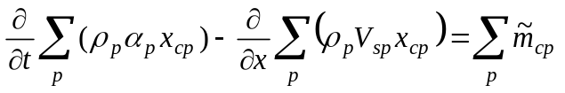 (1)
where t is time, ρ _{p} is the phase density, 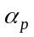is free holdup of phase p, x _{cp} is the molar fraction of component c in phase p in the segment. Thus the first term in Eq. 1 is the mass accumulation of component c in the segment over a time step. In the second term, x is position along the wellbore, V_{sp} is the superficial velocity of phase p, so the second term represents the flux of component c over the segment.
The density can be expressed as for gas and water
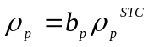 (2)
And for oil component :
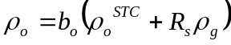 (3)

where 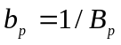and B_{p} is the formation volume factor, and 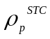 is the phase density under standard conditions. The phase superficial velocity is defined as
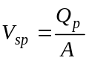 (4)
where A is the cross-sectional area of the well and Q_{p} is the phase volumetric flow rate.
The source/sink term, 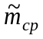in Eq. 1 can be expressed as
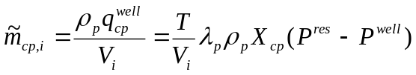 (5)
where V_{i} is the volume of the segment i, and 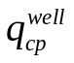is the volumetric flow of component c in phase p in and out of grid block into segment i, which is obtained from an inflow performance relationship. When the reservoir grid block and segment node are at the same location:
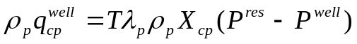 (6)
where T is the well index, which has units of transmissibility, and depends on the rock permeability and the block geometry. In a Cartesian grid, it is usually calculated from Peaceman’s expression. It is specified for each connection in GPRS input data file. 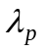is the mobility:
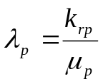 (7)
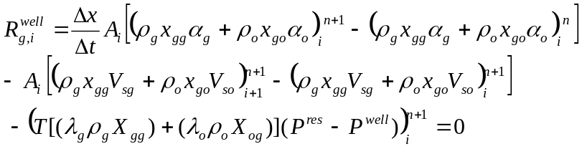Dividing Eq. 1 by A_{i} and introducing a finite difference discretization, the general mass balance equation for each component in dead Black Oil formulation are: (source term is written in production well form)

(8)
(9)
(10)
where n is the time step. In the gas balance, 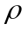_{g} is obtained using the PVT table and the equation 2.

For the pressure loss equation, we have two options. The first option is to apply the pressure equation used in ECLIPSE (Schlumberger GeoQuest, 2001). This pressure equation has three components, the hydrostatic pressure, the frictional pressure, and the acceleration component:
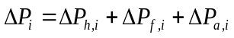 (11)
The hydrostatic pressure difference between two segments is given by
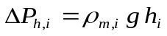 (12)
where g is the gravitational acceleration, h_{i} is the height difference between the segments, which equals 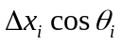, θ_{ι} is the inclination of the well from vertical. ρ_{m,i} is the mixture density defined as
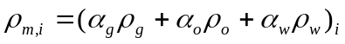 (13)
The frictional pressure component between two segments is:
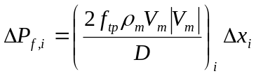 (14)
where f_{tp,i} is the friction factor and D_{i} is the wellbore diameter. The Haaland (1981) correlation is used to obtain this parameter:
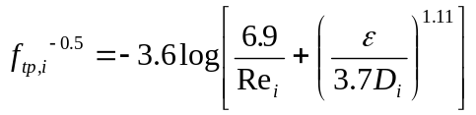 (15)
where is the pipe roughness and Re is the Reynolds number defined as
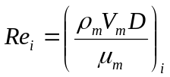 (16)
with 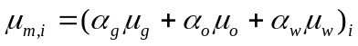. The pressure component due to acceleration is given by:
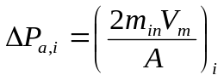 (17)
where m_{in,i} is the mass flow rate of the mixture entering the segment, which is calculated by
(18)
considering a production well. The residual equation for pressure drop can then be written as:
(19)
The other option for the pressure equation is to use Ouyang’s (1998) model. In this model, the total pressure gradient is decomposed into four parts:
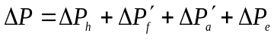 (20)
where 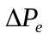 is the accelerational pressure gradient caused by fluid expansion. Among the other three components, only the hydrostatic pressure drop is calculated exactly the same as in the ECLIPSE pressure model (Eq. 12). For a complete description of this model, see Ouyang (1998).

The pressure equation can also be set to govern a choke. In this case the all segment is going to characterize the choke. The model used for this equation is the Sachdeva model described in Yeten et al in 2004.
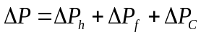 (21)
Where
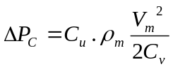 (22)
With 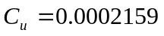and 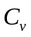is the dimensionless flow coefficient for the valve, defined by the user and Vm the mixture velocity.

- Drift-Flux Model and Homogenous Model

3.1 Drift-flux model
The drift-flux model as described in the technical description of ECLIPSE, is different from the most of other slip correlations, which require superficial velocities as input to determine the holdup fractions. The drift-flux model used in our work requires the in situ volume fractions of each phase as input to determine the superficial velocities across a section of well segment, given the global mixture velocity.
In GPRS the drift flux model is not the exact same than the default one in ECLIPSE. The optimized model developed by default by H. Shi et al. has been used as the default one. There are more details about the optimization in these two articles: Drift-Flux Modeling of Two-Phase Flow in Wellbores by H. Shi et al. and Drift-Flux Parameters for Three-Phase Steady-State Flow in Wellbores by H. Shi et al. but here we present the default drift flux model to help to understand how they work. The following equations present this optimized model.

Figure 1 is a schematic of two consecutive well segments (i and i+1), the phase in situ volume fractions at the center of the segments and the phase superficial velocities across the junction. In the following section, we will illustrate how drift-flux model works in a multi-segment well model for simple gas-liquid, oil-water and oil-water-gas flows.

V_{sw} V_{sg}

α_{w} α_{g}

α_{w} α_{g}

segment i+1
segment i
Fig. 1: Two consecutive well segments

3.1.1 Gas-liquid flow
The general form of drift-flux model is:
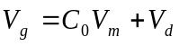 (23)
where V_{g} is the flow velocity of the gas phase, averaged across the pipe area, the definition of flow velocity or called in situ velocity of phase p is:
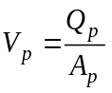 (24)
where A_{p} is the cross-sectional area occupied by phase p.
C₀ is the profile parameter (or distribution coefficient), which describes the effect of the velocity and concentration profiles, V_{m} is the volumetric flux (or average velocity) of the mixture and V_{d} is the drift velocity of the gas, describing the buoyancy effect.
The superficial velocity of phase p is defined by Eq. 4 and since in situ volume fraction is defined as:
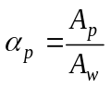 (25)
We can derive the relationship between superficial velocity and in situ (flow) velocity:
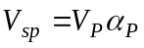 (26)

In the implementation of drift-flux model in multi-segment well model, the superficial gas velocity is calculated as:
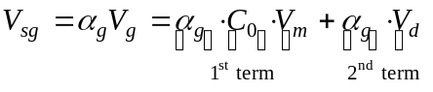 (27)
The first term is computed using the fluid conditions in the segment that is upstream to the junction according to the direction of the mixture velocity V_{m}.
The second term, drift flux across the junction is given by
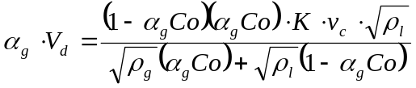 (28)
where the density of the liquid phase is an average of the two phases
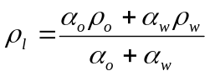 (29)
A distinction is made between the upper segment and the lower segment to calculate the drift flux. The terms 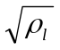 and 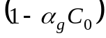 are calculated using the conditions in the upper segment, while the terms 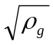 and 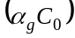 are determined using the conditions in the lower segment. With this definition, the exchange of fluids across the junction will not occur if the upper segment is pure gas or the lower segment is pure liquid, which is a stable condition.
The constant K is calculated in the segment i, and the rise velocity, v_{c}, is determined using the conditions in the upper segment.
Therefore, when drift-flux model is implemented in a well model for reservoir simulation, the well needs to have at least two segments. In case of multi-lateral wells, which enable different fluid steams to co-mingle at branch junctions, we have the situation that one segment at the main stem connects with two segments from branches as shown in Fig. 2.
Fig. 2: Three consecutive well segments

V_{sw} (i+1) V_{sg}(i+1)

α_{w}(i) α_{g}(i)

α_{w} (i+1) α_{g}(i+1)

V_{sw} (i+2) V_{sg}(i+2)

α_{w} (i+2) α_{g}(i+2)

3.1.2 oil-water flow
The superficial velocity of oil across the junction is
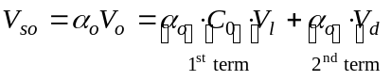 (30)
where the liquid mixture velocity, V_{l}, is given by
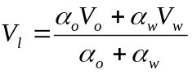 (31)
This liquid mixture velocity is defined in order to have
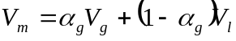 (32)
In the expression of the oil velocity, the first term is calculated from the conditions in the segment upstream to liquid flux V_{l}. The second term (drift flux) is expressed as
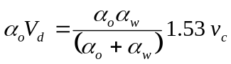 (33)
The oil volume fraction, α_{o}, is taken from the lower segment while the water volume fraction, α_{w}, is taken from the upper segment. So there will be an exchange of oil and water across the junction only if the upper segment contains some water and the lower segment contains some oil.

3.1.3 oil-water-gas flow
A two-stage technique is proposed to model three-phase flow in wellbores. This approach uses two-phase liquid-gas and oil-water flow models. In the first stage, oil-water-gas flow is treated as a liquid-gas flow with flow-weighted average properties for the liquid phase. The liquid-gas drift-flux model is applied to determine the gas and liquid holdups. In the second stage, the oil-water drift-flux model is applied to compute the oil and water holdups within the liquid phase. The drift-flux model for oil-water within three-phase flow includes extra a gas effect parameter to account interaction between gas and liquid. This parameter is deviation related.

3.2 Homogeneous model
In homogeneous model, all phases have same velocities:
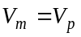 (34)
where V_{p} is the phase in situ velocity.
Therefore, in homogeneous model, we have following relationship:
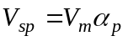 (35)
and the derivative of phase superficial velocity with respect to V_{m} is very simple as 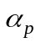.

Derivatives and Jacobian matrix
The non-zero elements in RRJ, RWJ, WRJ, and WWJ are needed to form the Jobian matrix for solving coupled system of reservoir and wells.
In the first implementation stage, we consider the homogeneous model to simplify the complexities involving in the coupled Jacobian matrix of reservoir and a multi-segment well, e.g. to simplify the equations and derivatives. However, the implementation of data structure has been generalized so as to be able to handle both homogeneous model and drift-flux multi-segment well model.
4.1 Derivatives in RRJ and RWJ

The mass flow rate of component c in a perforated cell is

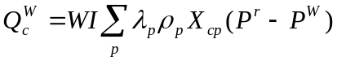

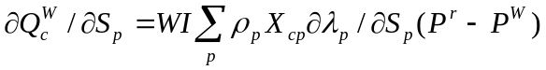

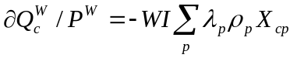

4.1 Derivatives in WWJ
In this section we discuss the elements in WWJ. Here we divide WWJ to three parts: the diagonal part, upper off-diagonal part (off-diagonal A part), and lower off-diagonal part (off-diagonal B part). We now derive every element in the three parts respectively.
Part I: The segment equations with respect to the variables of same segment i: (i.e. diagonal part)
1. Pressure equation:
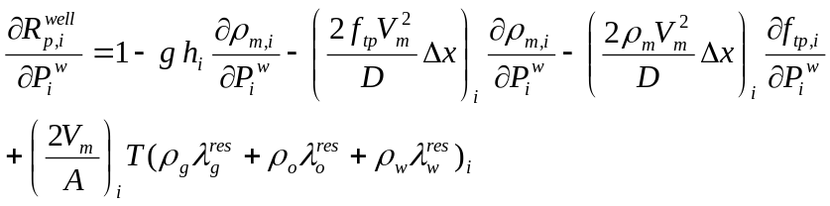 (36)
(37)
(38)
(39)
2. Gas component equation:
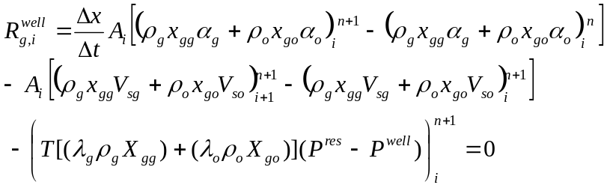 (40)

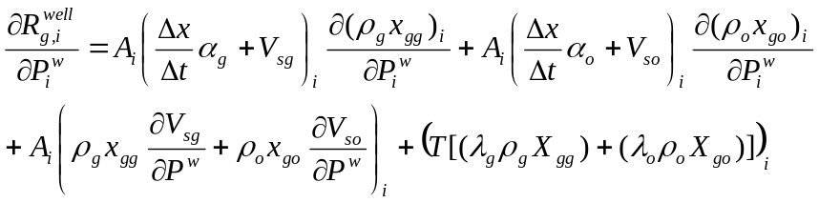 (41)

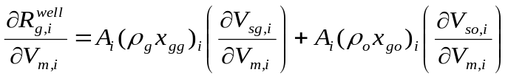 (42)
For homogeneous model:
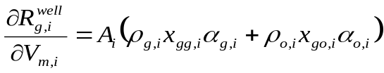 (43)
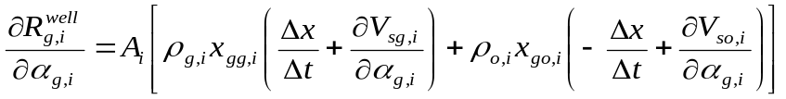 (44)
For homogeneous model:
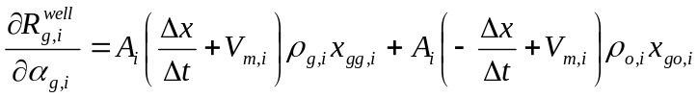 (45)
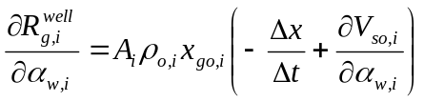 (46)

3. Water component equation:
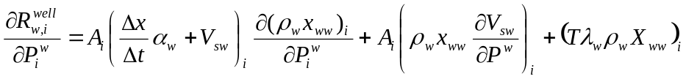 (47)
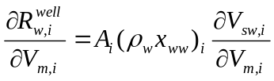 (48)
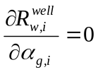 (49)
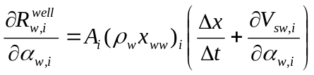 (50)
4. Oil component equation:
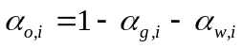 (51)
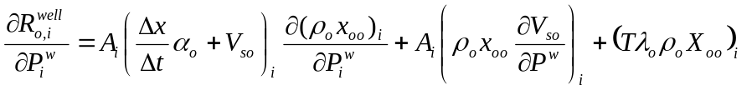 (52)
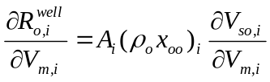 (53)
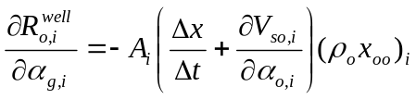 (54)
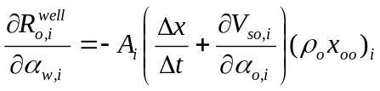 (55)

Part II: The segment equations with respect to the variables of previous segment i+1: (i.e. off-diagonal A part)
1. Pressure equation:
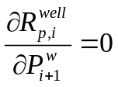 (56)
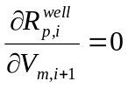 (57)
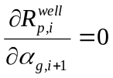 (58)
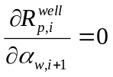 (59)
2. Gas component equation:
(60)
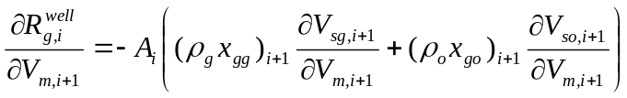 (61)
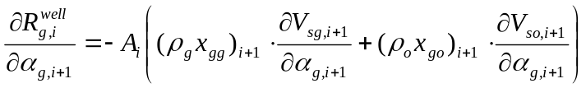 (62)
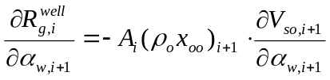 (63)
3. Water component equation:
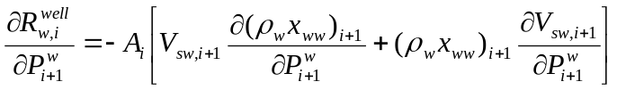 (64)
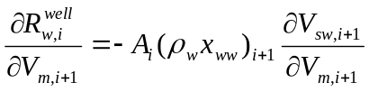 (65)
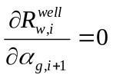 (66)
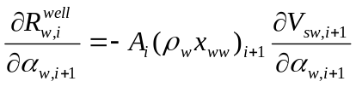 (67)
4. Oil component equation:
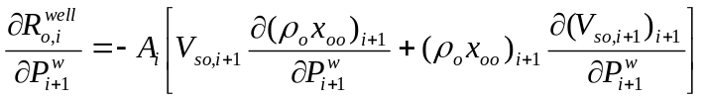
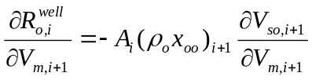 (68)
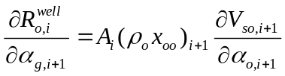 (69)
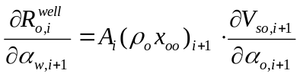 (70)
Part III: The segment equations with respect to the variables of next segment i-1: (i.e. off-diagonal B part)
1. Pressure equation:
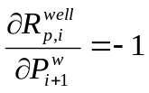 (71)
(72)
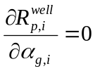 (73)
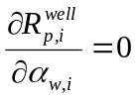 (74)
All the other elements are zero for homogeneous model, because it is downstream segment, but this is not the case if drift-flux model is applied.

4.2. Derivatives in WRJ
In this section, we discuss the derivatives of segment equations with respect to the variables of perforated cell: the elements in WRJ. At this stage, we discuss WRJ of an oil-water reservoir. The reservoir variables are Pw, So. (The type of reservoir and the corresponding reservoir variables are listed in App. 1)
1. Pressure equation:
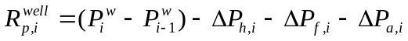
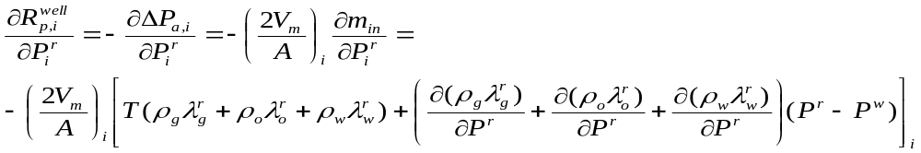 (75)
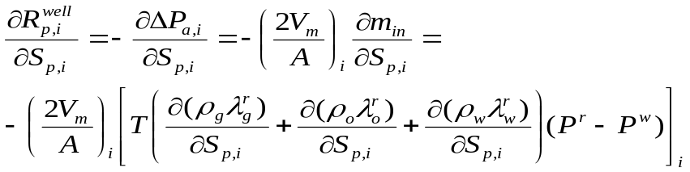 (76)
2. Gas component equation:
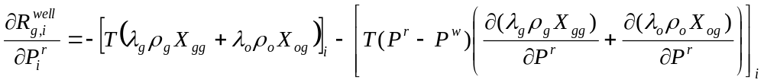 (77)
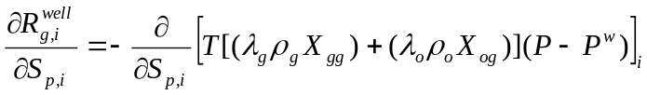 (78)

3. Oil and water component equations:
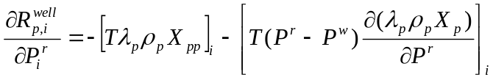 (79)
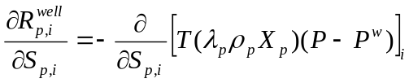 (80)

5. Test cases and validation.
5.1 The optimized drift flux model
After the development of the drift flux model in GPRS several test cases has been develop to test the different slip between each phases. These test cases try every phase combination in order to be sure of the drift velocity computed by GPRS. A study has been done to check if the deviation effect works.
In the following test cases the aim is to study the flow pattern in the well bore. In order to be more precise on the well flow pattern wells are most of the time long with only one perforation. Indeed with this geometry the drift flux model can be study more in details. The flow has the time to be established and evolve with the decrease of the pressure.
- Oil-Water case
This example was build to match the results from ECLIPSE and shows that the two-phase flow along the multilateral geometry is right. We checked the pressure and the hold-up in each segment and the results gives a very good agreement with Eclipse.
Fig 2 : Geometry of the multi-segment well.

Fig 3 : Pressure along wells.
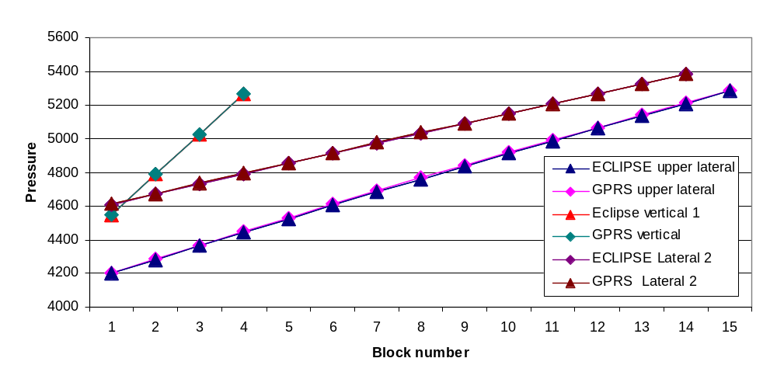
Fig 4 : Holp-up along wells.
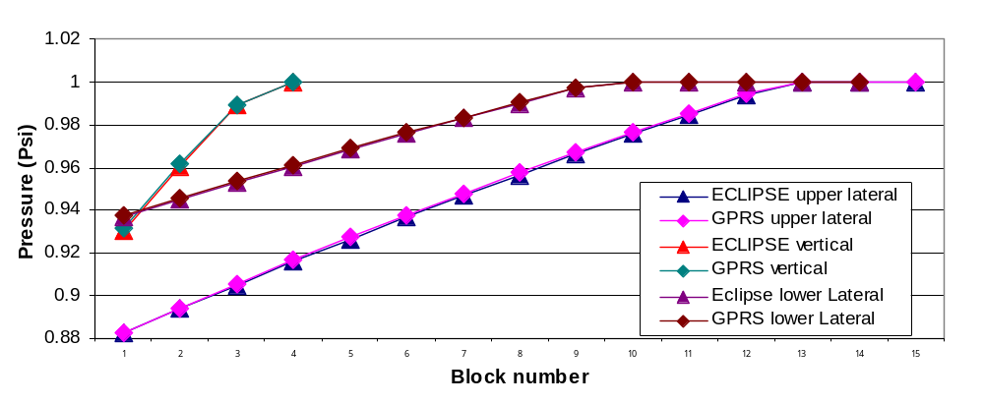
With these results we see that the results between ECLIPSE and GPRS match, so we validate the oil water slip.

- Gas-Oil-Water model
The three phase model is the combination of the two different phase interaction model. It is computed with at first the slip between the liquid phase and the gas phase, and after the slip between the two liquid phases is taking into account.
Fig 5 : Geometry of the multi-segment well.

12 layers
In this deviated well, the inclination and a three-phase model has been checked. In this case the pressure and the holdup along the well between ECLIPSE and GPRS are matching, the inclination and the three-phase behavior match so the drift flux model into GPRS has been validated model by model and parameter by parameter.
Fig 6 : Holp-up along wells.

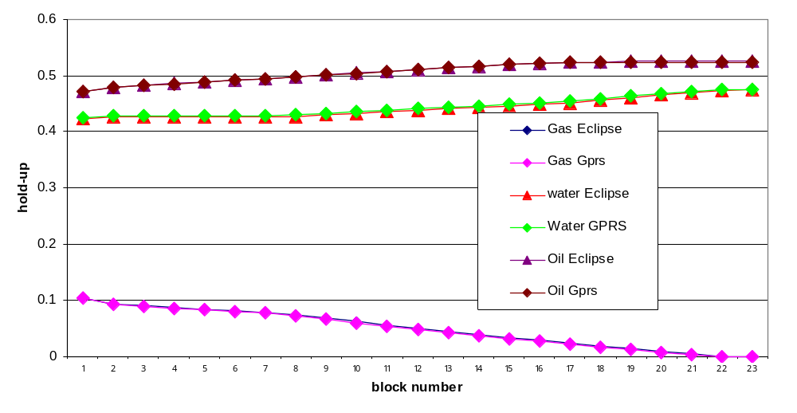

5.2 Choke implementation
The choke implementation is implemented as a different setting for a segment in its pressure equation. The segment set to be a choke becomes a choke by itself and use the pressure equation of a choke only. In ECLIPSE a choke is just a part of a segment. The choke adds a non-linear term for the pressure drop which is most of time a lot more important than the one from the friction effect. Due to that there is a discontinuity in the pressure along the well and it may increase the number of iteration. In our test the iteration number was increased mostly for the first time steps.
In order to validate the choke implementation a model with a long well has been tested. In the middle of a long horizontal well, we put a choke and we checked its. The results on the pressure between ECLIPSE and GPRS are in a very good agreement. The error is in this case less then 0.01%.
Here is the presentation of the pressure along the well, and we can see the effect of the choke in the pressure along the well is the same between these two simulators.
Fig 7 : Pressure along wells.

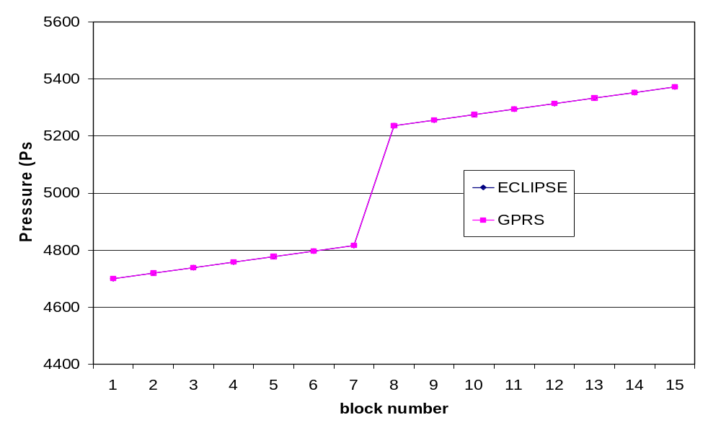
6. Jacobi matrix
Based on above analysis, the Jacobi matrix of 2-components system with drift-flux model can be shown as following. The “x” in the figure stands for non-zero element.
Fig. 8 Jacobi Matrix of a O-W reservoir with a 4-segment drift-flux MSWell

 | 1p | 1s | 2p | 2s | 3p | 3s | 4p | 4s | 5p | 5s | p | vm | ag | a o | p | vm | ag | a o | p | vm | ag | a o | p | vm | ag | a o
Cell1
Cell1
Cell2 |  |  | x | x |  |  |  |  |  |  | x
Cell2 |  |  | x | x |  |  |  |  |  |  | x
Cell3
Cell3
Cell4 |  |  |  |  |  |  | x | x |  |  |  |  |  |  | x
Cell4 |  |  |  |  |  |  | x | x |  |  |  |  |  |  | x
Cell5
Cell5
Seg1 p |  |  |  |  |  |  |  |  |  |  | x | x | x | x
Seg1 g |  |  |  |  |  |  |  |  |  |  | x | x | x |  | x | x | x
Seg1 o |  |  |  |  |  |  |  |  |  |  | x | x |  | x | x | x |  | x
Seg1 w |  |  |  |  |  |  |  |  |  |  | x | x | x | x | x | x | x | x
Seg2 p |  |  | x | x |  |  |  |  |  |  | x |  |  |  | x | x | x | x
Seg2 g |  |  | x | x |  |  |  |  |  |  | x | x | x |  | x | x | x |  | x | x | x
Seg2 o |  |  | x | x |  |  |  |  |  |  | x | x |  | x | x | x |  | x | x | x |  | x
Seg2 w |  |  | x | x |  |  |  |  |  |  | x | x | x | x | x | x | x | x | x | x | x | x
Seg3 p |  |  |  |  |  |  | x | x |  |  |  |  |  |  | x |  |  |  | x | x | x | x
Seg3 g |  |  |  |  |  |  | x | x |  |  |  |  |  |  | x | x | x |  | x | x | x |  | x | x | x
Seg3 o |  |  |  |  |  |  | x | x |  |  |  |  |  |  | x | x |  | x | x | x |  | x | x | x |  | x
Seg3 w |  |  |  |  |  |  | x | x |  |  |  |  |  |  | x | x | x | x | x | x | x | x | x | x | x | x
Seg4 p |  |  |  |  |  |  |  |  |  |  |  |  |  |  |  |  |  |  | x |  |  |  | x | x | x | x
Seg4 g |  |  |  |  |  |  |  |  |  |  |  |  |  |  |  |  |  |  | x | x | x |  | x | x | x
Seg4 o |  |  |  |  |  |  |  |  |  |  |  |  |  |  |  |  |  |  | x | x |  | x | x | x |  | x
Seg4 w |  |  |  |  |  |  |  |  |  |  |  |  |  |  |  |  |  |  | x | x | x | x | x | x | x | x

Based on above analysis, the Jacobi matrix of 2-components system with homogeneous model can be shown as following. The “x” in the figure stands for non-zero element.
Fig. 9 Jacobi Matrix of a O-W reservoir with a 4-segment homogeneous MSWell

 | 1p | 1s | 2p | 2s | 3p | 3s | 4p | 4s | 5p | 5s | p | vm | ag | a o | p | vm | ag | a o | p | vm | ag | a o | p | vm | ag | a o
Cell1
Cell1
Cell2 |  |  | x | x |  |  |  |  |  |  | x
Cell2 |  |  | x | x |  |  |  |  |  |  | x
Cell3
Cell3
Cell4 |  |  |  |  |  |  | x | x |  |  |  |  |  |  | x
Cell4 |  |  |  |  |  |  | x | x |  |  |  |  |  |  | x
Cell5
Cell5
Seg1 p |  |  |  |  |  |  |  |  |  |  | x | x | x | x
Seg1 g |  |  |  |  |  |  |  |  |  |  | x | x | x |  | x | x | x
Seg1 o |  |  |  |  |  |  |  |  |  |  | x | x |  | x | x | x |  | x
Seg1 w |  |  |  |  |  |  |  |  |  |  | x | x | x | x | x | x | x | x
Seg2 p |  |  | x | x |  |  |  |  |  |  | x |  |  |  | x | x | x | x
Seg2 g |  |  | x | x |  |  |  |  |  |  |  |  |  |  | x | x | x |  | x | x | x
Seg2 o |  |  | x | x |  |  |  |  |  |  |  |  |  |  | x | x |  | x | x | x |  | x
Seg2 w |  |  | x | x |  |  |  |  |  |  |  |  |  |  | x | x | x | x | x | x | x | x
Seg3 p |  |  |  |  |  |  | x | x |  |  |  |  |  |  | x |  |  |  | x | x | x | x
Seg3 g |  |  |  |  |  |  | x | x |  |  |  |  |  |  |  |  |  |  | x | x | x |  | x | x | x
Seg3 o |  |  |  |  |  |  | x | x |  |  |  |  |  |  |  |  |  |  | x | x |  | x | x | x |  | x
Seg3 w |  |  |  |  |  |  | x | x |  |  |  |  |  |  |  |  |  |  | x | x | x | x | x | x | x | x
Seg4 p |  |  |  |  |  |  |  |  |  |  |  |  |  |  |  |  |  |  | x |  |  |  | x | x | x | x
Seg4 g |  |  |  |  |  |  |  |  |  |  |  |  |  |  |  |  |  |  |  |  |  |  | x | x | x
Seg4 o |  |  |  |  |  |  |  |  |  |  |  |  |  |  |  |  |  |  |  |  |  |  | x | x |  | x
Seg4 w |  |  |  |  |  |  |  |  |  |  |  |  |  |  |  |  |  |  |  |  |  |  | x | x | x | x

Data Structure

If there is more than one multi-segment well presented in system, the Jacobi matrix looks like following system (fig.2). Each well has a set of WWJ, WRJ, RWJ. The structures of them are shown in fig.1.
Fig. 10 Jacobi Matrix of a simply reservoir with 3 MSWell

 |  | MSWell 1 | MSWell2 | MSWell3
 | RRJ | RWJ1 | RWJ1 | RWJ1
MSWell1 | WRJ1 | WWJ1
MSWell2 | WRJ2 |  | WWJ2
MSWell3 | WRJ3 |  |  | WWJ3

In order to storage the matrix efficiently, and decouple the data structure as much as we can, we define a multi-level matrix storage.
In the top level, we define the highest level matrix as following:
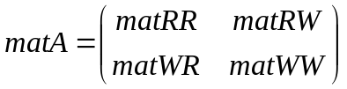

A MV operation for this matrix is defined the MV operation of its sub-matrices. Theatrically, the sub-matrix in matA can be any type of matrix, as long as it has MV operation. matRR is relatively simply. Most likely, it’s a compressed-row matrix (point-wise or block-wise). However, the other 3 sub-matrix have more complex structures.

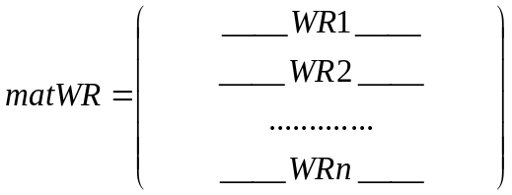

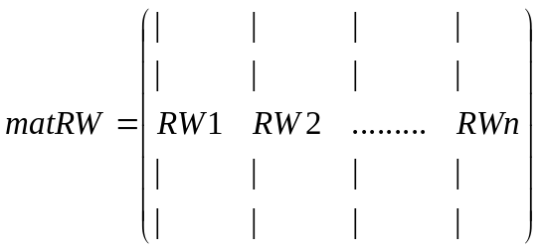

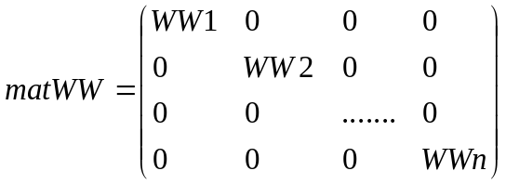

WR, RW and WW are matrices defined based on block.
For this small test case, GMRES can work through without preconditiner.

Description.

Segment
Segment node

Segment 0
Segment 1
Segment 2

Cell 0
Cell 1
Cell 2

Cell 3
Cell 4
Cell 5

Cell 7
Cell 8
Cell 6

P_2
_2
_2
Vm_2
Segment 0
Segment 1
Segment 2
Surface 0
Surface 1
Surface 2
Surface 3
Flow direction
Nextsurface of Segment 0
Presurface of Segment 0

9. Initialization.

The initialization for the well is an important issue. The guess needs to be as good as possible to allow the convergence. Without pre-conditioner it works even with a bad guess. For kown we initialize the pressure as the hydrostatic pressure and for the velocity the initialization is a fraction of the velocity without pressure drop in the well.
There is an important need to add a good initialization to be able to use the preconditioner in all of the cases. There are different ways to do that, either crate a local iterative solver with a dumping to be able to have the right pressure for the well, to solve the problem with a dumping on the multi-segment well part. Some other option might be possible like liking all the pressure together and solve a local implicit problem just with the well condition.

Appendix A:

In GPRS, the number of equations per cell is same to the number of components. The variables are chose based on the fluid type.
Fluid Type | Variables
GOW | Po, Sg, Sw
GO | Po, Sg
GW | Pw, Sg
OW | Pw, So

See more detail in class mthRockFluidModel and class RockFluid2P and class RockFluid3P

9. Input file
Multi-segment well input file.

The aim of the multi-segment well is to handle complex wells and to be able to have a large possibility of different option in it. It has to take into account the geometry the different settings for the flow behavior and some other options like down-hole controls.

The input file has to be constructed as following:
# ----------------- Wells Data --------------------#
NumOfMSWells 1

# WELL No. 1
####################################################

# --- definition (WELSPECS) -------------
# WELL_NAME GROUP RES_NAME TYPE STATUS
MSWell_1 PROD RES1 P OPEN
END

After the definition of the name of the well and the links between its and the reservoir, the beginning of the multi-segment well part by itself starts.
In this part, the three-first numbers are useless and won’t change the results, It has been done to be like the Eclipse input file but these numbers are not used yet. The “INC” keyword defines how the geometry needs to be defined. Each segment is defined with its incremental changes from the upper one. The pressure drop by default takes into account the hydrostatic and the friction effects. The pressure drop from the acceleration effect can be added with an A in the keyword HF.
# (WELSEGS)
# Dep Tlen Vol Len&Dep PresDrop FlowModel
10 1 1 INC HFA HO
END

The geometry of the well needs to be defined as fallowing. There are two details to be aware when you define a well.
The first segment defined after the segment 0 needs to be the only one connected to the segment 0 and its incremental-deviation change is going to be divided by two. So here is an example to define a horizontal well.
In that case to prevent from a wrong deviation effect between the segment 0 and the segment 1 a small segment has been added, it will not have change the results.

number_of_segments 4
# No.of Branch Outlet Length Depth Diam Rough
# Seg Num Seg Change Change
# 0 default homogeneous segment
1 0 0 0.1 0 0.15 0.001
2 0 1 400 0 0.15 0.01
3 0 2 1 0 0.03 0.01
4 0 3 400 0 0.15 0.01

For the integration of the choke the input file has to be modified but this part is facultative. The setting of a segment in a choke will define the all segment to be a single choke and won’t be as in ECLIPSE as the addition of a choke in the segment. The settings here set the segment 3 to be a choke with a choke parameter of 0.632 and its length and its diameter are the same than the segment definition so 1 foot long and 0.03 for the diameter.

# --- Choke definition ------
CHOKES
number_of_chokes 1
#--Seg num Choke model Cv
3 0 0.632

To finish the description of the connection list of the segment and their specifications:
END

