PE224 Advanced Reservoir Simulation
Project Report

EXTENSIONS IN GPRS: TRANSMISSIBILITY
& RELATIVE PERMEABILITY OPTIONS

Student : Mun-Hong (Robin) Hui
Faculty contact : Lou Durlofsky

Petroleum Engineering Dept.
Stanford University, Stanford, CA 94305

Author’s email: mhhui@pangea.stanford.edu
TABLE OF CONTENTS
1. Introduction 1
2. Transmissibility extension 2
3. Relative permeability extension 5
4. Test case 1: Homogeneous reservoir 7
5. Test case 2: Channel Reservoir 10
6. Application 16
7. Conclusions 17
8. References 18

TABLE OF FIGURES
Figure 1 : 1-D block-centered grid illustrating transmissibility computation 2
Figure 2 : The C++ code for the added “readSomeConnections” method in “Grid.cpp” 3
Figure 3 : The C++ code for the modified “buildConnectionList” method in “Grid.cpp” 4
Figure 4 : The C++ code for the modified “readData” method in “Reservoir.cpp” 5
Figure 5 : The C++ code for the modified “calcProps” method in “mthRockFluidModel.cpp” 6
Figure 6 : Test case 1 is a homogeneous reservoir model with a single injector 8
Figure 7 : Case 1 injector pressure history validation (base case) 8
Figure 8 : Case 1 injector pressure history validation (transmissibility extension) 9
Figure 9 : Case 1 injector pressure history validation (relative permeability extension) 9
Figure 10 : Case 1 injector pressure history validation (both extensions) 10
Figure 11 : Permeability map of a 50 by 50 channel reservoir (colorbar in mD) 10
Figure 12 : Water saturation map at late time 11
Figure 13 : Case 2 producer water cut history validation (base case) 12
Figure 14 : Case 2 producer liquid rate history validation (base case) 12
Figure 15 : Case 2 producer water cut history validation (transmissibility extension) 13
Figure 16 : Case 2 producer liquid rate history validation (transmissibility extension) 13
Figure 17 : Case 2 producer water cut history validation (relative permeability extension) 14
Figure 18 : Case 2 producer liquid rate history validation (relative permeability extension) 14
Figure 19 : Case 2 producer water cut history (both extensions) 15
Figure 20 : Case 2 producer liquid rate history validation (both extensions) 15
Figure 21 : Fine-scale model of a near-well upscaling example (local well domains shown) 16
Figure 22 : Coarse-scale model from standard upscaling (local well domains shown) 16
Figure 23 : Producer water-cut for fine, coarse and optimized models 17

Introduction
GPRS is the acronym for the in-house research reservoir simulator developed in the department: the General Purpose Research Simulator¹. It has been designed to be a platform upon which a research group can preserve and enhance the work of a succession of investigators over time.

In this project, the objectives are to extend the modeling capabilities of GPRS. Specifically, there are two extensions. The first one allows GPRS to read in and use the block-to-block transmissibilities for certain block connections while leaving the transmissibilities for the remaining connections to be computed via the usual harmonic averaging of permeabilities. This flexibility is useful in the context of the simulator being able to employ the transmissibility values for a certain region of interest in the reservoir (a fault, for instance) without affecting the calculations for the other regions. The second extension enables GPRS to use a different set of relative permeabilities for every block. This versatility is handy when different sets of relative permeabilities are applicable to different facies or rock types in the reservoir. In addition, these extensions enhance the ability of GPRS to employ the coarse-scale transmissibilities (from near-well upscaling², for example) and multiple sets of pseudo relative permeabilities from two-phase upscaling³⁻⁴.

A brief description of the steps performed in this project is now given. As a first step, we analyze the GPRS code in order to understand its structure and organization. GPRS is a big and complex C++ program comprising some 120 files separated into 11 sub-directories. As such, this step is indeed a time-consuming one. For the first extension (see Chapter 2), we begin by testing & verifying the existing transmissibility option of GPRS, which expects the transmissibilities for all block connections in the input reservoir model. We then modify the grid module to allow the reading in of transmissibilities for only certain block connections. For the second extension (see Chapter 3), we alter the rock-fluid module so as to permit the inputting of multiple sets of relative permeabilities and the information relating each block to its relevant set. A rather extensive debugging phase next ensues. As coding is a significant part of the project, a few examples of actual code written will be shown for illustration and documentation purposes.

Upon implementing the extensions in GPRS, a simple test case involving a small, homogeneous model is used to validate the implementations (see Chapter 4). We compare the GPRS simulation results when using the transmissibility and/or relative permeability option against those given by the equivalent ECLIPSE runs. Next, we test the new GPRS options on a large, channel reservoir case (see Chapter 5) by once again using equivalent ECLIPSE results. The perfect match of results proves that the extensions have been implemented correctly. Finally, we show an application of the extensions in a near-well upscaling example (see Chapter 6).

Transmissibility extension
Ordinarily, the transmissibilities between block connections are computed using the harmonic averaging of permeabilities. For example, in the 1-D block-centered grid shown in Figure 1, the x-direction transmissibilities are defined as:
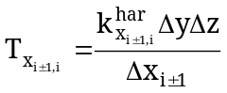 ()
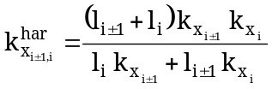,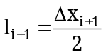, 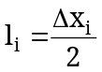 ()

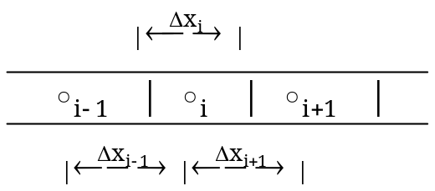

Figure 1 : 1-D block-centered grid illustrating transmissibility computation
However, sometimes we would like to input the transmissibilities for certain block connections, e.g. when only a region of the reservoir has been upscaled. There is an existing option in GPRS but it expects the transmissibilities for all block connections in the input reservoir model. We first test & validate that option using ECLIPSE as reference. Having confirmed its validity, we then modify the grid module to allow the reading in of transmissibilities for only certain block connections while ensuring that the transmissibilities for the remaining connections are still computed via the harmonic averaging of permeabilities.

This extension mainly affects the grid module of GPRS. As a significant part of the project is spent on coding, several examples of actual code written are shown for illustration and documentation. In order to allow the reading in of transmissibilities for only certain block connections, we add the “readSomeConnections” method (see Figure 2) to read in the selected transmissibilities. The “buildConnectionList” method (see Figure 3) is also altered to enable the rest of the transmissibilities to be computed via the harmonic averaging of permeabilities. Other parts of the code that are affected include the header, destructor and “readData” method of “Grid.cpp”.

// --- Method to read in the transmissibilities only for certain connections ---
void Grid::readSomeConnections(FileIO &fio)
{
readSomeConns = true; // -- Activate boolean indicator of option
nSomeConns = fio.popInt(); // -- Read in number of connections involved --
someData = new Conn[nSomeConns]; // -- Create the input transmissibility data array --

for (int i=0; i<nSomeConns; i++) { // -- Read in block locations & transmissibilities --
someData[i].a = fio.popInt();
someData[i].b = fio.popInt();
someData[i].T = fio.popReal();
}
}
Figure 2 : The C++ code for the added “readSomeConnections” method in “Grid.cpp”

// -- Method to build the connectivity array --
void Grid::buildConnectionList()
{
nConns = nx*ny*(nz-1)+nx*(ny-1)*nz+(nx-1)*ny*nz; // -- Only for Cartesian --
Conn *data = new Conn[nConns]; // -- Create connection list --

// -- Build the connections in X, Y and Z directions via harmonic averaging of permeabilities --
int i=0, bandsize;
buildXDirConnections(data, &i);
buildYDirConnections(data, &i);
buildZDirConnections(data, &i);
assert(i==nConns);

// -- Override connections whose transmissibilities have been read in --
int j, k;
if (readSomeConns) {
for (j=0; j<nConns; j++) {
for (k=0; k<nSomeConns; k++) {
if (data[j].a == someData[k].a && data[j].b == someData[k].b)
data[j].T = someData[k].T;
}
}
}
… // -- More code but not shown
}
Figure 3 : The C++ code for the modified “buildConnectionList” method in “Grid.cpp”

This option is activated by keyword “SOME_CONNECTION” in the grid data section of the “res_comp.in” input file and its usage is illustrated as follows:

SOME_CONNECTION 2
2 5 25.5
4 5 5.2
The preceding lines indicate that there are two connections for which the transmissibilities we wish to input. The transmissibilities for the connection between block 7 and 12 and the one between block 12 and 17 are therefore 719.5 and 96.8 mD-ft respectively.

Relative permeability extension
Prior to this extension, GPRS only allows the usage of a single set of relative permeabilities for the entire reservoir. This can be a severe limitation to its modeling capability as there can be situations in which we want to use a different set for different facies or rock type. In addition, we often end up with multiple sets of pseudo relative permeabilities in two-phase upscaling – sometimes as many as one for each coarse block.

// -- Read input file --
void Reservoir::readData(FileIO &fio)
{
…
else if (strcmp(junk, "ROCKFLUID_DATA") == 0) { // -- Read in default rel. perm --
…
mRockFluidList.insert(mRockFluidList.end(), mRockFluid); // Add to rock-fluid module
mCellRelPermSet = new double[nCells]; // Array indicating which set for each block
for (int i=0; i<nCells; i++) mCellRelPermSet[i] = 0; // Default rel perm (1st set)
}
else if (strcmp(junk, "MULTI_ROCKFLUID") == 0) { // -- Read multiple sets --
int i, nSets = fio.popInt();
for (i=0; i<nSets; i++) {
if (nPhases==2)
mRockFluidList.insert(mRockFluidList.end(), new RockFluid2P(fio));
else if (nPhases==3)
mRockFluidList.insert(mRockFluidList.end(), new RockFluid3P(fio));
}
fio.popRealArray(mCellRelPermSet, nCells); // Read in array
…
}
Figure 4 : The C++ code for the modified “readData” method in “Reservoir.cpp”
Thus, the ability to use multiple sets of relative permeabilities will certainly be a useful feature. We again show some code for illustration and documentation. This extension affects the reservoir module of GPRS (see Figure 4); introducing a new keyword for the inputting of multiple sets of relative permeabilities and also the array indicating which set is relevant to which block. The rock-fluid module is also significantly modified, affecting the header, constructor, destructor and “calcProps” method of “mthRockFluidModel.cpp” (see Figure 5).

// -- Method to calculate relative permeabilities, capillary pressures and their derivatives --
void mthRockFluidModel::calcProps()
{
int ib;
if(nPhases == 3) { // -- Three phases --
for (ib=0; ib<nCells; ib++)
mRockFluidList[int(mCellRelPermSet[ib])]->calcKrpPc
(mSat[0+ib*nPhases], mSat[2+ib*nPhases], // Sg, Sw
…
&mPc[1+ib*2], &mDPc_Ds[(1+ib*(nPhases-1))*2]); // Pcwg, dPcwg_dS
}
else if (nPhases == 2) { // -- Two phases --
for (ib=0; ib<nCells; ib++)
mRockFluidList[int(mCellRelPermSet[ib])]->calcKrpPc
(mSat[0+ib*nPhases], // S1
…
&mPc[ib], &mDPc_Ds[ib]); // Pc21, dPc21_dS1 …
}
Figure 5 : The C++ code for the modified “calcProps” method in “mthRockFluidModel.cpp”

This option is activated by keyword “MULTI_ROCKFLUID” in the rock-fluid section of the “res_comp.in” input file, followed by an integer indicating how many extra sets of curves to be read in. The keyword informing the type of fluid system investigated is then expected. The table for each extra set is next, followed by the array indicating which set to use for which block. An example demonstrating usage is given below:

MULTI_ROCKFLUID # Keyword for multiple sets of relative permeabilities
1 # No. of extra sets
OW # Oil-water system
NUM_OF_TABLE_ENTRIES 3
# Sw Krw Krow Pcow
0.0 0.0 1.0 0
0.5 0.1 0.4 0
1.0 0.6 0.0 0
END
# Specify which set for which cell (like Eclipse's SATNUM)
0 2*1 0

In this example of a 2 by 2 model, there are 2 sets of curves in total - blocks 1 and 4 will employ set 1 while blocks 2 and 3 will use set 2.

Test case 1: Homogeneous reservoir
After implementing the extensions, we employ test cases to validate the implementation by comparing against the simulation results yielded by the equivalent ECLIPSE runs. Test case 1 is a simple, homogeneous model that is 3 by 3 in size (see Figure 6). There is a water injector in the center of the reservoir, which is surrounded by producers at its boundaries. It is essentially a local well model under constant pressure boundary conditions – a domain around a well defined for the purpose of upscaling². The injector and producers are kept at a constant bottom-hole pressure of 6000 and 2000 psi respectively. Initially, the reservoir has zero water saturation and as time passes, water emanating from the injector sweeps the oil toward the producers at the reservoir boundaries. We compare the injection block pressure histories given by GPRS and ECLIPSE. For the base case without any extension, the resulting curves are identical as expected (see Figure 7).
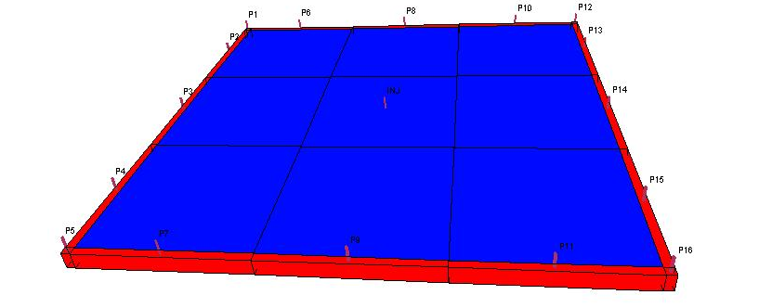
Figure 6 : Test case 1 is a homogeneous reservoir model with a single injector

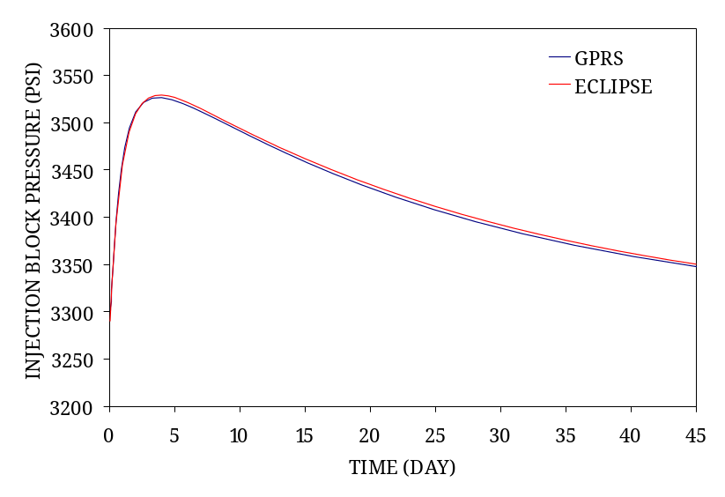
Figure 7 : Case 1 injector pressure history validation (base case)

The results for the scenario in which only the four transmissibilities of the injection well block have been altered are given in Figure 8. The exact match between GPRS and ECLIPSE indicates that the transmissibility extension has been done correctly. We next use a different set of relative permeabilities for the injection well block and the perfect duplication of curves in Figure 9 assures us that the relative permeability extension has also been implemented correctly.
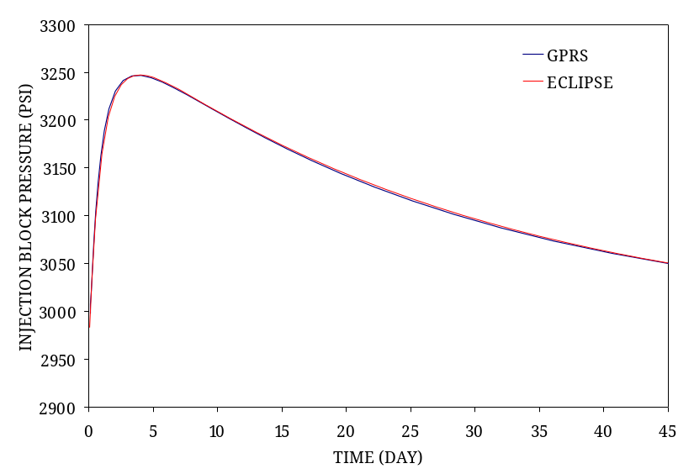
Figure 8 : Case 1 injector pressure history validation (transmissibility extension)

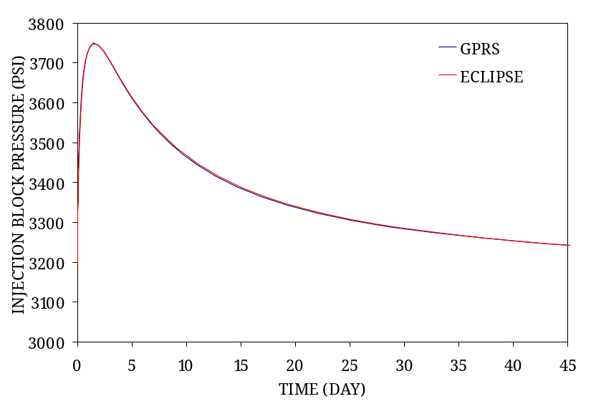
Figure 9 : Case 1 injector pressure history validation (relative permeability extension)

Finally, in order to confirm that the two extensions do not interfere with each other in any way, we test the situation when both extensions are employed at the same time. As can be seen in Figure 10, our assertion of implementation correctness still holds true.

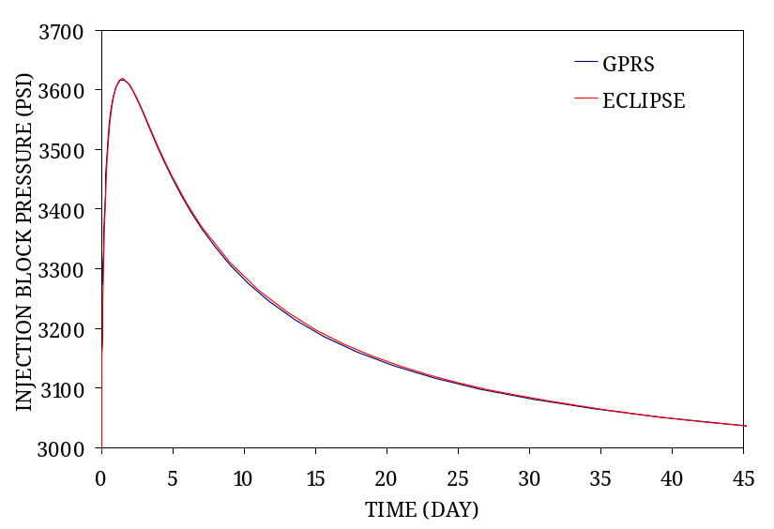
Figure 10 : Case 1 injector pressure history validation (both extensions)

Test case 2: Channel Reservoir
Having confirmed that the extensions work correctly for the simple, homogeneous case (see Chapter 4), we next validate the implementation using a more complicated model.

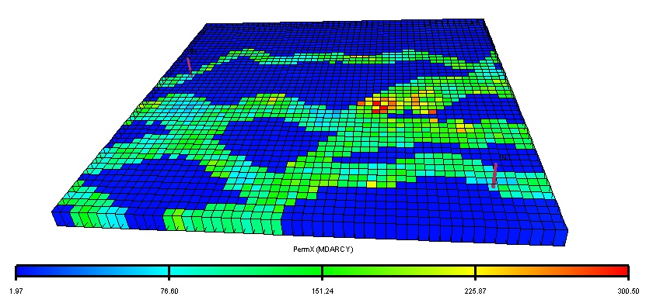
Figure 11 : Permeability map of a 50 by 50 channel reservoir (colorbar in mD)

Test case 2 is a heterogeneous, 50 by 50 channel reservoir with high permeability contrasts (see Figure 11). There is an injector completed within the channel sands on the southeastern side of the domain while a producer exists at the northwestern side. The injector and producer are kept at a constant bottom-hole pressure of 6000 and 2000 psi respectively. Initially, the reservoir has zero water saturation and with time, injected water moves toward the producer, mainly via the high permeability channels. The total simulation duration is set to be 450 days.

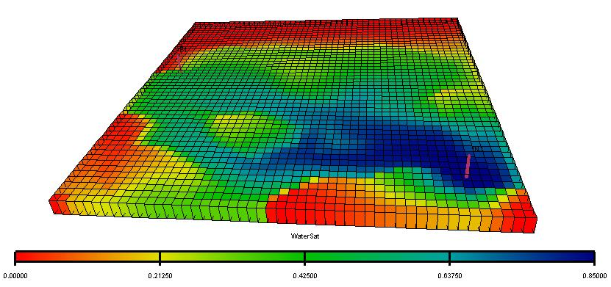
Figure 12 : Water saturation map after 450 days

We compare the producer water cut and total liquid rate history from GPRS and ECLIPSE. The simulation results for the base case without any extension (see Figure 13 and Figure 14) match exactly as expected.

When we use the transmissibility option in GPRS to specify the transmissibilities just for the injection and production well block, we observe that the simulation results match those from ECLIPSE (see Figure 15 and Figure 16). This shows that the transmissibility extension has been implemented correctly.
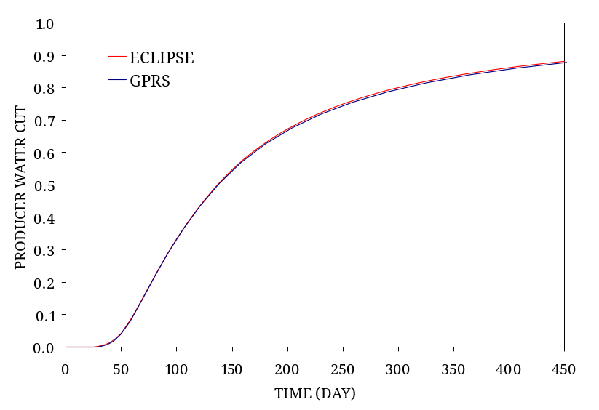
Figure 13 : Case 2 producer water cut history validation (base case)

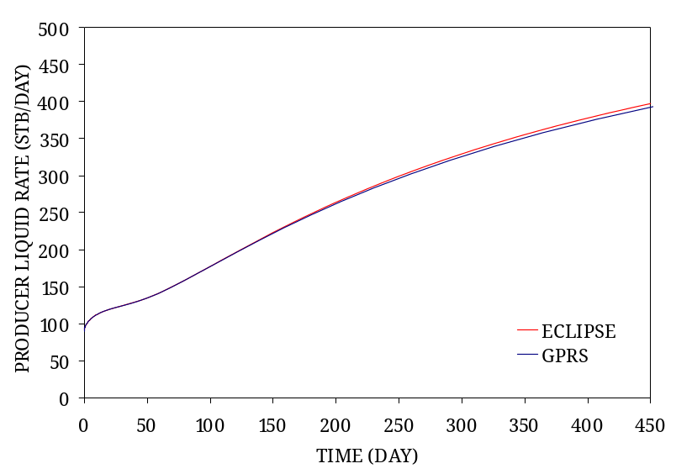
Figure 14 : Case 2 producer liquid rate history validation (base case)

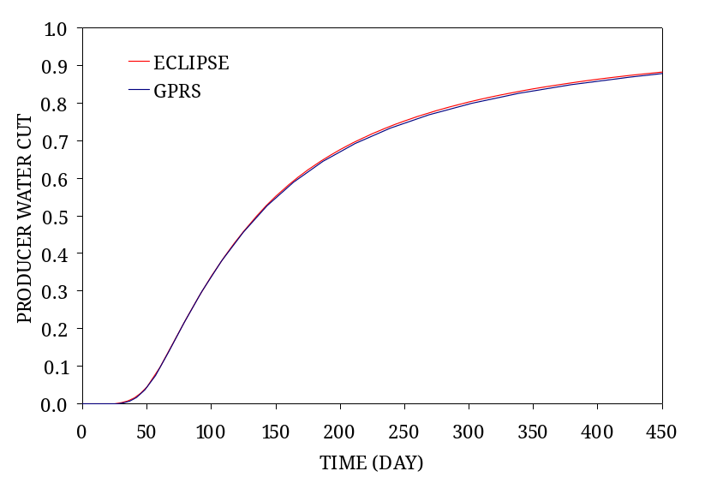
Figure 15 : Case 2 producer water cut history validation (transmissibility extension)

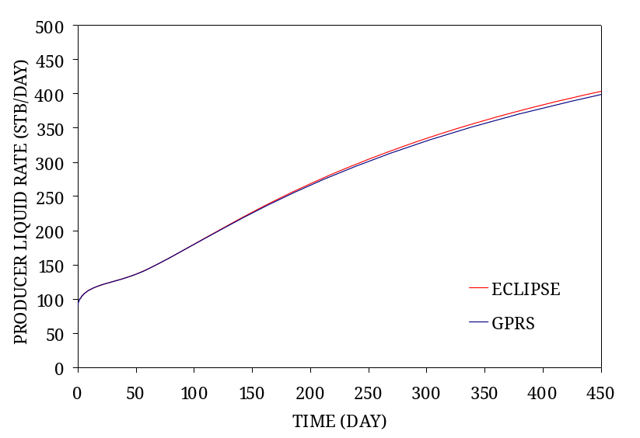
Figure 16 : Case 2 producer liquid rate history validation (transmissibility extension)

We next employ the relative permeability option in GPRS to read in two sets of relative permeabilities, one for the channel sands and the other for the low permeability regions. The GPRS simulation run for this scenario mysteriously aborts after about 140 days but nonetheless, the results match those from ECLIPSE up till that point (see Figure 17 and Figure 18). Once again, this is proof that the extension has been implemented in the right manner.

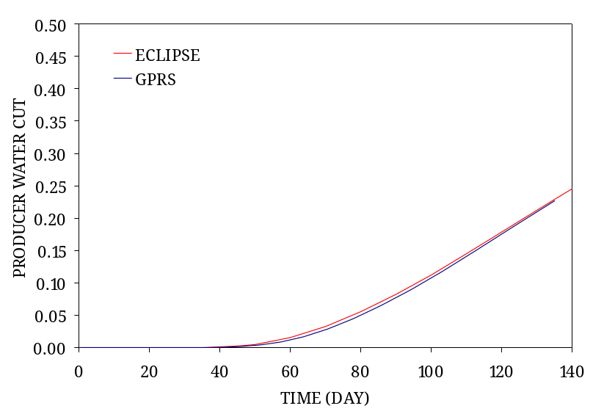
Figure 17 : Case 2 producer water cut history validation (relative permeability extension)

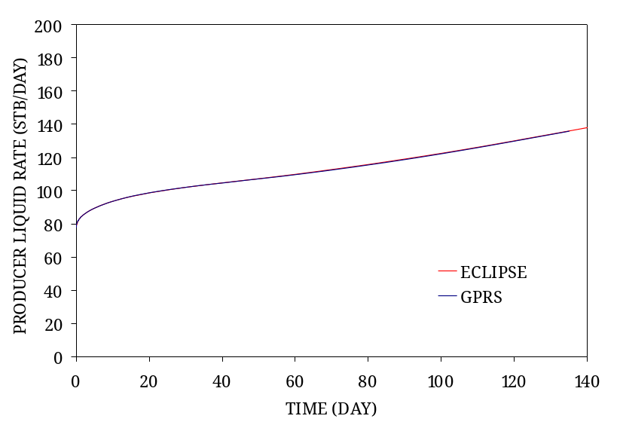
Figure 18 : Case 2 producer liquid rate history validation (relative permeability extension)

Lastly, to ascertain that the extensions work when used together, we investigate the scenario in which there are both inputted well block transmissibilities and multiple sets of relative permeabilities. The matching results in Figure 19 and Figure 20 show that this is indeed the case.

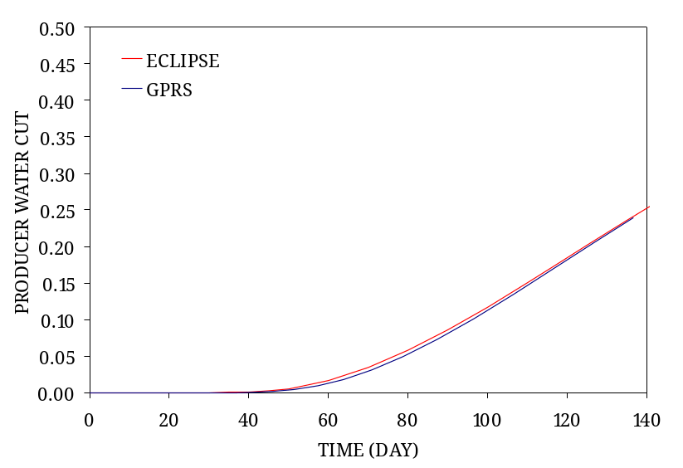
Figure 19 : Case 2 producer water cut history (both extensions)

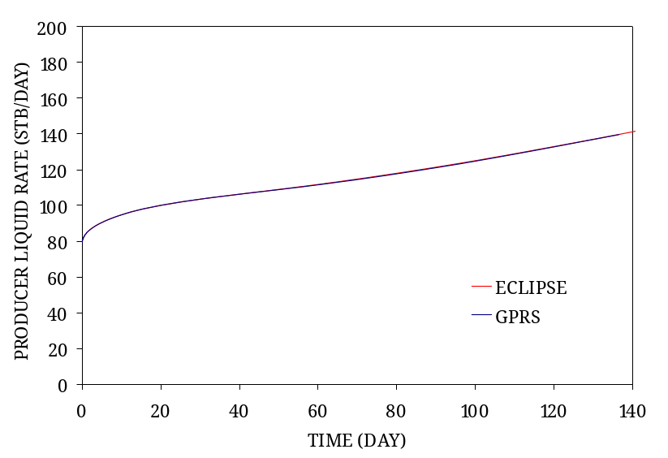
Figure 20 : Case 2 producer liquid rate history validation (both extensions)

Application
To demonstrate the usefulness of the extensions, we use a near-well upscaling example to illustrate one of the possible applications. The model employed is the same 50 by 50 channel reservoir discussed in Chapter 5 but with different injector and producer locations (see Figure 21). We then use the standard upscaling program, “Flowsim” from the GSLIB software⁵ to coarsen the model to a 10 by 10 model (see Figure 22). Local well domains around the two wells are then defined (see boxes in Figure 21 and Figure 22).

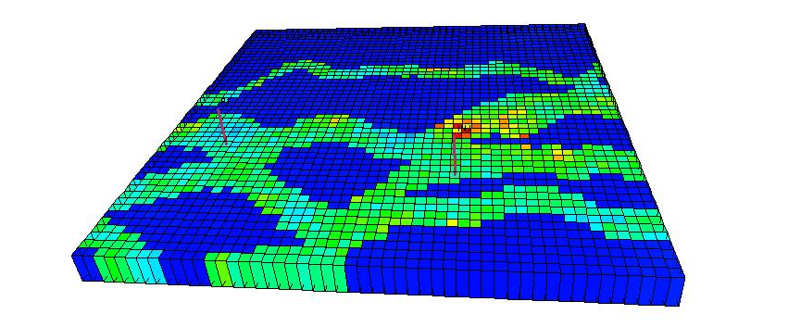
Figure 21 : Fine-scale model of a near-well upscaling example (local well domains shown)

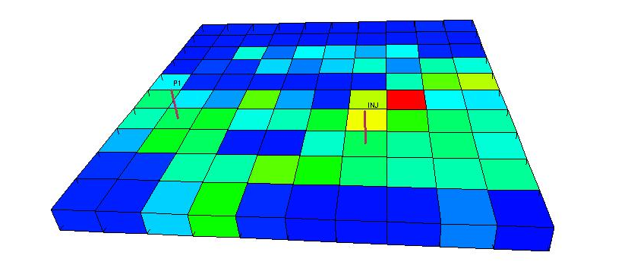
Figure 22 : Coarse-scale model from standard upscaling (local well domains shown)

A near-well, single-phase upscaling procedure² is performed on both local well domains in order to extract the optimized well-block transmissibilities and well indices. Following that, a two-phase upscaling procedure⁶ is applied on the injector local well domain, yielding the set of optimized well pseudo relative permeabilities for the injector.

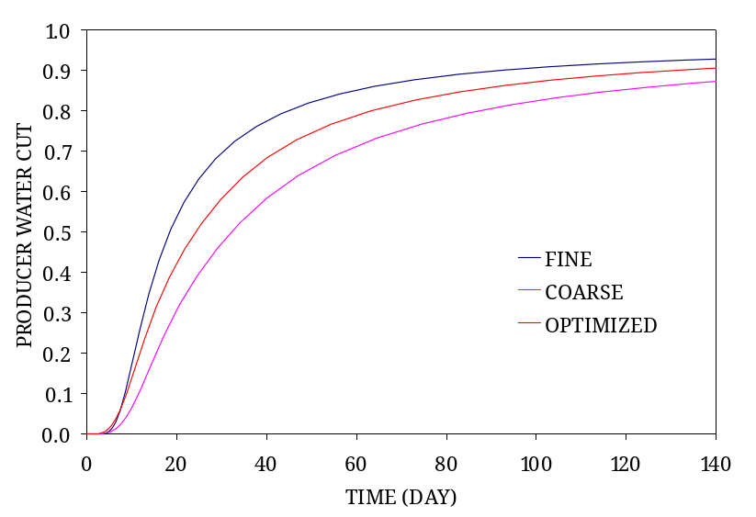
Figure 23 : Producer water-cut for fine, coarse and optimized models

We compare the upscaling performance using the producer water cut curves. As can be see in Figure 23, the curve from the coarse model obtained via standard upscaling is not as close to the fine-scale solution as the upscaled model which employs optimized well block transmissibilities, well index and injector well pseudo relative permeabilities.

Conclusions
This project extends the modeling capabilities of the research reservoir simulator, GPRS. The first extension allows GPRS to read in user-specified transmissibilities for certain block connections while leaving the remaining transmissibilities to be computed via the usual harmonic averaging of permeabilities. The second extension enables GPRS to use a different set of relative permeabilities for every block in the reservoir model.
After analyzing the GPRS code, we implemented the transmissibility and relative permeability options. We then validated the implementation using a simple homogeneous test case. We compared the GPRS simulation results when using the transmissibility and/or relative permeability option against those given by the equivalent ECLIPSE runs. We found that the results match perfectly, indicating that the extensions have been implemented correctly. We then tested the new GPRS options on a more involved channel reservoir case and once again observed that the simulation results match exactly. We are therefore convinced of the validity of the extensions. Lastly, we showed an application of the extensions in a near-well upscaling example.

References
- Cao, H.: “Development of techniques for general purpose simulators”; Ph.D. dissertation, Stanford University (June 2002).
- Mascarenhas, O. and Durlofsky, L.J.: “Coarse scale simulation of horizontal wells in heterogeneous reservoirs”; Journal of Petroleum Science and Engineering, 25, 135-147 (2000).
- Cao, H. and Aziz, K.: “Evaluation Of Pseudo Functions”; SPE54589 (1999).
- Barker, J.W. and Dupouy, P.: “An analysis of dynamic pseudo-relative permeability methods for oil-water flows”; Petroleum Geoscience, 5, 385-394 (1999).
- Deutsch, C.V. and Journel. A.G.: “GSLIB: Geostatistical software library”; Oxford University Press (1998).
- Hui, M. and Durlofsky, L.J.: “Upscaling of two-phase flow parameters in the near-well region”; Ph.D dissertation, Stanford University (work in progress).

GPRS comes in two versions, namely two-point and multi-point flux. The extensions in this project have only been added to the former version but the incorporation into the latter should be straightforward.

