GPRS Technical Report

Multi-stage Preconditioning for Group Constraints on Multi-segment Wells

August, 2008

Yifan Zhou

SUPRI-B Industrial Consortium

Department of Petroleum Engineering

Stanford University

Abstract

Well group model has been introduced to GPRS by Yuanlin Jiang in his PhD thesis. Concerning this model, the work described in this technical report primarily includes these four aspects: (1) Design and implement a CPR-based multi-stage preconditioner working on fully coupled reservoir-facilities simulation with well group model; (2) Make modification in the solver, preconditioner and their relevant data structures to be compatible with AIM formulation; (3) Implement more accurate initial junction pressure estimation for group rate control mode and implement junction pressure control mode with initial rates estimation for well group model; (4) Test the method with both homogeneous and heterogeneous problems of different scales. The time for 80x80x1, 365 days (max. 1 day per step), 2-phase black-oil simulation with 1 standard injection well and 1 well group containing 3 multi-segment producing wells is decreased from 1446s (using only BILU) to 196s (using CPR+BILU, 13.55% of BILU case). And if AIM formulation (90% IMPES + 10% FIM) is used, the simulation time is further decreased to 174s (12.03% of BILU case, 88.78% of FIM+CPR case). With the above improvement, GPRS is able to solve fully coupled simulation including well groups, with either FIM or AIM formulation, in an efficient and accurate way.

- Introduction
In Yuanlin Jiang’s PHD thesis, “A Flexible Computational Framework for Efficient Integrated Large-Scale Modeling of Advanced Wells and Complex Reservoirs”, well group was proposed and implemented as a new facility model. At the same time, multi-level sparse block matrix data structure, block GMRES solver without AIM compatibility, and CPR preconditioner working on multi-segment and standard wells were also introduced.
With new group constraints, strong coupling behavior is introduced into the system so that without a good preconditioner, we cannot even get converged solution in a large problem. Besides that, due to the various advantages of AIM formulation and the necessity of well control switch, adaptive data structure is needed to be developed. What’s more, for fast and correct convergence, good initial guess is required for both control modes of the well group model, whereas originally it only had constant estimation of initial junction pressure, which was really rough, in group rate control and no junction pressure control was implemented.
In order to solve these problems, the CPR-based multi-stage preconditioner was extended to deal with the well group model. Now it can work well on fully coupled reservoir-facilities simulation. Solver, preconditioner and their relevant data structures are also modified to be compatible with AIM formulation and well control switch. Moreover, initial pressure estimation for group rate control, and the junction pressure control with initial rates estimation were designed and implemented for the well group model to make it more practical in usage.

- Theory and Methods
2.1 CPR Preconditioner for Group Constraints
The well group class in GPRS is inherited from the common Ifacility class, just like StdWell and MSWell classes. The original CPR preconditioner in GPRS can only handle the facility preconditioning data with 1 column in RF matrix, 1 row in FR matrix, and 1 element in FF matrix, as are provided by MSWell and StdWell classes. Of course we can reduce the preconditioning data of a well group model to that of a quasi-equivalent StdWell model by algebraic reduction. Then the original CPR preconditioner will be supposed to work on it. However, if we have a lot of multi-segment wells in a single well group, especially when we consider the possibility of nested well groups (e.g. several well groups were under the control of a higher-order well group.), the program will still reduce them into a single equation with a single well variable, which will cause considerable error and negative impact on the preconditioning effect.

Therefore the well group model should be handled in a different way in the CPR preconditioner. One feasible way is to reduce it to n wells without integrated governance, where n is the number of wells contained in the well group. Then the preconditioning data of it will contain n columns in RF matrix, n rows in FR matrix and n elements in FF matrix. This could be further extended to the nested case, where n becomes the total number of wells contained in the base well group and all the sub well groups in it.

As a quick review, CPR (Constrained Pressure Residual) preconditioner is a 2 stage preconditioner, with its 1st stage working globally on the reduced pressure-like equations and 2nd stage working locally on the overall system.

In a well group model, junction is defined as the point where pipelines join in a common facility and where constraint is applied. In group rate control mode, the junction object introduces n+1 new variables (1 junction pressure P_{J} ,and n well rate variables Q_{i}), which correspond to the same number of extra equations (1 constant rate control and n pressure relation equations):

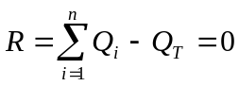 (1)

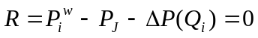 (2)

where Q_{T} is the specified total rate for the well group, 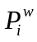 is the reference pressure (well head pressure for MSWell model) for well i, and we have:

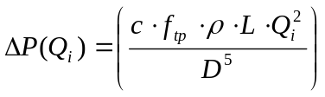 (3)

in which c is a conversion constant, f_{tp} is the dimensionless Darcy friction factor,  is the density of the governing phase, L is the length of the pipeline from well to the junction, D is the diameter of the pipeline.

The equations for well group model in FR and FF matrices look like follows: 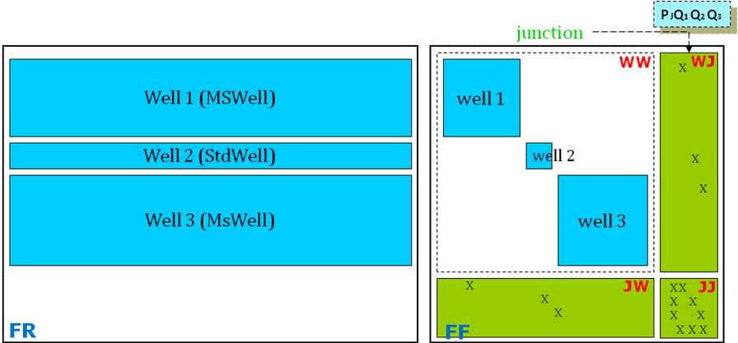

The key idea of the 1st stage (pressure stage, implemented in GlobalCPRPre class) in the CPR preconditioner for well group model is to reduce the group of n sub-wells to n wells w/o group constraint. The detailed procedure is as follows:
- Use standard true IMPES reduction to reduce the reservoir matrix (RR part);
- For each well group, let all facilities included in it generate their reduced FR, RF & FF part (e.g. algebraic reduction for MSWell model);
- Assemble the reduced matrices to form the pressure system 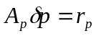, solve it with AMG, and perform prolongation: 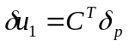;
- Update residual vector r: 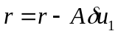.

The 2nd stage (overall stage, implemented in ResFacBILU class) of CPR preconditioner contains the following steps:
- Use BILU(0) preconditioner to solve RR part (RF part is decoupled with RR in 1st stage through updating the residual vector using the solution to algebraic reduced pressure system);
- In a sub matrix for well group in FF, solve JJ using ILU (JW part is dropped due to pressure decoupling in 1st stage);
- For each sub matrix in WW (e.g. well 1, well 2 and well 3 in the figure above), use BILU(1) preconditioner to solve it all alone. (FR part is dropped due to pressure decoupling in 1st stage).

In order for the preconditioner to correctly recognize well group model, such member variables have been added to the Ifacility class:
Name | Type | Meaning | Value
nTWells | int | total number of wells in a facility | 1 for StdWell and MSWell; n for Well group
mnWellEqns | int* | number of governing equations for each well | 1 int (= nObjEqns) for StdWell and MSwell, n ints for Well group
mSubPerf | int* | number of perforations for each well | 1 int (= nPerfs) for StdWell and MSwell, n ints for Well group

Correspondingly, the member function to get preconditioning info has been changed to include these three new variables:

virtual void getPreMatInfo (double* &mPreWWJ_, double* &mPreWRJ_, double* &mPreRWJ_, int* &mPreWWRHSflag_, int* &mPresVarflag_, int &mnWells_, int* &mnWellEqns_, int* &mSubPerf_);

Linearization function in Well group class will collect all these information from its sub wells and form corresponding integrated matrices, which have the same data structure as the preconditioning matrices from StdWell and MSWell models. The preconditioner can then recognize these matrices from the Well group model and reform them into preconditioning matrices for n separate wells with the help of the three new variables. In this way the 1st stage in CPR preconditioner can work just like the way it works with only StdWell and MSWell models.

2.2 Adaptive Data Structures

Originally, Block GMRES Solver was not compatible with AIM formulation since it could not deal with the run-time structure change in multi-level block sparse matrix. For the same reason, it cannot correctly handle the well control switch of standard well from rate control (1 extra well equation) to BHP control (no extra equation). That is to say, run-time data structure change is needed to handle AIM formulation and well control switch.

In order to solve the above problems, changes have first been made to the multi-level block sparse matrix classes, including SysFFJWrapper class (for FF, WW matrices), SysFRJWrapper class (for FR matrix), and SysRFJWrapper class (for RF matrix), to enable the user to remove a submatrix from them, recalculate their size and reconstruct their temporary column vector for executing multiplication. CoordMatWrapper class (for JW, WJ matrices in a well group and the blank part of FR, RF matrices) is also updated. Users can now change the dimension of a CoordMatWrapper object without reconstructing the object, consequently making the blank part of FR, RF matrices flexible to the change in number of rows or columns.

To be specific, these member functions were added to SysFFJWrapper, SysFRJWrapper, and SysRFJWrapper class:

void DelSubmatrix ( int ib ); // For removing ib’th submatrix from the wrapper

void calcSize(); // For recalculating the size of the wrapper and reconstructing the column vector y

And the following member function was added to CoordMatWrapper class:

void changedim(int nRows_, int nCols_); // For changing the number of rows and columns of the coordinate matrix wrapper without reconstructing it

Then, in the Block GMRES Solver, such code was added in order to change the data structure when GPRS detects a changing requirement in the structure of Jacobian matrix, either in reservoir or facilities part, due to AIM formulation or well control switch. The solver will correspondingly change the structure of wrapper matrices, i.e. to delete unnecessary matrices, set implicit variables of sub matrices in SysFFJWrapper, SysFRJWrapper, SysRFJWrapper or change the dimension of CoordMatWrapper, to make their size consistent and recalculate the size of the base wrapper, which contains RR, RF, FR, and FF matrices.

Hence the block GMRES solver with multi-level block sparse matrix can now handle both AIM formulation and well control switch.

2.3 Enhancement of Well Group Model

2.3.1 Initial Junction Pressure Estimation for Group Rate Control

Originally, junction pressure was set to a constant (1449.43) in the implementation of well group model in GPRS, which is a very rough estimation and not accurate for most cases. Since there is some threshold on the Newton update of junction pressure, i.e. the maximum changing rate in a time step, it would take a long time to find the proper junction pressure if the initial guess is far from its real value. Sometimes the system cannot even get converged. That is to say, good initial guess is needed for fast and correct convergence.

First consider the extra governing equations of a well group model in group rate control mode:

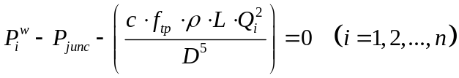, 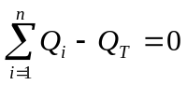

If we consider as a known coefficient, which is actually computed using calcStartupProps function in each iteration, and solve these n+1 equations for the following variable vector containing n+1 variables: 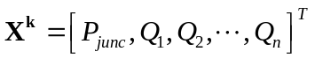. The residual vector 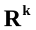 will be constructed as follows:

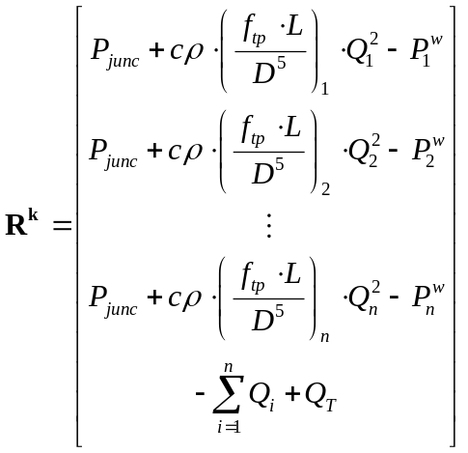

Using Newton’s method, the Jacobian matrix 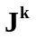 (blank entries are zeros) is built as follows

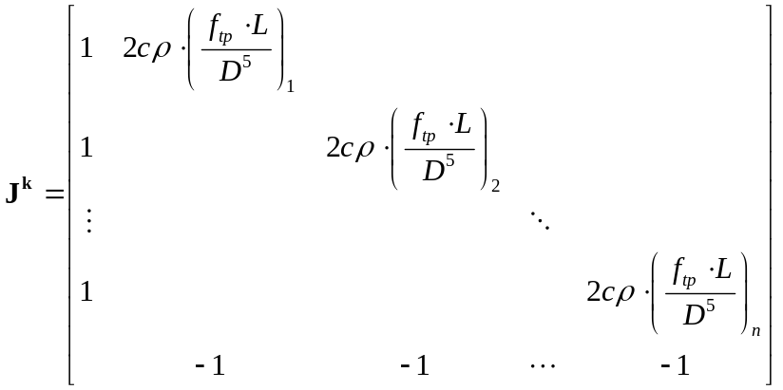

In each Newton iteration, we will first set the well rate to 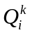 (the solution in last iteration), call calcStartupProps function to calculate the initial reference pressure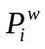, and then construct the residual vector and Jacobian matrix . Afterwards, we solve 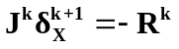, perform the Newton update: 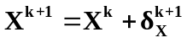 and go to the next iteration.

When the system converges, i.e. 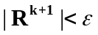, we will get both accurate initial pressure and proper initial rate for each sub well. This is more meaningful if the sub well configurations are different from each other since the system can find the distinct initial rate for each sub well.

2.3.2 Junction Pressure Control and Initial Rates Estimation

As an alternative control mode of well group model, the junction pressure control is now implemented into GPRS. Instead of changing the extra equation from total rate constraint () to pressure constraint (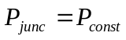), the system actually removes the extra 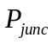 variable and the original total rate constraint. is considered as a constant and always moved to the right hand side in the simulation. Hence the number of additional variables and equations for a well group becomes n 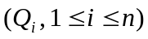 instead of n+1. This way of implementation is primarily for avoiding zero pivot in ILU decomposition since the total constraint equation is now the last equation.

In order to give reasonable initial guess to the well rates in junction pressure control, the following algorithm is implemented into the WellGroup class:

For each sub well #i, do the following:
- Give initial guess of well rate 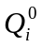, set 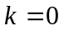.
- Set well rate of sub well #i to 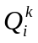, and call CalcStartupProps to calculate the initial well head pressure 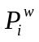.
- Calculate 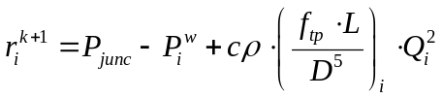.
- Check the convergence criteria: 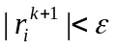? If yes, the initial rate for well #i is determined. Let 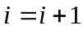 and go to 1 when 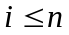. If no, go to 5.
- Calculate 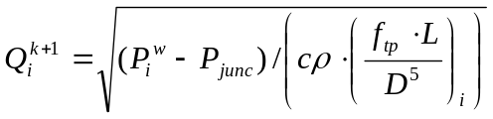 .
- Let 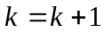 and go to 2 for the next iteration.

In this way the initial rate for all the sub wells can be estimated with the condition 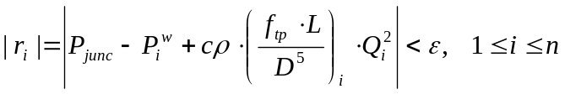 satisfied. Since the initial reference pressure for a MultiSegment well is not a simple function of the well rate, we cannot get explicit form of 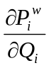. This is the reason why a Newton iteration is not used in this situation and why is considered as a coefficient in the previous discussion for initial pressure estimation in group rate control.

- Efficiency and Accuracy Comparisons
  - Test Case 1 (Base Case)
Test Case | 20x20x1, oil-water system, 365 days, 1 well group with 3 multi-segment producing wells (5 segments of each), group oil rate control, 1 standard injection well with BHP control
Solver Option | BILU | CPR+BILU | AIM+CPR+BILU
Timestep | 370 | 370 | 371
Newton Iter | 3962 | 3402 | 3458
Solver Iter | 79074 | 13677 | 13662
Pressure Iter | 0 | 13677 | 13662
Solver Time (sec) | 32.18 | 15.76 | 12.34
Total Time (sec) | 58 | 39 | 37

From the table above, we can see CPR improves performance a lot. It decreases solver iteration by 82.7% and solver time by 51.0%. In a 2-phase, 2-component small case, AIM does not have big impact on the performance. But it will provide great improvement when number of component or size of the problem goes up. The simulation result is compared in the figure below. We can see that the CPR result matches BILU result very well and AIM result is also close to them. Therefore we obtained almost the same result with much less computation time.

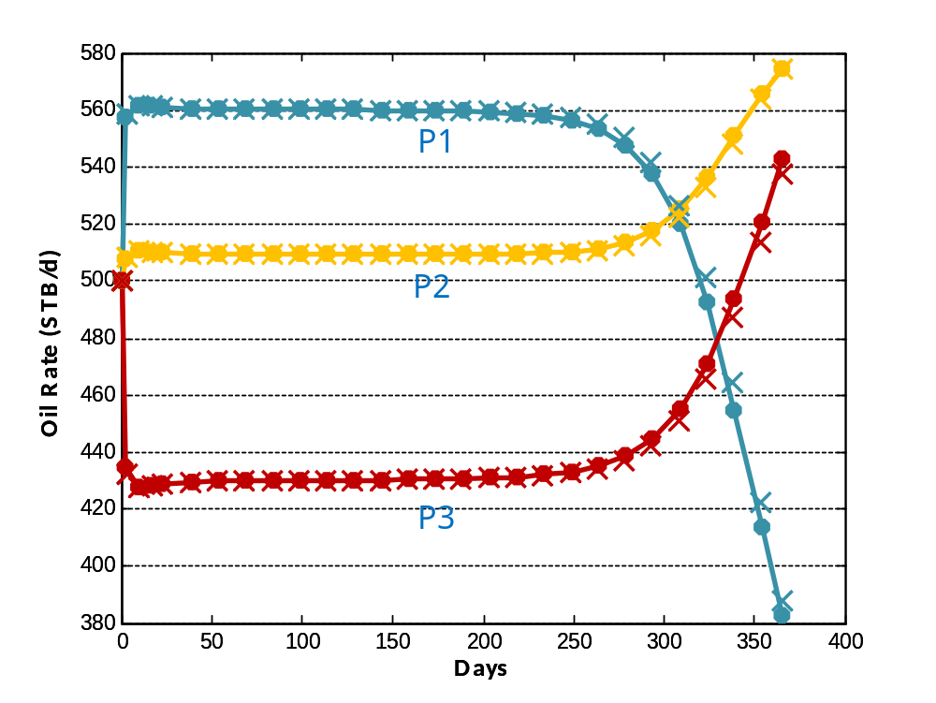

Figure 3.1 Oil Rate Comparison for Test Case 1

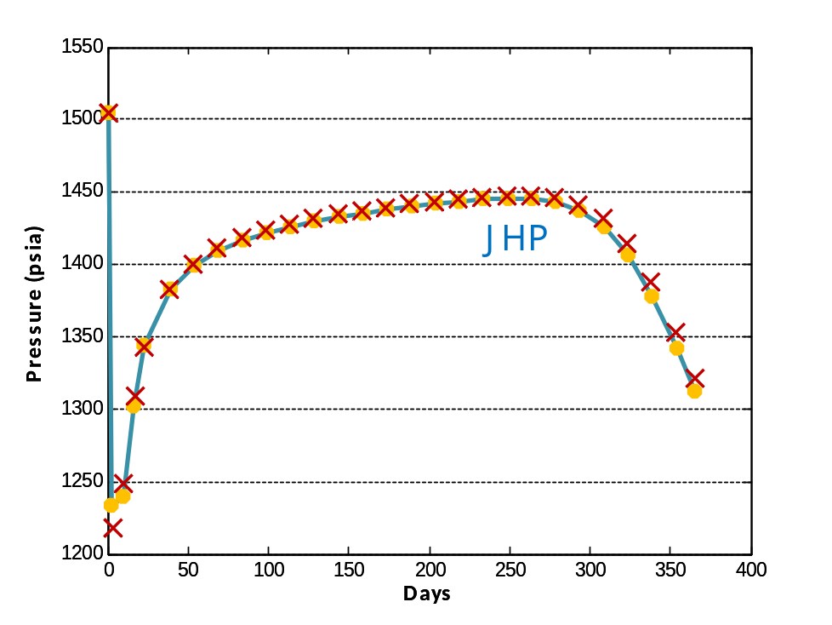

Figure 3.2 Junction Pressure Comparison for Test Case 1

  - Test Case 2 (Larger Problem Size, Junction Pressure Control, Well Control Switch)
Test Case | 80x80x1, oil-water system, 365 days with max. 1 day / time step, 1 well group with 3 multi-segment producing wells (5 segments of each), junction pressure control @ 1500psi, 1 standard injection well with water rate control @ 2100 STB/day and backup BHP constraint @ 8000psi
Solver Option | BILU | CPR+BILU | AIM+CPR+BILU
Timestep | 372 | 372 | 372
Newton Iter | 1843 | 1831 | 1821
Solver Iter | 137646 | 6304 | 6123
Pressure Iter | 0 | 6304 | 6123
Solver Time (sec) | 1358.76 | 108.66 | 81.60
Total Time (sec) | 1446 | 196 | 174

In a larger case, CPR has much larger impact on solver iteration and solver time. It saves 95.42% solver iteration and 92% solver time. AIM has more obvious impact in this case. It further decreases the solver time by 24.9% from that based on CPR approach, which is considerable improvement. From the result comparison, we can see that junction pressure control with initial rates estimation works well. Well control switch can also be properly handled with adaptive data structure.

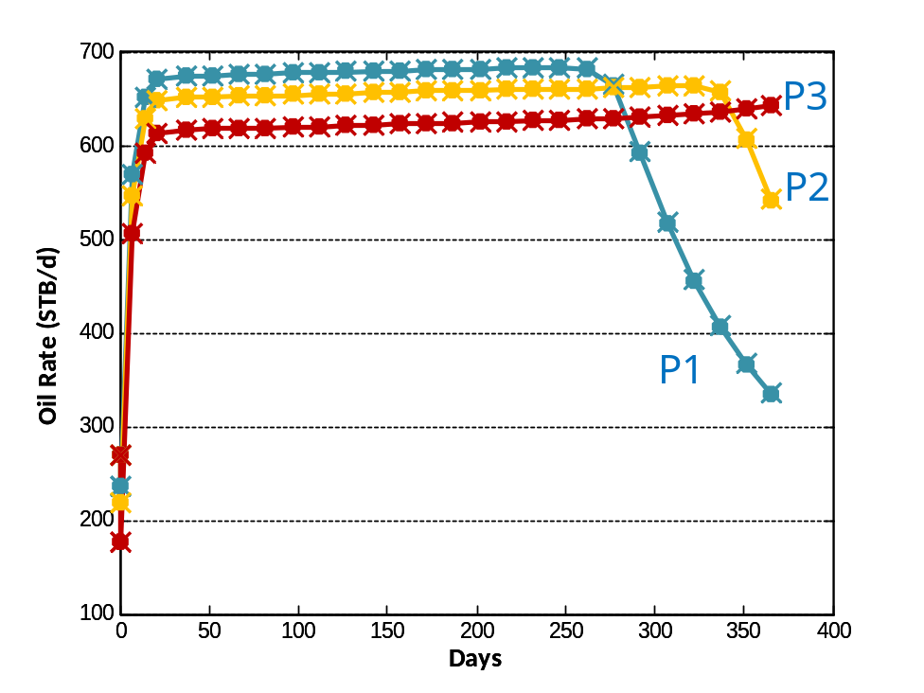

Figure 3.3 Oil Rate Comparison for Test Case 2

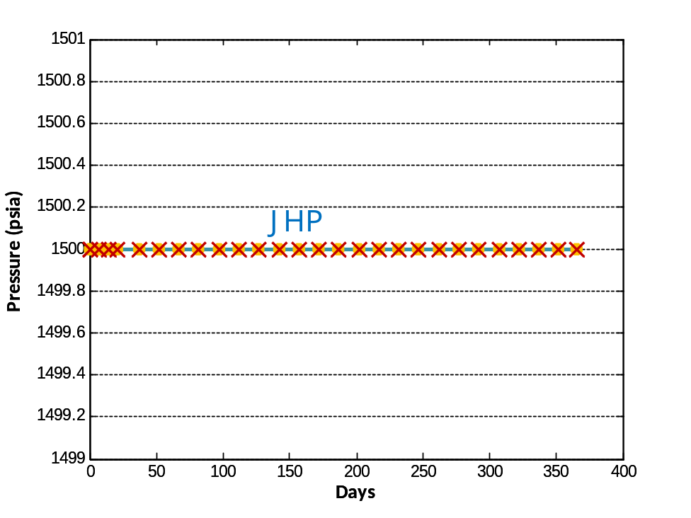

Figure 3.4 Junction Pressure Comparison for Test Case 2

  - Test Case 3 (3D gas-oil system with group oil rate control and high initial pressure)
Test Case | 50x50x2, gas-oil system, 200 days with max. 1 day / time step, 1 well group with 2 multi-segment producing wells (53 vertical / tilted / horizontal segments of each, 50 completions), group oil rate control @ 500 STB/day, primary depletion
Solver Option | BILU | CPR+BILU | AIM+CPR+BILU
Timestep | 206 | 206 | 206
Newton Iter | 527 | 530 | 529
Solver Iter | 35872 | 5385 | 5403
Pressure Iter | 0 | 5385 | 5403
Solver Time (sec) | 283.80 | 63.21 | 48.71
Total Time (sec) | 323 | 102 | 89

The block GMRES solver and global CPR preconditioner work fine for system with gas phase presence and show a considerable improvement in solver performance. As expected, AIM formulation helps decreasing solver time by 22.94% and obtains nearly the same solution.

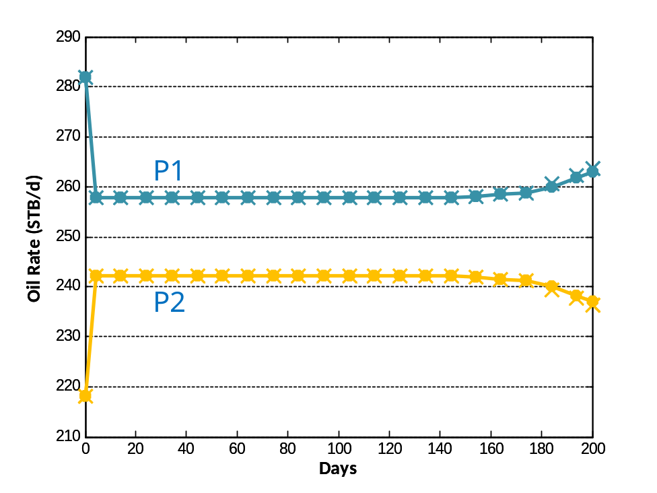

Figure 3.5 Oil Rate Comparison for Test Case 3

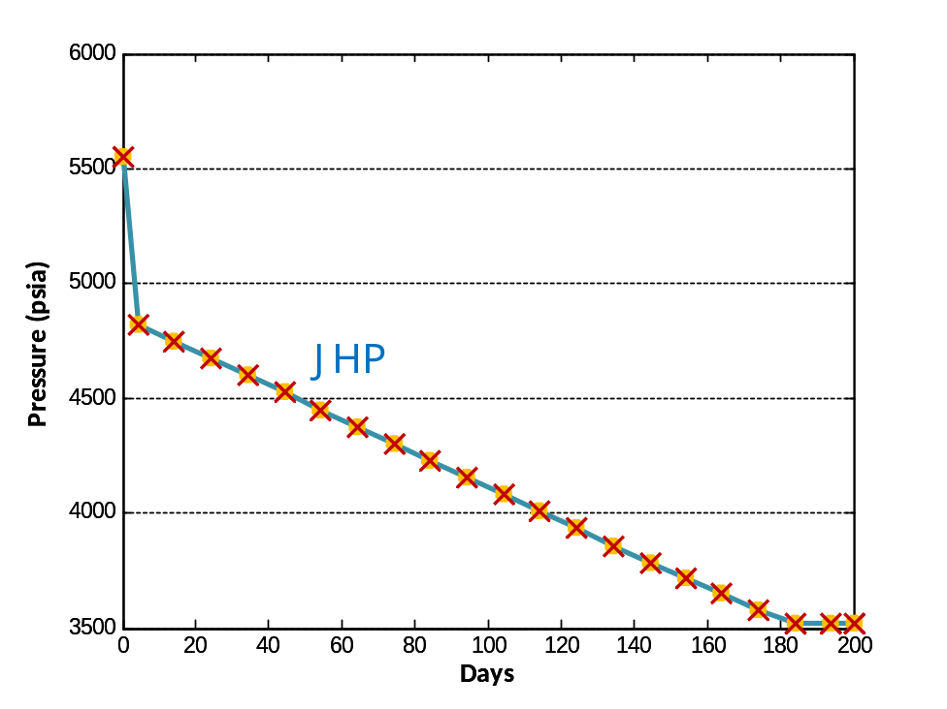

Figure 3.6 Junction Pressure Comparison for Test Case 3
  - Test Case 4 (Longer Simulation Time and Larger Time Step Size)
Test Case | 110x110x1, oil-water system, 8000 days with max. 30 day / time step for first half and max. 20 day / time step for second half, 1 well group with 3 producing multi-segment wells (7 segments each, multi grid completion), group oil rate control @ 1500 STB/day, 1 standard injector well with BHP control @ 4900psi
Solver Option | BILU | CPR+BILU | AIM+CPR+BILU
Timestep | 349 | 349 | 349
Newton Iter | 1191 | 1499 | 1340
Solver Iter | 105327 | 8661 | 8049
Pressure Iter | 0 | 8661 | 8049
Solver Time (sec) | 2209.75 | 223.55 | 160.72
Total Time (sec) | 2346 | 370 | 311

The solver and preconditioner also work fine for cases with longer simulation period and larger time step size. The system stability is validated in this case.

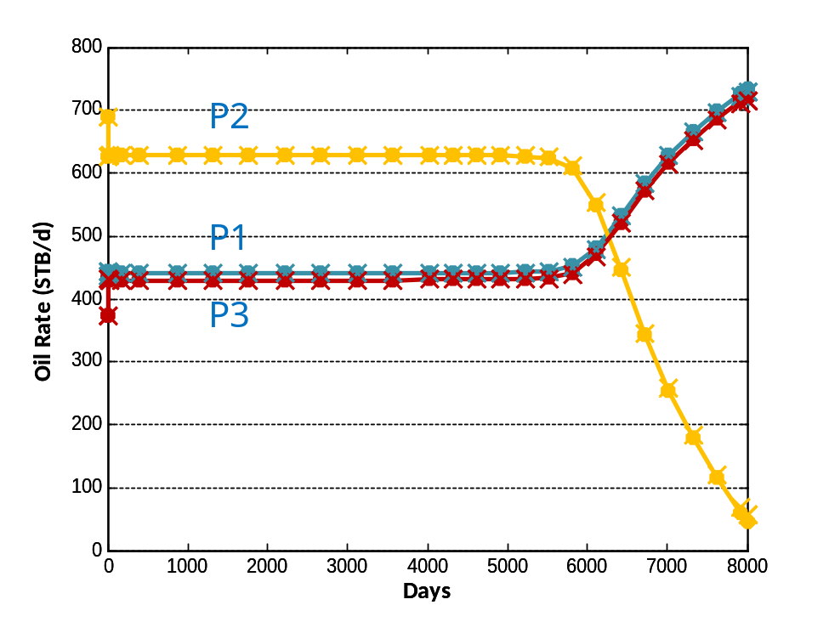

Figure 3.7 Oil Rate Comparison for Test Case 4

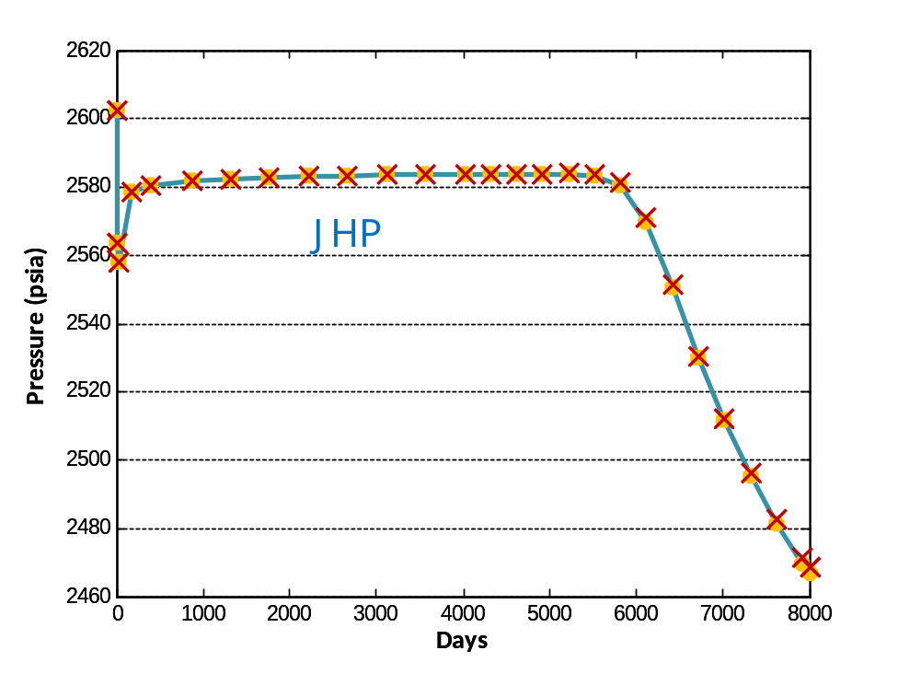

Figure 3.8 Junction Pressure Comparison for Test Case 4

  - Test Case 5 (Large 3-D Homogeneous Reservoir - 400000 cells)
Test Case | 200x200x10, oil-water system, 365 days with max. 1 day / time step for 1st, 2nd setting and max. 10 day / time step for 3rd setting, 1 well group with 3 multi-segment producers (15 segments of each, 10 completions), group oil rate control @ 1500 STB/day, 1 standard injection well with water rate control @ 1500 STB/day
Solver Option | CPR+BILU | AIM+CPR+BILU | AIM with large Δt
Newton Iter | 4106 | 3738 | 1507
Solver Iter | 20682 | 19251 | 8445
Pressure Iter | 20682 | 19251 | 8445
Solver Time (sec) | 45202.4 | 39545.0 | 15817.8
Total Time (sec) | 50833 | 45261 | 18040

For this case, BILU is too slow and cannot get converged solution, while FIM with large Δt has large time truncation error and cannot obtain accurate solution. In settings with small time steps, such a large system can be solved in 14.12 hours with CPR preconditioner (or 12.57 hours with AIM formulation). While in the setting with large time step size, the simulation time can be further decreased to 5.01 hours, which reflects high efficiency and accuracy at the same time.

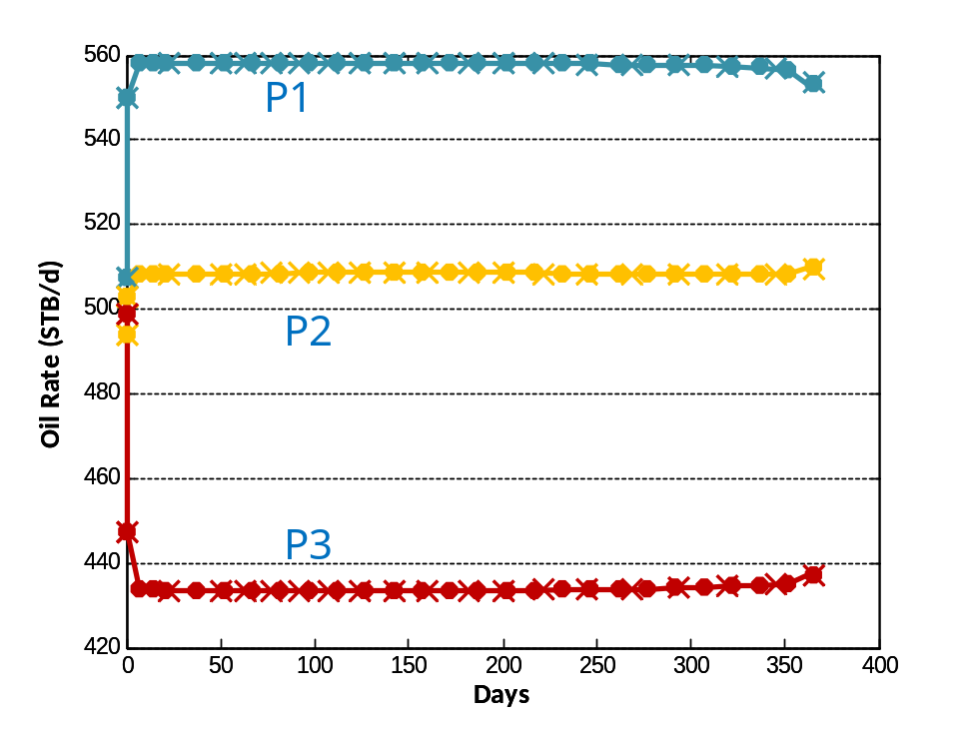

Figure 3.9 Oil Rate Comparison for Test Case 5

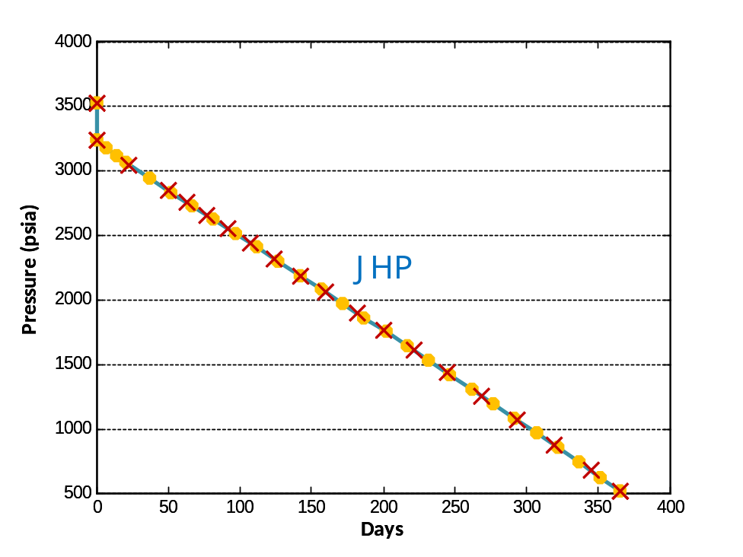

Figure 3.10 Junction Pressure Comparison for Test Case 5
  - Test Case 6 (Full SPE10 with group constraints on multi-segment wells)
Test Case | 60x220x85 (1122000 cells), oil-water system, 2000 days (0.8375 PVI) with max. 50 day / time step, 2 well groups, each with 2 multi-segment producers (90 segments of each, 85 completions), one with group oil rate control @ 500 STB/day, the other with junction pressure control @ 1200psi, 1 standard injection well with BHP control @ 8100psi
Solver Option | CPR+BILU (AIM formulation does not work well with the current time stepping strategy)
Time Step | 62
Newton Iter | 1199
Solver Iter | 12617
Pressure Iter | 12617
Solver Time (sec) | 27285.9
Total Time (sec) | 60602

Strong coupling is introduced by group constraints. It took GPRS 16 hours to solve this problem on a single 2.2GHz CPU with 8GB RAM. Reasonable results were obtained and shown below. With better AIM time stepping strategy, the efficiency can be further enhanced.

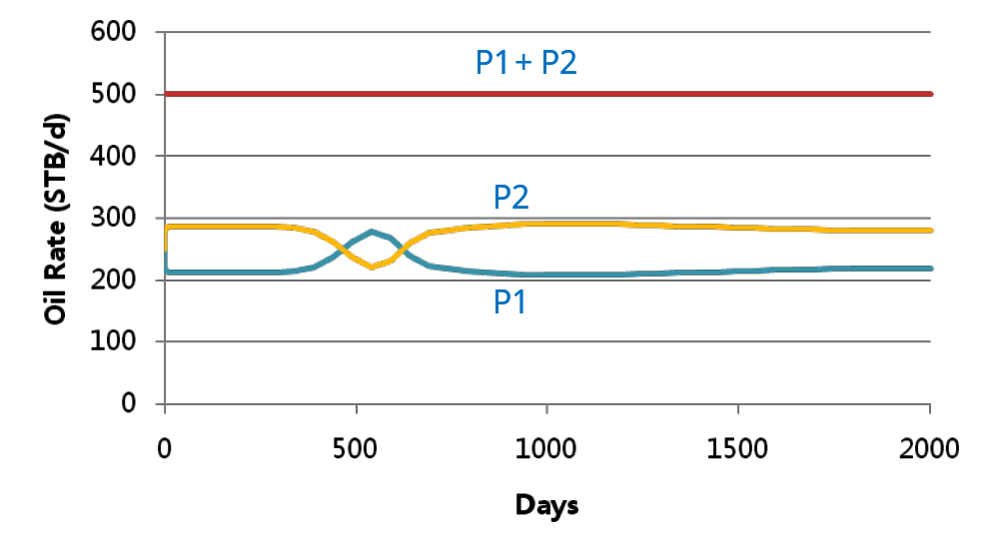

Figure 3.11 Oil Rate Comparison for Test Case 6 – Well Group 1

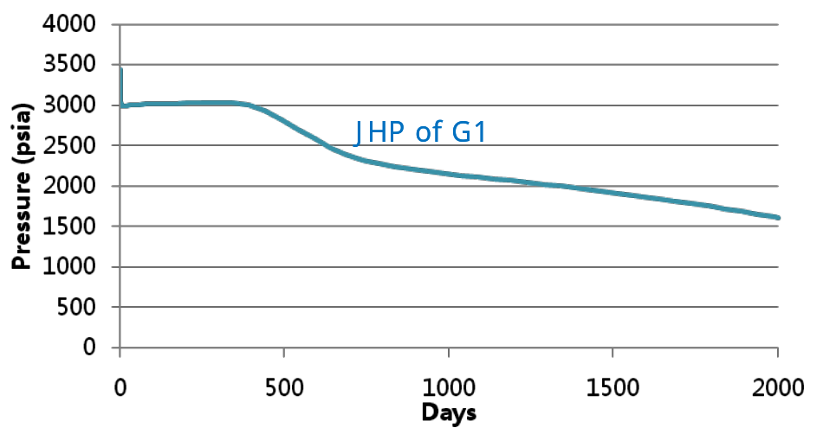

Figure 3.12 Junction Pressure Comparison for Test Case 6 – Well Group 1

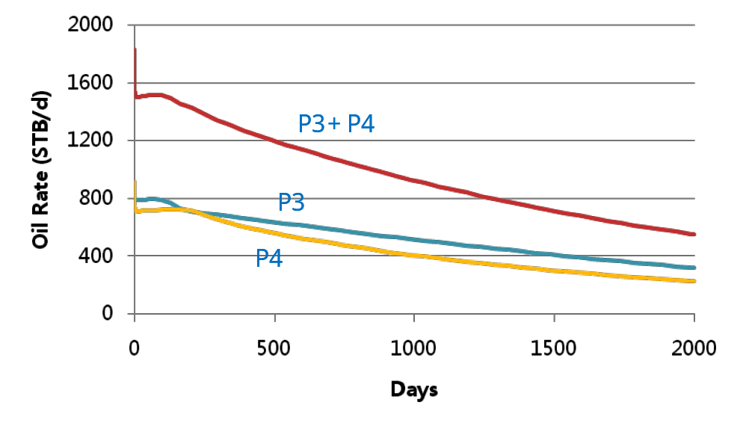

Figure 3.13 Oil Rate Comparison for Test Case 6 – Well Group 2

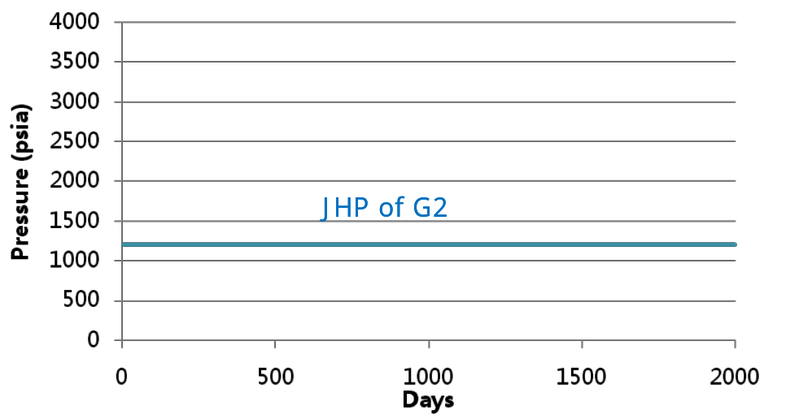

Figure 3.14 Junction Pressure Comparison for Test Case 6 – Well Group 2

4. Conclusion

The following work has been described in this technical report: (1) CPR Multi-stage Preconditioner has been extended to deal with well groups; (2) AIM formulation and well control switch are now fully supported by block GMRES solver with adaptive data structure; (3) Initial junction pressure estimation for group rate control and junction pressure control with initial rates estimation have been designed and implemented for well group model; (4) Large heterogeneous problems with group constraints on multi-segment wells have been tested to validate the efficiency and accuracy of the method.

From the result comparisons in section 3, we can see that CPR preconditioner can greatly improve the solver performance compared with that using only BILU preconditioner, especially in large scale problems. If AIM formulation is used instead of FIM, the simulation time can be further decreased. This is also more obvious in large problems. Moreover, the simulation result using CPR preconditioner matches that using only BILU preconditioner very well, and the result using both AIM formulation and CPR preconditioner is close to that using FIM formulation. The efficiency and accuracy of the method are validated.

Summarily, with the improved multi-stage preconditioner for group constraints on multi-segment wells, adaptive data structure and enhanced well group model, GPRS can run fully coupled reservoir-facilities simulation, including standard wells, multi-segment wells and well groups, with either FIM or AIM formulation in an efficient and accurate way.

User Manual of Well Group Control
In the wells data part of GPRS input file, we can first specify the number of well groups by:
NumOfWellGroup [any non-negative integer]
After that, we can define all the well groups one by one.
In each well group, first we need to specify the name of the group and the number of wells in the group by:
# GROUP_NAME No. of wellS in group
[any string] [any non-negative integer]
After that, we need to specify the parameters for the pipelines between wellheads and the junction one by one:
#length, dh, diameter, rough
[any double] [any double] [any double] [any double]
…
[any double] [any double] [any double] [any double]

Where “length” is the length of the pipeline [ft], “dh” is the depth change of the pipeline [ft] (0 for horizontal pipeline, full length for vertical pipeline), “diameter” is the diameter of the pipeline [ft], and “rough” is the roughness coefficient of the pipeline.
After the definition of pipelines, we can define all the sub wells one by one just like the definition of each single well:
# WELL_NAME GROUP RES_NAME TYPE STATUS
MSWell_1 PROD RES1 P OPEN
END
…
NOCTRL
END_WELL
…
# WELL_NAME GROUP RES_NAME TYPE STATUS
MSWell_n PROD RES1 P OPEN
END
…
NOCTRL
END_WELL

We must set NOCTRL keyword for the control mode of each well since all the sub wells are now governed by the group constraint.
After defining all the wells, we need to specify the group control by:
GRPORATE [Target group oil rate] [Junc. P. constraint] [oil density]
END
Or by:
JHP [Target Junc. P.] [P. constraint for sub wells] [oil density]
END
Then one well group is completed defined and we can define another well group in the same way. After all the well groups are defined, we need to end this section by:
END_WELLGROUP
Appendix
Sample Input File (For the base case with the following configuration: block GMRES solver, CPR preconditioner, FIM formulation)
…
####################################################
# ----------------- Wells Data --------------------#
####################################################
# ------------------------------------------------------------------------------------------------
NumOfWellGroup 1

# --- definition (WELSPECS) -------------
# GROUP_NAME No. of wellS in group
PROD 3

#Pipeline between wellheads and junction
#length, dh, diameter, rough
800 0 0.15 0.05
800 0 0.15 0.05
800 0 0.15 0.05

#---------------------------------------------------
# subwell No. 1
#---------------------------------------------------

# --- definition (WELSPECS) -------------
# WELL_NAME GROUP RES_NAME TYPE STATUS
MSWell_1 PROD RES1 P OPEN
END

# (WELSEGS)
# Dep Tlen Vol Len&Dep PresDrop FlowModel
10 1 1 INC HF HO
END

number_of_segments 5
# No.of Branch Outlet Length Depth Diam Rough
# Seg Num Seg Change Change
1 0 0 3000 3000 0.15 0.001 # vertical zone
2 0 1 3000 3000 0.15 0.001 # vertical zone
3 0 2 3000 3000 0.15 0.001 # vertical zone
4 0 3 3000 3000 0.15 0.001 # vertical zone
END

# -completion (COMPDAT)---------------
number_of_connections 1
#LOC(i,j,k) WI Seg No.
304 15782 4
END

NOCTRL

END_WELL

#---------------------------------------------------
# subwell No. 2
#---------------------------------------------------

# --- definition (WELSPECS) -------------
# WELL_NAME GROUP RES_NAME TYPE STATUS
MSWell_2 PROD RES1 P OPEN
END

# (WELSEGS)
# Dep Tlen Vol Len&Dep PresDrop FlowModel
10 1 1 INC HF HO
END

number_of_segments 5
# No.of Branch Outlet Length Depth Diam Rough
# Seg Num Seg Change Change
1 0 0 3000 3000 0.15 0.001 # vertical zone
2 0 1 3000 3000 0.15 0.001 # vertical zone
3 0 2 3000 3000 0.15 0.001 # vertical zone
4 0 3 3000 3000 0.15 0.001 # vertical zone
END

# -completion (COMPDAT)---------------
number_of_connections 1
#LOC(i,j,k) WI Seg No.
# branch 1
57 15782 4
END

NOCTRL

END_WELL

#---------------------------------------------------
# subwell No. 3
#---------------------------------------------------

# --- definition (WELSPECS) -------------
# WELL_NAME GROUP RES_NAME TYPE STATUS
MSWell_3 PROD RES1 P OPEN
END

# (WELSEGS)
# Dep Tlen Vol Len&Dep PresDrop FlowModel
10 1 1 INC HF HO
END

number_of_segments 5
# No.of Branch Outlet Length Depth Diam Rough
# Seg Num Seg Change Change
1 0 0 3000 3000 0.15 0.001 # vertical zone
2 0 1 3000 3000 0.15 0.001 # vertical zone
3 0 2 3000 3000 0.15 0.001 # vertical zone
4 0 3 3000 3000 0.15 0.001 # vertical zone
END

# -completion (COMPDAT)---------------
number_of_connections 1
#LOC(i,j,k) WI Seg No.
# branch 1
42 15782 4
END

NOCTRL
END_WELL

# --- control (WCONPROD/WCONINJE)--------
# CTRL BHPmin
GRPORATE 1500 14.7 53.0
# Group Oil Rate Control: 1500 bbl/day with 14.7psi BHP constraint, oil density at STC: 53 lbm/ft³
END

END_WELLGROUP

#---------------------------------------------------------------------

NumOfStdWells 1

####################################################
# WELL No. 1
####################################################
# --- definition (WELSPECS) -------------
# WELL_NAME GROUP RES_NAME TYPE STATUS
I1 INJW RES1 I OPEN
END

# --- completion (COMPDAT)---------------
number_of_connections 1
#LOC(i,j,k) WI
357 15782

END

# --- control (WCONPROD/WCONINJE)--------
# CTRL Q BHP std_den Ncomp %comp1 %comp2
# WRATE 1500 7000 64.0 2 0 1
BHP 7000 2 0 1
END
END_WELL

END_WELLS

####################################################
# ---------------- Control Data -------------------#
####################################################
# Timestep boundaries
# TSINIT TSMAX TSMIN
0.01 -1 0.0001

# Total Simulation Time (Days)
365

#No of points: different maximum & minimum timesteps
2

#TIME TSMAXZ TSMIN
0 1 0.001
300 1 0.001

# Newton iterations control
# minNewtonIter maxNewtonIter fixedNewtonIter
1 30 50
# Timestep increase control
# dpress dsat dx w(tuning) small w ~ aggressive increasing ts
200 0.4 0.02 0.8

# Newton iteration convergence control
# MB_Error PE_Error P_Change S_Change MF_Change
# 0.1 0.02 0.0001 0.005 0.001 0.001
0.1 0.02 1 1 1 0.001

# Formulation (variables and implicit levels) control
# varType(AorB) nbImpLevel %AIM (if nbImpLevel>1)
1 1 # 2 0.9
# for each Implicit Level (1 to nbImpLevel):
# nImpVars transOption CFL
# 1 1 1.0
2 4 1.0

# Linear solver control
# LinearSolverChoice Preconditioner tol maxLinearIter
5 12 1E-3 300 200
# 5: Block GMRES Solver 2P; 12: Global CPR Preconditioner

# --- debug information ---
#Flag NumOfTimeSteps
0 10
0 1 0

BREAKTIME 14
10
20
30
40
50
100
130
150
155
160
200
250
300
350
END_CONTROL

