Build Guide of GPRS Software for Windows Operation System in Visual Studio 2008

Huanquan Pan

SUPRI-B
Department of Petroleum Engineering
Stanford University
Required Software
- Microsoft Visual studio 2005

Compile and Link
In the PC_CODE\code folder, double-click the solution file: Main.sln to open the GPRS project. Before compiling, one also needs to set: /force:multiple in Menu ->properties->Configuration properties->linker->Command Line->Additional Options. The following picture shows the setting:

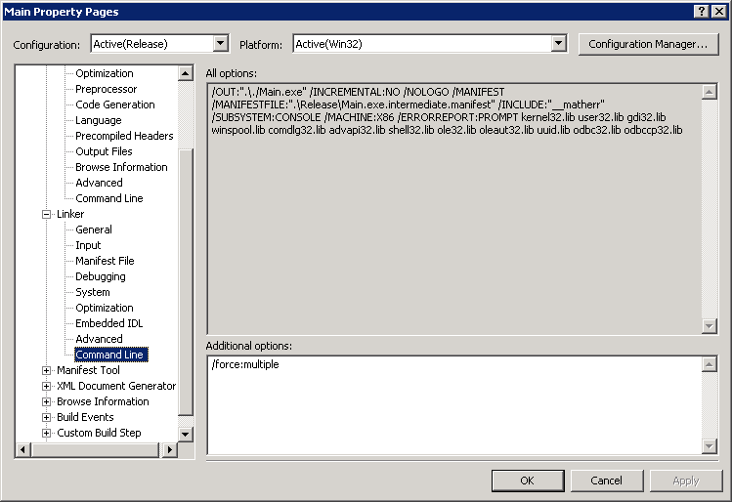

Now you should be able to compile and link to generate the GPRS executable (GPRS.exe) by pressing “F7” key or selecting “Build solution” in the “Build” Menus. This is a debug version of GPRS. If you build a release version (less memory consumption and fast speed), just select the release build, then press “F7” key or select “Build solution” in the “Build” Menus. Don’t forget to set: /force:multiple shown in the above figure for the release version build. The executable name for the release version is GPRSRelease.exe.

There are two OpenMP versions of projects: one is debug (debug OpenMP) and the other is release (release OpenMP). Currently, they have problem to build them.

Execute GPRS
To execute GPRS, one needs to put the input files in the same directory as the executable (GPRS.exe). For example, if you run the SPE1 problem (see the Samples in the GPRS user manual document), the input files: gprs.in, control.in, res_spe1.in and wells_spe1.in must be in the same directory as GPRS.exe. One also needs to put these three support libraries: amgdll.dll, samg_dyn.dll and libguide40.dll in the same folder as the executable or in the environment variable “PATH”.

