GPRS Technical Report

Injection Well Implementation

October, 2005

Huanquan Pan

SUPRI-B Industrial Consortium

Department of Petroleum Engineering

Stanford University

1. Introduction

In the current version of GPRS, the source term for an injection well is handled almost in the same way as that for a production well. This may yield incorrect simulation results and make the simulator hard to maintain. In this report, the current implementation and its consequences are discussed first. Then the general wellbore flow equations and mass conservation equations are derived for an injection well. Finally, the new implementation for black oil and compositional fluid is described and tested.

2. Problems in Existing GPRS

In the current version of GPRS (version 1.3), the wellbore flow equation in a well block for an injection well is

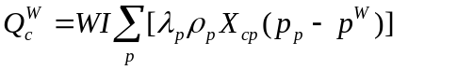 (1)

where 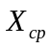 is the mole fraction of component c in phase p in the well block, and 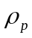 is the phase density of the injection fluid at the reservoir block pressure. The implementation is inappropriate because and in Eqn. 1 should be at the wellbore conditions rather than at the well block (or reservoir) conditions.

The mobility, 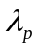 is treated correctly (see Eqn. 5 below) in GPRS. The problems arise from the treatment of and in Eqn. 1. Because of difference in the behavior, the treatment of black oils and compositional fluids is discussed separately.

1.1 Block Oils

In the current version of GPRS (version 1.3), only the injection of single phase (water or gas) is handled. Therefore 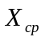 is equal to 1.0 for the injection component because there is no oil in the gas or water phase. However, for a non-injected component, in Eqn. 1 is the value in the reservoir block of the wellbore. But the final results are right because the mobility is zero for an non-injected component. For example, if gas is injected, 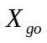, which is the mole fraction of gas in the oil phase at reservoir condition, is not zero, but 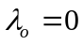, since 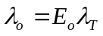 and the volume fraction 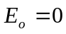. This causes confusion and leads to problems in maintaining and debugging the software. The density in Eqn. 1 is treated as a function of well block pressure p (p represents the non-wetting phase pressure in this report), which is not correct. It should be a function of wellbore pressure, 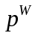. If water is injected, this may not cause a big error because of the small compressibility of water. This explains why the GPRS results match those of Eclipse for two-phase water-oil systems. But if gas is injected, the results may not be correct due to the large compressibility of gas. If a well is controlled by a rate, the density in the rate constraint equation has the same problem, i.e., is determined at the well block pressure.

If the injection fluid is oil, then the 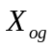 is not equal to 1.0 because gas is soluble in the oil phase, but practically we never inject oil.

1.2 Compositional Fluids

GPRS currently handles only single phase injection (gas or water) for a compositional simulation. If water or a pure gas (single component) is injected, the problem is that the density of the injected fluid is determined at the well block pressure. This is the same problem as the case for block oil. If a gas mixture is injected, we have both density and composition problems, because the composition in Eqn. 1 is different from that of the injected mixture.

3. General Flow Equations

The component mass injected from a well in a well block can be expressed as

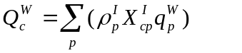 (2)

where superscript I denotes injection, i.e. at the wellbore conditions, 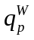 is the phase volumetric injection rate from the well, which can be written as

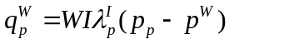 (3)

where,  is the well index for the well block, which is a constant,  is the pressure of the well block and 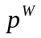 is the wellbore pressure in the well block. Substituting Eqn. 3 into Eqn. 2, we get

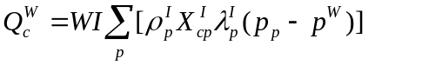 (4)

Eqn. 4 is the general flow equation for an injection well.

In the injection block, the phase mobility is

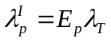 (5)

where 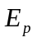 is the phase volume fraction for the injected fluid in the well, defined as

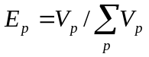. (6)

where 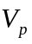 is the volume of phase p in the wellbore. is estimated by flash computation. The 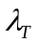 in Eqn. 5 is the total mobility of the fluids in the well grid block, defined as

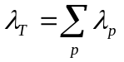 (7)

Substituting Eqn. 5 into Eqn. 4, we get the general flow equation of a component c for an injection well block as

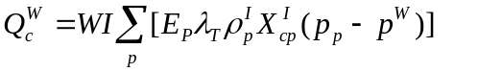 (8)

Let 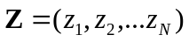 denote the overall composition of the injected fluid at standard conditions. Then 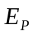, 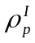 and 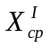 are determined by flash computations with the overall composition Z at the wellbore pressure and temperature 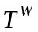. Since Z and are given, each of these terms: , and is only a function of . depends on all reservoir variables in the block (pressure p, phase saturation(s) 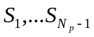, and mole fractions …., , ….). Therefore, 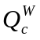 is a function of p, saturation(s), mole fractions in the well block and the wellbore pressure :

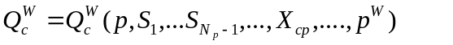 (9)

but is independent of the composition in the well grid block.

4. Jacobian Matrix

The non-zero elements in RRJ from Eqn. 8 are:

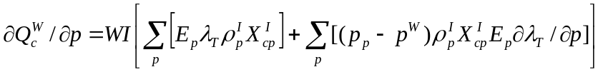 (10)

(11)

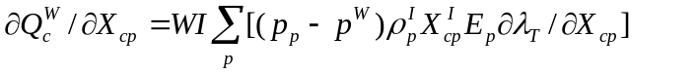 (12)

If the well is under rate control, the non-zero element in RWJ from Eqn. 8 is:

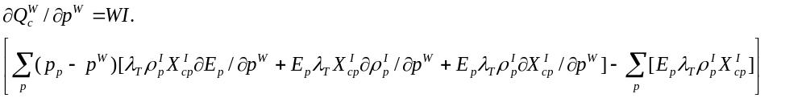 (13)
The phase volume fraction is (see Eqn. 6). Since 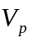 is calculated by flash computation, we know that 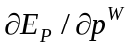 cannot be calculated analytically for a compositional fluid. The numerical calculation of or an explicit approach (from previous iteration) may be required.

5. Rate Constraint

Assuming the injection well is at steady state, mass flow rate of a component at the well bottom (summation for all well blocks) should be equal to the mass flow rate of that component at the injection well head, which can be expressed as

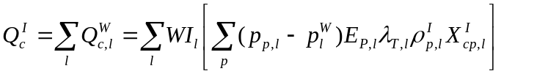 (14)

where subscript l index for the perforated well blocks. The total mass flow from the injection well head is

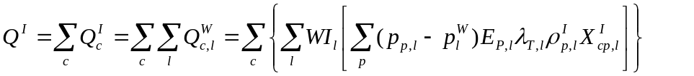 (15)

The rate control equation at constant flow rate of phase p at standard condition is

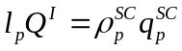 (16)

where 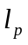 is the mole fraction of phase p in the injection fluid at standard condition. Introducing Eqn. 16 into Eqn. 15, we obtain

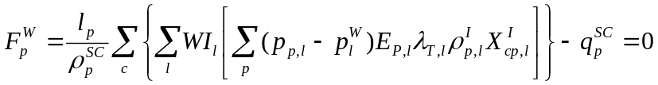 (17)

Eqn. 17 is the generalized rate constraint equation with a constant injection rate of 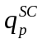.

Note that the subscript l will be neglected in the following derivative equations for simplicity. The non-zero elements in the block index l in WRJ from Eqn. 17 are:

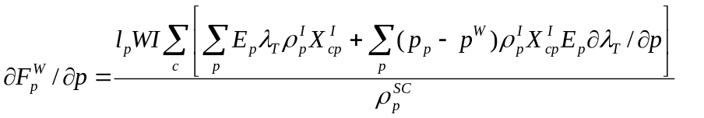 (18)

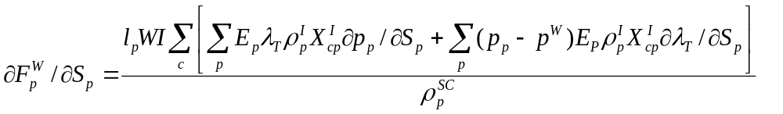 (19)

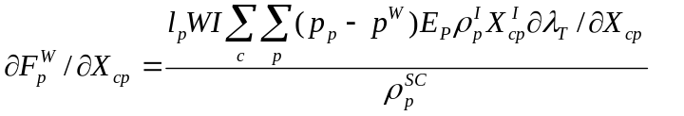 (20)

The element in WWJ from Eqn. 17 is:

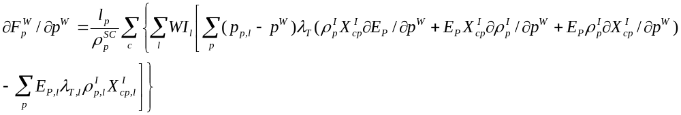 (21)

Note that there is a summation over all perforations (index l) in Eqn. 21 because 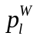 are not independent of each other and they depend on the 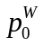 (or BHP) through Eqn. 22 below.

6. Wellbore Pressures in a Multiple Perforations Well

The detailed description to relate a wellbore pressure 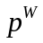in perforation i to the wellbore pressure at reference depth, is given by (Cao, 2002),

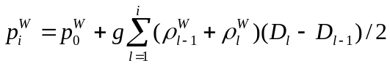 (22)

where 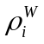 is the total fluid density within the wellbore at well block i, which can be calculated as

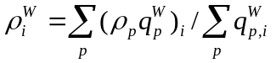 (23)

In computation, the second term of RHS in Eqn. 22 is treated explicitly, i.e., the density in Eqn. 22 is calculated by the values in the previous iteration. Any derivative with respect to , 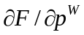 is replaced with 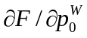.

7. Limitations in Current Implementation

The current implementation has the following limitations:

1. The capillary pressures are neglected in the following flow equations, therefore,

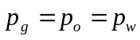 (24)

and

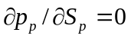 (25)

where, the phase p is gas, oil or water.

2. The injected fluid is in single phase for each well. For a black oil, the injected fluid can be gas, oil or water (no mixture). For a compositional fluid, the injected fluid can be water, gas or oil, and the gas or oil can be a multi-component mixture. We assume that the wellbore is at steady-state, i.e., the concentration of the injected fluid is constant in the wellbore and it is equal to the concentration at the well head.

The injected gas or oil mixture can be in either the liquid or gas state at a perforation, depending on the wellbore pressure in that perforation of the well. Currently GPRS limits that there are no gas-oil two phases at a well perforation.

8. Implementation in GPRS Code

The code in the well control class “WellCont” and its child classes: “WellGRateCont”, “WellORateCont”, and “WellWRateCont” has been modified to implement the injection well.

The major modification is in the “WellCont” class. For each well block, only 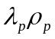 and 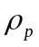values and their derivatives are provided. First, 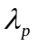and its derivatives are calculated from the and values and their derivatives. This is implemented in “convertMobData()” function. Then, the properties ( and their derivatives) in each perforation are estimated using the upstream conditions (wellbore for an injection well and well block for a production well). This is implemented in “setUpstreamProps()” function. After that, the code in the “calcBOJac()”, “calcCompJac()” and “calcRHS()” functions is modified to compute the RHS and the Jacobin matrix for the flow equation (Eqn. 1).

In each of the child classes of the “WellCont” class, the code in the “calcBOJac()”, “calcCompJac()” and “calcRHS()” functions is modified to compute the RHS and Jacobin matrix of the rate constraint equation.

9. Testing

We have tested the implementation with three samples. The results from GPRS are compared with Eclipse 100 and 300.

Sample 1: This is water-oil two phases, black oil problem, reservoir is homogenous with 10x10x5 blocks. One production well is located in block 1,1,1 and one injection well in 10,10,5. The injection fluid is water with BHP control. The results from the current GPRS (labeled GPRS in these figures), the previous GPRS (labeled GPRS-Old) and the Eclipse 100 (labeled ECL) are plotted in Figures 1a to 1e. All results match one another among these three software packages. Note that the oil saturation in the production well block (1,1,1) also matches from the three packages (not plotted). As explained in the Section 2 (Problems in Existing GPRS), in the previous version of GPRS, 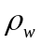 is at the reservoir block pressure while it is at wellbore pressure in the current GPRS. Since water has little compressibility, the difference in at these two pressures is also small, therefore we get very close results for GPRS and GPRS-Old in this sample.

Sample 2: This is a four-component, two-phase (gas-oil) compositional fluid, reservoir is homogenous with 5x5x5 blocks. One production well is located in block 1,1,1 and one injection well is in 5,5,1. The injection fluid is pure methane with BHP control. The results from GPRS, GPRS-Old and the Eclipse 300 are plotted in the Figures 2a to 2g. The results from GPRS match those from Eclipse 300. There are some significant differences in the results between GPRS-Old and Eclipse 300.

Sample 3: This sample is a nine-component two-phase (gas-oil) compositional fluid (described in the 3rd SPE comparative project), reservoir is homogenous with 5x5x5 blocks. One production well is located in block 1,1,1 and one injection well in 5,5,1. The injection fluid is 90% (mole fraction) methane and 10% ethane. Wells are at BHP controls. The results from GPRS, GPRS-Old and the Eclipse 300 are plotted in the Figures 3a to 3g. Again, the results from GPRS match those from Eclipse 300 very well, while there are significant differences between GPRS-Old and Eclipse 300.

Acknowledgment

We would like to thank Mr. Jianping Chen of Schlumberger for his review of Sections 3 to 6 in this report.

References
- Cao, H.: “Development of Techniques for General Purpose Simulators” Ph.D. Dissertation, Stanford University, 2002.

