**Problem statement:**

Write a python program (using keras) to classify the text as positive or negative.

**Approach:**

* **Prerequisite:**

Libraries used: NumPy, Pandas, Sci-kit learn, Keras

Dataset: Twitter sentimental analysis dataset

Step1: Load data set using Pandas

Step2: Data preprocessing (removing neutral sentiments, taking in only valid text/words,

setting features to 2000

Step3: Identifying bias in dataset. 4472 sentences with positive sentiment. 16986 sentences

with negative.

Step3: Building LSTM Network, tuning hyper-parameters, setting activation function to SoftMax.

Step4: Training Network for 7 epochs. RECOMMENDED more than 7. But this being a POC

I have used only 7 epochs

Step5: Using validation set to measure performance.

Step6: Checking bias in network. (As our data set was bias it also reflects in our trained network)

Steps7: testing on our own given sample output.

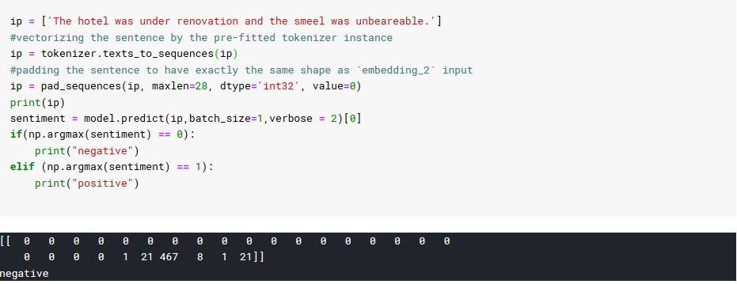

Sample data works just fine.

Now let’s try positive sentence and check whether our predictor works fine.

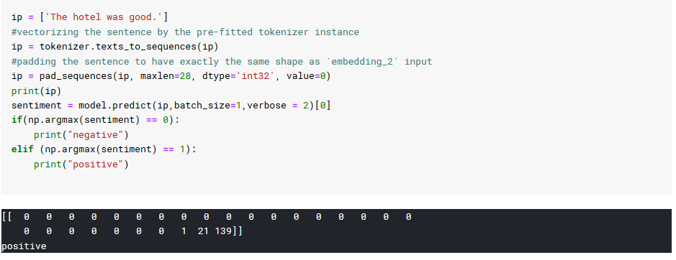

It works just fine.

**THANK YOU.**