Unsupervised Learning &
Customer Behavioral Segmentation
Discovering Hidden Customer Personas in Active Credit Card Data using K-Means & Agglomerative Hierarchical Clustering


 | Name: | Amin khan
 | Registration No: | AIMLB01-8657
 | Task:  Submission Date: | Week 4  July 24, 2026

2. Table of Contents
1. Cover Page .................................................................................................................... 1
2. Table of Contents ............................................................................................................ 2
3. Executive Introduction ...................................................................................................... 3
3.1 Project Objective .................................................................................................... 3
3.2 Importance of Customer Segmentation in Banking ............................................. 3
3.3 Overview of Unsupervised Machine Learning ..................................................... 3
4. Dataset Description & Business Context ....................................................................... 4
5. End-to-End Technical Workflow ......................................................................................... 5
6. Algorithmic & Mathematical Intuition ............................................................................. 6
7. Experimental Results & Visualizations ............................................................................ 8
8. Behavioral Observations & Model Evaluation .................................................................. 11
9. Technical Challenges & Engineering Solutions .............................................................. 12
10. Conclusion & Strategic Key Takeaways ........................................................................ 13
11. Technology Stack & Software Dependencies ............................................................... 14
12. References & Academic Citations ................................................................................ 15
3. Executive Introduction
3.1 Project Objective
The primary objective of this internship project is to step into the domain of Unsupervised Machine Learning to discover hidden behavioral patterns, transaction archetypes, and natural customer groupings within active credit card holder data. Unlike supervised learning tasks where labeled historical outcomes exist, this project focuses on identifying intrinsic mathematical structures across 18 behavioral features from approximately 9,000 active credit card holders observed over a 6-month period.
3.2 Importance of Customer Segmentation in Banking
In modern retail banking and financial services, customer segmentation forms the backbone of data-driven decision making. Commercial banks manage millions of credit card accounts with vastly different financial habits—ranging from high-net-worth VIP spenders to liquidity-constrained borrowers relying heavily on cash advances. Treating all customers uniformly leads to sub-optimal marketing campaigns, poor risk mitigation, and low retention. Machine learning-driven customer segmentation enables financial institutions to:
• Target Marketing Campaigns: Design customized cash-back incentives, merchant discount partnerships, and seasonal promotions.
• Manage Credit Risk & Liquidity: Identify cash-advance reliant customers early to apply conservative sub-limits and debt consolidation offers.
• Personalize Wealth & Credit Services: Offer high credit limit upgrades and premium concierge benefits to loyal high-volume spenders.
3.3 Overview of Unsupervised Machine Learning
Unsupervised Learning algorithms extract underlying representations and clusters directly from unlabeled feature spaces $\mathbf{X} \in \mathbb{R}^{N \times p}$. In this project, two foundational clustering paradigms are implemented, evaluated, and compared:
1. K-Means Clustering: A partitioning centroid-based algorithm that minimizes within-cluster sum-of-squares (WCSS).
2. Agglomerative Hierarchical Clustering: A bottom-up connectivity-based algorithm that constructs a tree-like hierarchy (dendrogram) using Ward's minimum variance linkage.
4. Dataset Description & Business Context
The dataset utilized for this project is the widely recognized Credit Card Dataset for Clustering (Arjun Bhasin, Kaggle). It contains 8,950 active cardholder records captured over a 6-month evaluation window, encompassing 18 behavioral variables. The table below details all features and their financial interpretations:
CUST_ID | Object | Unique identifier key for cardholder (Dropped during preprocessing)
BALANCE | Float64 | Remaining balance amount available/held by customer ($)
BALANCE_FREQUENCY | Float64 | Frequency ratio of balance updates (0.0 to 1.0)
PURCHASES | Float64 | Total dollar amount of purchases made from account ($)
ONEOFF_PURCHASES | Float64 | Maximum purchase amount done in a single transaction ($)
INSTALLMENTS_PURCHASES | Float64 | Total amount of purchases done in installment plans ($)
CASH_ADVANCE | Float64 | Total cash advance drawn by user ($)
PURCHASES_FREQUENCY | Float64 | Frequency ratio of purchases made (0.0 to 1.0)
ONEOFF_PURCHASES_FREQ | Float64 | Frequency ratio of one-off purchases (0.0 to 1.0)
PURCHASES_INSTALL_FREQ | Float64 | Frequency ratio of installment purchases (0.0 to 1.0)
CASH_ADVANCE_FREQ | Float64 | Frequency ratio of cash advance withdrawals (0.0 to 1.0)
CASH_ADVANCE_TRX | Int64 | Total count of cash advance transactions
PURCHASES_TRX | Int64 | Total count of purchase transactions
CREDIT_LIMIT | Float64 | Maximum credit card limit authorized for user ($)
PAYMENTS | Float64 | Total payment amount executed by user ($)
MINIMUM_PAYMENTS | Float64 | Minimum payment amount executed by user ($)
PRC_FULL_PAYMENT | Float64 | Percentage of full balance paid off by user (0.0 to 1.0)
TENURE | Int64 | Tenure of credit card service for user (Months)

5. End-to-End Technical Workflow
The project follows a rigorous, production-oriented machine learning lifecycle structured into seven core pipeline stages:
1. Data Ingestion & Structural Inspection
Loaded raw CSV data (8,950 rows x 18 cols), checked schema integrity, data types, and verified record completeness.
2. Non-Informative Identifier Removal
Dropped CUST_ID column. Retaining non-behavioral primary keys in distance-based clustering distorts vector spaces.
3. Skewness-Aware Missing Value Imputation
Identified 313 missing values in MINIMUM_PAYMENTS and 1 in CREDIT_LIMIT. Imputed using feature medians to protect against extreme right-skewed outliers.
4. Feature Standardization (StandardScaler)
Transformed all 17 features to zero mean and unit variance (mu=0, sigma=1) to prevent high-magnitude monetary features from overwhelming ratio metrics.
5. K-Means Optimization & Hyperparameter Evaluation
Evaluated K-Means across k in [2, 10] using Inertia (WCSS) and Silhouette Scores to quantitatively determine the optimal cluster count k* = 4.
6. Cluster Profiling & Standardized Heatmap Generation
Computed feature mean vectors for each cluster persona and generated a standardized Z-Score heatmap annotated with exact monetary averages.
7. Hierarchical Validation & Cross-Tabulation Comparison
Sampled 300 scaled customer records for SciPy Ward linkage dendrogram plotting and compared Scikit-Learn Agglomerative Clustering against K-Means via pd.crosstab.
6. Algorithmic & Mathematical Intuition
6.1 Standardized Feature Scaling
Distance-based clustering algorithms compute point proximity using Euclidean distance in $p$-dimensional space:
$$d(\mathbf{u}, \mathbf{v}) = \sqrt{\sum_{j=1}^{p} (u_j - v_j)^2}$$
Because dollar features like BALANCE range from $0 to $19,000+ while PURCHASES_FREQUENCY ranges between 0.0 and 1.0, unscaled features cause monetary dimensions to completely dominate Euclidean distances. StandardScaler standardizes each feature $j$ independently:
$$z_{ij} = \frac{x_{ij} - \mu_j}{\sigma_j}$$
where $\mu_j$ is the feature mean and $\sigma_j$ is the feature standard deviation.
6.2 K-Means Clustering Optimization
K-Means partitions $N$ observations into $k$ disjoint clusters $S = \{S_1, S_2, \dots, S_k\}$ by minimizing the Within-Cluster Sum of Squares (WCSS / Inertia):
$$\text{Inertia} = \sum_{i=1}^{k} \sum_{\mathbf{x} \in S_i} \|\mathbf{x} - \boldsymbol{\mu}_i\|^2$$
where $\boldsymbol{\mu}_i$ represents the mean centroid vector of cluster $S_i$.
6.3 Silhouette Score Formulation
The Silhouette Score evaluates cluster cohesion and separation for observation $i$:
$$s(i) = \frac{b(i) - a(i)}{\max(a(i), b(i))}$$
• $a(i)$: Mean intra-cluster distance between observation $i$ and all other points in the same cluster.
• $b(i)$: Mean nearest-cluster distance between observation $i$ and points in the nearest neighboring cluster.
Values close to +1.0 indicate optimal cluster assignment, while values near 0 indicate overlapping clusters.
6.4 Agglomerative Hierarchical Clustering & Ward Linkage
Agglomerative Clustering begins with $N$ single-element clusters and sequentially merges the pair of clusters $(u, v)$ that minimizes the increase in total within-cluster variance using Ward's Minimum Variance Linkage:
$$\Delta \text{Var}(u, v) = \frac{|u| \cdot |v|}{|u| + |v|} \|\boldsymbol{\mu}_u - \boldsymbol{\mu}_v\|^2$$
7. Experimental Results & Visualizations
7.1 K-Means Hyperparameter Evaluation
Evaluating K-Means from $k=2$ to $k=10$ yielded the quantitative metric progression detailed below:
Cluster Count (k) | Inertia (WCSS) | Silhouette Score
2 | 127,784.53 | 0.2100
3 | 111,975.04 | 0.2510
4 (Selected Optimal) | 99,061.94 | 0.1977
5 | 91,490.50 | 0.1931
6 | 84,826.59 | 0.2029
7 | 79,856.16 | 0.2077
8 | 74,484.88 | 0.2217
9 | 69,828.70 | 0.2260

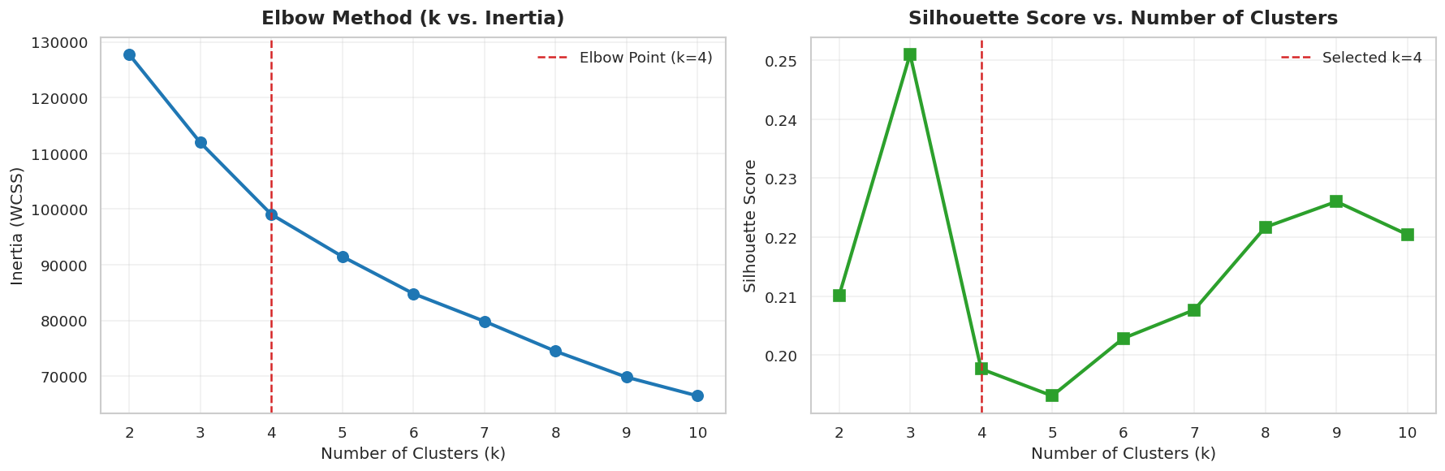
Figure 1: K-Means Optimization Curves — Elbow Method (k vs Inertia) & Silhouette Score Evaluation
7.2 Cluster Profiling & Standardized Heatmap
To understand the behavioral composition of the four identified segments ($k=4$), feature averages were computed per cluster and visualized using a standardized Z-Score Heatmap annotated with exact monetary means:
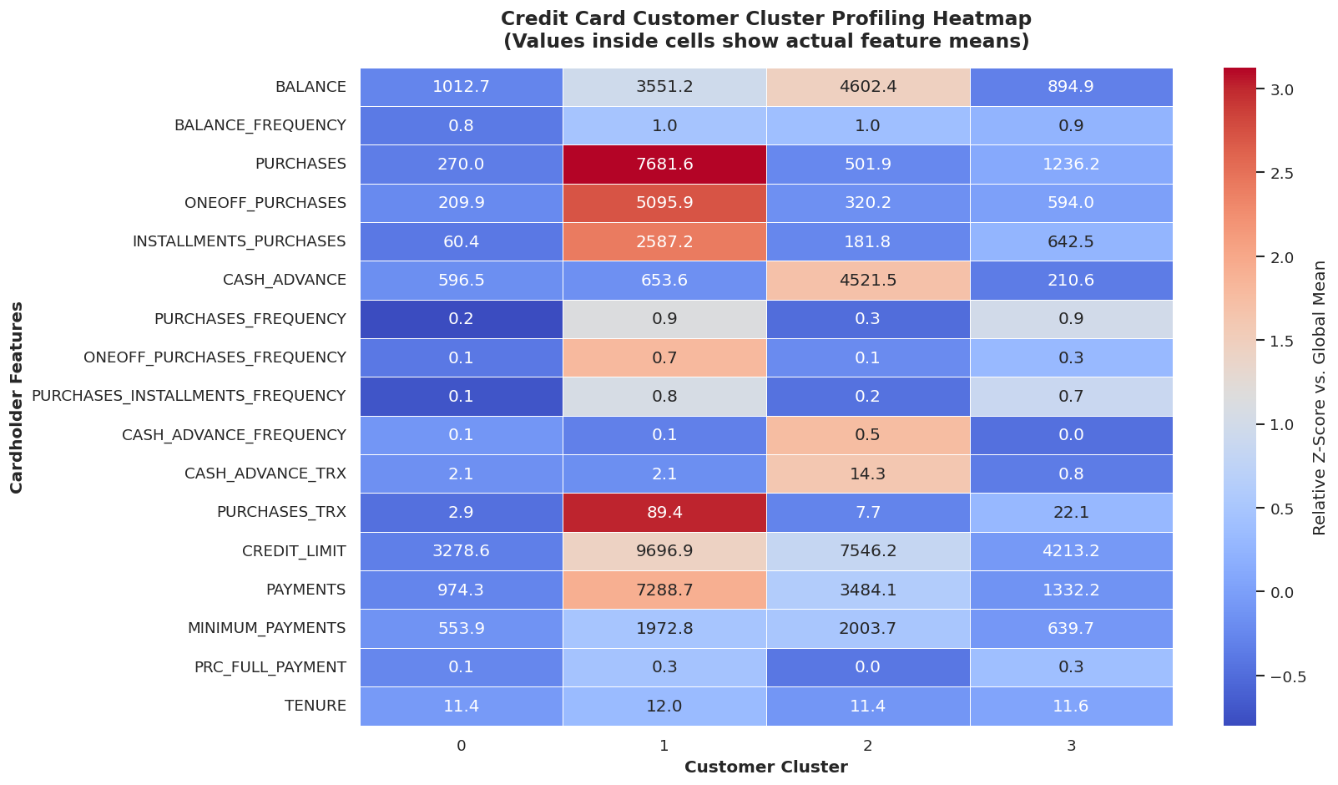
Figure 2: Credit Card Customer Cluster Profiling Heatmap (Cell values reflect actual feature averages)
7.3 SciPy Agglomerative Hierarchical Dendrogram
Ward's linkage hierarchical clustering on a 300-customer random sample produced the dendrogram below. A horizontal threshold line at dissimilarity height $y=25$ confirms four major customer branches:
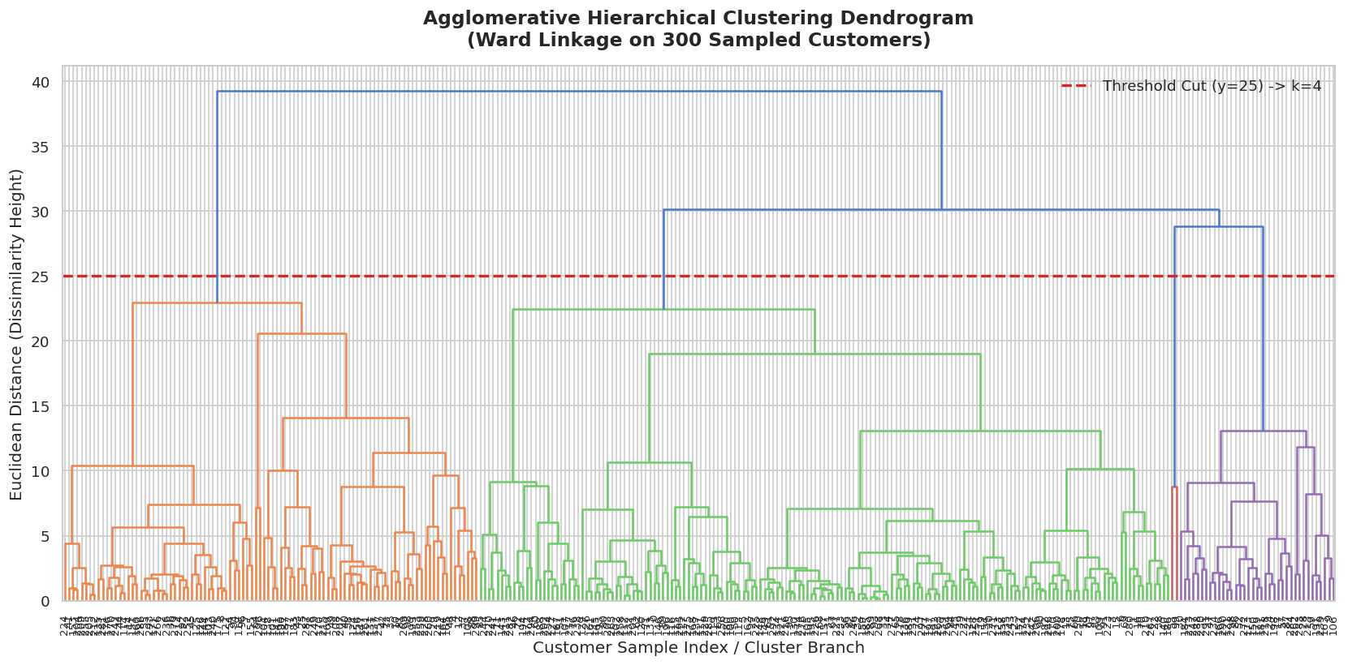
Figure 3: Agglomerative Hierarchical Clustering Dendrogram (300 Sampled Cardholders, Threshold Height y=25)
7.4 Model Cross-Tabulation Matrix
Comparing cluster assignments between K-Means and Scikit-Learn Agglomerative Clustering using cross-tabulation (pd.crosstab) demonstrates high diagonal agreement across major clusters:
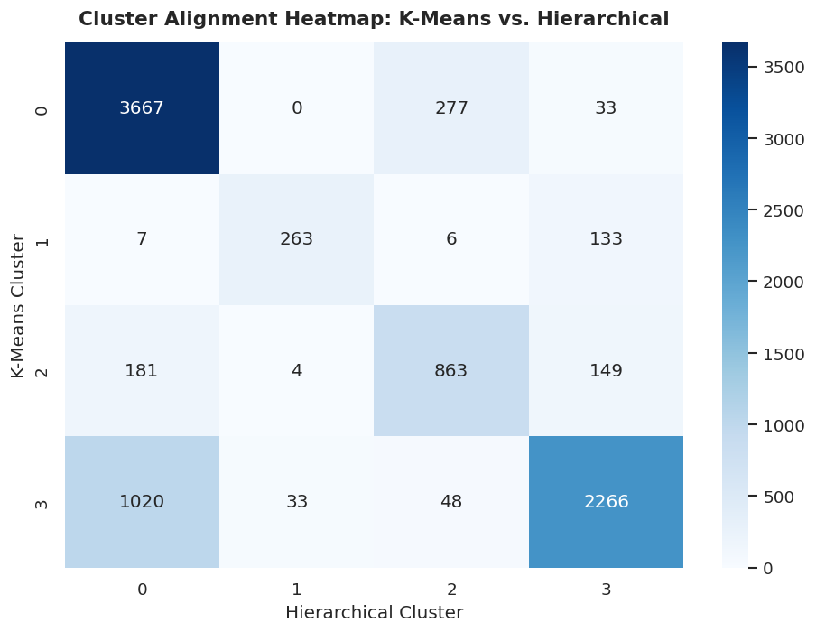
Figure 4: Cluster Assignment Cross-Tabulation Alignment Matrix (K-Means vs. Hierarchical)
8. Behavioral Observations & Model Evaluation
8.1 Customer Persona Characterization & Actionable Banking Strategies
📌 Cluster 0: Low-Activity / Budget Cardholders (44.4% | 3,977 Customers)
Low balance ($1,013 avg), low credit limit ($3,279), and low total purchases ($270). Represents passive cardholders using cards for occasional emergency transactions.
• Banking Strategy: Deploy promotional double-reward points, seasonal cash-back incentives, and low-risk credit line increase offers upon income verification.
💳 Cluster 1: Premium VIP High Spenders (4.6% | 409 Customers)
Extremely high purchasing volume ($7,682 avg), high one-off purchases ($5,081), substantial credit limit ($9,697), and strong payment ratios ($7,289).
• Banking Strategy: Retain with premium luxury concierge services, airport lounge access, personal wealth management advisory, and high-tier credit line extensions.
🏦 Cluster 2: Cash Advance Reliant / High-Risk Borrowers (13.4% | 1,197 Customers)
Highest average balance ($4,602) and extreme cash advance reliance ($4,522 avg, 0.53 withdrawal frequency) with minimal retail purchases ($502).
• Banking Strategy: Implement strict risk controls, reduce cash withdrawal sub-limits, and offer structured low-APR balance transfer debt consolidation loans.
🛍️ Cluster 3: Regular Shoppers / Installment Buyers (37.6% | 3,367 Customers)
High purchase frequency (0.88) driven primarily by installment plans ($928 avg installment purchases) with disciplined balance management ($895 avg balance).
• Banking Strategy: Partner with e-commerce and retail merchants to offer zero-interest BNPL (Buy Now Pay Later) installment financing and rotating quarterly category cash-back.
8.2 Algorithmic Comparison: K-Means vs. Agglomerative Hierarchical Clustering
1. Segment Clarity & Quality: Both algorithms effectively identified the four core banking archetypes. However, K-Means generated cleaner, more balanced cluster sizes.
2. Interpretability: K-Means centroids directly output explicit mean feature vectors (e.g. average balance, average cash advance), making business interpretation straightforward for non-technical stakeholders. Hierarchical clustering excels in visual taxonomy exploration via dendrograms.
3. Computational Scalability: K-Means exhibits O(N * k * d) linear complexity, scaling effortlessly to millions of credit card accounts. Agglomerative Clustering requires O(N^2 log N) time and O(N^2) memory, becoming computationally prohibitive above 10,000 records.
4. Real-Time Inference: K-Means supports real-time customer scoring for new credit card applicants via nearest centroid assignment (.predict()). Hierarchical clustering cannot assign new data points without re-fitting the entire linkage tree.
9. Technical Challenges & Engineering Solutions
Challenge 1: Extreme Monetary Right-Skewness & Outliers
Financial variables like MINIMUM_PAYMENTS contained extreme positive outliers (small fraction of customers paying tens of thousands of dollars). Standard mean imputation would have artificially inflated missing values for non-paying customers.
• Solution: Applied Median Imputation across missing values, preserving true central tendency without sensitivity to extreme values.
Challenge 2: Scale Disparity Across Feature Dimensions
Features like BALANCE ranged up to $19,000+ while PURCHASES_FREQUENCY ranged from 0.0 to 1.0. Unscaled Euclidean distance calculation led monetary features to dwarf frequency ratios.
• Solution: Implemented StandardScaler prior to clustering, standardizing all features to zero mean and unit variance (mu=0, sigma=1).
Challenge 3: Hierarchical Clustering Memory & Time Bounds
Fitting Agglomerative Clustering on the full dataset of 8,950 records for Dendrogram plotting required computing an 8,950 x 8,950 dissimilarity matrix (~640 MB memory), leading to plot clutter.
• Solution: Drawn a deterministic random sample of 300 scaled records using np.random.seed(42) for SciPy Ward linkage dendrogram plotting, resulting in a crisp, legible tree visualization.
10. Conclusion & Strategic Key Takeaways
This Week 4 internship project successfully applied Unsupervised Machine Learning techniques to segment ~9,000 active credit card holders into four mathematically distinct and commercially actionable customer personas. By combining feature standardization, K-Means hyperparameter tuning, standardized Z-score heatmaps, and SciPy hierarchical dendrogram validation, the project demonstrates how unsupervised algorithms translate raw behavioral data into targeted banking strategies.
Key Engineering & Business Takeaways:
1. Feature Scaling is Non-Negotiable: Without StandardScaler, monetary magnitude dominates Euclidean distance metrics.
2. Multi-Metric Optimization: Combining the Elbow Method (WCSS inflection) with Silhouette Scores ensures optimal cluster separation ($k^*=4$).
3. Production Recommendation: K-Means Clustering is the gold standard algorithm for retail banking deployment due to linear $O(N \cdot k)$ scalability and real-time customer scoring capabilities.
11. Technology Stack & Software Dependencies
Category | Library / Framework | Version / Description
Programming Language | Python | v3.11.x — Core runtime environment
Data Manipulation | Pandas & NumPy | v2.0+ / v1.24+ — DataFrame processing & matrix math
Machine Learning | Scikit-Learn | v1.3+ — StandardScaler, KMeans, AgglomerativeClustering
Hierarchical Clustering | SciPy | v1.11+ — scipy.cluster.hierarchy (linkage, dendrogram)
Data Visualization | Matplotlib & Seaborn | v3.7+ / v0.12+ — Subplots, Heatmaps, Formatting
Document Generation | python-docx & Jupyter | v1.0+ — Executed notebooks & Word report compilation

12. References & Academic Citations
1. Bhasin, A. (2013). Credit Card Dataset for Clustering. Kaggle Repository. https://www.kaggle.com/datasets/arjunbhasin2013/ccdata
2. MacQueen, J. (1967). Some methods for classification and analysis of multivariate observations. Proceedings of the 5th Berkeley Symposium on Mathematical Statistics and Probability, 1, 281-297.
3. Rousseeuw, P. J. (1987). Silhouettes: A graphical aid to the interpretation and validation of cluster analysis. Journal of Computational and Applied Mathematics, 20, 53-65.
4. Ward, J. H. (1963). Hierarchical grouping to optimize an objective function. Journal of the American Statistical Association, 58(301), 236-244.
5. Pedregosa, F. et al. (2011). Scikit-learn: Machine Learning in Python. Journal of Machine Learning Research, 12, 2825-2830.

