AI Fitness Trainer

*Progress Report #4*

# TL; DR

**On track (*Github:***[*AI-FitnessTrainer*](https://github.com/aminuabdusalam/AI-FitnessTrainer)*)***.** Kickstarted build of Trainer - Trainer can now detect landmarks and find angle between three landmarks**.**

# Project Goals (Recap)

The goal of the project can be summarized as developing an **AI fitness trainer** embedded with **storage and recommender systems** and an **AI virtual mouse**.

The AI fitness trainer will help the user lose weight, gain muscle, and accomplish other fitness goals. In addition, it'd attempt to understand the client goals, develop a fitness routine, recommend a healthy eating plan, and ensure all exercises are performed correctly.

# Highlights

* Kickstarted build of trainer ([Kickstarted build of Trainer (can find angle) · aminuabdusalam/AI-FitnessTrainer@f57fd24 (github.com)](https://github.com/aminuabdusalam/AI-FitnessTrainer/commit/f57fd242bc59320a3024a6643ff980e433aea055)
  + Ran into issue with detecting the three landmarks fed into the findAngle function as you can see in the image to the left below [the three **blue** dots are not all on the **red** dots representing the shoulder, elbow, and wrist), but apparently, I was using the same x coordinate for the three landmarks and the issue was rectified as seen in the image to the right below [the three **blue** dots are on the appropriate points representing the shoulder, elbow, and wrist].

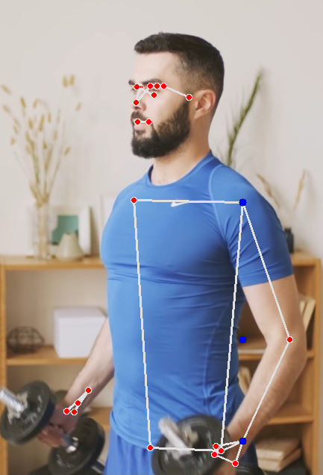

* + Implemented and Added method to PoseDetector class for calculating angle between three landmarks ([Added method to find angle between 3 landmarks. · aminuabdusalam/AI-FitnessTrainer@3754b19 (github.com)](https://github.com/aminuabdusalam/AI-FitnessTrainer/commit/3754b19f1cbecb6fa23d135addc5b695d6e52664))

Above image shows angle between landmarks (11,13,15) i.e. between left_shoulder, left_elbow, left_wrist = 135 degrees **and** angle between landmarks (12,14,16) i.e. between right_shoulder, right_elbow, right_wrist = 152 degrees.

* + Deciding between two methods to calculate angle: one is saying 134.5 one is saying 334 (exterior angle)

# Lowlights

None

# Next Steps

* Set up PoseDetection program to capture video from webcam input ([Pose - mediapipe (google.github.io)](https://google.github.io/mediapipe/solutions/pose#static_image_mode)) and **complete by 09/26**. NB: program currently detects pose in saved images/video.
* Continue build of personal trainer and **complete by 10/25.**
  + Program should be able to leverage angle between landmarks to ensure an exercise such as **basic curl** is performed correctly and complete by **09/26.**
  + Extend program to ensure other exercises like **pushup/armraise** areperformed appropriately by **10/03**.

# Timeline

This section lists the milestones of the project spread across two semesters (Fall 2022 and Spring 2023).

|  |  |  |  |
| --- | --- | --- | --- |
| **Milestones** | | **ETA** | **Status** |
| **Requirements Gathering** (Project Idea, Project Proposal) | | 08/22 | Completed |
| **Design Exploration** (Setup and Installation of necessary technologies, Addition of Project to remote repo, Skill Preparation, Framework Project) | | 08/29 | Completed |
| **Implementation** | Complete Pose Estimation Build | 09/19 | Completed |
| Complete AI Personal Trainer Build | 10/25 | **In Progress** |
| Partly Complete Storage System Build | 10/31 | Not Started |
| **Quality Testing** | | 11/7 | Not Started |
| **Midpoint Presentation Draft** | | 11/14 | Not Started |
| **Midpoint Demo & Report** | | 11/21 | Not Started |
|  | **WINTER BREAK** | | |
| **Project Review** (Current status and Re-evaluation of Next Steps as Needed) | | 01/16 | Not Started |
| **Implementation** | Complete Storage System Build | 01/30 | Not Started |
| Complete Recommender System Build | 02/20 | Not Started |
| Complete Hand Tracking Build (Stretch Goals) | 03/13 | Not Started |
| Complete AI Virtual Mouse Build (Stretch Goals) | 03/27 | Not Started |
| **Quality Testing** | | 04/3 | Not Started |
| **Final Presentation Draft** | | 04/10 | Not Started |
| Final Demo & Report | | 04/17 | Not Started |