AI Fitness Trainer

*Progress Report #15*

# TL; DR

**On track (*Github:***[*AI-FitnessTrainer*](https://github.com/aminuabdusalam/AI-FitnessTrainer)*)***.** Continued build of webapp by **02/06.**

# Project Goals (Recap)

The goal of the project can be summarized as developing an **AI fitness trainer** embedded with **storage and recommender systems** and an **AI virtual mouse**.

The AI fitness trainer will help the user lose weight, gain muscle, and accomplish other fitness goals. In addition, it'd attempt to understand the client goals, develop a fitness routine, recommend a healthy eating plan, and ensure all exercises are performed correctly.

# Highlights

* Continued build of Webapp.
  + **Fixed Video processing and storing recorded video:** recording button works and the trainer is now compatible with it. Also, recorded video can now be sent to client as a report. [Fixed recording by aminuabdusalam · Pull Request #8](https://github.com/aminuabdusalam/AI-FitnessTrainer/pull/8)

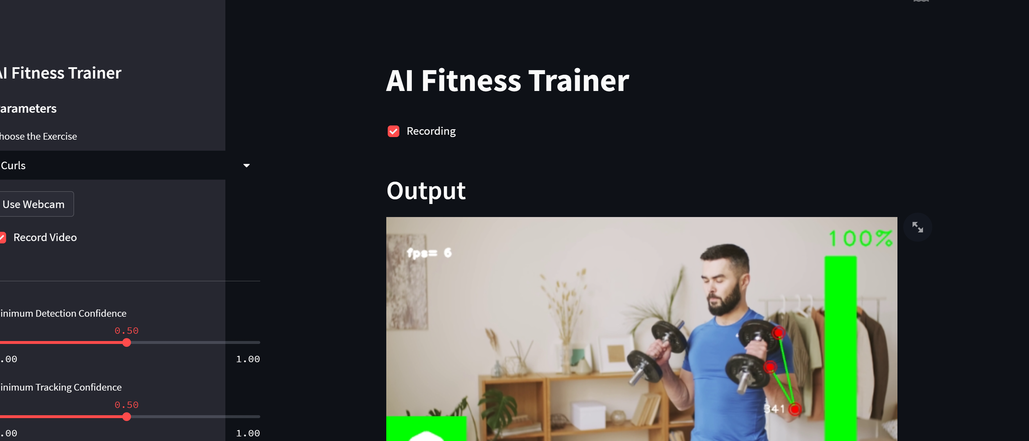

* + Augmented website with multi pages to allow for selection of exercise choice
    - Allows user choose exercise, use webcam, record video, select detection confidence and tracking confidence, etc.

**Click Windows Media to Watch Demo:**

# Lowlights

None

# Next Steps

* Continue Web app build.
  + Implement “about developer and project” page including instructions on how to use product by **02/12**
  + Develop a “report” page that showcases details about their fitness sessions at the end of each session including an option to send these details to their mail by **02/20**
  + Add authentication/login capabilities by **03/05**

# Timeline

This section lists the milestones of the project spread across two semesters (Fall 2022 and Spring 2023).

|  |  |  |  |
| --- | --- | --- | --- |
| **Trainer service build completed** | | 11/21 | Completed |
| **WINTER BREAK 2022** | | | |
| **Project Review** (Current status and Re-evaluation of Next Steps as Needed) | | 01/16 | Completed |
| **Implementation** | Complete FigJam design for the Web app | 01/22 | Completed |
| Build Web app with only one exercise type option | 01/22 | Completed |
| Augment website with multi pages to allow for selection of exercise choice | 02/05 | **Completed** |
| Implement “about developer and project” page including instructions on how to use product | 02/12 |  |
| Develop a “report” page that showcases details about their fitness sessions at the end of each session including an option to send these details to their mail | 02/20 |  |
| Add authentication/login capabilities | 03/05 |  |
| Complete Hand Tracking Build (Stretch Goals) | 03/13 |  |
| Complete AI Virtual Mouse Build (Stretch Goals) | 03/27 |  |
| **Quality Testing** (arrange project file and refs, test project) | | 04/3 |  |
| **Final Presentation Draft** | | 04/10 |  |
| Final Demo & Report | | 04/17 |  |