SOUTHERN WISCONSIN HAIL RESPONSE

A Madison Response Built for Ownership
Recent southern Wisconsin hail left visible damage to glass, siding, and exposed exterior surfaces. Boardroom-level storm response starts with calm local accountability, disciplined documentation, and a clean decision path.

Madison roots matter after a storm.
Founded in Madison in 1973 by Lee Hustad, Hustad is built for local accountability after the weather clears - from rapid assessments to ownership-ready summaries and full exterior execution.

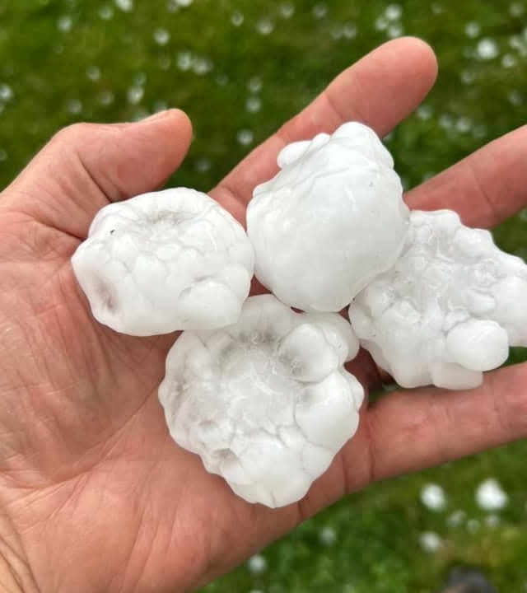 |  | 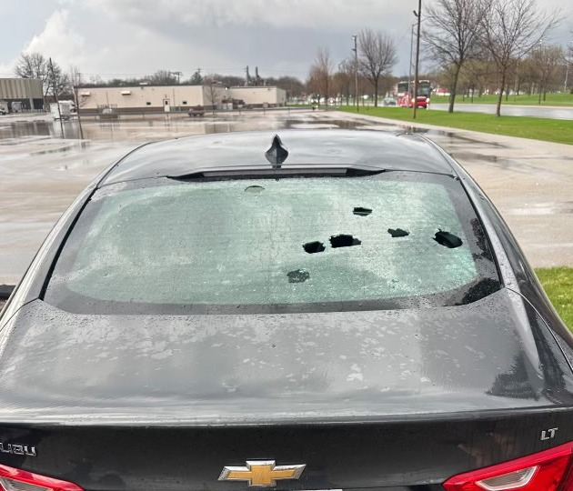
Large hail documented locally | Measured impact scale | Broken rear glass after the storm

Why this storm matters  • Visible exterior impact often understates roof-system exposure on day one.  • Siding, screens, windows, soft metals, and roof sections can all be part of one loss event.  • The real cost of delay is confusion, interior risk, and avoidable operational noise. | What leadership needs next  • Building-by-building documentation instead of guesswork.  • A clear separation between urgent repairs, claim-position items, and monitor-only conditions.  • One local partner that can address roof, siding, window, gutter, and related exterior scope.
Why Hustad looks different  • Madison-founded and locally accountable after the storm passes.  • Executive communication designed for onsite teams, regionals, and ownership.  • Calm occupied-property execution - not high-pressure door-to-door sales tactics. | What Hustad delivers  • Rapid local field assessment with photo-supported reporting.  • Ownership-ready summaries that help teams move from damage to decision.  • Repair, stabilization, or replacement planning when the facts support it.

Wisconsin born. Wisconsin accountable.
When southern Wisconsin takes a direct hit, Hustad helps leadership move from evidence to action with local response, full exterior scope, and executive-grade documentation.

