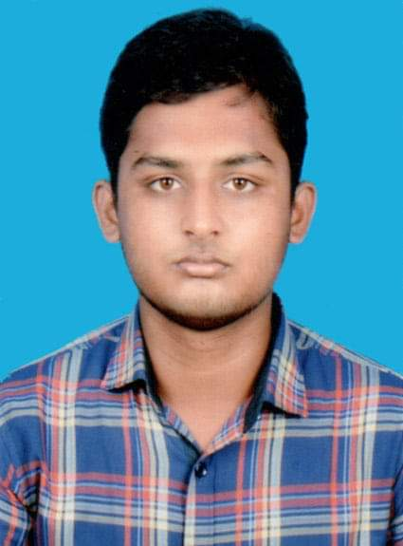**Curriculum Vitae**

**Name :** Aminul Islam

**Father’s name :** Md. Azim

**Mother’s name :** Nurzahan Akter

**Parmanent address :** Village:Yousufnagar,Post:Ghorashal

Thana: Muradnagar,District:Cumilla

**Present address :** Muradpur high school road,Dhaka-1204

**Nationality :** Bangladeshi

**Date of Birth :** 22/11/2001

**Religion :** Islam

**Mobile No :** 01784446009

**Email Adress :** aminulashik@gmail.com

**Educational Qualification :**

|  |  |  |  |  |
| --- | --- | --- | --- | --- |
| **Degree** | **Group** | **Board** | **Year** | **Result** |
| SSC | Science | Dhaka | 2014 | GPA 5.00 |
| HSC | Science | Dhaka | 2016 | GPA 5.00 |
| BSC | Computer science& Telecommunication Engineering | Public University(NSTU) | 2021 | CGPA 3.50 |

**Other Qualification :** Expert at Ms word,powerpoint,excel,adobe

Illustrator and photoshop

**Communication Skill :** Good command over reading , writing,

speaking in English and Bangla

**Date Signature**

**10/11/21 Aminul Islam**