**Lab Report No:** 01

**Lab Report Name:** Network configuration and routing table.

**Name:** Md. Aminul Islam

**ID:** IT-17025

**Question 1:**

If you have a network that ranges from 192.168.1.0 to 192.168.1.255.explain why individual devices in the network can only be assigned IP addresses in the range of 192.168.1.1 to 192.168.1.254.

ANS: Here 192.168.1.0 is a network address and 192.168.1.255 is a broadcast address

Those 2 are not useful.For this we have only assigned IP addresses in the range of 192.168.1.1 to 192.168.1.254 .It is called subnetting

**Question2:** Find ip and Mac address on your pc

Solution:

MAC Address

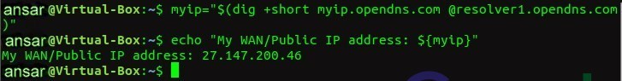

MAC Address

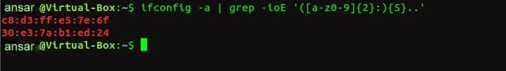

**Question 3:**

Now,enter the command:"$ netstat=r" to print your computers routing table. Explain

(very briefly) he different columns: Destination,Gateway,Genmask,Flags,MSS, Window,rtt and Iface,

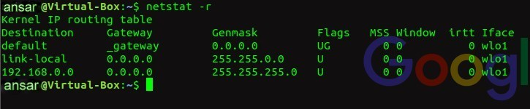

* **Destination** : The destination network or destination host. • **Gateway** : The gateway address or â€™*â€™ if none set.
* **Genmask** : The netmask for the destination net; 255.255.255.255 for a host destination and 0.0.0.0 for the default route.
* **Flags** : Possible flags include
* U (route is up)
* H (target is a host)
* G (use gateway)
* **MSS** : Default maximum segment size for TCP connections over this route.
* **Window** : Default window size for TCP connections over this route.
* **irtt** : Initial RTT (Round Trip Time). The kernel uses this to guess about the best TCP protocol parameters without waiting on (possibly slow) answers. **Iface** : Interface to which packets for this route will be sent

**Question 4:**

a)Create a virtual interface

