**Lab Report No :** 02

**Lab Report Name :** Install Wireshark in Linux

**Name:** Md. Aminul Islam

**ID:** IT-17025

**Installing Wireshark:**

Wireshark is available in the official package repository of Ubuntu 14.04 LTS and later. So it is really easy to install.

**Ping information & captured packet: ping 8.8.8.8 in powershell**

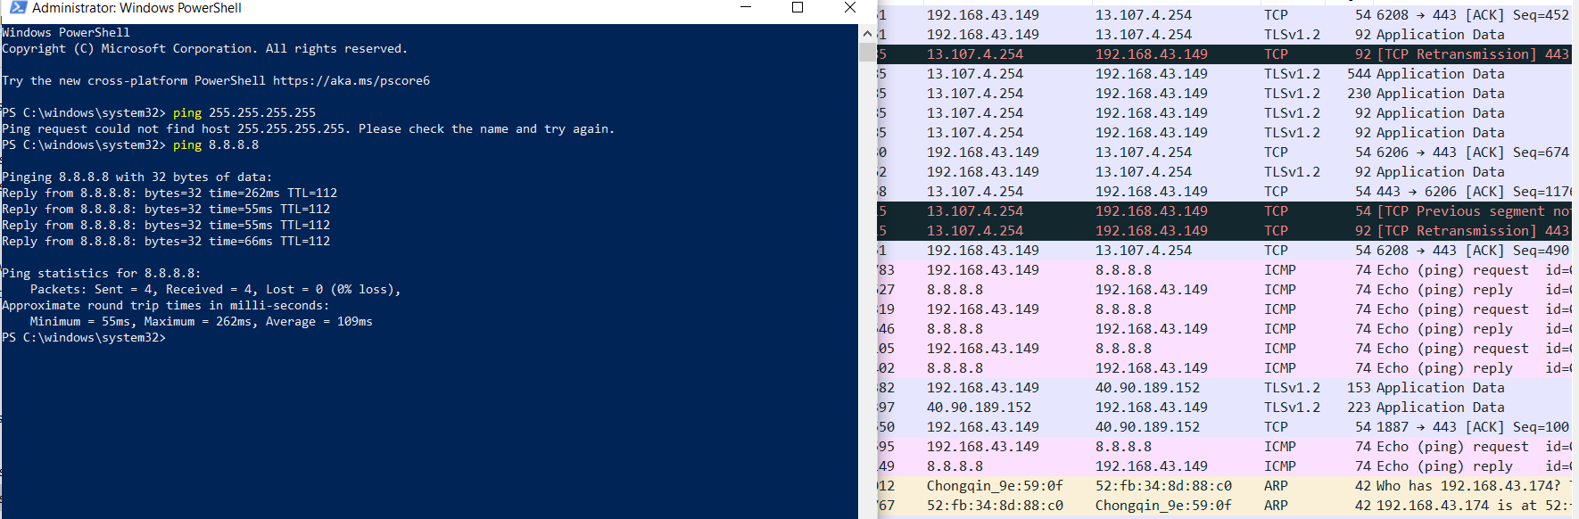

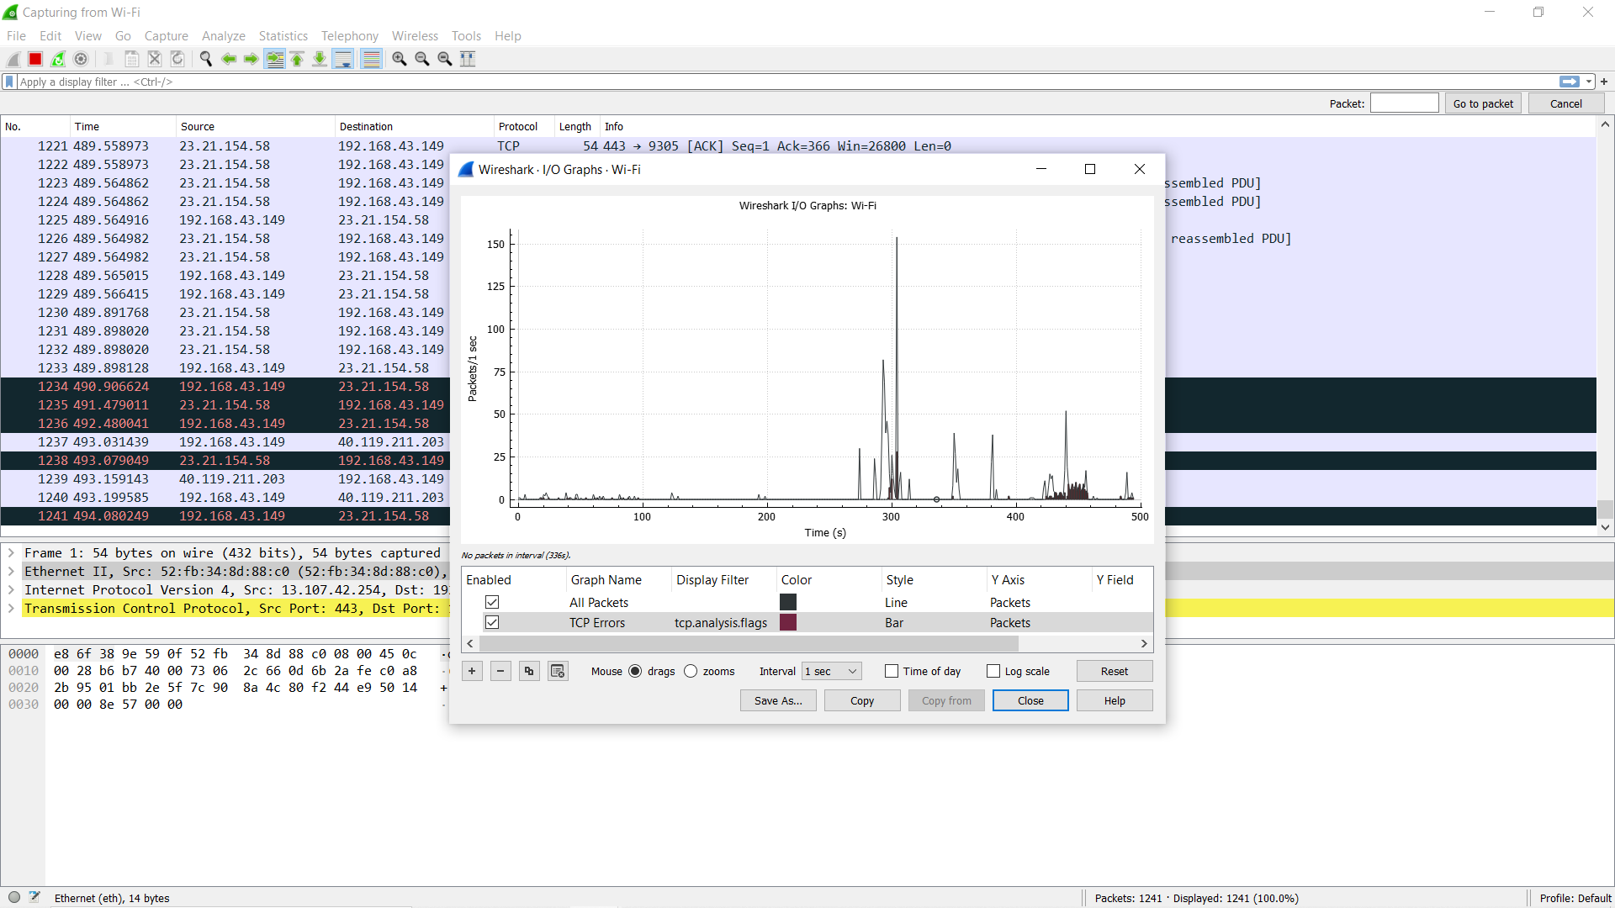

**The protocol information :**

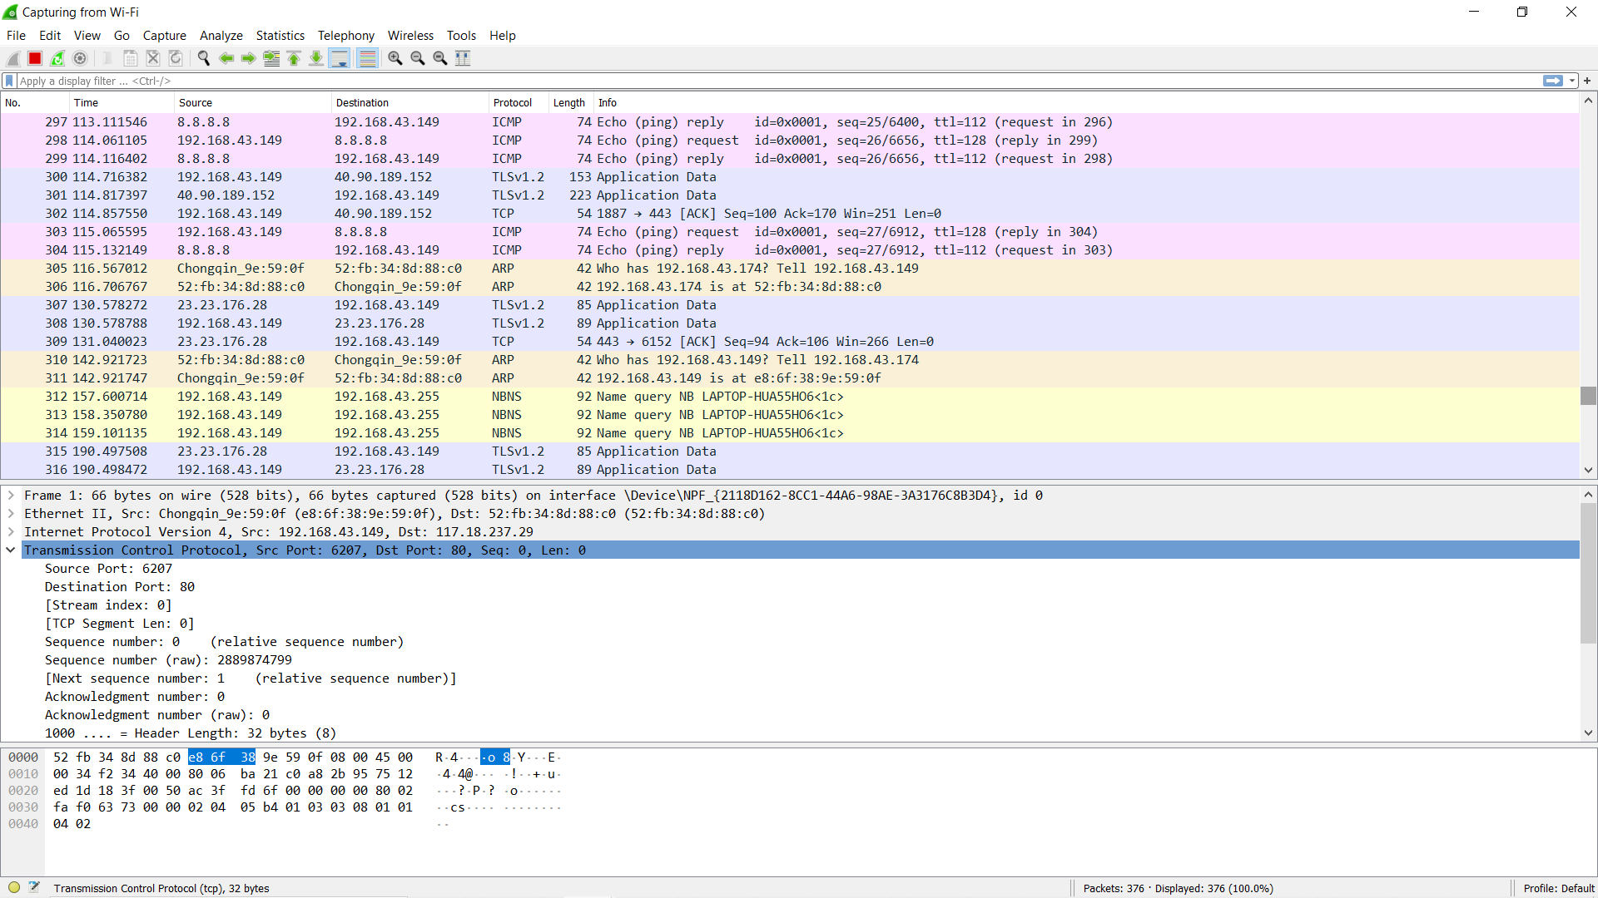

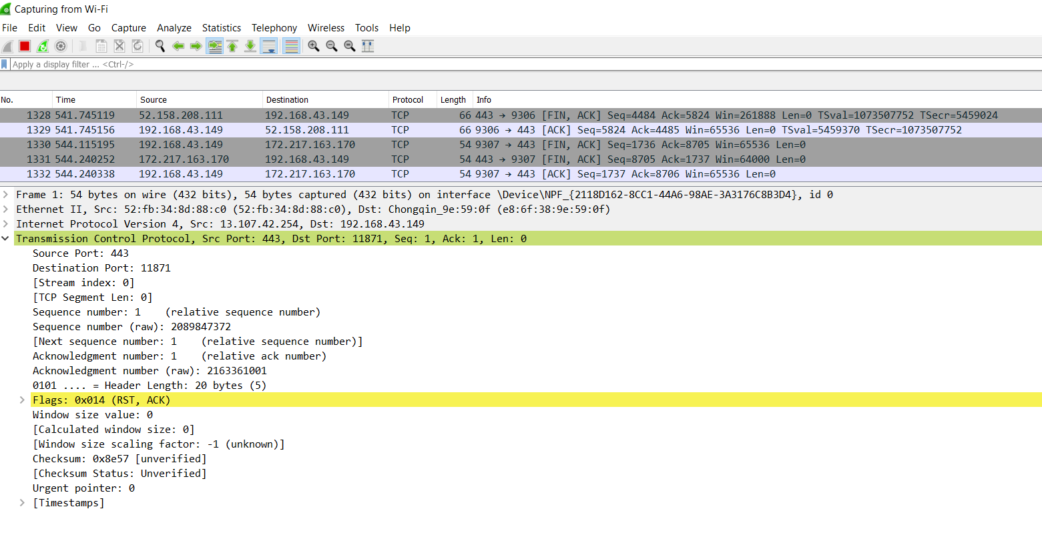

**Port Security Hashing Algorithm:**

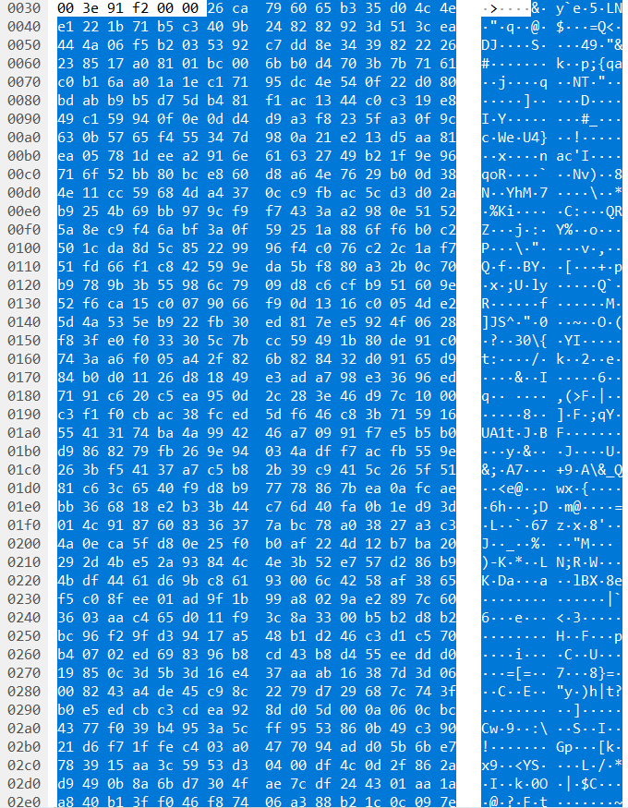

**Different Statistics:**

**Wi_Fi file capture**

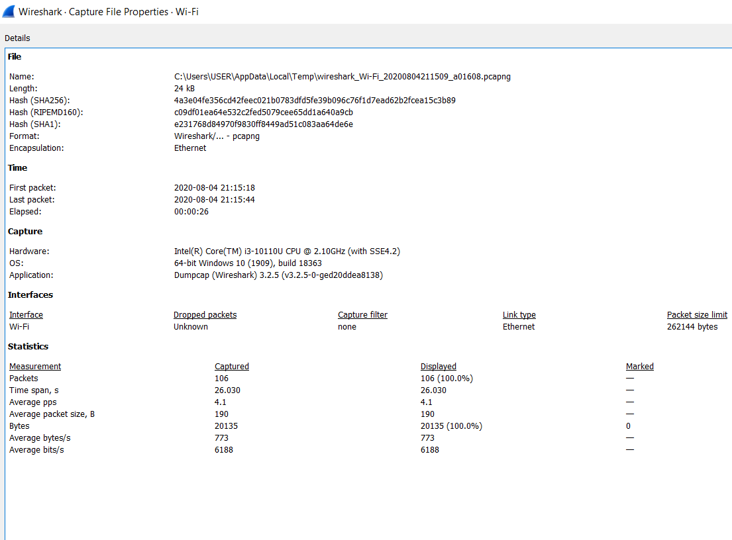

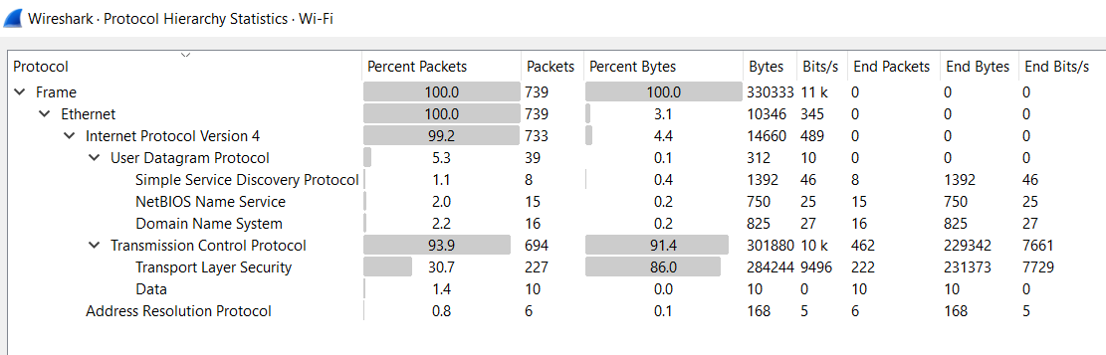

**DNS**

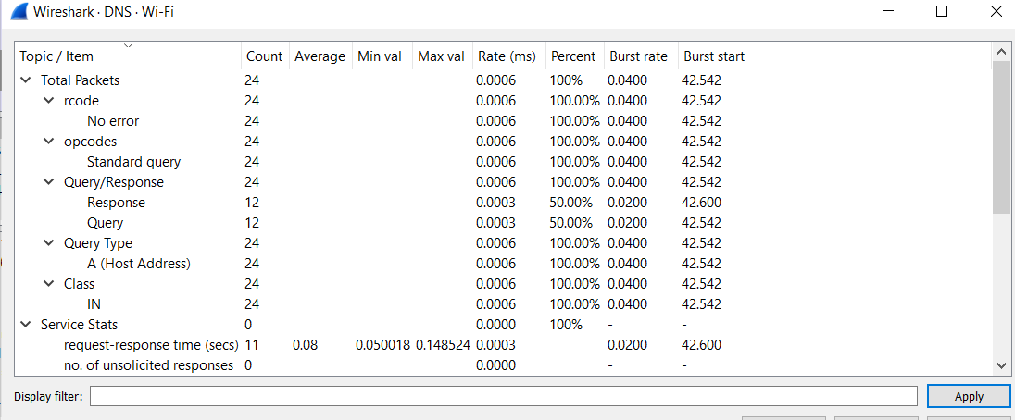

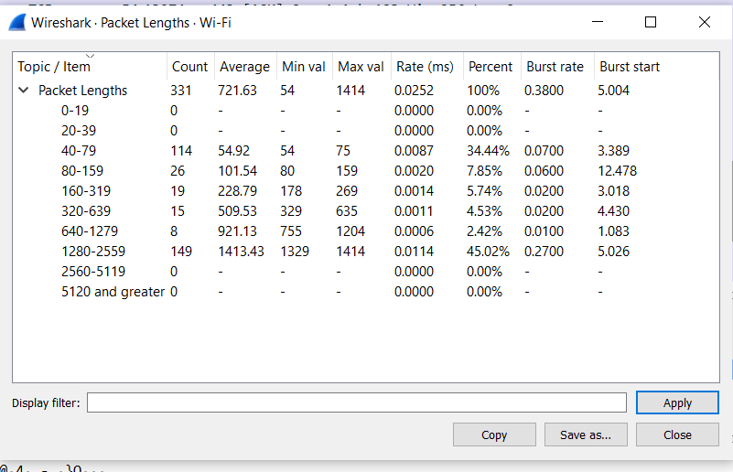

**Protocol have been used:**

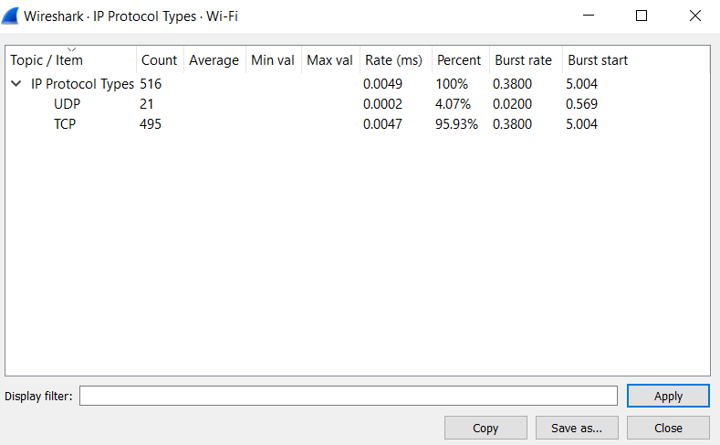

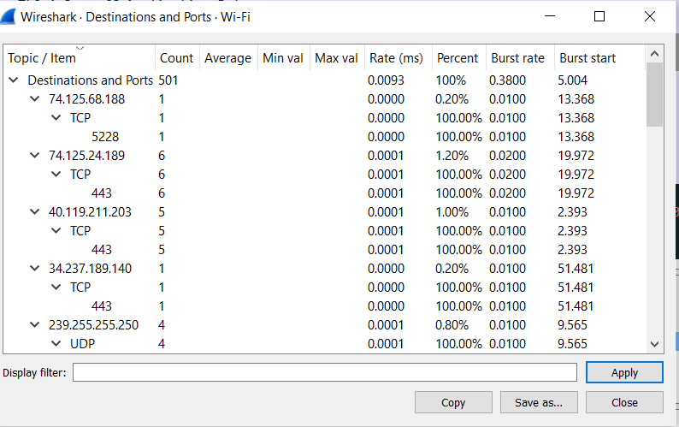

**Real time Response:**

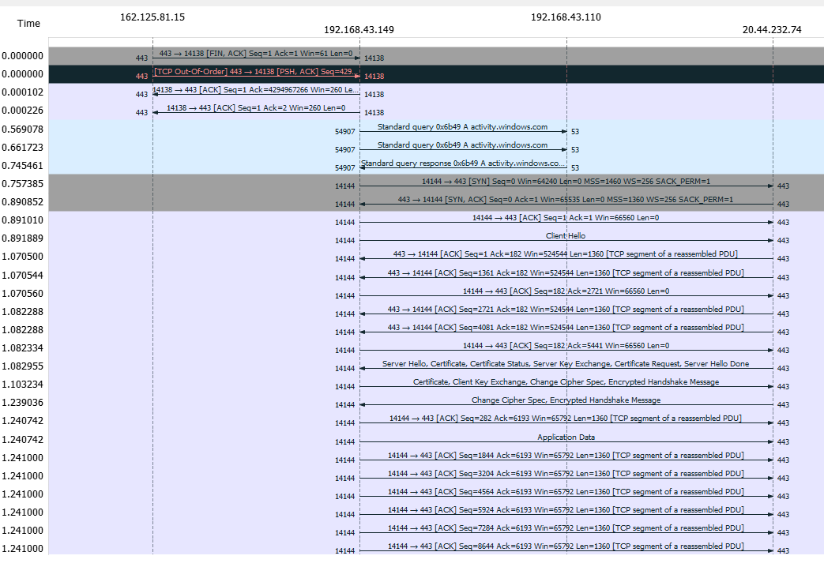

**Conclution:**

Wireshark is a open source and free software. It is a Graphical alternative to TCP dump and display packet in details. Open files contains packet data captures. This is useful for analyzing data captured “off the wire” from a live network connection, or data read from a capture file. The Wireshark package contains a network protocol analyzer

.